What is Web Server and Different Types of Web Servers?
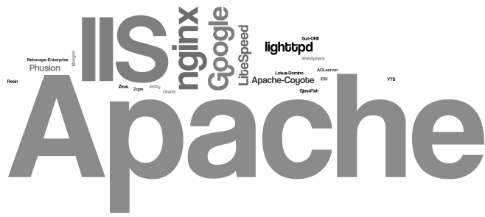
you will see what is a web server? How does it work? and why is it important for the web hosting servers. Web servers are of different kinds. Hosting companies use different web servers considering the requirements of their clients.

Is web server plays a very important role in hosting?
Do you know something? web server is the core for any web hosting. Yes, without a web server, you can’t even dream of pulling your website content online.

What is Web Server and how it works?
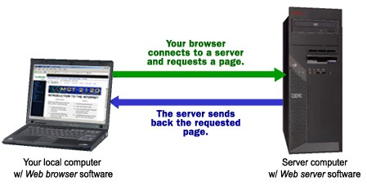
Web server is a program that uses HTTP to serve files that create web pages to users in response to their requests, which are forwarded by their computers HTTP connection.
Any server that delivers an XML document to another device can be a Web server. A better definition might be that a Web server is an Internet server that responds to HTTP requests to deliver content and services.
Let me explain you with a simple example, I can say if you are in front of your computer, browsing your Web, and you get a message from a friend saying, "I had just read a great article! You can check it from the following URL. It's at http://www.cvr.ac.in/blog" So you will type that URL into your browser and press enter.
And that’s it, no matter where the website hosted in the world, the page will be displayed on your computer screen.
Always a web server is connected to the internet. Every Web server that connects to the Internet will be provided with a unique address which was arranged with a series of four numbers between 0 and 255 separated by periods.
Also, web server enables the hosting providers to manage multiple domains(users) on a single server.

A web host is a company that leases out space on a cluster of servers to empower people to serve their own content & webpages.

Different Types of Web Servers
There are different types of web servers available in open market. The most popular web servers are Apache, IIS, Nginx and LiteSpeed.

Apache Web Server

Apache is the most popular web server in the world developed by the Apache Software Foundation. Apache is an open source software and can be installed on almost all operating systems including Linux, Unix, Windows, FreeBSD, Mac OS X and more. About 60% of machines run on Apache Web Server.
An Apache server can be customized easily as it contains a modular structure. It is also an open source which means that you can add your own modules to the server when to require and make modifications that suit your specific needs.
It is more stable than any other web servers and is easier to solve administrative issues. It can be install on multiple platforms successfully.
​
Recent Apache releases provide you the feasibility of handling more requests when you compare to its earlier versions.

IIS Web Server

IIS is a Microsoft product. IIS server has all the features just like Apache. But it is not an open source and more over personal modules cannot be added easily and modification becomes a little difficult job.
Microsoft developed, maintains it, thus works with all the Windows operating system platforms. Also, they had good customer support if it had any issues.

Nginx Web Server

Nginx is another free open source web server, it includes IMAP/POP3 proxy server. Nginx is known for its high performance, stability, simple configuration and low resource usage.
This web server doesn’t use threads to handle requests rather a much more scalable event-driven architecture which uses small and predictable amounts of memory under load. It is getting popular in the recent times and it is hosting about 7.5% of all domains worldwide.

LightSpeed Web Server

1LiteSpeed (LSWS) is a high-performance Apache drop-in replacement. LSWS is the 4th most popular web server on the internet and it is a commercial web server.
Upgrading your web server to LiteSpeed will improve your performance and lower operating costs.
This is compatible with most common Apache features, including mod_rewrite, .htaccess, and mod_security. LSWS can load Apache configuration files directly and works as a drop-in replacement for Apache with hosting control panels — replacing Apache in less than 15 minutes with zero downtime.
Unlike other front-end proxy solutions, LSWS replaces all Apache functions, simplifying use and making the transition from Apache smooth and easy. Most of the hosting companies were using LSWS in recent times.

Conclusion
Most of the web hosting companies select web server based on clients requirement, the number of clients on a single server, the applications/software clients use and the amount of traffic they generate that could handle by a web server. So, choose the web server which meets your requirements better.

HTTP (Hyper Text Transfer Protocol)
The Hypertext Transfer Protocol (HTTP) is application-level protocol for collaborative, distributed, hypermedia information systems. It is the data communication protocol used to establish communication between client and server.
HTTP is TCP/IP based communication protocol, which is used to deliver the data like image files, query results, HTML files etc on the World Wide Web (WWW) with the default port is TCP 80. It provides the standardized way for computers to communicate with each other.
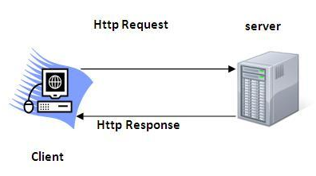
The Basic Characteristics of HTTP (Hyper Text Transfer Protocol):
- It is the protocol that allows web servers and browsers to exchange data over the web.
- It is a request response protocol.
- It uses the reliable TCP connections by default on TCP port 80.
- It is stateless means each request is considered as the new request. In other words, server doesn't recognize the user by default.
The Basic Features of HTTP (Hyper Text Transfer Protocol):
There are three fundamental features that make the HTTP a simple and powerful protocol used for communication:
- HTTP is media independent: It refers to any type of media content can be sent by HTTP as long as both the server and the client can handle the data content.
- HTTP is connectionless: It is a connectionless approach in which HTTP client i.e., a browser initiates the HTTP request and after the request is sends the client disconnects from server and waits for the response.
- HTTP is stateless: The client and server are aware of each other during a current request only. Afterwards, both of them forget each other. Due to the stateless nature of protocol, neither the client nor the server can retain the information about different request across the web pages.
The Basic Architecture of HTTP (Hyper Text Transfer Protocol):
The below diagram represents the basic architecture of web application and depicts where HTTP stands:
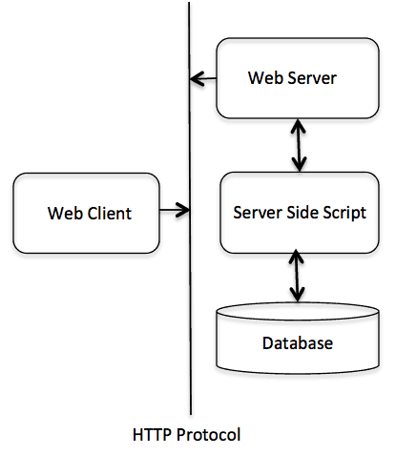
HTTP is request/response protocol which is based on client/server based architecture. In this web browser, search engines, etc behaves as a HTTP clients, and the Web server like Servlet behaves as a server.
1)Install TOMCAT web server and APACHE.
While installation assign port number 4040 to TOMCAT and 8080 to APACHE. Make sure that these ports are available i.e., no other process is using this port.
2)Access the above developed static web pages for books web site, using these servers by putting the web pages developed in week-1 and week-2 in the document root.
Access the pages by using the urls:http://localhost:4040/systemname/books.html.(for tomcat)
http://localhost:8080/books.html (for apache)
PROGRAM:
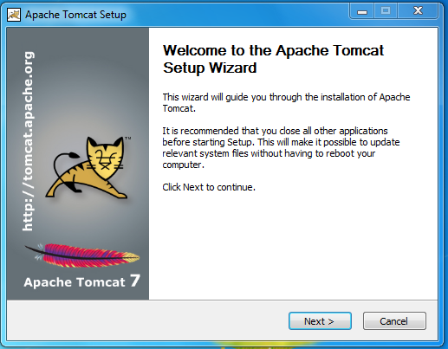
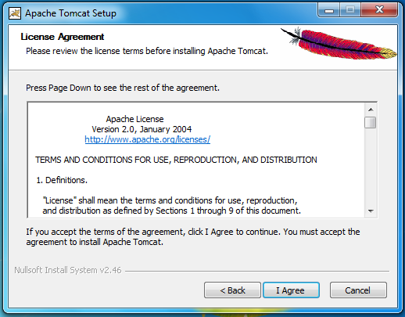
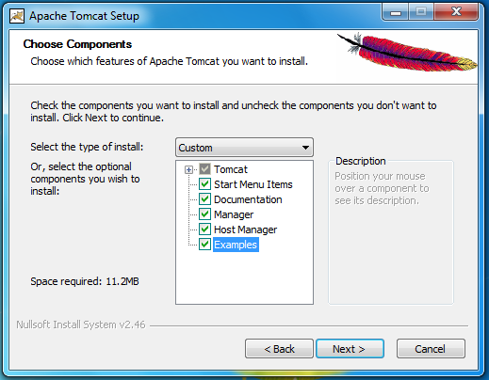
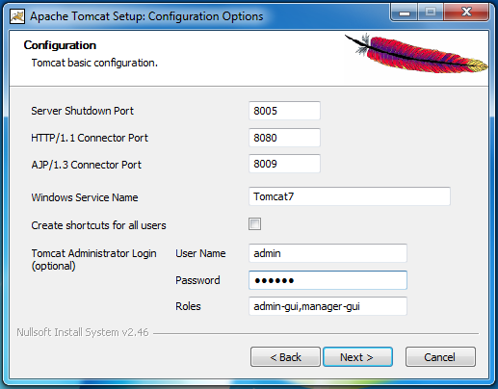
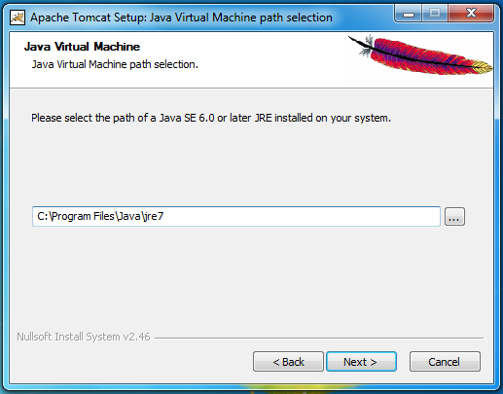
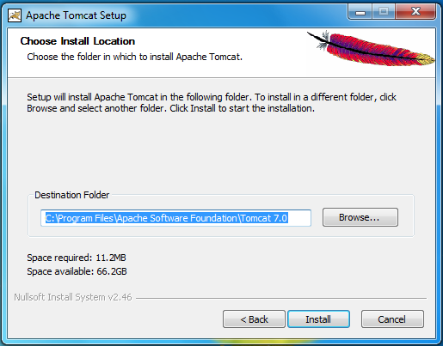
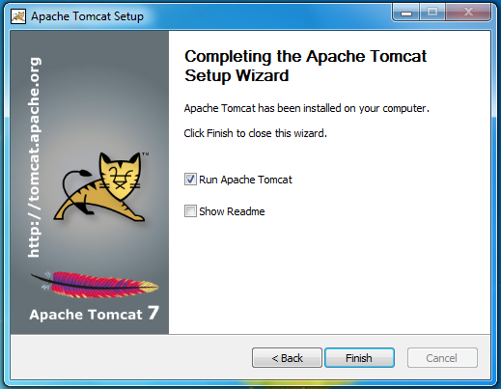

Steps to create a servlet example
- Steps to create the servlet using Tomcat server
  - Create a directory structure
  - Create a Servlet
  - Compile the Servlet
  - Create a deployment descriptor
  - Start the server and deploy the application
There are given 6 steps to create a servlet example. These steps are required for all the servers.
The servlet example can be created by three ways:
- By implementing Servlet interface,
- By inheriting GenericServlet class, (or)
- By inheriting HttpServlet class
The mostly used approach is by extending HttpServlet because it provides http request specific method such as doGet(), doPost(), doHead() etc.
Here, we are going to use apache tomcat server in this example. The steps are as follows:
- Create a directory structure
- Create a Servlet
- Compile the Servlet
- Create a deployment descriptor
- Start the server and deploy the project
- Access the servlet

download this example of servlet
download example of servlet by extending GenericServlet
download example of servlet by implementing Servlet interface

1)Create a directory structures
The directory structure defines that where to put the different types of files so that web container may get the information and respond to the client.
The Sun Microsystem defines a unique standard to be followed by all the server vendors. Let's see the directory structure that must be followed to create the servlet.
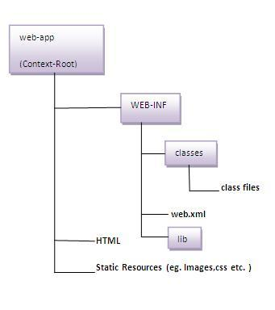
As you can see that the servlet class file must be in the classes folder. The web.xml file must be under the WEB-INF folder.

2)Create a Servlet
There are three ways to create the servlet.
- By implementing the Servlet interface
- By inheriting the GenericServlet class
- By inheriting the HttpServlet class
The HttpServlet class is widely used to create the servlet because it provides methods to handle http requests such as doGet(), doPost, doHead() etc.
In this example we are going to create a servlet that extends the HttpServlet class. In this example, we are inheriting the HttpServlet class and providing the implementation of the doGet() method. Notice that get request is the default request.
DemoServlet.java
- import javax.servlet.http.*;
- import javax.servlet.*;
- import java.io.*;
- public class DemoServlet extends HttpServlet{
- public void doGet(HttpServletRequest req,HttpServletResponse res)
- throws ServletException,IOException
- {
- res.setContentType("text/html");//setting the content type
- PrintWriter pw=res.getWriter();//get the stream to write the data

- //writing html in the stream
- pw.println("<html><body>");
- pw.println("Welcome to servlet");
- pw.println("</body></html>");

- pw.close();//closing the stream
- }}

3)Compile the servlet
For compiling the Servlet, jar file is required to be loaded. Different Servers provide different jar files:
Jar file | Server
1) servlet-api.jar | Apache Tomcat
2) weblogic.jar | Weblogic
3) javaee.jar | Glassfish
4) javaee.jar | JBoss

Two ways to load the jar file
- set classpath
- paste the jar file in JRE/lib/ext folder
Put the java file in any folder. After compiling the java file, paste the class file of servlet in WEB-INF/classes directory.

4)Create the deployment descriptor (web.xml file)
The deployment descriptor is an xml file, from which Web Container gets the information about the servet to be invoked.
The web container uses the Parser to get the information from the web.xml file. There are many xml parsers such as SAX, DOM and Pull.
There are many elements in the web.xml file. Here is given some necessary elements to run the simple servlet program.
web.xml file
- <web-app>

- <servlet>
- <servlet-name>cvrcse</servlet-name>
- <servlet-class>DemoServlet</servlet-class>
- </servlet>

- <servlet-mapping>
- <servlet-name>cvrcse</servlet-name>
- <url-pattern>/welcome</url-pattern>
- </servlet-mapping>

- </web-app>

Description of the elements of web.xml file
There are too many elements in the web.xml file. Here is the illustration of some elements that is used in the above web.xml file. The elements are as follows:

<web-app> represents the whole application.
<servlet> is sub element of <web-app> and represents the servlet.
<servlet-name> is sub element of <servlet> represents the name of the servlet.
<servlet-class> is sub element of <servlet> represents the class of the servlet.
<servlet-mapping> is sub element of <web-app>. It is used to map the servlet.
<url-pattern> is sub element of <servlet-mapping>. This pattern is used at client side to invoke the servlet.

5)Start the Server and deploy the project
To start Apache Tomcat server, double click on the startup.bat file under apache-tomcat/bin directory.

One Time Configuration for Apache Tomcat Server
You need to perform 2 tasks:
- set JAVA_HOME or JRE_HOME in environment variable (It is required to start server).
- Change the port number of tomcat (optional). It is required if another server is running on same port (8080).

1) How to set JAVA_HOME in environment variable?
To start Apache Tomcat server JAVA_HOME and JRE_HOME must be set in Environment variables.
Go to My Computer properties -> Click on advanced tab then environment variables -> Click on the new tab of user variable -> Write JAVA_HOME in variable name and paste the path of jdk folder in variable value -> ok -> ok -> ok.
Go to My Computer properties:
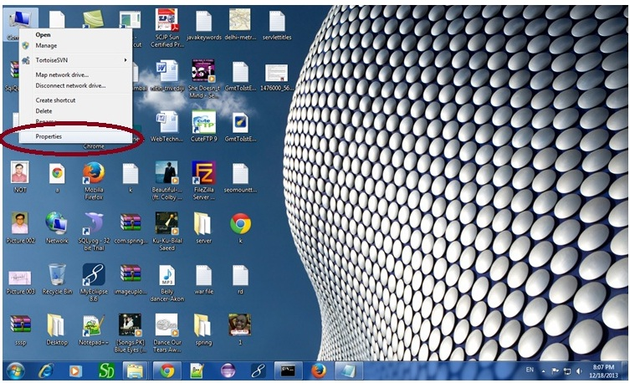
Click on advanced system settings tab then environment variables:
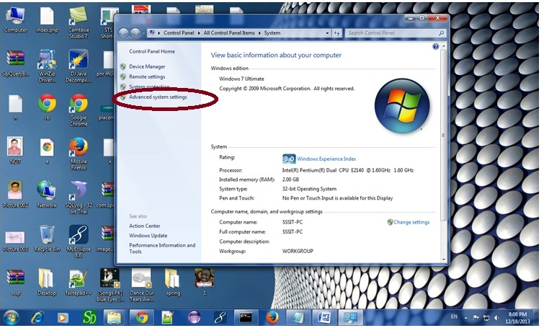
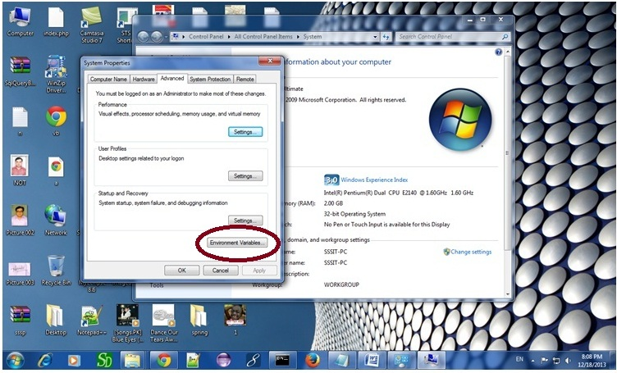
Click on the new tab of user variable or system variable:
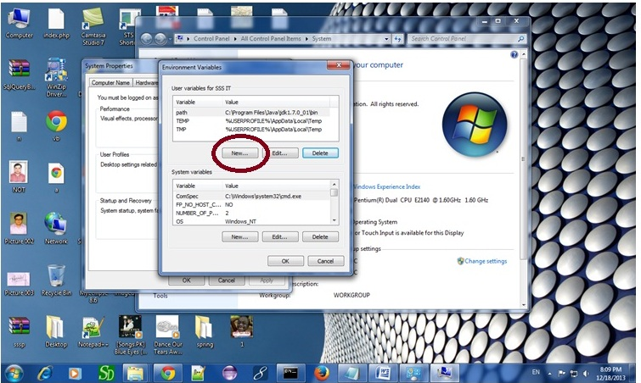
Write JAVA_HOME in variable name and paste the path of jdk folder in variable value:
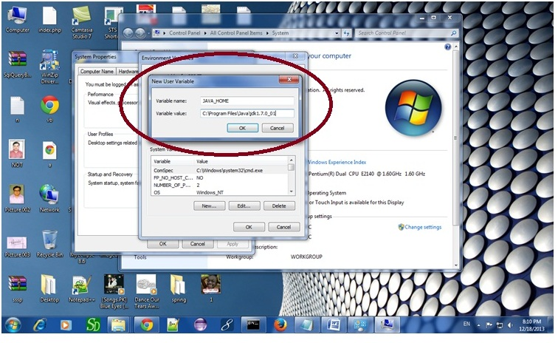
There must not be semicolon (;) at the end of the path.

After setting the JAVA_HOME double click on the startup.bat file in apache tomcat/bin.
Note: There are two types of tomcat available:
- Apache tomcat that needs to extract only (no need to install)
- Apache tomcat that needs to install
It is the example of apache tomcat that needs to extract only.
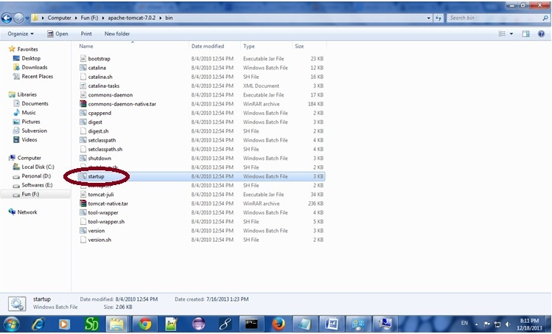
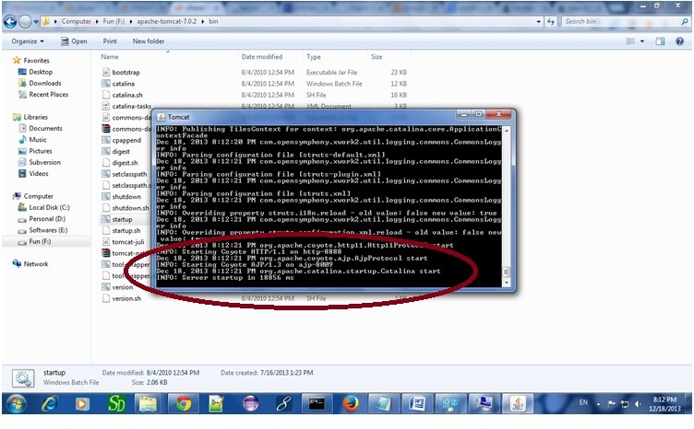

Now server is started successfully.

2) How to change port number of apache tomcat
Changing the port number is required if there is another server running on the same system with same port number.Suppose you have installed oracle, you need to change the port number of apache tomcat because both have the default port number 8080.
Open server.xml file in notepad. It is located inside the apache-tomcat/conf directory . Change the Connector port = 8080 and replace 8080 by any four digit number instead of 8080. Let us replace it by 9999 and save this file.

5) How to deploy the servlet project
Copy the project and paste it in the webapps folder under apache tomcat.
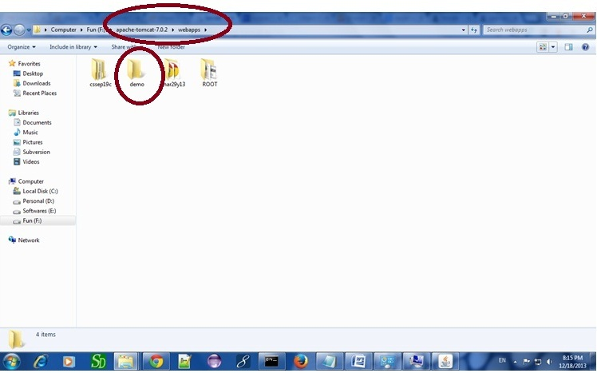
But there are several ways to deploy the project. They are as follows:
- By copying the context(project) folder into the webapps directory
- By copying the war folder into the webapps directory
- By selecting the folder path from the server
- By selecting the war file from the server
Here, we are using the first approach.
You can also create war file, and paste it inside the webapps directory. To do so, you need to use jar tool to create the war file. Go inside the project directory (before the WEB-INF), then write:
- projectfolder> jar cvf myproject.war *
Creating war file has an advantage that moving the project from one location to another takes less time.

6) How to access the servlet
Open broser and write http://hostname:portno/contextroot/urlpatternofservlet. For example:
- http://localhost:9999/demo/welcome
