NACHRCOI

National Anticrime and Human Rights Council of India

V.Umamaheswari Head - Department of social work, Bangalore City College is a National level women cell secretary, State level President of Karnataka. The main aim of this organization is Crime free India. Mr.Diwash Lama is a founder and chairman from West Bengal controlling all over India and some cases of International too. As a social worker it is very easy for me to do various operations, awareness, training programs. No members and higher official of this organization will get any stipend or service charges. Everything is a service and free of cost. We are providing free legal aid to the public. We are working for human rights protection, child labor protection, police atrocities, crime investigation, corruption investigation, RTI, RTE, human trafficking, training on human rights etc. Feel free to contact us.

[www.nachrcoi.com](http://www.nachrcoi.com/)

 Helpline numbers.7479044440/41/42/43

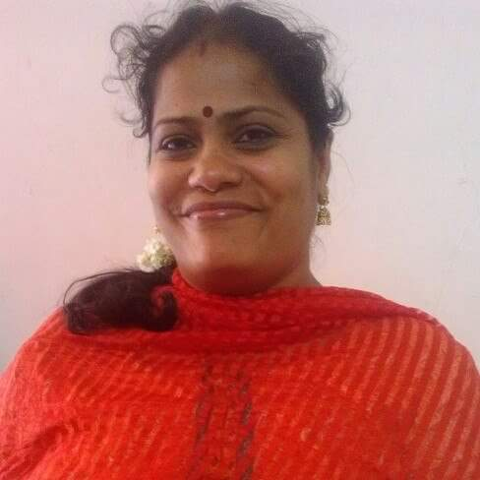

V.Umamaheswari

Head-Department of Social Work

Bangalore City College