# United Nations Convention on the Rights of the Child

The most significant of all international laws for children in the UN Convention on the Rights of the Child popularly refers as the CRC. Human rights belong to all people, regardless of their age, including children. However, because of their special status - whereby children need extra protection and guidance from adults – children also have some special right of their own.

## Significant features of the UN convention on the Rights of the Child (CRC)

* Applies equally to both girls and boys up to the age of 18, even if they are married or already have children of their own.
* The convention is guided by the principles of Best interest of the Child and Non-discrimination and respect for views of the child.
* It emphasizes the importance of the family and the need to create an environment that is conducive to the healthy growth and development of children.
* It obligates the state to respect and ensure that children get a fair and equitable deal in society.

## It draws attention to four sets of civil, political, social, and cultural rights:

* Survival
* Protection
* Development
* Participation

## Right to Survival includes

* Right to life.
* The highest attainable standard of health.
* Nutrition.
* Adequate standard of living.
* A name and Nationality.

## Right to Development includes

* Right to education
* Support for early childhood and development.
* Social security.
* Right to leisure, recreation and cultural activities.

## Right to Protection includes freedom from all forms of

* Exploitation.0
* Abuse.
* Inhuman or degrading treatment.
* Neglect.
* Special protection in special circumstances such as situations of emergency and armed conflicts, in case of disability etc.

## Right to Participation includes

* Respect for the views of the child.
* Freedom from expression.
* Access to appropriate information.
* Freedom of thought, conscience and religion.

All rights are dependent on each other and are indivisible. However, because of their nature all rights are divided into

Immediate Rights (Civil and political Rights) which include such things as discrimination, punishment, right to a fair hearing criminal cases and a separate system of juvenile justice, right to life, right to nationality, right to reunification with the family.

Most protection rights fall within the category of immediate rights therefore demand immediate attention and intervention.

Progressive rights (Economic, social and cultural rights), which include health and education and the rights that are not covered by the first category.

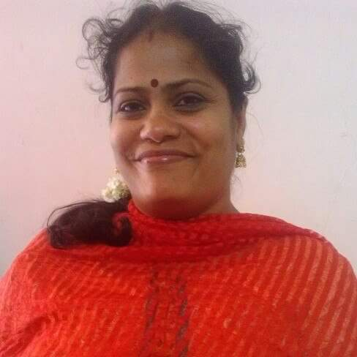

V.Umamaheswari

Head – Department of Social Work

National Anti-Crime and Human Rights Council of India