NotesApp
Project submitted to the
SRM University – AP, Andhra Pradesh
for the partial fulfilment of the requirements to award the degree of
Bachelor of Technology
In
Computer Science and Engineering
School of Engineering and Sciences

Submitted by

JVS Sankar – AP22110011323
CNV Tharuna Sree – AP22110011316
Y.Sai Chandana Sri - AP22110011323
M.Jyothi sree - AP22110011333
E.Shiva Krishna – AP22110011233

Under the Guidance of
Prof. Kavitha Rani Karnena
SRM University–AP
Neerukonda, Mangalagiri, Guntur
Andhra Pradesh – 522 240
April, 2025

Certificate

Date: 30-Apr-25

This is to certify that the work present in this Project entitled “Notes App” has been carried out by the above team under my/our supervision. The work is genuine, original, and suitable for submission to the SRM University – AP for the award of Bachelor of Technology/Master of Technology in School of
Engineering and Sciences.

Supervisor

(Signature)
Prof. / Kavitha Rani
Assistance Professor,
Department of Computer Science.

ACKNOWLEDGEMENT

We would like to express our deep sense of gratitude and honor to our beloved faculty supervisor, Prof. Kavitha Rani mam, for his constant encouragement and priceless intellectual motivation throughout the course of this project. His academic excellence, critical reviews, and constructive feedback significantly enriched our understanding of the subject and guided us toward the successful and fruitful completion of this work.

His unwavering support, patience, and expert guidance served as the backbone of this project, and we are truly grateful to have had the opportunity to work under his supervision.

We also extend our heartfelt thanks to the Department of Computer Science and Engineering, SRM University, AP, for providing the necessary facilities and a
conducive environment for carrying out our project. We are thankful to all the faculty
members and peers who directly or indirectly contributed to this journey
TABLE OF CONTENTS
Certificate 2
Acknowledgement 3
Abstract 5
Introduction 6
Background 7
Problem statement and Architecture 8

Methodology .................................................................................................... 9
Source Code ..................................................................................................... 11
Results ............................................................................................................... 37
Discussion and Conclusion .......................................................................... 41
Future work...................................................................................................... 42
References ....................................................................................................... 43

ABSTRACT
Notes App is an intuitive and efficient mobile application developed using Java and Android Studio, with the user interface designed in XML. This app is built to help users quickly jot down thoughts, manage tasks, and organize important information in a structured and accessible way — all from their Android devices.

The inspiration behind Notes App comes from the everyday need for a simple, reliable tool to capture ideas, create to-do lists, and keep track of reminders. Whether you're a student, a professional, or someone who simply wants to stay organized, this app offers a clean and powerful solution.

The app features a modern and responsive UI built with XML layouts, making it easy to navigate and visually appealing. Users can create, edit, delete, and categorize notes, assign colors or tags for better organization, and search or sort notes as needed.

Designed with modular architecture and clear code structure in Java, the app is also easy to maintain and expand. The development process followed best practices in Android app design, ensuring a smooth and reliable user experience.

Notes App is more than just a note-taking tool — it's a productivity companion designed to simplify and enhance the way users organize their thoughts and tasks.

INTRODUCTION

In an age where information flows constantly and ideas can strike at any moment, having a reliable tool to capture, organize, and manage notes is essential. From students and professionals to everyday users, the need for quick, efficient note-taking is universal. However, many people still rely on scattered paper notes or overly complex apps that hinder rather than help productivity.

This project, titled Notes App, was developed as a lightweight, user-friendly Android application to meet this exact need. Built using Java for backend logic, XML for UI design, and developed in Android Studio, the app offers a seamless experience for creating, editing, and organizing personal notes.

Designed with simplicity and usability in mind, Notes App features an intuitive interface that allows users to jot down thoughts, manage tasks, and store important information on the go. With support for color coding, categorization, search functionality, and offline access via SQLite, the app ensures users can stay organized anytime, anywhere.

Notes App is more than just a digital notepad — it's a practical, real-world solution that combines clean design, effective functionality, and thoughtful engineering to enhance daily productivity.

BACKGROUND

In today's fast-moving digital world, staying organized is more important than ever. Whether it's a student keeping track of lecture notes, a professional managing tasks and ideas, or anyone needing a quick way to capture thoughts, the demand for simple, accessible, and efficient note-taking tools continues to grow.

While there are many note-taking applications available on the market, many of them come with drawbacks — they require constant internet access, are cluttered with unnecessary features, or store user data on cloud servers, raising concerns about privacy and data ownership. These issues can make such applications less suitable for users who prefer speed, simplicity, and control over their personal information.

This project was created to address those concerns by developing a lightweight, offline-capable, and user-friendly notes-making Android application. Built using Java and XML within Android Studio, the app focuses on core functionality without overwhelming users with complexity. It enables users to create, edit, delete, and categorize notes, with an intuitive interface that emphasizes ease of use and quick access.
The app's development also showcases key software engineering principles such as:
- XML-based UI design for responsive and clean layouts

- Java-driven backend logic for handling user interactions and data processing

- Modular coding practices to support scalability and future feature enhancements

This project is not just a digital notebook — it's a practical and educational tool that bridges academic learning with real-world application development. It empowers users to stay organized while respecting their need for simplicity, speed, and privacy.

PROBLEM STATEMENT AND ARCHITECTURE

Problem Statement:

In an increasingly digital world, people rely on mobile devices to organize their personal and professional lives. Managing notes, ideas, reminders, and to-do lists is a common daily activity. However, many existing note-taking applications either demand constant internet access, overcomplicate the user interface with unnecessary features, or compromise user privacy by storing data on remote cloud servers.
These limitations are especially problematic for users seeking a simple, secure, and offline-capable tool that focuses on core note management functionality. Generic apps often do not offer personalized control over note organization or the responsiveness expected in modern Android applications.
There is a need for a lightweight and user-friendly mobile solution that allows users to create, organize, search, and manage notes efficiently, without relying on external servers or complex features. This application aims to fill that gap by providing an offline, privacy-focused, Android-based notes app with a clean interface and essential functionality tailored for mobile users.

System Architecture

The application follows a three-layer architecture inspired by the Model-View-Controller (MVC) design pattern, which promotes separation of concerns and ensures scalability and maintainability.

1. Presentation Layer (User Interface)
Built with: XML (Android Layouts) Responsibilities:
- Handles user interaction through intuitive and responsive screens such as Home, Note Editor, Categories, and Search.

- Displays notes using RecyclerView and other Material Design components for a modern look and feel.

- Offers user-friendly input fields, color tags, and navigation elements.

- Application Logic Layer
Built with: Java (Android SDK) Responsibilities:
  - Manages core functionality including note creation, editing, deletion, sorting, and search.

  - Processes user inputs, validates actions, and updates the UI accordingly.

  - Implements activity lifecycle handling, intent passing, and data binding between components.

  - Contains helper classes and controllers to manage business logic (e.g., filtering, sorting, date formatting).
- Data Layer
Built with: SQLite Responsibilities:
  - Stores persistent data such as notes, categories, timestamps, and color tags.

  - Handles all CRUD operations (Create, Read, Update, Delete) on the local database.

  - Ensures offline access and data security by keeping all information on the device.

  - Supports future upgrades such as cloud sync or backup through modular database design.
This architecture provides a clean separation of concerns, ensuring the app remains efficient, secure, and easy to enhance, while delivering a smooth note-taking experience tailored to everyday users.

METHODOLGY

The development of the Notes Android Application followed a structured and modular approach, with a focus on building a lightweight, intuitive, and offline-capable mobile app for efficiently managing personal notes. The goal was to offer essential note-taking features without unnecessary complexity, ensuring ease of use, performance, and privacy. The following methodology was adopted during the course of the project:

- Requirements Analysis
The project began with identifying the key features needed by typical users — students, professionals, or anyone needing to capture and organize ideas. The core requirements included:
  - Creating, editing, and deleting text-based notes

  - Categorizing or color-coding notes

  - Searching and sorting notes for quick access

  - Ensuring offline availability and data privacy

  - Storing notes persistently using a local database

- Technology Stack Selection
  - Programming Language: Java (Android SDK)

  - UI Layout and Design: XML (Android Layouts)

  - Database: SQLite (for local data persistence)

  - IDE: Android Studio (for development, design, and testing)

- Modular Design
To ensure clean structure and scalability, the app was divided into independent, manageable modules:

  - Home Screen: Displays list of saved notes using RecyclerView

  - Note Editor: Interface to add or modify note content

  - Database Helper: Handles SQLite interactions (CRUD operations)

  - Search & Filter Module: Allows users to find notes based on keywords or categories

  - Category/Tagging Module: Enables color-coding or categorization for better organization

- Iterative Development
Each module was developed and tested in isolation using Android Studio, following agile principles:
  - UI screens were created using XML layout files and styled with Material Design components

  - Java activities and fragments were linked to handle input events and navigation

  - Local data persistence was implemented using SQLiteOpenHelper

  - Frequent testing after each module ensured early detection of bugs or usability issues

- Testing and Feedback
Manual testing was carried out throughout development to verify:
  - Core functionality like saving, editing, and deleting notes

  - Edge cases such as empty notes, long texts, duplicate entries, and invalid characters

  - Search and sort behavior

  - Offline data access reliability

  - Input validation and error handling

  - UI responsiveness across different screen sizes

6.. Final Integration
After all modules were tested, they were integrated into a single, smooth user experience:
  - A unified navigation system using the Action Bar and intents

  - Data persistence ensured notes were available across app restarts

  - Default behaviors like showing most recent notes on startup improved usability

  - App icons, themes, and launcher settings were finalized for deployment

This methodology ensured the delivery of a functional, polished, and user-friendly note-taking app, developed using real-world tools and best practices in Android development.

Implementation

CreateNoteActivity

package com.example.noteapp.database; import android.content.Context; import androidx.room.Database; import androidx.room.Room; import androidx.room.RoomDatabase; import com.example.noteapp.dao.NoteDao; import com.example.noteapp.entities.Note;
@Database(entities = Note.class, version = 1, exportSchema = false) public abstract class NotesDatabase extends RoomDatabase { private static NotesDatabase notesDatabase; public static synchronized NotesDatabase getDatabase(Context context) { if (notesDatabase == null) { notesDatabase = Room.databaseBuilder(context, NotesDatabase.class, "notes_db").build();
}
return notesDatabase;
}
public abstract NoteDao noteDao();
}

NoteActivity

package com.example.noteapp.database; import android.content.Context; import androidx.room.Database; import androidx.room.Room; import androidx.room.RoomDatabase; import com.example.noteapp.dao.NoteDao; import com.example.noteapp.entities.Note;

@Database(entities = Note.class, version = 1, exportSchema = false)
public abstract class NotesDatabase extends RoomDatabase { private static NotesDatabase notesDatabase; public static synchronized NotesDatabase getDatabase(Context context) { if (notesDatabase == null) { notesDatabase = Room.databaseBuilder(context, NotesDatabase.class, "notes_db").build();
}
return notesDatabase;
}
public abstract NoteDao noteDao();
}

SplashActivity
package com.example.noteapp.activities; import android.content.Intent; import android.os.Bundle; import androidx.activity.EdgeToEdge; import androidx.appcompat.app.AppCompatActivity; import androidx.core.graphics.Insets; import androidx.core.view.ViewCompat; import com.airbnb.lottie.LottieAnimationView; import com.example.noteapp.R; import androidx.core.view.WindowInsetsCompat; import java.util.Timer; import java.util.TimerTask; public class SplashActivity extends AppCompatActivity { private LottieAnimationView animationView;
@Override protected void onCreate(Bundle savedInstanceState) { super.onCreate(savedInstanceState); EdgeToEdge.enable(this); setContentView(R.layout.activity_splash);
ViewCompat.setOnApplyWindowInsetsListener(findViewById(R.id.main), (v, insets) -> {
Insets systemBars = insets.getInsets(WindowInsetsCompat.Type.systemBars());
v.setPadding(systemBars.left, systemBars.top, systemBars.right, systemBars.bottom);
return insets;
});
animationView = findViewById(R.id.animationView); animationView.playAnimation(); Timer timer = new Timer(); timer.schedule(new TimerTask() {
@Override public void run() {
Intent intent = new Intent(SplashActivity.this, MainActivity.class); startActivity(intent); finish();
}
}, 2000);
}
}

NotesDatabase

package com.example.noteapp.database; import android.content.Context; import androidx.room.Database; import androidx.room.Room; import androidx.room.RoomDatabase; import com.example.noteapp.dao.NoteDao; import com.example.noteapp.entities.Note;
@Database(entities = Note.class, version = 1, exportSchema = false) public abstract class NotesDatabase extends RoomDatabase { private static NotesDatabase notesDatabase; public static synchronized NotesDatabase getDatabase(Context context) { if (notesDatabase == null) { notesDatabase = Room.databaseBuilder(context, NotesDatabase.class, "notes_db").build();
}
return notesDatabase;
}

public abstract NoteDao noteDao();
}

AndroidManifestXML
<?xml version="1.0" encoding="utf-8"?>
<manifest xmlns:android="http://schemas.android.com/apk/res/android" xmlns:tools="http://schemas.android.com/tools">
<uses-permission android:name="android.permission.READ_MEDIA_IMAGES" />
<application android:allowBackup="true" android:dataExtractionRules="@xml/data_extraction_rules" android:fullBackupContent="@xml/backup_rules" android:icon="@mipmap/ic_launcher_foreground" android:label="Note" android:requestLegacyExternalStorage="true" android:roundIcon="@mipmap/ic_launcher_round" android:supportsRtl="true" android:theme="@style/Theme.NoteApp" tools:targetApi="31">
<activity android:name=".activities.CreateNoteActivity" android:exported="false" android:screenOrientation="portrait" android:windowSoftInputMode="stateHidden" />
<activity android:name=".activities.MainActivity" android:exported="false" android:screenOrientation="portrait" android:windowSoftInputMode="stateHidden" />
<activity android:name=".activities.SplashActivity" android:exported="true" android:screenOrientation="portrait">
<intent-filter>
<action android:name="android.intent.action.MAIN" />

<category android:name="android.intent.category.LAUNCHER" />
</intent-filter>
</activity>
</application>
</manifest>

RESULTS

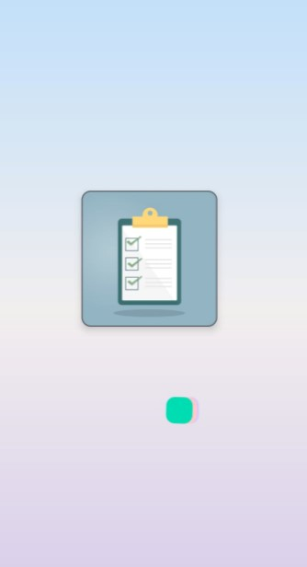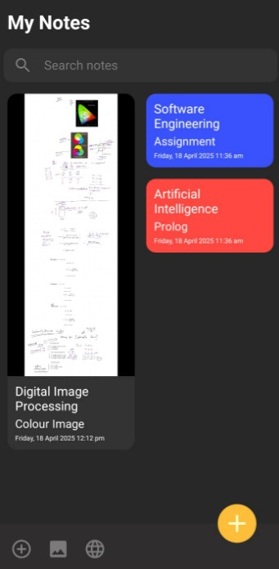

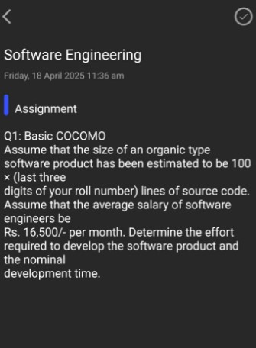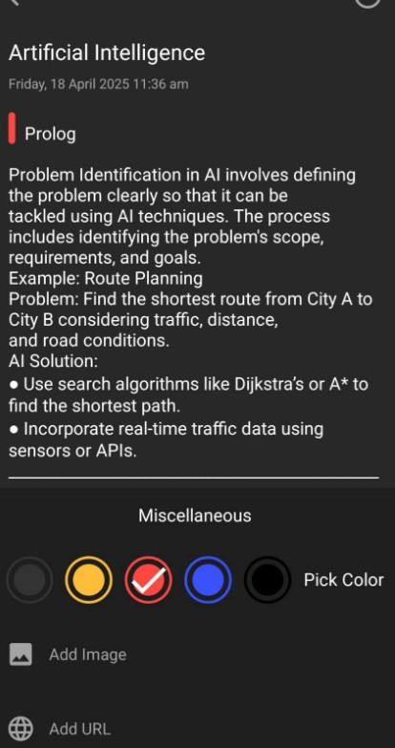

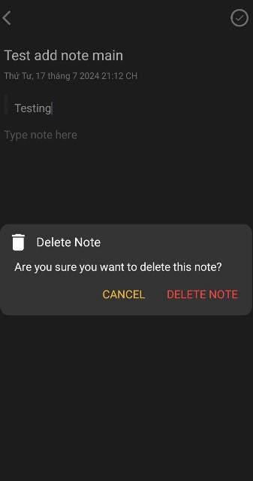

DISCUSSION AND CONCLUSION

Developing the Notes Making Android App was both a technically engaging and user-focused experience. From conceptualization to deployment, the project followed a structured development process aimed at solving a real-world problem—providing users with a simple, efficient, and private way to capture and manage their notes.
One of the key learnings throughout this project was the importance of balancing usability with functionality. The app was intentionally kept lightweight and distraction-free, focusing on core features like note creation, editing, deletion, and categorization.
From a development perspective, using Java and XML in Android Studio offered flexibility in both UI design and backend logic. SQLite was chosen for its reliability and offline capabilities, allowing users to access and manage their notes at any time without relying on cloud storage or internet connectivity. Efficient data operations, along with careful handling of lifecycle events and user interactions, helped ensure the app runs smoothly across different devices and Android versions.
During development, several technical skills were put into practice, including:
- Modular Java coding for activity and fragment management

- Designing responsive and accessible UIs using XML layouts

- Handling data persistence with SQLite and SQL queries

- Implementing input validation and exception handling

- Testing for both functional reliability and usability

The final application meets all initial objectives: it is offline-capable, secure, and offers a minimal yet powerful user experience for everyday note-taking. The intuitive design, fast performance, and offline-first architecture make it ideal for users who value privacy and simplicity.
In conclusion, this Notes Making App is more than a personal productivity tool—it is a real-world demonstration of applying mobile development principles to solve a common organizational challenge. It highlights how thoughtful UI/UX design, paired with solid technical architecture, can lead to a meaningful and usable application. The project lays a strong foundation for future enhancements, such as cloud sync, reminders, or voice note integration.

FUTURE WORK

While the current version of the Notes Making Android App offers a clean, reliable, and offline-first platform for basic note-taking, there is ample room for enhancement to make the app more feature-rich, user-friendly, and intelligent. The following improvements are proposed for future development:

1. Cloud Sync and Cross-Device Access
Introduce optional cloud integration (e.g., using Firebase or Google Drive) to allow users to back up notes and sync them across multiple devices, ensuring data is safe and accessible from anywhere.

2. Reminders and Notifications
Enable users to set reminders for time-sensitive notes, with push notifications to help them stay organized and on schedule.

3. Voice Notes and Speech-to-Text Input
Add functionality to record voice notes or convert spoken content into text using speech recognition APIs, making the app more accessible and convenient.

4. Rich Text Editing
Support rich text formatting options such as bold, italics, bulleted lists, and headings, allowing users to create structured and visually clear notes.

5. Dark Mode and Theme Customization
Provide a selection of visual themes, including dark mode, to enhance readability and reduce eye strain in low-light conditions.

6. Pinning and Favorite Notes
Allow users to pin important notes at the top of the list or mark certain notes as favorites for quick access.

7. Categorization and Tagging
Introduce labels or tags for organizing notes into categories (e.g., Work, Personal, Ideas), improving searchability and organization.

8. Export and Share Notes
Enable notes to be exported as PDF or text files and shared via messaging or email apps, making it easier to collaborate or store records externally.

9. Search Filters and Sorting Options
Enhance the search functionality with advanced filters (by date, tag, keyword) and customizable sorting (e.g., by title or last modified).

10. App Lock and Security Features
Add password or biometric (fingerprint) authentication to secure user data and prevent unauthorized access.

These future enhancements aim to evolve the Notes Making App into a more robust productivity tool while maintaining its simplicity and offline-first design. Each proposed feature is driven by real-world use cases and feedback, ensuring continued value for users as their organizational needs grow.

REFERENCES:
Android Developers. Android Fundamentals. Retrieved from https://developer.android.com/docs

SQLite. (2023). SQLite Documentation. Retrieved from https://www.sqlite.org/docs.html
Oracle. (2023). The Java™ Tutorials. Retrieved from https://docs.oracle.com/javase/tutorial/

JetBrains. (2023). Android Studio User Guide. Retrieved from https://developer.android.com/studio/intro

