MicroGoals
Secure Goal Management Backend API
Complete Project Documentation
Node.js • Express.js • MongoDB • JWT

Team ID : SWTID-2026-5168

Team Leader : THARUN ADHITHYAA N— Project Lead & Backend Developer
Team Member : SASIDHARAN S — Database Administrator
Team Member : SIVANESH S — API Developer
Team Member : SUDHARSAN S— Backend Support Developer
Team Member : SUJITH A — Testing & Documentation

Abstract
MicroGoals is a secure, scalable RESTful backend API designed to help users manage and track personal micro-goals. Developed using Node.js, Express.js, and MongoDB, the system provides JWT-based authentication, full goal management capabilities, and structured error handling. The architecture follows the MVC (Model-View-Controller) pattern to ensure clean separation of concerns, maintainability, and ease of future scaling.

This document presents a comprehensive overview of the system including the problem statement, proposed solution, technology stack, system architecture, entity-relationship model, project structure, API documentation, backend implementation details, testing approach, and final conclusions.

Project Overview
MicroGoals is a backend RESTful API that enables users to register, log in, create personal goals, and manage them securely. The system is designed around the concept of micro-goals — breaking large objectives into smaller, trackable units to improve consistency and motivation.

The backend is developed using Node.js, Express.js, and MongoDB and follows REST API principles along with MVC architecture to ensure maintainability and scalability. JWT authentication is integrated to protect routes and ensure that users can only access their own goal data.

Problem Statement
Many individuals struggle to maintain consistency when working toward long-term goals. Large goals often become overwhelming, leading to a lack of motivation and poor progress tracking. There is a clear need for a structured backend system that supports applications capable of managing micro-goals effectively — enabling users to break objectives into smaller, trackable steps with secure data access.

Proposed Solution
The proposed solution is a secure backend API that enables users to break larger objectives into smaller manageable goals. The system allows users to:

- Register and authenticate securely using JWT
- Create personal micro-goals linked to their account
- Delete completed or unwanted goals
- Access all data through protected API endpoints
- Benefit from centralized error handling and structured responses

Technology Stack
The following technologies were selected for the development of the MicroGoals backend:

Category | Technology
Runtime Environment | Node.js
Backend Framework | Express.js
Database | MongoDB
Authentication | JWT (JSON Web Token)
Architecture Pattern | MVC (Model-View-Controller)
Testing Tool | Thunder Client
Code Editor | VS Code

System Architecture
The system follows a layered backend architecture that ensures clean separation of concerns and modular development. Incoming client requests flow through the following layers:

- Client Requests — HTTP requests from front-end or testing tools
- Express Server — Receives and routes all incoming requests
- Route Handlers — Direct requests to the appropriate controller logic
- Middleware Layer — Handles authentication and error processing
- Controllers and Models — Business logic and database schema definitions
- MongoDB Database — Persistent storage for users and goals

This modular structure ensures maintainability, scalability, and organized development throughout the project lifecycle.

Entity-Relationship (ER) Diagram
The system contains two core entities: User and Goal. Each user can own multiple goals, establishing a one-to-many (1:N) relationship.

┌──────────────────────────┐ ┌──────────────────────────────┐
│ USER │ │ GOAL │
├──────────────────────────┤ ├──────────────────────────────┤
│ _id ObjectId PK │ 1 * │ _id ObjectId PK │
│ name String │───────────────│ title String │
│ email String │ │ completed Boolean │
│ password String │ │ userId ObjectId FK ──▶ │
└──────────────────────────┘ └──────────────────────────────┘

One User can own and manage MANY Goals (1 : N Relationship)

The userId field in the Goal entity serves as a foreign key reference to the User entity, enforcing data ownership and ensuring users can only access their own goals.

Project Structure
The project follows a clean MVC-based directory structure for maintainability and scalability:

MicroGoals/
├── middleware/
│ ├── authMiddleware.js
│ └── errorMiddleware.js
├── models/
│ ├── userModel.js
│ └── goalModel.js
├── routes/
│ ├── authRoutes.js
│ └── goalRoutes.js
├── .env
├── index.js
└── package.json

File Descriptions
The following table describes the role of each key file and folder:

File / Folder | Purpose
middleware/authMiddleware.js | Verifies JWT tokens and protects private routes
middleware/errorMiddleware.js | Centralized error handling with structured JSON responses
models/userModel.js | Mongoose schema and model definition for User data
models/goalModel.js | Mongoose schema and model definition for Goal data
routes/authRoutes.js | Route definitions for registration and login endpoints
routes/goalRoutes.js | Route definitions for goal creation and deletion
.env | Environment variables (MongoDB URI, JWT secret, Port)
index.js | Entry point — initializes the Express server and routes
package.json | Project metadata and dependency declarations

Features
The MicroGoals backend provides the following core features:

Feature | Description
User Registration | Allows new users to create an account securely
Secure Login | Authenticates users and returns a JWT token
Create Goal | Users can create new micro-goals tied to their account
Delete Goal | Users can permanently remove completed or unwanted goals
Protected Routes | All goal endpoints require a valid JWT token
Error Handling | Centralized middleware returns structured error responses

User Flow
The following table describes the sequential steps a user takes when interacting with the MicroGoals system:

Step | Action
1 | User registers in the system
2 | User logs in with credentials
3 | JWT token is generated by the server
4 | Token is included in request headers
5 | User accesses protected routes via token
6 | User performs CRUD operations on goals

API Documentation
All API endpoints are prefixed with /api. Goal endpoints require a valid JWT token in the Authorization header.

Method | Endpoint | Description | Auth
POST | /api/auth/register | Register a new user | No
POST | /api/auth/login | Login and receive JWT token | No
POST | /api/goals | Create a new goal | Yes
DELETE | /api/goals/:id | Delete a goal by ID | Yes

Authentication Header Format
Authorization: Bearer <your_jwt_token>

Backend Development

Server Setup
An Express server handles all API requests and connects application routes. MongoDB is connected using Mongoose, and the connection string is stored securely in the .env environment configuration file.

Authentication Implementation
Authentication APIs were implemented for user registration and login, including:
- Password hashing using bcryptjs before storage
- JWT token generation on successful login
- Token verification on every protected route request

Project Initialization
To initialize and run the project:

# Initialize the project
npm init -y

# Install dependencies
npm install express mongoose jsonwebtoken bcryptjs dotenv

# Start the server
node index.js

Middleware

Authentication Middleware
The authentication middleware verifies JWT tokens on every protected route. If the token is missing, expired, or invalid, the request is rejected with an appropriate HTTP error response before reaching the controller.

Error Middleware
The error middleware captures runtime errors across all routes and sends structured JSON responses with appropriate HTTP status codes. This prevents unhandled exceptions from exposing sensitive stack traces to clients.

Database Development
MongoDB is used as the primary database. It can be configured using MongoDB Atlas (cloud) or a local MongoDB instance. Mongoose schemas enforce data structure and validation for both the User and Goal collections.

User Schema Fields
- name — Full name of the user (String, required)
- email — Unique email address (String, required)
- password — Hashed password stored via bcryptjs (String, required)

Goal Schema Fields
- title — Description of the micro-goal (String, required)
- completed — Completion status flag (Boolean, default: false)
- userId — Reference to the owning User document (ObjectId, required)

API Testing
APIs were tested using Thunder Client in Visual Studio Code. Testing covered the following scenarios:

- User registration with valid and invalid inputs
- Login with correct and incorrect credentials
- Goal creation with a valid JWT token
- Goal deletion with a valid JWT token
- Accessing protected routes without a token (expected 401 response)
- Centralized error handling for malformed requests

Project Execution
Follow these steps to run the MicroGoals backend locally:

- Start MongoDB (local instance or connect to MongoDB Atlas)
- Configure the .env file with MONGO_URI, JWT_SECRET, and PORT
- Run the backend server using: node index.js
- Register a new user via POST /api/auth/register
- Login via POST /api/auth/login to obtain a JWT token
- Include the token in the Authorization header for all goal requests
- Use POST /api/goals and DELETE /api/goals/:id to manage goals

Results
The MicroGoals backend system was successfully tested using Thunder Client in Visual Studio Code. All API endpoints responded correctly with appropriate status codes, data, and messages. The following screenshots demonstrate the actual output from each stage of the system.

Output 1 — Server Running & MongoDB Connected
The screenshot below shows the project structure in VS Code and the terminal output after starting the server with nodemon. The server successfully started on port 8000 and established a connection to MongoDB, confirming the environment setup and database configuration are working correctly.

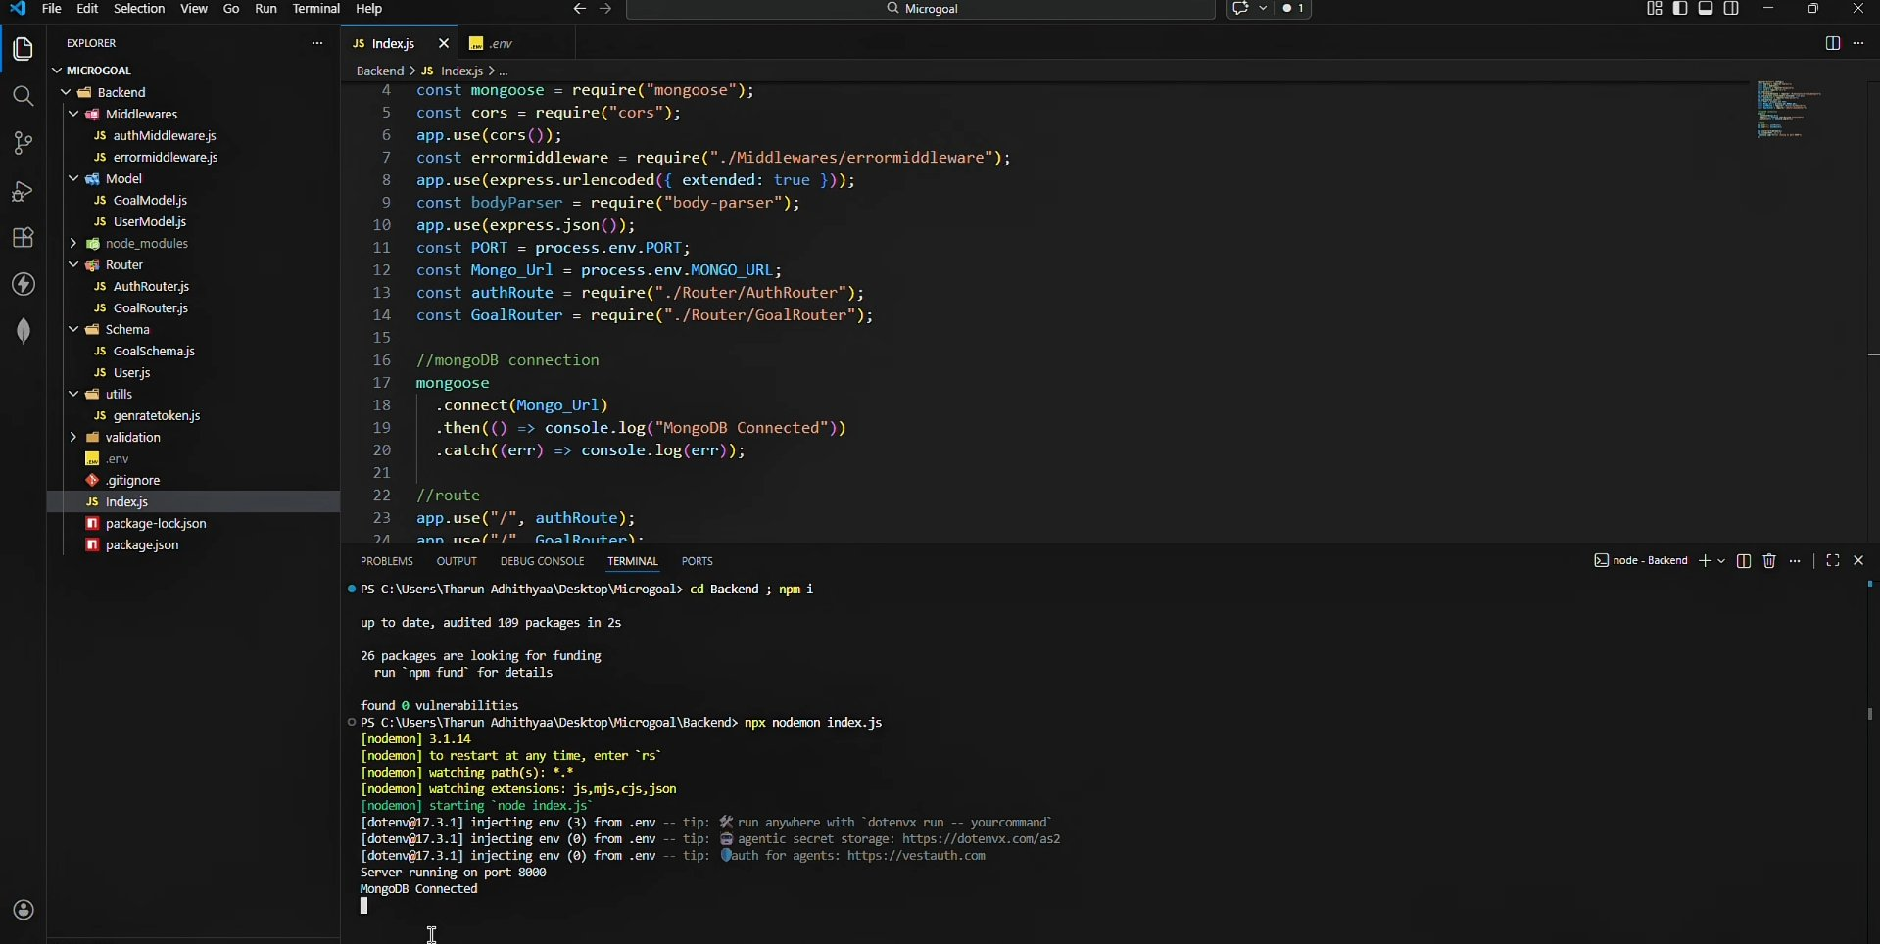

Output 2 — User Registration (POST /signup)
This screenshot shows a successful user registration request sent to POST http://localhost:8000/signup. The server returned a 200 OK status with a success message, the newly created user data, and a JWT token. The password is stored as a bcrypt hash, confirming secure password handling.

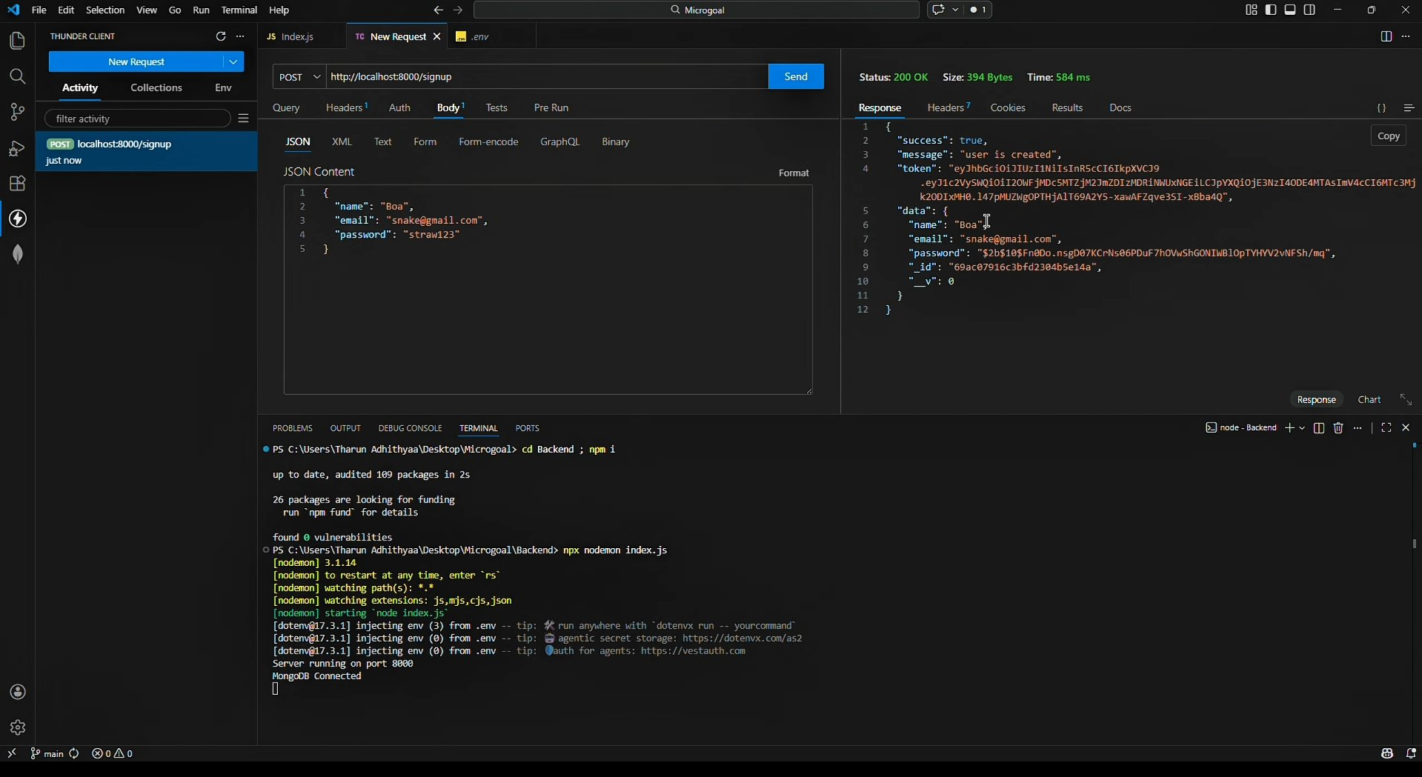

Output 3 — Create Goal (POST /create)
This screenshot demonstrates a successful goal creation request sent to POST http://localhost:8000/create with a valid JWT token in the header. The server responded with 200 OK, returning the new goal object including its title, completed status (false by default), and the associated user ID, confirming that goals are correctly linked to authenticated users.

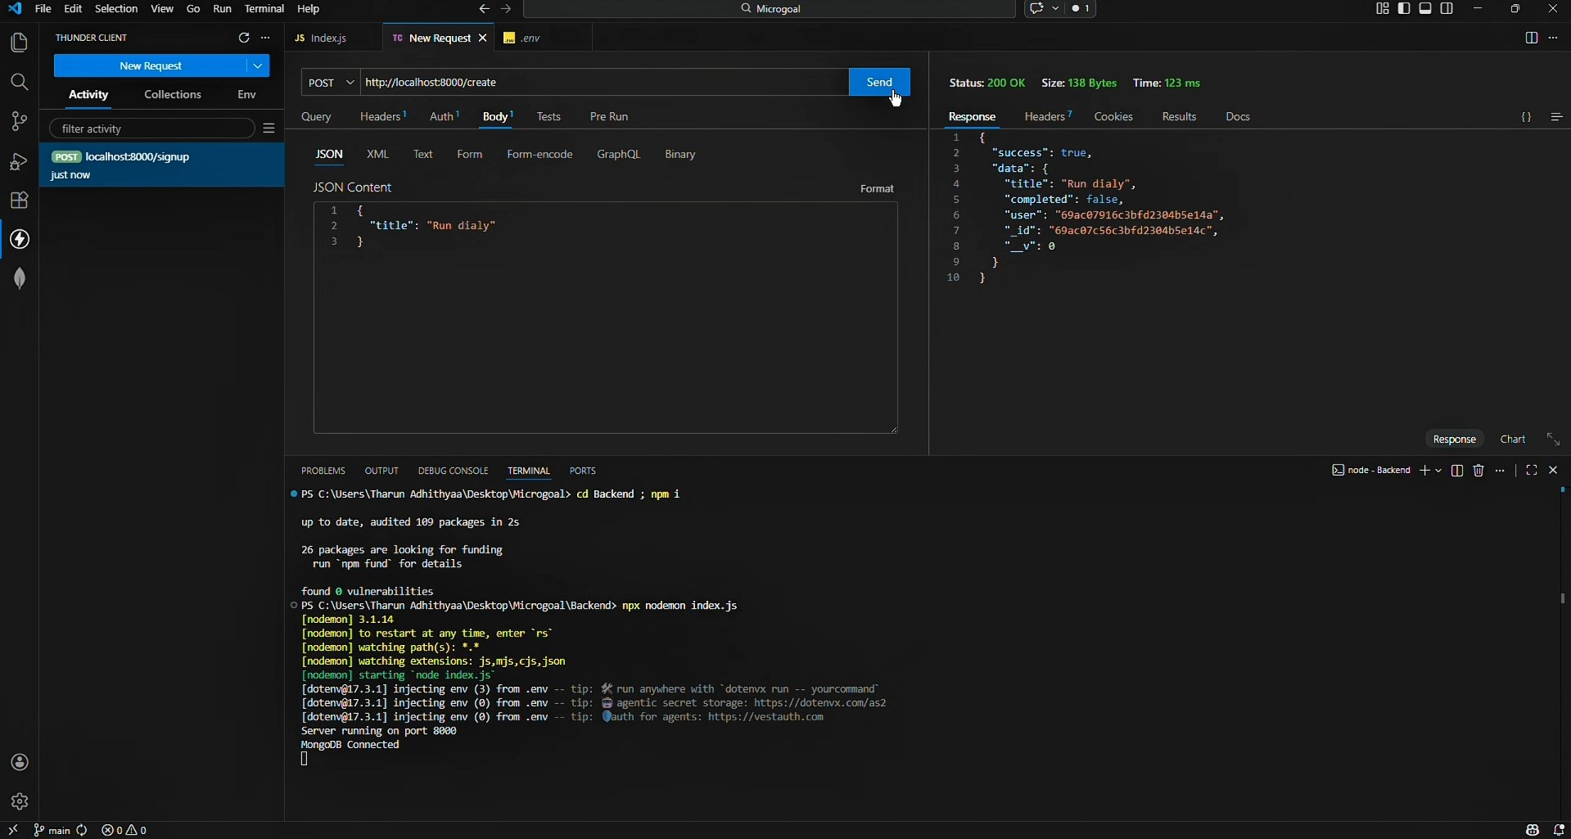

Output 4 — Delete Goal (DELETE /:id)
This screenshot shows a DELETE request sent to http://localhost:8000/:id with the goal's ID in the URL. The server returned a 200 OK response with the message 'Goal deleted', confirming that the goal was successfully removed from the database. The response size of 26 bytes and 118ms response time indicate a clean and efficient deletion operation.

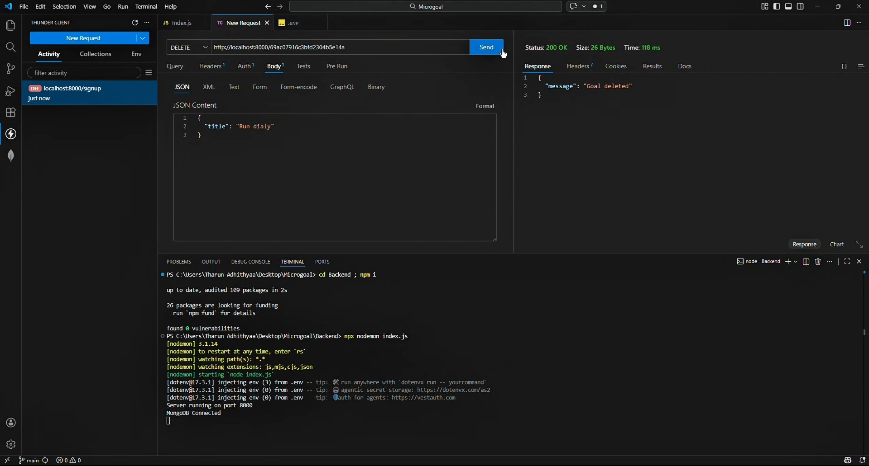

All four API endpoints performed as expected. The system demonstrates secure authentication, proper data association, and reliable CRUD operations across all tested scenarios.

Conclusion
The MicroGoals backend provides a scalable and secure system for personal goal management. By integrating JWT authentication, RESTful APIs, and MongoDB, the system ensures reliable data handling and secure user-specific access control.

The MVC architecture and modular project structure allow easy scalability and maintainability for future enhancements such as goal categories, progress tracking, notifications, and a front-end client integration. The project demonstrates a complete backend implementation following industry-standard practices for authentication, data modeling, and API design.

