Name: Tharun Bhukya

700# : 700747504

Github Link: <https://github.com/tharunbhukya/CS5720_ICP1>

Video Link: https://drive.google.com/file/d/1a_E6O692hQpNxUjnxNafde3BKaVwqZk4/view?usp=sharing

1)

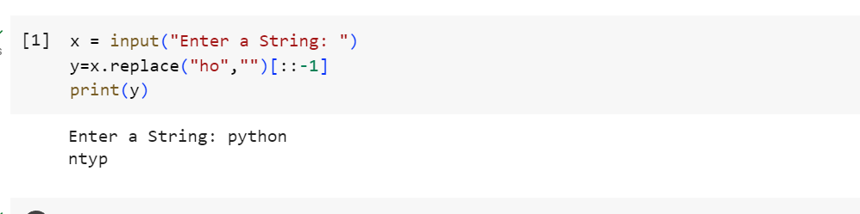

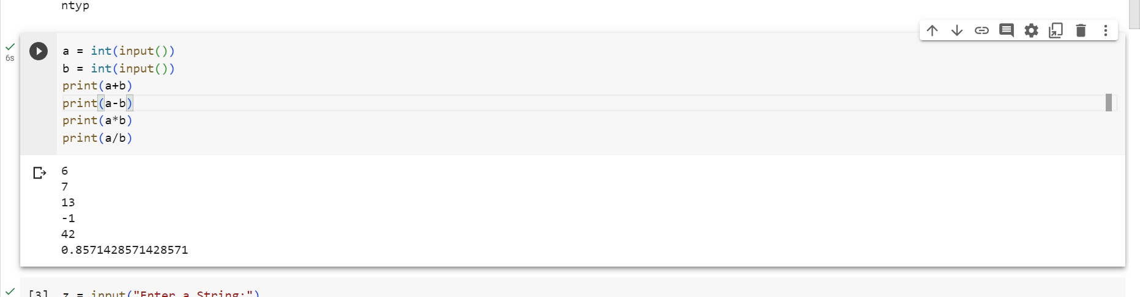

2)

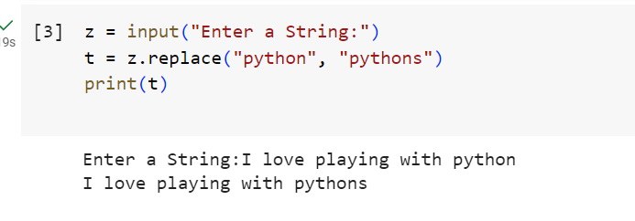

3)

