**NEURAL NETWORK DEEP LEARNING**

**ICP-9**

**700747504**

**Tharun Bhukya**

**GitHub: Repository URL for the source code:**

https://github.com/tharunbhukya/ICP9

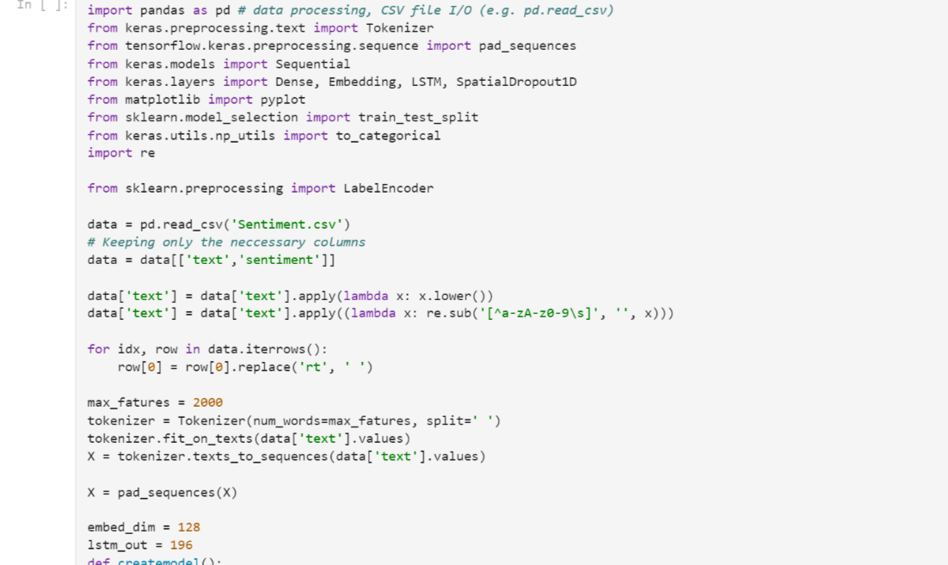

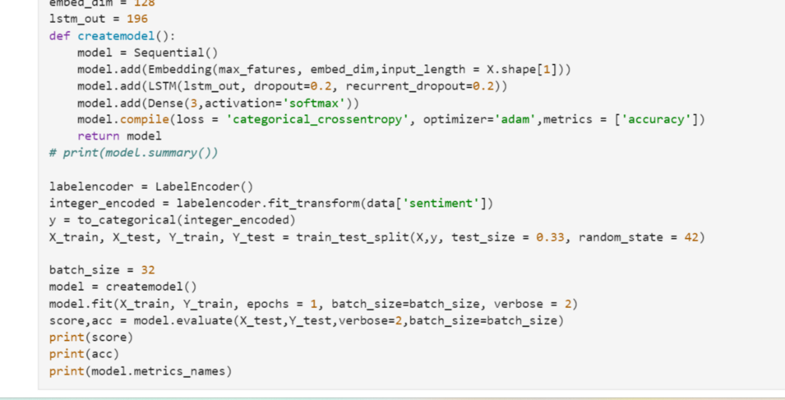

Output:

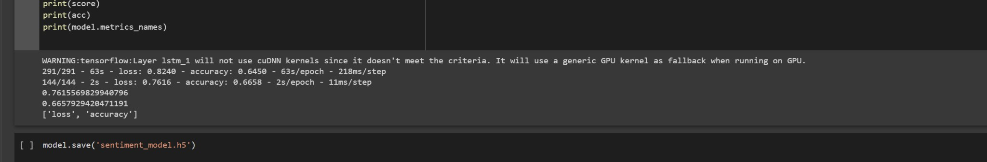

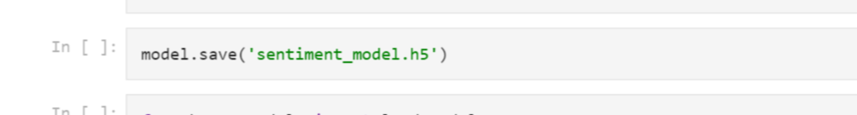

This code loads the saved model using the load_model function, and then preprocesses the new text data in the same way as the training data. The predict method is called on the loaded model to get the predicted

class probabilities for the new text data. The class with the highest probability is chosen as the predicted sentiment. The predicted sentiment and probabilities are then printed to the console.

To apply GridSearchCV on the provided source code, we can use the GridSearchCV class from sklearn to search for the best combination of hyperparameters for the LSTM model. The hyperparameters that can be tuned are the number of LSTM units, the dropout rate, and the learning rate of the optimizer.

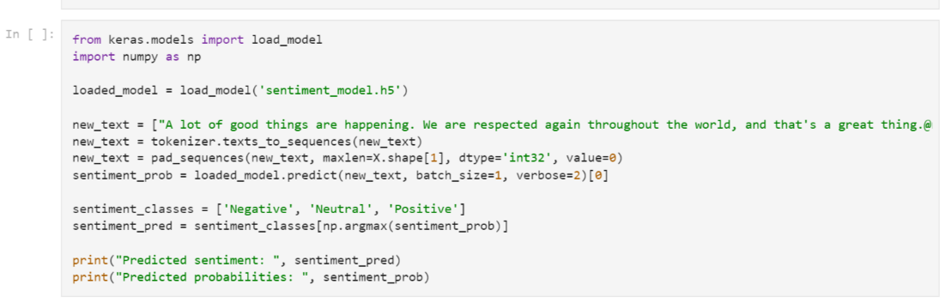

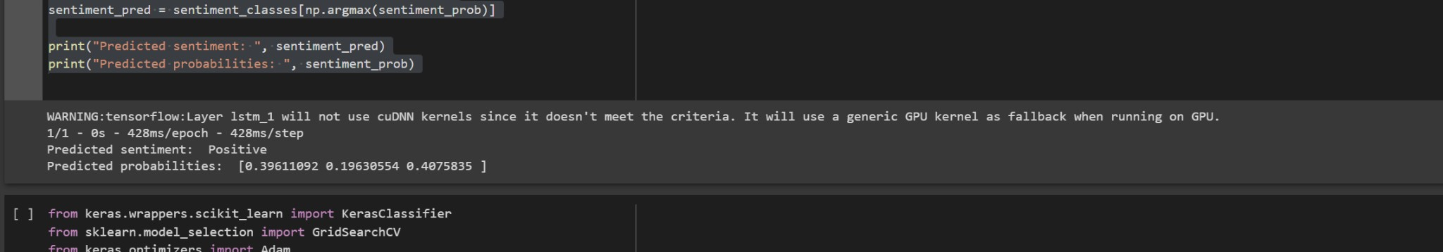

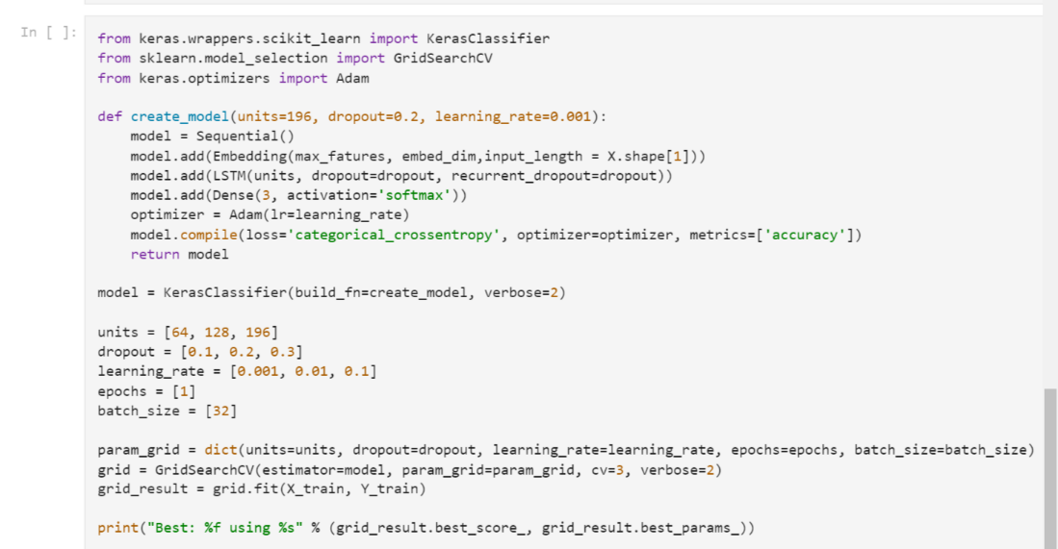

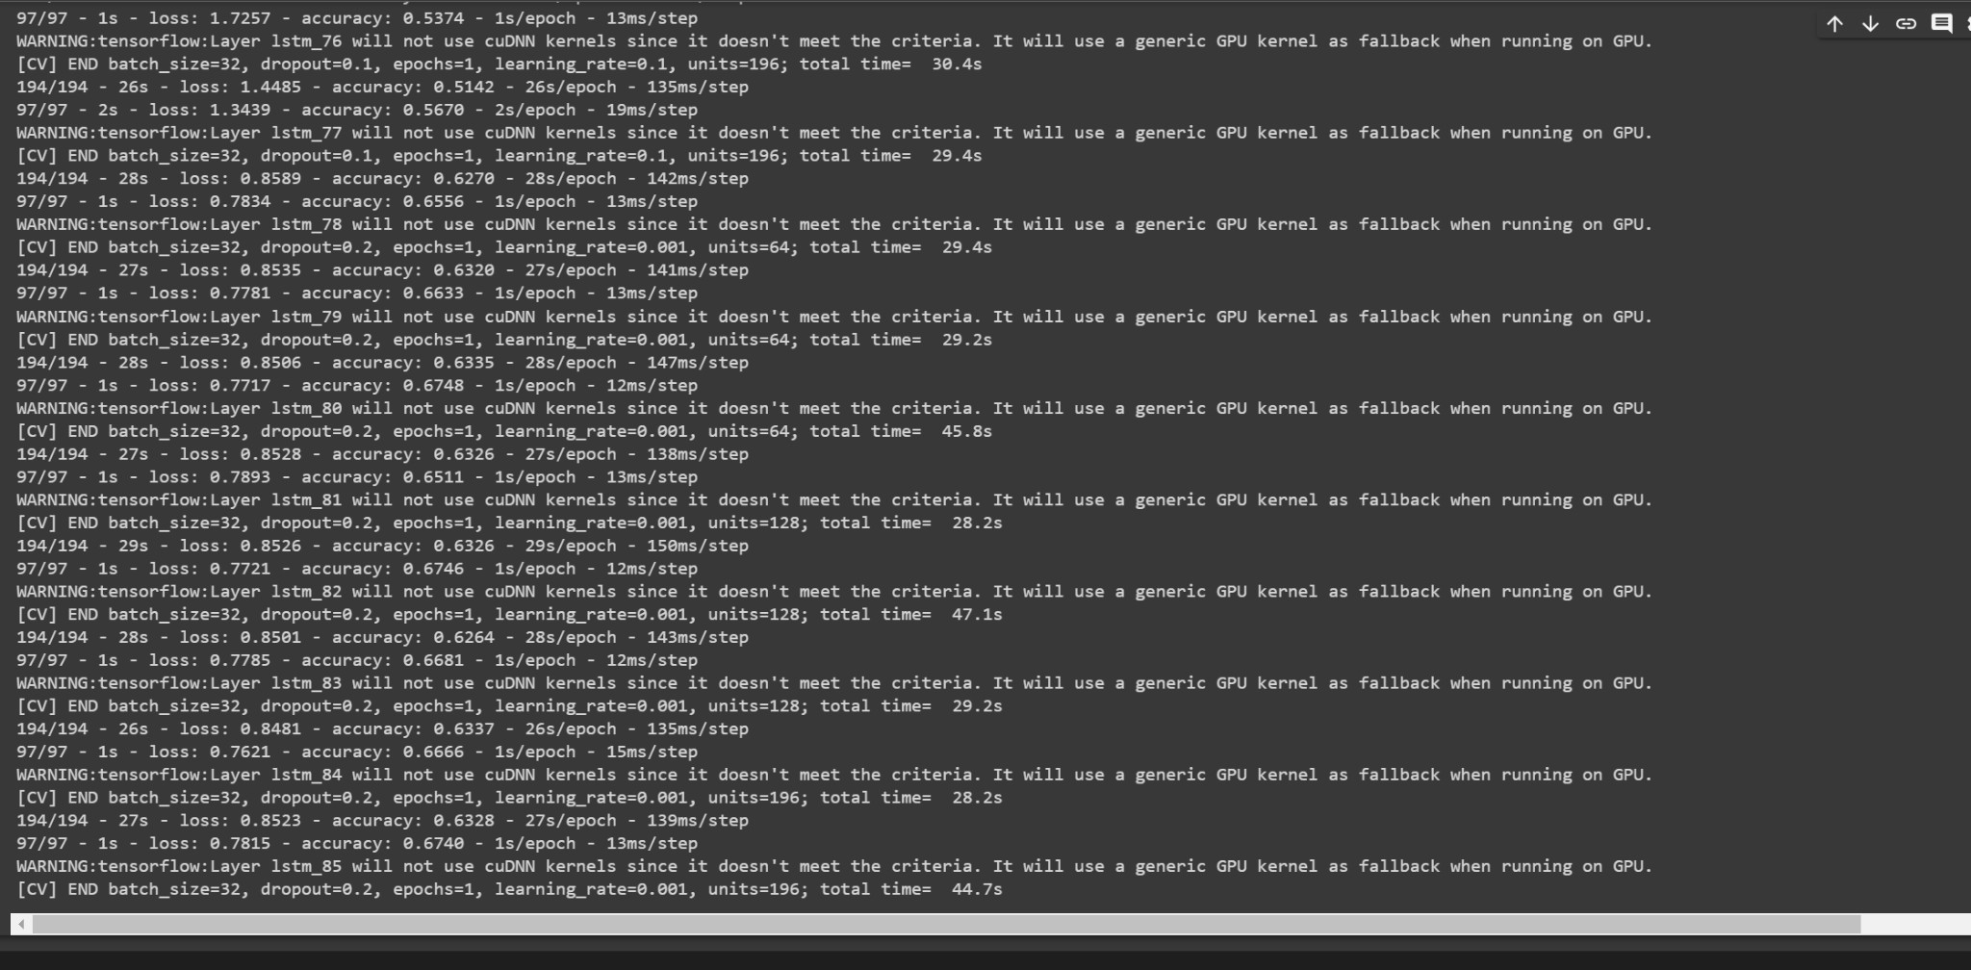

This code defines the create_model function that returns a Keras model with the specified hyperparameters. The KerasClassifier class is used to create a wrapper for the create_model function,

which can be used as an estimator for GridSearchCV. The hyperparameters to be tuned are defined in the param_grid dictionary. GridSearchCV is then called with the KerasClassifier object, the param_grid dictionary