MINE ENVIRONMENT
MONITORING ROVER
An IoT-based rover for gas detection, obstacle avoidance and live monitoring
Detail | Information
Submitted by | Snigdha Kanakam (2505A21024)  Pranith Billa (2505A21025)  Imran Mohammad (2505A21026)  Vivek Korivi (2505A21027)  Tharun Bioroju (2505A21028)  Hemanth Marri (2505A21029)  Rohan Gorantala (2505A21030)
Department | Electrical and Electronics Engineering (EEE)
Year | Second year
Domain | Embedded Systems, IoT
Course Guide / Faculty | Mr. M. Pavan Kumar
Course Co-Ordinator | Dr. Ch Hussain Basha
College | S R UNIVERSITY

ABSTRACT
The objective of this project is to design and implement an IoT-based Mine Environment Monitoring Rover that can enter underground mines and other enclosed spaces ahead of people, measure the condition of the air and send the information to people outside in real time. Harmful gases such as methane and carbon monoxide cannot be seen or smelled, and sending workers or rescue teams to check them puts their lives at risk. The rover is built around an ESP32 microcontroller on a four-wheel-drive chassis. MQ-135, MQ-4 and MQ-7 sensors detect air-quality gases (ammonia, CO₂, smoke), methane and carbon monoxide, while a DHT11 sensor measures temperature and humidity. An HC-SR04 ultrasonic sensor detects obstacles, and an L298N motor driver lets the rover stop, beep and turn away from them. An ESP32-CAM module streams live video of the path ahead, and a buzzer gives audible alerts for obstacles and gas hazards.
All readings and alerts are sent over Wi-Fi to a ThingsBoard dashboard, which shows the current values with a SAFE status, plots their history as graphs and keeps a telemetry log, so that dangerous areas can be monitored from a safe distance. The report describes the literature survey, the components, the circuit design, the operation of the rover and the results obtained. The project shows how low-cost embedded systems can improve safety in mines and similar hazardous places.
Keywords: Mine safety, IoT, ESP32, Gas detection, Obstacle avoidance, ThingsBoard
TABLE OF CONTENTS
DESCRIPTION PAGE NO.
ABSTRACT i
LIST OF TABLES vi
LIST OF FIGURES vii
LIST OF TERMS AND ABBREVIATIONS viii

1. INTRODUCTION 1
1.1 PROBLEM STATEMENT 1
1.2 PROPOSED SOLUTION 2
1.3 LITERATURE SURVEY 2
1.4 RESEARCH OBJECTIVES 4
1.5 ORGANIZATION OF THE PROJECT REPORT 4
2. COMPONENTS DESCRIPTION 6
2.1 ESP32 MICROCONTROLLER 6
2.1.1 Block Diagram 7
2.1.2 Working Principle 8
2.1.3 Technical Features 8
2.1.4 Role in the Proposed Rover 8
2.1.5 Applications 8
2.1.6 Advantages and Disadvantages 9
2.2 MQ-135 AIR QUALITY SENSOR 9
2.2.1 Block Diagram 10
2.2.2 Working Principle 10
2.2.3 Technical Features 11
2.2.4 Role in the Proposed Rover 11
2.2.5 Applications 11
2.2.6 Advantages and Disadvantages 11
2.3 MQ-4 GAS SENSOR 12
2.3.1 Block Diagram 12
2.3.2 Working Principle 13
2.3.3 Technical Features 13
2.3.4 Role in the Proposed Rover 13
2.3.5 Applications 13
2.3.6 Advantages and Disadvantages 14
2.4 MQ-7 GAS SENSOR 14
2.4.1 Block Diagram 15
2.4.2 Working Principle 15
2.4.3 Technical Features 15
2.4.4 Role in the Proposed Rover 15
2.4.5 Applications 15
2.4.6 Advantages and Disadvantages 16
2.5 DHT11 TEMPERATURE AND HUMIDITY SENSOR 16
2.5.1 Block Diagram 17
2.5.2 Working Principle 17
2.5.3 Technical Features 17
2.5.4 Role in the Proposed Rover 18
2.5.5 Applications 18
2.5.6 Advantages and Disadvantages 18
2.6 ULTRASONIC SENSOR (HC-SR04) 18
2.6.1 Block Diagram 19
2.6.2 Working Principle 19
2.6.3 Technical Features 20
2.6.4 Role in the Proposed Rover 20
2.6.5 Applications 20
2.6.6 Advantages and Disadvantages 20
2.7 L298N MOTOR DRIVER WITH 4WD CHASSIS 20
2.7.1 Block Diagram 21
2.7.2 Working Principle 21
2.7.3 Technical Features 22
2.7.4 Role in the Proposed Rover 22
2.7.5 Applications 22
2.7.6 Advantages and Disadvantages 22
2.8 4WD CAR CHASSIS WITH DC MOTORS 23
2.8.1 Block Diagram 23
2.8.2 Working Principle 23
2.8.3 Technical Features 23
2.8.4 Role in the Proposed Rover 24
2.8.5 Applications 24
2.8.6 Advantages and Disadvantages 24
2.9 ESP32-CAM MODULE 24
2.9.1 Block Diagram 25
2.9.2 Working Principle 25
2.9.3 Technical Features 26
2.9.4 Role in the Proposed Rover 26
2.9.5 Applications 26
2.9.6 Advantages and Disadvantages 26
2.10 BUZZER 27
2.10.1 Block Diagram 27
2.10.2 Working Principle 27
2.10.3 Technical Features 28
2.10.4 Role in the Proposed Rover 28
2.10.5 Applications 28
2.10.6 Advantages and Disadvantages 28
2.11 BATTERY PACK, BUCK CONVERTER AND CONNECTIONS 28
2.11.1 Block Diagram 29
2.11.2 Working Principle 29
2.11.3 Technical Features 29
2.11.4 Role in the Proposed Rover 30
2.11.5 Applications 30
2.11.6 Advantages and Disadvantages 30
2.12 THINGSBOARD IOT PLATFORM 30
2.12.1 Block Diagram 31
2.12.2 Working Principle 31
2.12.3 Technical Features 31
2.12.4 Role in the Proposed Rover 31
2.12.5 Applications 32
2.12.6 Advantages and Disadvantages 32
3. DESIGN OF PROPOSED SYSTEM 33
3.1 CIRCUIT DIAGRAM 33
3.2 OVERALL BLOCK DIAGRAM 34
3.3 CIRCUIT DESCRIPTION 36
3.3.1 Power Supply Connections 36
3.3.2 Gas Sensor Connections 36
3.3.3 Temperature, Humidity and Distance Sensor Connections 36
3.3.4 Motor Driver and Buzzer Connections 37
3.3.5 Wi-Fi and Camera Connections 37
4. OPERATION OF PROPOSED ROVER 38
4.1 POWER-UP AND INITIALIZATION 38
4.2 SENSING AND DATA ACQUISITION 38
4.3 OBSTACLE DETECTION AND MOTION CONTROL 39
4.4 GAS HAZARD DETECTION AND ALERT GENERATION 39
4.5 LIVE VIDEO STREAMING 39
4.6 DATA TRANSMISSION AND DASHBOARD MONITORING 40
4.7 SUMMARY OF THE OPERATION 40
5. RESULTS 41
5.1 PHOTOGRAPH OF THE HARDWARE 41
5.2 OUTPUT RESULTS: WAVEFORMS (GRAPHS) 41
5.3 DIGITAL OUTPUT 42
5.4 TEST CASES AND EXPECTED RESULTS 43
6. CONCLUSIONS 45
FUTURE SCOPE 45
APPLICATIONS 46
REFERENCES 46
LIST OF TABLES
TABLE NO. DESCRIPTION PAGE NO.
1.1 Summary of the literature survey 2
2.1 List of apparatus 6
3.1 ESP32 pin connections 36
4.1 Operating conditions and the response of the rover 40
5.1 Test cases and expected results 43
LIST OF FIGURES
FIGURE NO. DESCRIPTION PAGE NO.
2.1 ESP32 development board pinout 7
2.2 Block diagram of ESP32 microcontroller 7
2.3 MQ-135 air quality sensor 10
2.4 MQ-135 air quality gas sensor module 10
2.5 Block diagram of MQ-135 air quality sensor 10
2.6 MQ-4 methane gas sensor 12
2.7 Block diagram of MQ-4 gas sensor 13
2.8 MQ-7 carbon monoxide sensor 14
2.9 Block diagram of MQ-7 gas sensor 15
2.10 DHT11 temperature and humidity sensor 17
2.11 Block diagram of DHT11 sensor 17
2.12 HC-SR04 ultrasonic sensor 19
2.13 Block diagram of ultrasonic sensor 19
2.14 L298N motor driver module 21
2.15 Block diagram of L298N motor driver 21
2.16 Block diagram of 4WD chassis and DC motors 23
2.17 ESP32-CAM pinout 25
2.18 Block diagram of ESP32-CAM module 25
2.19 Buzzer 27
2.20 Block diagram of buzzer 27
2.21 Block diagram of the power supply 29
2.22 Block diagram of ThingsBoard monitoring 31
3.1 Circuit diagram of the Mine Environment Monitoring Rover 34
3.2 ESP32-CAM power wiring and live video over Wi-Fi 35
3.3 Overall block diagram of the proposed rover 35
4.1 Operating flow of the rover (repeated continuously) 38
5.1 Hardware of the Mine Environment Monitoring Rover 41
5.2 Dashboard graphs of gas levels, temperature and humidity 42
5.3 Dashboard digital output showing live readings 43
5.4 Dashboard trends and mine rover telemetry log 43
LIST OF TERMS AND ABBREVIATIONS
IoT - Internet of Things
ESP32 - Espressif 32-bit microcontroller with Wi-Fi and Bluetooth
ESP32-CAM - ESP32 module with camera
MQ - Metal-oxide semiconductor gas sensor series
CO - Carbon monoxide
CH₄ - Methane
CO₂ - Carbon dioxide
SnO₂ - Tin dioxide
DHT11 - Digital humidity and temperature sensor
HC-SR04 - Ultrasonic distance sensor module
L298N - Dual H-bridge motor driver
4WD - Four-wheel drive
DC - Direct current
PWM - Pulse width modulation
GPIO - General purpose input/output
RH - Relative humidity
ppm - Parts per million
USB - Universal serial bus
LAN - Local area network
HVAC - Heating, ventilation and air conditioning

CHAPTER- 1

INTRODUCTION
Underground mines, tunnels and other enclosed spaces are among the most dangerous places in which people are required to work. The air inside them can change quickly and without any warning, and many of the hazards cannot be seen or smelled. Gases such as methane, carbon monoxide and carbon dioxide can build up slowly in poorly ventilated pockets, and by the time a worker feels the effects the situation may already be life-threatening. Fires, explosions, roof falls and oxygen shortage are the usual consequences when such conditions are not detected in time, and rescue teams who enter after an accident face exactly the same risks as the workers they are trying to help.
Traditionally, mine air has been checked with portable gas detectors carried by miners or with fixed sensors installed at selected points. Portable detectors need a person to enter the hazardous area, and fixed sensors can only report the condition of the single location where they are installed. Both approaches are therefore limited, especially in large or changing workings where gas may collect suddenly in a place that nobody is monitoring. A mobile machine that can travel into the area ahead of people, measure the environment as it goes and report the readings immediately offers a much safer alternative.
Recent progress in embedded systems, low-cost sensors and the Internet of Things (IoT) has made it practical to build such a machine cheaply. Microcontrollers with built-in Wi-Fi can read several sensors, drive motors and send data to an online dashboard at the same time, while small camera modules can stream live video. This project brings these technologies together in the Mine Environment Monitoring Rover, an IoT-based rover for gas detection, obstacle avoidance and live monitoring. The rover carries gas, temperature and humidity sensors, avoids obstacles on its own, shows the path ahead through a camera and reports everything to people who stay at a safe distance.
1.1 PROBLEM STATEMENT
Underground mines and enclosed spaces can contain harmful gases such as carbon monoxide, methane and smoke, which cannot be seen or smelled. Sending workers or rescue teams in to check the conditions puts their lives at risk, because the very first person to enter a contaminated area is also the first to be exposed to the danger. There is a need for a low-cost machine that can enter such areas first, measure the environment, avoid obstacles, show the path ahead, and report everything to people outside in real time.
The machine must be small and cheap enough to be replaced if it is damaged, simple enough to be built and repaired with easily available parts, and connected enough to give the people outside a continuous picture of what it senses. It must also be able to protect itself by stopping when it meets an obstacle, and to warn anybody nearby, through an audible alert, when it finds a dangerous gas level. These requirements together define the problem addressed by this project.
1.2 PROPOSED SOLUTION
This project presents a Mine Environment Monitoring Rover built around the ESP32 microcontroller on a four-wheel-drive (4WD) chassis. The rover carries an MQ-135 sensor for air quality (ammonia, CO₂, smoke and benzene), an MQ-4 sensor for methane and an MQ-7 sensor for carbon monoxide, together with a DHT11 sensor for temperature and humidity. These sensors cover the gases that are most commonly responsible for accidents in mines, and they are inexpensive enough to be used in a disposable rover.
An HC-SR04 ultrasonic sensor detects obstacles in front of the rover so that it can stop, beep and turn away, and an L298N motor driver converts the low-power control signals of the ESP32 into the high-current drive needed by the four DC motors. An ESP32-CAM module streams live video of the path ahead, and a buzzer gives audible alerts for obstacles and gas hazards. A battery pack with a switch powers the whole rover.
All readings and alerts are sent over Wi-Fi to a ThingsBoard dashboard. The dashboard displays the current values, plots their history as graphs and marks each reading as SAFE or not, so that people can monitor dangerous areas from a safe distance and decide whether it is safe to enter.
1.3 LITERATURE SURVEY
Several researchers have studied the use of IoT, low-cost gas sensors and mobile robots for improving safety in mines. The studies most relevant to this project are summarized in Table 1.1 and discussed below.
Table 1.1: Summary of the literature survey
S.No | Author Name | Title & Year | Key Findings
1 | A. K. Tripathi,  M. Aruna, S. Prasad,  J. Pavan, R. Kant and  C. K. Choubey | 2023  New Approach for Monitoring the Underground Coal Mines Atmosphere Using IoT Technology | Develops an IoT-based wireless system with MQ-series gas sensors and a DHT11 sensor to measure CO₂, CO, methane, temperature and humidity in underground coal mines. The system was tested in the laboratory and its data can be stored to predict hazardous conditions with machine learning, moving mine safety from preventive to predictive.
2 | A. K. Tripathi,  M. Mangalpady,  N. R. N. V. Rao and S. Ray | 2023  Design and Development of an IoT-Based Gas Monitoring System for Underground Coal Mines | Presents a multi-sensor IoT gas monitoring system validated in the laboratory for CO₂, CO and CH₄. Its readings were compared with a digital multi-gas detector and found to agree well, showing that low-cost sensors can give useful real-time information.
3 | F. Feng, H. Yang  and Q. Du | 2024  Intelligent Remote Search and Rescue Vehicle | Designs a four-wheel-drive rescue vehicle for mine disasters using STM32 and ESP32 controllers, MQ-2, MQ-4 and MQ-9 gas sensors, HC-SR04 ultrasonic sensors for automatic obstacle avoidance, an L298N motor driver and an ESP32-CAM that sends live images over Wi-Fi.
4 | L. Sudarshan et al. | 2025  Web-based Hazardous Gas Monitoring and Alerting Rover System | Proposes a rover for mining environments in which an ESP32-CAM handles control and navigation and an ESP32 acquires gas data from MQ-7, MQ-135 and MQ-4 sensors. Readings go to a web dashboard that lets remote users monitor hazardous gas levels, analyse trends and receive alerts.
5 | B. Jo and  R. M. A. Khan | 2018  An Internet of Things System for Underground Mine Air Quality Pollutant Prediction Based on Azure Machine Learning | Proposes an IoT system for monitoring underground mine air quality and predicting air pollutant levels with a cloud machine learning service, showing how cloud analytics can be added on top of sensor data from a mine.

Tripathi et al. [1] built an IoT monitoring system for underground coal mines using metal-oxide gas sensors (MQ-2, MQ-7 and MQ-135) and a DHT11 sensor for temperature and humidity, and tested it in a closed laboratory chamber. Their results were close to those of a commercial multi-gas detector, and the authors point out that stored data can later be used with machine learning to predict dangerous conditions. The same group reported a related gas monitoring system for CO₂, CO and methane [2]. These works confirm that inexpensive MQ-series sensors together with a DHT11 are suitable for mine environment monitoring, which is the same sensor combination used in this project. Their systems, however, are stationary and measure only at the place where they are installed.
Feng et al. [3] moved the sensors onto a vehicle. Their search and rescue vehicle uses a four-wheel-drive base driven by L298N motor drivers, HC-SR04 sensors for obstacle avoidance, MQ-series sensors for smoke, carbon monoxide and methane, and an ESP32-CAM that streams images over HTTP. Sudarshan et al. [4] describe a web-based hazardous gas monitoring and alerting rover that uses an ESP32-CAM for the rover and an ESP32 with MQ-7, MQ-135 and MQ-4 sensors for gas data, with a web dashboard for remote monitoring. Jo and Khan [5] show that cloud-based machine learning can be used to predict air pollutant levels in underground mines from IoT sensor data.
From the survey it is clear that gas monitoring, mobile platforms, camera streaming and cloud dashboards have each been explored, but many existing systems are either fixed installations or concentrate on only one of these aspects. The Mine Environment Monitoring Rover presented here combines all of them in a single low-cost machine: three gas sensors and a temperature and humidity sensor, autonomous obstacle avoidance on a 4WD chassis, a live camera feed, an audible alarm and a ThingsBoard dashboard for remote monitoring.
1.4 RESEARCH OBJECTIVES
The primary objective of this project is to design and build a low-cost rover that can enter a hazardous enclosed area ahead of people and report the conditions inside it in real time. The rover is expected to measure the quality of the air, protect itself from collisions and give people outside both numerical data and a view of the path. The specific objectives are listed below.
- To detect air-quality gases, methane and carbon monoxide using the MQ-135, MQ-4 and MQ-7 sensors.
- To measure the temperature and humidity of the surroundings using the DHT11 sensor.
- To detect obstacles with the ultrasonic sensor and drive the 4WD chassis safely through the L298N motor driver.
- To show the path ahead through live video streamed by the ESP32-CAM module.
- To warn nearby people with a buzzer when an obstacle or a dangerous gas level is detected.
- To send all readings and alerts over IoT to an online ThingsBoard dashboard so that the area can be monitored from a safe distance.
1.5 ORGANIZATION OF THE PROJECT REPORT
This report is organized into six chapters. Chapter 1 introduces the problem statement, the proposed solution, the literature survey and the objectives of the project. Chapter 2 lists the apparatus and describes each component in detail, covering its construction, block diagram, working principle, technical features, role in the rover, applications, and advantages and disadvantages. Chapter 3 presents the circuit diagram, the overall block diagram and the circuit description, including the ESP32 pin connections. Chapter 4 explains the operation of the proposed rover step by step, from power-up to alert generation and dashboard monitoring. Chapter 5 presents the results, including the photograph of the hardware, the dashboard graphs and the digital output. Chapter 6 concludes the report, followed by the future scope, the applications of the project and the references.

CHAPTER- 2

COMPONENTS DESCRIPTION
The Mine Environment Monitoring Rover is built from low-cost and easily available modules. The ESP32 microcontroller is the centre of the system: it reads the sensors, drives the motors and the buzzer, and sends the data to the online dashboard. The sensing part of the rover consists of three metal-oxide gas sensors, a temperature and humidity sensor and an ultrasonic distance sensor. The moving part consists of the L298N motor driver and the 4WD chassis. A separate ESP32-CAM module provides live video, a buzzer gives audible alerts, and a rechargeable battery pack supplies power through a buck converter.
The apparatus used in the project is listed in Table 2.1. Each component is then explained in detail in the sections that follow. For every component the description covers its construction, its block diagram, its working principle, its main technical features, the role it plays in the rover, its common applications, and its advantages and disadvantages.
Table 2.1: List of apparatus
S.No | Component | Purpose
1 | ESP32 | Main controller
2 | MQ-135 sensor | Air quality (ammonia, CO₂, smoke, benzene)
3 | MQ-4 sensor | Methane detection
4 | MQ-7 sensor | Carbon monoxide detection
5 | DHT11 sensor | Temperature and humidity
6 | Ultrasonic sensor (HC-SR04) | Obstacle detection
7 | L298N motor driver | Motor control
8 | 4WD car chassis with DC motors | Movement
9 | ESP32-CAM | Live video of path ahead
10 | Buzzer | Audible alerts
11 | Battery pack, switch and jumper wires | Power and connections
12 | ThingsBoard (software) | Online dashboard

2.1 ESP32 MICROCONTROLLER
The ESP32 is a low-cost, low-power system-on-chip microcontroller developed by Espressif Systems with Wi-Fi and dual-mode Bluetooth built into the same chip. It is the successor of the popular ESP8266 and has become one of the most widely used controllers for IoT projects because it combines a powerful processor, a large number of input/output pins and wireless communication in a single, inexpensive module. In this project the ESP32 DevKit board is used, which carries the ESP32 module together with a USB connector, a USB-to-serial converter, a 3.3 V regulator and the EN and BOOT buttons that are needed for programming and resetting the chip.
Internally the ESP32 contains a dual-core 32-bit Xtensa LX6 processor that can run at up to 240 MHz, about 520 KB of on-chip SRAM, and an external flash memory (typically 4 MB) that stores the program. The chip offers a 12-bit analog-to-digital converter with many input channels, digital-to-analog converters, capacitive touch inputs, hardware PWM outputs, hardware timers and the common serial interfaces UART, I2C and SPI. The pinout of the board is shown in Figure 2.1.
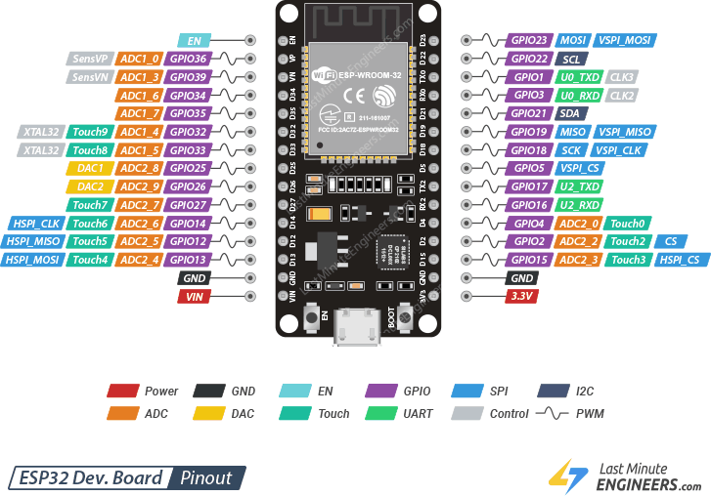
Figure: 2.1. ESP32 development board pinout
2.1.1 Block Diagram

Sensors | → | ESP32 | → | Motors / Buzzer / Wi-Fi

Figure: 2.2. Block diagram of ESP32 microcontroller
The block diagram shows the ESP32 sitting between the sensors on one side and the outputs on the other. The sensors feed measurements into the ESP32, which processes them and then controls the motors through the driver, switches the buzzer and sends the data to the cloud over Wi-Fi.
2.1.2 Working Principle
The ESP32 reads analog voltages from the three gas sensors through its analog-to-digital converter, digital data from the DHT11 sensor, and the echo pulse of the ultrasonic sensor, whose width it measures with a hardware timer. The program compares each reading with a preset limit and then decides what the rover should do next: drive forward, stop and turn away from an obstacle, or switch on the buzzer because a gas level is too high.
The same program also keeps the Wi-Fi connection alive. The ESP32 joins the local Wi-Fi network as a station, opens a connection to the ThingsBoard server and sends the latest values at regular intervals. Because the chip has two cores, the sensor reading and motor control tasks can run alongside the wireless communication without making the rover wait for the network.
2.1.3 Technical Features
Several features of the ESP32 are important for this design. It works at 3.3 V logic levels, so signals coming from 5 V sensors have to be reduced before they are connected to its pins. Its Wi-Fi supports the 2.4 GHz 802.11 b/g/n standard, and the Bluetooth part supports classic and low-energy modes. The analog converter is divided into two groups, ADC1 and ADC2, and the ADC2 pins cannot be used while Wi-Fi is switched on. For this reason the analog gas sensors of the rover are connected to the ADC1 pins GPIO 34, 35 and 32.
The ESP32 can also be put into several sleep modes to save energy, supports PWM on almost any output pin, and can be programmed from the Arduino IDE using familiar functions. These features make it much more capable than a basic Arduino board for a project that needs both control and connectivity.
2.1.4 Role in the Proposed Rover
In the proposed rover the ESP32 is the main controller. It collects the data of the MQ-135, MQ-4, MQ-7, DHT11 and HC-SR04 sensors, sends direction and speed signals to the L298N motor driver, switches the buzzer on GPIO 4 and connects to Wi-Fi to forward the readings and alerts to the ThingsBoard dashboard. All decisions of the rover, such as turning away from an obstacle or raising a gas alert, are taken by the program running on this controller.
2.1.5 Applications
The ESP32 is used wherever a small device needs both processing power and wireless connectivity. Typical uses are:
- IoT and smart-home devices such as smart switches, sensors and appliances.
- Robotics and automation projects that need wireless control or data logging.
- Wireless sensor networks that report measurements to a cloud service.
- Industrial and environmental monitoring.

2.1.6 Advantages and Disadvantages
Advantages:
- Built-in Wi-Fi and Bluetooth, so no extra communication module is needed.
- Fast dual-core processor that can handle sensing, control and communication together.
- Low cost and low-power sleep modes.
- Many input/output pins and several hardware interfaces (UART, I2C, SPI, PWM, ADC).
Disadvantages:
- Analog readings are less accurate near the ends of the input range and need calibration for precise work.
- Power consumption is higher than that of basic Arduino boards while Wi-Fi is switched on.
- It works at 3.3 V, so 5 V sensors need a voltage divider or level shifter.
- ADC2 channels cannot be used while Wi-Fi is active.
2.2 MQ-135 AIR QUALITY SENSOR
The MQ-135 is a metal-oxide semiconductor sensor made for monitoring the overall quality of air. It belongs to the MQ family of low-cost gas sensors and responds to a wide group of gases, including ammonia, nitrogen oxides, alcohol, benzene, smoke and carbon dioxide. Because it responds to many gases at once, it is used as a general indicator that the air has become polluted rather than as a measuring instrument for one particular gas.
The sensor consists of a small ceramic tube coated with tin dioxide (SnO₂), an electrode, and a heating coil, all enclosed inside a stainless-steel mesh cap. The module in the photograph in Figure 2.3 carries the sensor on a small board with four pins (VCC, GND, digital output DO and analog output AO), a blue potentiometer for setting the digital threshold, and an LM393 voltage comparator, as shown in the module diagram of Figure 2.4.
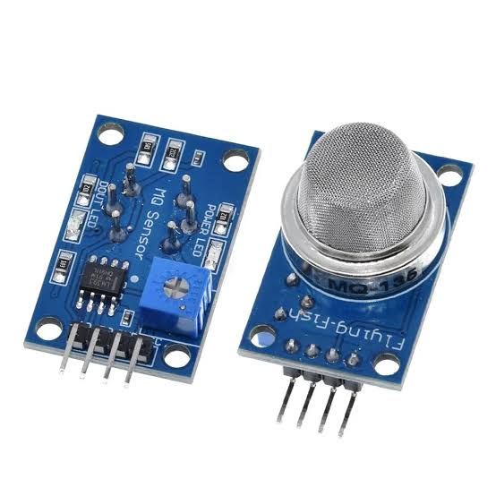
Figure: 2.3. MQ-135 air quality sensor
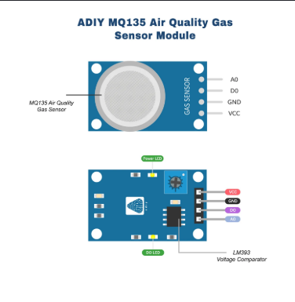
Figure: 2.4. MQ-135 air quality gas sensor module
2.2.1 Block Diagram

Air pollutants | → | MQ-135 (SnO₂ element) | → | Analog voltage | → | ESP32

Figure: 2.5. Block diagram of MQ-135 air quality sensor
In the block diagram the polluted air reaches the SnO₂ sensing element, which changes its resistance. The module converts this change into an analog voltage that is read by the ESP32.
2.2.2 Working Principle
The heater inside the MQ-135 keeps the sensing layer at a working temperature of a few hundred degrees. In clean air the tin dioxide layer has a high resistance, because oxygen from the air is adsorbed on its surface and traps free electrons. When a polluting gas such as ammonia, benzene, alcohol or smoke reaches the hot surface, it reacts with the adsorbed oxygen and releases the trapped electrons. The layer then conducts better and its resistance falls. The more gas is present, the lower the resistance becomes.
The sensor is connected in series with a load resistor, so that the change in resistance appears as a change in voltage at the analog output. The ESP32 converts this voltage to a number with its analog-to-digital converter and compares it with a safe limit that was fixed during calibration in clean air. If the value goes above the limit, the air quality is judged to be poor. The digital output of the module, which is produced by the LM393 comparator, can also be used, but the analog output gives much more useful information because it shows how the level changes with time.
2.2.3 Technical Features
The MQ-135 normally works from a 5 V supply, and the heater draws a current of the order of 150 mA, so it must be powered from the battery supply and not from the 3.3 V pin of the ESP32. It must be warmed up for a few minutes before the readings become steady, and datasheets recommend an initial burn-in period of many hours for the best accuracy. Its readings depend on temperature and humidity, so they are best treated as relative values and not as exact concentrations.
The sensor is sensitive to a broad range of gases in the order of tens to a few hundred parts per million. Since its analog output can reach about 5 V while the ESP32 accepts only 3.3 V, the output of the module is scaled down with a resistor divider before it is connected to the ESP32 pin, as shown in the circuit diagram.
2.2.4 Role in the Proposed Rover
In the proposed rover the MQ-135 acts as the general air-quality sensor. Its reading is read by the ESP32 on GPIO 34 and is sent to the dashboard, where it is plotted as an air-quality graph. When the value rises well above its clean-air level, the rover treats it as a sign of smoke, ammonia or carbon dioxide build-up and raises an alert, so that the people outside know that the air ahead is not safe.
2.2.5 Applications
The MQ-135 is widely used for judging air quality in many fields. Typical applications are:
- Air-quality monitoring in homes, offices and industries.
- Indoor and outdoor pollution detection.
- Ventilation control in buildings, where fans are switched on when the air quality falls.
- Mine and tunnel air checks, as in this project.

2.2.6 Advantages and Disadvantages
Advantages:
- Detects a wide range of harmful gases with a single sensor.
- Low cost and easily available.
- Fast response to changes in air quality.
- Easy analog output that can be read directly by a microcontroller.
Disadvantages:
- Not selective: it cannot tell which particular gas is present.
- Needs warm-up and burn-in time before the readings are stable.
- Readings are affected by temperature and humidity.
- Gives approximate values only, not certified concentrations in ppm.
2.3 MQ-4 GAS SENSOR
The MQ-4 is a metal-oxide semiconductor sensor that is tuned for methane (CH₄), the main component of natural gas and the gas that causes explosions in coal mines. Methane is colourless and odourless, and it is lighter than air, so it tends to collect near the roof of a mine working. Reports on mine atmospheres note that methane forms an explosive mixture with air when its concentration lies roughly between 5 % and 15 % [1], which makes its early detection one of the most important tasks of any mine monitoring system.
The construction of the MQ-4 is the same as that of the other MQ sensors: a ceramic tube coated with tin dioxide and heated by an internal coil, protected by a metal mesh cap and mounted on a small module with an analog output, a digital output and a comparator circuit. The sensing layer of the MQ-4 is prepared so that it responds most strongly to methane, as seen in Figure 2.6.
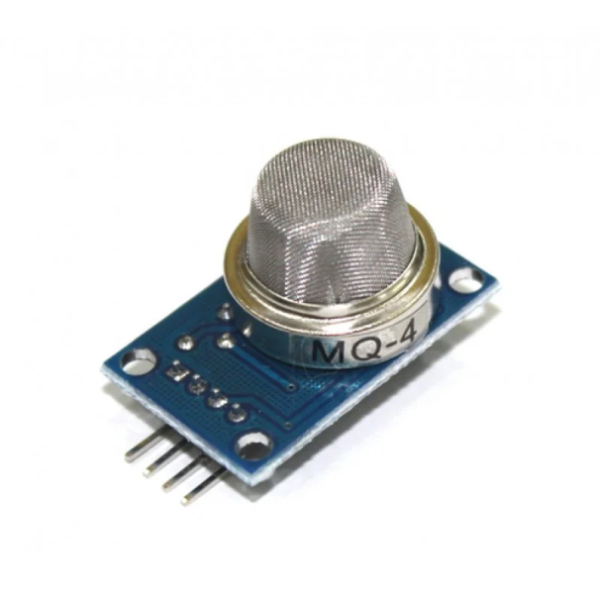
Figure: 2.6. MQ-4 methane gas sensor
2.3.1 Block Diagram

Methane (CH₄) | → | MQ-4 (SnO₂ element) | → | Analog voltage | → | ESP32

Figure: 2.7. Block diagram of MQ-4 gas sensor
The block diagram shows methane present in the surrounding air reaching the heated SnO₂ element of the MQ-4, which produces an analog voltage proportional to the gas level. The ESP32 reads this voltage and uses it to judge how much methane is present.
2.3.2 Working Principle
When the MQ-4 is powered, its heater raises the sensing layer to the working temperature. In clean air the layer has a high resistance. When methane touches the hot surface it reacts with the oxygen that is adsorbed there, electrons are released and the resistance of the layer falls. The module turns the fall in resistance into a rise in output voltage, so that a higher voltage means more methane.
The ESP32 samples this voltage, converts it into a number with its analog-to-digital converter, and compares it with a preset limit. Because a rise in methane is dangerous well before the explosive range is reached, the limit is set low, so that the rover gives its warning early. The reading is also sent to the dashboard, where its changes over time are plotted.
2.3.3 Technical Features
The MQ-4 operates from a 5 V supply and its heater needs a warm-up period before the output becomes stable. The datasheet range for methane is of the order of a few hundred to ten thousand parts per million, which covers the concentrations that matter for early warning. The sensor responds quickly to a change in gas, and the sensitivity can be adjusted on the module with the potentiometer when the digital output is used.
Like the other MQ sensors, the MQ-4 also reacts to some other combustible gases such as LPG, hydrogen and alcohol vapour, and its output changes with temperature and humidity. In the circuit its analog output is reduced by a resistor divider before the ESP32 pin GPIO 35.
2.3.4 Role in the Proposed Rover
In the rover the MQ-4 is the methane detector. It is mounted on the front part of the chassis, where it can sample the air that the rover is entering. Its reading is shown on the dashboard as the methane level graph, and a high value causes the buzzer to sound and an alert to appear on the dashboard.
2.3.5 Applications
Methane detection is needed wherever natural gas, biogas or coal-bed gas can collect. Typical applications are:
- Methane detection in coal mines.
- Natural gas and biogas leak detection.
- Industrial and household gas alarms.

2.3.6 Advantages and Disadvantages
Advantages:
- Good sensitivity to methane.
- Low cost.
- Quick response to changes in gas level.
- Simple analog output.
Disadvantages:
- Also reacts to other gases such as LPG and alcohol, so it is not perfectly selective.
- Needs pre-heating and calibration.
- Accuracy changes with temperature and humidity.
- It is not a certified safety instrument.
2.4 MQ-7 GAS SENSOR
The MQ-7 is a metal-oxide semiconductor sensor designed for carbon monoxide (CO). Carbon monoxide is produced when fuel burns without enough oxygen, for example in a mine fire, in a blast or in engine exhaust. It has no colour, taste or smell, but it is extremely poisonous, because it binds to the haemoglobin of the blood much more strongly than oxygen does and so starves the body of oxygen. Even low concentrations cause headache and dizziness, and higher concentrations can kill within minutes.
The MQ-7 has the same basic construction as the other sensors of its family, with a tin dioxide layer, a heater and electrodes in a metal-mesh housing, as seen in Figure 2.8. What makes it different is the way its heater is operated. The sensor gives the best selectivity for carbon monoxide when its heater is cycled between a high voltage and a low voltage.
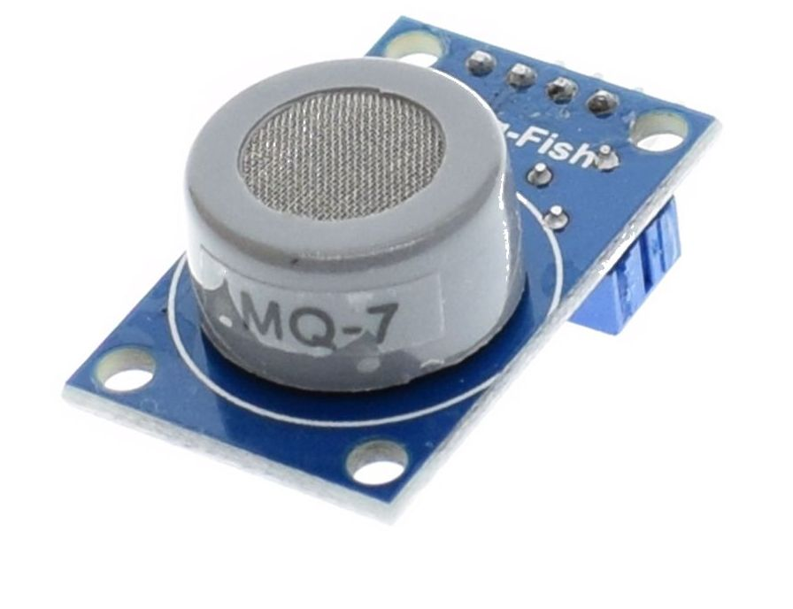
Figure: 2.8. MQ-7 carbon monoxide sensor
2.4.1 Block Diagram

Carbon monoxide (CO) | → | MQ-7 (SnO₂ element) | → | Analog voltage | → | ESP32

Figure: 2.9. Block diagram of MQ-7 gas sensor
The block diagram shows carbon monoxide in the air changing the resistance of the SnO₂ element of the MQ-7. The change is converted into an analog voltage which is read by the ESP32 and compared with the alert limit.
2.4.2 Working Principle
In clean air the sensing layer of the MQ-7 has a high resistance. When carbon monoxide is present, it reacts with the oxygen on the hot surface of the layer and the resistance falls, in the same manner as in the other MQ sensors. The sensor circuit converts the change in resistance into an analog voltage, and the ESP32 reads this voltage.
When the heater is cycled, the high-voltage phase burns off other gases from the surface, and the reading is taken during the low-voltage phase, when the layer is most sensitive to carbon monoxide. In simple projects such as this one, the module is powered continuously and the readings are treated as relative values. A high reading means that carbon monoxide is building up, and the buzzer and the dashboard alert are triggered.
2.4.3 Technical Features
The MQ-7 normally works from a 5 V supply and can detect carbon monoxide over a range of the order of 20 to 2000 parts per million. Its heater consumes a noticeable current, so it must be fed from the battery supply through the buck converter and not from the pin of the ESP32. The sensor needs a warm-up time before the readings settle, and its output depends on temperature and humidity.
The analog output of the module can reach 5 V, so in the rover it is reduced with a resistor divider before it is connected to the ESP32 analog pin GPIO 32. Its response is quick, which is important because carbon monoxide can reach dangerous levels fast in a closed space.
2.4.4 Role in the Proposed Rover
In the rover the MQ-7 is the carbon monoxide detector. Since carbon monoxide is the gas responsible for many fatalities in mine fires, its reading is one of the most important values on the dashboard. The value is plotted as the CO level graph, and any rise beyond the limit raises an audible and a dashboard alert.
2.4.5 Applications
Carbon monoxide sensors are used wherever combustion takes place in a closed space. Typical applications are:
- Carbon monoxide leak detection in homes and industries.
- Mines, tunnels and garages.
- Vehicle and boiler exhaust monitoring.
- Home CO alarms.

2.4.6 Advantages and Disadvantages
Advantages:
- Sensitive to carbon monoxide.
- Low cost and compact.
- Long life.
- Easy analog output.
Disadvantages:
- Best accuracy needs a special heating cycle.
- Reacts to some other gases such as hydrogen and alcohol.
- Needs warm-up time.
- Gives approximate readings only.
2.5 DHT11 TEMPERATURE AND HUMIDITY SENSOR
The DHT11 is a low-cost digital sensor that measures both the temperature and the relative humidity of the air. It is one of the most popular sensors for beginners and small projects because it needs only three connections and gives its result as a ready-made digital value. In a mine, temperature and humidity are important in two ways: they affect the comfort and health of workers, since high humidity combined with heat can lead to heat stress, and they affect the behaviour of the gas sensors, whose readings change with the temperature and moisture of the air.
The DHT11 consists of two sensing parts and a small control chip, all enclosed in a blue plastic housing with a grid of holes, as in Figure 2.10. Humidity is sensed by a capacitive element made of two electrodes with a moisture-holding layer between them, and temperature is sensed by a negative temperature coefficient (NTC) thermistor. The chip converts both analog signals into a digital word.
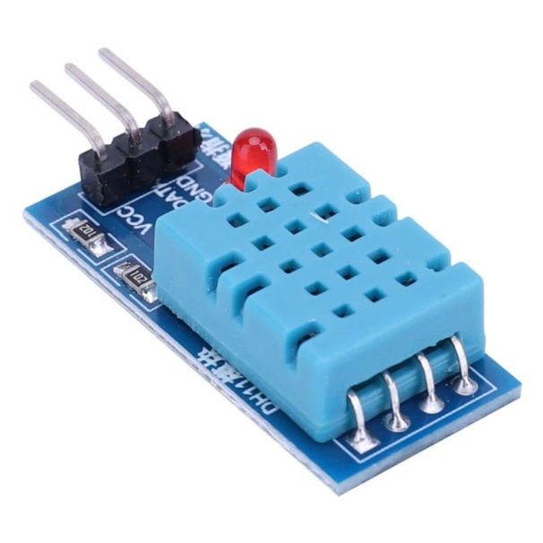
Figure: 2.10. DHT11 temperature and humidity sensor
2.5.1 Block Diagram

Air | → | DHT11 (thermistor + humidity element) | → | Digital signal | → | ESP32

Figure: 2.11. Block diagram of DHT11 sensor
The block diagram shows the surrounding air acting on the thermistor and the humidity element inside the DHT11. The internal chip converts the two measurements into a digital signal which is sent to the ESP32 on a single data wire.
2.5.2 Working Principle
The moisture-holding layer between the two electrodes of the humidity element absorbs water vapour from the air, and as it absorbs more water its dielectric property changes, which changes the capacitance between the electrodes. The thermistor, on the other hand, changes its resistance with temperature. The chip inside the DHT11 measures both quantities, calibrates them using values stored at the factory, and prepares a 40-bit data packet containing the humidity and the temperature together with a check sum.
When the ESP32 wants a reading, it pulls the data line low for a short time as a start signal. The DHT11 answers and sends the 40 bits one after the other on the same wire, using the length of the high pulse to represent a zero or a one. The ESP32 decodes the packet, checks the check sum and then uses the temperature and humidity values.
2.5.3 Technical Features
The DHT11 works from 3.3 V to 5 V and uses very little current. Its temperature range is about 0 to 50 °C with an accuracy of about ±2 °C, and its humidity range is about 20 % to 90 % relative humidity with an accuracy of about ±5 %. It can give only one new reading per second, so it is suitable for slowly changing quantities such as the temperature of a mine passage, but not for rapid measurements.
The sensor has three useful pins, VCC, DATA and GND, as shown in the wiring diagram. The data line is connected to GPIO 26 of the ESP32 and, in module form, already includes the pull-up resistor that the single-wire protocol requires.
2.5.4 Role in the Proposed Rover
In the rover the DHT11 measures the ambient temperature and humidity of the mine air. The values are shown on the dashboard as large readings (in °C and % RH) and as the temperature and humidity history graph. Operators can use them to see whether the environment is becoming dangerously hot or damp, and to understand the behaviour of the gas sensors, whose output depends on these two factors.
2.5.5 Applications
The DHT11 is used wherever simple climate measurement is required. Typical applications are:
- Weather stations.
- Home automation and HVAC systems.
- Greenhouses and agriculture.
- Environmental monitoring, as in this project.

2.5.6 Advantages and Disadvantages
Advantages:
- Very low cost.
- Digital output, so no calibration or analog conversion is needed.
- Easy to use with libraries available for the ESP32.
- Low power consumption.
Disadvantages:
- Limited accuracy (about ±2 °C and ±5 % RH).
- Slow: it gives only one reading per second.
- Limited temperature range (0 to 50 °C).
2.6 ULTRASONIC SENSOR (HC-SR04)
The HC-SR04 is a low-cost ultrasonic ranging module that measures the distance to an object without touching it. It works in the same way as the echo-location used by bats: it sends out a burst of sound that is too high for humans to hear and measures how long the echo takes to return. In a robot, this gives the machine a sense of what is in front of it, which is essential for avoiding collisions in the narrow and uneven passages of a mine.
The module has two metal cylinders on the front, one is the ultrasonic transmitter and the other is the receiver, mounted on a small circuit board that also carries a 40 kHz crystal oscillator and the control electronics, as can be seen in Figure 2.12. Four pins are available: VCC, TRIG, ECHO and GND.
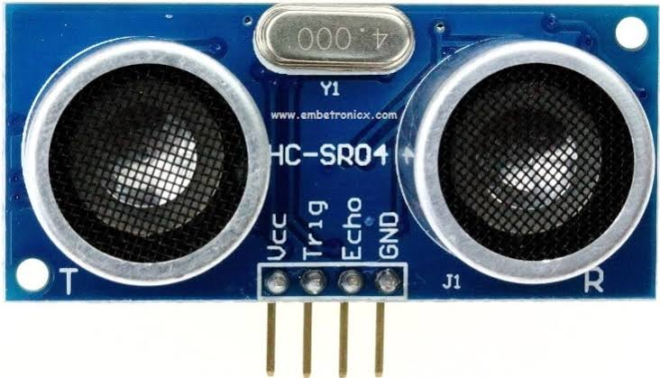
Figure: 2.12. HC-SR04 ultrasonic sensor
2.6.1 Block Diagram

ESP32 trigger | → | Ultrasonic pulse sent | → | Echo from obstacle | → | Distance calculated

Figure: 2.13. Block diagram of ultrasonic sensor
In the block diagram the ESP32 first gives a trigger pulse. The sensor then sends an ultrasonic pulse, the pulse is reflected by an obstacle, the echo returns to the receiver, and the ESP32 calculates the distance from the time taken.
2.6.2 Working Principle
To start a measurement the ESP32 sends a short pulse of about 10 microseconds to the TRIG pin. The module responds by sending out a burst of eight ultrasonic pulses at 40 kHz and then raises its ECHO pin to a high level. The ECHO pin stays high until the reflected sound is received. The ESP32 measures the width of this pulse, which is the time that the sound needed to travel to the obstacle and back. Since the sound has travelled the distance twice, the distance is calculated with the following relation, where the speed of sound in air is about 343 metres per second:
Distance = (Time × Speed of sound) / 2
If the distance is below a set limit, the ESP32 decides that an obstacle is in front of the rover, so that it stops the motors, sounds the buzzer in short beeps and turns the rover away. Because the speed of sound changes slightly with temperature, the distance calculated is only approximate, but the accuracy is sufficient for obstacle avoidance.
2.6.3 Technical Features
The HC-SR04 works from a 5 V supply and draws a small current of about 15 mA. It can measure distances from about 2 cm to 4 m with a resolution of about 3 mm, and its sensing beam is a cone of about 15 degrees. Measurements should not be taken more often than about every 60 milliseconds, so that the echo of one measurement does not disturb the next.
The ECHO pin gives a 5 V pulse, which is above the 3.3 V limit of the ESP32 input. For this reason the ECHO line is connected to the ESP32 through a resistor divider, as seen in the circuit diagram. The TRIG pin is driven from GPIO 25 and the echo is read on GPIO 13.
2.6.4 Role in the Proposed Rover
In the rover the ultrasonic sensor is fixed at the front of the chassis and looks straight ahead. It continuously measures the distance to the nearest object in front. When the distance falls below the limit, the ESP32 stops the rover, sounds the buzzer and turns it away, so that the rover can move through the mine without being damaged by collisions with walls or fallen material.
2.6.5 Applications
Ultrasonic distance sensors are used in many fields where non-contact distance measurement is needed. Typical applications are:
- Obstacle avoidance robots.
- Parking assistance in vehicles.
- Level measurement in tanks.
- General distance measurement.

2.6.6 Advantages and Disadvantages
Advantages:
- Low cost.
- Accurate for short range (2 cm to 4 m).
- Works in darkness and is not affected by the colour of the object.
- Easy to interface with a microcontroller.
Disadvantages:
- Soft or angled surfaces may not reflect the sound well, so such obstacles can be missed.
- Readings are affected by temperature and noise.
- Narrow detection cone, so objects at the side may not be detected.
2.7 L298N MOTOR DRIVER WITH 4WD CHASSIS
A microcontroller pin can supply only a few tens of milliamperes, whereas a small DC motor needs hundreds of milliamperes or more. The ESP32 therefore cannot drive the motors of the rover directly, and a motor driver is placed between them. The L298N module is a popular motor driver based on the L298 dual full-bridge (H-bridge) integrated circuit. It can control two DC motors at the same time, in both directions and at variable speeds, and it is designed to be driven directly by logic signals.
The module shown in Figure 2.14 is built on a red circuit board with a large heat sink on the L298 chip, screw terminals for the two motor outputs (OUT1 to OUT4), terminals for the motor supply and ground, and a 5 V terminal. It has input pins IN1 to IN4 that select the direction of the motors, and enable pins ENA and ENB that switch the motors on and control their speed.
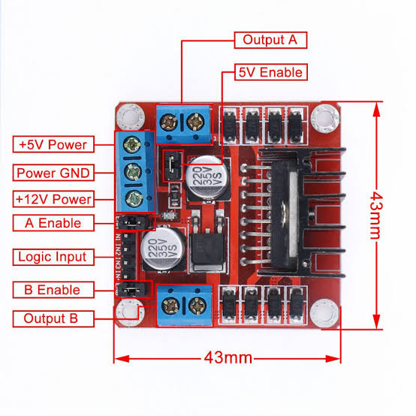
Figure: 2.14. L298N motor driver module
2.7.1 Block Diagram

ESP32 signals | → | L298N driver | → | DC motors | → | Wheels move

Figure: 2.15. Block diagram of L298N motor driver
The block diagram shows the control signals of the ESP32 entering the L298N driver, which switches the battery power to the DC motors that turn the wheels.
2.7.2 Working Principle
An H-bridge is a circuit with four electronic switches arranged in the shape of the letter H, with the motor in the middle. When the switches on one diagonal are closed, current flows through the motor in one direction. When the other diagonal is closed, the current flows in the opposite direction and the motor turns the other way. The inputs IN1 and IN2 control the bridge of the first motor channel and IN3 and IN4 control the second one, so that the ESP32 can make the motors go forward, go backward or stop by choosing the high and low levels of these pins.
The speed of the motors is controlled by the enable pins ENA and ENB. The ESP32 gives them a pulse-width modulated (PWM) signal, which switches the motor supply on and off many times per second. A longer on-time means a higher average voltage and a higher speed. To turn the rover, the motors on one side are driven forward while the motors on the other side are stopped or driven backward.
2.7.3 Technical Features
The L298N accepts a motor supply of about 5 V to 35 V and can deliver up to 2 A per channel, which is more than enough for small gear motors. The module also has an on-board 5 V regulator that can be used to supply logic circuits when the motor supply is above about 7 V. Because the L298 uses bipolar transistors, the driver loses about 2 V across the bridge, which reduces the voltage reaching the motors and makes the chip warm when it carries large currents.
In the rover, the four motors of the 4WD chassis are connected in two pairs, so that the left-side motors are connected to one channel and the right-side motors to the other. The direction inputs are connected to GPIO 18, 19, 21 and 22 of the ESP32, and the enable pins to GPIO 5 and 23.
2.7.4 Role in the Proposed Rover
In the proposed rover the L298N is the link between the thinking part and the moving part. The ESP32 decides to move forward, to stop or to turn, and the L298N turns these decisions into the strong currents that drive the four motors. A properly working driver is what allows the rover to carry the sensors, the camera and the battery through the mine.
2.7.5 Applications
L298N motor drivers are found in many projects that involve small DC motors. Typical applications are:
- Robotic vehicles.
- Automated carts.
- Remote-control cars.
- Educational robots.

2.7.6 Advantages and Disadvantages
Advantages:
- Controls two motors with both speed and direction.
- Handles good current for small motors.
- Cheap and widely available.
- Easy to connect to a microcontroller.
Disadvantages:
- Voltage drop of about 2 V makes it less efficient and warm.
- A heat sink is needed for heavy loads.
- Not suitable for large motors or very low-voltage batteries.
2.8 4WD CAR CHASSIS WITH DC MOTORS
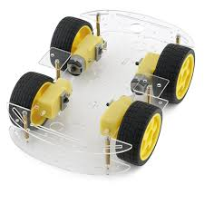
The chassis is the body of the rover. It is a four-wheel-drive (4WD) car platform made of a rigid plastic or acrylic plate with mounting holes, on which four geared DC motors with wheels are fixed, one at each corner. The plate also has enough space for the electronics, the camera and the battery pack, as can be seen in the photograph of the hardware in Chapter 5.
Each motor is a small brushed DC motor with a gearbox attached to it. The gearbox reduces the speed of the motor and increases its torque, which gives the rover the strength to carry its load and to climb over small obstacles. The wheels are rubber tyres that grip the floor.
2.8.1 Block Diagram

L298N outputs | → | DC gear motors | → | Wheels | → | Rover movement

Figure: 2.16. Block diagram of 4WD chassis and DC motors
The block diagram shows the outputs of the L298N driver supplying the four DC gear motors, which turn the wheels and make the rover move.
2.8.2 Working Principle
When a voltage is applied to a brushed DC motor, current flows through the coil of its rotor, which is placed in a magnetic field. The magnetic force on the current-carrying coil produces a torque that turns the shaft. Reversing the polarity of the supply reverses the direction of rotation. The built-in gearbox reduces the speed and increases the torque available at the wheel.
In the 4WD chassis all four wheels are driven. The two wheels on each side are driven together, so the rover steers like a tank: when the wheels on both sides turn forward the rover moves straight ahead, and when the wheels on one side turn slower, stop or turn backward, the rover turns. This skid-steering arrangement needs no separate steering mechanism, which keeps the mechanical design simple.
2.8.3 Technical Features
A 4WD platform gives better traction than a two-wheel-drive one, since the load is shared by four wheels and the rover can keep moving even if one wheel slips. The platform is compact, and the mounting holes make it easy to fix the L298N driver, the ESP32 board and the sensors. The motors typically work at 3 V to 9 V, so the battery voltage of 7.4 V to 8.4 V used in the rover is suitable.
The disadvantage of skid steering is that the wheels slide sideways when the rover turns, which wears the tyres and uses extra energy. Four motors also draw a larger current from the battery than two motors, so the battery drains more quickly.
2.8.4 Role in the Proposed Rover
The chassis carries all the components of the rover and makes it mobile, so that the sensors can be taken into the area that must be inspected. Its four-wheel drive gives the rover the grip it needs on the rough floor of a mine, and its simple steering makes the obstacle-avoidance program easy to write.
2.8.5 Applications
Four-wheel-drive chassis are widely used as the base of small mobile robots. Typical applications are:
- Robotic vehicles and rovers.
- Educational and hobby robots.
- Inspection and surveillance robots.
- Remote-control cars.

2.8.6 Advantages and Disadvantages
Advantages:
- Good traction on uneven floors.
- Carries a reasonable payload of sensors and batteries.
- Simple mechanical design with no steering mechanism.
- Low cost.
Disadvantages:
- Skid steering wears the tyres and wastes energy in turns.
- Four motors use more battery power.
- Limited ground clearance for very rough terrain.
2.9 ESP32-CAM MODULE
The ESP32-CAM is a small, low-cost development board that combines an ESP32 chip with a camera and a micro-SD card slot. It has the same Wi-Fi and Bluetooth abilities as the ESP32 DevKit, but it adds a 2-megapixel OV2640 camera, so it can capture pictures and stream video over Wi-Fi without any other hardware. The size of the board is only a few centimetres, which makes it ideal for a small rover.
The board does not have a USB connector, so it is normally programmed through an external USB-to-serial adapter. It also has a bright white LED that can be used as a flash to light the scene, and fewer free pins than the DevKit, as can be seen in the pinout in Figure 2.17.
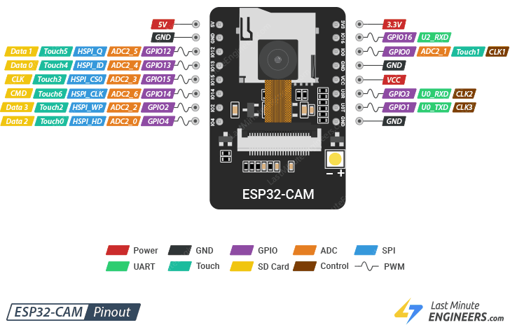
Figure: 2.17. ESP32-CAM pinout
2.9.1 Block Diagram

Camera lens | → | ESP32-CAM | → | Wi-Fi | → | Dashboard / Browser

Figure: 2.18. Block diagram of ESP32-CAM module
The block diagram shows the picture formed by the camera lens being processed by the ESP32-CAM, sent over Wi-Fi and displayed on a dashboard or browser.
2.9.2 Working Principle
The OV2640 camera converts light into a digital image. The ESP32 captures each frame, compresses it in JPEG format and sends the frames one after another as a Motion JPEG (MJPEG) stream using a small web server that runs on the board itself. Any phone or computer on the same network can open the address of this web server in a browser to see the live video.
In the rover, the camera board is powered separately from a regulated 5 V source, as shown in the power wiring diagram (Figure 3.2), and its video is viewed by the operator on a browser or on the dashboard. Because the video path is independent of the sensor path, the operator keeps the view of the path ahead even when the sensor data are being updated.
2.9.3 Technical Features
The ESP32-CAM needs a stable 5 V supply capable of at least 1 A at peak, since Wi-Fi streaming and the camera draw a large current. A weak supply is the most common cause of resets and poor video. The board must never be given 5 V on its 3.3 V pin. The video quality is basic, typically up to about 1600 × 1200 pixels, and the frame rate falls as the resolution increases or the Wi-Fi signal weakens.
The board has an on-board antenna and in the open can work over a range of a few tens of metres. In an underground mine the range will be shorter because rock and metal absorb the radio waves, which is why a Wi-Fi repeater would be needed in a real installation.
2.9.4 Role in the Proposed Rover
The ESP32-CAM is the eye of the rover. It lets the operator outside see the path ahead, find obstacles that the ultrasonic sensor cannot detect and understand what the gas readings mean in the surroundings of the rover. Together with the sensor data, it gives the people outside a complete picture of the mine environment.
2.9.5 Applications
The ESP32-CAM is used in many low-cost vision applications. Typical applications are:
- Remote surveillance.
- Inspection of unsafe areas, as in this project.
- Smart doorbells and security cameras.
- Robot vision.

2.9.6 Advantages and Disadvantages
Advantages:
- Very low cost.
- Wi-Fi streaming is built in.
- Small size.
- Has an LED flash for dark places.
Disadvantages:
- Video quality is basic.
- Needs a stable 5 V supply.
- Limited range and dependence on Wi-Fi.
- No built-in USB programmer.
2.10 BUZZER
A buzzer is a small audio signalling device that produces a loud beep when it is given a voltage. It is the simplest way of giving a warning sound in an electronic project. The buzzer used in the rover is an active buzzer, that is, one that contains its own oscillator, so that it makes a sound as soon as it is connected to a supply, without needing any special signal.
The buzzer has a round black plastic body with a sound hole in the middle, and two pins that are marked positive (+) and negative (−) as shown in Figure 2.19. Inside the body is a piezoelectric or electromagnetic element that vibrates when the voltage is applied and makes the sound.
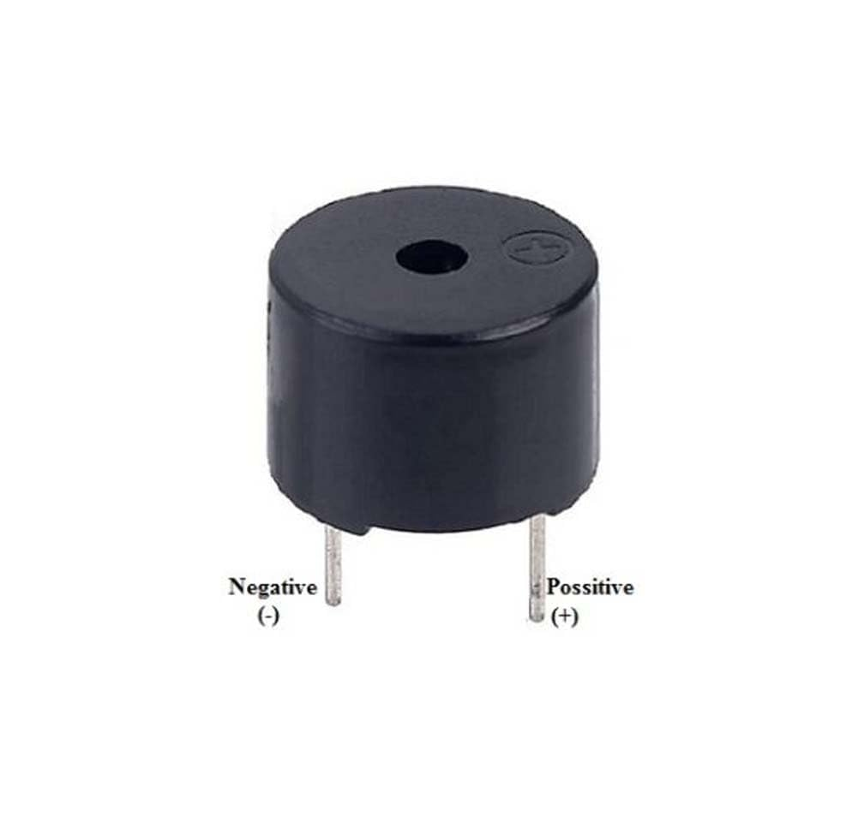
Figure: 2.19. Buzzer
2.10.1 Block Diagram

ESP32 output | → | Buzzer | → | Loud alert sound

Figure: 2.20. Block diagram of buzzer
In the block diagram, a high level on an output pin of the ESP32 energizes the buzzer, which then produces a loud alert sound.
2.10.2 Working Principle
When the ESP32 sets the buzzer pin (GPIO 4) high, the voltage is applied across the buzzer. The internal oscillator makes the vibrating element move back and forth at a fixed frequency, usually in the range of 2 to 4 kHz, and this produces a loud, piercing tone. When the pin is set low again, the sound stops.
By switching the pin on and off in a pattern, the ESP32 can give different alerts with the same buzzer. In the rover, short beeps tell people nearby that the rover has met an obstacle, while a continuous tone indicates that a gas sensor has crossed its limit.
2.10.3 Technical Features
A typical small active buzzer works from 3 V to 5 V and draws a current of about 15 to 30 mA, which is within what an ESP32 pin can supply for a short time. For larger buzzers a transistor can be used as a switch. The sound level is of the order of 80 to 90 dB at a distance of 10 cm, which is loud enough to be noticed in a quiet room but may be missed in a noisy workplace.
Since an active buzzer has a fixed tone, it cannot play melodies, but it is simple, reliable and needs only one output pin.
2.10.4 Role in the Proposed Rover
The buzzer gives local audible feedback. It warns people who are near the rover, for instance a rescue worker following it, that an obstacle is ahead or that a dangerous gas is present, even if they are not looking at the dashboard. This direct warning adds to the safety of the system.
2.10.5 Applications
Buzzers are used in many electronic products as a basic warning device. Typical applications are:
- Alarms and alerts.
- Timers and appliances.
- Security systems.
- Industrial warnings.

2.10.6 Advantages and Disadvantages
Advantages:
- Very cheap and small.
- Loud and attention-grabbing.
- Simple to drive from a single pin.
Disadvantages:
- Only one tone is possible with an active buzzer.
- Can be missed in noisy places.
- Gives no detail about the cause of the alert.
2.11 BATTERY PACK, BUCK CONVERTER AND CONNECTIONS
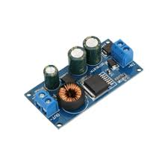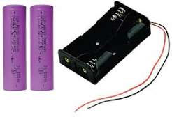
The rover is a mobile machine, so it must carry its own power. The circuit diagram of Figure 3.1 shows a battery pack made of two 18650 lithium-ion cells in series, which gives a voltage of 7.4 V when the cells are partly discharged and 8.4 V when they are fully charged, with a capacity of about 2600 mAh. A switch is placed in the supply line so that the whole rover can be turned on and off.
The 18650 cell is a cylindrical lithium-ion cell, 18 mm in diameter and 65 mm long, which is popular because of its high energy density, its ability to give large currents and the fact that it can be recharged hundreds of times. Since the sensors, the ESP32 and the camera need 5 V and not the battery voltage, a 5 V buck (step-down) converter is used to produce a regulated supply.
2.11.1 Block Diagram

Battery pack | → | Switch | → | Buck converter / L298N | → | ESP32, sensors, motors

Figure: 2.21. Block diagram of the power supply
The block diagram shows the battery pack feeding the switch, which then supplies the buck converter and the motor driver, from where power is distributed to the ESP32, the sensors and the motors.
2.11.2 Working Principle
A buck converter is a switching regulator that steps a higher voltage down to a lower one with high efficiency. It switches the input voltage on and off many thousand times per second and uses an inductor and a capacitor to smooth the result into a steady output. The module used in the rover contains such a circuit and gives a fixed 5 V output from the 7.4 V to 8.4 V of the battery. Because it is a switching regulator, it wastes much less energy as heat than a linear regulator would.
The 5 V output of the converter feeds the VIN pin of the ESP32 board and the supply pins of the MQ sensors, the DHT11 and the ultrasonic sensor, while the battery voltage is connected directly to the motor supply terminal of the L298N driver. All the grounds are connected together, so that the signals have a common reference.
2.11.3 Technical Features
The two 18650 cells in series provide a nominal 7.4 V and an energy of about 19 Wh with the 2600 mAh capacity. The actual running time of the rover depends on the load, because the four motors, the heaters of the three MQ sensors and the Wi-Fi radio all draw considerable current. The MQ sensors alone use several hundred milliamperes, since each has a heater.
Lithium-ion cells must be protected from over-discharge, short circuit and overcharge. A protection circuit or a careful charging procedure is therefore needed in a practical rover. Jumper wires are used for all the signal connections, which keeps the wiring flexible and allows the parts to be replaced easily.
2.11.4 Role in the Proposed Rover
The battery pack and the buck converter provide the energy that all the other components need. A clean, steady 5 V supply is especially important for the gas sensors and the ESP32-CAM, since voltage dips make their readings unreliable and can reset the boards. The switch lets the operator power the rover on and off conveniently.
2.11.5 Applications
Rechargeable battery packs with buck converters are the standard power solution in portable electronics. Typical applications are:
- Mobile robots and rovers.
- Portable measuring instruments.
- Remote and wireless sensor nodes.
- Power banks and handheld devices.

2.11.6 Advantages and Disadvantages
Advantages:
- Rechargeable, so there is no need to replace cells.
- High energy density in a compact size.
- Buck converter gives efficient and steady 5 V.
- Low cost and easily available.
Disadvantages:
- Limited running time for a small pack.
- Lithium cells need protection against over-discharge and short circuit.
- Switching converters can add electrical noise.
2.12 THINGSBOARD IOT PLATFORM
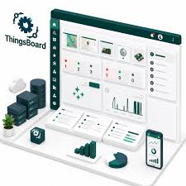
ThingsBoard is an open-source IoT platform for collecting, processing, visualizing and managing data from connected devices. It runs on a server (in the cloud or on a local machine) and provides ready-made dashboards, device management and alarm features, so that the person building a project does not need to write a complete web application. Devices can send their data to ThingsBoard over standard protocols such as MQTT, HTTP and CoAP.
In this project ThingsBoard is the software at the far end of the system. The rover is registered on the platform as a device, and a dashboard is built with widgets that show the rover’s data: numerical readings with their status, time-series graphs and a table that lists the latest telemetry, as seen in the dashboard screenshots in Chapter 5.
2.12.1 Block Diagram

ESP32 telemetry | → | Wi-Fi / Internet | → | ThingsBoard server | → | Dashboard widgets and alarms

Figure: 2.22. Block diagram of ThingsBoard monitoring
The block diagram shows the telemetry of the ESP32 travelling through the Wi-Fi network and the internet to the ThingsBoard server, which displays it in dashboard widgets and raises alarms.
2.12.2 Working Principle
The ESP32 connects to the Wi-Fi network and uses an access token to authenticate itself with the ThingsBoard server. It then publishes its sensor readings, such as the air quality, methane level, carbon monoxide level, temperature and humidity, as telemetry, together with the time stamp. The server stores the data and sends it to the dashboard, which updates its widgets.
The dashboard can be opened from a web browser on a phone or a computer. Time-series widgets draw the history of each quantity as a graph, value widgets show the latest reading with its status (SAFE or alert), and table widgets list the recent data. Rules and alarms can also be defined, so that a notification is raised when a value crosses a set limit.
2.12.3 Technical Features
ThingsBoard offers a rule engine for processing incoming data, flexible widgets with real-time updates, support for many device protocols, and the ability to scale from a few devices to thousands. It is available as a free community edition that can be installed on a local server, and also as a cloud service. Its dashboards are responsive and can be viewed on different screen sizes.
Since the data are sent through the internet, the platform requires a working network connection at the place where the rover operates. In a real mine, a network of repeaters or a local server inside the mine would be needed to carry the data from the rover to the outside.
2.12.4 Role in the Proposed Rover
ThingsBoard gives the people outside the mine a single place to see everything that the rover senses. It turns the raw numbers of the sensors into graphs, status indicators and logs, and it keeps a history of the readings, which can be used afterwards to study how the mine environment changed.
2.12.5 Applications
IoT platforms such as ThingsBoard are used in many data-driven applications. Typical applications are:
- Remote monitoring of industrial equipment.
- Smart city and smart building systems.
- Environmental and agricultural monitoring.
- Safety monitoring in hazardous workplaces, as in this project.

2.12.6 Advantages and Disadvantages
Advantages:
- Ready-made dashboards and widgets save development time.
- Real-time display and history of the data.
- Alarms and notifications for dangerous values.
- Open source with support for common IoT protocols.
Disadvantages:
- Needs a reliable internet or network connection.
- Server setup and maintenance are needed for a local installation.
- Dashboard design takes time to learn.

CHAPTER- 3

DESIGN OF PROPOSED SYSTEM
The design of the rover is based on the ESP32 microcontroller, to which all the sensors, the motor driver and the buzzer are connected. The design had to satisfy four requirements: the rover must sense the main hazardous gases and the climate of the mine, it must move and avoid obstacles by itself, it must show the path ahead, and it must report all its data over a wireless network. Each requirement is met by a separate group of components, and the ESP32 ties the groups together.
This chapter presents the circuit diagram, the power wiring and the live-video path of the ESP32-CAM, the overall block diagram of the complete system and a detailed description of the circuit connections, including the ESP32 pin assignment.
3.1 CIRCUIT DIAGRAM
Figure 3.1 shows the circuit diagram of the rover. The ESP32 DevKit is placed at the centre. On its left are the three MQ gas sensors (MQ-4, MQ-135 and MQ-7), the DHT11 temperature and humidity sensor and the HC-SR04 ultrasonic sensor. On its right are the L298N motor driver, which drives the four motors of the chassis, and the buzzer. At the bottom of the diagram are the 5 V buck converter and the battery pack of two 18650 cells.
The diagram uses colour-coded wires so that the power lines, the ground lines, the analog signals and the digital control signals can be followed easily. A common ground connects the battery, the buck converter, the motor driver, the ESP32 and all the sensors.
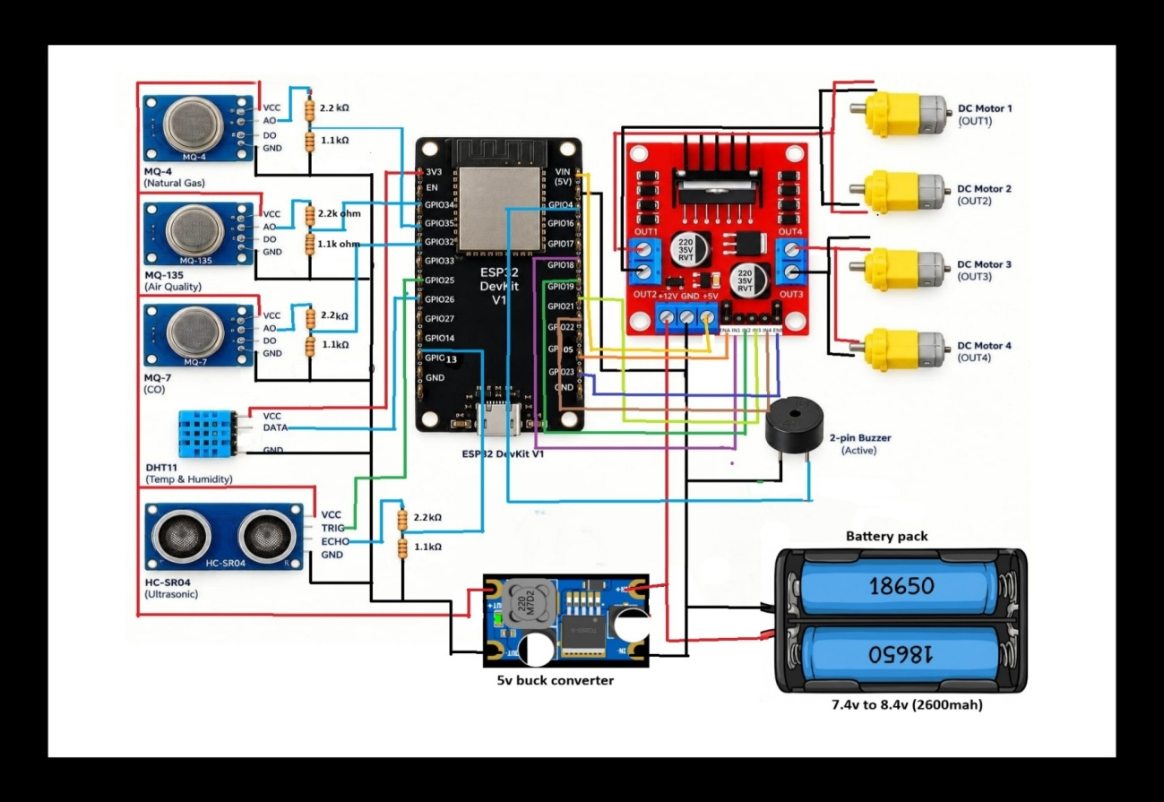
Figure: 3.1. Circuit diagram of the Mine Environment Monitoring Rover
3.2 OVERALL BLOCK DIAGRAM
The ESP32-CAM does not take part in the sensor circuit. It runs separately from its own regulated 5 V supply and streams video over Wi-Fi. Its power wiring and live-video path are shown in Figure 3.2. The 5 V output of the supply is connected to the 5V pin of the board and the negative terminal to GND, and the onboard regulator then produces the 3.3 V needed by the chip. The camera is joined to the board by its ribbon connector, so no external wires are needed for it. The video is made available as a web page and an MJPEG stream, which a phone or a computer on the same network can open in a browser.
The overall block diagram of the complete system is shown in Figure 3.3. It groups the system into the sensing section, the control and processing section, the actuation section, the video section and the communication and monitoring section, and shows how data and power flow between them.
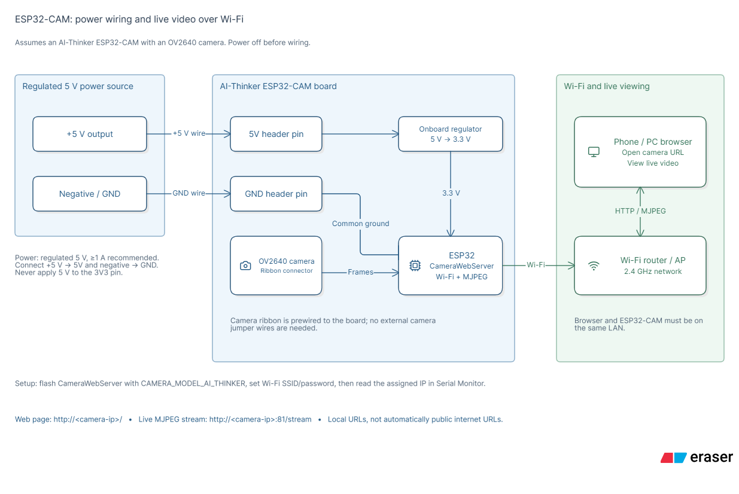
Figure: 3.2. ESP32-CAM power wiring and live video over Wi-Fi
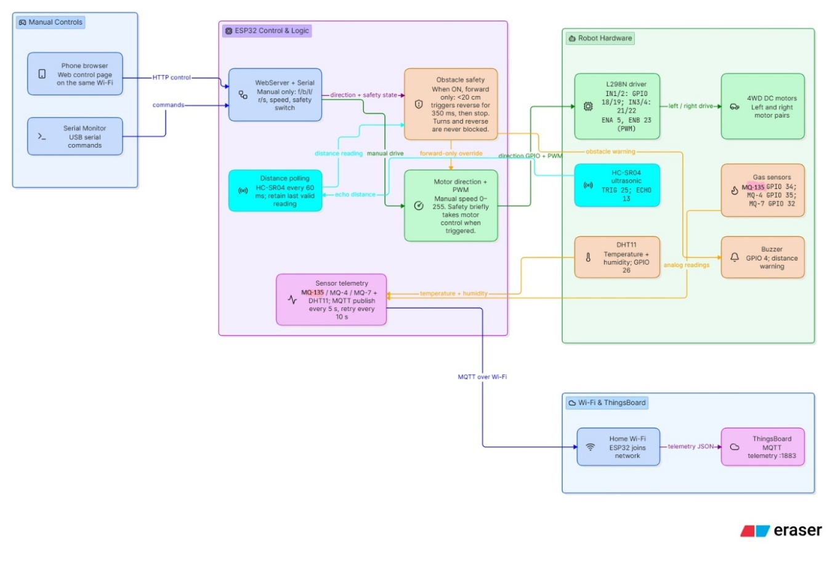
Figure: 3.3. Overall block diagram of the proposed rover
3.3 CIRCUIT DESCRIPTION
The ESP32 is the centre of the circuit. All sensors, the motor driver and the buzzer connect to it. The connections are described below, and the pin assignment is summarized in Table 3.1.
Table 3.1: ESP32 pin connections
Device | Connection | ESP32 pin
MQ-135 (analog out) | Analog input | GPIO 34
MQ-4 (analog out) | Analog input | GPIO 35
MQ-7 (analog out) | Analog input | GPIO 32
DHT11 (data) | Digital input | GPIO 26
Ultrasonic TRIG / ECHO | Digital out / in | GPIO 25 / 13
Buzzer | Digital output | GPIO 4
L298N IN1 to IN4 | Direction control | GPIO 18, 19, 21, 22
L298N ENA, ENB | Speed (PWM) | GPIO 5, 23

3.3.1 Power Supply Connections
The battery pack gives 7.4 V to 8.4 V. This voltage is connected directly to the motor supply terminal of the L298N driver, and it is also connected to the input of the 5 V buck converter. The 5 V output of the converter feeds the VIN pin of the ESP32 board and the VCC pins of the MQ-4, MQ-135, MQ-7, DHT11 and HC-SR04 sensors. All the ground lines are joined together, because the analog and digital signals have meaning only with respect to a common ground. The three MQ sensors have heaters that draw a considerable current, so the 5 V rail has to be able to supply it.
3.3.2 Gas Sensor Connections
The analog outputs (AO) of the MQ-4, MQ-135 and MQ-7 modules are connected to GPIO 35, GPIO 34 and GPIO 32 of the ESP32 respectively. These three pins belong to the ADC1 group of the converter, which can be used while Wi-Fi is on. Since the analog outputs of the modules can go up to 5 V and the ESP32 inputs tolerate only 3.3 V, each output is passed through a divider of a 2.2 kΩ and a 1.1 kΩ resistor, which reduces the voltage to one third. The digital outputs (DO) of the modules are not used, because the analog values are needed for the graphs on the dashboard.
3.3.3 Temperature, Humidity and Distance Sensor Connections
The DATA pin of the DHT11 is connected to GPIO 26. The TRIG pin of the HC-SR04 is connected to GPIO 25 and its ECHO pin is connected to GPIO 13 through another 2.2 kΩ and 1.1 kΩ divider, since the echo pulse is 5 V. The ESP32 gives a trigger pulse on GPIO 25 and measures the width of the pulse returning on GPIO 13 to find the distance.
3.3.4 Motor Driver and Buzzer Connections
The direction inputs IN1 to IN4 of the L298N are connected to GPIO 18, 19, 21 and 22, and its enable inputs ENA and ENB are connected to GPIO 5 and GPIO 23, which carry the PWM signals for speed control. The left-side motors are connected to one output channel and the right-side motors to the other. The buzzer is connected to GPIO 4, so that the ESP32 can switch it on and off directly.
3.3.5 Wi-Fi and Camera Connections
The ESP32 uses its built-in Wi-Fi to join the local network and to send the readings to ThingsBoard. The ESP32-CAM is a separate board with its own Wi-Fi connection and its own 5 V supply, and it streams video on the same network. Keeping the camera separate prevents the heavy load of video streaming from disturbing the timing of the sensor readings and the motor control.
The main points of the circuit are summarized below.
- The three MQ sensors need a 5 V supply and give an analog voltage that changes with gas concentration.
- The DHT11 sends temperature and humidity as a digital signal on one wire.
- The ultrasonic sensor sends a pulse and the ESP32 measures the echo time to find distance.
- The L298N takes direction and speed signals from the ESP32 and powers the four motors from the battery.
- The buzzer is switched on by the ESP32 for obstacle or gas alerts.
- The ESP32 connects to Wi-Fi and sends all readings to ThingsBoard. The ESP32-CAM runs separately on its own supply and streams video.
- All grounds (battery, L298N, ESP32 and sensors) are connected together.

CHAPTER- 4

OPERATION OF PROPOSED ROVER
This chapter explains how the Mine Environment Monitoring Rover works once it has been assembled. The operation can be seen as a repeating cycle in which the rover senses its surroundings, takes a decision, acts, and reports the result. The complete flow is shown in Figure 4.1 and each step is described in the following sections.

Power ON | → | Initialize ESP32 and sensors | → | Connect to Wi-Fi and ThingsBoard | → | Read all sensors

Check obstacle distance | → | Compare gas values with limits | → | Move / stop / turn and buzzer | → | Send data to dashboard

Figure: 4.1. Operating flow of the rover (repeated continuously)
4.1 POWER-UP AND INITIALIZATION
The rover is started by closing the battery switch. The battery voltage goes to the L298N driver and to the buck converter, which produces the steady 5 V needed by the ESP32 board and the sensors. As soon as the ESP32 receives power it starts running its program. The program first sets up the input and output pins: the analog pins for the three gas sensors, the digital pin for the DHT11, the trigger and echo pins of the ultrasonic sensor, the direction and PWM pins of the motor driver, and the buzzer pin.
The heaters of the three MQ sensors begin to warm up when the power is applied, and the sensors need some time before their readings become steady. During this period the readings are not used for decisions. When the sensors are stable, the ESP32 joins the Wi-Fi network using the stored name and password and then connects to the ThingsBoard server with the device access token. The ESP32-CAM, which has its own supply, starts its own web server and begins to stream video at the same time.
4.2 SENSING AND DATA ACQUISITION
Once the rover is ready, the ESP32 repeatedly reads all its sensors. The outputs of the MQ-135, MQ-4 and MQ-7 sensors are analog voltages. After they are reduced by the resistor dividers, they are applied to the ADC1 inputs of the ESP32, which converts each one to a number between 0 and 4095. To reduce the effect of electrical noise, several samples are taken and averaged, and the result is taken as the reading of that sensor.
The DHT11 is read about once a second, which is the fastest rate that it allows. It returns the temperature in degrees Celsius and the relative humidity in percent. The ultrasonic sensor is read much more often because the rover is moving and the distance in front of it changes quickly. For each reading the ESP32 sends a 10 microsecond trigger pulse, measures the width of the echo pulse and calculates the distance with the formula given in Section 2.6.2.
4.3 OBSTACLE DETECTION AND MOTION CONTROL
The rover moves forward by driving all four motors in the forward direction through the L298N driver. The ESP32 sets the direction inputs and gives a PWM signal to the enable inputs, which sets the speed. While the rover is moving, the distance measured by the ultrasonic sensor is compared with a preset safe distance after every reading.
When the measured distance falls below the safe distance, the ESP32 decides that an obstacle is ahead. It immediately stops the motors, switches the buzzer on in short beeps to warn people nearby and then turns the rover away. The turn is made by driving the motors of one side forward and the motors of the other side backward or by stopping them, as described in Section 2.8. After the turn the distance is measured again. If the way ahead is clear, the rover continues forward. If it is still blocked, the turn is repeated. In this way the rover finds a free path through the mine without help from an operator.
4.4 GAS HAZARD DETECTION AND ALERT GENERATION
At the same time as it moves, the rover keeps checking the air. The value of each gas sensor is compared with its own limit: the MQ-135 for general air quality (ammonia, CO₂ and smoke), the MQ-4 for methane and the MQ-7 for carbon monoxide. As long as all the values are below their limits, the status of the readings is SAFE and the buzzer remains silent.
If any value rises above its limit, the ESP32 treats this as a hazard. The buzzer is switched on with a continuous tone, which is different from the short beeps used for obstacles, and an alert status is sent to the dashboard along with the reading. The people outside can then see exactly which gas has exceeded its limit and can decide not to enter the area. Since the gas values are sent with every update, the dashboard also shows how fast the level is rising, which is often as important as the level itself.
The temperature and humidity are checked in the same cycle and sent with the gas values. They are not used to trigger the buzzer in this version, but they are valuable for understanding the conditions in which the gas readings were taken.
4.5 LIVE VIDEO STREAMING
The ESP32-CAM captures the scene in front of the rover through its camera, compresses each frame into JPEG format and sends the frames as a continuous stream over Wi-Fi. An operator on the same network opens the camera address in a browser or on the dashboard and sees the live video of the path ahead. The video lets the operator confirm obstacles, see the condition of the passage, and interpret the gas readings in context. Because the camera board runs independently, the video continues without interruption while the main controller reads the sensors and drives the motors.
4.6 DATA TRANSMISSION AND DASHBOARD MONITORING
After each cycle of readings, the ESP32 packages the values of the three gas sensors, the temperature, the humidity and, where needed, the alert status, and sends them as telemetry to the ThingsBoard server over the Wi-Fi network. The server stores the data and updates the dashboard, where it appears in several forms: large digital readings with a SAFE or alert status, time-series graphs of each gas level and of temperature and humidity, a combined graph of the gas concentration trends, and a table that logs the telemetry.
If the Wi-Fi connection is lost, the ESP32 keeps the rover and the buzzer working locally and tries to reconnect to the network. When the connection returns, the data are sent again, so that the dashboard continues to show the latest condition of the mine environment. The whole cycle is then repeated continuously for as long as the rover is switched on.
4.7 SUMMARY OF THE OPERATION
The behaviour of the rover under the main operating conditions is summarized in Table 4.1.
Table 4.1: Operating conditions and the response of the rover
Condition | Response of the rover
All gas values below limits, path clear | Moves forward, buzzer off, status SAFE on dashboard
Obstacle closer than safe distance | Motors stop, short beeps, rover turns away and continues
Air quality (MQ-135) above limit | Continuous buzzer, alert on dashboard
Methane (MQ-4) above limit | Continuous buzzer, methane alert on dashboard
Carbon monoxide (MQ-7) above limit | Continuous buzzer, CO alert on dashboard
Wi-Fi connection lost | Local control continues, rover reconnects and resumes sending data

CHAPTER- 5

RESULTS
The rover was assembled on the 4WD chassis and tested with the sensors, motor driver, buzzer and camera connected to the ESP32. The testing checked that every part of the system worked as expected: that the gas sensors responded to changes in the air, that the rover stopped and turned when an obstacle appeared, that the buzzer sounded for the right reasons, that the camera showed the path ahead and that the readings reached the dashboard.
This chapter presents the photograph of the hardware, the output graphs and the digital output shown on the ThingsBoard dashboard, and a table of the test cases with the expected results.
5.1 PHOTOGRAPH OF THE HARDWARE
The hardware of the rover is shown in Figure 5.1. The 4WD chassis carries the ESP32 board and the L298N motor driver, the gas and temperature sensors, the ultrasonic sensor at the front, the buzzer, the camera board and the battery pack with its cells. Jumper wires make all the connections, so that any part can be replaced easily.
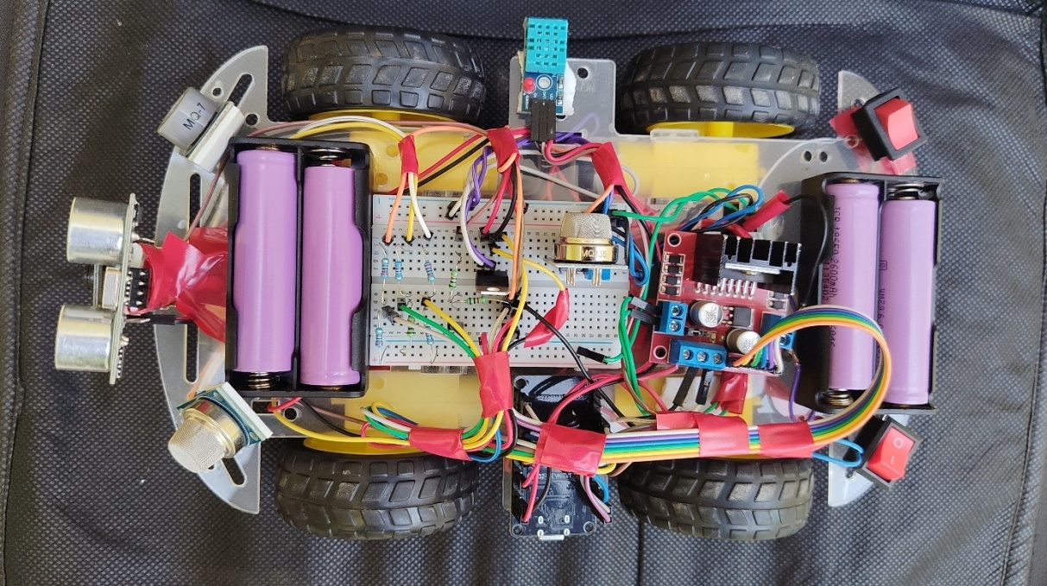
Figure: 5.1. Hardware of the Mine Environment Monitoring Rover
5.2 OUTPUT RESULTS: WAVEFORMS (GRAPHS)
The ThingsBoard dashboard plots the air quality (MQ-135), methane (MQ-4) and carbon monoxide (MQ-7) levels, the temperature and humidity history, and the combined mine gas concentration trends as graphs, as shown in Figure 5.2. In the gas graphs the level rises sharply when a gas source is brought near the sensor and then falls back slowly as the gas disperses and the sensor recovers.
These waveforms show the sensors responding to changes in the air, and they also show the typical behaviour of metal-oxide sensors, which react quickly when gas arrives but take longer to return to their clean-air level. The graphs of temperature and humidity change in steps, because the DHT11 reports its values at a low resolution.
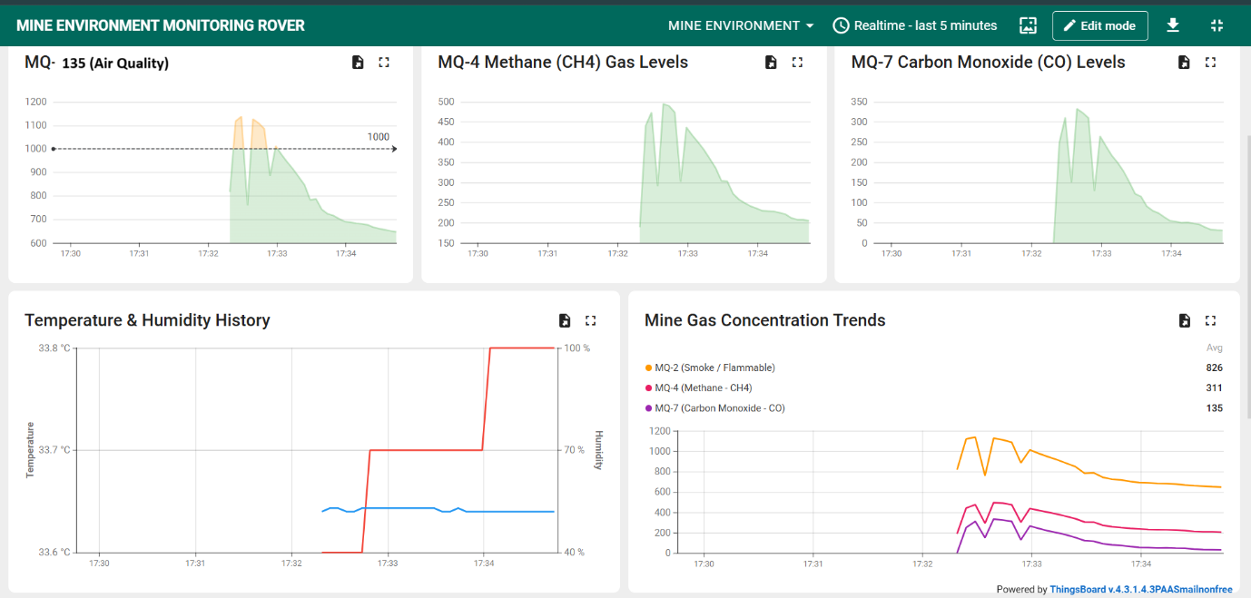
Figure: 5.2. Dashboard graphs of gas levels, temperature and humidity
5.3 DIGITAL OUTPUT
The dashboard also shows the latest readings in digital form: the ambient temperature, the humidity and the values of the gas sensors, each marked SAFE while it stays within its limit (Figure 5.3). This view lets the operator see the present condition of the mine environment at a glance, without reading the graphs.
A telemetry log of the readings sent by the rover is shown in Figure 5.4, together with the trend graphs. Each row of the log gives the time and the values of the sensors, so that the history of the rover’s run can be reviewed afterwards.
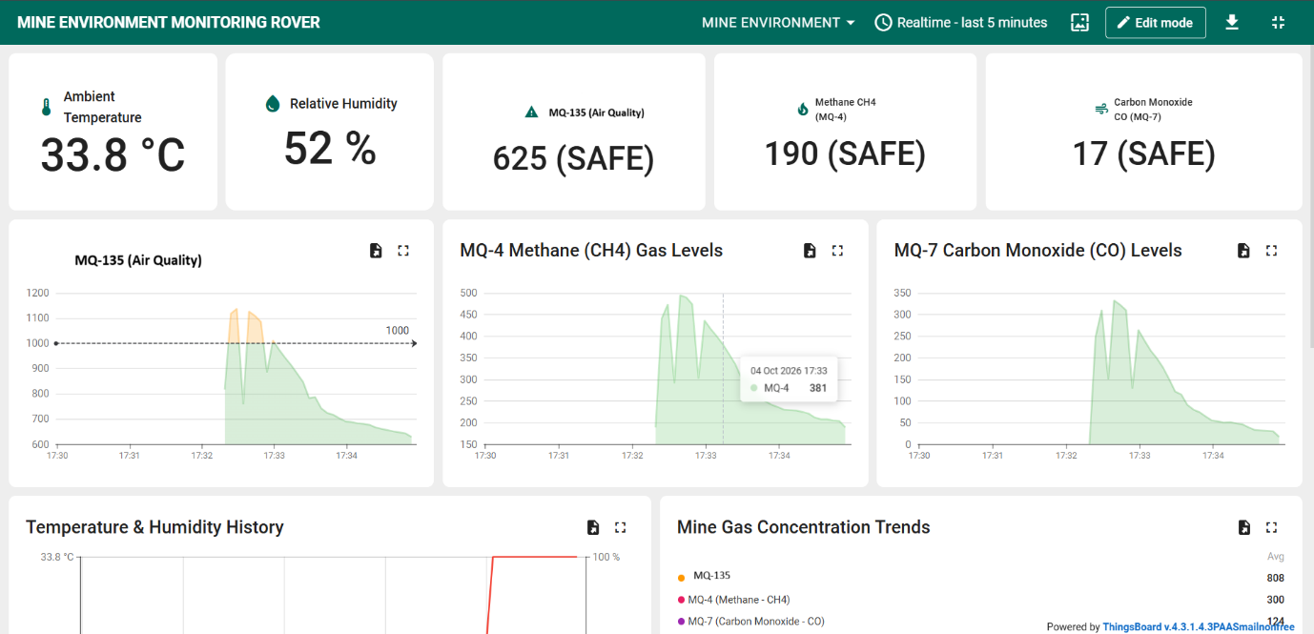
Figure: 5.3. Dashboard digital output showing live readings
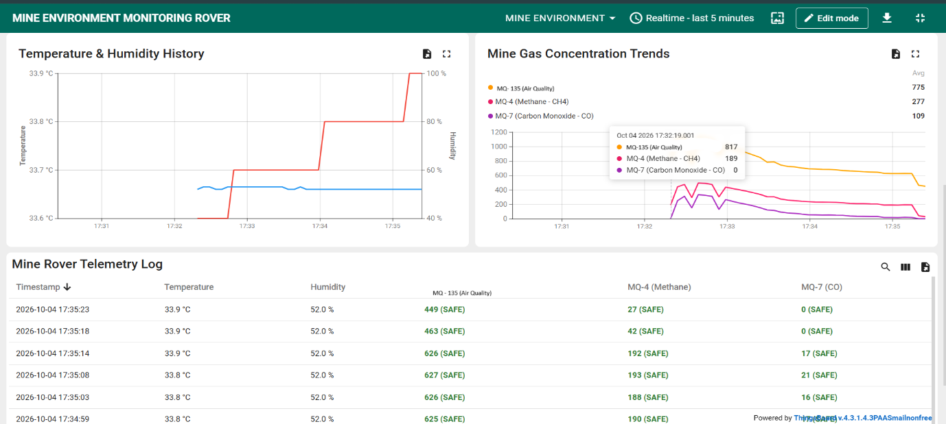
Figure: 5.4. Dashboard trends and mine rover telemetry log
5.4 TEST CASES AND EXPECTED RESULTS
The behaviour of the rover under the different test conditions is summarized in Table 5.1.
Table 5.1: Test cases and expected results
Test | Expected result
Clean air | Low sensor values, no alarm
Gas near sensor | Value rises, buzzer on, dashboard alert
Obstacle ahead | Rover stops, beeps, turns
Temperature / humidity | Values shown on dashboard
Camera | Live video visible

CHAPTER- 6

CONCLUSIONS
The Mine Environment Monitoring Rover successfully detects air-quality gases (smoke, ammonia, CO₂), methane and carbon monoxide, measures temperature and humidity, avoids obstacles, and shows the path ahead through a camera. Readings and alerts are sent over IoT to a ThingsBoard dashboard, so people can monitor dangerous areas from a safe distance.
The project shows how low-cost embedded systems can improve safety in mines and similar hazardous places. By using the ESP32, a few inexpensive sensors, a standard motor driver and a 4WD chassis, a machine was built that does the first and most dangerous part of the inspection work, which is to enter an unknown area and report its condition. The cost of the parts is small, so the rover can be treated as a disposable tool, and the use of common modules makes it easy to build, repair and extend.
The study of the literature and the results of the testing both show that low-cost metal-oxide sensors, when used with an IoT platform, can give a useful early warning of dangerous gases, even though they do not match certified instruments in accuracy. The rover is therefore best seen as a first-line scout that tells people whether it is safe to proceed, and not as a replacement for the calibrated detectors used in regulated safety procedures.
FUTURE SCOPE
The rover can be improved in many ways. The main directions for future work are given below.
- Longer-range communication, such as LoRa or a mesh network of Wi-Fi repeaters, so that the rover can be used deeper inside mines and tunnels where ordinary Wi-Fi does not reach.
- More accurate sensors, such as calibrated electrochemical or infrared gas sensors, to give gas readings that are closer to certified measurements.
- Remote driving, so that the operator can take over control of the rover from outside and steer it using the live video.
- AI-based hazard detection, to recognise dangerous conditions automatically from the sensor data and the camera images, and to predict hazards before the limits are reached.
- Additional sensors for oxygen, hydrogen sulphide and dust, and a GPS or other positioning method to record where each reading was taken.

APPLICATIONS
The rover can be used wherever a small mobile machine is needed to check a hazardous or hard-to-reach space. Its main applications are:
- Gas and air-quality checks in underground mines and tunnels.
- Inspection of enclosed or unsafe areas before workers or rescue teams enter.
- Methane and carbon monoxide leak detection in industrial areas.
- Remote environmental monitoring (temperature, humidity and air quality).
- Training and educational demonstrations of IoT, robotics and embedded systems.

REFERENCES
[1] A. K. Tripathi, M. Aruna, S. Prasad, J. Pavan, R. Kant and C. K. Choubey, “New Approach for Monitoring the Underground Coal Mines Atmosphere Using IoT Technology,” Instrumentation Mesure Métrologie, vol. 22, no. 1, pp. 29–34, Feb. 2023, doi: 10.18280/i2m.220104.
[2] A. K. Tripathi, M. Mangalpady, N. R. N. V. Rao and S. Ray, “Design and Development of an IoT-Based Gas Monitoring System for Underground Coal Mines,” Lecture Notes in Mechanical Engineering, Springer, 2023, pp. 489–495.
[3] F. Feng, H. Yang and Q. Du, “Intelligent Remote Search and Rescue Vehicle,” in Intelligent Computing Technology and Automation, Z. Hou, Ed., IOS Press, 2024, pp. 105–113, doi: 10.3233/ATDE231178.
[4] L. Sudarshan et al., “Web-based Hazardous Gas Monitoring and Alerting Rover System,” International Research Journal of Engineering and Technology (IRJET), vol. 12, no. 5, 2025.
[5] B. Jo and R. M. A. Khan, “An Internet of Things System for Underground Mine Air Quality Pollutant Prediction Based on Azure Machine Learning,” Sensors, vol. 18, no. 4, p. 930, 2018, doi: 10.3390/s18040930.
[6] P. K. Mishra, S. Kumar, M. Kumar and J. Kumar, “IoT Based Multimode Sensing Platform for Underground Coal Mines,” Wireless Personal Communications, vol. 108, no. 2, pp. 1227–1242, 2019, doi: 10.1007/s11277-019-06466-z.
[7] Y. Wu, M. Chen, K. Wang and G. Fu, “A Dynamic Information Platform for Underground Coal Mine Safety Based on Internet of Things,” Safety Science, vol. 113, pp. 9–18, 2019, doi: 10.1016/j.ssci.2018.11.003.
[8] D. P. Tripathy, S. Parida and L. Khandu, “Safety Risk Assessment and Risk Prediction in Underground Coal Mines Using Machine Learning Techniques,” Journal of The Institution of Engineers (India): Series D, vol. 102, no. 2, pp. 495–504, 2021, doi: 10.1007/s40033-021-00290-1.
[9] A. Salam, “Internet of Things for Sustainable Mining,” in Internet of Things for Sustainable Community Development, Springer, Cham, 2020, doi: 10.1007/978-3-030-35291-2_8.
[10] “Sustainable Smart Helmet for Coal Miners,” E3S Web of Conferences, vol. 430, Art. no. 01099, 2023, doi: 10.1051/e3sconf/202343001099. (The page I found didn’t list the authors, so add them from the DOI link.)

