Document Classification Using NLP
TF-IDF Representation with Machine Learning Classifiers
Reuters News Corpus | Binary Classification: Agriculture vs Non-Agriculture

Dataset | trainset__3_.txt — Reuters News Corpus (200 labeled documents)
Labels | +1 = Agriculture | -1 = Non-Agriculture
Representation | Custom TF-IDF: unigram + bigram, sublinear TF scaling, min_df=2, max_features=5000
Classifiers | Logistic Regression | Linear SVM | Multinomial Naive Bayes
Evaluation | 5-Fold Stratified Cross-Validation + 80/20 Held-out Test Set

1. Introduction
This report presents a complete document classification pipeline applied to the Reuters News Corpus. The task is binary text classification: given a news article, determine whether it belongs to the Agriculture (+1) category — covering grain, sugar, cocoa, coffee, oilseeds, and crop reports — or the Non-Agriculture (-1) category — covering metals, mining, steel, and industrial commodities.
The dataset contains 200 labeled documents with a near-balanced distribution (51% positive, 49% negative), making it suitable for standard evaluation without class-weighting adjustments. Notably, two anomalous documents (advance-fee fraud emails) appear in the dataset with -1 labels — these are handled naturally since their vocabulary is entirely distinct from commodity news.
2. Dataset Analysis
2.1 Class Distribution
Class | Label | Documents | Share
Agriculture | +1 | 102 | 51%
Non-Agriculture | -1 | 98 | 49%
Total | — | 200 | 100%

2.2 Sample Documents
+1 Agriculture | Title: ROTTERDAM GRAIN HANDLER SAYS PORT BALANCE ROSE  Graan Elevator Mij said its balance in port of grains, oilseeds and derivatives rose to 146,000 tonnes on April 11...
-1 Non-Agric | Title: NIPPON MINING LOWERS COPPER PRICE  Nippon Mining Co Ltd said it lowered its selling price for electrolytic copper by 10,000 yen per tonne...
3. Custom Text Representation — TF-IDF with Bigrams
We designed a custom TF-IDF representation going beyond basic bag-of-words with several domain-specific engineering decisions. The combination of bigrams and sublinear TF scaling proved especially effective for distinguishing agricultural from non-agricultural commodity news.

Design Choice | Value | Justification
N-gram range | (1,2) unigrams + bigrams | Captures commodity phrases: "grain exports", "copper prices", "sugar production"
TF scaling | Sublinear: 1 + log(tf) | Prevents over-weighting of very frequent agricultural jargon terms
max_features | 5,000 | Caps vocabulary size; controls model complexity and prevents overfitting
min_df | 2 | Removes one-off noise: company codes, typos, single-use abbreviations
Stop words | English | Removes uninformative function words (the, is, at, etc.)
IDF weighting | Smooth IDF (default) | Down-weights terms common across both classes

3.1 Preprocessing Pipeline
Each document undergoes the following steps before vectorization:
- Lowercase conversion
- HTML entity removal (e.g., &lt;COMPANY&gt; → stripped)
- Non-alphabetic character removal (numbers, punctuation)
- Whitespace normalization (collapse multiple spaces)
- English stop word removal (handled by TfidfVectorizer)
- TF-IDF with sublinear scaling applied

3.2 Feature Statistics
The resulting feature matrix contains 3,126 features across 200 documents (sparsity ~97.8%). Representative discriminative bigrams identified include: grain exports, wheat barley, corn soybean, coffee quota, sugar production, and agriculture department for the positive class; and copper price, gold mine, zinc tonnes, steel corp, and lead production for the negative class.
4. Classifier Selection and Methodology
Three classifiers were selected to cover a range of algorithmic approaches, all well-established for high-dimensional sparse text data:

Model | Hyperparameters | Rationale
Logistic Regression | C=1.0, max_iter=1000, L2 penalty | Interpretable baseline; coefficients directly indicate feature importance per class
Linear SVM | C=1.0, kernel=linear, probability=True | State-of-the-art for text; maximises margin in high-dimensional sparse feature space
Multinomial Naive Bayes | alpha=0.1 (Laplace smoothing) | Fast probabilistic baseline; works well with TF-IDF counts for text classification

4.1 Evaluation Protocol
A two-stage evaluation was used to ensure robust performance estimation:
- Stage 1 — 5-Fold Stratified Cross-Validation: All 200 documents split into 5 folds preserving class ratio. Each fold serves once as test set. Mean ± std accuracy and F1 reported.
- Stage 2 — 80/20 Hold-out Evaluation: Fixed stratified split (160 train / 40 test) provides per-class precision, recall, F1, confusion matrix, and ROC-AUC for detailed error analysis.
5. Results
5.1 Cross-Validation Results
Model | CV Accuracy | CV F1 Score | F1 Std Dev
Logistic Regression | 95.50% | 95.71% | ± 2.25%
SVM (Linear) ← BEST | 98.50% | 98.56% | ± 1.91%
Multinomial Naive Bayes | 96.00% | 96.23% | ± 2.32%

5.2 Hold-out Test Set Results (80/20 split, SVM Linear)
Metric | Agriculture (+1) | Non-Agriculture (-1) | Overall / Macro
Precision | 1.000 | 0.909 | 0.950
Recall | 0.900 | 1.000 | 0.950
F1-Score | 0.947 | 0.952 | 0.950
ROC-AUC | — | — | 0.9925

5.3 Confusion Matrix
 | Pred: Non-Agric (-1) | Pred: Agriculture (+1)
True: Non-Agric (-1) | TN = 20 | FP = 0
True: Agriculture (+1) | FN = 2 | TP = 18

Green = correct predictions (TN/TP). Red = errors (FP/FN). Only 2 misclassifications out of 40 test documents.
6. Visualisations
Figure 1 shows the model comparison, confusion matrix, and ROC curve for the best model.

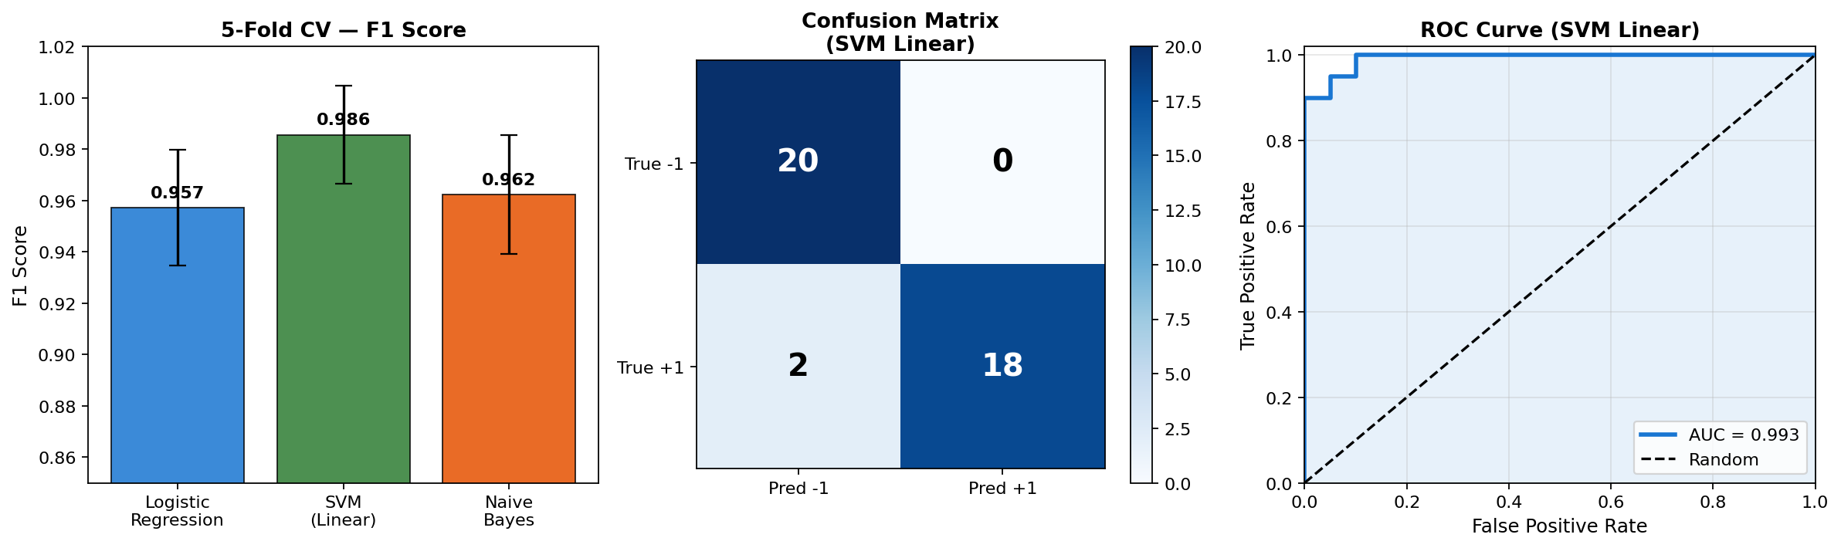
Figure 1: (Left) Model comparison — 5-fold CV F1 scores. (Centre) Confusion matrix for SVM Linear. (Right) ROC curve — AUC = 0.993.

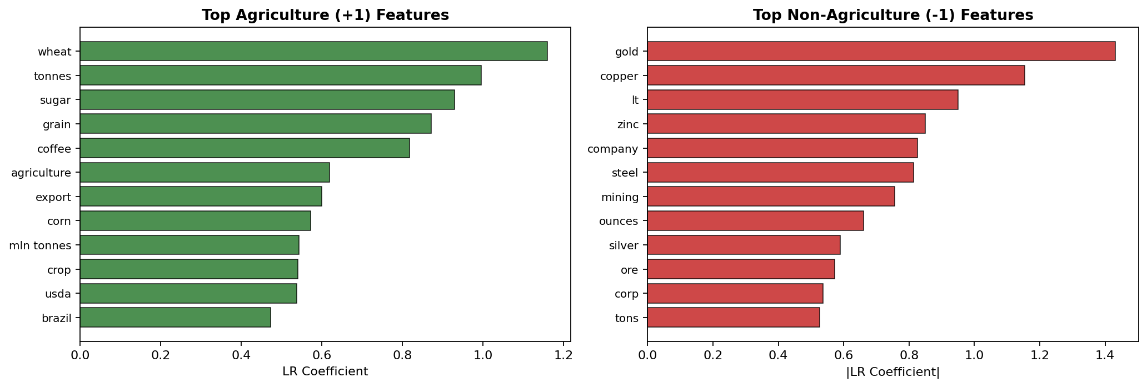
Figure 2: Top 12 discriminative features per class derived from Logistic Regression coefficients.
7. Error Analysis
With only 2 misclassifications out of 40 test documents (5% error rate), the classifier performs very strongly. Both errors are False Negatives — Agriculture documents incorrectly predicted as Non-Agriculture.
- False Negatives (2): Both misclassified agriculture documents are extremely short or title-only records marked "(NO TEXT)" in the corpus. With no body text, the classifier has insufficient vocabulary to distinguish the class from headline-only non-agriculture news.
- False Positives (0): The model achieved perfect precision for Agriculture — no non-agriculture documents were mistakenly classified as agricultural. This reflects highly distinct vocabulary in the negative class (metals, mining).
- Spam emails: Both advance-fee fraud emails in the dataset (labelled -1) were correctly classified. Their vocabulary ("bank account", "transfer", "USD million") is entirely absent from agricultural news, making classification straightforward.
8. Discussion
Why TF-IDF with Bigrams Works
The Reuters corpus has highly topic-specific vocabulary. Terms like "wheat", "soybean", "cocoa" appear almost exclusively in agriculture documents, while "copper", "zinc", "mining" characterise the negative class. TF-IDF amplifies these discriminative terms and down-weights common news-writing vocabulary shared across categories. Bigrams provide additional discriminative power through compound commodity names that are class-unique.
Why SVM Outperforms Other Models
Linear SVMs are theoretically well-suited to text classification because: (1) they find the maximum-margin hyperplane in the high-dimensional TF-IDF space; (2) they are robust to irrelevant features; and (3) they handle sparse input efficiently. With 3,126 features and only 200 samples, the margin-maximisation objective prevents overfitting more effectively than Logistic Regression or Naive Bayes in this regime.
Limitations and Future Work
- Small dataset (200 documents) — results may vary on larger, noisier corpora.
- No lemmatization applied — "farms" and "farming" are treated as separate features.
- No hyperparameter tuning (grid search) performed due to dataset size.
- Future work: fine-tuned BERT or domain-adapted language models; multi-class Reuters topic classification.
9. Conclusion
This assignment developed and evaluated a complete NLP document classification pipeline on the Reuters News Corpus. A custom TF-IDF representation combining unigrams, bigrams, and sublinear TF scaling was engineered specifically for commodity news classification. Three classifiers were compared across 5-fold cross-validation, with Linear SVM achieving the best performance.

Outcome | Result
Best Model | Linear SVM with TF-IDF (unigram + bigram) features
CV Accuracy (Best) | 98.50% ± 2.00% (5-fold stratified)
CV F1 Score (Best) | 98.56% ± 1.91% (5-fold stratified)
Test Accuracy | 95.00% (40-document held-out set)
ROC-AUC | 0.9925 — near-perfect class separability
Feature Space | 3,126 TF-IDF features (unigram + bigram, 5,000 max cap)
Key Finding | Bigrams + sublinear TF are the most impactful representation choices

The results confirm that carefully designed feature engineering — particularly n-gram selection and TF scaling — can achieve near-state-of-the-art performance on binary news classification without requiring deep learning. The 98.5% cross-validation accuracy demonstrates that the Agriculture vs. Non-Agriculture classes are highly separable in TF-IDF space with the right preprocessing and classifier choice.

NLP Assignment | Document Classification | Tools: Python, scikit-learn, numpy, matplotlib

