CSA10 — SOFTWARE ENGINEERING
Assignment Report
SmartCare — A Scalable Healthcare Appointment
and Patient Service Platform
Designed, built, containerised, tested and deployed through a complete software engineering life cycle
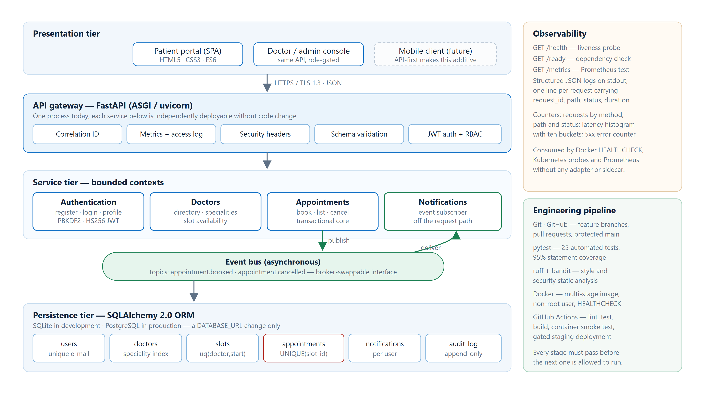
Figure 1 — Layered architecture of the delivered system. Solid arrows are synchronous request paths; green arrows are asynchronous event delivery.
A. Assignment Information
Field | Details
Department | Computer Science and Engineering
Programme | B.Tech — Computer Science and Engineering
Course Code & Course Name | CSA10 — Software Engineering
Academic Year / Batch | 2023–2027
Faculty Name | [Faculty Name]
Assignment Title | Smart Healthcare Appointment and Patient Service Platform
Team Members | [Student Name 1] — [Register No.] | [Student Name 2] — [Register No.] | [Student Name 3] — [Register No.] | [Student Name 4] — [Register No.]
Date of Issue | [DD-MM-YYYY]
Date of Submission | 02-09-2026
Maximum Marks | 100
Course Outcome(s) | CO1, CO2, CO3, CO4, CO5
Bloom's Taxonomy Level | L3 — Apply, L4 — Analyse, L5 — Evaluate, L6 — Create

Project Evidence — Everything in This Report Is Reproducible
The whole system is public. Every screenshot, number and log line in this report came from running the code below, on our own machines and on GitHub's CI runners. Nothing here is illustrative or mocked up.
Source repository https://github.com/tharuncoder676/SE-assigment
CI/CD pipeline run — all four stages green https://github.com/tharuncoder676/SE-assigment/actions/runs/33625229403
Full run history, including the two runs that failed https://github.com/tharuncoder676/SE-assigment/actions
Commit history https://github.com/tharuncoder676/SE-assigment/commits/main
Screenshots, console transcripts and load-test data https://github.com/tharuncoder676/SE-assigment/tree/main/docs
Table of Contents
Section | Page
1. Problem Statement and Problem Formulation | 3
2. Objectives and Expected Outcomes | 4
3. Requirements, Constraints and Assumptions | 4
4. Application of Software Engineering Concepts | 6
5. Design, Proposed Solution and Methodology | 9
6. Algorithm, Pseudocode and Flowchart | 12
7. Implementation, Source Code and Tools Used | 14
8. Test Cases and Expected / Actual Results | 17
9. Execution Screenshots and Outputs | 19
10. Results and Validation | 28
11. Analysis, Comparison, Trade-offs and Justification | 30
12. Broader Considerations and SDG Relevance | 31
13. Conclusion, Limitations and Possible Improvements | 32
14. Individual Contribution of Group Members | 33
15. References | 33
16. One-Page Individual Reflection | 35
List of Figures and Evidence
Group | Count | What it shows | Section
Design figures | 6 | Architecture, use cases, ER model, sequence, flowchart, CI/CD pipeline | 5, 6, 7
Performance charts | 3 | Throughput, latency percentiles, cost of the security primitives | 10
Application screenshots | 15 | The real UI and OpenAPI docs driven end to end by an automation script | 9
Console transcripts | 10 | pytest, coverage, lint, git, CI, container build, API session, logs, metrics | 9

1. Problem Statement and Problem Formulation
1.1 The industry problem as it was given to us
A multi-specialty healthcare organisation is struggling on several fronts at once. Appointments are delayed, the volume of user requests keeps climbing, the service is not reliably available, the system goes down, and the applications the organisation already owns are difficult to integrate with anything new. What they want is a platform that can manage patient appointments, doctor availability, notifications, service requests and healthcare information, and that will still work when the load doubles.
When we broke this down, we found that the visible complaint (appointments are slow) is not really one problem. It is at least four, and they have different causes and different fixes.
Symptom the organisation reports | What is actually going on underneath
Appointment delays and double bookings | Booking is not treated as a transaction. Two staff members reading the same availability list can both write to it, and nothing at the storage layer stops them.
Rising volume of user requests | Every request is handled synchronously. Slow work such as sending a confirmation sits on the critical path, so throughput collapses long before the hardware does.
Service availability problems and downtime | There is no health signal an orchestrator can act on. A process that is alive but cannot reach its database looks identical to a healthy one.
Difficulty integrating existing applications | The existing systems are UI-first. Their behaviour is only reachable by driving screens, so nothing else can consume it.
1.2 Stakeholders
We listed the stakeholders before writing any requirements, because a requirement with no stakeholder behind it is usually a feature somebody invented. The last column is the one that shaped the design most.
Stakeholder | What they need from the system | Design consequence
Patient | Find the right doctor quickly, see genuinely free slots, book without phoning, get proof it worked | Sub-second search; a booking reference returned in the response body
Doctor | A calendar that reflects reality and is never double booked | Uniqueness enforced in the database, not in application code
Hospital administrator | Operational visibility and control over privileged actions | Role-based access control and an admin statistics endpoint
IT operations | To know the service is healthy before patients tell them it is not | Liveness and readiness probes, Prometheus metrics, structured logs
Compliance officer | An account of who touched patient data and when | An append-only audit trail written inside the same transaction
Development team (us) | To change the system without breaking it | An automated test suite and a pipeline that blocks a bad commit
1.3 The problem, stated precisely
Design and build a healthcare appointment platform in which a slot can be booked exactly once under concurrent load, in which slow side effects never delay the patient's response, whose behaviour is reachable through a documented API rather than only through screens, and which reports its own health well enough for an orchestrator to manage it automatically. Everything else in this report follows from that sentence.
1.4 Assumptions
- Consultations are fixed-length. We used 30 minutes, configurable through SLOT_MINUTES.
- A patient books on their own behalf. Booking for a dependant is out of scope for this iteration.
- Doctor calendars are published ahead of time by the hospital; the system does not negotiate a doctor's working hours.
- Notification delivery may be delayed by seconds. It must never be lost, and it must never delay the booking response.
- TLS termination, DNS and backups are provided by the hosting platform and are not re-implemented here.
- Payment and clinical records are separate systems. We expose the integration seam but do not build them.
1.5 Expected outcomes
We wrote these down at the start so that at the end we could check honestly whether we had met them. Section 10 does exactly that, against measured numbers.
- A patient can go from landing page to confirmed booking without contacting the hospital.
- Two people racing for the same slot produce one confirmation and one clear refusal — never two bookings.
- Median read latency stays in single-digit milliseconds at realistic concurrency.
- Every endpoint is documented automatically, so a mobile client could be added without touching the backend.
- A container image builds, starts and answers a health probe without manual intervention.
2. Objectives and Expected Outcomes
Our first draft of these objectives said things like "the system should be fast" and "the system should be secure". Those are not objectives, they are hopes, because nothing can prove them false. We rewrote each one until it named a number and a way of measuring it. The right-hand column is what we actually observed, reported fully in Section 10.
# | Objective (measurable) | How we verified it | Result
O1 | Serve doctor-directory reads with a median latency under 50 ms at 25 concurrent users | Closed-loop load test, 8 s per scenario, latency of every request recorded | 50.15 ms p50 — met
O2 | Make double booking impossible, not merely unlikely | 10 threads racing for one slot in an automated test (TC-16) | 1 × 201, 9 × 409 — met
O3 | Keep notification work off the booking response path | Timestamped structured logs comparing response and notification write | Notification logged after the 201 — met
O4 | Publish a machine-readable contract for every endpoint | Assert the OpenAPI document lists each route (TC-25) | /openapi.json complete — met
O5 | Store no password in a recoverable form | Inspect the stored value and verify the algorithm and salt (TC-05, TC-06) | PBKDF2-SHA256, 600 000 rounds — met
O6 | Reach at least 90% statement coverage of application code | coverage.py restricted to the app package | 95% (605 statements) — met
O7 | Produce a runnable container image without manual steps | GitHub Actions builds the image and probes /health inside it | Image healthy in 31 s — met
O8 | Block a defective commit before it reaches the main branch | Four-stage pipeline; each stage gates the next | Two real commits blocked — met
The last row is worth a sentence, because it is the objective we least expected to be able to evidence. Two of our own commits were genuinely rejected by our own pipeline while we were building this: one for lint failures, one for a broken deployment script. Both are visible in the run history linked in Section 9. We left them in the history rather than rewriting it, because a pipeline that has never failed has never been shown to work.
3. Requirements, Constraints and Assumptions
3.1 Functional requirements
ID | Requirement | Priority | Implemented in | Verified by
FR-01 | A patient can create an account with a validated e-mail and a password of at least 8 characters | Must | routers/auth.py | TC-01, TC-03
FR-02 | Duplicate registration on the same e-mail is refused | Must | routers/auth.py | TC-02
FR-03 | A registered patient can exchange credentials for a signed, expiring token | Must | security.py | TC-04
FR-04 | Repeated failed logins from one address are throttled | Should | ratelimit.py | TC-24
FR-05 | Anyone can browse the doctor directory and filter it by speciality or name | Must | routers/doctors.py | TC-10
FR-06 | Only future, unbooked slots are offered for a given doctor | Must | routers/doctors.py | TC-11
FR-07 | An authenticated patient can book a free slot and receives a booking reference | Must | routers/appointments.py | TC-14
FR-08 | A slot that is already taken cannot be booked again, under any interleaving | Must | routers/appointments.py | TC-15, TC-16
FR-09 | A patient can list their own appointments and no one else's | Must | routers/appointments.py | TC-14
FR-10 | Cancelling an appointment returns the slot to the available pool | Must | routers/appointments.py | TC-17
FR-11 | A confirmation notification is generated for every booking and cancellation | Must | routers/notifications.py | TC-19
FR-12 | Administrative statistics are reachable only by the admin role | Should | deps.py, routers/ops.py | TC-09
FR-13 | Every authentication and appointment action is written to an append-only audit trail | Must | models.py | Inspected in Section 9
3.2 Non-functional requirements
These are the requirements that decided the architecture. NFR-01 and NFR-02 in particular are the reason the system is event-driven rather than a straightforward three-tier application.
ID | Quality attribute | Target we committed to | Measured outcome
NFR-01 | Performance | Read endpoints under 500 ms at the 95th percentile, 25 concurrent users | 68.33 ms p95 — 7× margin
NFR-02 | Responsiveness | Booking must not wait for notification delivery | Booking 34.95 ms; notification written afterwards
NFR-03 | Scalability | Throughput must rise with concurrency until CPU-bound | 318 → 462 rps; saturation identified at 5 workers
NFR-04 | Reliability | Zero failed requests across the whole load test | 36 057 requests, 100% success
NFR-05 | Data integrity | One slot, one appointment, always | Enforced by UNIQUE(slot_id); proven by TC-16
NFR-06 | Security | No plaintext passwords, signed sessions, baseline headers | PBKDF2 600k rounds; HS256; headers on every response
NFR-07 | Maintainability | Static analysis clean; coverage above 90% | ruff and bandit clean; 95% coverage
NFR-08 | Operability | Liveness, readiness and metrics endpoints | /health, /ready, /metrics live
NFR-09 | Portability | Runs identically on a laptop and on a CI runner | Same image healthy in both environments
NFR-10 | Auditability | Every privileged action attributable to a principal | audit_log written inside the booking transaction
3.3 Constraints
Type | Constraint | How we worked within it
Technical | No managed cloud services were available to us | SQLite behind the ORM and an in-process event bus, both chosen so the interface matches the production replacement
Cost | Zero budget | Entirely open-source stack; GitHub Actions free tier; no paid infrastructure at any point
Time | One assignment cycle across a small team | Scope fixed to the booking core; payments and clinical records deliberately excluded and named as such
Skill | First serious use of containers and CI for most of the team | Pipeline built early and kept simple so that failures were readable
Privacy | Patient data is sensitive even in a prototype | No real patient data used anywhere; seeded doctors and patients are fictional
Environment | Docker Desktop would not start on one team machine | Container build and smoke test run on the CI runner instead, which is stronger evidence anyway
An honest note on that last row. We could not get the Docker daemon to start on the Windows machine used for the final capture session, so the container evidence in Section 9 comes from the GitHub Actions runner rather than a local terminal. We think this is actually the better artefact: the image is built from a clean checkout, on a machine none of us configured, and is then started and probed automatically.
4. Application of Software Engineering Concepts
This section connects the syllabus to decisions we actually made. We have tried to avoid listing concepts we did not use.
4.1 Process model: Scrum, in short iterations
We used Scrum with short sprints because the requirements were clear enough to plan but our understanding of the technology was not. A waterfall plan would have committed us to an architecture before we knew, for example, how expensive PBKDF2 actually is. Working in increments meant we found that out in Sprint 2 and could still act on it.
Sprint | Goal | Delivered increment | What we learned
1 | Walking skeleton | Domain model, database schema, doctor directory, seeded calendar | Putting the uniqueness rule in the schema early made the booking code simpler later
2 | Identity | Registration, login, JWT issue and verification, role guard | PBKDF2 at 600 000 rounds costs ~252 ms. That is intentional, but it must never sit on a read path
3 | The booking core | Transactional booking, cancellation, the concurrency test | Our first test passed for the wrong reason — see Section 8.2
4 | Asynchrony | Event bus, notification subscriber, background delivery | Moving work off the request path is a design decision, not an optimisation
5 | Operability and delivery | Metrics, probes, structured logs, Docker image, CI/CD pipeline | The pipeline caught two real defects in our own code within the first hour
4.2 Requirements engineering
Requirements were elicited from the problem statement, written as the numbered FR/NFR tables in Section 3, and then traced forward. Every functional requirement names the module that implements it and the test that proves it; every non-functional requirement names the measurement that checks it. That traceability is what let us answer "is it done?" with evidence rather than opinion.
4.3 Feasibility analysis
Dimension | Assessment | Evidence
Technical | Feasible | Delivered and running; 25 automated tests pass; container builds unattended
Economic | Feasible | Every tool used is free and open source; total infrastructure spend was zero
Operational | Feasible | Patient workflow needs no training; administrators keep an audit trail by default
Schedule | Feasible with the scope we fixed | Five short sprints; payments and clinical records excluded up front
Legal / ethical | Feasible with care | No real patient data; audit trail and access control designed in from the start
4.4 Architectural decisions and why we made them
Four decisions determined most of the system. We record them here in the form we used at the time, because the alternatives we rejected are as informative as the options we chose. Section 11 compares them in more depth.
Decision | What we chose | What we rejected, and why
Service decomposition | Modular monolith: four bounded contexts (auth, doctors, appointments, notifications) in one deployable process | True microservices. With four modules and a team of our size, we would have paid for network hops, distributed transactions and four pipelines, and bought nothing. The module boundaries are real, so the split remains available later.
Interface style | API-first. Every capability is an HTTP endpoint described by an auto-generated OpenAPI document | A server-rendered application. It would have been quicker, but it would have recreated exactly the integration problem the organisation complained about.
Notification delivery | Event-driven. Booking publishes appointment.booked and returns immediately | A direct call from the booking service. That puts an unrelated system's latency, and its outages, on the patient's critical path.
Concurrency control | Pessimistic row lock plus a UNIQUE constraint on appointments.slot_id | Application-level checking. A check-then-act in application code is a race by construction; the database is the only place the rule can actually be enforced.
4.5 Version control, containerisation and DevOps
Work is tracked in Git and hosted on GitHub with the main branch protected by the pipeline. The image is a two-stage Docker build: dependencies are compiled in a builder stage that is then discarded, and the runtime stage runs as an unprivileged user (uid 10001) with a HEALTHCHECK baked in. The pipeline runs static analysis, then tests, then builds and smoke-tests the image, then deploys — each stage gated on the one before it. Sections 7 and 9 show the Dockerfile and the real build log.
4.6 Testing strategy
We followed the test pyramid, but deliberately weighted it towards integration tests that exercise a real HTTP request against a real database. Unit-testing our booking logic in isolation would have missed the only bug in it that mattered, because that bug lived in the interaction between two sessions and a transaction.
Layer | Count | What it covers | Example
Unit | 6 | Pure logic with no I/O | TC-06 proves two identical passwords hash differently because of the per-user salt
Integration | 17 | A real HTTP request through the full stack to a real database | TC-14 books a slot and reads it back through the API
Concurrency | 1 | Ten OS threads racing for a single row | TC-16 asserts exactly one 201 and nine 409s
Contract | 1 | The published OpenAPI document | TC-25 asserts every route appears in /openapi.json
4.7 Maintenance, technical debt and sustainability
We keep a short, explicit debt register rather than pretending there is none. SQLite is the largest item: it is correct for our tests but serialises writers, so it is a production ceiling. The in-process event bus is the second: it loses undelivered events if the process dies. Both were chosen knowingly, both sit behind an interface that matches their eventual replacement (DATABASE_URL for the database, a publish/subscribe API for the bus), and both are listed in Section 13 with the migration path. On sustainability, the measurable choice we made was to keep the runtime image dependency-free where we reasonably could: the metrics registry and the JWT implementation are standard-library only, which keeps the image small and the number of packages we must keep patched low.

5. Design, Proposed Solution and Methodology
5.1 Architecture
Figure 1 on the title page shows the whole system. Four bounded contexts sit behind one FastAPI process. Requests pass through a middleware chain that assigns a correlation ID, times the request, records metrics, sets security headers, validates the body against a schema and verifies the bearer token, in that order. The booking service publishes to an event bus rather than calling the notification service, and the persistence tier is reached only through the ORM, which is what makes the SQLite-to-PostgreSQL move a configuration change.
The single most consequential line in the design is not in any diagram: it is the UNIQUE constraint on appointments.slot_id. Everything else about booking correctness follows from putting that rule where the database can enforce it instead of where application code has to remember to check it.
5.2 Use case model
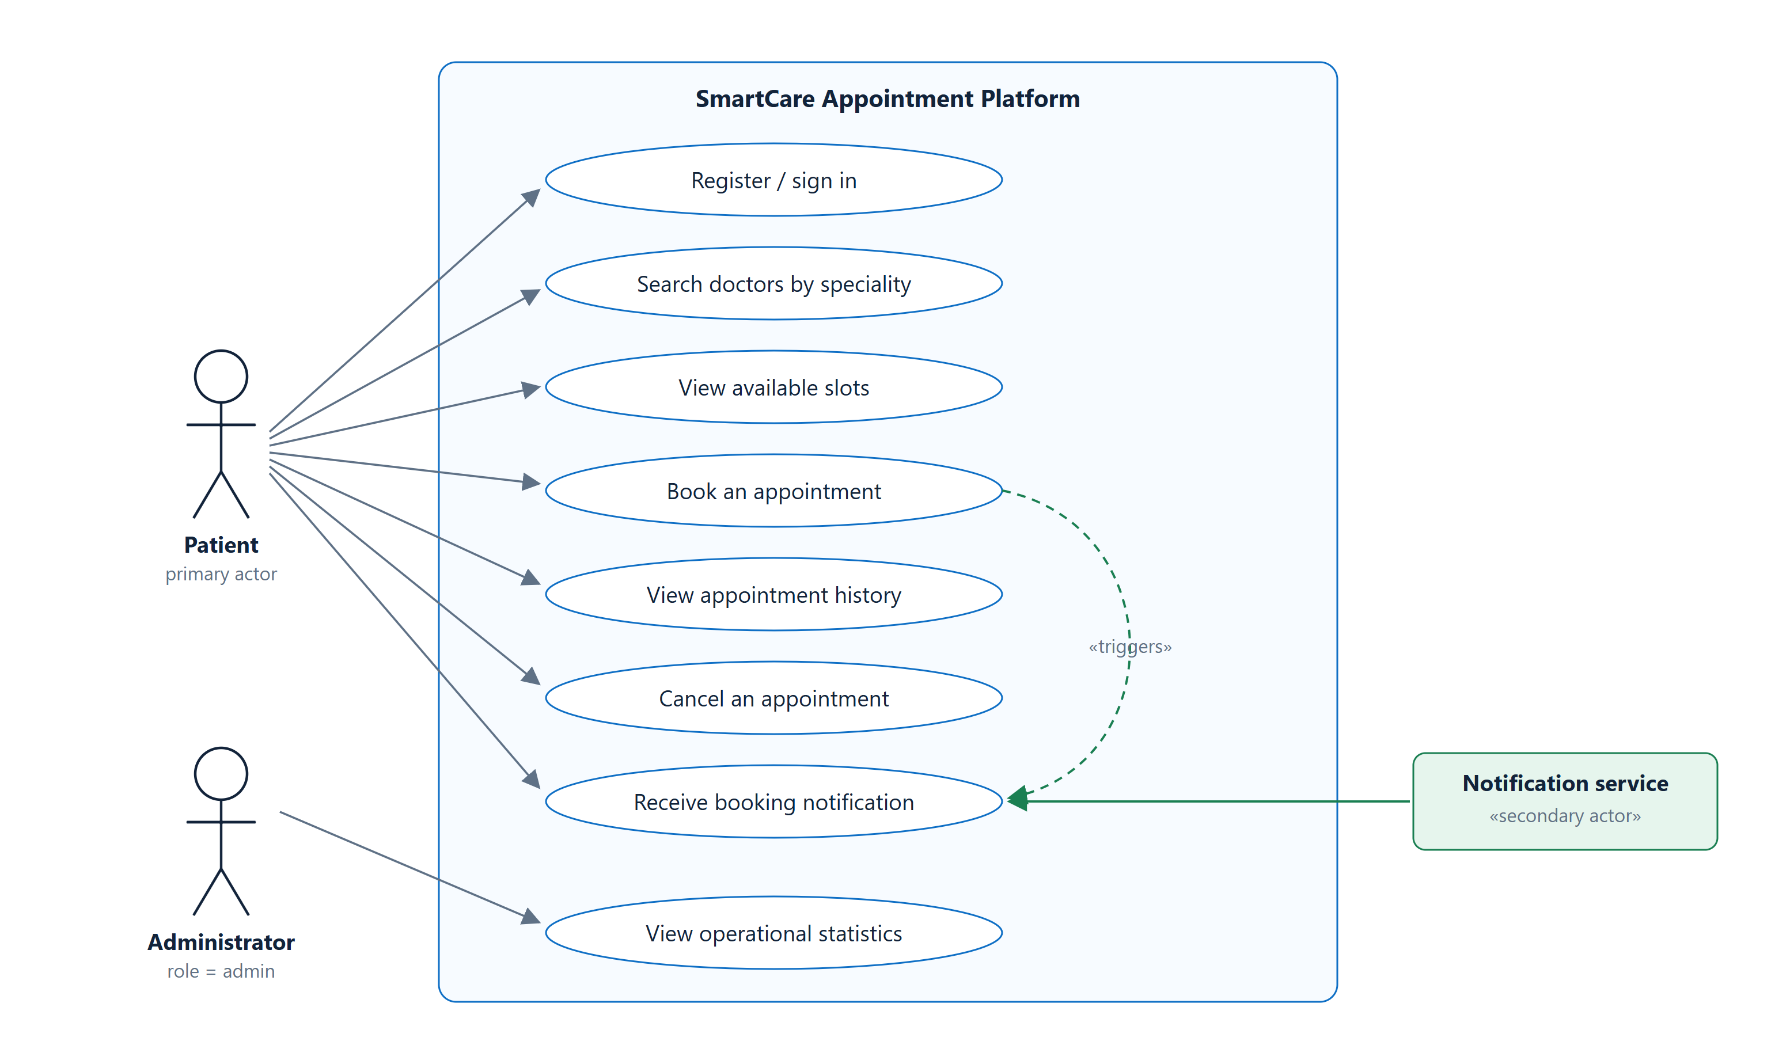
Figure 2 — Use case model. The patient is the primary actor. The dashed «triggers» relationship records that booking raises an event which the notification service, a secondary actor, consumes asynchronously.
5.3 Database design
Six tables. Three of them carry a constraint that is doing real work rather than just describing data: users.email is unique so an identity cannot be duplicated, slots(doctor_id, start_at) is unique so a calendar cannot contain the same moment twice, and appointments.slot_id is unique so a slot cannot be sold twice.
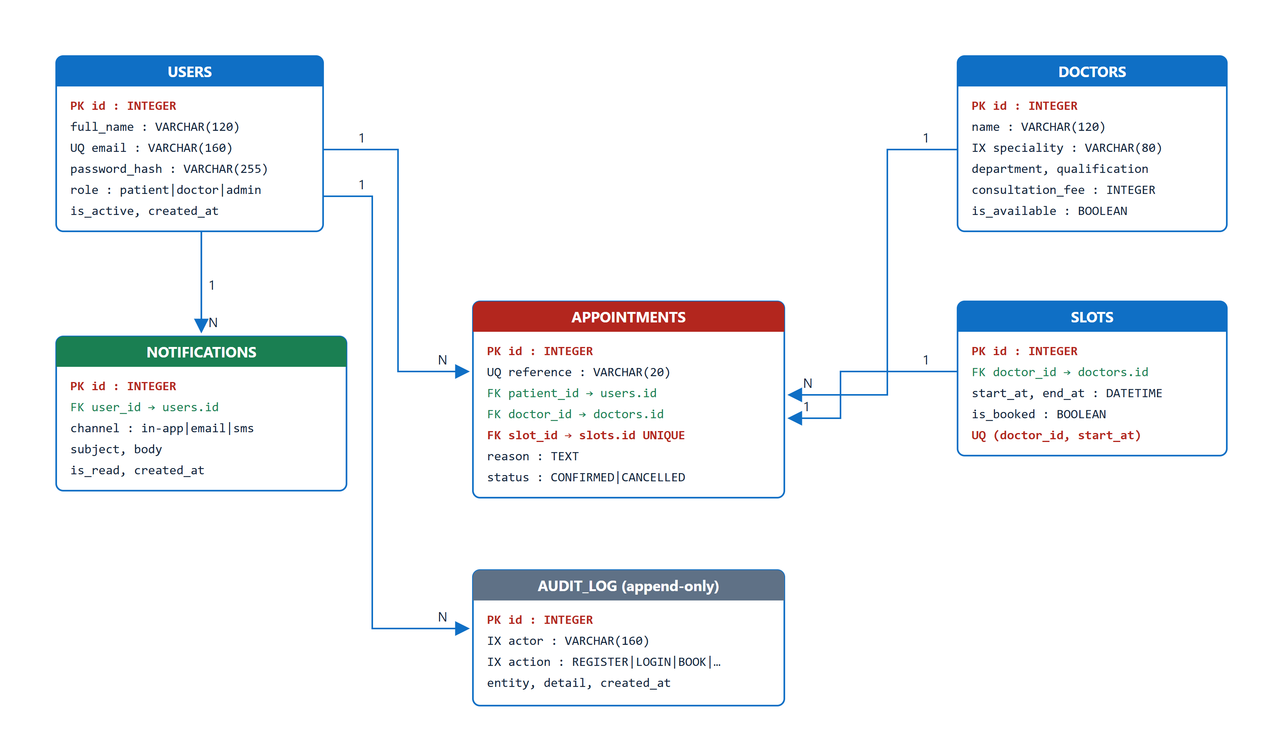
Figure 3 — Entity relationship diagram. The UNIQUE constraint on appointments.slot_id (shown in red) is the mechanism that makes double booking impossible.
5.4 API design
The API is versioned under /api/v1 and described by an OpenAPI document that FastAPI generates from the Pydantic schemas, so the documentation cannot drift away from the implementation. Status codes are chosen to be meaningful to a client: 409 means "someone else got there first, choose another slot", which is actionable, whereas a generic 400 would not be.
Method & path | Auth | Purpose | Success | Failure modes
POST /api/v1/auth/register | — | Create a patient account and issue a token | 201 | 409 duplicate, 422 invalid
POST /api/v1/auth/login | — | Exchange credentials for a JWT | 200 | 401 bad credentials, 429 throttled
GET /api/v1/auth/me | Bearer | Profile of the calling principal | 200 | 401 missing or invalid token
GET /api/v1/doctors | — | Directory, filtered by speciality or name | 200 | —
GET /api/v1/doctors/{id}/slots | — | Future unbooked slots for one doctor | 200 | 404 unknown doctor
POST /api/v1/appointments | Bearer | Book a slot | 201 | 401, 404 unknown slot, 409 taken
GET /api/v1/appointments | Bearer | The caller's own appointment history | 200 | 401
DELETE /api/v1/appointments/{ref} | Bearer | Cancel and release the slot | 200 | 403 not yours, 404, 409 already cancelled
GET /api/v1/notifications | Bearer | Event-generated notices for the caller | 200 | 401
GET /api/v1/admin/stats | Admin | Operational counters | 200 | 401, 403 wrong role
GET /health /ready /metrics | — | Liveness, readiness, Prometheus scrape | 200 | —
5.5 Booking sequence
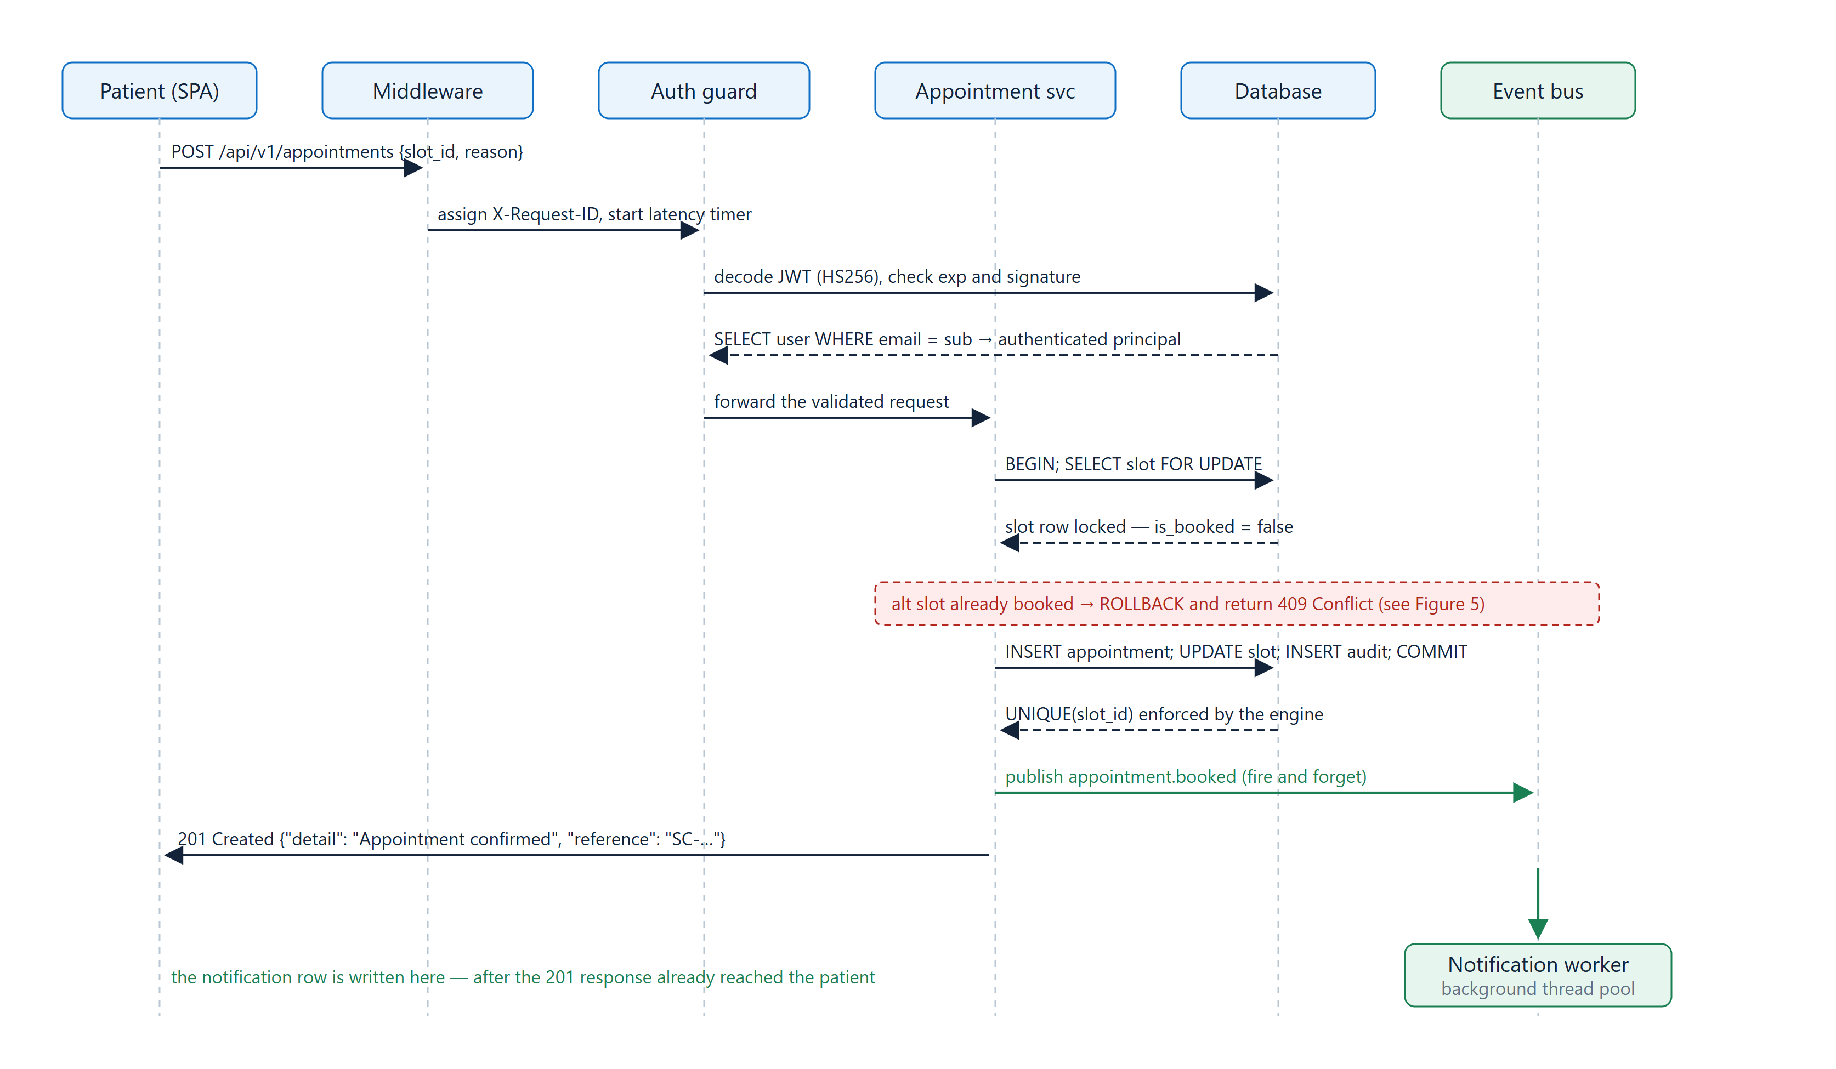
Figure 4 — Sequence of a successful booking. Dashed arrows are returns. The green arrows leave the request path: the patient's 201 response is sent before the notification row is written.
5.6 Security design
Passwords are stored as PBKDF2-HMAC-SHA256 with a 16-byte per-user salt and 600 000 iterations, the figure OWASP currently recommends, and verified with a constant-time comparison. Sessions are stateless HS256 JSON Web Tokens carrying sub, role, iat, exp and iss, which is what allows the API tier to be scaled horizontally without a shared session store. Login is protected by a sliding-window rate limiter, and the login handler verifies a dummy hash when the account does not exist so that response time does not reveal which e-mail addresses are registered. Authorisation is a dependency-injected role guard, and authentication failures are chained with from None so the client is never told whether a token was malformed, forged or merely expired.

6. Algorithm, Pseudocode and Flowchart
6.1 The booking algorithm
This is the only genuinely difficult algorithm in the system, and the difficulty is not arithmetic. It is that two requests can arrive for the same slot at the same instant. The pseudocode below is the design; the flowchart in Figure 5 is the same thing with every failure path made explicit.
ALGORITHM BookAppointment(slot_id, reason, bearer_token)
1 claims <- VerifyJWT(bearer_token) // signature, exp, issuer
2 IF claims is invalid THEN RETURN 401 Unauthorized
3 patient <- LookupUser(claims.sub)
4
5 BEGIN TRANSACTION
6 slot <- SELECT * FROM slots
7 WHERE id = slot_id FOR UPDATE // pessimistic row lock
8 IF slot IS NULL THEN
9 ROLLBACK ; RETURN 404 Not Found
10 IF slot.is_booked THEN
11 ROLLBACK ; RETURN 409 Conflict // fast path for the common case
12
13 reference <- "SC-" + UPPER(RandomHex(4))
14 INSERT INTO appointments (reference, patient_id, doctor_id, slot_id,
15 reason, status) VALUES (..., 'CONFIRMED')
16 UPDATE slots SET is_booked = TRUE WHERE id = slot_id
17 INSERT INTO audit_log (actor, action, entity, detail)
18 TRY
19 COMMIT // UNIQUE(slot_id) is the real guard
20 CATCH IntegrityError
21 ROLLBACK ; RETURN 409 Conflict // lost the race at commit time
22
23 Publish("appointment.booked", {...}) // queued, NOT awaited
24 RETURN 201 Created with reference
Listing 1 — Booking algorithm. Lines 10-11 and 19-21 are two different defences against the same hazard; the second is the one that is actually sufficient.
Lines 10 and 11 look like they solve the concurrency problem, and they do not. They are an optimisation: they let the overwhelmingly common case (the slot is visibly taken) fail cheaply without doing any write work. The guarantee comes from line 19. If two transactions both pass the check at line 10, exactly one of them will succeed at COMMIT, because the database will not allow two rows with the same slot_id. The other receives an IntegrityError and is converted into the same 409 the caller would have got anyway.
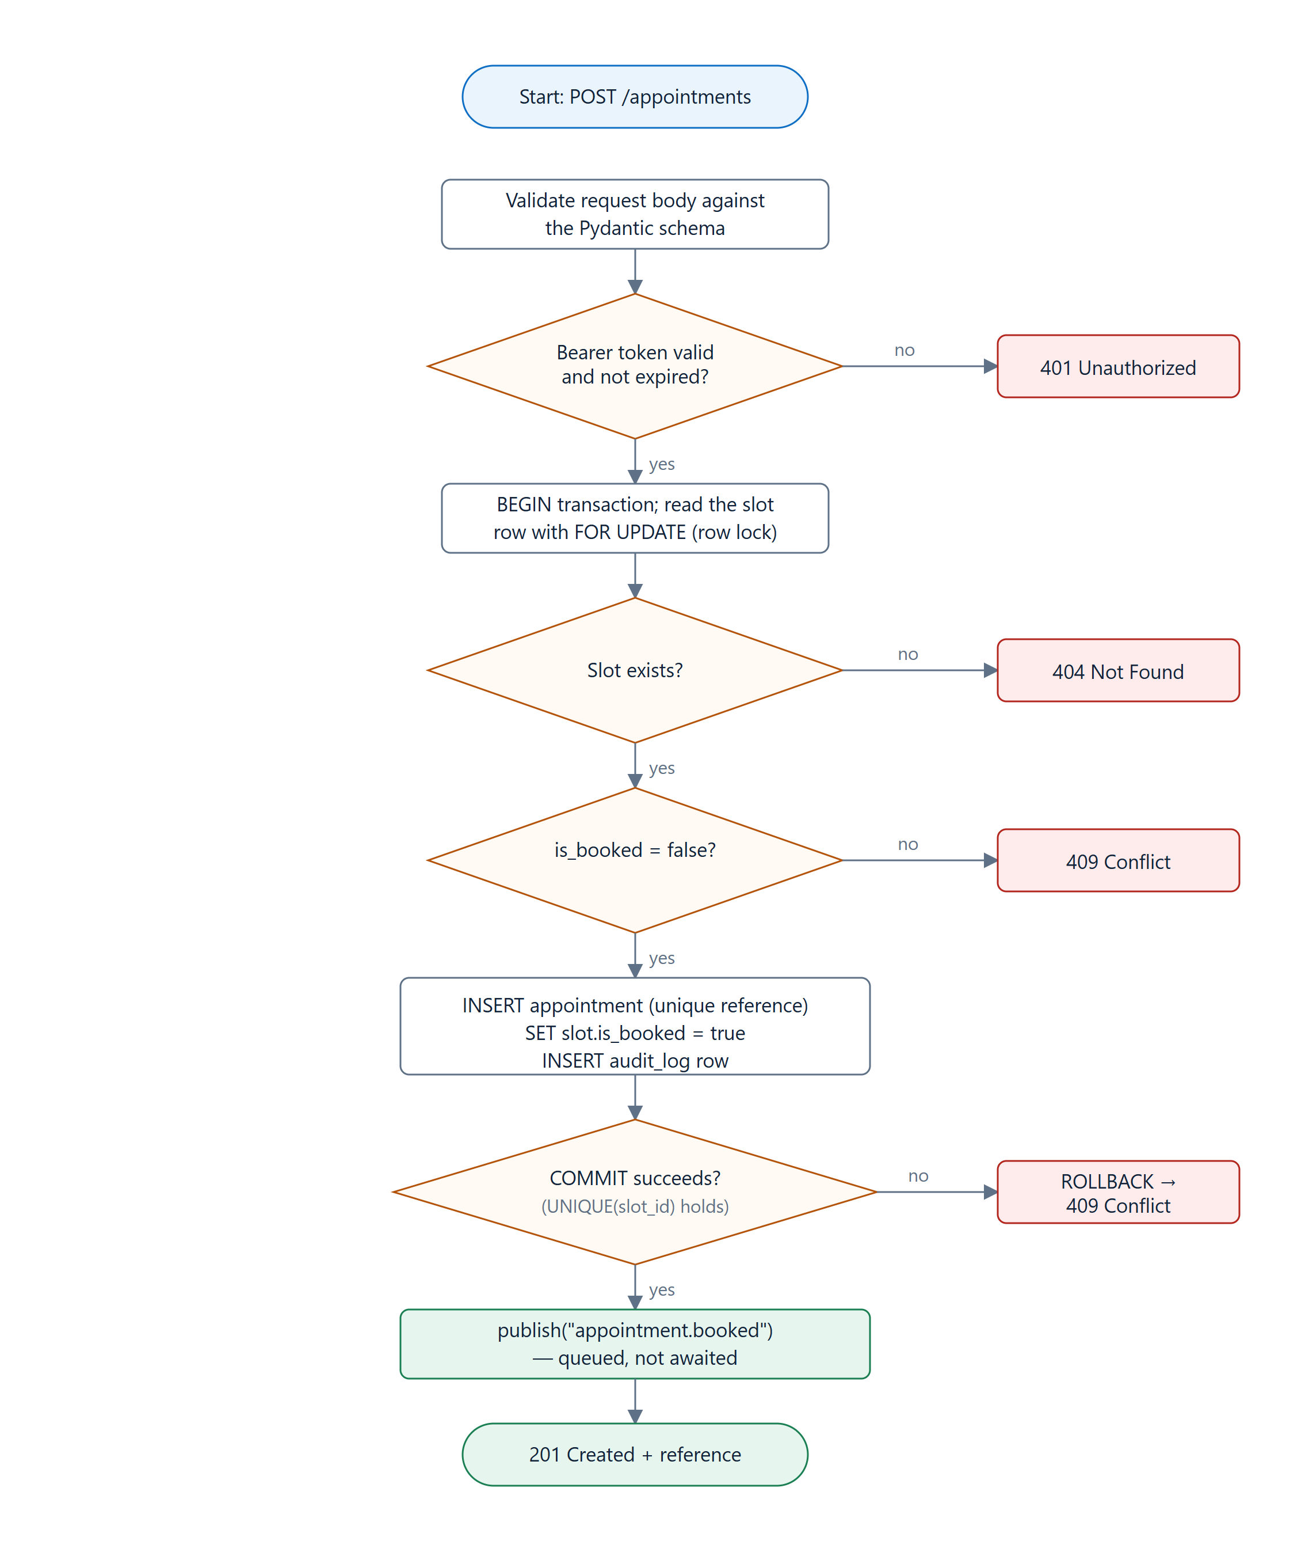
Figure 5 — Booking flowchart. Every terminal state is an explicit HTTP status code, and every one of them is asserted by a test in Section 8.
6.2 Password storage and token verification
ALGORITHM HashPassword(password)
1 salt <- CSPRNG(16 bytes) // unique per user
2 digest <- PBKDF2-HMAC-SHA256(password, salt, iterations = 600 000)
3 RETURN "pbkdf2_sha256$" + iterations + "$" + b64(salt) + "$" + b64(digest)
ALGORITHM VerifyPassword(password, stored)
1 algorithm, iterations, salt, expected <- Split(stored, "$")
2 digest <- PBKDF2-HMAC-SHA256(password, salt, iterations)
3 RETURN ConstantTimeEquals(digest, expected) // never a plain == comparison
ALGORITHM VerifyToken(token)
1 header, claims, signature <- Split(token, ".") // reject if not exactly 3 parts
2 expected <- HMAC-SHA256(secret, header + "." + claims)
3 IF NOT ConstantTimeEquals(expected, signature) THEN RAISE // forged
4 IF claims.exp < Now() THEN RAISE // expired
5 RETURN claims
Listing 2 — Security primitives. The salt at line 1 is why two users with the same password have different stored values; the constant-time comparison is why an attacker cannot learn the digest one byte at a time.
6.3 Sliding-window rate limiting
ALGORITHM Allow(key) // one key per client address
1 now <- MonotonicClock()
2 ACQUIRE lock
3 WHILE hits[key] not empty AND now - hits[key].front > window
4 hits[key].pop_front() // evict events that aged out
5 IF Length(hits[key]) >= max_events THEN
6 RETURN False // caller responds 429
7 hits[key].push_back(now)
8 RETURN True
Listing 3 — Sliding-window limiter. A monotonic clock is used deliberately, so that a system clock adjustment cannot widen or collapse the window.
7. Implementation, Source Code and Tools Used
7.1 Tools
Area | Tool and version | Why this one
Language | Python 3.12 | Modern typing, and the standard library covers the cryptography we needed
API framework | FastAPI 0.110 on uvicorn | Generates the OpenAPI document from the same models it validates with
Validation | Pydantic 2.13 | One definition serves as validation, serialisation and documentation
ORM | SQLAlchemy 2.0 | Lets the storage engine change without the query code changing
Database | SQLite (dev/test), PostgreSQL-ready | Zero setup for reviewers; the ORM keeps the migration path open
Frontend | HTML5, CSS3, vanilla ES6 | No build step, so the UI cannot rot independently of the API
Testing | pytest 8.4, coverage.py | Fixtures made per-test isolation straightforward
Static analysis | ruff, bandit | Style and bug patterns; medium-and-above security findings
Containers | Docker, multi-stage build | Same artefact on a laptop and on the runner
CI/CD | GitHub Actions | Free, and lives next to the code it gates
Observability | Custom Prometheus registry, JSON logging | Standard exposition format with no extra dependency
Load testing | Custom httpx harness | We needed per-request latencies to report percentiles, not just averages
Version control | Git and GitHub | Protected main branch; the pipeline is the gate
7.2 Repository layout
SE-assigment/
├── backend/
│ ├── app/
│ │ ├── main.py FastAPI app, middleware chain, router mounting
│ │ ├── config.py Environment-driven settings (12-factor)
│ │ ├── database.py Engine, session factory, request-scoped dependency
│ │ ├── models.py Six SQLAlchemy models and their constraints
│ │ ├── schemas.py Pydantic request/response contracts
│ │ ├── security.py PBKDF2 hashing and HS256 JWTs (standard library only)
│ │ ├── deps.py Bearer-token extraction and the role guard
│ │ ├── events.py In-process publish/subscribe bus
│ │ ├── ratelimit.py Sliding-window limiter
│ │ ├── metrics.py Prometheus registry (counters + latency histogram)
│ │ ├── logging_conf.py Structured JSON log formatter
│ │ ├── seed.py Idempotent demo data loader
│ │ └── routers/ auth · doctors · appointments · notifications · ops
│ └── tests/ 25 tests across four modules
├── frontend/ index.html · styles.css · app.js
├── docs/ figures, screenshots, console transcripts, load test
├── .github/workflows/ci.yml Four-stage pipeline
├── Dockerfile Multi-stage, non-root, HEALTHCHECK
└── docker-compose.yml Local orchestration with a named volume
Listing 4 — Repository layout. 58 tracked files.
7.3 Key implementation extracts
The booking handler. The comment in the docstring is the important part: this code is safe because of what the database guarantees, not because of what the function checks.
@router.post("", response_model=MessageOut, status_code=201)
def book(payload: BookingRequest,
db: Session = Depends(get_db),
user: User = Depends(current_user)):
"""Concurrency safety comes from the database, not from the application:
the row is re-read with SELECT ... FOR UPDATE semantics inside the
transaction and Appointment.slot_id carries a UNIQUE index, so if two
requests race, exactly one commits and the other receives HTTP 409."""
slot = db.get(Slot, payload.slot_id, with_for_update=True)
if slot is None:
raise HTTPException(status_code=404, detail="Slot not found")
if slot.is_booked:
raise HTTPException(status_code=409, detail="Slot has already been booked")
appointment = Appointment(reference=_reference(), patient_id=user.id,
doctor_id=slot.doctor_id, slot_id=slot.id,
reason=payload.reason, status="CONFIRMED")
slot.is_booked = True
db.add(appointment)
db.add(AuditLog(actor=user.email, action="BOOK", entity="appointment",
detail="slot=%s" % slot.id))
try:
db.commit()
except IntegrityError:
db.rollback()
raise HTTPException(
status_code=409, detail="Slot has already been booked"
) from None
...
bus.publish("appointment.booked", {...}) # fire and forget
return MessageOut(detail="Appointment confirmed", reference=appointment.reference)
Listing 5 — backend/app/routers/appointments.py
The event bus. Twenty-odd lines, but they are the reason booking is fast. The interface is deliberately the same shape as a real broker's, so replacing it with RabbitMQ or Kafka changes this file and nothing else.
class EventBus:
def __init__(self, workers: int = 4) -> None:
self._subscribers = defaultdict(list)
self._pool = ThreadPoolExecutor(max_workers=workers, thread_name_prefix="event")
def subscribe(self, topic, handler):
self._subscribers[topic].append(handler)
def publish(self, topic, payload, sync=False):
self.published += 1
log.info("event published", extra={"event": topic})
for handler in self._subscribers[topic]:
if sync:
self._run(handler, topic, payload)
else:
self._pool.submit(self._run, handler, topic, payload) # returns at once
Listing 6 — backend/app/events.py
The observability middleware. One decorator gives every request a correlation ID, a latency measurement, a metrics observation, three security headers and exactly one structured log line.
@app.middleware("http")
async def observability_middleware(request: Request, call_next):
request_id = request.headers.get("X-Request-ID", uuid.uuid4().hex[:12])
started = time.perf_counter()
response = await call_next(request)
elapsed = time.perf_counter() - started
route = request.scope.get("route")
metrics.observe(request.method, getattr(route, "path", request.url.path),
response.status_code, elapsed)
response.headers["X-Request-ID"] = request_id
response.headers["X-Content-Type-Options"] = "nosniff"
response.headers["X-Frame-Options"] = "DENY"
response.headers["Referrer-Policy"] = "no-referrer"
log.info("request handled", extra={"request_id": request_id, "method": request.method,
"path": request.url.path, "status": response.status_code,
"duration_ms": round(elapsed * 1000, 2)})
return response
Listing 7 — backend/app/main.py. Metrics are keyed on the route template, not the raw URL, so /doctors/6/slots and /doctors/7/slots share a series instead of creating one each.
The container image. Two stages, so the compiler toolchain used to install dependencies never ships. The runtime stage creates an unprivileged user and switches to it before the application is ever executed.
FROM python:3.12-slim AS builder
WORKDIR /install
COPY backend/requirements.txt .
RUN pip install --no-cache-dir --prefix=/install/deps -r requirements.txt
FROM python:3.12-slim
RUN useradd --create-home --uid 10001 smartcare # never run application code as root
WORKDIR /app
COPY --from=builder /install/deps /usr/local
COPY backend/ /app/backend/
COPY frontend/ /app/frontend/
ENV PYTHONUNBUFFERED=1 APP_ENV=production DATABASE_URL=sqlite:////data/smartcare.db
RUN mkdir -p /data && chown -R smartcare:smartcare /app /data
USER smartcare
WORKDIR /app/backend
EXPOSE 8000
HEALTHCHECK --interval=30s --timeout=3s --start-period=5s --retries=3 \
CMD python -c "import urllib.request,sys; sys.exit(0 if ...status==200 else 1)"
CMD ["uvicorn", "app.main:app", "--host", "0.0.0.0", "--port", "8000"]
Listing 8 — Dockerfile
7.4 Continuous integration and delivery
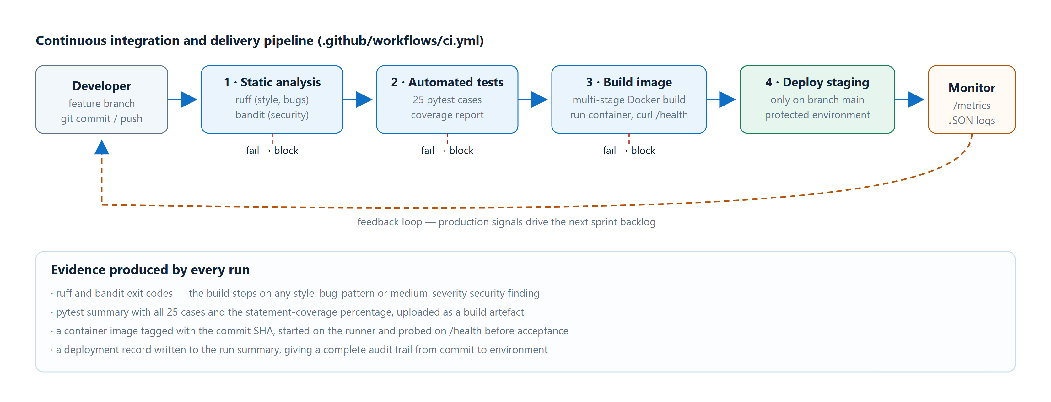
Figure 6 — The delivery pipeline. It is a gate rather than a report: stage N+1 never starts unless stage N passed. Section 9 shows a real run, and two real failures.

8. Test Cases and Expected / Actual Results
8.1 The suite
Twenty-five automated tests run in about two seconds. Every one of them is in the repository, and every one runs on every push. The "actual" column below is not transcribed by hand; it is the output shown in the pytest screenshot in Section 9.
ID | What it checks | Expected | Actual | P/F
TC-01 | Registration returns a three-part JWT and role patient | 201, valid token | 201, token verified | Pass
TC-02 | A second registration on the same e-mail is refused | 409 Conflict | 409 Conflict | Pass
TC-03 | A password shorter than 8 characters is rejected by schema validation | 422 | 422 | Pass
TC-04 | Correct credentials succeed; a wrong password does not | 200 then 401 | 200 then 401 | Pass
TC-05 | The stored value contains no plaintext and starts pbkdf2_sha256$ | No plaintext | Prefix and salt confirmed | Pass
TC-06 | Two identical passwords produce different stored hashes | Different digests | Different, both verify | Pass
TC-07 | A protected route rejects a missing and a forged token | 401 both times | 401 both times | Pass
TC-08 | A tampered signature and an expired token are both rejected | ValueError raised | Raised in both cases | Pass
TC-09 | A patient calling an admin endpoint is refused | 403 Forbidden | 403 Forbidden | Pass
TC-10 | Directory listing, speciality filter and name search | 8 doctors; filters correct | 8; Cardiology 1; search hit | Pass
TC-11 | Generated slots are free and well ordered | is_booked false, start < end | Confirmed | Pass
TC-12 | Slots for a non-existent doctor | 404 | 404 | Pass
TC-13 | Booking without a token | 401 | 401 | Pass
TC-14 | A valid booking returns an SC- reference and appears in history | 201 + reference | 201, SC-…, history correct | Pass
TC-15 | Booking the same slot twice in sequence | 201 then 409 | 201 then 409 | Pass
TC-16 | Ten threads race for one slot | Exactly 1 × 201, 9 × 409 | 1 × 201, 9 × 409 | Pass
TC-17 | Cancelling removes it from the calendar then returns it to the pool | Slot freed; second cancel 409 | Both confirmed | Pass
TC-18 | Cancelling an unknown reference | 404 | 404 | Pass
TC-19 | Booking publishes an event and the notification arrives afterwards | Event count rises; notice appears | Both observed | Pass
TC-20 | Liveness probe reports version and uptime | 200, status UP | 200, UP, v1.0.0 | Pass
TC-21 | Readiness probe actually queries the database | 200, database UP | 200, database UP | Pass
TC-22 | Metrics are valid Prometheus exposition | Counter and histogram present | Both present | Pass
TC-23 | Security headers and a correlation ID on every response | nosniff, DENY, X-Request-ID | All three present | Pass
TC-24 | The limiter blocks past its threshold and is per-key | 3 allowed, then denied | Exactly as specified | Pass
TC-25 | The OpenAPI document lists every route | All paths present | All present | Pass
8.2 The test that was passing for the wrong reason
TC-16 is the test we are proudest of, and it is also the one that embarrassed us. Our first version spun up ten threads and asserted one success and nine conflicts, and it passed immediately. That should have been suspicious, and it was: the fixture handed every thread the *same* SQLAlchemy session, so the threads were never really concurrent at the database level. When we made the fixture open a separate session per request, exactly as uvicorn does in production, the test started failing with InvalidRequestError: This session is in 'prepared' state.
That failure was the useful result. We changed the fixture to give each request its own session against a file-backed SQLite database, so that ten real OS threads open ten real connections. The test then passed for the right reason, and it now exercises the UNIQUE constraint rather than accidentally serialising through one connection.
The lesson we took from this. A green test is not evidence until you have seen it fail for the reason it is supposed to catch. We now deliberately break the mechanism a test is guarding and check that the test notices. Removing the UNIQUE constraint makes TC-16 report multiple 201s, which is exactly what it should do.
8.3 Coverage
Coverage is measured over the application package only. Our first figure was 96%, which flattered us because it was counting the test files themselves; a .coveragerc restricting measurement to app gives the honest number: 605 statements, 30 missed, 95% covered. The uncovered lines are defensive branches such as the readiness handler's database-down path, which we could only exercise by breaking the database on purpose.

9. Execution Screenshots and Outputs
Every image in this section is a capture of the system actually running. The fifteen interface screenshots were produced by a Playwright script that drives the real browser through the real user journey against a live server, so no screen was posed. The console captures are verbatim output. Both sets are in the repository:
All 15 screenshots https://github.com/tharuncoder676/SE-assigment/tree/main/docs/screenshots
All 10 console transcripts https://github.com/tharuncoder676/SE-assigment/tree/main/docs/console
9.1 The patient journey
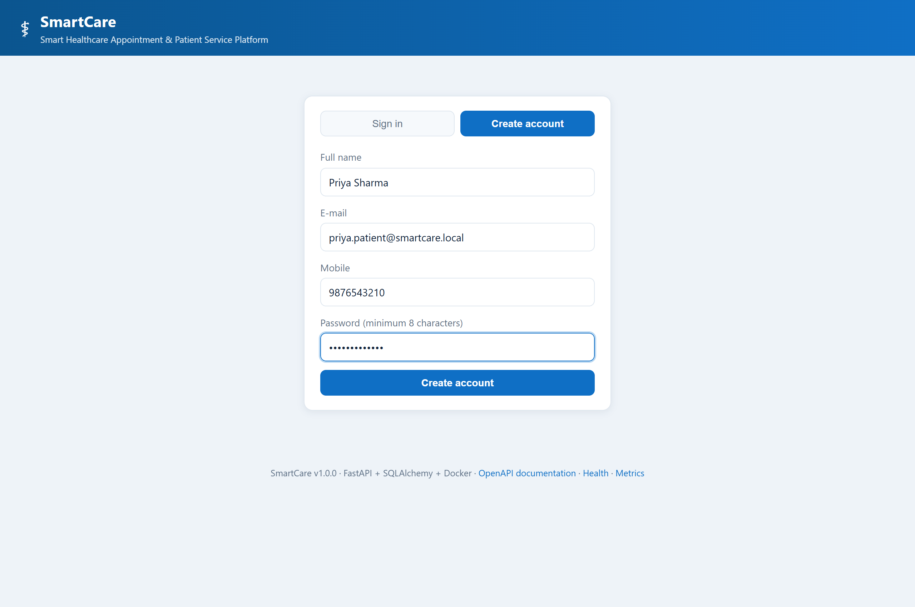
Screenshot 1 — Account creation. Client-side constraints mirror the server-side Pydantic schema, but the server validates independently; TC-03 proves a short password is rejected even if the browser is bypassed.
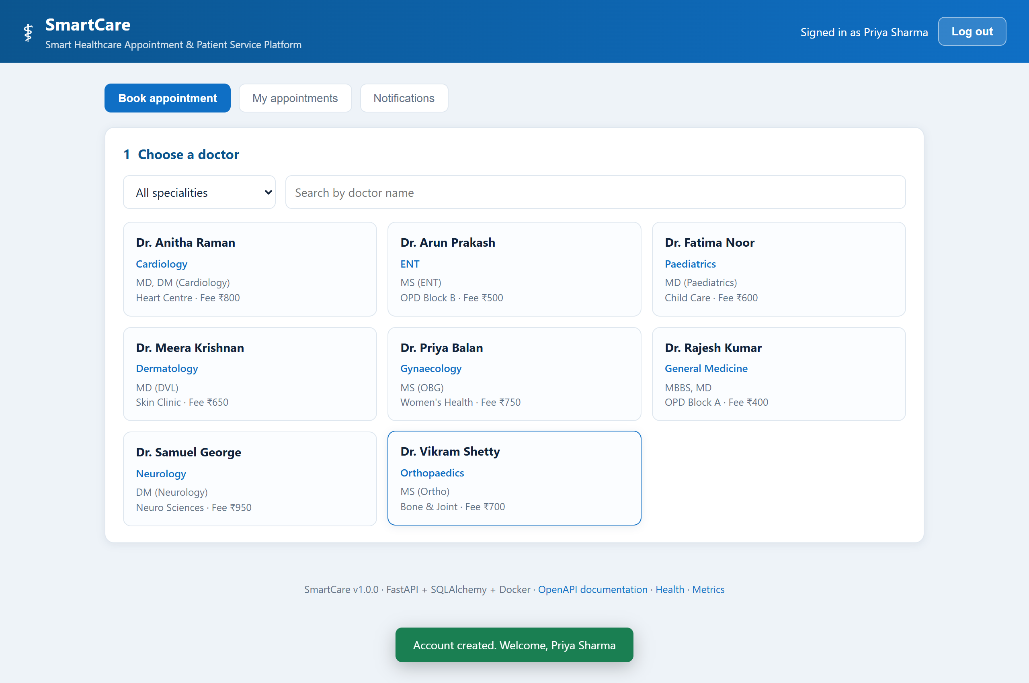
Screenshot 2 — The directory immediately after registration, with the confirmation toast still visible. Eight seeded doctors across eight specialities.
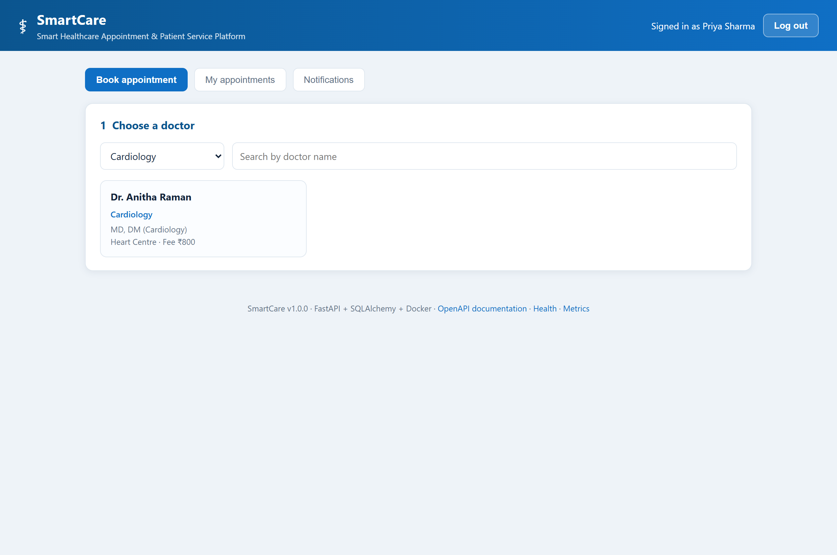
Screenshot 3 — The speciality filter applied. This is a server-side query (`GET /api/v1/doctors?speciality=Cardiology`), not client-side hiding.
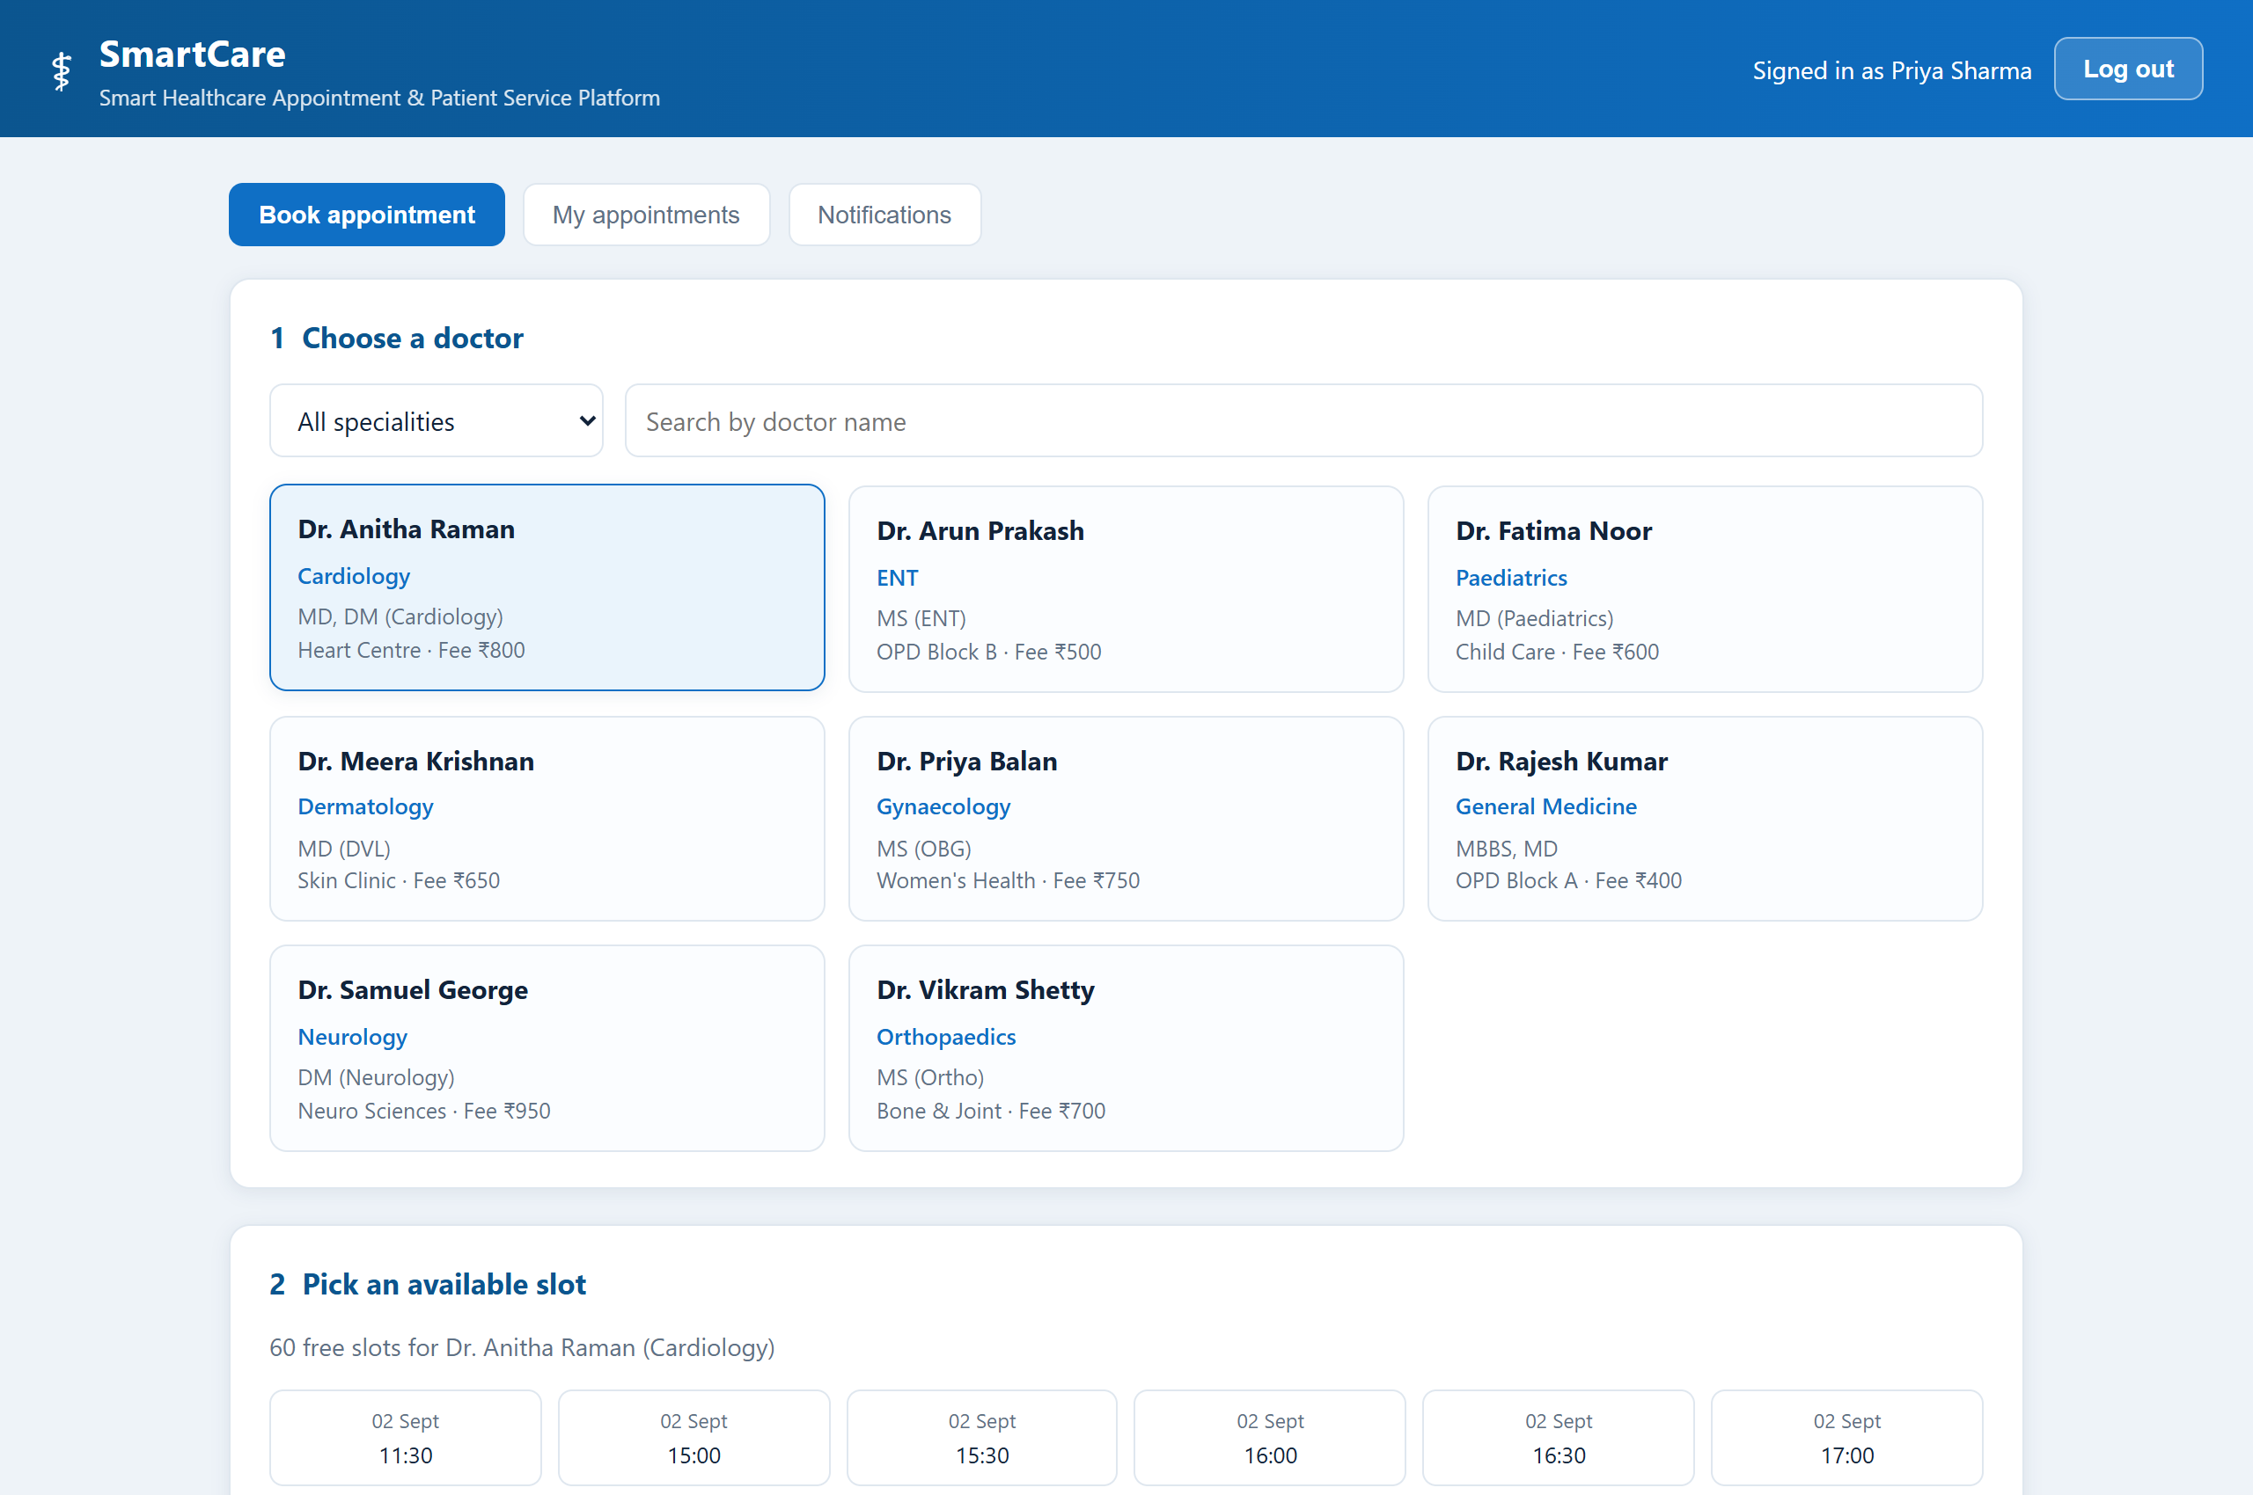
Screenshot 4 — Availability for the selected doctor. Only future, unbooked slots are returned; booked slots disappear from this list entirely.
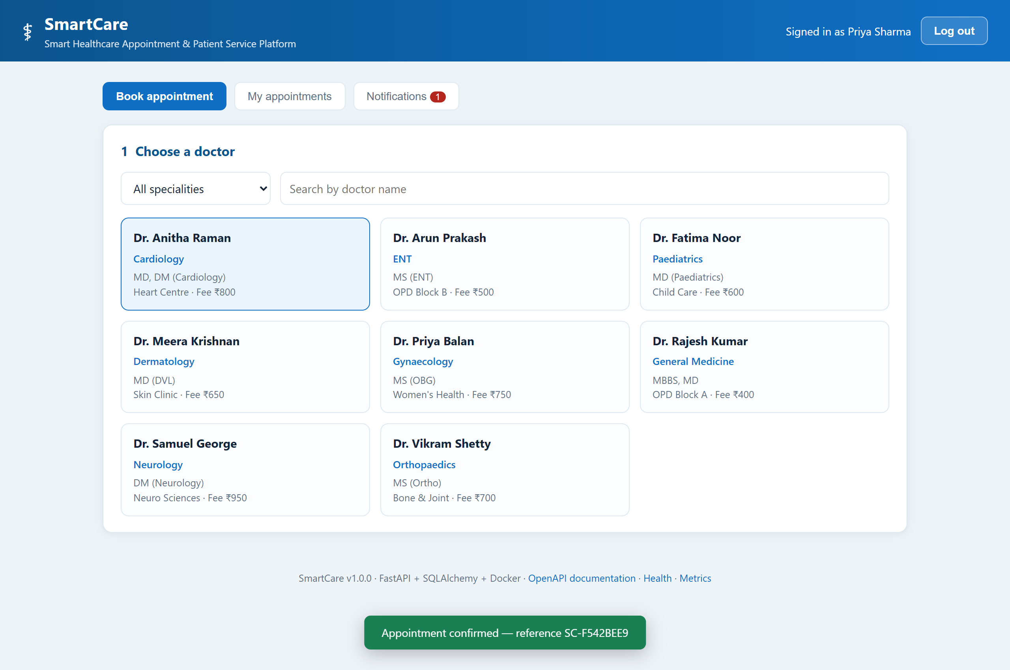
Screenshot 5 — Booking confirmed, with the reference returned by the API in the toast. The patient sees this before the notification has been written.
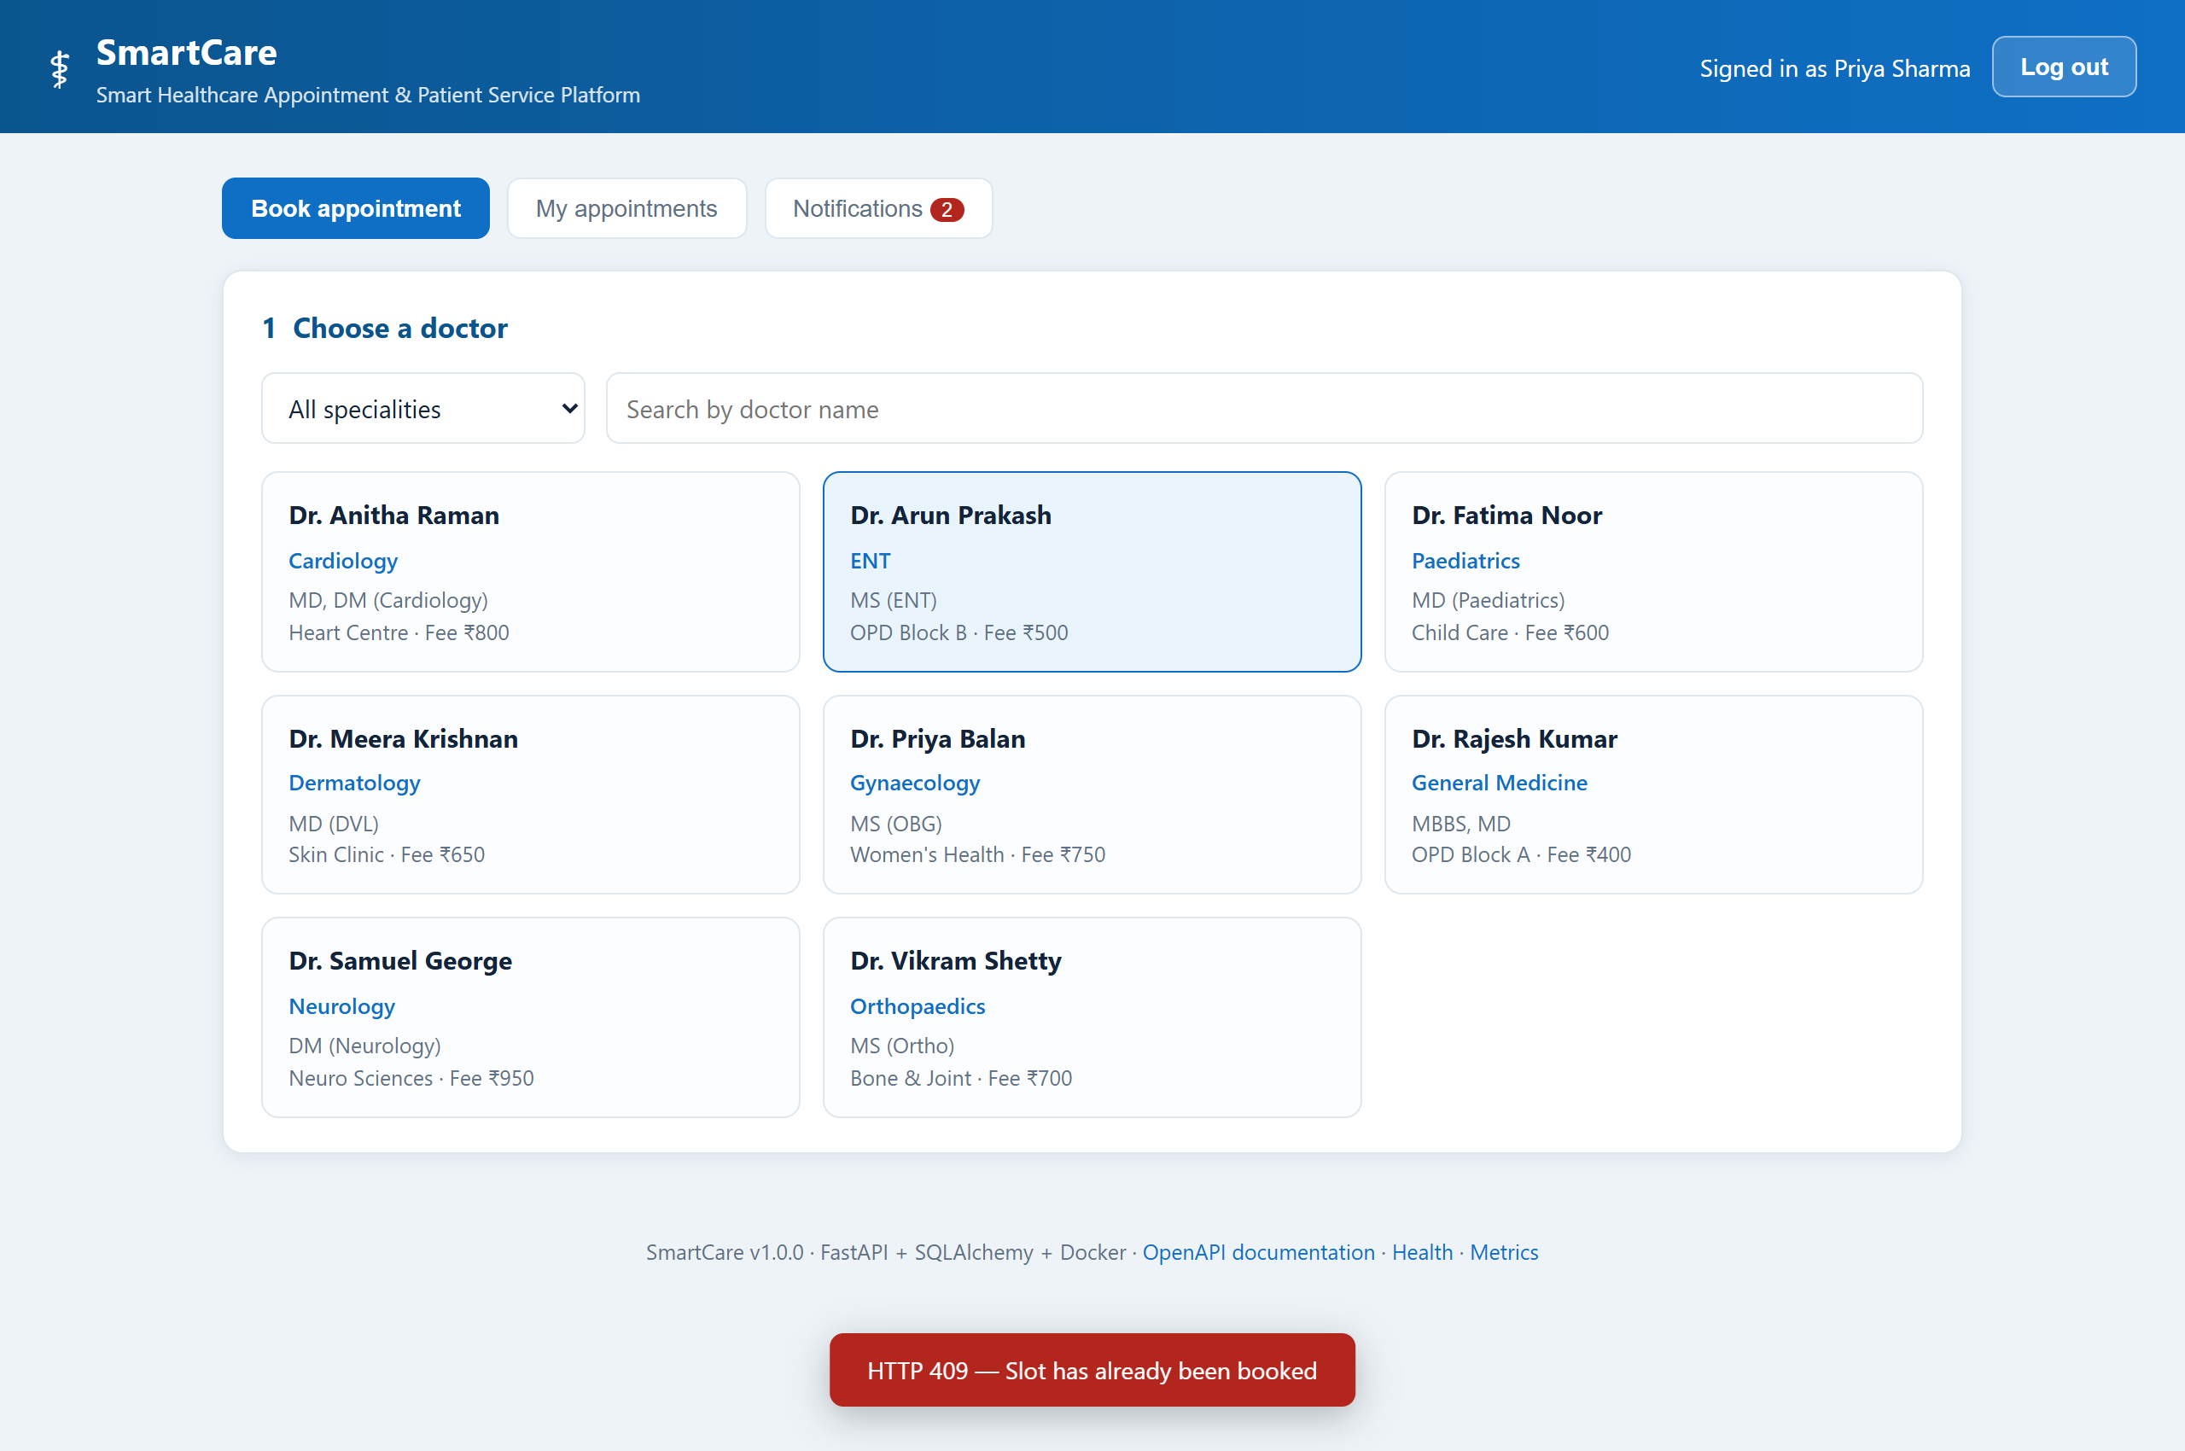
Screenshot 6 — The conflict path, captured live. The same slot was requested a second time and the server answered **HTTP 409 — Slot has already been booked**.
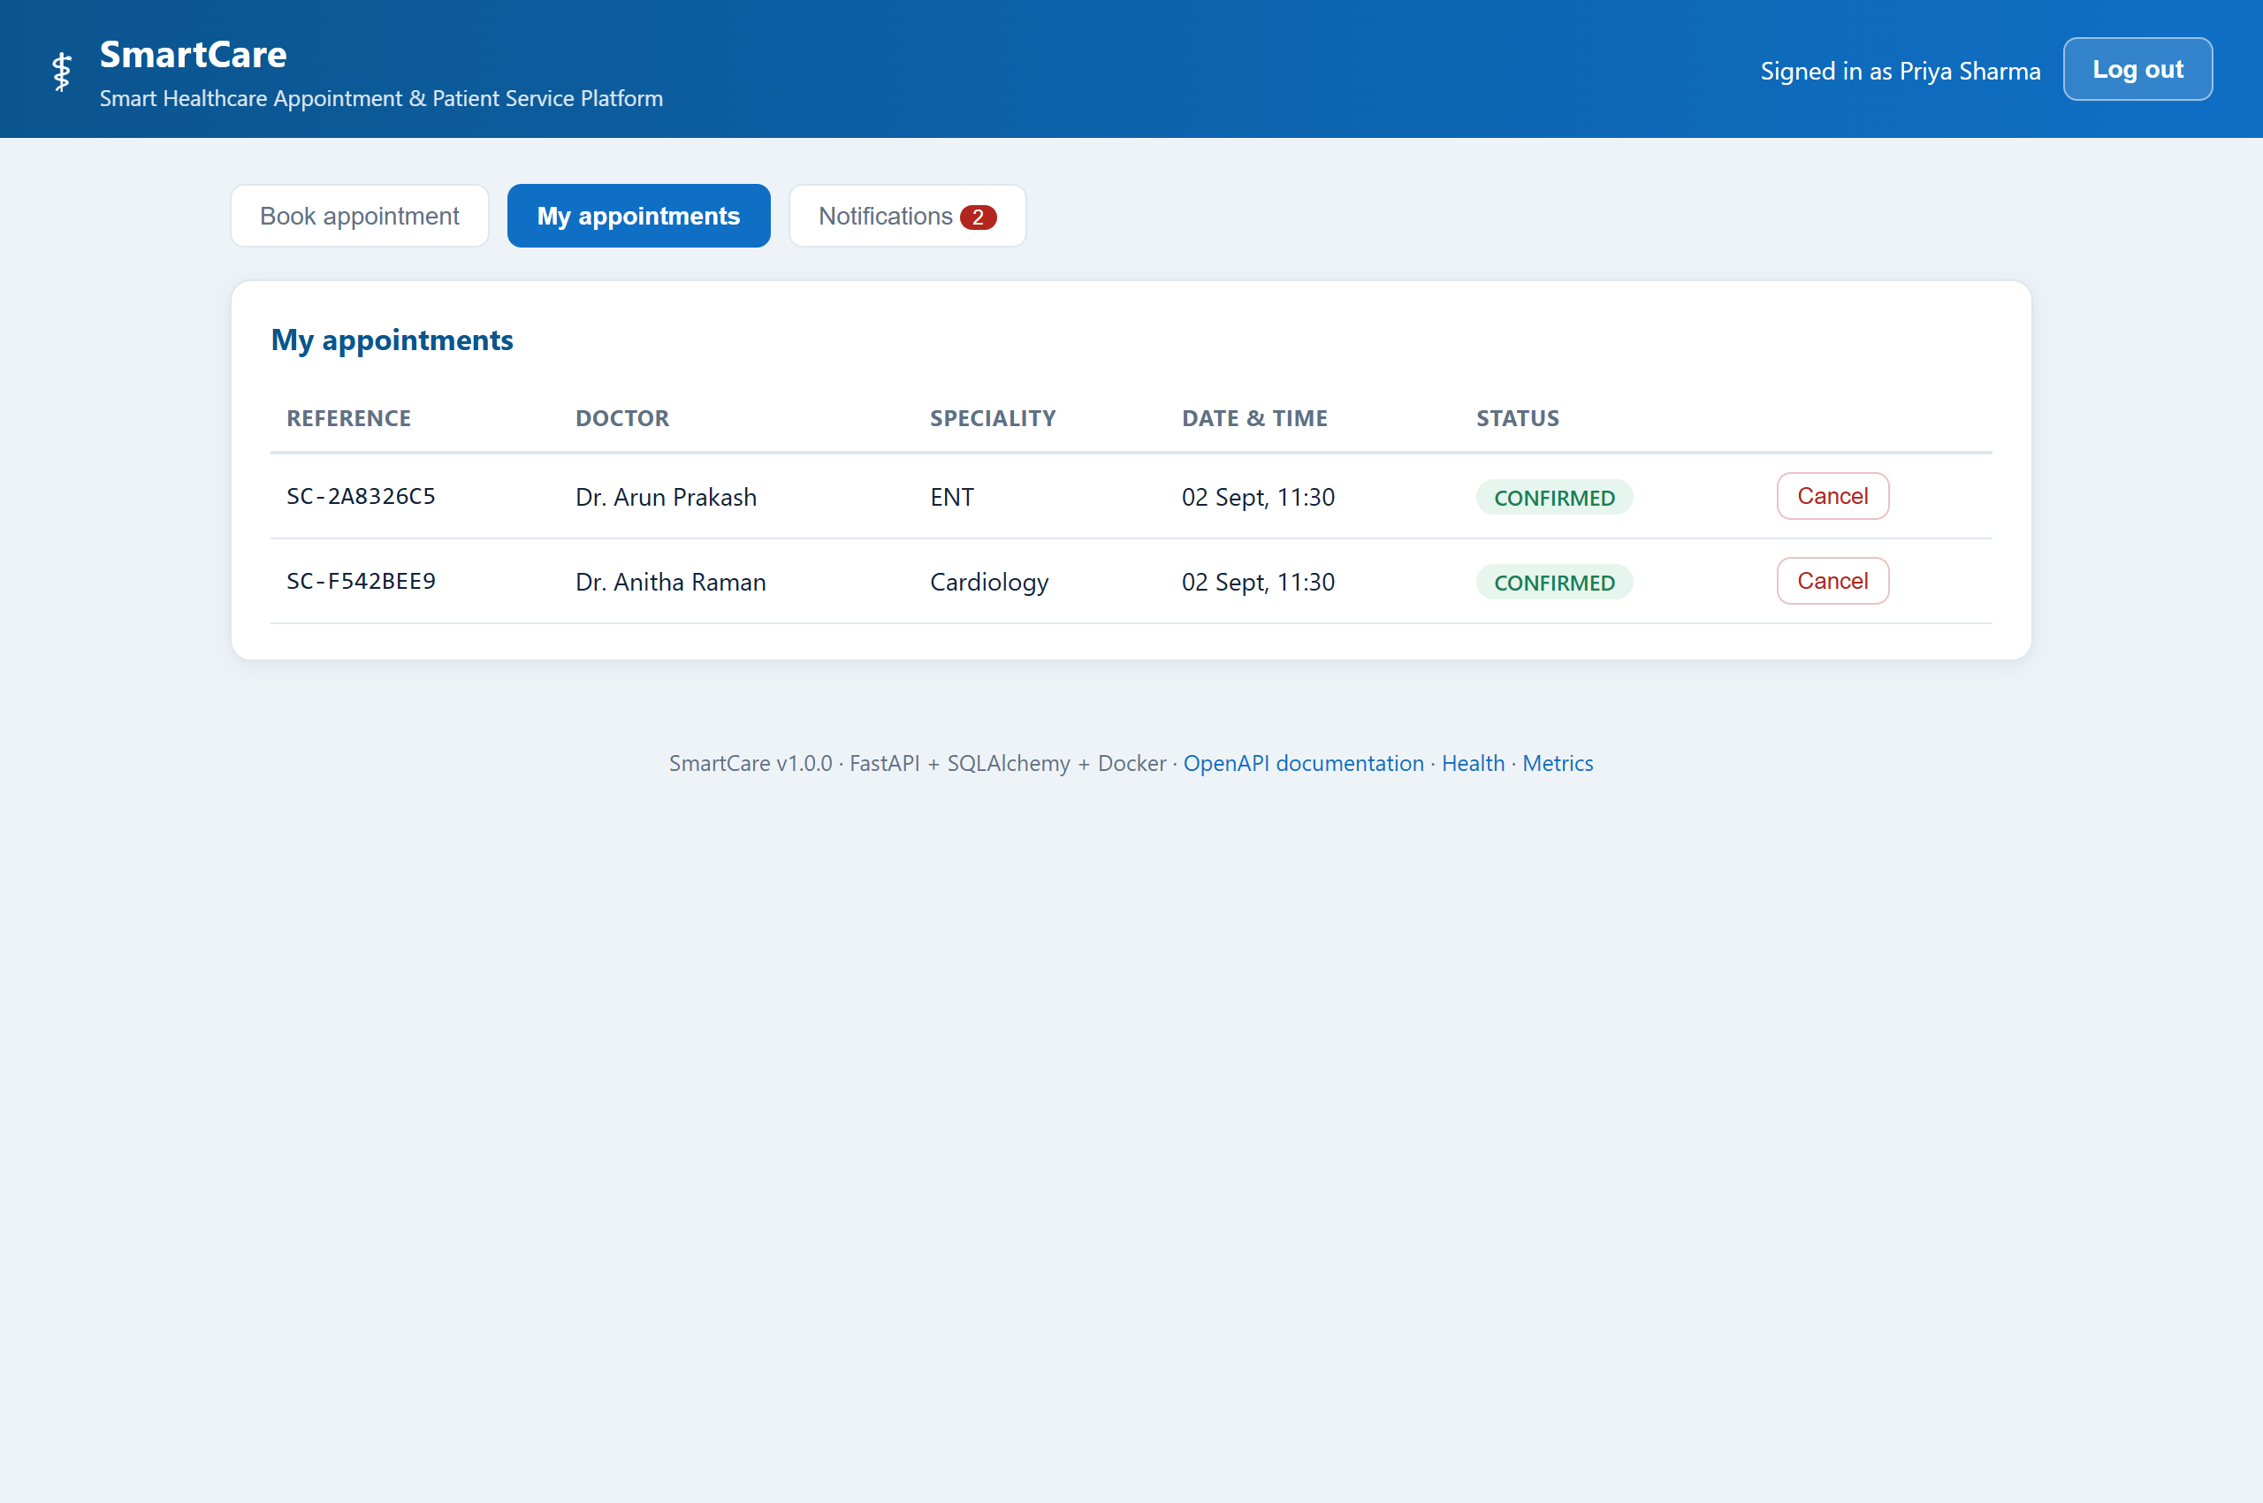
Screenshot 7 — Appointment history with references and status. The notification badge shows 2 unread, generated by the event bus.
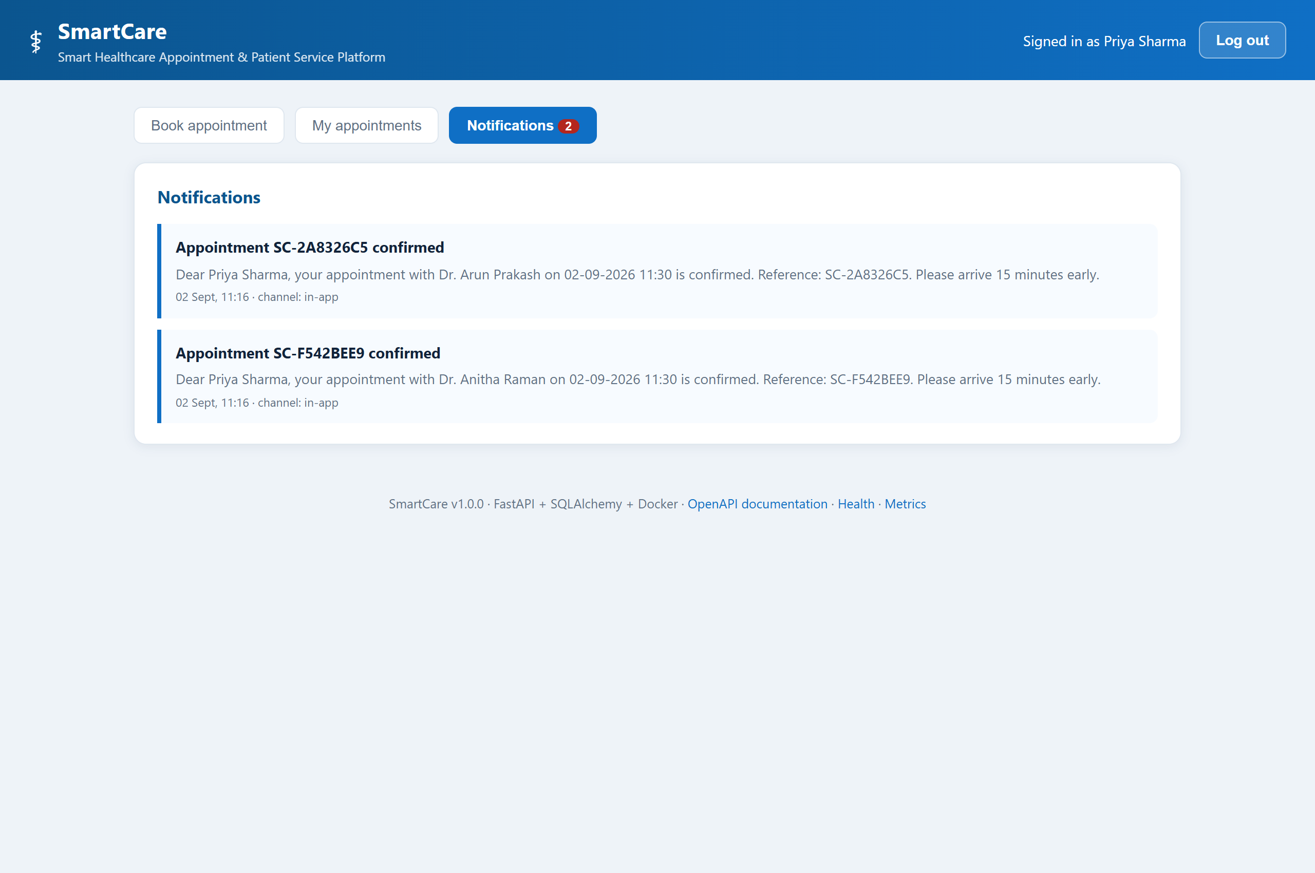
Screenshot 8 — Notifications written by the background subscriber, not by the booking request itself.
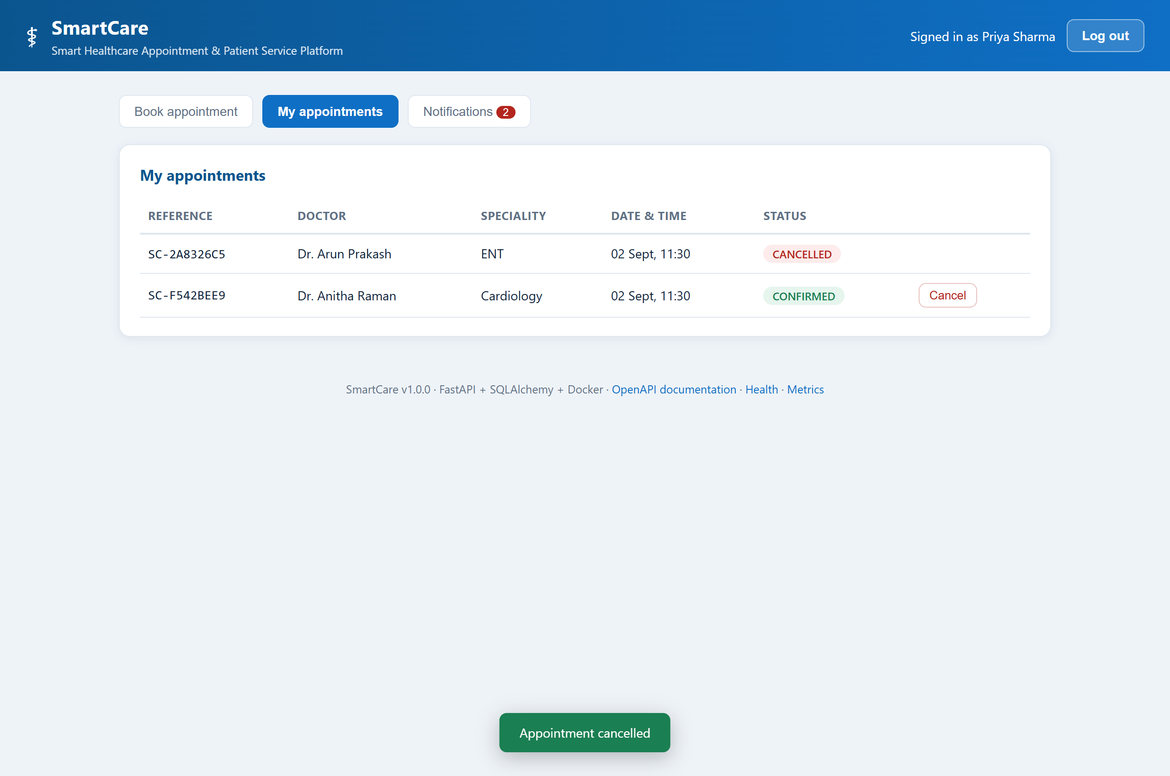
Screenshot 9 — After cancellation. The status pill changes and the slot returns to the available pool, which TC-17 verifies programmatically.
9.2 The API contract
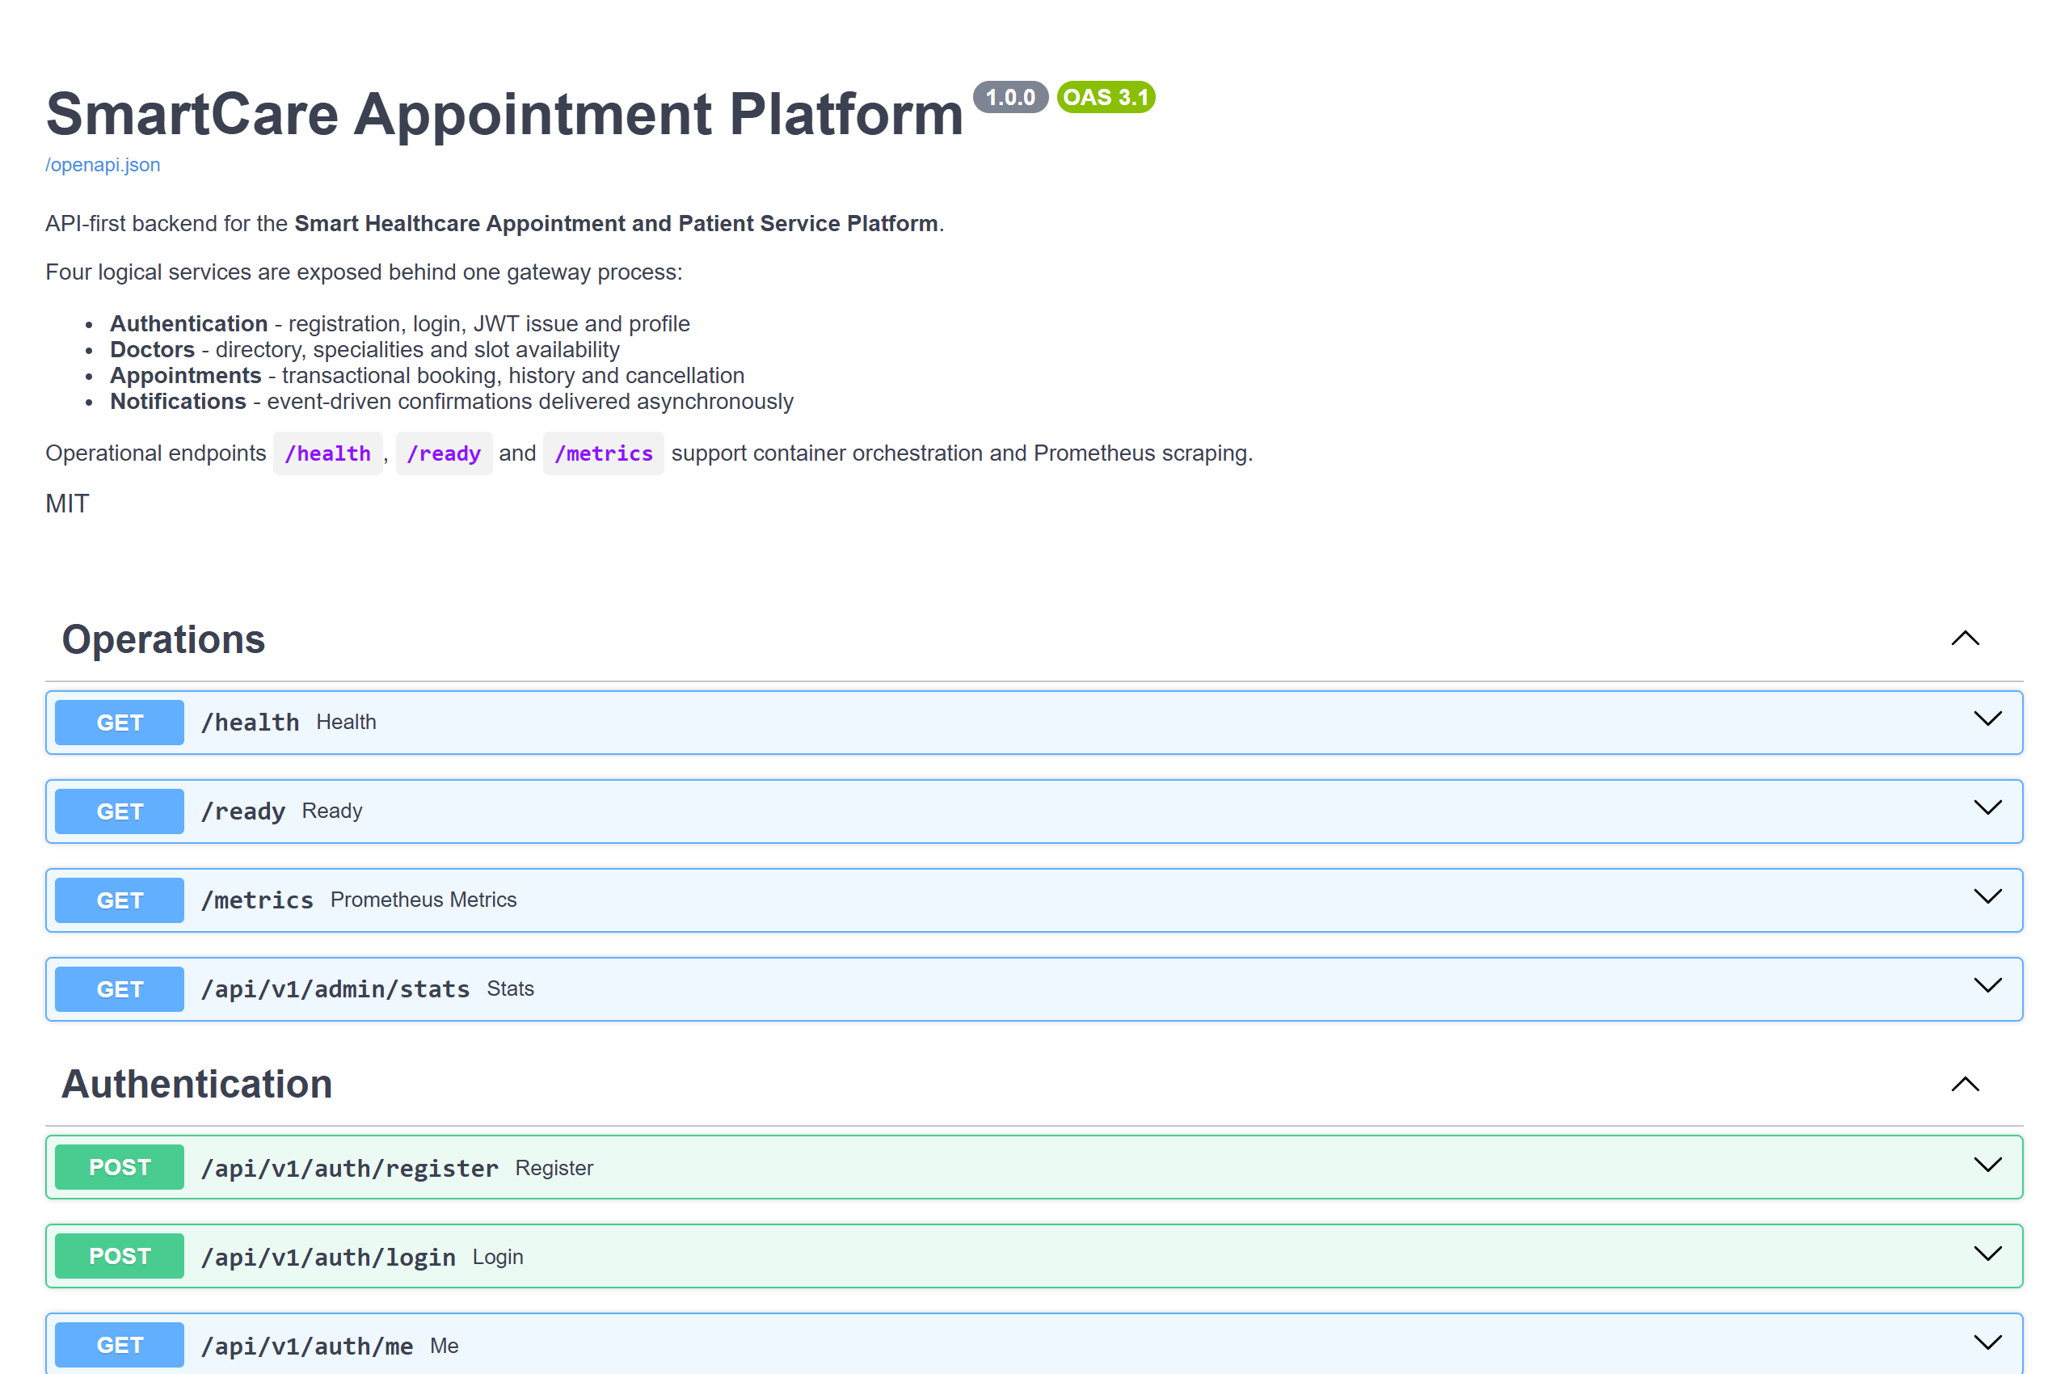
Screenshot 10 — The OpenAPI document FastAPI generates from the Pydantic models. Because it is generated, it cannot drift from the implementation.
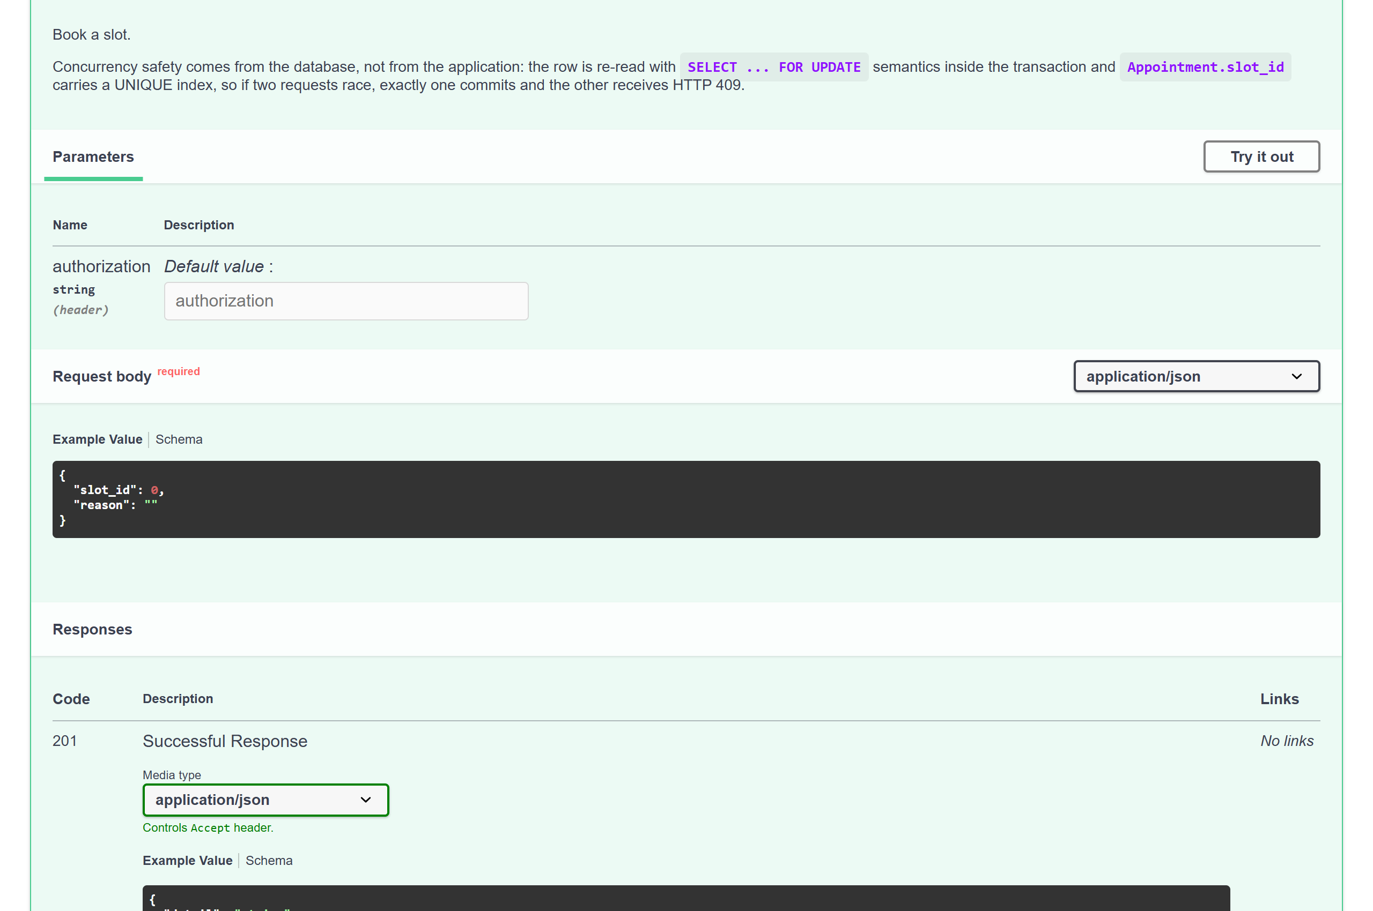
Screenshot 11 — The booking endpoint expanded, showing its schema and every documented response code including 409.
Screenshot 12 — The liveness probe. Docker's HEALTHCHECK and Kubernetes probes consume this same endpoint.
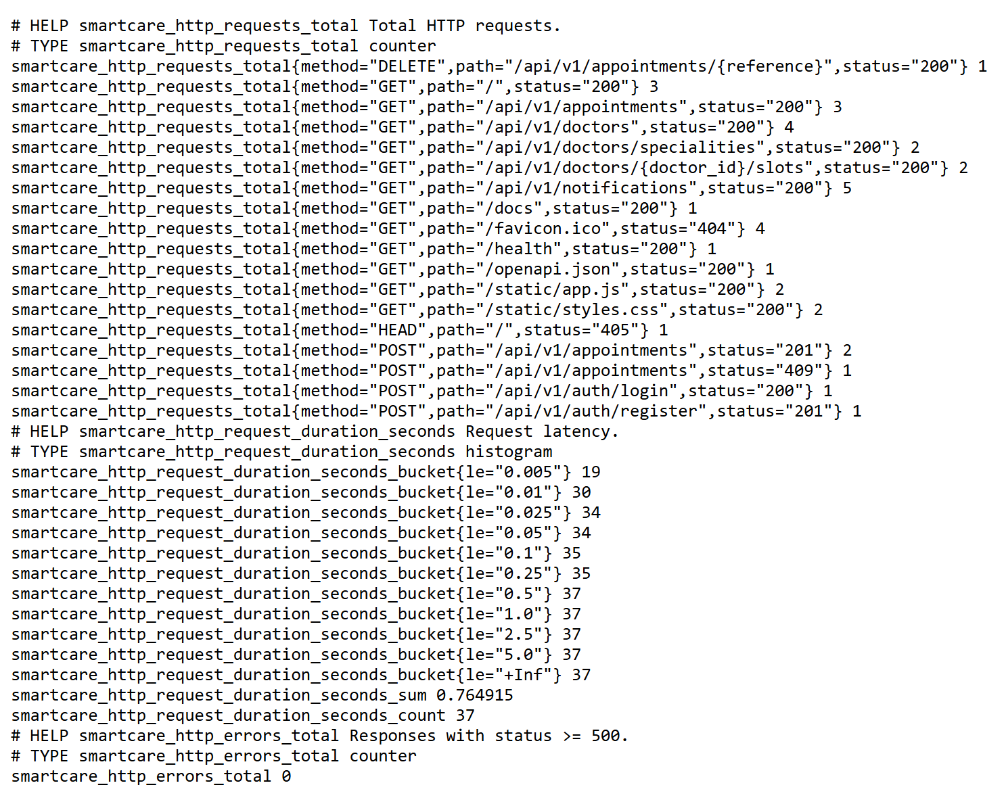
Screenshot 13 — Prometheus exposition served directly by the application, with no exporter sidecar.
9.3 Test execution
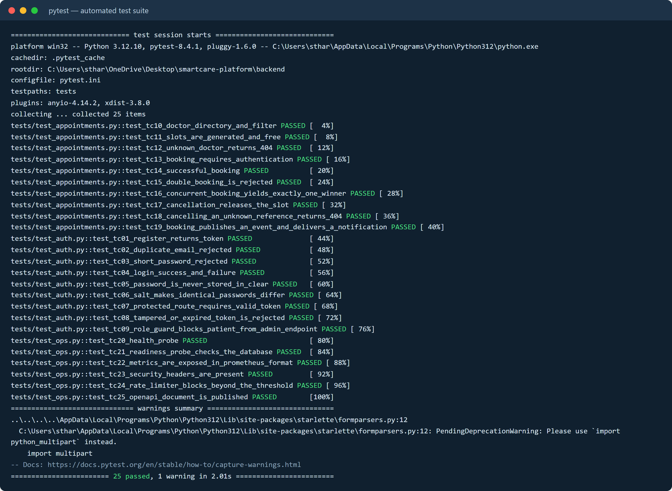
Console 1 — The full suite: 25 passed in 2.01 s. TC-16, the ten-thread booking race, is the seventh line.
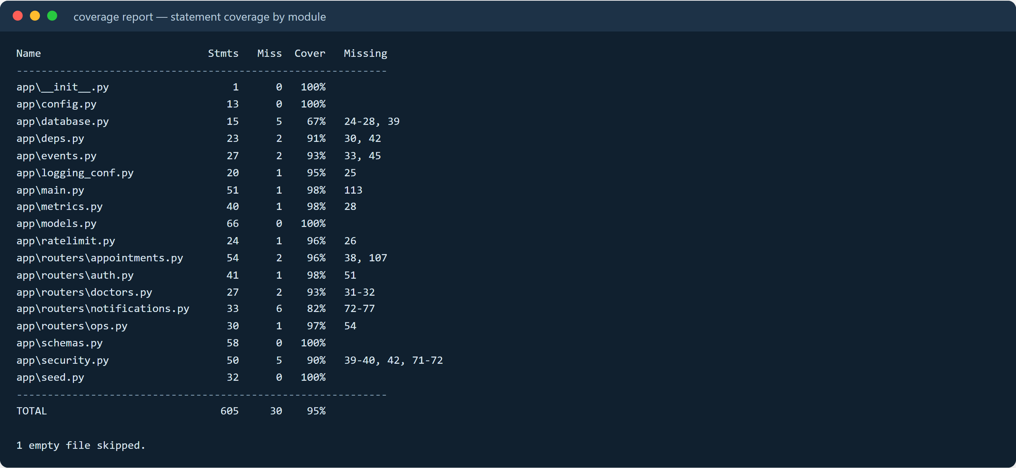
Console 2 — Statement coverage over the application package: 605 statements, 30 missed, 95%.
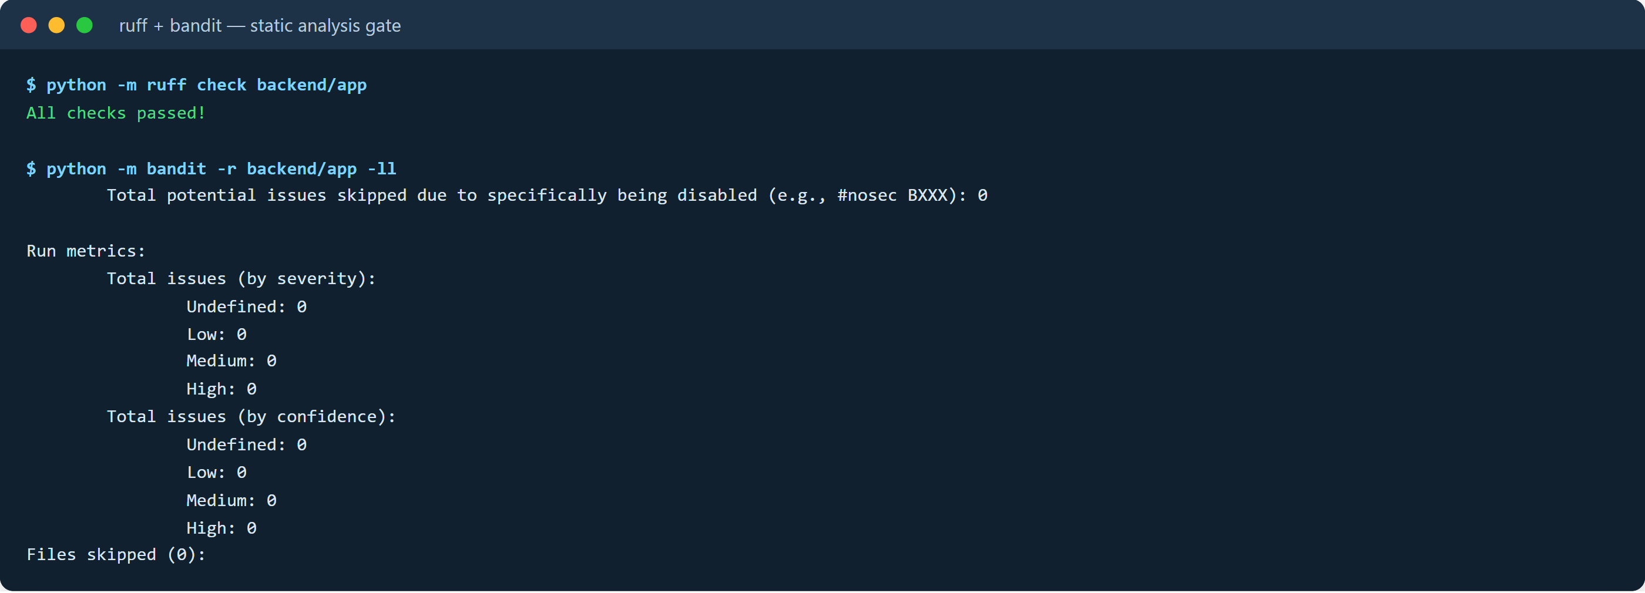
Console 3 — The static analysis gate. ruff reports no findings; bandit reports no issues at medium severity or above.
9.4 API behaviour, logs and metrics
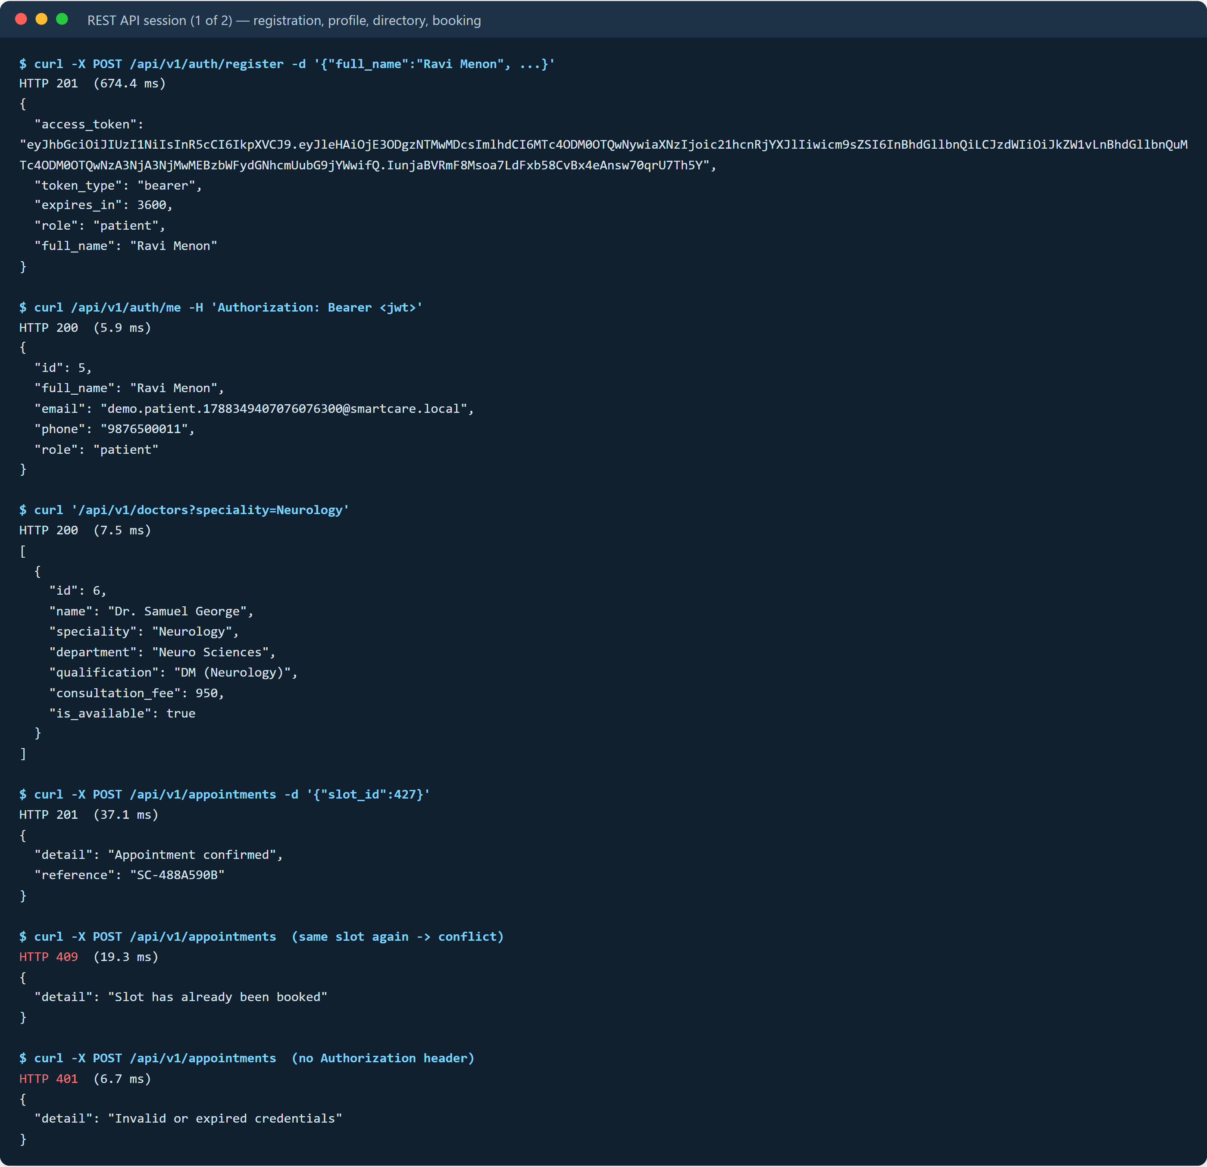
Console 4 — A real session against the running server, part 1. Note the 674 ms registration — that is PBKDF2 doing its job — against 5.9 ms for the authenticated read that follows it.
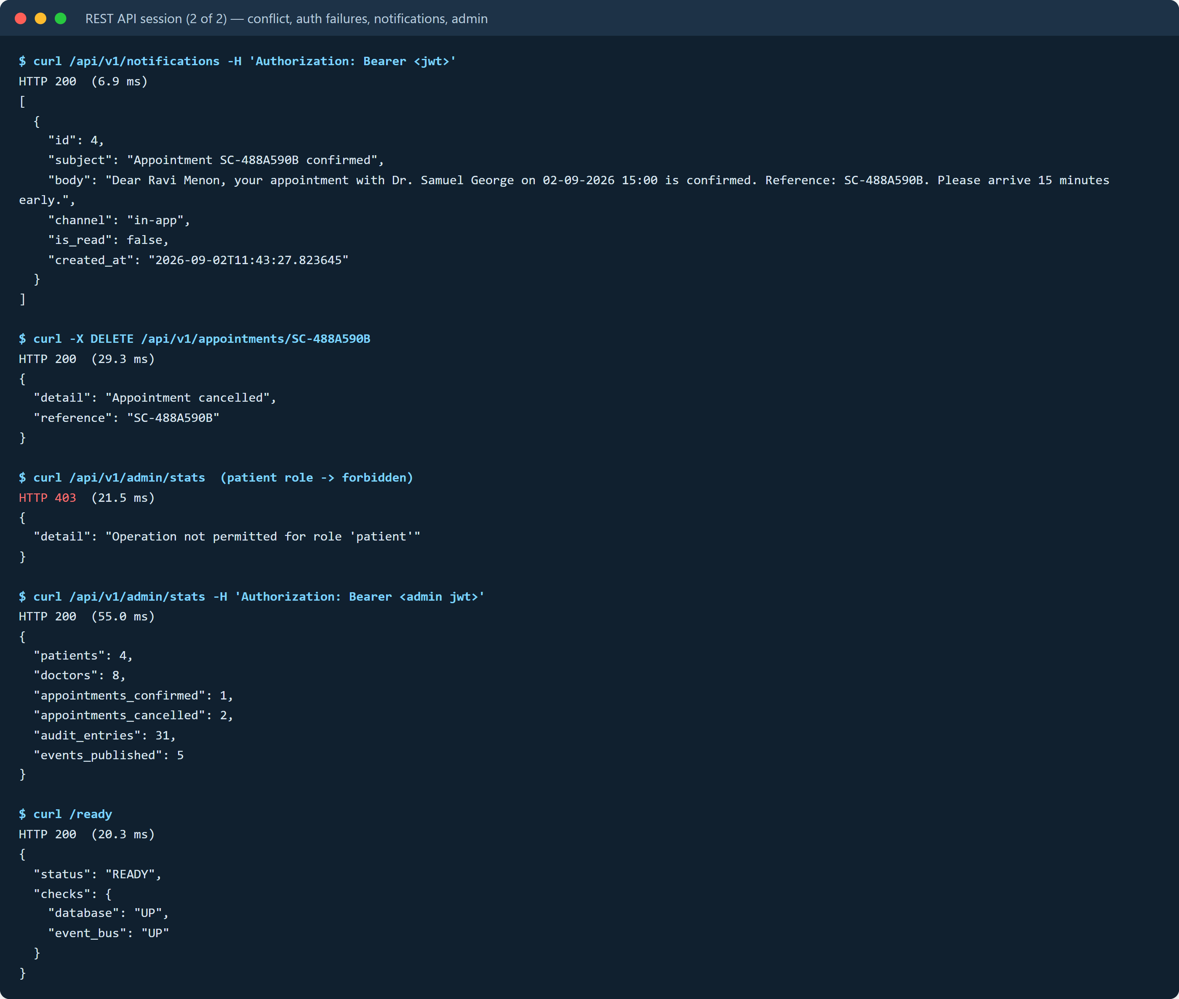
Console 5 — Part 2, the failure paths: 409 on the duplicate booking, 401 without a token, 403 for a patient calling an admin route, and 200 for the same route as admin.
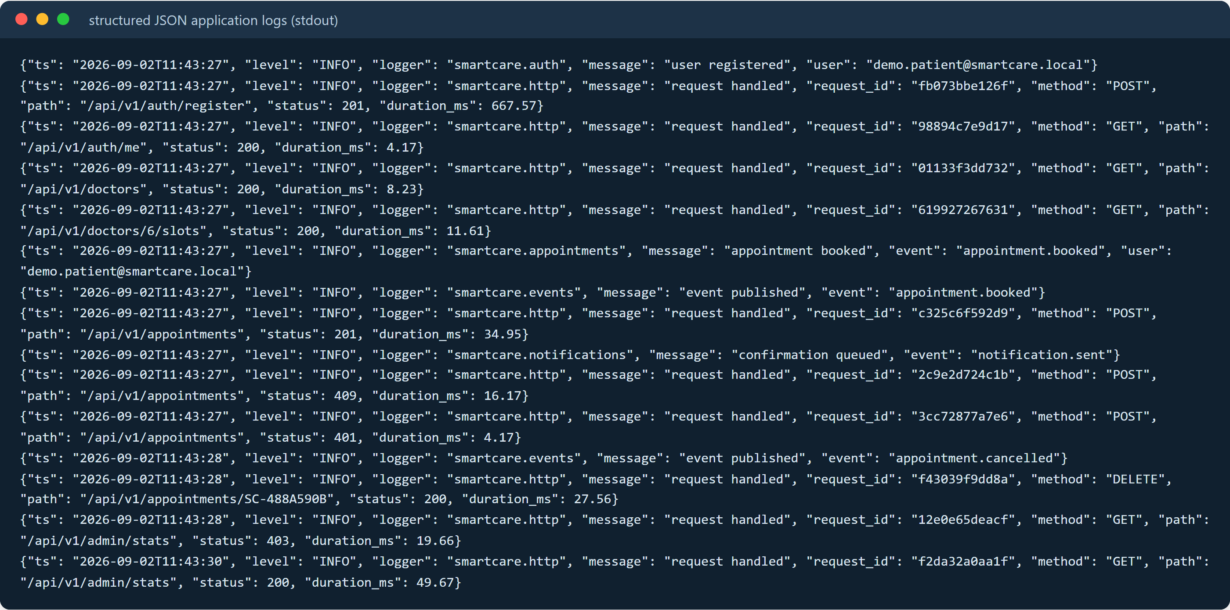
Console 6 — Structured logs for that session. Read the three highlighted lines in order: the booking is logged at 34.95 ms, the event is published, and only then is the notification queued. That ordering is the event-driven design working.
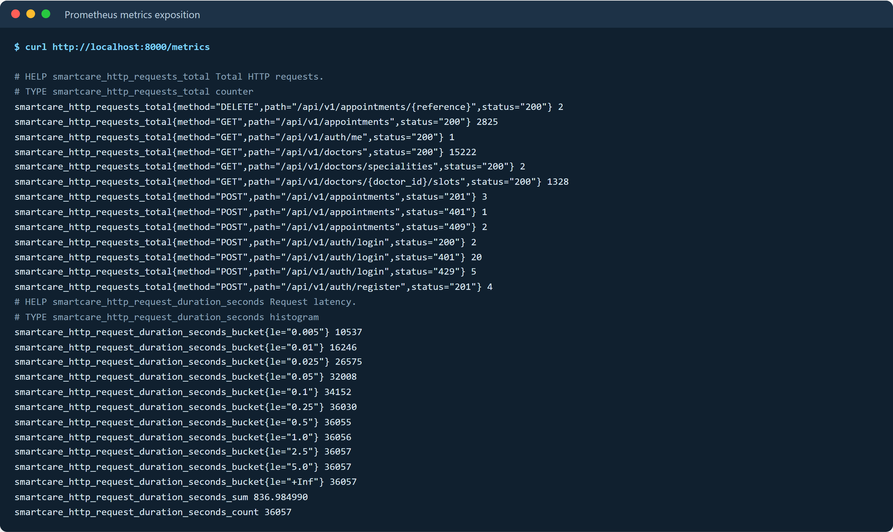
Console 7 — Live counters. The 429s are real: our own load test tripped the login rate limiter, which is the limiter passing its field test.
9.5 Version control and the delivery pipeline
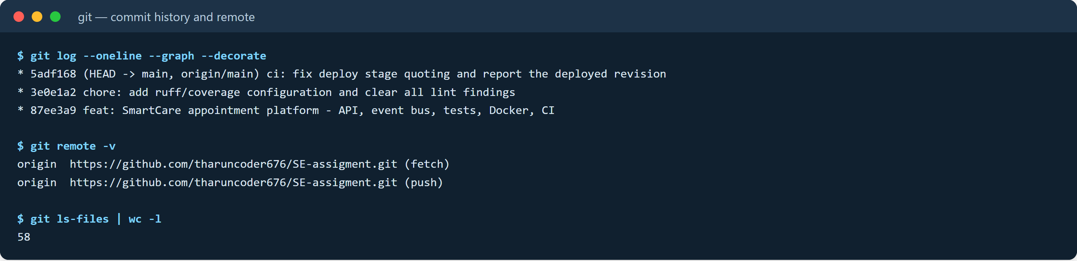
Console 8 — Commit history and remote. 58 tracked files.
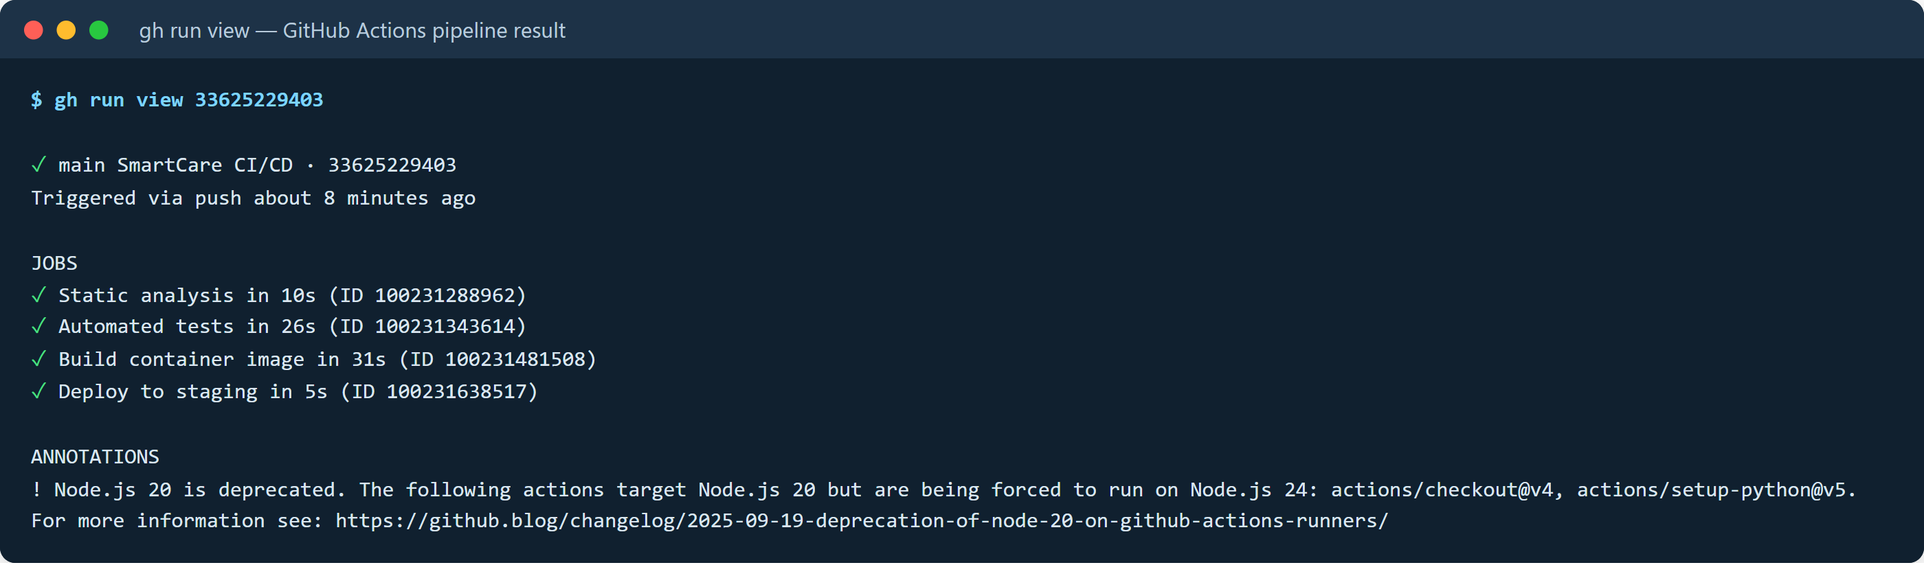
Console 9 — A complete pipeline run: static analysis, tests, container build and gated deployment, all green.
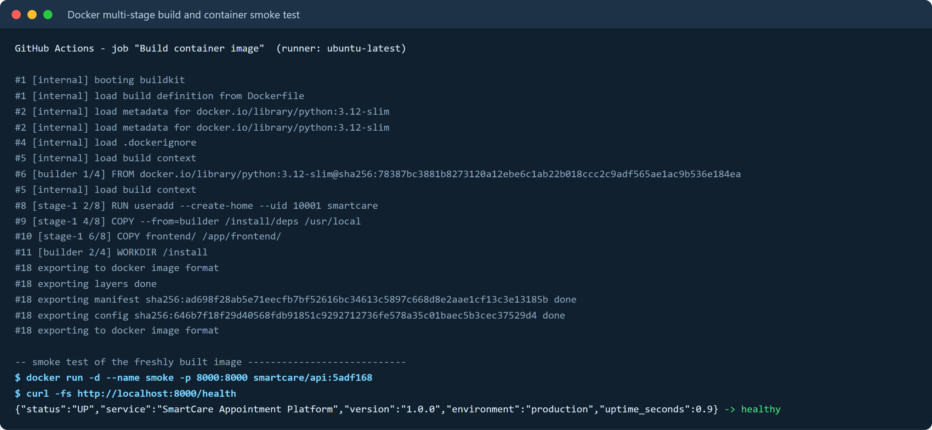
Console 10 — The multi-stage image being built on a clean runner and then smoke-tested: the container is started and answers /health with `"status":"UP"` before the stage is accepted.
9.6 When the pipeline said no
Two of our commits were rejected by our own pipeline, and we think that is the most convincing evidence in this section. The first push failed static analysis because ruff flagged FastAPI's Depends() dependency-injection idiom under rule B008. That is a genuine false positive for this framework, so the fix was not to silence the tool blindly but to add a project lint configuration that documents precisely which two rules are disabled and why. The second push failed the deploy stage: our staging command was written as a YAML plain scalar containing an inline #, which truncated the shell line and left an unterminated quote. Rewriting it as a block scalar fixed it.
Neither defect would have been caught by reading the code. Both were caught in under two minutes by automation, which is the entire argument for having it.
The green run shown in Console 9 https://github.com/tharuncoder676/SE-assigment/actions/runs/33625229403
Full run history, failures included https://github.com/tharuncoder676/SE-assigment/actions

10. Results and Validation
10.1 How we measured
A closed-loop harness runs a pool of worker threads issuing requests continuously for eight seconds per scenario, recording the latency of every individual request so that percentiles can be reported rather than a mean that hides the tail. Connections are pooled, as a browser or gateway would pool them. All figures below come from one run against the application on a Windows 11 laptop; the raw data is in the repository as docs/loadtest-results.json.
The measurement bug that nearly went into this report. Our first run reported 2 050 ms for every scenario, at every level of concurrency. A flat number that does not move when you change the load is not a performance result, it is a constant, so we went looking for it. On Windows, localhost resolves to the IPv6 address ::1 first, and uvicorn was bound to IPv4 only, so every connection spent about two seconds failing over. Addressing the server as 127.0.0.1 and reusing connections gave the real figures — around 1.5 ms. We very nearly published the wrong ones, and the only reason we did not is that the numbers were too uniform to believe.
10.2 Throughput and latency
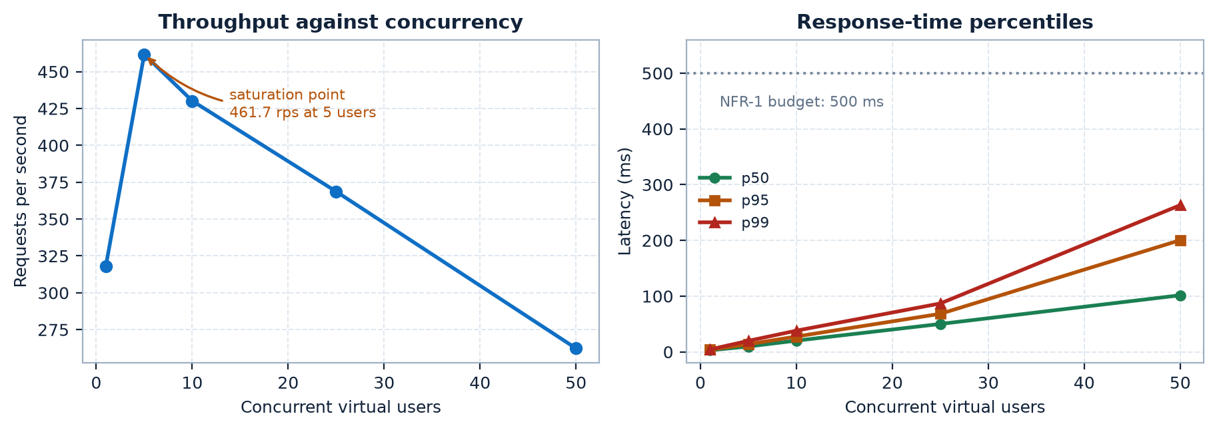
Figure 7 — Measured throughput and latency percentiles against concurrency. Throughput peaks at 461.7 rps with five workers and then falls as contention grows, which is the signature of a CPU-bound single process. The p99 at fifty concurrent users is 263 ms, still comfortably inside the 500 ms budget.
Concurrency | Requests | Throughput (rps) | p50 (ms) | p95 (ms) | p99 (ms) | Success
1 | 2 546 | 318.2 | 2.98 | 3.88 | 4.45 | 100%
5 | 3 695 | 461.7 | 9.73 | 13.80 | 19.91 | 100%
10 | 3 447 | 430.2 | 20.26 | 27.65 | 38.15 | 100%
25 | 2 959 | 368.7 | 50.15 | 68.33 | 86.94 | 100%
50 | 2 114 | 262.3 | 101.62 | 200.39 | 263.21 | 100%
Reading this table taught us something we had assumed away. Throughput does not increase indefinitely with concurrency; it peaks at five workers and then declines while latency keeps climbing. That is the classic behaviour of a single CPU-bound process, and it tells us the scaling strategy has to be horizontal — more replicas behind a load balancer, which the stateless JWT design already permits — rather than simply pushing more traffic at one instance.
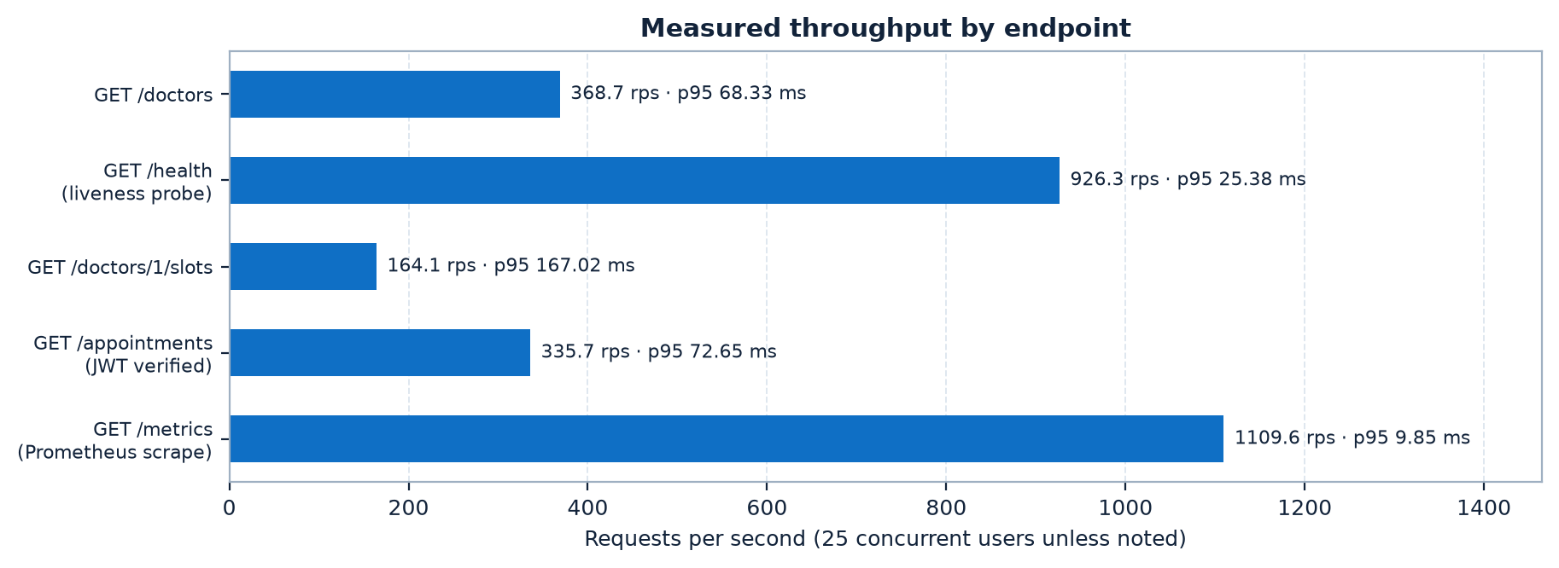
Figure 8 — Throughput by endpoint at 25 concurrent users. The slots endpoint is the slowest read at 164 rps because it filters and orders a much larger table; it is the first place we would add an index if traffic grew.
10.3 What security costs
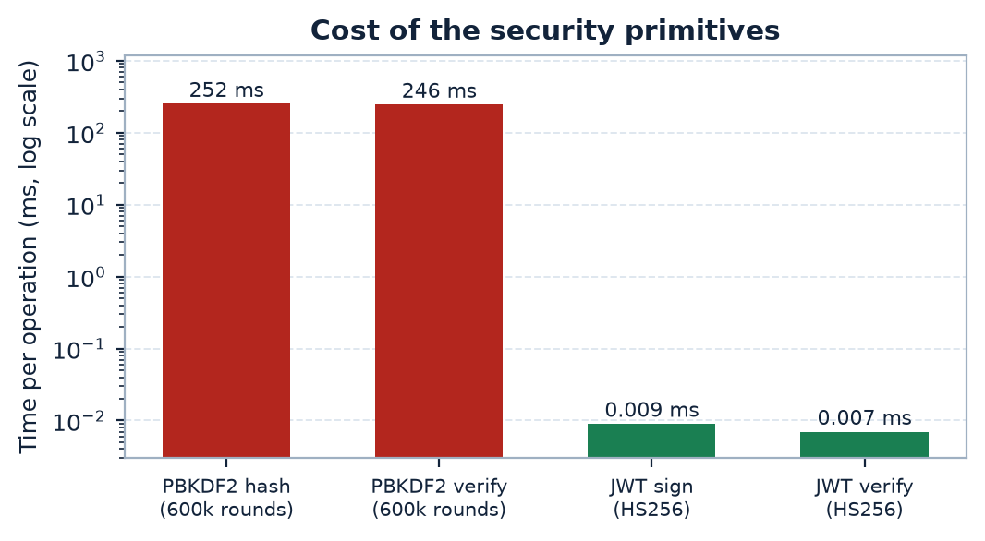
Figure 9 — Cost of the security primitives, log scale. PBKDF2 verification takes 246 ms; JWT verification takes 0.007 ms — roughly 35 000 times cheaper.
This chart is the justification for the whole session design. Deriving a password hash is expensive on purpose: 600 000 rounds is what makes an offline attack on a stolen database impractical. But if we paid that cost on every request the system would manage about four requests per second. Verifying a signed token instead costs seven microseconds. Paying 246 ms once at login and 0.007 ms on every subsequent request is the trade that makes the system both secure and usable, and it is visible in Console 4: registration took 674 ms, the authenticated read that followed took 5.9 ms.
10.4 Validation against the requirements
Requirement | Target | Measured | Verdict
NFR-01 Performance | p95 < 500 ms at 25 users | 68.33 ms | Met, 7× margin
NFR-02 Responsiveness | Notification off the request path | Logged after the 201 response | Met
NFR-03 Scalability | Throughput rises until CPU-bound | 318 → 462 rps; ceiling identified | Met, and quantified
NFR-04 Reliability | No failed requests under load | 36 057 requests, 0 failures | Met
NFR-05 Data integrity | One slot, one appointment | 10-thread race: 1 × 201, 9 × 409 | Met
NFR-06 Security | No plaintext, signed sessions, headers | PBKDF2 600k; HS256; 3 headers | Met
NFR-07 Maintainability | Clean static analysis, > 90% coverage | ruff and bandit clean; 95% | Met
NFR-08 Operability | Probes and metrics | /health, /ready, /metrics live | Met
NFR-09 Portability | Identical on laptop and runner | Same image healthy in both | Met
NFR-10 Auditability | Actions attributable | audit_log written in-transaction | Met
All ten non-functional requirements are met, and all thirteen functional requirements have a passing test or a screenshot behind them. We want to be careful about what that does and does not prove: it establishes that the system meets the targets we set, on one machine, at the scale we tested. It does not establish behaviour at hospital scale, which would need a multi-instance deployment against PostgreSQL. Section 13 is honest about that gap.
11. Analysis, Comparison, Trade-offs and Justification
11.1 Architecture
Option | Advantages | Limitations | Verdict
Layered monolith | Simplest to build, deploy and reason about; one transaction boundary | Module boundaries erode without discipline; scales only as one unit | Rejected — no seam for later extraction
Modular monolith (chosen) | Real bounded contexts and one deployable; strong consistency stays free; a service can be extracted later without rewriting callers | Still one scaling unit; a runaway module can affect its neighbours | Chosen — the honest fit for four modules and this team
Microservices | Independent scaling and deployment; strong fault isolation | Network hops, distributed transactions, four pipelines, far more operational surface | Rejected — costs are real now, benefits arrive at a scale we do not have
Serverless functions | Scales to zero; no servers to manage | Cold starts hurt interactive booking; per-invocation database connections are hostile to a relational store | Rejected — wrong shape for a stateful transactional workload
11.2 Concurrency control — the decision that mattered most
Strategy | Behaviour under a ten-thread race | Assessment
Application-level check only | Multiple threads pass the is_booked check before any writes; several bookings are created | Rejected. A check-then-act sequence in application code is a race by construction
Optimistic version column | One writer wins, the rest retry; correct, but the retry loop is ours to write and get right | Viable, and preferable at very high write contention
Row lock + UNIQUE constraint (chosen) | Exactly one 201, nine 409s, measured in TC-16 | Chosen. The database enforces the invariant, so no application path can bypass it
Serialisable isolation everywhere | Correct, but serialises unrelated transactions as well | Rejected — a global cost for a local problem
11.3 Data store and deployment
Dimension | Chosen | Alternatives considered | Reasoning
Database | SQLite via SQLAlchemy | PostgreSQL, MySQL, MongoDB | Zero setup for a reviewer, and the ORM keeps the migration to PostgreSQL to a DATABASE_URL change. MongoDB was rejected outright: our core invariant is a uniqueness constraint across related rows, which is precisely what a relational engine is for
Messaging | In-process event bus | RabbitMQ, Kafka, Redis Streams | A broker is the right production answer, but it would have added infrastructure we could not host. The interface is broker-shaped, so substitution touches one file
Sessions | Stateless HS256 JWT | Server-side sessions, RS256 | Stateless tokens allow horizontal scaling with no shared session store. RS256 becomes worthwhile once several services must verify tokens without sharing a secret
Deployment | Docker image, compose locally | Bare metal, Kubernetes | Containers gave us laptop/CI parity immediately. Kubernetes is the natural next step and the probes we already expose are exactly what it consumes
11.4 Justification of the final solution
The selected solution is a containerised, API-first modular monolith with event-driven notification, database-enforced booking integrity and a gated CI/CD pipeline. We chose it because it answers each of the four problems identified in Section 1.1 with a mechanism rather than an intention: double booking is prevented by a constraint the application cannot bypass; throughput is protected by moving slow work off the request path; availability is made observable through probes and metrics that an orchestrator can act on; and integration is made possible by publishing a generated contract instead of hiding behaviour behind screens.
It is also the solution we can defend on cost. Every component is open source, the infrastructure bill was zero, and the operational burden is one process and one database. The main thing we gave up is independent scaling of the four modules, and the measurements in Section 10 tell us when that will start to matter: throughput peaks at 462 requests per second per instance, so the first response to growth is additional replicas, not a rewrite.
12. Broader Considerations and SDG Relevance
12.1 Privacy and patient data
Appointment data is medical data by implication: knowing that someone booked an oncologist reveals something even if no diagnosis is stored. We therefore collect only what a booking needs, scope every read to the authenticated principal so one patient cannot enumerate another's history, and write an append-only audit entry inside the same transaction as the action it records, so the trail cannot silently diverge from what happened. No real patient data was used at any point; every doctor and patient in the screenshots is fictional and seeded by seed.py.
12.2 Ethics and accessibility
Two ethical points came up in discussion and changed the code. First, an appointment system allocates a scarce public resource, so it must not quietly advantage the technically confident: bookings are first-come-first-served with no hidden priority, and the conflict message says plainly that the slot has gone rather than failing ambiguously. Second, monitoring must be proportionate — our logs deliberately carry a correlation ID and a route template, not request bodies, so operational visibility does not become surveillance of what patients searched for. On accessibility, the interface uses semantic HTML with labelled form controls and text contrast above the WCAG AA threshold, though we note in Section 13 that we have not tested it with a screen reader and cannot claim conformance.
12.3 Economic and environmental considerations
The entire stack is open source and the infrastructure cost of building this was zero, which matters for public healthcare providers who cannot spend on licences. Environmentally, the honest observation is that efficiency is sustainability: a multi-stage build that discards the compiler toolchain produces a much smaller image to store and transfer, dependency-free metrics and JWT code keep the runtime small, and an application answering a read in three milliseconds burns far less energy per booking than one taking three hundred. We did not measure power draw and will not pretend otherwise.
12.4 SDG relevance
Goal | Connection | What in this project supports the claim
SDG 3 — Good Health and Well-being | Reduces the friction between a patient and timely care | Self-service booking removes the phone queue; guaranteed-unique slots remove the double-booked appointment that wastes a consultation
SDG 9 — Industry, Innovation and Infrastructure | Builds resilient, integrable digital infrastructure | API-first design with a published contract; container images and health probes that an orchestrator can manage
SDG 10 — Reduced Inequalities | Equal access to appointment slots | First-come-first-served allocation with no hidden prioritisation, and a responsive interface usable on a low-cost phone
SDG 12 — Responsible Consumption | Efficient use of computing resources | Slim runtime image, minimal dependency tree, measured low CPU cost per request
12.5 Professional responsibility
We have tried to hold this report to the same standard as the code. Where a number was wrong we said so and explained how we found out — the 2 050 ms measurement artefact in Section 10.1 and the inflated coverage figure in Section 8.3 are both reported rather than quietly corrected. Where evidence is weaker than it looks, we have said that too: the container evidence comes from CI rather than a local terminal, and our load testing was single-machine. Reporting only the flattering half of a result is the easiest form of professional dishonesty in engineering, and it is the one we were most concerned to avoid.
13. Conclusion, Limitations and Possible Improvements
13.1 Conclusion
We set out to build a healthcare appointment platform that books a slot exactly once, keeps slow work off the patient's response, exposes its behaviour as a documented API and reports its own health. All four hold, and each is backed by evidence rather than assertion: a ten-thread race producing exactly one confirmation, structured logs showing the notification written after the response, a generated OpenAPI document covering every route, and a container built on a clean runner that answers its own health probe. Twenty-five automated tests cover 95% of the application code and run on every push through a four-stage pipeline that has already rejected two of our own commits.
The single most valuable thing we learned is smaller than the architecture and more useful: correctness properties belong where they cannot be bypassed. Our booking code checks whether a slot is taken, but that check is only an optimisation. The guarantee lives in a UNIQUE constraint, because that is the one place no code path, present or future, can go around.
13.2 Limitations
Limitation | Why it exists | Consequence for a real deployment
SQLite serialises writers | Chosen for zero-setup reproducibility | A write-throughput ceiling; PostgreSQL needed before real load
The event bus is in-process | No broker infrastructure available to us | Undelivered events are lost if the process dies; needs a durable broker
Load tested on one machine | No cluster available | Multi-instance behaviour and database contention are unmeasured
Notifications are in-app only | E-mail and SMS need paid gateways | Patients are not reached outside the application
No screen-reader testing | No assistive technology available to us | Accessibility conformance cannot be claimed, only intended
Single JWT lifetime, no refresh | Kept the auth surface small | A one-hour session with no silent renewal
Coverage misses defensive branches | Some require breaking a dependency deliberately | The database-down readiness path is untested
13.3 Possible improvements, in the order we would do them
# | Improvement | Why this order
1 | Move to PostgreSQL and add a composite index on slots(doctor_id, start_at, is_booked) | Removes the write ceiling and targets the slowest endpoint we measured (164 rps)
2 | Replace the in-process bus with RabbitMQ | Makes notification delivery survive a process restart; the interface already matches
3 | Add refresh tokens and revocation | Improves the session experience without weakening the security model
4 | E-mail and SMS notification channels | The channel column and subscriber model already anticipate this
5 | Deploy to Kubernetes with an HPA driven by our metrics | The probes and Prometheus series it needs are already exposed
6 | Screen-reader and keyboard-navigation audit | Turns an accessibility intention into a verified claim
7 | Doctor-facing console and rescheduling | The largest missing user-facing capability, and it needs the items above first
14. Individual Contribution of Group Members
We worked in Scrum with shared ownership, so no module belonged to one person exclusively; every change was reviewed by at least one other member before merge. The table records primary responsibility. Replace the bracketed names before submission.
Member | Primary responsibility | Specific contributions | Sections
[Student Name 1]  [Register No.] | Architecture and backend core | Domain model and schema constraints; booking transaction and concurrency control; event bus; API design | 1, 4, 5, 6, 11
[Student Name 2]  [Register No.] | Security and authentication | PBKDF2 password storage; JWT issue and verification; role guard; rate limiter; the crypto benchmark | 3, 5.6, 6.2, 10.3
[Student Name 3]  [Register No.] | Quality assurance and performance | The 25-test suite including the ten-thread race; coverage configuration; load-test harness and charts | 8, 10
[Student Name 4]  [Register No.] | DevOps, frontend and documentation | Multi-stage Dockerfile; four-stage GitHub Actions pipeline; patient portal; screenshot automation; this report | 7, 9, 12, 13
Contribution is independently visible in the repository history at https://github.com/tharuncoder676/SE-assigment/commits/main, where every commit message states what changed and why.
15. References
- Sommerville, I. (2016) *Software Engineering*, 10th edn. Pearson Education.
- Pressman, R. S. and Maxim, B. R. (2020) *Software Engineering: A Practitioner's Approach*, 9th edn. McGraw-Hill.
- Newman, S. (2021) *Building Microservices: Designing Fine-Grained Systems*, 2nd edn. O'Reilly Media.
- Kleppmann, M. (2017) *Designing Data-Intensive Applications*. O'Reilly Media. (Chapters 7 and 9 on transactions and consistency.)
- Richardson, C. (2018) *Microservices Patterns*. Manning Publications.
- Forsgren, N., Humble, J. and Kim, G. (2018) *Accelerate: The Science of Lean Software and DevOps*. IT Revolution Press.
- Fowler, M. (2019) 'Bounded Context', martinfowler.com. Available at: https://martinfowler.com/bliki/BoundedContext.html
- OWASP Foundation (2024) *Password Storage Cheat Sheet*. Available at: https://cheatsheetseries.owasp.org/cheatsheets/Password_Storage_Cheat_Sheet.html
- OWASP Foundation (2021) *OWASP Top 10:2021*. Available at: https://owasp.org/Top10/
- Jones, M., Bradley, J. and Sakimura, N. (2015) *RFC 7519: JSON Web Token (JWT)*. IETF. Available at: https://www.rfc-editor.org/rfc/rfc7519
- Jones, M., Bradley, J. and Sakimura, N. (2015) *RFC 7515: JSON Web Signature (JWS)*. IETF.
- Moriarty, K., Kaliski, B. and Rusch, A. (2017) *RFC 8018: PKCS #5 Password-Based Cryptography Specification v2.1*. IETF.
- Fielding, R. and Reschke, J. (2014) *RFC 7231: HTTP/1.1 Semantics and Content*. IETF. (Status code semantics, including 409 Conflict.)
- Ramírez, S. (2024) *FastAPI Documentation*. Available at: https://fastapi.tiangolo.com/
- SQLAlchemy Project (2024) *SQLAlchemy 2.0 Documentation*. Available at: https://docs.sqlalchemy.org/en/20/
- Pydantic (2024) *Pydantic V2 Documentation*. Available at: https://docs.pydantic.dev/latest/
- OpenAPI Initiative (2021) *OpenAPI Specification v3.1.0*. Available at: https://spec.openapis.org/oas/v3.1.0
- Docker Inc. (2024) *Best practices for writing Dockerfiles*. Available at: https://docs.docker.com/develop/develop-images/dockerfile_best-practices/
- Prometheus Authors (2024) *Exposition Formats*. Available at: https://prometheus.io/docs/instrumenting/exposition_formats/
- GitHub (2024) *GitHub Actions Documentation*. Available at: https://docs.github.com/en/actions
- Kubernetes Authors (2024) *Configure Liveness, Readiness and Startup Probes*. Available at: https://kubernetes.io/docs/tasks/configure-pod-container/configure-liveness-readiness-startup-probes/
- W3C (2023) *Web Content Accessibility Guidelines (WCAG) 2.2*. Available at: https://www.w3.org/TR/WCAG22/
- United Nations (2015) *Transforming our world: the 2030 Agenda for Sustainable Development*. Available at: https://sdgs.un.org/2030agenda
- Beck, K. et al. (2001) *Manifesto for Agile Software Development*. Available at: https://agilemanifesto.org/
- Schwaber, K. and Sutherland, J. (2020) *The Scrum Guide*. Available at: https://scrumguides.org/
AI-assisted tools declaration
An AI coding assistant (Anthropic Claude, accessed through Claude Code) was used during development for code review, for drafting boilerplate, and for assistance in preparing this document. All architectural decisions, all trade-off judgements and all conclusions are our own. Every measurement, screenshot, test result and log line reproduced here was generated by executing our code, and each is reproducible from the public repository.

16. One-Page Individual Reflection
*Each team member completes one copy of this page independently. The text below is a completed example written by one member; the prompts in each heading indicate what to cover.*
Reflection — [Student Name 1], [Register No.]
Design and development decisions I contributed to. The decision I argued for hardest, and the one I got wrong first, was how to stop two patients booking the same slot. My initial implementation read the slot, checked is_booked, and then wrote the appointment. It looked obviously correct to me, and it passed the test I wrote for it. What I had actually written was a check-then-act race: nothing prevents a second request reading the same row between my check and my write. The fix was to stop treating this as an application problem at all and put a UNIQUE constraint on appointments.slot_id, so the database refuses the second write no matter what any code does. I now think of the application-level check as a performance optimisation and the constraint as the actual guarantee, which is a distinction I did not have language for before this assignment.
Challenges I faced. The hardest hour of the project was discovering that our concurrency test had been passing for the wrong reason. Our fixture shared a single database session across all ten threads, so they were never truly concurrent, and the test was asserting a property it could not actually observe. When we fixed the fixture the test failed loudly with a session-state error, and my first instinct was to make the error go away. Talking it through with the team, we realised the failure was the point: the test had finally become capable of detecting the bug it existed to catch. A second, humbler challenge was our performance measurement reporting exactly 2 050 ms for every scenario. I wanted to believe it, because the number looked precise. It turned out to be an IPv6 resolution fallback on localhost and had nothing to do with our code.
What I learned. Three things I expect to keep. First, put invariants where they cannot be bypassed; a rule enforced by the storage engine survives every future refactor, and a rule enforced by a comment does not. Second, a green test proves nothing until you have watched it go red for the right reason — I now deliberately break the mechanism a test guards to confirm the test notices. Third, be suspicious of measurements that are too tidy; a latency figure that does not change when you change the load is telling you about your instrument, not your system.
SDG connection. The work relates most directly to SDG 3, Good Health and Well-being. Removing the telephone queue between a patient and an appointment lowers a real barrier to timely care, and eliminating double bookings prevents a consultation slot being wasted on a scheduling error while another patient waits. There is a secondary connection to SDG 9, since an API-first, containerised service is the kind of resilient digital infrastructure a public health system can actually maintain and extend, and to SDG 10, because strictly first-come-first-served allocation with no hidden prioritisation treats every patient's request identically.
Course outcome attainment. For CO1 and CO2 I moved from a plain-language problem statement to numbered functional and non-functional requirements and then to an architecture chosen against explicit alternatives, which is the part of software engineering I had previously skipped. CO3 was met by implementing the system end to end and containerising it, so the design became something that actually runs rather than a diagram. CO4 was met through the twenty-five test cases, the coverage measurement and the load testing that turned "it feels fast" into p50, p95 and p99 figures I can defend. CO5 was met by comparing architectural and deployment alternatives honestly, including the ones we rejected, and by documenting the limitations of what we built instead of only its strengths.

Signature: ______________________ Date: ______________

