Statistics with R Programming
Course Code: ITA04 | Programs 1 – 5

Program 1
Question: Create numeric, character, and logical vectors and display type and content.
Code:
numbers <- c(10, 20, 30, 40, 50)
names <- c("Alice", "Bob", "Charlie", "Diana", "Ethan")
flags <- c(TRUE, FALSE, TRUE, FALSE, TRUE)

print(numbers)
print(class(numbers))

print(names)
print(class(names))

print(flags)
print(class(flags))
Output:
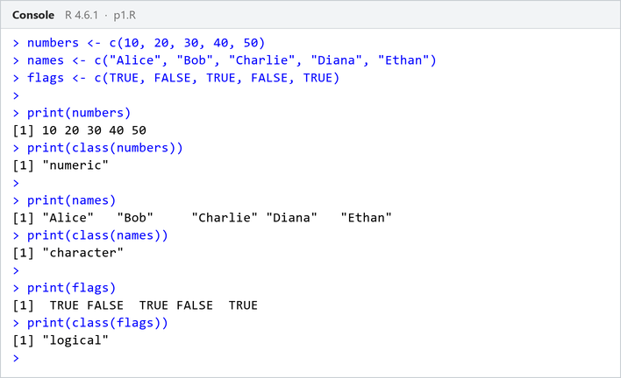

Program 2
Question: Create labeled matrices (5×4, 3×3, 2×2) filled by row/column.
Code:
matrix_5x4 <- matrix(
1:20,
nrow = 5,
byrow = TRUE,
dimnames = list(
paste0("Row", 1:5),
paste0("Column", 1:4)
)
)

matrix_3x3 <- matrix(
1:9,
nrow = 3,
byrow = FALSE,
dimnames = list(
paste0("Row", 1:3),
paste0("Column", 1:3)
)
)

matrix_2x2 <- matrix(
1:4,
nrow = 2,
byrow = TRUE,
dimnames = list(
paste0("Row", 1:2),
paste0("Column", 1:2)
)
)

print(matrix_5x4)
print(matrix_3x3)
print(matrix_2x2)
Output:
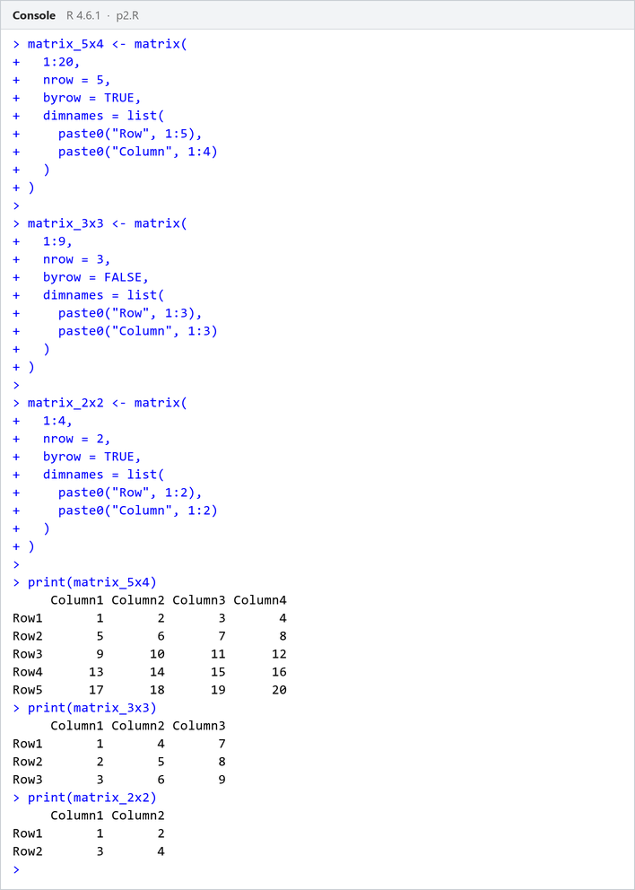

Program 3
Question: Write an R program to create and display a 3D array with specified rows, columns, and tables.
Code:
three_dimensional_array <- array(1:24, dim = c(2, 3, 4))

print(three_dimensional_array)
Output:
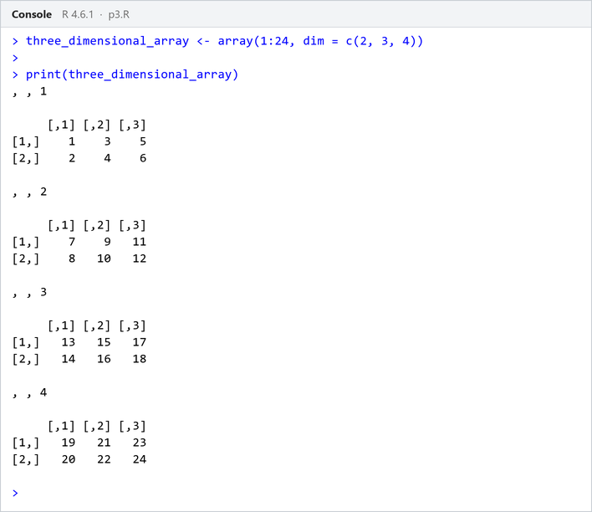

Program 4
Question: Create arrays from vectors with dimension names, print specific elements.
Code:
named_array <- array(
1:8,
dim = c(2, 2, 2),
dimnames = list(
Rows = c("R1", "R2"),
Columns = c("C1", "C2"),
Tables = c("T1", "T2")
)
)

print(named_array)
print(named_array["R2", "C1", "T2"])
Output:
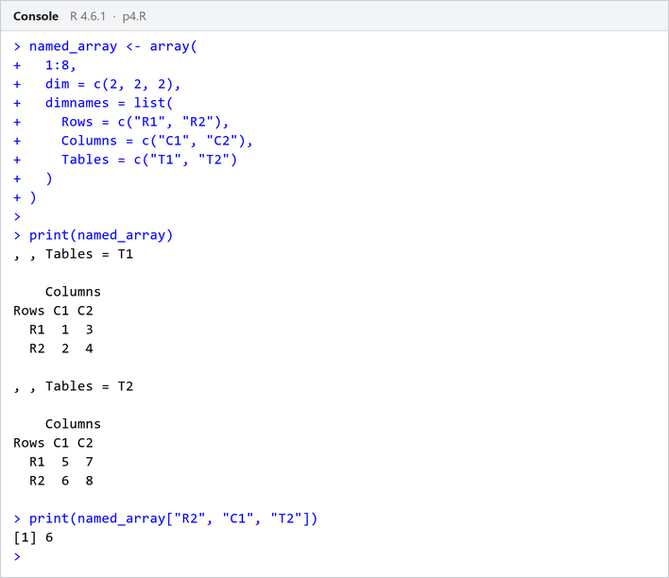

Program 5
Question: Create and manipulate factor variables (e.g., women’s dataset heights, random LETTERS sample).
Code:
height <- factor(c("Short", "Medium", "Tall", "Medium", "Tall", "Short"))
print(height)

set.seed(10)
letters_factor <- factor(sample(LETTERS[1:5], 8, replace = TRUE))
print(letters_factor)
Output:
