Statistics with R Programming
Course Code: ITA04 | Lab Programs 1 – 10

Program 1
Question: Create numeric, character, and logical vectors and display type and content.
Code:
a <- c(1, 2, 3, 4, 5, 6)
print(a)
print(paste("Type:", class(a)))
b <- c("Gokul", "Raghul", "Dhanush")
print(b)
print(paste("Type:", class(b)))
c <- c(TRUE, FALSE, TRUE, FALSE)
print(c)
print(paste("Type:", class(c)))
Output:
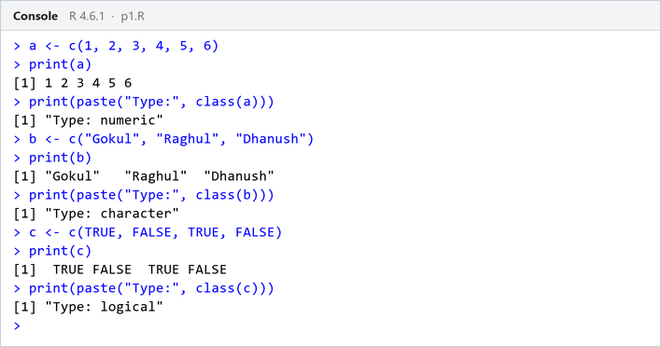

Program 2
Question: Create labeled matrices (5×4, 3×3, 2×2) filled by row/column.
Code:
a <- matrix(1:20, nrow = 5, ncol = 4, byrow = TRUE,
dimnames = list(c("R1", "R2", "R3", "R4", "R5"), c("C1", "C2", "C3", "C4")))
print(a)
b <- matrix(1:9, nrow = 3, ncol = 3,
dimnames = list(c("R1", "R2", "R3"), c("C1", "C2", "C3")))
print(b)
c <- matrix(1:4, nrow = 2, ncol = 2,
dimnames = list(c("R1", "R2"), c("C1", "C2")))
print(c)
Output:
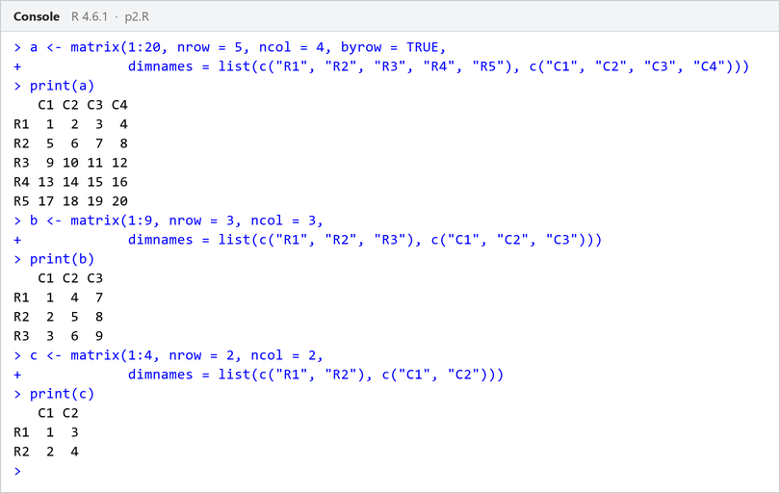

Program 3
Question: Write an R program to create and display a 3D array with specified rows, columns, and tables.
Code:
a <- 1:24
arr <- array(a, dim = c(2, 3, 4))
print(arr)
Output:
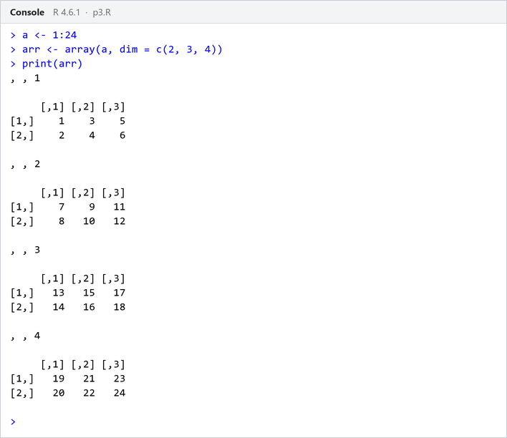

Program 4
Question: Create arrays from vectors with dimension names, print specific elements.
Code:
a <- 1:8
b <- array(a, dim = c(2, 2, 2),
dimnames = list(c("Row1", "Row2"), c("Col1", "Col2"), c("Table1", "Table2")))
print(b)
print(b[2, 1, 2])
print(b["Row1", "Col2", "Table1"])
Output:
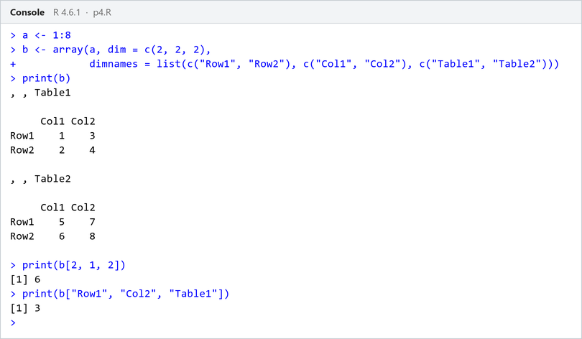

Program 5
Question: Create and manipulate factor variables (e.g., women’s dataset heights, random LETTERS sample).
Code:
a <- c("Short", "Medium", "Tall", "Medium", "Tall", "Short")
b <- factor(a)
print(b)
set.seed(10)
c <- sample(LETTERS[1:5], 8, replace = TRUE)
d <- factor(c)
print(d)
Output:
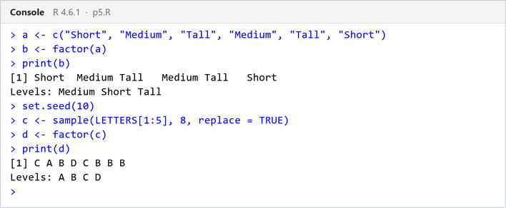

Program 6
Question: Create an R list containing vectors, matrices, and functions; display contents.
Code:
a <- c(1, 2, 3, 4)
b <- matrix(1:6, nrow = 2, ncol = 3)
c <- function(x) x^2
mylist <- list(Vector = a, Matrix = b, Function = c)
print(mylist)
Output:
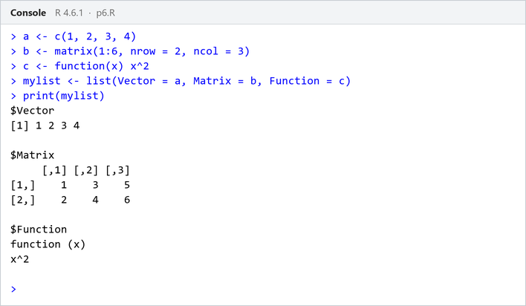

Program 7
Question: Write R programs for basic tasks: factors of a number, generate a vector of 10 random integers between -50 and 50, print numbers 1–100 with FizzBuzz logic.
Code:
n <- 12L
factors <- integer(0)
for (i in seq_len(n)) {
if (n %% i == 0L) {
factors <- c(factors, i)
}
}
print("Factors of the number:")
print(factors)
set.seed(123)
print("10 random integers:")
print(sample(-50:50, 10, replace = TRUE))
fb <- character(100)
for (i in 1:100) {
if (i %% 15 == 0) fb[i] <- "FizzBuzz"
else if (i %% 3 == 0) fb[i] <- "Fizz"
else if (i %% 5 == 0) fb[i] <- "Buzz"
else fb[i] <- i
}
print(fb, quote = FALSE)
Output:
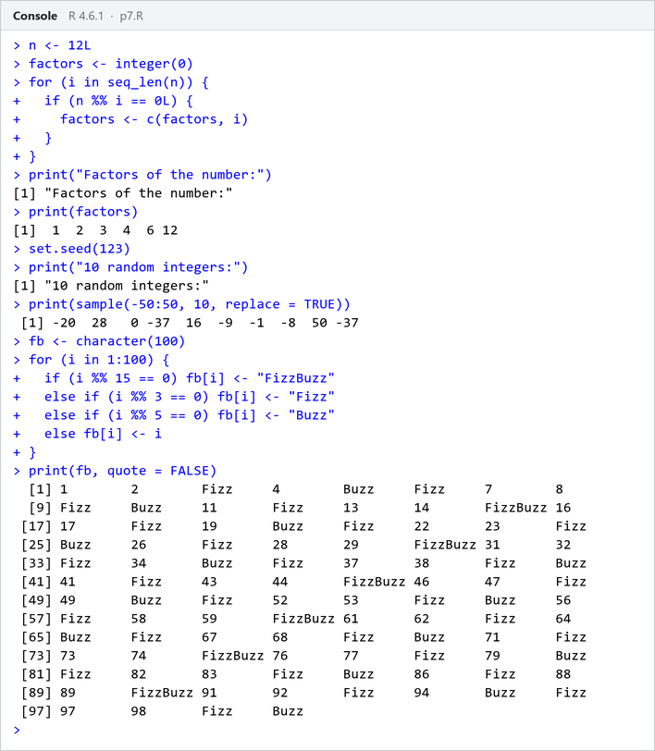

Program 8
Question: Generate random numbers from a normal distribution; count occurrences.
Code:
set.seed(123)
x <- rnorm(100)
y <- table(round(x))
print(as.data.frame(y))
Output:
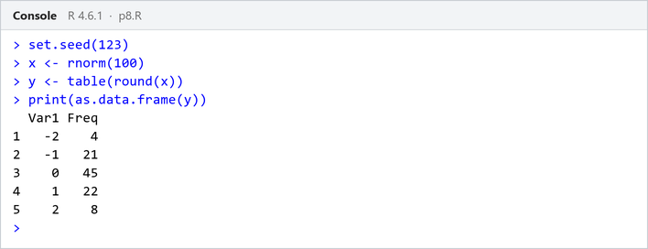

Program 9
Question: Create empty plots with specified axis limits.
Code:
plot(1, type = "n",
xlim = c(0, 10), ylim = c(0, 100),
xlab = "x axis", ylab = "y axis",
main = "Empty Plot with Axis Limits")
Output:
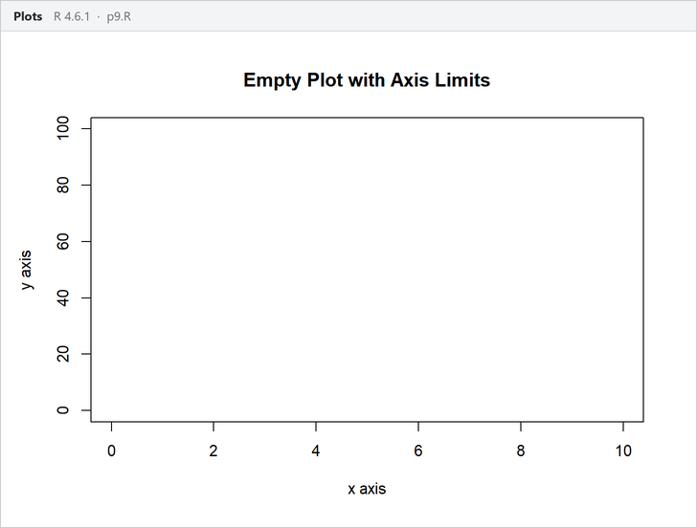

Program 10
Question: Create and explore a data frame exam_data with name, score, attempts, and qualifying fields. Perform extract, add row/column, sort, save to file.
Code:
exam_data <- data.frame(
name = c("Anu", "Bala", "Charan", "Divya", "Esha"),
score = c(85, 62, 90, 75, 88),
attempts = c(1, 3, 2, 2, 1),
qualify = c("yes", "no", "yes", "no", "yes")
)
print(exam_data)
print(exam_data[, c("name", "score")])
exam_data <- rbind(exam_data, data.frame(name = "Farhan", score = 70, attempts = 3, qualify = "no"))
exam_data$grade <- c("A", "C", "A+", "B", "A", "B")
exam_data <- exam_data[order(-exam_data$score), ]
write.csv(exam_data, "exam_data.csv", row.names = FALSE)
print(exam_data)
Output:
