CAPSTONE 9

AI-Based Power Factor Pattern Analysis and Classification
Project Report | Second-Year Electrical and Electronics Engineering
Dataset: Synthetic single-phase electrical readings | Model: Random Forest Classifier

Abstract
This project demonstrates a data-driven workflow for analyzing electrical operating intervals and classifying power-factor conditions. A synthetic dataset of voltage, current, active power, reactive power, and time/load features is generated. The dataset is cleaned, power factor is calculated, and intervals are labeled Low, Moderate, or Good using explicit project-defined thresholds. A Random Forest classifier is trained and evaluated on held-out data. A Streamlit dashboard presents power-factor trends, active/reactive power trends, flagged intervals, and a sample classification interface. Because the dataset is synthetic, the results demonstrate workflow feasibility rather than validated field performance.

1. Problem Statement and Objectives
Objective: develop a reproducible pipeline that identifies patterns in power factor and flags intervals that may warrant further engineering review.
- Generate or use safe, authorized electrical data.
- Clean missing and duplicate observations and document assumptions.
- Calculate power factor and define transparent class labels.
- Perform exploratory data analysis (EDA).
- Train and evaluate a machine-learning classifier on held-out data.
- Build a dashboard for trends, classification, and flagged intervals.

2. Dataset and Data Dictionary
The supplied CSV contains 6,003 rows before duplicate removal and 6,000 rows after duplicate removal. Readings are simulated at 15-minute intervals. A small number of missing sensor values and duplicate rows are intentionally included to demonstrate preprocessing.
Column | Meaning
timestamp | Synthetic time stamp at 15-minute intervals
voltage_V | RMS voltage in volts
current_A | RMS current in amperes
active_power_W | Active/real power in watts
reactive_power_var | Reactive power in vars
load_level | Synthetic normalized load index, 0–1
hour | Hour of day
day_of_week | Monday=0 through Sunday=6
simulated_load_type | Generator-only synthetic load category; excluded from model features
apparent_power_VA | Apparent power estimate V×I
power_factor | Reference PF value generated from active power and apparent power
pf_class | Low, Moderate, or Good label

3. Electrical Theory and Assumptions
For the single-phase approximation used here, apparent power S = V × I (VA), and power factor PF = P / S = P/(V×I). For an ideal sinusoidal inductive load, S² = P² + Q². The synthetic generator uses Q = sqrt(S² − P²). Real systems may require true-RMS measurements, three-phase formulas, waveform/harmonic considerations, and instrument-specific definitions.
Class definitions used in this project: Low if PF < 0.80; Moderate if 0.80 ≤ PF < 0.90; Good if PF ≥ 0.90. These are chosen for educational classification and are not asserted to be universal utility or regulatory limits.

4. Data Preprocessing and Feature Engineering
- Remove exact duplicate rows.
- Convert feature columns to numeric values; treat invalid values as missing.
- Calculate PF from active power divided by voltage × current; replace infinities and clip to the physically plausible [0,1] range for this synthetic dataset.
- Fill missing feature values using median imputation inside the model pipeline.
- Create class labels using the documented thresholds.
- Use voltage, current, active power, reactive power, load level, hour, and day of week as model features. Do not include the calculated PF or target label as features.

5. Model and Evaluation
A Random Forest classifier with 250 trees, a maximum depth of 12, median imputation, class weighting, and a fixed random seed is trained on 80% of the data. The remaining 20% is held out for evaluation. The split is stratified by class.
Held-out accuracy: 0.9383.
Detailed class-wise precision, recall, F1-score, and sample counts are available in outputs/classification_report.txt. The confusion matrix is included in outputs/confusion_matrix.png.
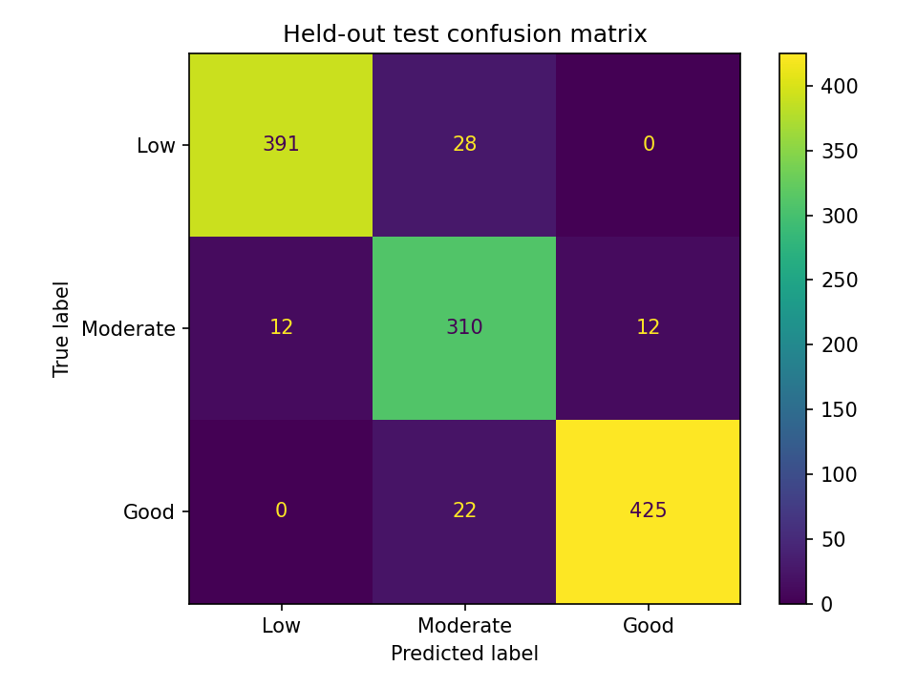

6. Exploratory Data Analysis
The histogram summarizes the distribution of the calculated PF values. The hourly trend shows simulated daily variation. These plots are descriptive and reflect the assumptions built into the synthetic generator.
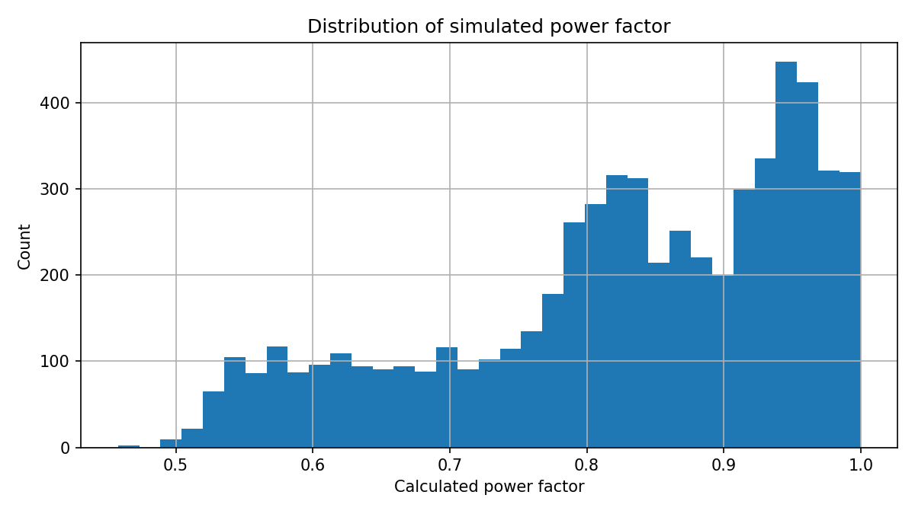
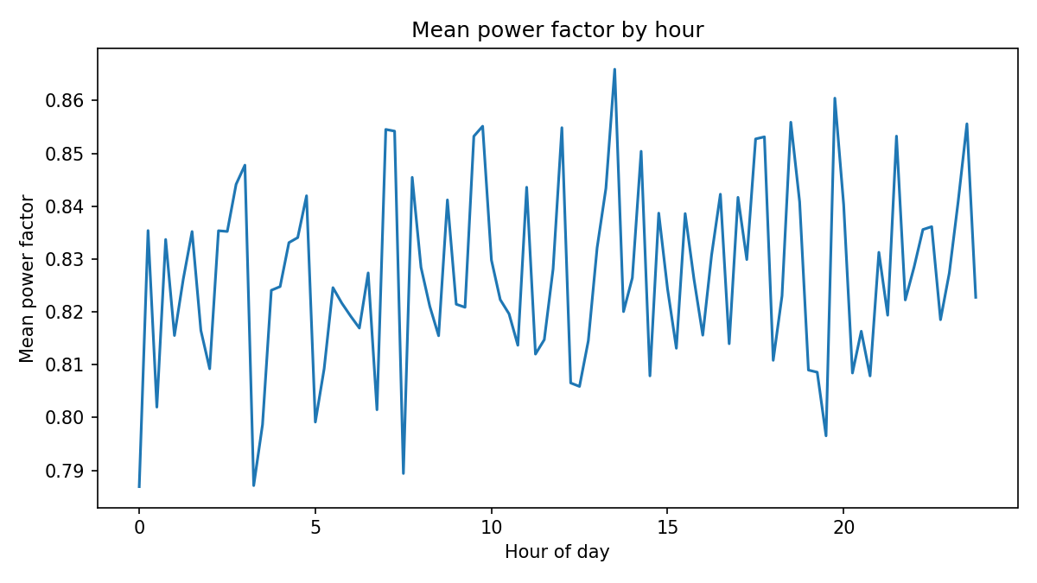

7. Dashboard
The Streamlit application provides date and class filters, key metrics, hourly power-factor trends, active/reactive power charts, class distribution, an example classification form, flagged intervals, and CSV export. Run it with: streamlit run app.py

8. Limitations
- The dataset is synthetic; it does not establish performance on real installations.
- The PF target is mathematically derived from electrical quantities. The model is therefore a proxy classifier, not a substitute for measurement.
- V, I, P, and Q are physically dependent, so strong test metrics may partly reflect the generator's built-in relationships.
- Single-phase S=V×I is an approximation; three-phase systems need the correct line/phase voltage and current relationship.
- The project does not implement a physical power-factor correction circuit and must not be used to control electrical equipment.

9. Future Work
- Validate against authorized, calibrated real measurements from a low-voltage educational setup.
- Compare Random Forest with Decision Tree, Logistic Regression, and regression models.
- Use time-aware train/test splits to better represent future prediction.
- Add drift detection, uncertainty reporting, and sensor-quality flags.
- Model capacitor compensation only mathematically, with qualified engineering review; do not connect an unsupervised circuit to mains.

10. Conclusion
The project provides an end-to-end demonstration of synthetic electrical-data generation, preprocessing, EDA, supervised classification, evaluation, and dashboard deployment. The deliverable is suitable as an educational baseline. Any claim about real-world performance requires validation using representative, authorized measurements.

References
- Scikit-learn documentation: RandomForestClassifier and model evaluation — https://scikit-learn.org/
- Pandas documentation — https://pandas.pydata.org/docs/
- Streamlit documentation — https://docs.streamlit.io/
- Basic electrical relation used in this project: PF = P/S; for the single-phase approximation, S = V×I.

