Customer_churn_prediction

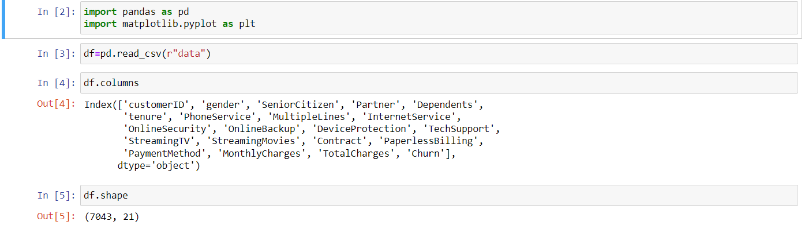

DATA VISUALIZATION



