SIMATS ENGINEERING
CO3 – ASSESSMENT TOOL 1
Experiments
Course Name: Computer Networks
Course Code: CSA0706

Course Outcome Covered
CO3: Analyze the performance of core network protocols such as TCP, UDP, HTTP, and DNS under varying conditions.
Faculty: Dr. V. Parthipan
Assessment Tool Weightage: 40%

Code of Conduct
I, M.Tharun (19252128) certify that this submission is my original work and that I have adhered to the guidelines specified for this assessment.
I understand that any violation of academic integrity rules will result in disciplinary action.
Signature of the student:
M.Tharun
Criteria | Understandingof Concepts (2.5) | ExperimentalDesign (3) | Use ofTools (2) | Analysis ofResults (1.5) | Documentation (1) | Total (10)
Q1 | 2.5 | 3 | 2 | 1.5 | 1 | 10
Q2 | 2 | 3 | 2 | 1.5 | 1 | 9.5
Q3 | 2 | 3 | 2 | 1.5 | 1 | 9.5
Q4 | 2.5 | 2 | 2 | 1.5 | 1 | 9
Faculty Signature:

Experiments
Total Marks: 40
1. Capture packets during a TCP connection setup. Identify the three packets involved in the handshake (SYN, SYN-ACK, and ACK). Demonstrate the role of each flag and how they establish a reliable connection. (BL4) (10)
2. Capture a DNS query using UDP in Wireshark. Compare the UDP header size with TCP and note the absence of sequence numbers or acknowledgments. Discuss how this lightweight design impacts speed and reliability. (BL4) (10)
.
3. Simulate packet loss (e.g., disconnect briefly) and capture traffic in Wireshark. Observe how TCP retransmits lost packets while UDP does not. Explain why this difference makes TCP reliable but slower compared to UDP. (BL4) (10)
4. Use Wireshark to capture DNS traffic while resolving a domain name. Identify the query type (A, AAAA, MX) and the response received. Measure the time taken for resolution and explain why DNS typically uses UDP. (BL4) (10)

Question 1
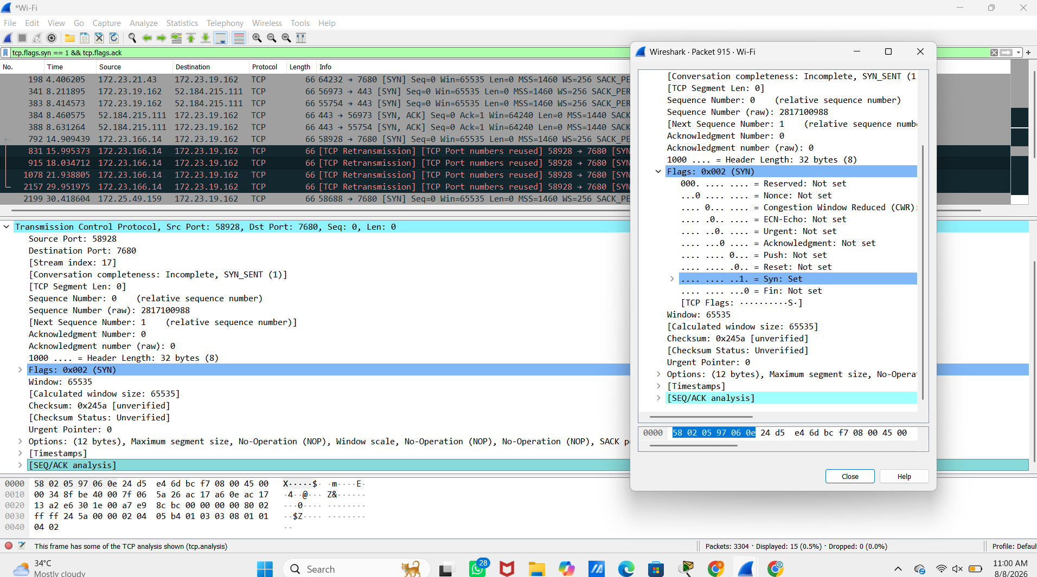
Question 2 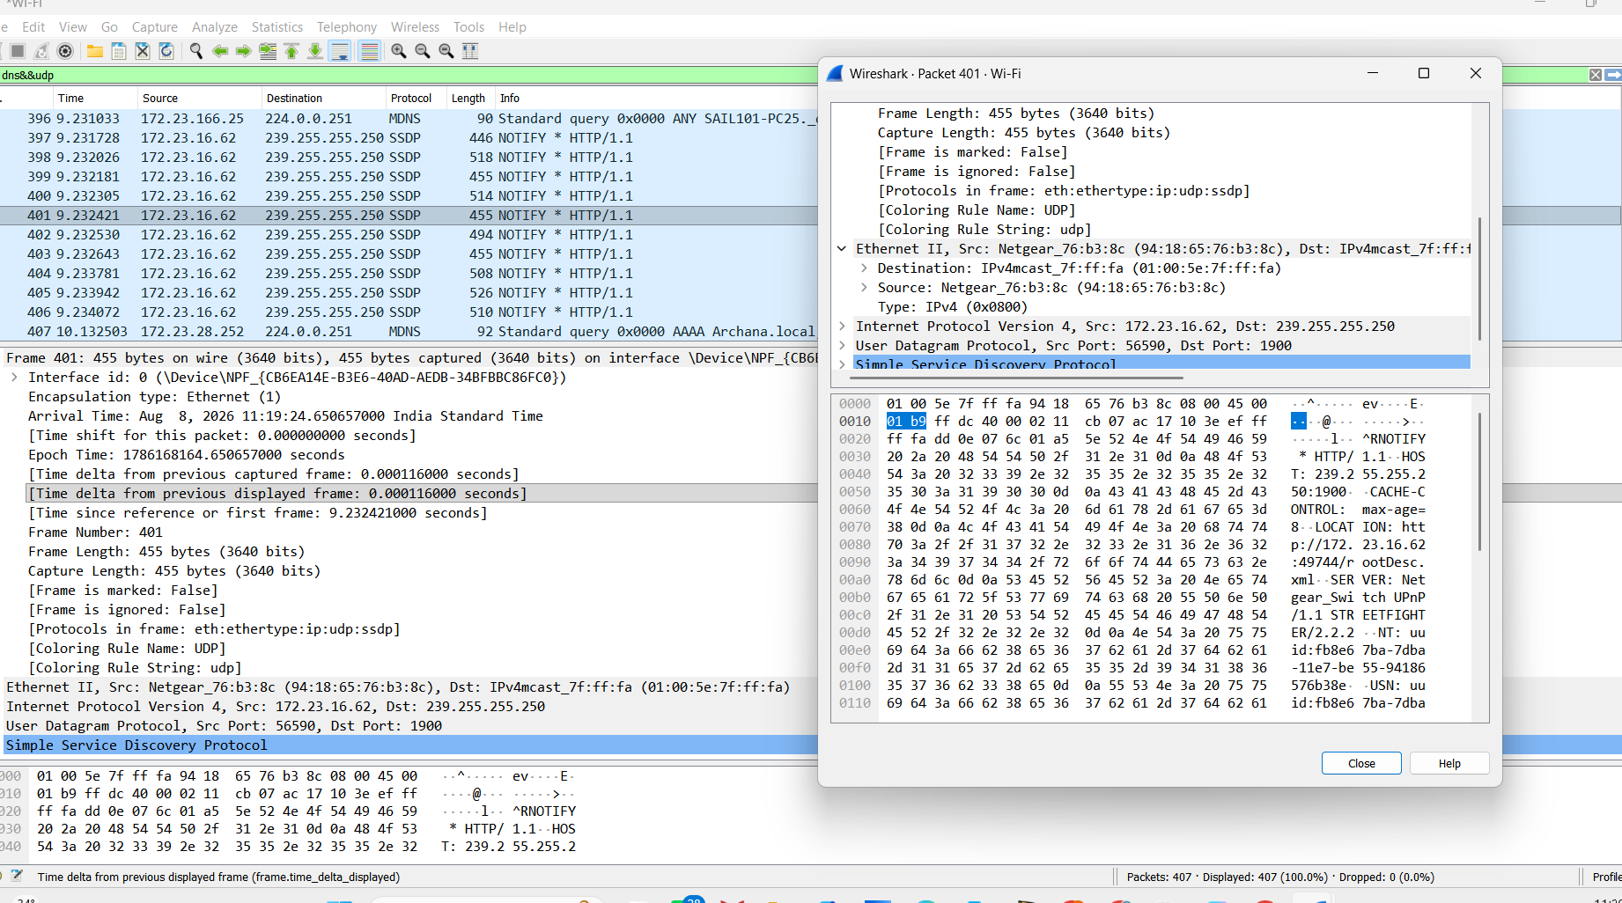
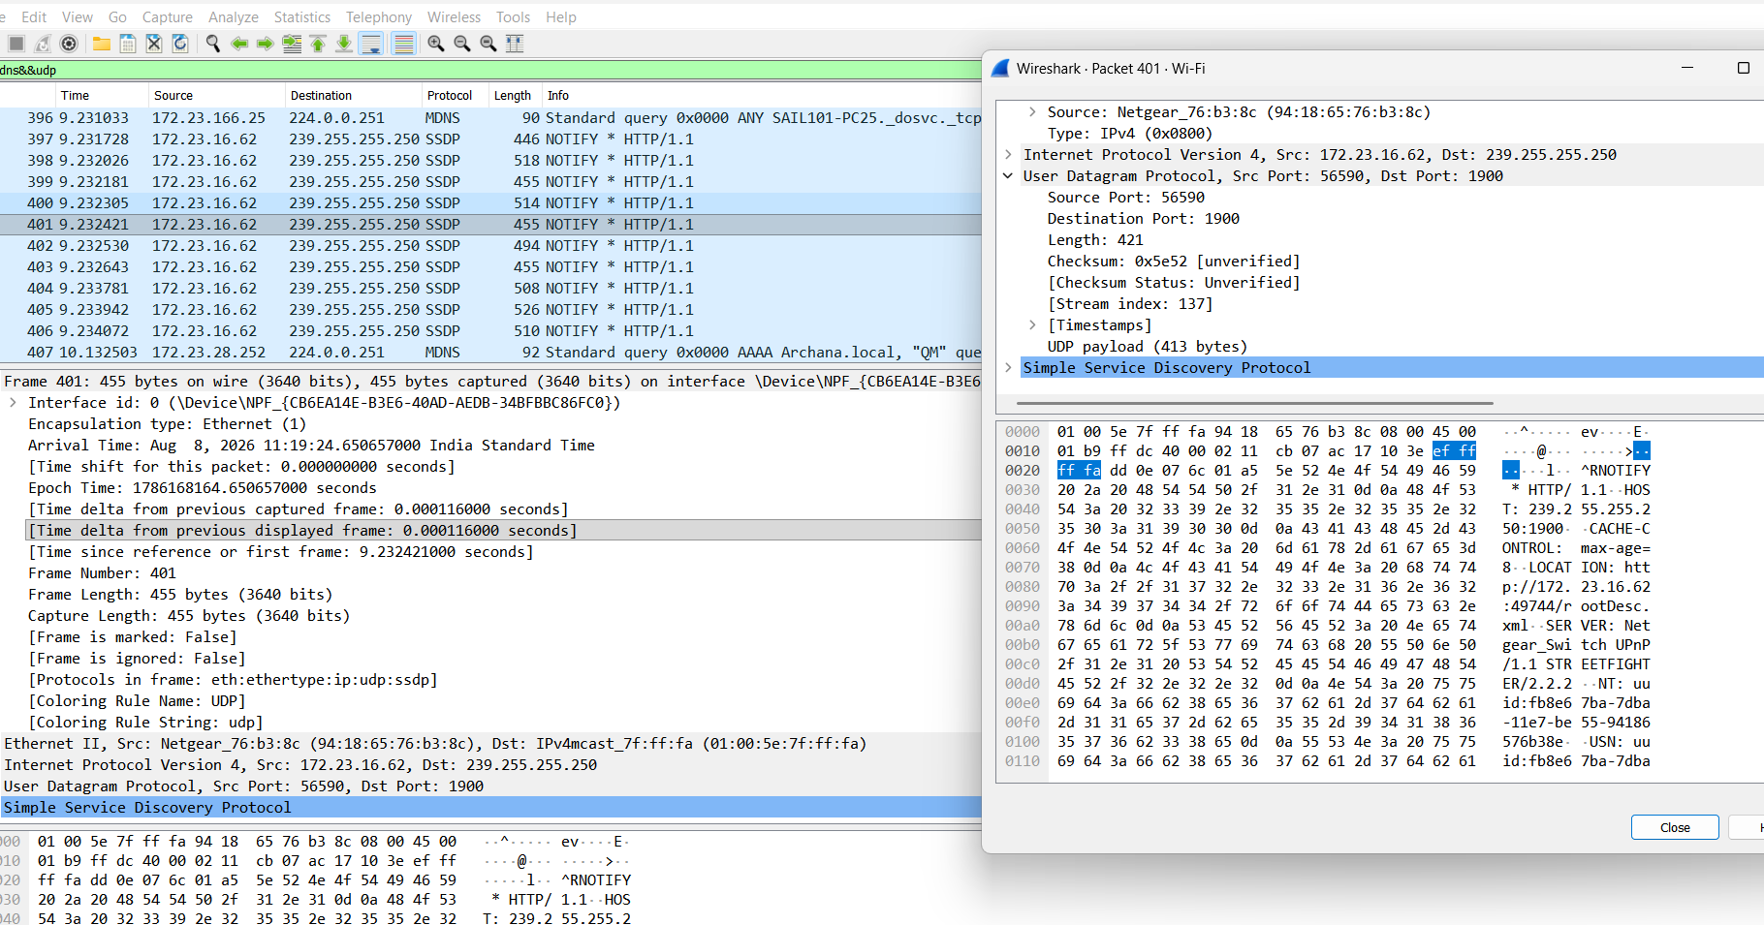

Question 3
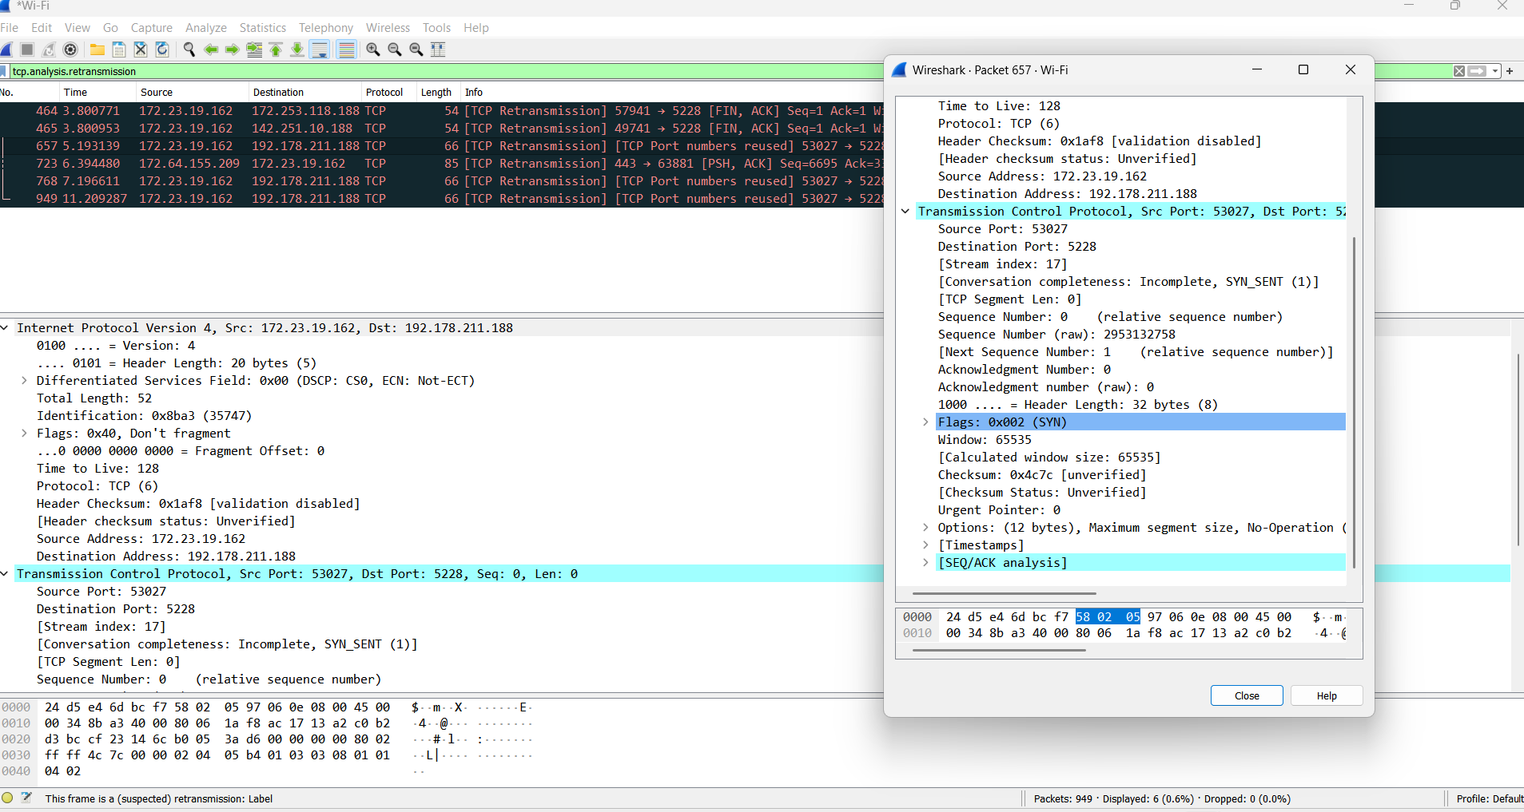

Question 4
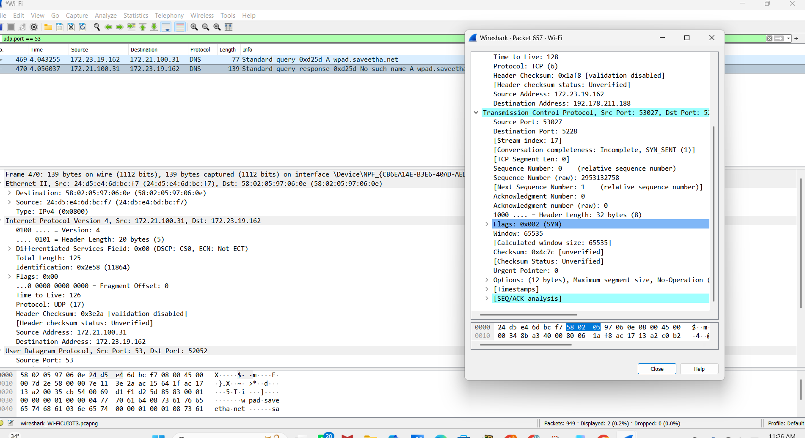

Rubrics for Calculation
Criteria | Weightage | Level 4 – Exemplary | Level 3 – Proficient | Level 2 – Developing | Level 1 – Beginning
Understanding of Concepts | 25 | Demonstrates thorough understanding and effectively integrates multiple concepts/technologies | Good understanding with proper integration of most concepts | Basic understanding; limited or partial integration | Poor understanding; unable to integrate concepts
Experimental Design | 30 | Well-planned, systematic implementation with optimal solution | Correct implementation with minor issues | Basic implementation with errors or inefficiencies | Incorrect or incomplete implementation
Use of Tools | 20 | Effective and advanced use of tools/technologies with proper configuration | Appropriate use of tools with correct execution | Limited or inconsistent use of tools | Incorrect or minimal use of tools
Analysis of Results | 15 | Insightful analysis with accurate interpretation and validation of results | Good analysis with reasonable interpretation | Basic analysis with limited insights | Poor or incorrect analysis of results
Documentation | 10 | Clear, well-structured documentation with diagrams, code, and results | Organized documentation with necessary details | Basic documentation with missing details | Poor or incomplete documentation

