1. Set **JAVA_HOME** in Environment Variables. **Sample: C:\Program Files\Java\jdk1.8.0_161**
2. Download and install Android Studio, if you want to use Emulators, in this test I have used real device.
3. Set **ANDROID_HOME** in Environment Variable **Sample: C:\Users\tharun\AppData\Local\Android\sdk**
4. Make sure you have **SDK Platform Tools** installed. It can be downloaded from here <https://developer.android.com/studio/releases/platform-tools>
5. Connect your real device to your PC with USB debugging ON
6. Now find out the device ID and device name for the device which you will use for testing
7. Device name can be found it the **Phone Setting** and for DeviceID, Open **adb.exe** from the **SDK Platform Tools** in command prompt and enter the following command: **adb devices**. This will return the device ID for the connected device and it current status.
8. Download and install Appium from the following link <https://github.com/appium/appium-desktop/releases/tag/v1.13.0>
9. Open Appium application after installation and click on the start server button

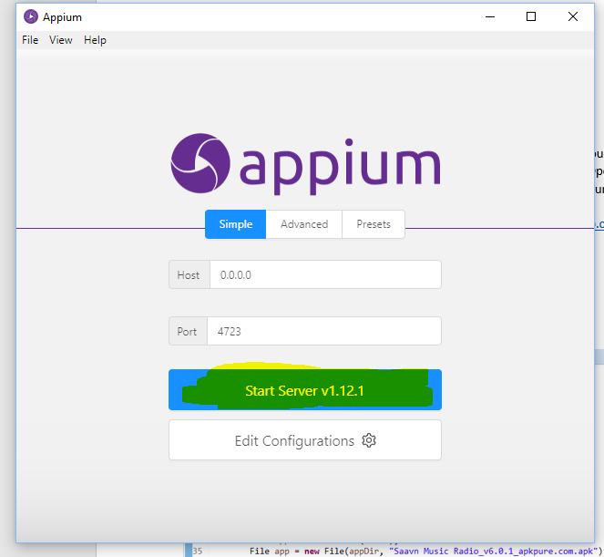

1. Verify Appium is up and running

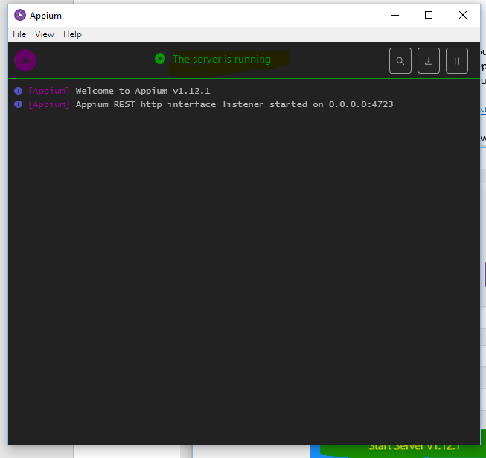

1. Now Open the MobileAutomation Project in eclipse replace the Device name and device ID in the Test Scripts

**Onboarding Script:**

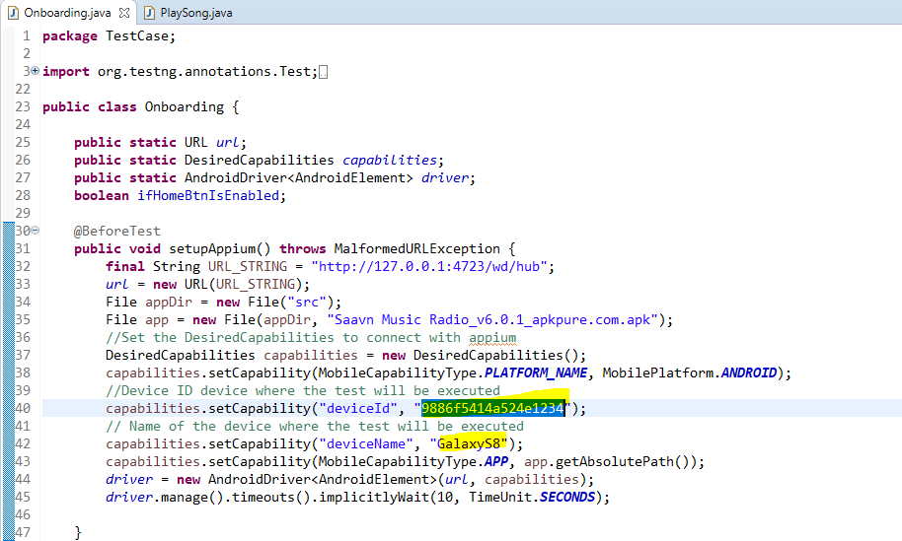

**PlaySong Script:**

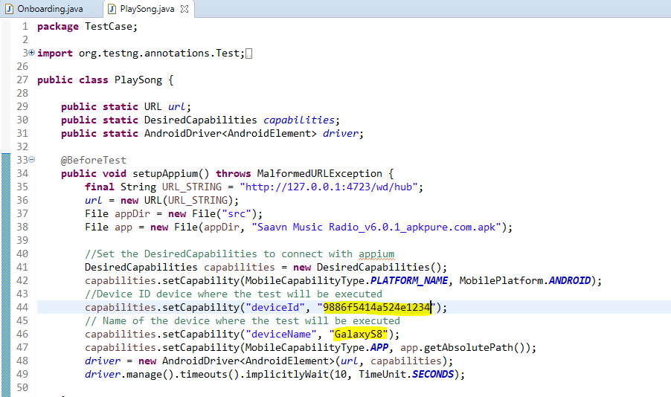

1. Now right click on the testing.xml file

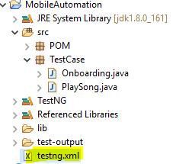

1. Now select Run As > TestNG Suite. This should start running the script one by one.