**PHASE 3: Development Part 1**

In this part we have to begin building our project. We have to start building the image recognition system using IBM cloud account

**Steps:**

1. Create an IBM account.
2. Set up the visual recognition service
3. Obtain API keys

**Implementation:**

**1.Creating an IBM account**

Using the IBM feature code provide in the skill up online create an IBM account. First step for the account creation is the account information, provide this space with the email address and a specific password for the IBM account.

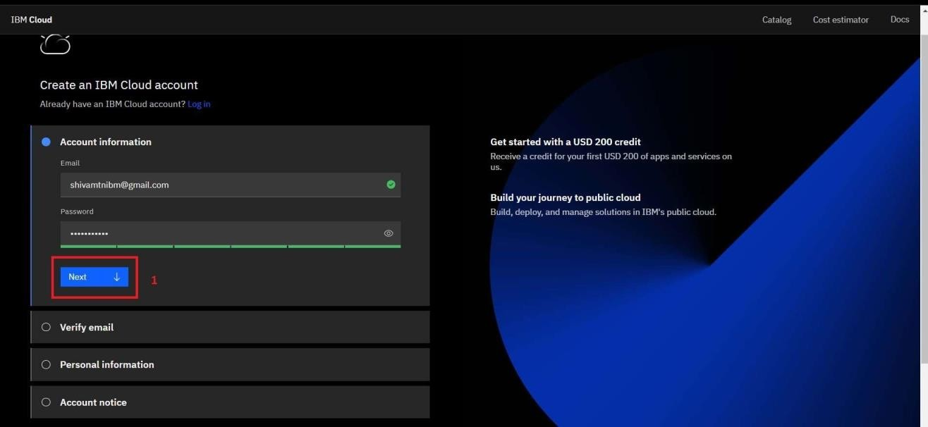

After providing the email address and the password a verifictaion code will be sent to the gmail account provide the code obtained form the mail in the box given and verify your account.

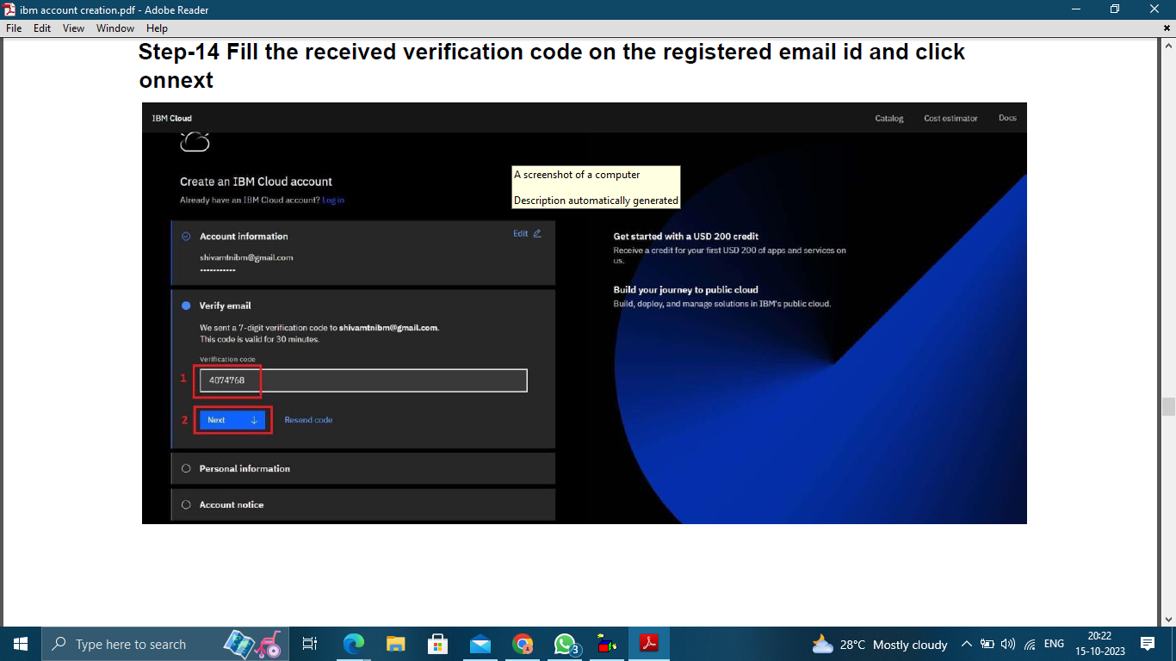

After account verification provide your personal information such as first name, last name and country.

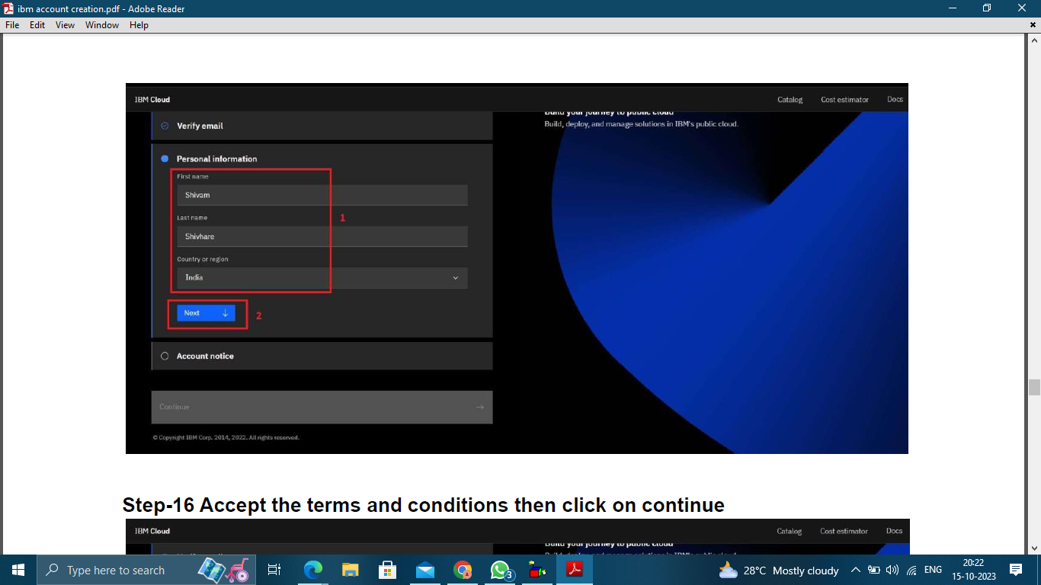

Accept the terms and conditions provided by the IBM cloud after reading them carefully. Click the continue button to go to the next step.

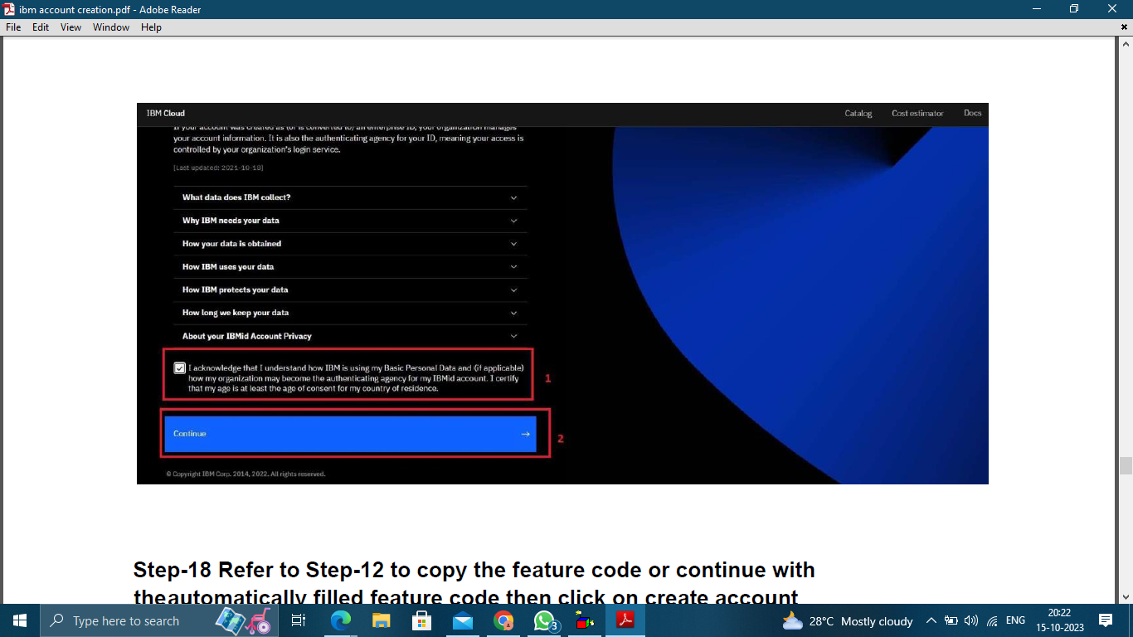

Provide the ‘Enter code’ section with the trial code obtained from the skill up account

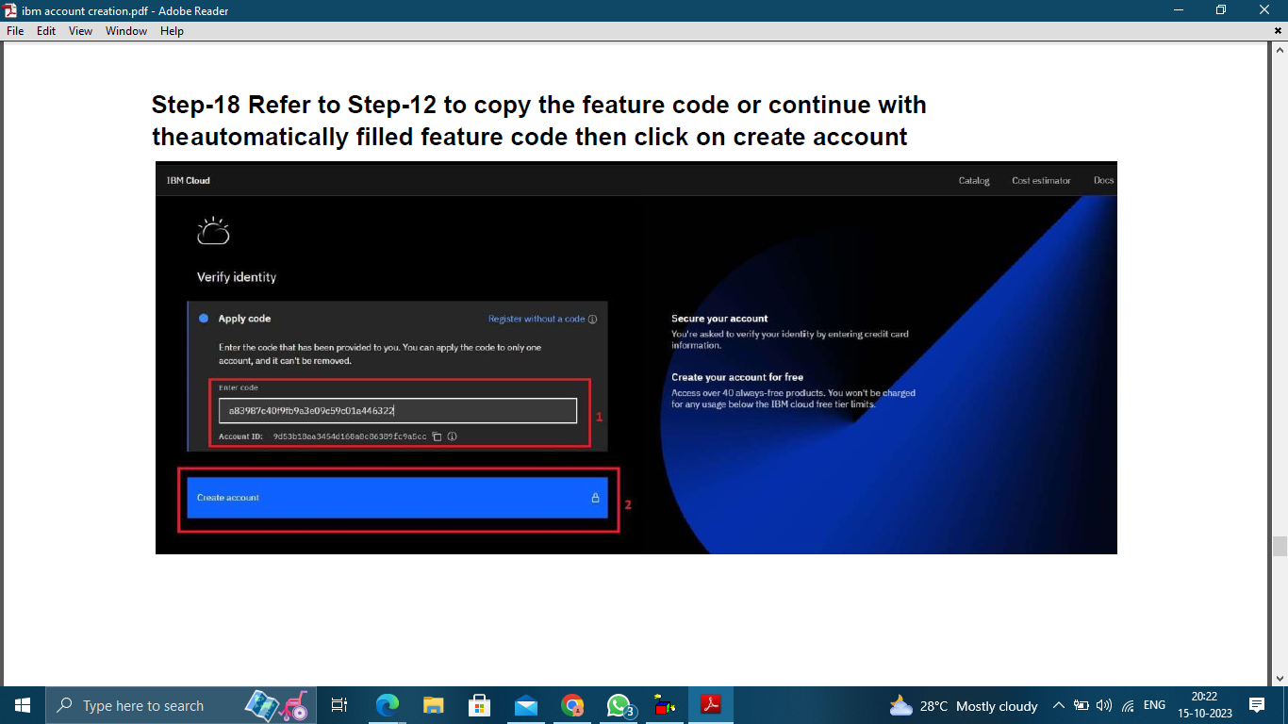

After the account creation process you will be led to the dashboard.

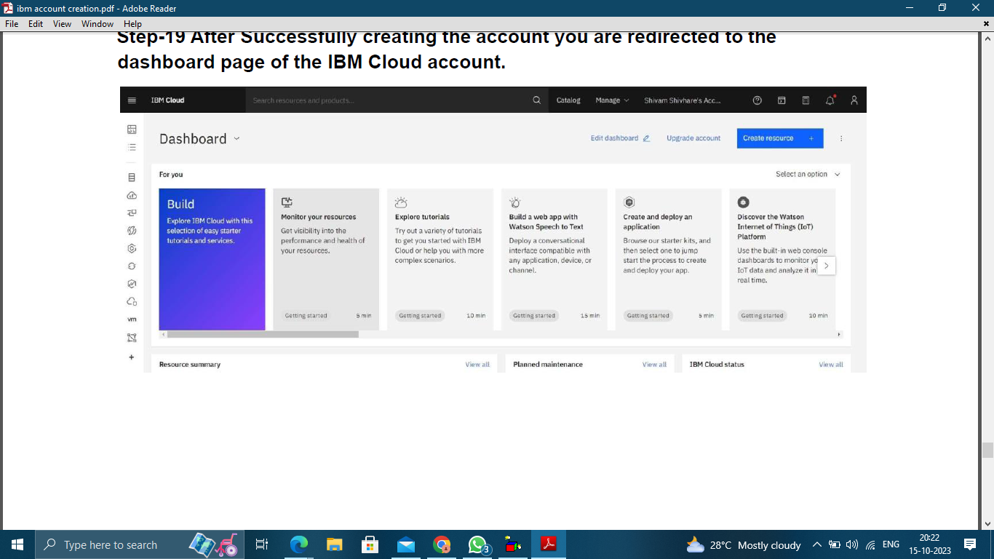

**2. Setting up visual recognition**

Create a Visual Recognition and Watson Studio Resource from the AI option provided in the IBM cloud.

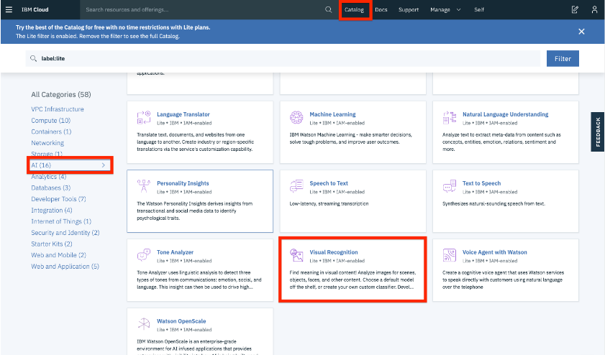

Click the Get Started button to start using Watson Studio.



Once you land on the IBM Watson Studio main page, start by creating a project.

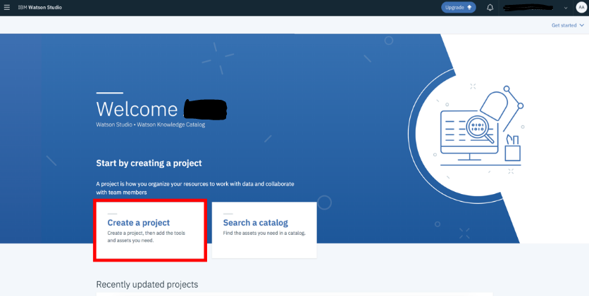

Choose create empty project.

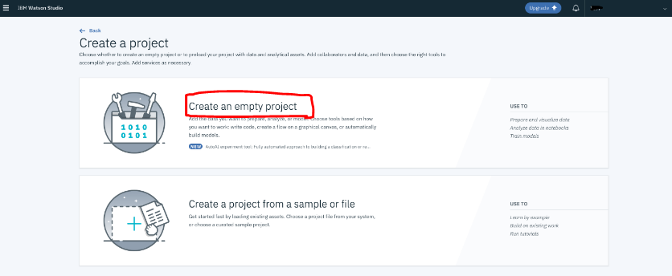

Go to Add to project and choose Image classification.

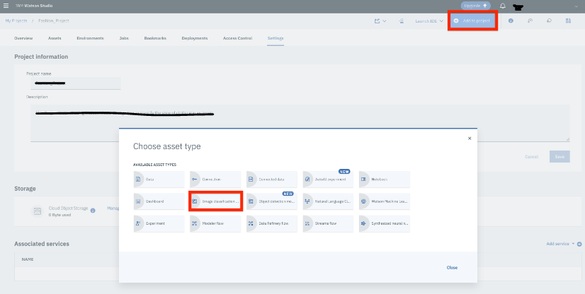

Select Built-in Models for Watson Visual Recognition.

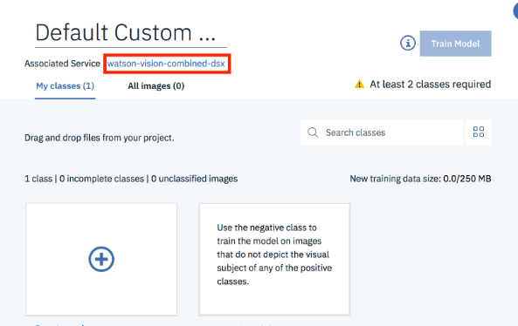

**3.Obtaining API keys**

After setting up the Watson visual recognition in IBM cloud go to the API keys section. In the API section click on the create an IBM cloud API key button

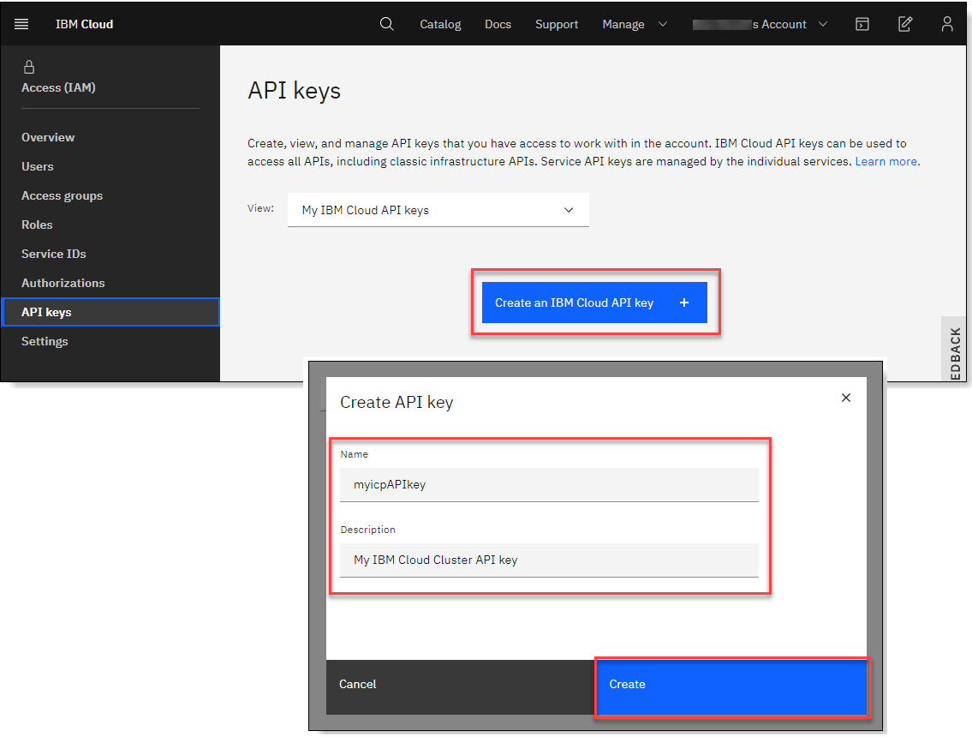

After clicking on the create button give fill the boxes provided with the name and the description of the image that you are going to classify.



After providing all the necessary details click on the create button. Click download

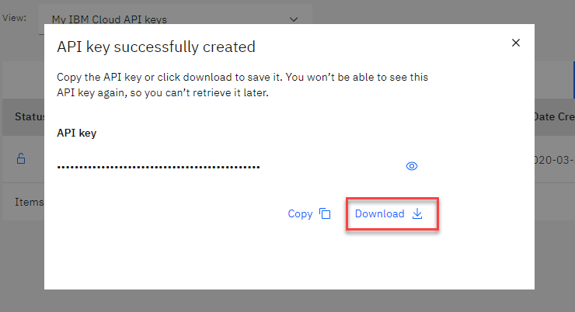

Thus the development part 1 for the image recognition using IBM cloud visual recognition is done and documented successfully.