**Image Recognition with IBM Cloud Visual Recognition**

**Phase 4: Development Part 2**

In this part we will continue building our image recognition system by

* Integrating IBM Cloud Visual Recognition and AI-generated captions.
* Implement the image classification process using the IBM Cloud Visual Recognition API.
* Use natural language generation to create captions for the recognized images.

**Steps:**

**Integrating IBM Cloud Visual Recognition and AI-generated captions:**

**1) Set Up an IBM Cloud Account:**

The first step of the project is to create an IBM cloud account. If you don't have an IBM Cloud account, sign up for one. You will need an account to access IBM Cloud services. As we have already created an account in the development phase1 we just need to sign in to the account.

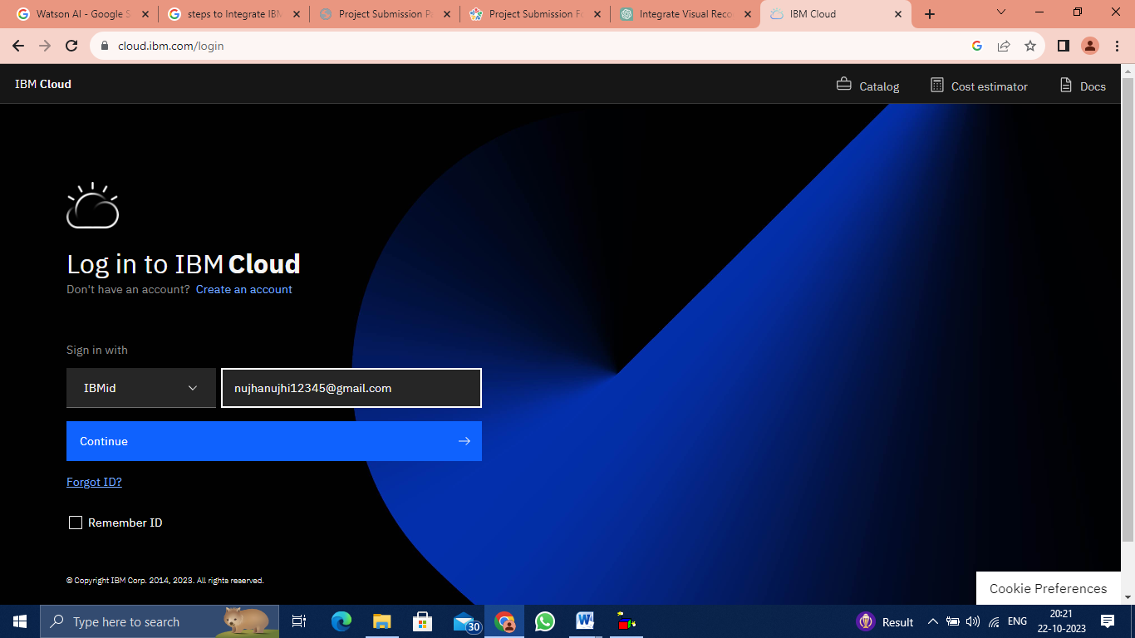

**2) Access IBM Cloud Visual Recognition:**

Once you have an IBM Cloud account, log in to the IBM Cloud console and navigate to the Visual Recognition service. If you don't see it, you may need to create an instance of this service. Use the Visual Recognition service to create a custom classifier or model for the specific types of images you want to analyse and generate captions for. Train this model with relevant image data.

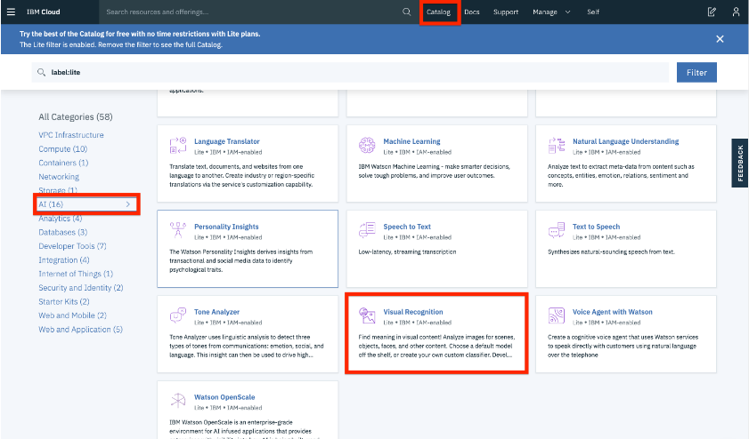

**3) Set Up an AI Caption Generator:**

You'll need a separate AI model or service for generating captions from the analysed images. This AI model can be developed using deep learning techniques, such as using neural networks and natural language processing. You can create a custom model or use pre-trained models, such as those available in the Hugging Face Transformers library. Train your AI caption generator with a dataset of images and corresponding captions. The dataset should ideally be relevant to the type of images you'll be analysing.

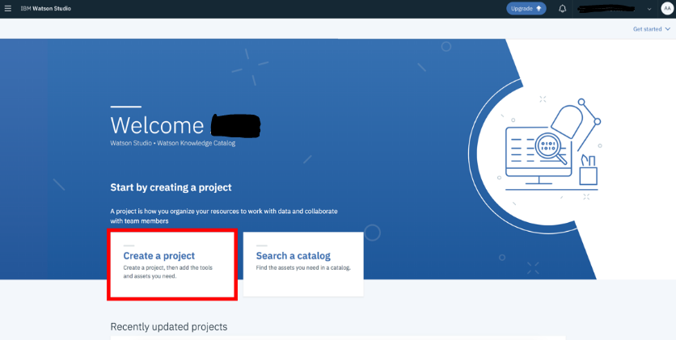

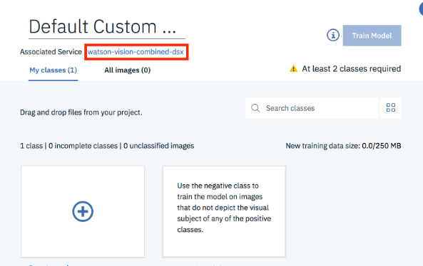

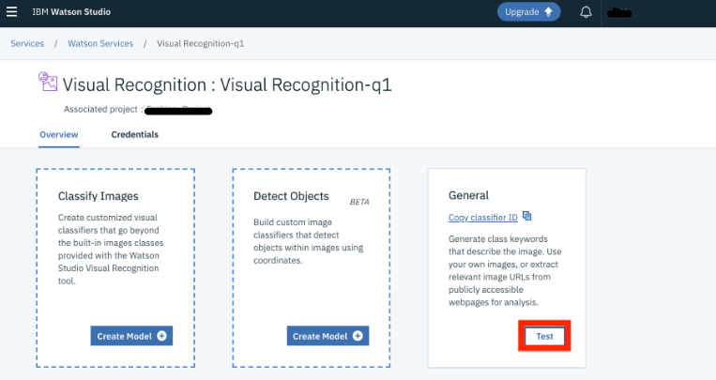

**Implement the image classification process using the IBM Cloud Visual Recognition API:**

**4) Set Up API Access:**

Both the Visual Recognition service and the AI caption generator will likely offer APIs for programmatic access. Set up API access for both services. You'll need API keys or credentials for authentication. Create a script or application that uses the Visual Recognition service to analyse images. When you analyse an image, the service will return labels or tags that describe the contents of the image.

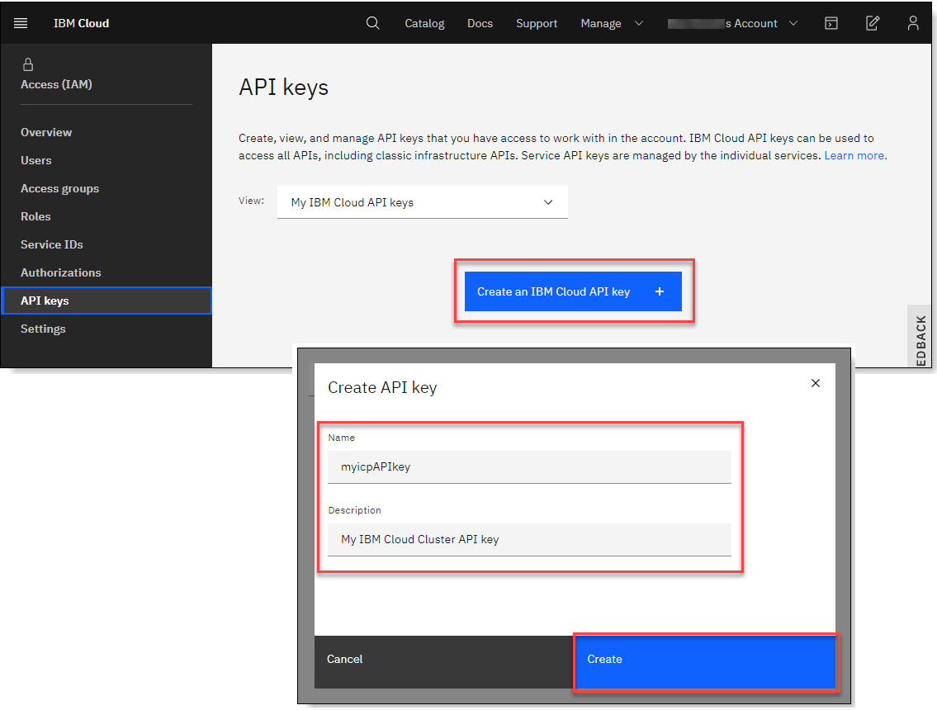



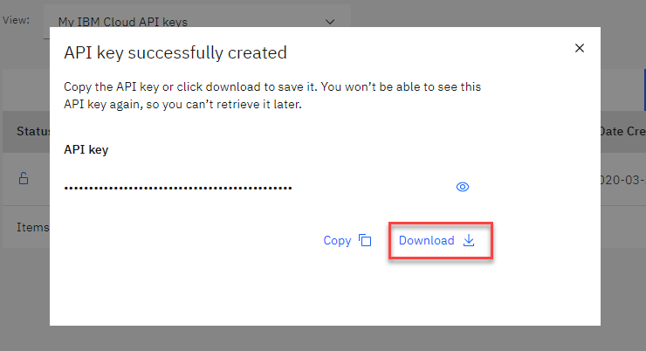

**Use natural language generation to create captions for the recognized images:**

**5) Pass Image Data to Caption Generator:**

After receiving labels or tags from the Visual Recognition service, pass this information, along with the original image, to your AI caption generator. The generator should use the labels or tags to create a meaningful caption for the image. Use your AI caption generator to produce captions for the analysed images. You can make an API call to the caption generator service, providing the relevant input. Integrate the generated captions with the images in your application or user interface. You can display the captions along with the images to provide context or understanding.

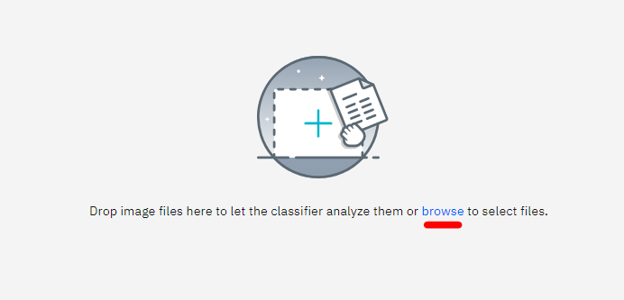

**6) Testing and Fine-tuning:**

Test the integration thoroughly to ensure that the generated captions are accurate and relevant to the images. You may need to fine-tune your AI models to improve the quality of captions. Depending on your requirements, scale the integration to handle a larger volume of images and users. Deploy the solution in a production environment. Continuously monitor the performance of both the Visual Recognition service and the AI caption generator. Perform regular maintenance and updates to keep the integration running smoothly.

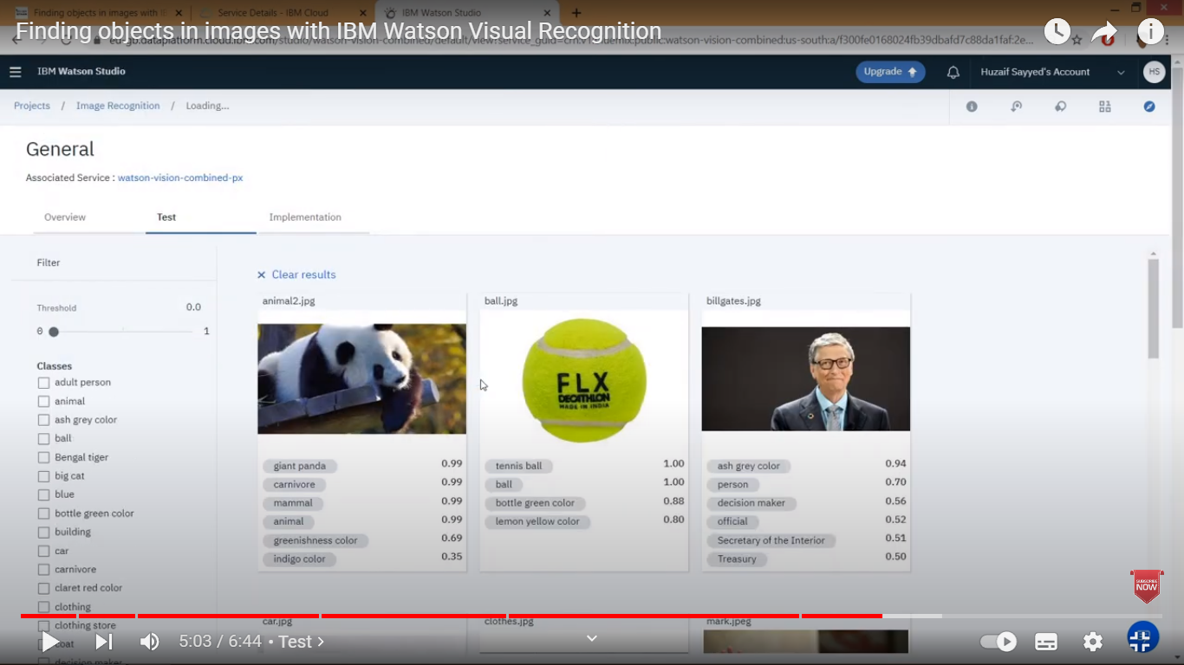

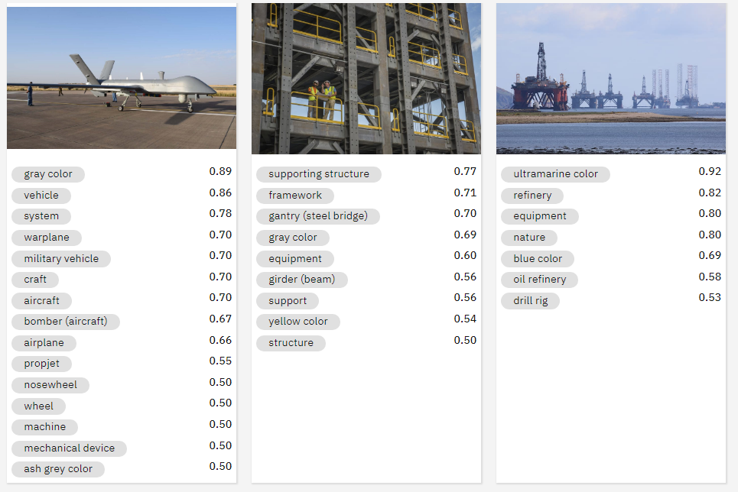

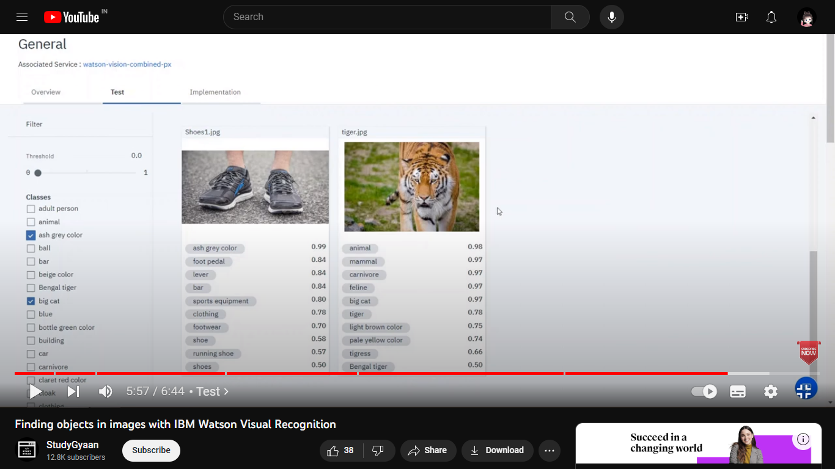

Thus the development part 2 for the image recognition using IBM cloud visual recognition is done and documented successfully.