**Image Recognition with IBM Cloud Visual Recognition**

**Phase 5: Project documentation and Submission**

In this part we will document our project and prepare it for submission.

We have to document the image recognition project and prepare it for submission.

**Objective:**

The project involves creating an image recognition system using IBM Cloud Visual Recognition. The goal is to develop a platform where users can upload images, and the system accurately classifies and describes the image contents. This will enable users to craft engaging visual stories with the help of AI-generated captions, enhancing their connection with the audience through captivating visuals and compelling narratives.

**Design Thinking:**

1. **Image Recognition Setup:** Set up the IBM Cloud Visual Recognition service and obtain the necessary API keys.
2. **User Interface:** Design a user-friendly interface for users to upload images and view the AI-generated captions.
3. **Image Classification:** Implement the image classification process using the IBM Cloud Visual Recognition API.
4. **AI-Generated Captions:** Integrate natural language generation to create captions for the recognized images.
5. **User Engagement:** Design features to allow users to explore, save, and share their AI enhanced images.

**Development:**

The development phase includes the account creation, enabling the IBM cloud visual recognition services and using it to generate the ideal image recognition for our images.

**The development stages and steps are as follows:**

The first step of the project is to create an IBM cloud account. The following steps are to be followed to create an account. First step for the account creation is the account information provide this space with the email address and a specific password for the IBM account. After providing the email address and the password a verification code will be sent to the mail, provide the code obtained from the mail in the box given and verify your account.

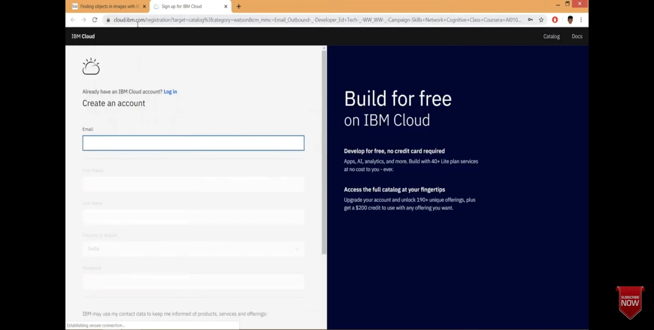

After account verification provide your personal information such as first name, last name and country. Accept the terms and conditions provided by the IBM cloud after reading them carefully. Click the ‘create account’ button to go to the next step.

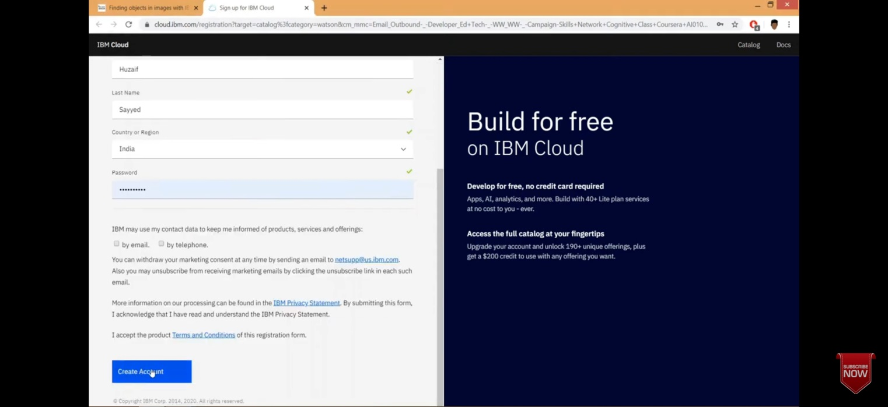

After creating an account sign in to your account with the email id you used to create an account and click on the continue button.

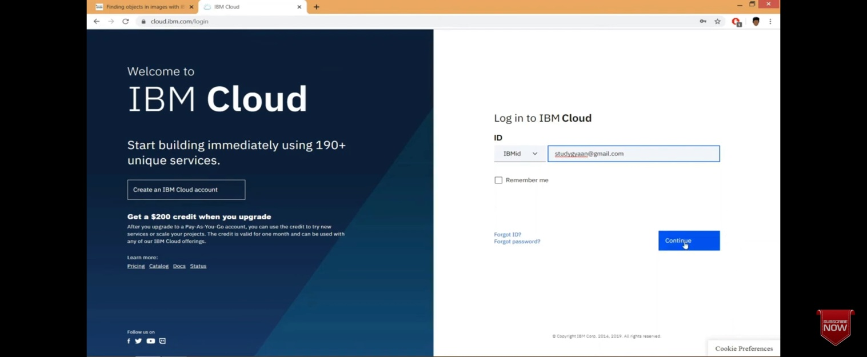

After signing in you will be directed to the dashboard of the IBM cloud. Click on the create resource option given on the top right corner.

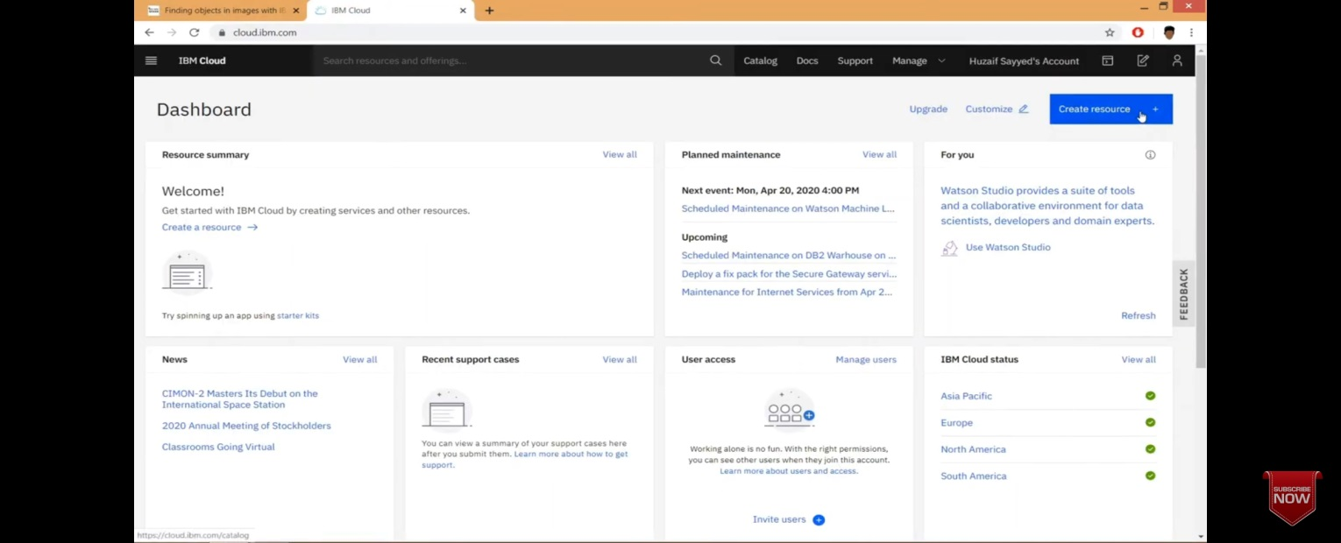

After doing the previous step you will be directed to this page. From the options given on the left click on the services option provided there.

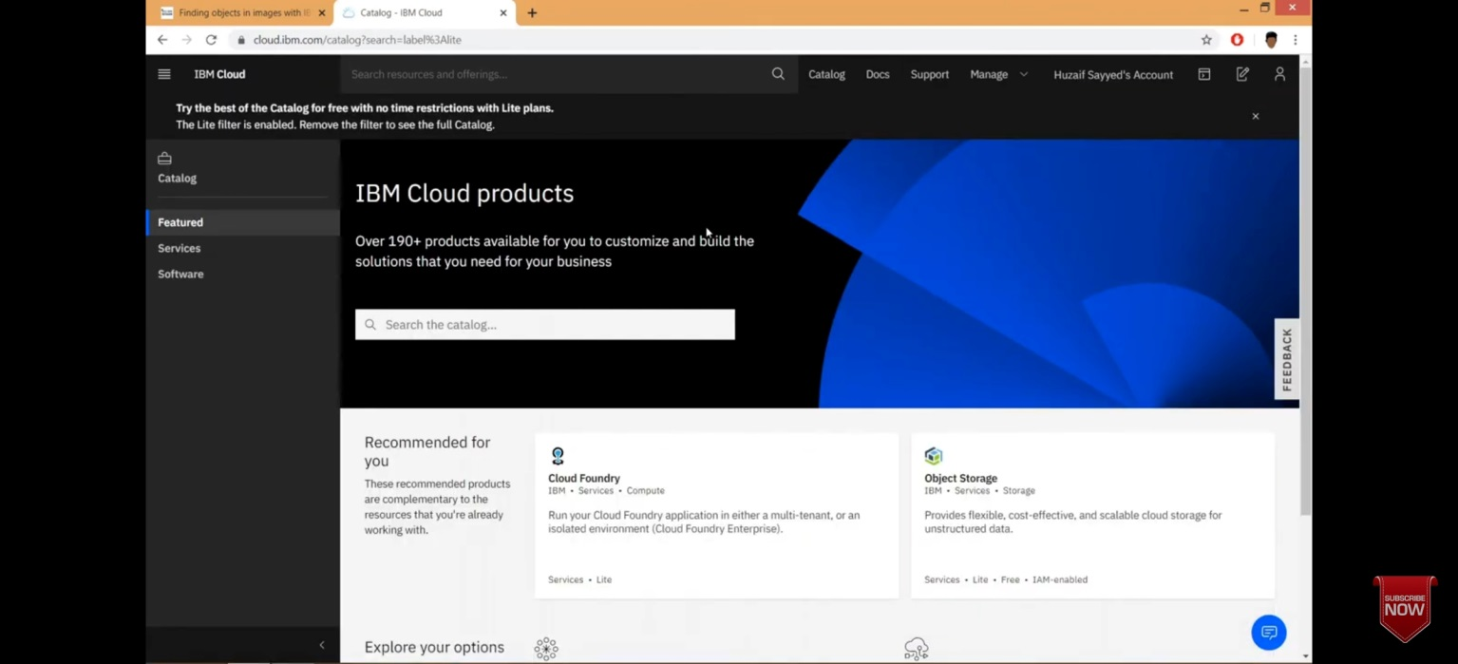

Now you will be directed to the page given below Select AI from the list in the left side of the page and click on the Watson studio to enable the IBM Watson cloud visual recognition services.

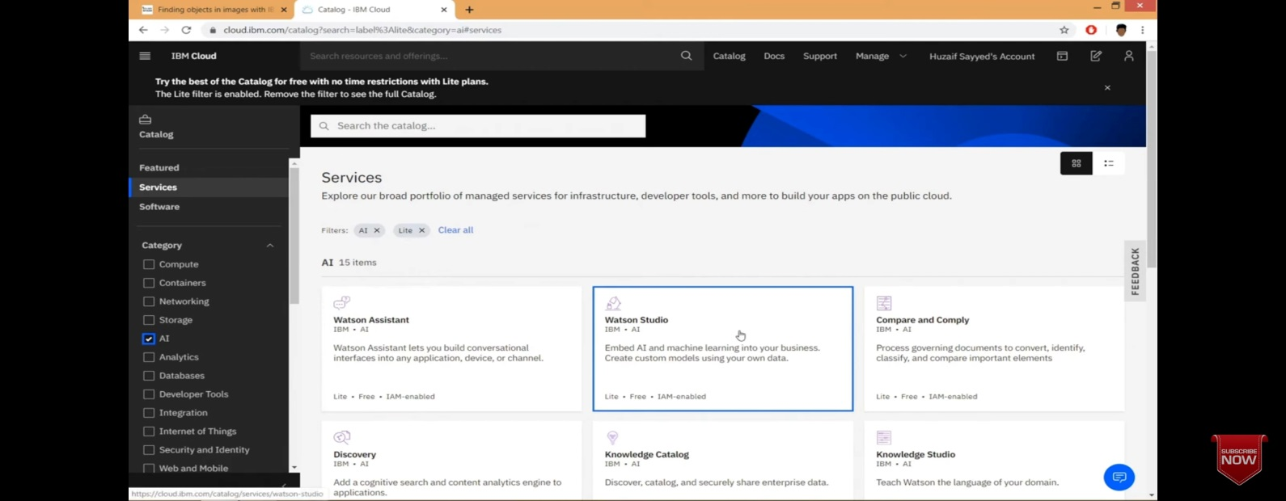

On the directed page select a region and click on the create button provided in the right corner of the page.

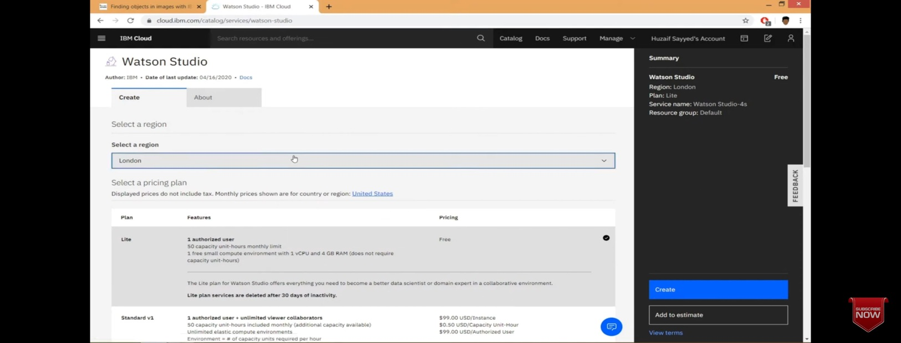

Click on the get started option.

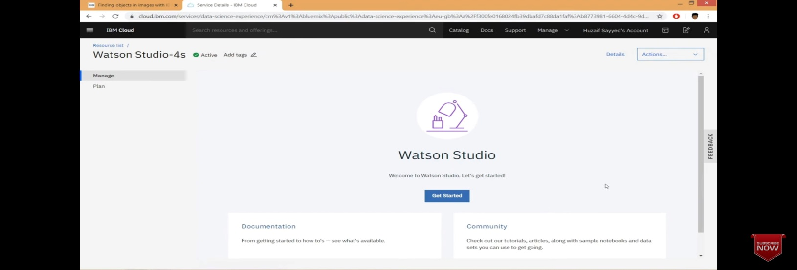

Then on the dashboard of the directed page click on the create a resource button to create our project.

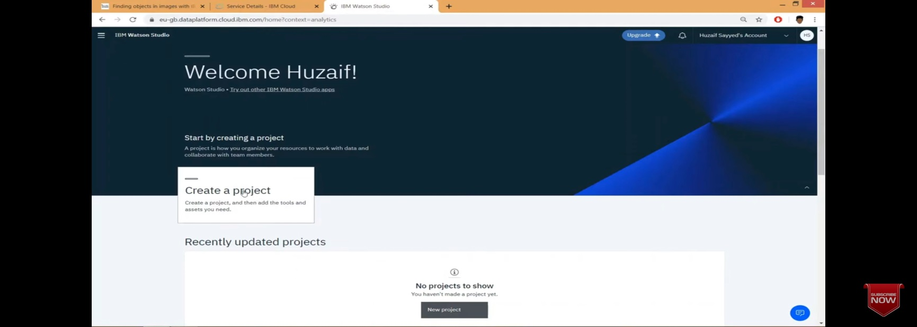

Click on create an empty project.

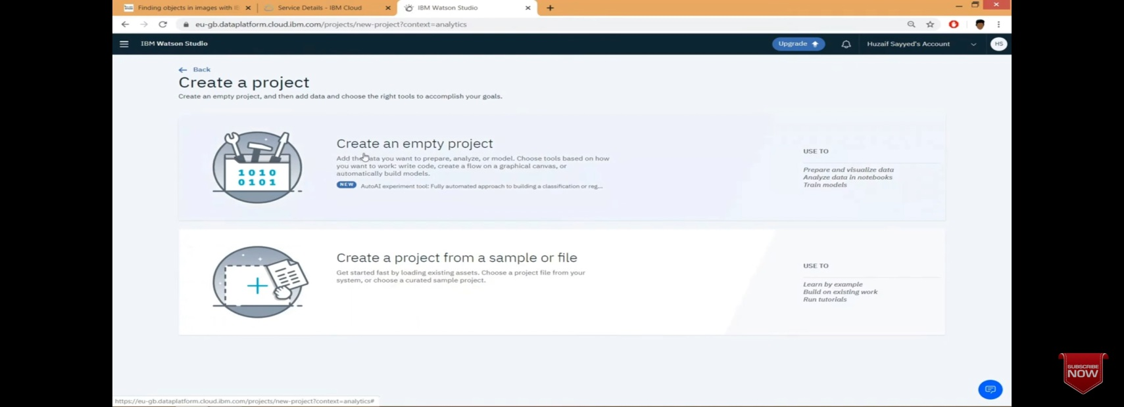

In this page click on the add button provided below the select storage service.

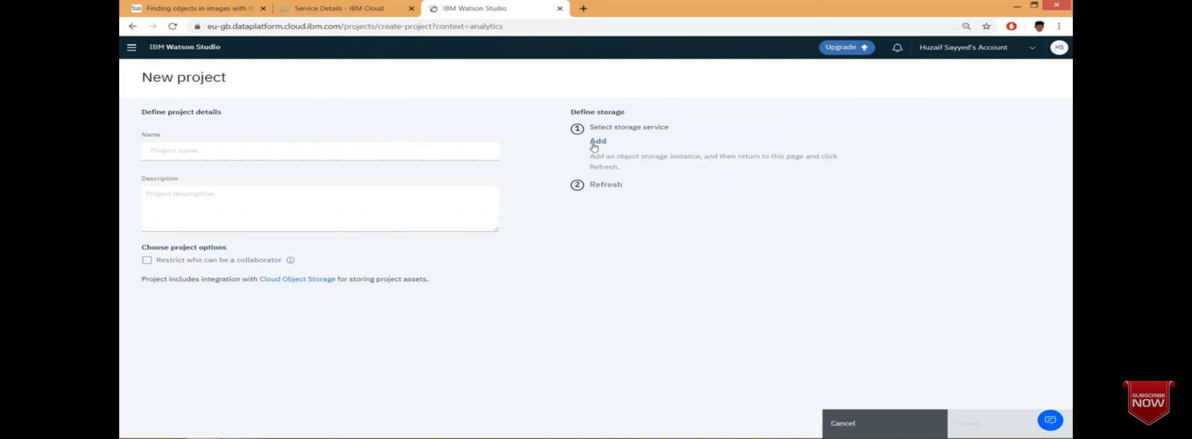

The previous step is used to direct you to this page click on the create button.

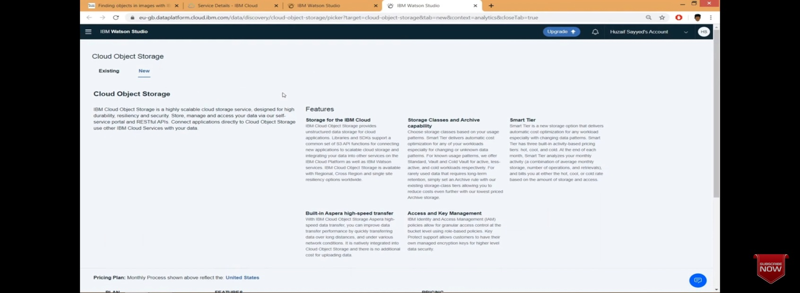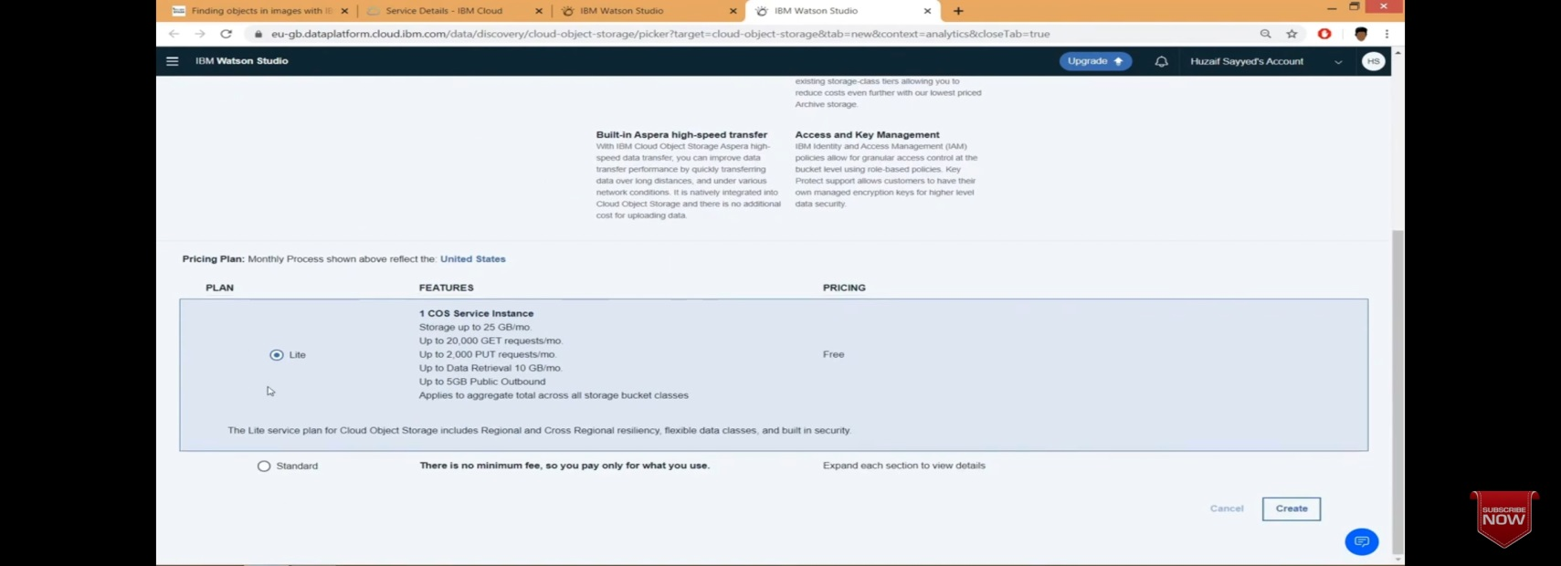

Confirm the creation by verifying the plan, resource group and the service name. After verifying click on the confirm button.

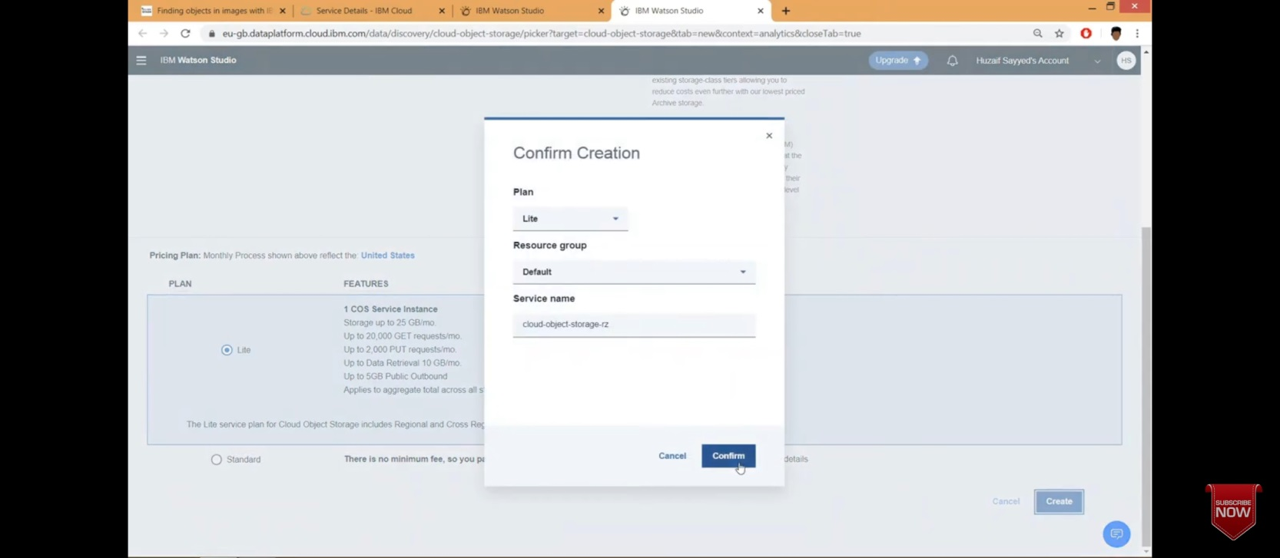

Now you will be redirected to the new project page. Give a name and description to your project and select on the create button.

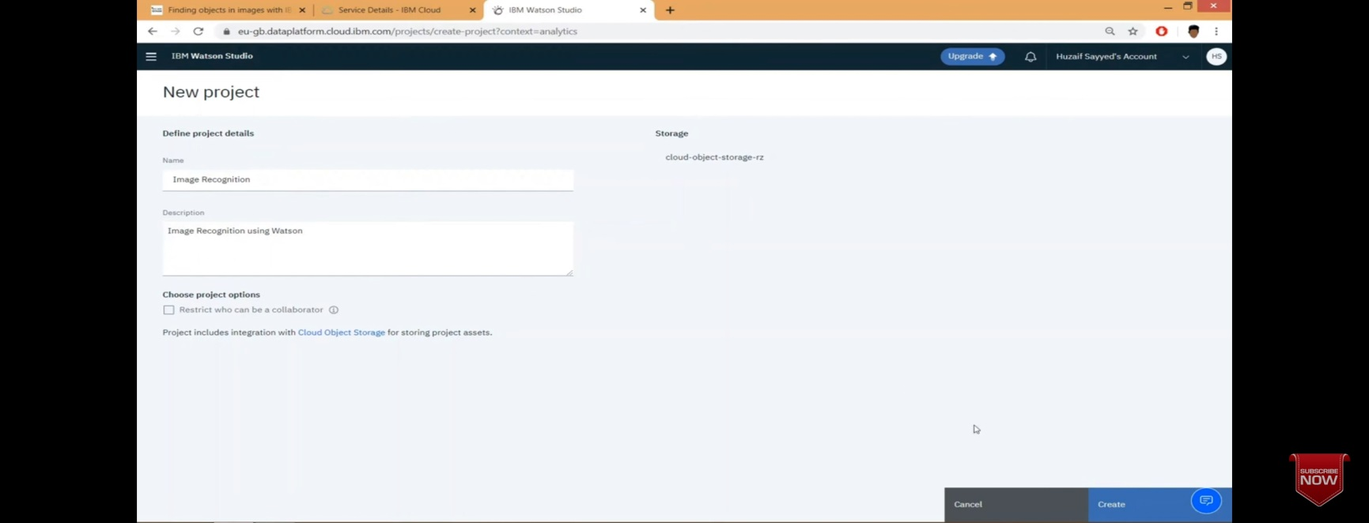

Now you will be directed to the image recognition dashboard. Click on add to project.

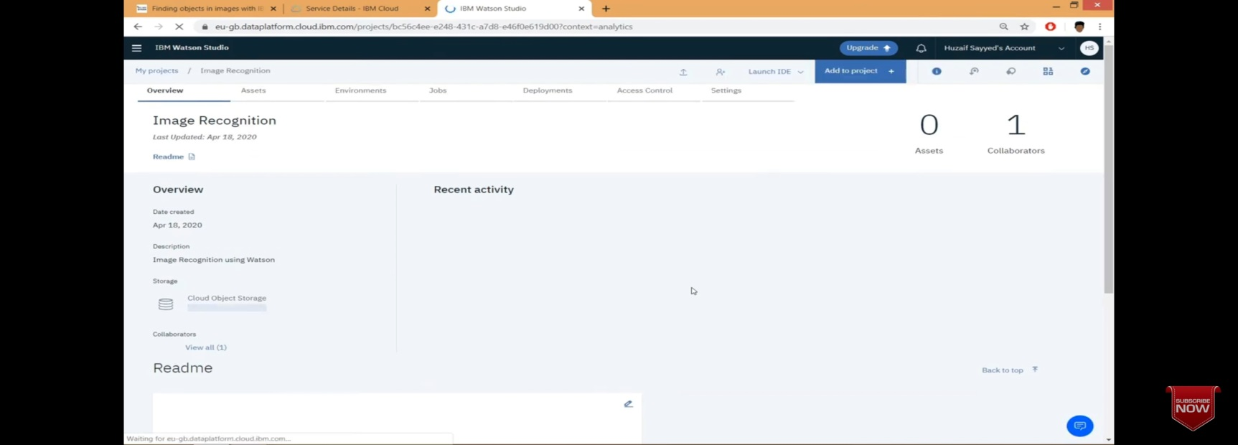

A tab as given in the below picture will be opened. Click on the visual recognition.

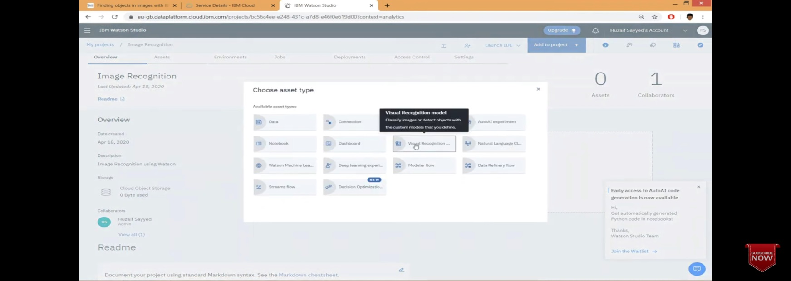

On clicking on the visual recognition a notice such as the below picture will pop out. Click the click here button to associate the service with Watson visual recognition service.

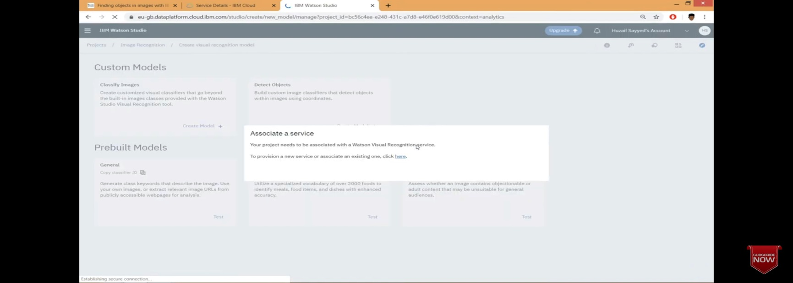

You will be directed to a dashboard for visual recognition click on the create button.

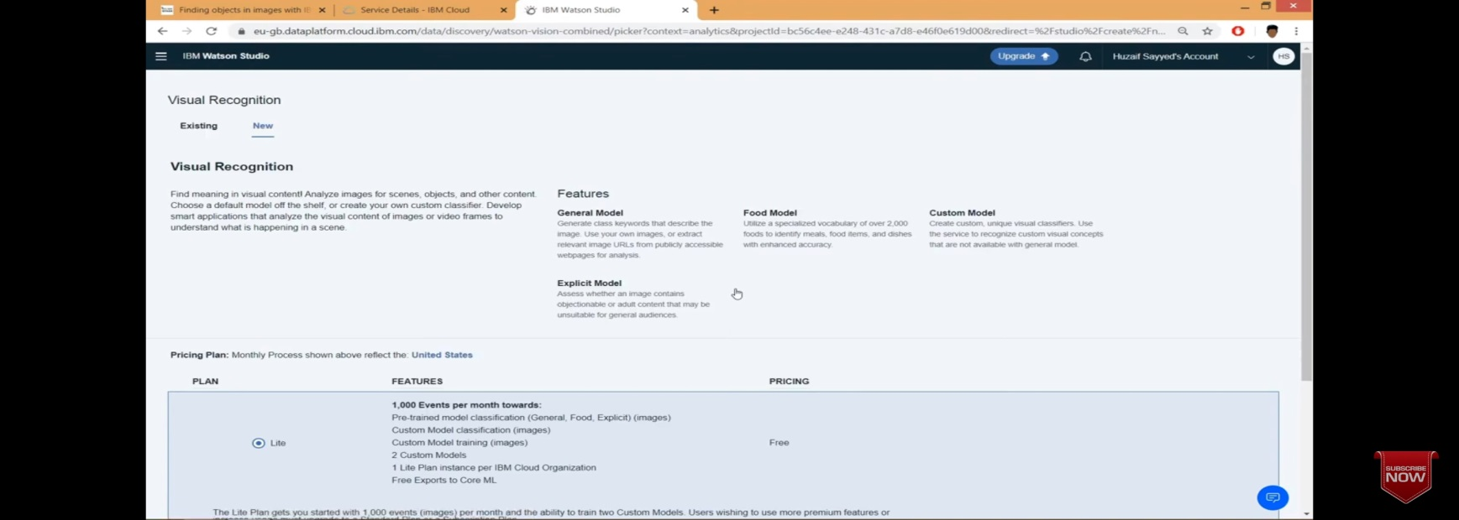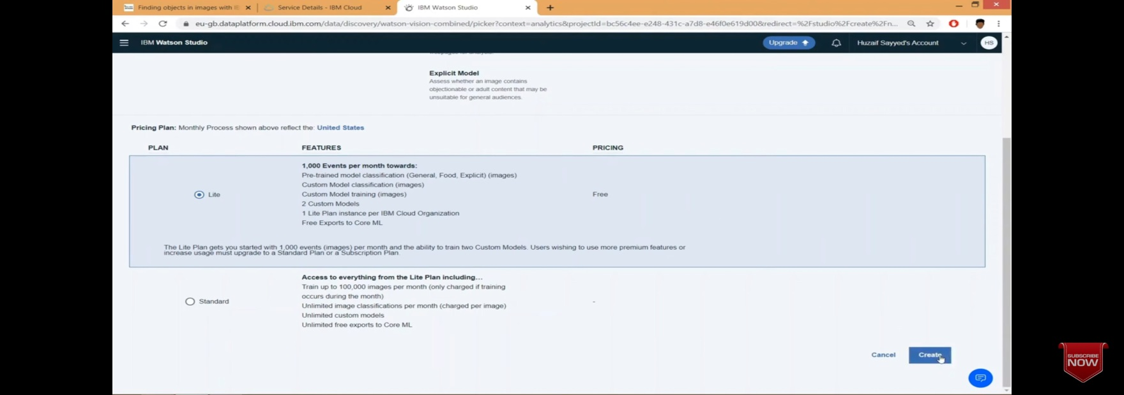

Confirm the creation by selecting the region, plan, organization, space and service name. After selecting them click on the confirm button.

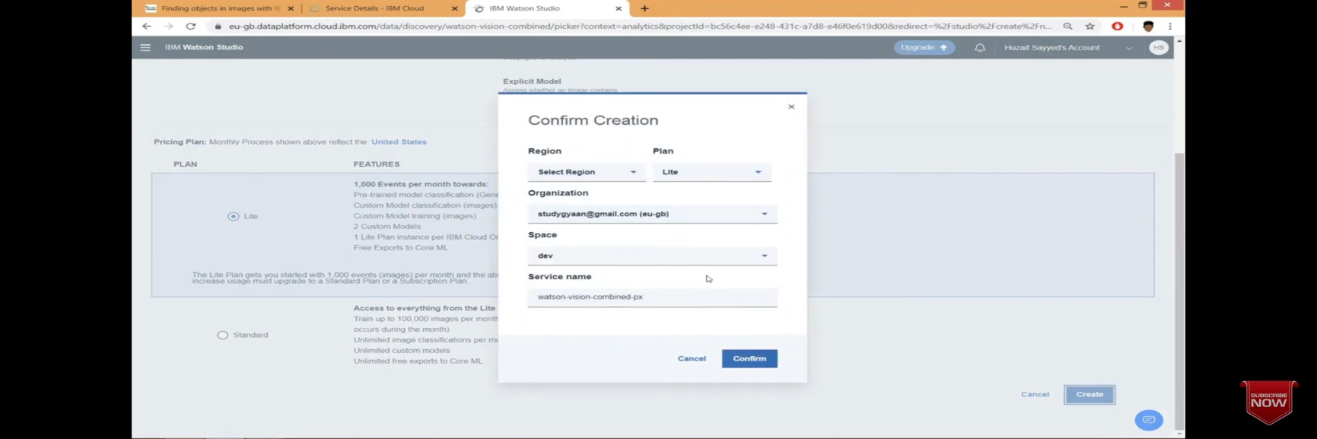

In the custom models page go to the prebuilt models and click the test button provided in the general table.

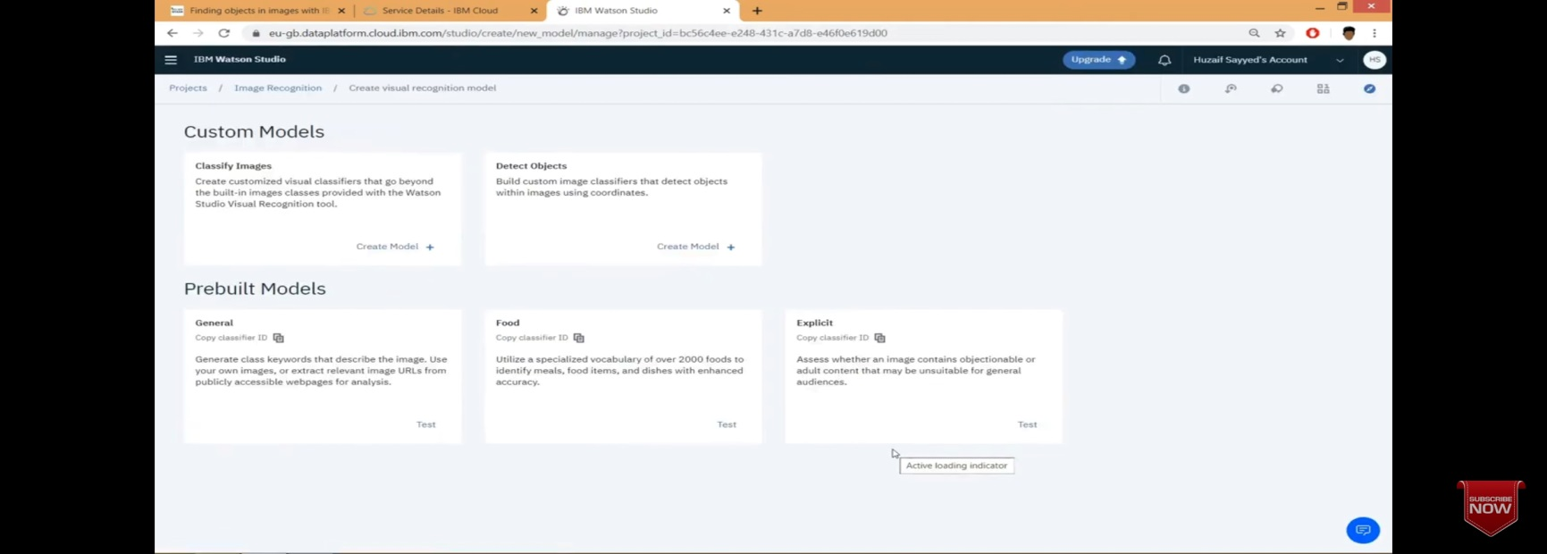

Now click on the test option in the general page.

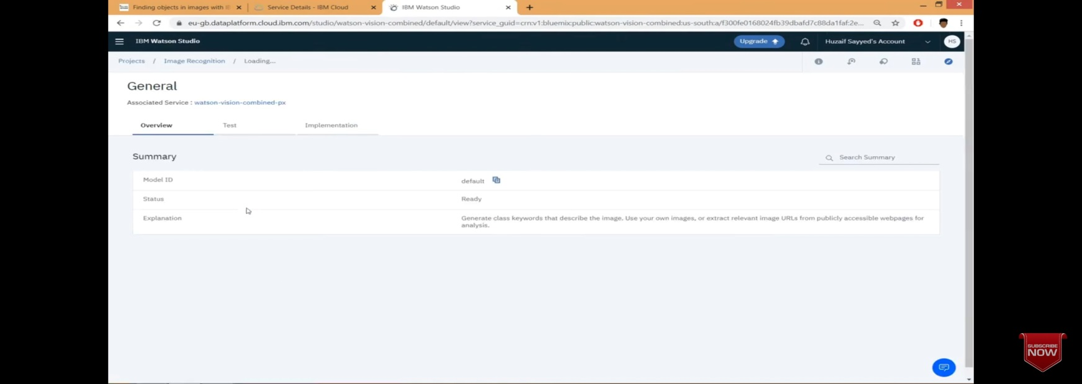

Here click on the browse button to select the images that you want to classify.

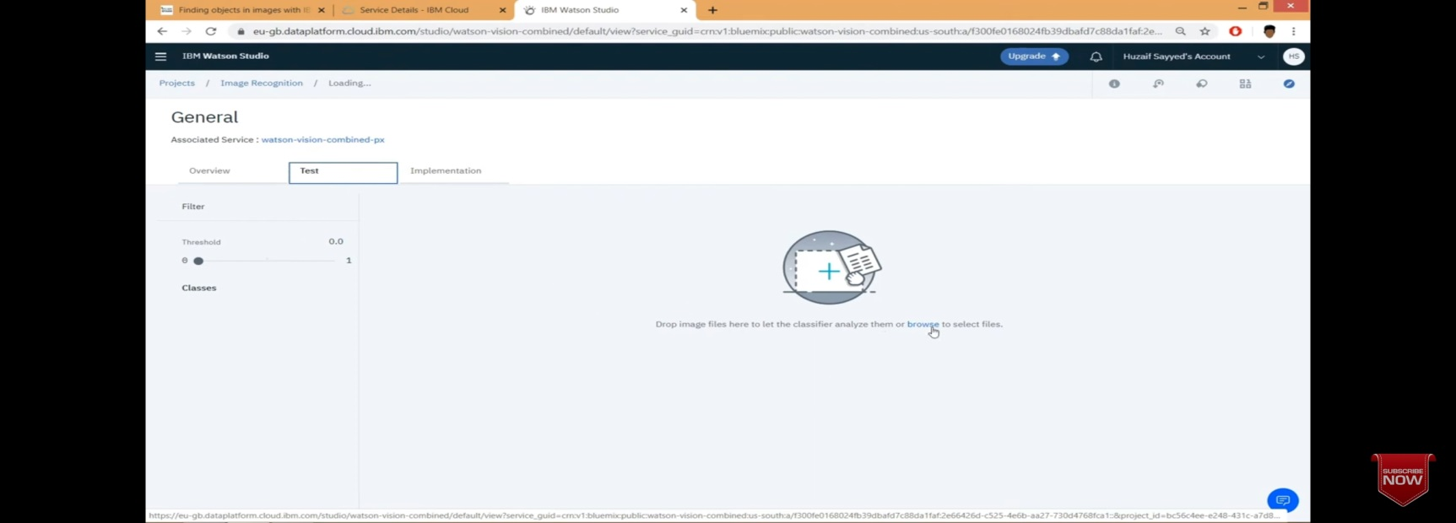

Browse and select the images that you want to classify.

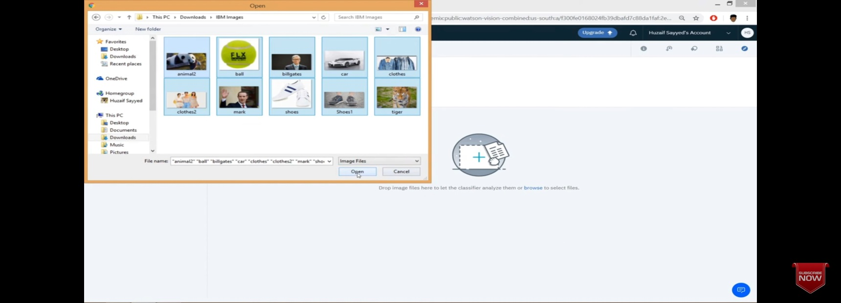

The expected result for the browsed images will be as follows

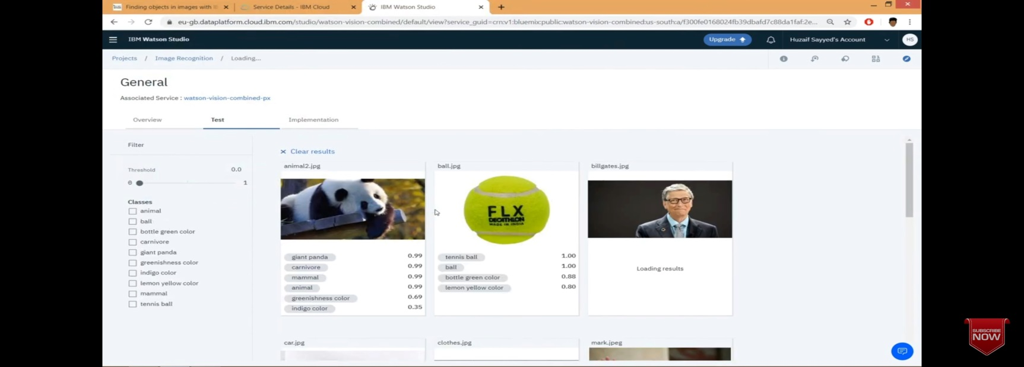

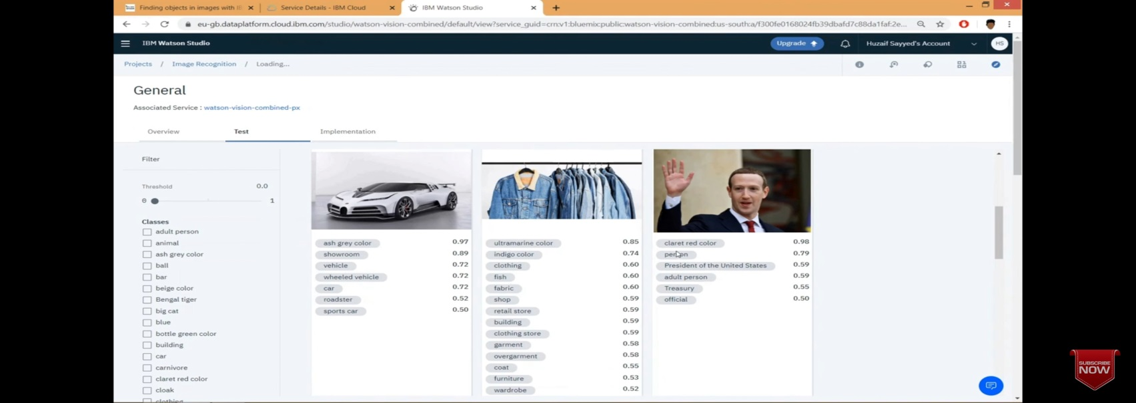

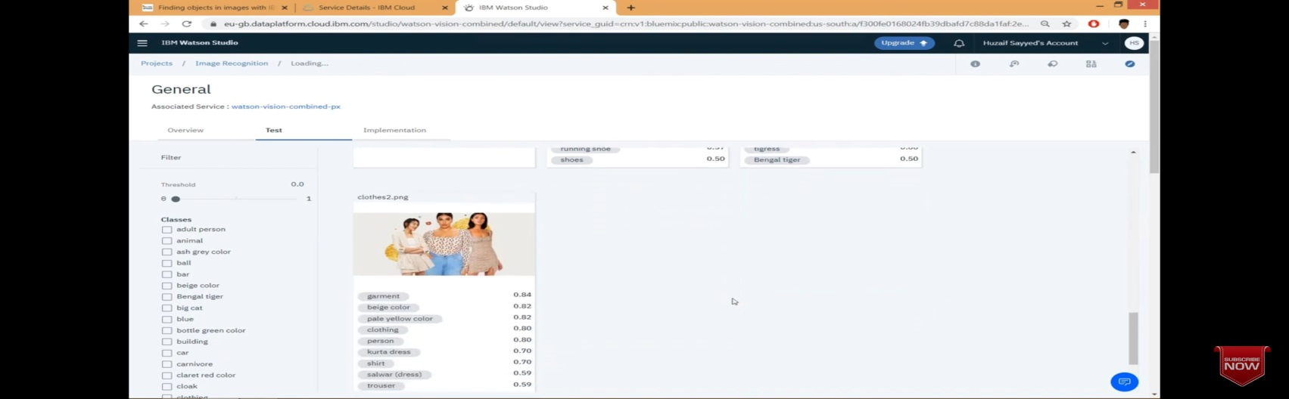

The images will be classified based on their specific key characters. We are also able to classify the images based on their colours, characteristics etc. by selecting a class from the options provided. For example if you select on the ash grey column all the images that has the colour ash grey will be available from thee given images.

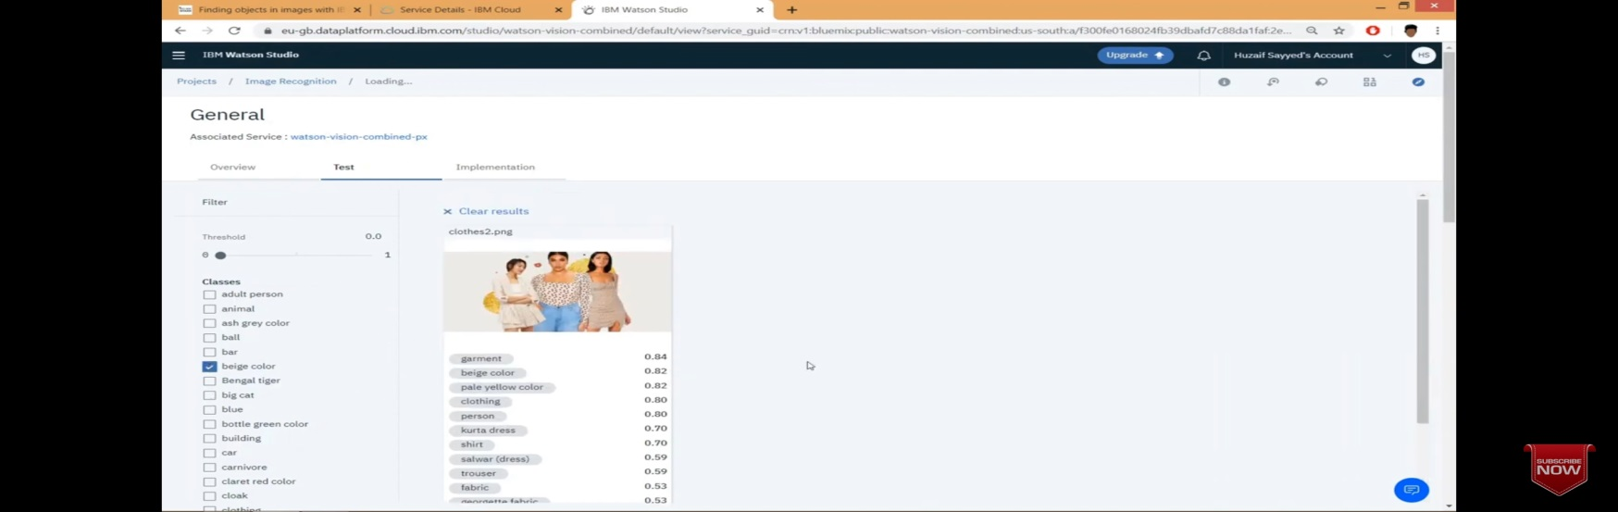

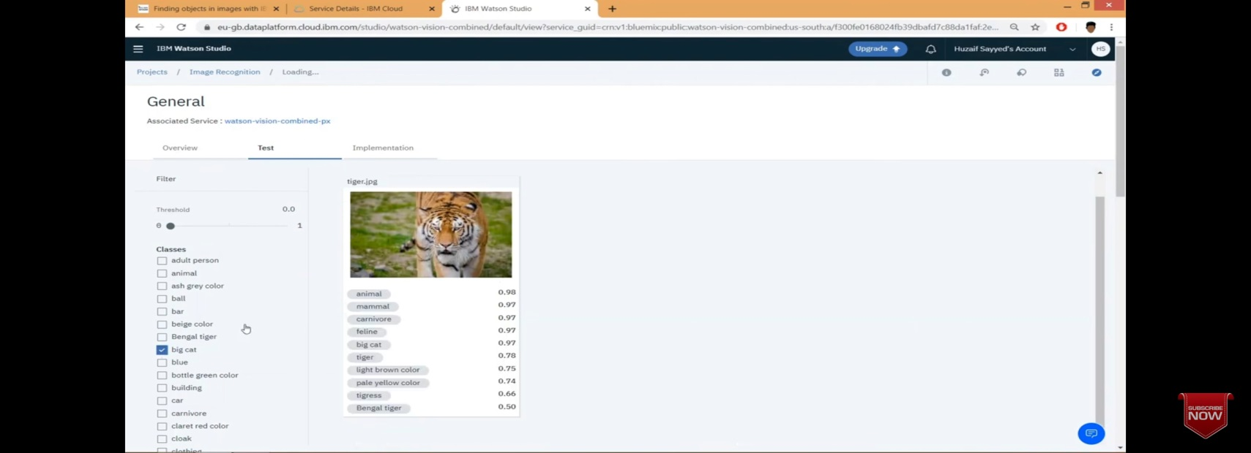

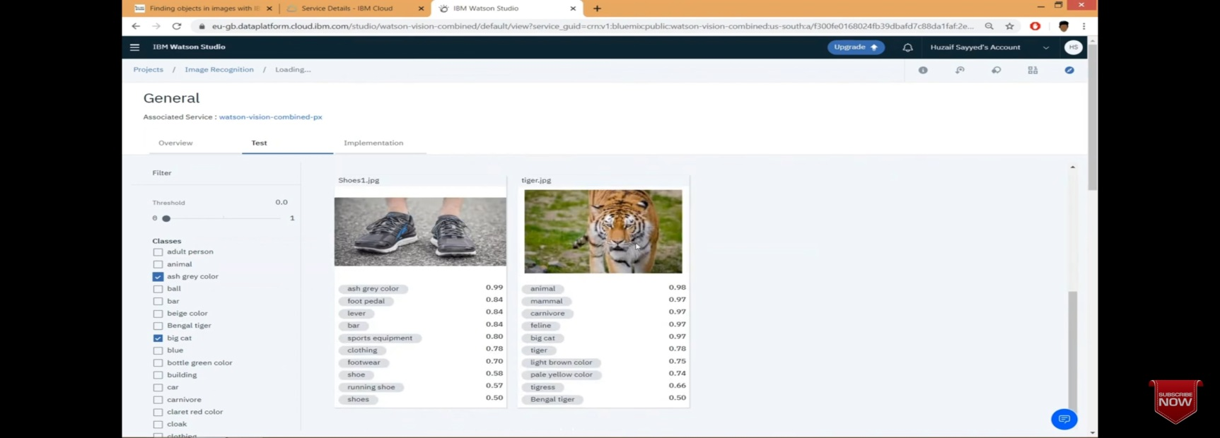

Thus the documentation segment for the image recognition using IBM cloud visual recognition project is done successfully.