Configuring node port to the kubernets:

Service.yaml file :

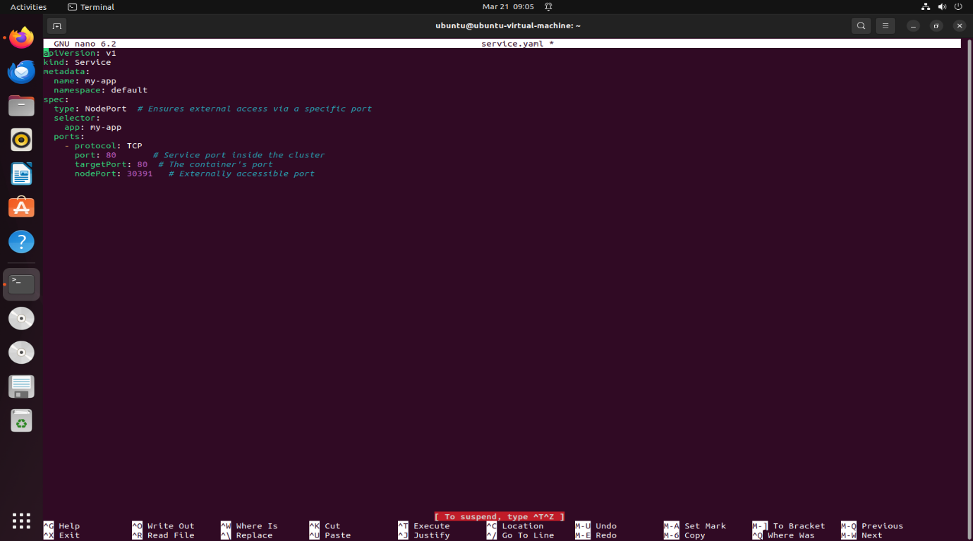

Configured to kubernets :

