Enhanced Encryption Before LSB: Capacity vs Quality Trade-Off

Abstract
This project explores the secure embedding of encrypted messages in grayscale images using the Least Significant Bit (LSB) technique, preceded by AES encryption. It critically analyzes how varying the amount and capacity of embedded data affects image quality using quantitative metrics such as PSNR (Peak Signal-to-Noise Ratio) and SSIM (Structural Similarity Index). The workflow and code are modular, extensible, and include both command-line driven and visual analysis capabilities.

Table of Contents
- 1. Introduction
- 2. Motivation & Objectives
- 3. Methodology
- - System Workflow
- - Encryption Module
- - LSB Embedding Module
- - Quality Metrics
- - Overall Pipeline
- 4. Experiment & Results
- - Setup
- - Trade-off Analysis
- - Sample Results
- 5. Code Structure
- 6. Discussion
- 7. References
- 8. Appendix

1. Introduction
Rapid digital communication requires robust confidentiality and undetectability. While cryptography secures message content, it signals the presence of secret communication. Steganography, specifically LSB embedding, conceals the existence of the message itself. By fusing these—first encrypting using AES, then hiding using LSB—this work achieves both strong content security and concealment. The effects of increased embedding capacity on image quality are analyzed using standard metrics.

2. Motivation & Objectives

Motivation
Existing steganography may face detection if high payloads degrade image quality.
Combining cryptography (for content safety) and steganography (for covert channel) enhances security but should not sacrifice perceptual image quality.

Objectives
- Encrypt messages with AES before embedding into images using LSB.
- Vary payload capacity to measure the PSNR and SSIM vs. message length.
- Support blind extraction and decryption—no original image needed to recover the hidden message.
- Provide an automated, modular framework for future extension and benchmarking.

3. Methodology

System Workflow
System steps:
1. Input: User supplies cover image, secret message, and key.
2. Encryption: Message is AES-encrypted.
3. Embedding: Encrypted ciphertext is embedded in the LSBs of the grayscale cover image.
4. Transmission/Storage: Stego image may be sent or stored.
5. Extraction: LSBs are extracted, producing the ciphertext.
6. Decryption: Ciphertext is decrypted using the key to recover the plaintext.
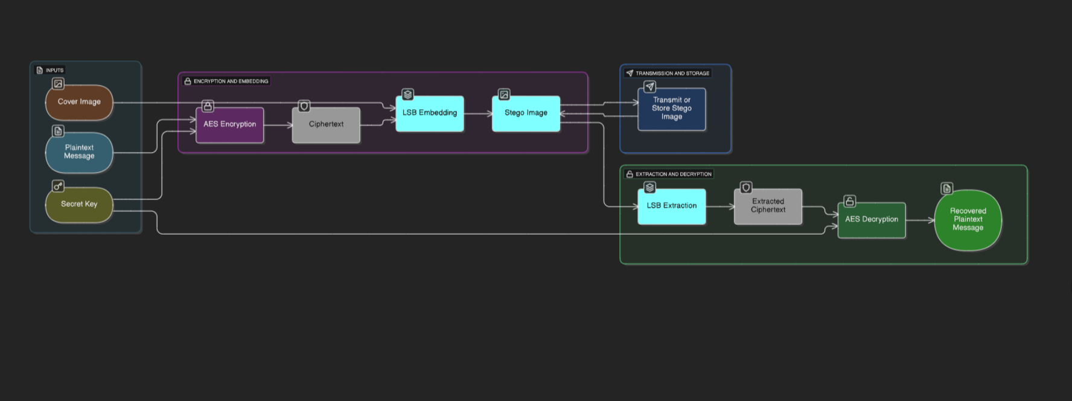
Figure 1: System Workflow Diagram

Encryption Module
AES encryption: Symmetric key block cipher; uses ECB mode for demonstration.
Functions for:
- Padding/unpadding (PKCS-style).
- AES and XOR encryption/decryption (for comparison/testing).
All keys must match between sender and receiver.

LSB Embedding Module
Embedding: Converts message to binary. Each bit replaces the LSB of one pixel.
Extraction: Reads LSBs from modified image and reassembles bits into a message.
Works on single-channel (grayscale) images for simplicity and higher imperceptibility.

Quality Metrics
Calculates PSNR and SSIM between cover and stego images.
PSNR = 20 log10(MAX/MSE), where MAX=255 for 8-bit images.
SSIM measures structural similarity.
Used to report capacity vs. quality.

Overall Pipeline
Steps:
1. Encrypt the user's message.
2. Embed ciphertext.
3. Compute PSNR/SSIM.
4. Extract & decrypt.
5. Plot results.
Optional plotting: visualizer.py generates charts like 'Capacity vs Quality Trade-Off'.

Experiment & Results
Setup:
- Grayscale images, secret messages of varying lengths.
Workflow:
- Encrypt → Embed → Save stego → Measure PSNR/SSIM → Extract & Decrypt.
Trade-off Analysis:
- PSNR and SSIM decline gently with higher capacity but remain high.
Sample Results:
Message Length=10 → PSNR>80dB, SSIM=1.0
Message Length=24 → PSNR=74.76dB, SSIM=1.0

Code Structure
File Purpose
encryption.py AES/XOR encryption + padding
lsb_embedder.py LSB embedding and extraction
quality_metrics.py PSNR/SSIM calculation
main.py Pipeline orchestration
visualizer.py Plots results
requirements.txt Dependencies

Discussion
Security: Combining AES + LSB maximizes secrecy and undetectability.
Performance: Quality remains high (PSNR > 70, SSIM ~1.0).
Usability: Modular design.
Future work: Add CBC mode, color images, robustness against steganalysis.

References
Alanzy, M. et al. (2023). Image Steganography Using LSB and Hybrid Encryption Algorithms. Appl. Sci., 13, 11771.
Damrudi, M., et al. (2019). Image Steganography using LSB and AES, RSA, DES, 3DES, Blowfish. IJEAT, 8(6S3).
Project code and architecture files.

Appendix
Includes workflow diagrams, transmission diagrams, and example code snippet.
Example Python snippet:
ciphertext = aes_encrypt(message, key)
embed_message(cover_image_path, ciphertext, stego_image_path)
psnr = compute_psnr(cover_image_path, stego_image_path)
ssim = compute_ssim(cover_image_path, stego_image_path)

