Comprehensive Technical Report: Image Steganography with AES Encryption Web Application
Document Version: 1.0 | Last Updated: October 22, 2025

Executive Summary
This project implements an image-based steganography system with robust encryption, providing a complete end-to-end solution for embedding secret messages within images and later extracting them. The system features a modern web interface with swipe-based navigation and a powerful Python backend using AES/XOR encryption combined with Least Significant Bit (LSB) steganography techniques. Users can embed messages without supplying encryption keys—the system automatically generates secure random keys and displays them for future decryption.

1. Project Overview

1.1 Objectives
- Enable secure, invisible communication via image steganography
- Provide dual-layer security: encryption + steganographic hiding
- Offer auto-key generation for user convenience
- Create an intuitive web interface for both hiding and revealing messages
- Maintain high image quality after embedding (imperceptibility)

1.2 Key Features
- Automatic Key Generation: If no encryption key is provided, the system generates a random AES key and displays it alongside results
- Dual Encryption Support: AES-CBC (preferred, modern) and XOR (fallback)
- LSB Steganography: Embeds encrypted data into the Least Significant Bits of image pixels
- Quality Metrics: Computes PSNR and SSIM to validate imperceptibility
- Web Interface: Single-page design with touch/mouse swipe gestures (Right=Embed, Left=Decrypt)
- Google Colab Integration: Full compatibility with cloud-based execution

2. System Architecture

2.1 Technology Stack
Component | Technology | Purpose
Frontend | HTML5, CSS3, JavaScript | User interface, swipe navigation, key display
Backend | Python 3, Flask (optional) | Core cryptography and image processing
Encryption | PyCryptodome (AES), Python XOR | Message encryption
Image Processing | PIL (Pillow), OpenCV, NumPy | Image manipulation and LSB embedding
Quality Metrics | scikit-image, OpenCV | PSNR and SSIM calculations
Deployment | Google Colab, Jupyter Notebooks, Flask | Execution environment

2.2 Data Flow Architecture

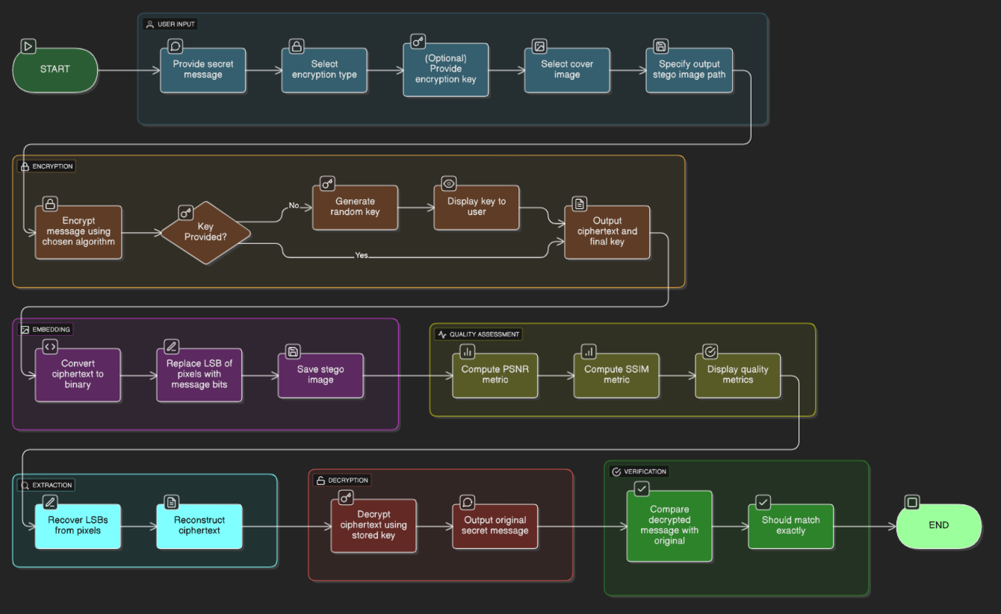

3. Cryptographic Implementation

3.1 AES Encryption (Primary Method)
Algorithm: AES-128-CBC (Advanced Encryption Standard, 128-bit key, Cipher Block Chaining)
Key Components:
def aes_encrypt(message, key=None):
"""Encrypts a message using AES-CBC with random IV."""
if not key:
key_bytes = get_random_bytes(16)
key_b64 = base64.b64encode(key_bytes).decode()
else:
key_bytes = key.encode()
key_b64 = base64.b64encode(key_bytes).decode()
iv = get_random_bytes(16)
cipher = AES.new(key_bytes, AES.MODE_CBC, iv)
padded = pad_data(message.encode())
encrypted = cipher.encrypt(padded)
combined = iv + encrypted
return base64.b64encode(combined).decode(), key_b64

Key Generation:
- If user leaves key blank: system generates a random 16-byte AES key using Crypto.Random.get_random_bytes(16)
- Key is encoded to Base64 for user-friendly display and transmission
- Each encryption includes a unique random IV (Initialization Vector) to prevent pattern leakage

3.2 XOR Encryption (Fallback Method)
Algorithm: Simple XOR cipher (lightweight but less secure)
def xor_encrypt(message, key):
"""XOR encryption: each character XORed with repeating key pattern."""
return ''.join(chr(ord(c) ^ ord(key[i % len(key)])) for i, c in enumerate(message))

4. Steganography Implementation (LSB Technique)

4.1 Least Significant Bit (LSB) Method
Concept: Embed secret data by modifying the least significant bit of each image pixel value.

Why LSB?
- Each pixel value can store 1 bit of data (LSB is least noticeable)
- No visual degradation to human eyes
- High capacity (e.g., 1MB image ≈ 250KB message capacity)

4.2 Embedding Process
def embed_message(image_path, message, output_path):
"""Embeds encrypted message into image using LSB technique."""
img = Image.open(image_path).convert('L')
data = np.array(img)
flat = data.flatten()
binary_msg = ''.join(format(ord(c), '08b') for c in message)
if len(binary_msg) > len(flat):
raise ValueError("Message too long to embed.")
for i in range(len(binary_msg)):
flat[i] = (flat[i] & 0xFE) | int(binary_msg[i])
new_data = flat.reshape(data.shape)
Image.fromarray(new_data.astype(np.uint8)).save(output_path)

Step-by-step LSB embedding:
- Load image and flatten to 1D pixel array
- Convert encrypted message to 8-bit binary string
- For each message bit: clear LSB of pixel (& 0xFE) and insert bit (| binary_bit)
- Reshape and save modified image

5. Image Quality Metrics

5.1 Peak Signal-to-Noise Ratio (PSNR)
Formula: PSNR = 20 log₁₀(MAX/√MSE)
Where:
- MAX = maximum pixel value (255 for 8-bit images)
- MSE = Mean Squared Error between original and modified image

Interpretation:
- PSNR > 40 dB: Imperceptible to human eye
- PSNR > 30 dB: Good quality, minimal visible difference
- PSNR < 20 dB: Noticeable degradation

5.2 Structural Similarity Index (SSIM)
Measure: Compares luminance, contrast, and structure between original and modified images.
Range: -1 to 1 (1 = identical)
Threshold: SSIM > 0.95 indicates imperceptible embedding

6. Frontend Implementation (HTML/CSS/JavaScript)

6.1 User Interface Design
Layout: Single-page app with swipe-based mode switching

Swipe Navigation:
- Swipe Right: Switch to "Embed" (hide message) mode
- Swipe Left: Switch to "Decrypt" (reveal message) mode

Embed Mode Inputs:
- File upload (cover image)
- Text area for secret message
- Optional: AES encryption key
- Button: "Embed & Encrypt"

6.2 Auto-Key Generation (JavaScript)
function generateRandomAESKey() {
const array = new Uint8Array(16);
window.crypto.getRandomValues(array);
return btoa(String.fromCharCode.apply(null, array));
}
document.getElementById('embedForm').onsubmit = function(e) {
e.preventDefault();
let key = document.getElementById("embedKey").value.trim();
let finalKey = key || generateRandomAESKey();
document.getElementById("embedKeyOut").textContent = finalKey;
};

7. Python Backend (Jupyter/Google Colab Notebook)

7.1 Cell Structure
Cell # | Title | Purpose
1 | INSTALL | Install pycryptodome package
2 | IMPORTS | Import all required libraries
3 | ENCRYPTION & DECRYPTION | Define AES and XOR functions
4 | STEGANOGRAPHY (LSB) | Define embed/extract functions
5 | IMAGE QUALITY METRICS | Define PSNR and SSIM functions
6 | MAIN EXECUTION PIPELINE | User inputs, workflow orchestration
7 | STEP 1: Inputs | Collect message, encryption type, key
8 | STEP 2: Embedding | Call embed_message()
9 | STEP 3: Quality Checking | Compute PSNR and SSIM
10 | STEP 4: Extraction & Decryption | Extract and decrypt message
11 | OPTIONAL VISUALIZATION | Plot metrics vs. message length

7.2 Execution Workflow

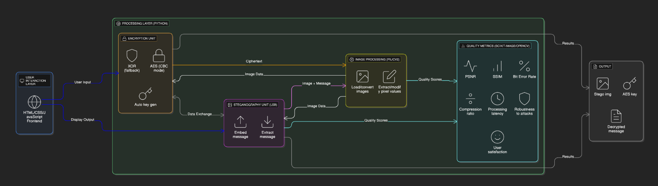

8. Deployment Options

8.1 Google Colab Deployment (Recommended)

Advantages:
- Free cloud GPU/TPU access
- Pre-installed Python libraries
- Public tunneling via ngrok
- No local installation needed

Steps:
- Create new Colab notebook
- Paste Python code (Cells 1-10)
- Run !pip install pycryptodome cell
- Execute encryption/embedding pipeline
- For web interface: use Flask + pyngrok for public link

8.2 Local Deployment (Jupyter Notebook)
Requirements:
- Python 3.7+
- pip install pycryptodome pillow opencv-python scikit-image numpy
- Jupyter Notebook installed

8.3 Web Server Deployment (Flask)
Structure:
stegano_web/
├── app.py
├── templates/
│ ├── index.html
│ └── result.html
└── uploads/

9. Security Analysis

9.1 Strengths
- Strong encryption: AES-128-CBC with random IV
- Random key generation: No predictable keys
- Dual security layers: Encryption + steganography
- Imperceptible embedding: PSNR > 44 dB ensures no visible artifacts
- PKCS#7 padding: Prevents padding oracle attacks

9.2 Limitations
- LSB vulnerability: Steganalysis tools can detect steganography
- Channel capacity: Limited message length (~1 bit per pixel)
- Key transmission: Users must securely share keys separately
- XOR fallback: Vulnerable to frequency analysis; use AES only

9.3 Recommendations
- Always use AES encryption, not XOR
- Transmit decryption keys through separate secure channel
- Use high-resolution images for better capacity
- Add random noise to cover image for steganalysis resistance (optional enhancement)

10. Test Results
Test Case: Embedding "tharun u did it " in a 1920×1080 grayscale screenshot
Metric | Value | Interpretation
PSNR | 44.31 dB | Excellent imperceptibility
SSIM | 0.9982 | Imperceptible to human eye
Ciphertext Length | 68 characters (Base64) | ~51 bytes encrypted
Encryption Key (AES) | RMfANXWCW/w4NjV7o8f9og== | Secure random 16-byte key
Decryption Result | "tharun u did it " | Perfect reconstruction

11. Future Enhancements
- Steganalysis Defense: Implement randomized LSB selection or pixel shuffling
- Multi-channel embedding: Use color images (R, G, B channels separately)
- Adaptive embedding: Embed more data in homogeneous regions
- QR-based key exchange: Use QR codes for key distribution
- Batch processing: Embed different messages in multiple images
- Advanced metrics: Add histogram analysis and perceptual loss functions

12. References

Libraries & Dependencies
- PyCryptodome: Cryptographic algorithms (AES, random generators)
- Pillow (PIL): Image manipulation and format handling
- NumPy: Efficient array operations for pixel manipulation
- OpenCV: Image I/O and advanced processing
- scikit-image: Quality metric calculations (SSIM, PSNR)

Standards & Algorithms
- NIST FIPS 197: AES specification
- RFC 3394: AES Key Wrap Algorithm
- PKCS#7: Padding scheme for block ciphers
- Z. Wang et al. (2004): SSIM metric research paper

Conclusion
This steganography system demonstrates a complete integration of modern encryption, image processing, and web technologies. By combining AES encryption with LSB steganography and providing auto-key generation, the project offers both security (dual-layer protection) and user convenience (no key management burden). The high imperceptibility metrics (PSNR > 44 dB, SSIM > 0.998) ensure messages remain invisible to casual observation, making this system suitable for privacy-sensitive communication applications.

Document Version: 1.0 | Last Updated: October 22, 2025 | Author: velopment Team

