**7PAM2000 Applied Data Science 1**

**Analysis of Web Traffic for Food Hygiene Rating**

The analysis of web traffic for food hygiene rating is an important factor in determining the overall health and safety of a food establishment. By understanding the patterns of web traffic, it is possible to determine which establishments are receiving the most attention from customers and which are being ignored. This information can be used to make informed decisions about the quality and safety of a particular establishment.

Web traffic analysis for food hygiene ratings involves looking at the number of visitors to a website, as well as how long they stay on the page and what type of information they are looking for. This data can provide valuable insights into how customers perceive a particular business or brand. Additionally, it can be used to identify areas where improvements need to be made in order to increase customer satisfaction. For example, if an establishment has low visitor numbers, it may be necessary to create a more engaging website or offer more attractive deals in order to draw more customers in.

In addition to web traffic analysis, food hygiene ratings can also be determined by analyzing headlines used by establishments on their websites. Headlines should be designed to draw attention and create interest in the products or services offered by an establishment. By analyzing headlines, it is possible to determine whether they are effective at increasing customer engagement or not. Furthermore, this data can be used to inform decisions about which areas need improvement in order for an establishment’s website to become more attractive and engaging for customers.

Now, to analyze the web traffic, the dataset has been collected from the Government portal of the United Kingdom. The data is regarding the web traffic of the visitors who have surfed and visited food hygiene websites and rated the food products from different regions of the UK. The below line chart is showing the total page view versus the unique page views by the visitors for food hygiene websites.

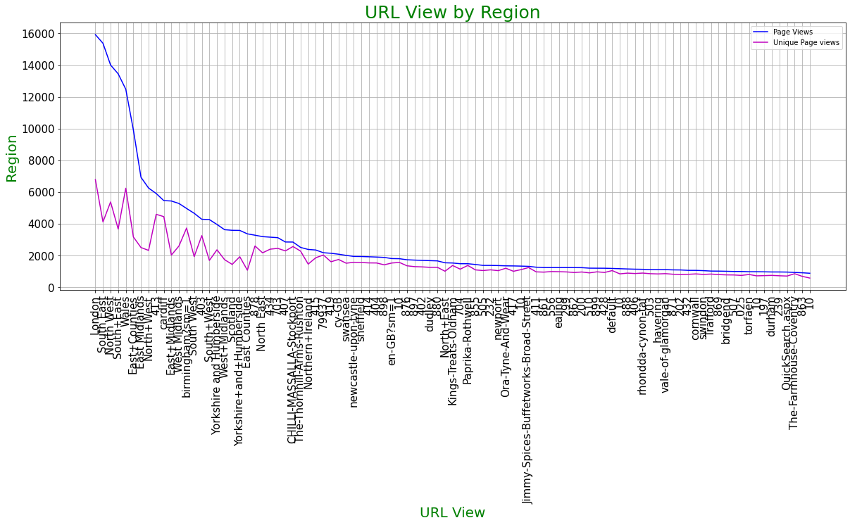

The major difference between the total view and the unique view lies in the fact of how many organic views the visitors have observed. This is important because one person can visit many times a website which cannot be taken as an organic or unique view. So, the number of unique views is important for a website from a particular region to understand the demand.

The bar chart is an important visualisation to show the count of the discrete events. Here bar charts have been visualised to show the count of the page views from top-10 and least-10 regions. It can be seen that most of the page views have been seen from the London region followed by the South East region. It means the demand for hygienic foods is higher in those regions.

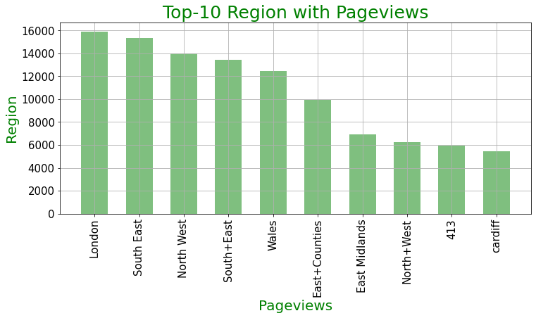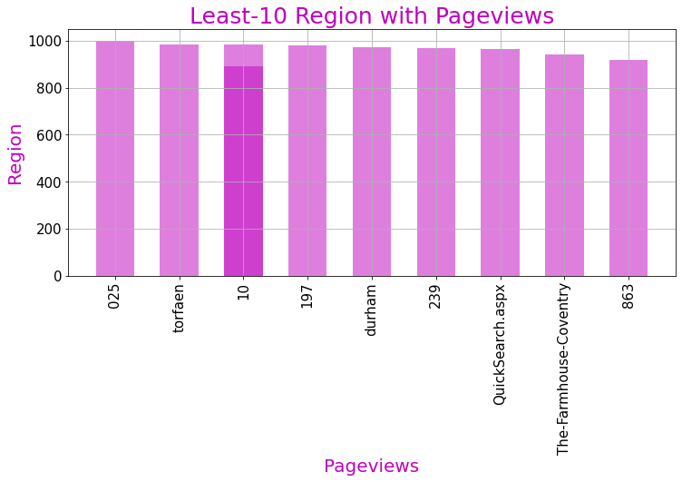

To visualize searches that occurred for certain URLs, pie charts have been applied. This is because it is very easy to present the percentage of data for the discrete events. In this context, it can be seen that most of the searches are related to Authority Search Landing followed by Local Authority for food hygiene rating. The Top-5 and Least-5 search types are shown below in the pie charts.

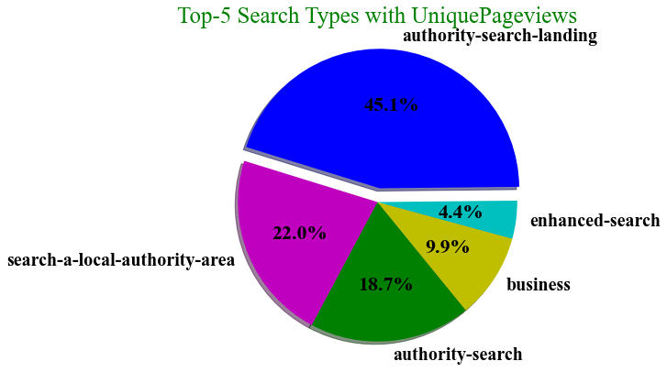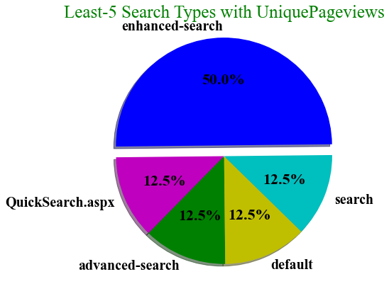

So, from the overall analysis, it can be said that the people from the regions such as London, South East, North West etc. Additionally, the mostly searched URL types belong to the authority landing search and local authority for the food hygiene rating.

**Data Link**: https://www.data.gov.uk/dataset/c4047886-c3ba-427f-bafc-9804c11a5ab9/food-hygiene-ratings-website-pages