Paper Title* (use style: paper title)
*Note: Sub-titles are not captured in Xplore and should not be used

line 1: 1st Given Name Surname
line 2: dept. name of organization
(of Affiliation)
line 3: name of organization
(of Affiliation)
line 4: City, Country
line 5: email address or ORCID
line 1: 4th Given Name Surname
line 2: dept. name of organization
(of Affiliation)
line 3: name of organization
(of Affiliation)
line 4: City, Country
line 5: email address or ORCID
line 1: 2nd Given Name Surname
line 2: dept. name of organization
(of Affiliation)
line 3: name of organization
(of Affiliation)
line 4: City, Country
line 5: email address or ORCID
line 1: 5th Given Name Surname
line 2: dept. name of organization
(of Affiliation)
line 3: name of organization
(of Affiliation)
line 4: City, Country
line 5: email address or ORCID
line 1: 3rd Given Name Surname
line 2: dept. name of organization
(of Affiliation)
line 3: name of organization
(of Affiliation)
line 4: City, Country
line 5: email address or ORCID
line 1: 6th Given Name Surname
line 2: dept. name of organization
(of Affiliation)
line 3: name of organization
(of Affiliation)
line 4: City, Country
line 5: email address or ORCID

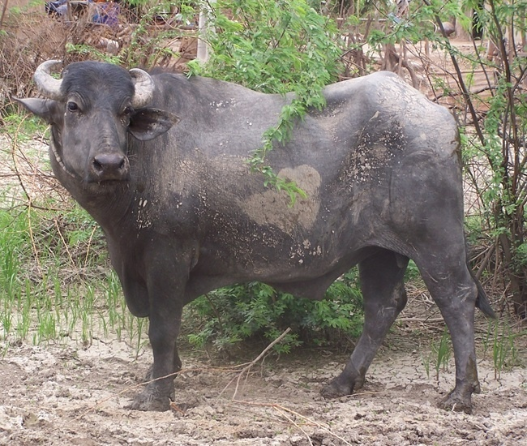  Fig. 1. Sample image.  - R1C1 | R1C2 | R1C3
R2C1 | R2C2 | R2C3
R3C1 | R3C2 | R3C3
This is a test body paragraph in Section 4.
I. INTRODUCTION

We suggest that you use a text box to insert a graphic (which is ideally a 300 dpi TIFF or EPS file, with all fonts embedded) because, in an MSW document, this method is somewhat more stable than directly inserting a picture.
To have non-visible rules on your frame, use the MSWord “Format” pull-down menu, select Text Box > Colors and Lines to choose No Fill and No Line.

