PROJECT REPORT

EXPLORATORY DATA ANALYSIS OF E-COMMERCE CUSTOMER BEHAVIOR DATA
A Project Report Submitted
in partial fulfillment of the requirements for
Data Science & Analytics Internship – Task 2
Submitted By
Name: Sagar Tharu
Unique Intern ID: KT1214070
Course: Data Science & Analytics
Submitted To
Organization / Internship Provider: Kicktern

1. Introduction
In today’s digital economy, e-commerce platforms generate vast customer data. This project performs Exploratory Data Analysis (EDA) on an E-Commerce Customer Behavior dataset to uncover insights related to spending patterns, membership influence, and customer satisfaction.

2. Project Objective
• Analyze customer purchase behavior
• Identify revenue drivers
• Perform feature engineering
• Conduct advanced exploratory data analysis
• Generate actionable business recommendations

3. Dataset Description
The dataset contains 5000+ customer records including demographic and behavioral variables such as age, gender, city, membership type, total spend, items purchased, average rating, discount applied, days since last purchase, and satisfaction level.

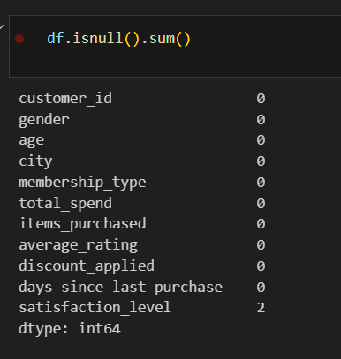
4. Data Cleaning and Preprocessing
• Removed duplicate records
• Checked and handled missing values
• Removed outliers using IQR method
• Standardized column names
• Validated dataset consistency

5. Feature Engineering
• Age Group segmentation
• High Value Customer identification
• Spend per Item calculation
• Rating Category classification
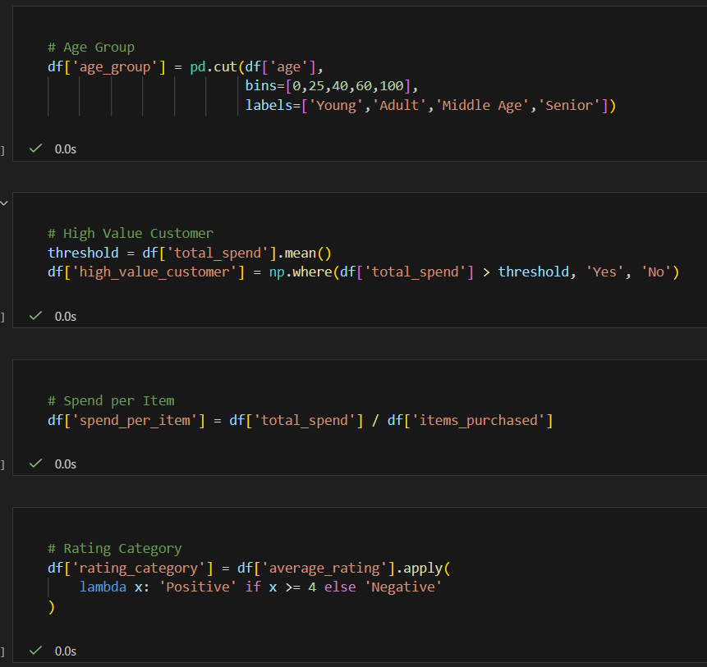

6. Exploratory Data Analysis
Statistical analysis and visualization techniques were applied to understand revenue distribution, membership impact, demographic influence, and customer satisfaction trends.
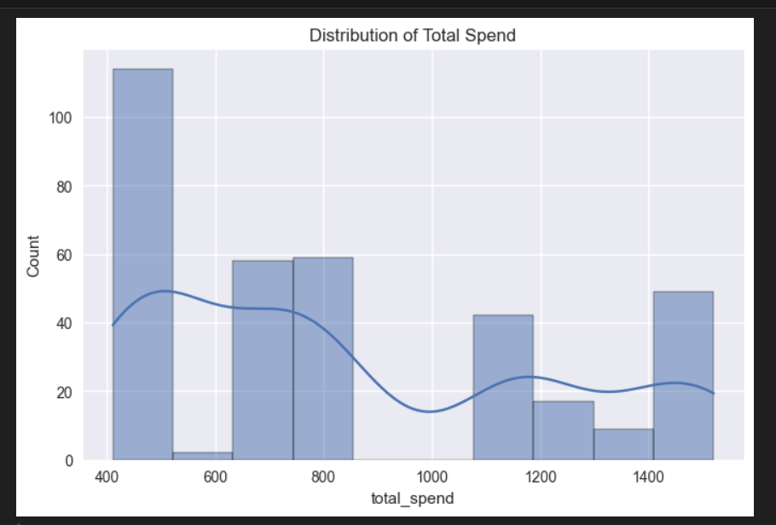

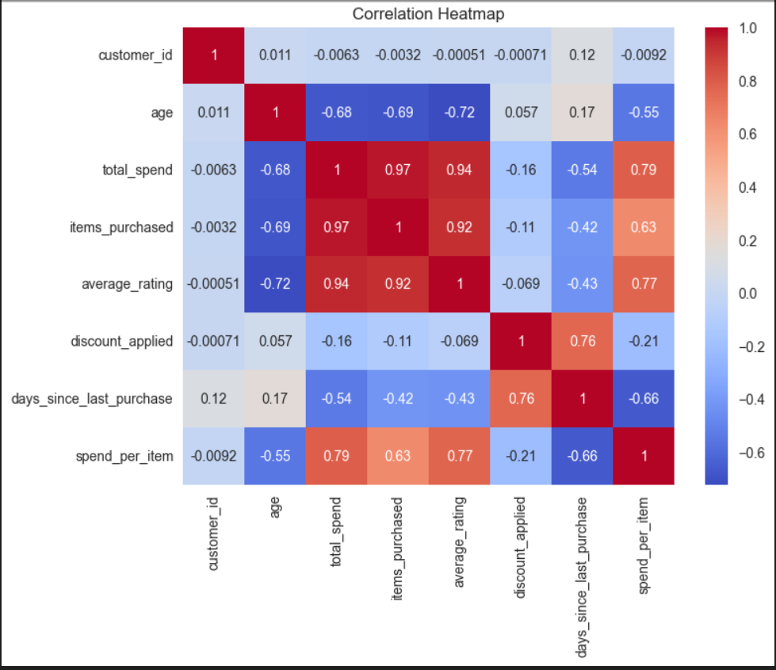
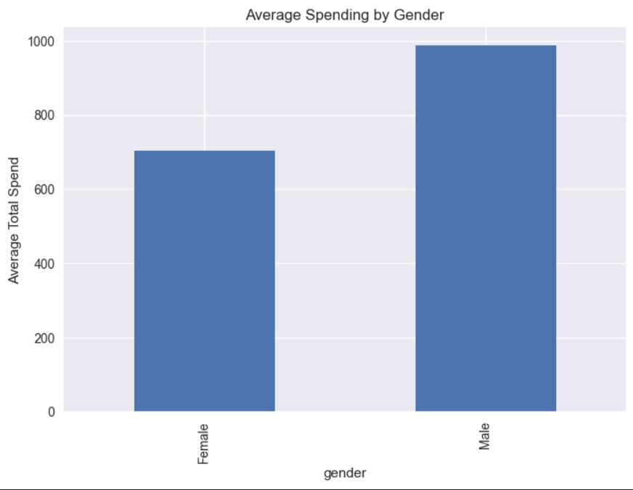

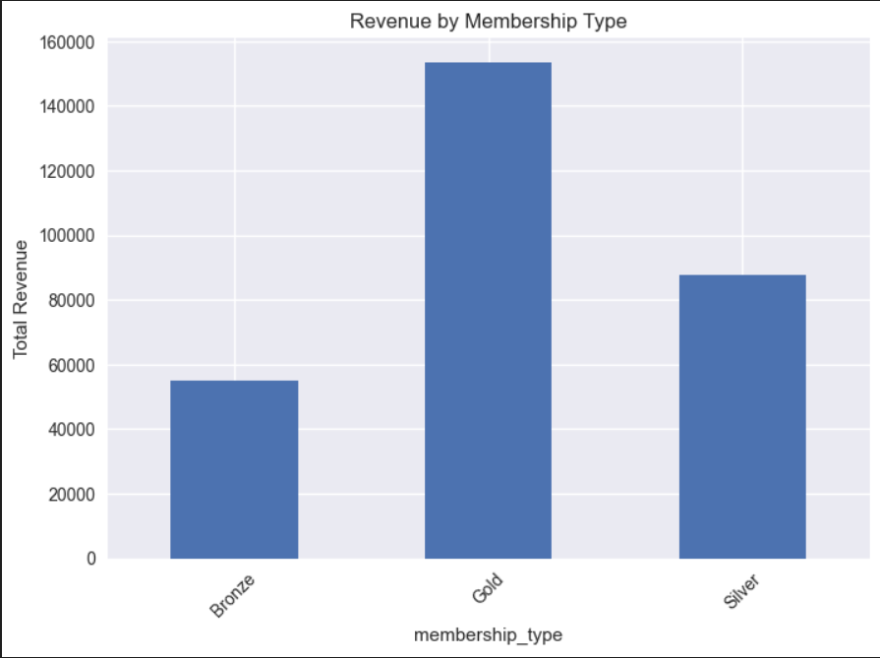
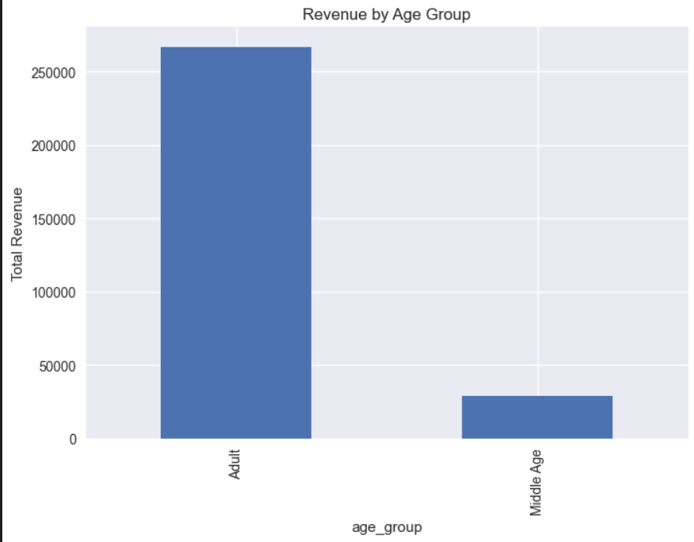
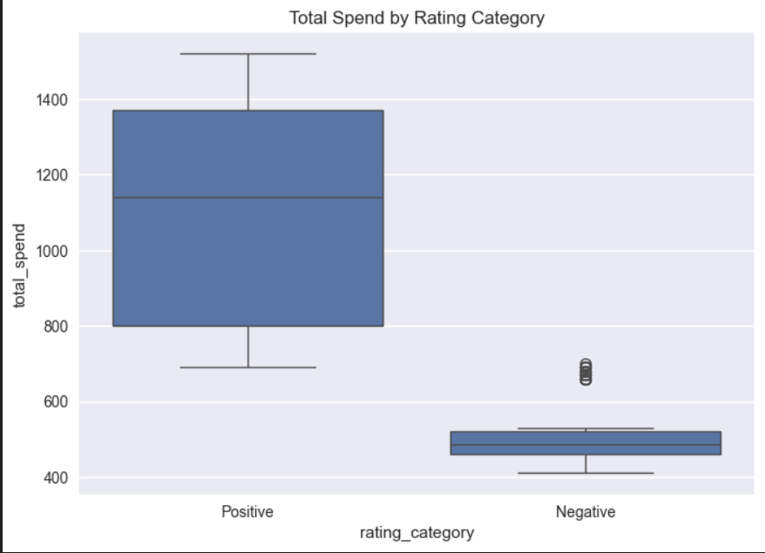
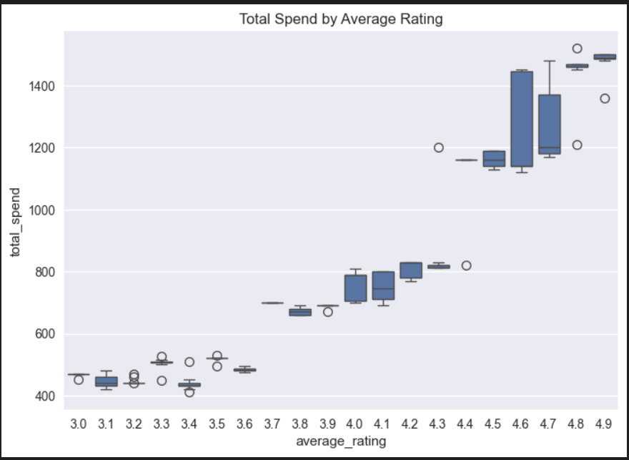

7. Advanced Analysis
Correlation heatmap analysis showed strong positive relationship between items purchased and total spend. Discount patterns and satisfaction levels were analyzed to understand profitability trends.

8. Key Insights
1. Membership type significantly impacts spending.
2. Premium members generate higher revenue.
3. Adult age group contributes most revenue.
4. High-value customers dominate revenue share.
5. Positive ratings correlate with higher spending.
6. Revenue distribution is slightly right-skewed.
7. Recency influences purchase behavior.
8. Spend per item highlights premium buying patterns.

9. Business Recommendations
• Develop loyalty programs for premium members.
• Improve low-rated services.
• Target adult demographic with marketing campaigns.
• Focus on customer retention strategies.
• Optimize discount strategy for profitability.

10. Conclusion
The analysis identified key revenue drivers and customer segments. The insights support data-driven marketing strategies and revenue optimization.

11. Future Scope
• Build dashboards using Power BI or Tableau
• Apply machine learning models for revenue prediction
• Perform customer segmentation using clustering
• Analyze customer lifetime value

