**Normalization Sample Answer**

Problem

An agency called Instant Cover supplies part-time/temporary staff to hotels within Scotland. The table shown in Figure 13.20 displays sample data, which lists the time spent by agency staff working at various hotels. The National Insurance Number (NIN) is unique for every member of staff.

Normalize the database to 3NF. State any assumptions.

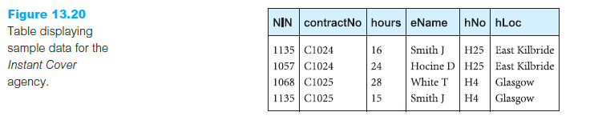

**Solution**

Assuming the employee names and hotel locations (hLoc) are atomic, the table below is in 1NF as not having lists, arrays or repeated groups of data.

Work_details(NIN, contractno, hours, eName, hNo, hLoc)

Functional dependencies are,

NIN 🡪 eName

hNo 🡪 hLoc

contractNo 🡪 hNo

NIN + contractNo 🡪 hours

Choosing the NIN + contractNo as the primary key, (i.e the table stores work details - hours) the Fd’s become,

NIN 🡪 eName (partial dependency)

hNo 🡪 hLoc (transitive dependency)

contractNo 🡪 hNo (partial dependency)

NIN + contractNo 🡪 hours (primary key dependency)

By decomposition the two partial dependencies can be removed and the resulting 2NF tables are,

Employees (NIN, eName)

Contracts( contractNo, hNo, hLoc)

Work_details(NIN, contractNo, hours)

By removing the transive dependency in Contracts table, the 3NF database is,

Employees (NIN, eName)

Contracts( contractNo, hNo)

Hotels(hNo, hLoc)

Work_details(NIN, contractNo, hours)