**Lab Worksheet 02-CT/2021/046**

**Question 01**

**Code:**

package Q_01;  
  
public class Q1 {  
 public static void main(String[] args) {  
 int A=10;  
 int B=20;  
 int C=30;  
 int X=40;  
 int Y=50;  
 int r=7;  
 double answer1=Math.*sqrt*(Math.*pow*(B,2)+4*A*C);  
 double answer2=Math.*sqrt*(X+4*Math.*pow*(Y,3));  
 double answer3=Math.*cbrt*(X*Y);  
 double circle_area=Math.*PI*\*Math.*pow*(r,2);  
 System.*out*.println("Answer for part a =" + answer1);  
 System.*out*.println("Answer for part b ="+ answer2);  
 System.*out*.println("Answer for part c ="+ answer3);  
 System.*out*.println("Answer for part d =" + circle_area);  
 }  
}

**Output:**

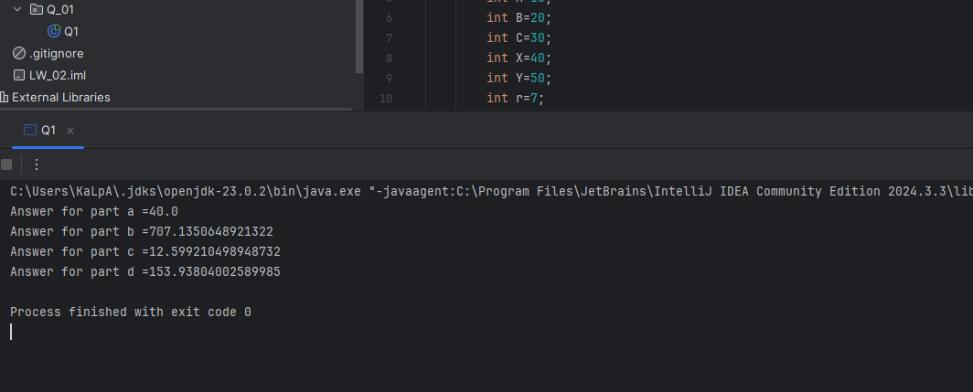

**Question 02**

**Code:**

package Q_02;  
  
import java.util.Scanner;  
  
public class Q2 {  
 public static void main(String[] args) {  
 Scanner scanner = new Scanner(System.*in*);  
 System.*out*.print("Enter length in centimeters: ");  
 double cm_value = scanner.nextDouble();  
  
 double totalInches = cm_value / 2.54;  
 int feet = (int) (totalInches / 12);  
 double inches =totalInches % 12;  
  
  
 System.*out*.println(cm_value + " cm is " + feet + " feet and " + inches + " inches.");  
 scanner.close();  
  
 }  
}

**Output:**

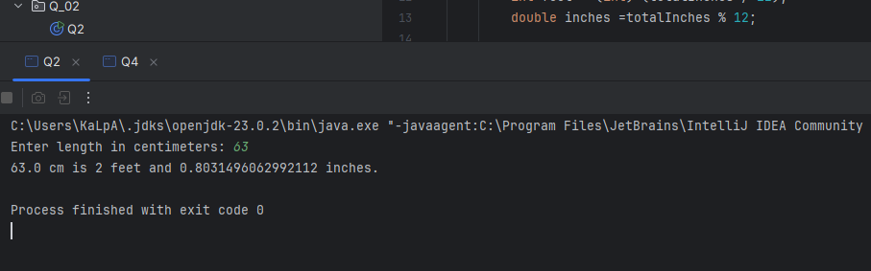

**Question 03**

**Code:**

package Q_03;  
  
import java.util.Scanner;  
  
public class Q3 {  
 public static void main(String[] args) {  
 Scanner scanner = new Scanner(System.*in*);  
 System.*out*.print("Enter temperature in Celsius: ");  
 double celsius = scanner.nextDouble();  
  
 double fahrenheit = (1.8 * celsius) + 32;  
 System.*out*.println("Temperature in Fahrenheit: " + fahrenheit);  
 scanner.close();  
 }  
}

**Output:**

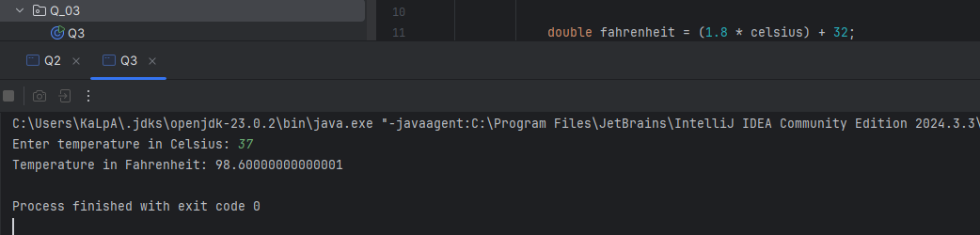

**Question 04**

**Code:**

package Q_04;  
  
import java.util.Scanner;  
  
public class Q4 {  
 public static void main(String[] args) {  
 Scanner scanner = new Scanner(System.*in*);  
 System.*out*.print("Enter weight in pounds: ");  
 double bodyWeight = scanner.nextDouble();  
  
 double calories = bodyWeight * 19;  
 System.*out*.println("Daily caloric needs: " + calories);  
 scanner.close();  
 }  
}

**Output:**

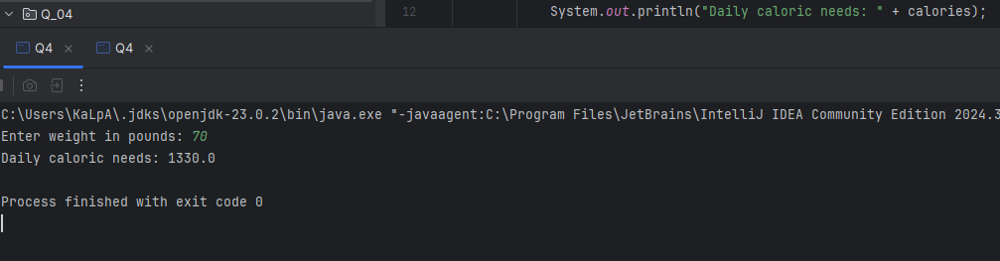

**Question 05**

**Code:**

package Q_05;  
  
import java.util.Scanner;  
  
public class Q5 {  
 public static void main(String[] args) {  
 Scanner scanner = new Scanner(System.*in*);  
 System.*out*.print("Enter temperature in Fahrenheit: ");  
 double fahrenheit = scanner.nextDouble();  
  
 double celsius = (5.0 / 9) * (fahrenheit - 32);  
 System.*out*.println("Temperature in Celsius: " + celsius);  
 scanner.close();  
 }  
}

**Output:**

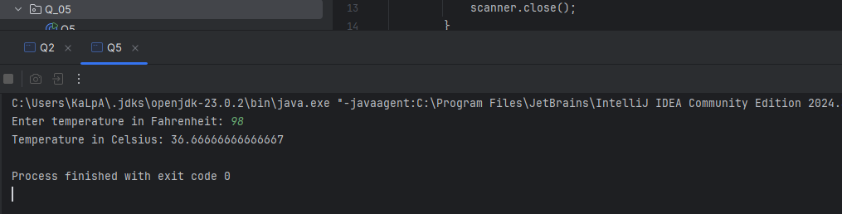

**Question 06**

**Code:**

package Q_06;  
  
import java.util.Scanner;  
import java.time.Year;  
  
public class Q6 {  
 public static void main(String[] args) {  
 Scanner scanner = new Scanner(System.*in*);  
 System.*out*.print("Enter your birth year: ");  
 int birthYear = scanner.nextInt();  
  
 int currentYear = Year.*now*().getValue();  
 int age = currentYear - birthYear;  
  
 System.*out*.println("You were born in " + birthYear + " and will be (are) " + age + " this year.");  
 scanner.close();  
 }  
}

**Output:**

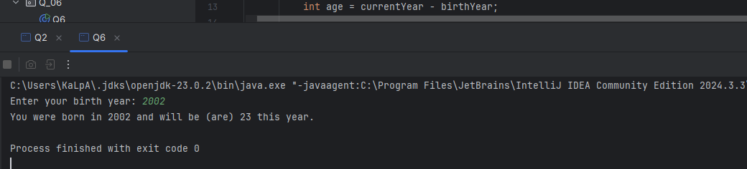

**Question 07**

**Code:**

package Q_07;  
  
import java.util.Scanner;  
  
public class Q7 {  
 public static void main(String[] args) {  
 Scanner scanner = new Scanner(System.*in*);  
 System.*out*.print("Enter weight in kg: ");  
 int w = scanner.nextInt();  
  
 System.*out*.print("Enter height in cm: ");  
 int h = scanner.nextInt();  
  
 double bmi = w / Math.*pow*(h / 100.0, 2);  
 System.*out*.println("Your BMI is: " + bmi);  
 scanner.close();  
 }  
}

**Output:**

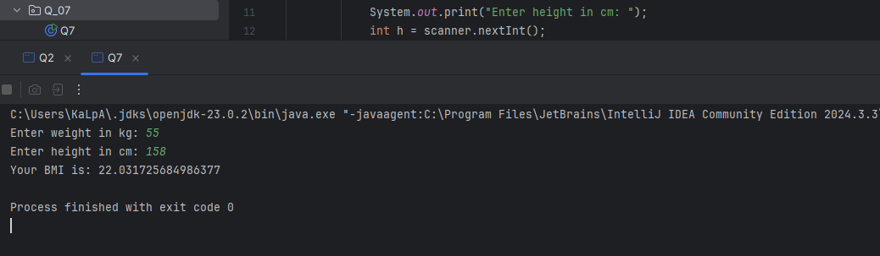

**Question 08**

**Code:**

package Q_08;  
  
import java.util.Scanner;  
  
public class Q8 {  
 public static void main(String[] args) {  
 Scanner scanner = new Scanner(System.*in*);  
 System.*out*.print("Enter radius of the sphere: ");  
 double r = scanner.nextDouble();  
  
 double volume = (4.0 / 3) * Math.*PI* * Math.*pow*(r, 3);  
 System.*out*.println("Volume of the sphere: " + volume);  
 scanner.close();  
 }  
}

**Output:**

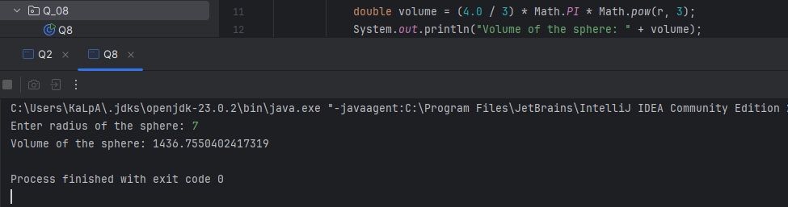

**Question 09**

**Code:**

package Q_09;  
  
import java.util.Scanner;  
  
public class Q9 {  
 public static void main(String[] args) {  
 Scanner scanner = new Scanner(System.*in*);  
 System.*out*.print("Enter how much dollars do you invest (P): ");  
 double P = scanner.nextDouble();  
  
 System.*out*.print("Enter annual interest rate (R) in %: ");  
 double R = scanner.nextDouble();  
  
 System.*out*.print("Enter number of years (N): ");  
 int N = scanner.nextInt();  
  
 double amount = P * Math.*pow*((1 + R / 100), N);  
 System.*out*.println("Total amount after " + N + " years: " + amount);  
 scanner.close();  
 }  
}

**Output:**

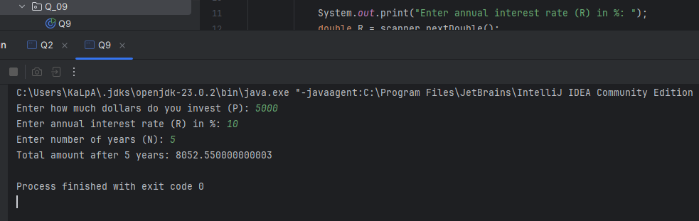

**Question 10**

**Code:**

import java.util.Scanner;  
  
public class Q10 {  
 public static void main(String[] args) {  
 Scanner scanner = new Scanner(System.*in*);  
 final int MONTHS_IN_YEAR = 12;  
  
 System.*out*.print("Enter loan amount: ");  
 double loanAmount = scanner.nextDouble();  
  
 System.*out*.print("Enter annual interest rate (in %): ");  
 double annualInterestRate = scanner.nextDouble();  
  
 System.*out*.print("Enter loan period (in years): ");  
 int loanPeriod = scanner.nextInt();  
  
 double monthlyInterestRate = annualInterestRate / 100.0 / MONTHS_IN_YEAR;  
 int numberOfPayments = loanPeriod * MONTHS_IN_YEAR;  
  
 double monthlyPayment = (loanAmount * monthlyInterestRate) /  
 (1 - Math.*pow*(1 / (1 + monthlyInterestRate), numberOfPayments));  
  
 double totalPayment = monthlyPayment * numberOfPayments;  
  
 System.*out*.println("Monthly Payment: " + monthlyPayment);  
 System.*out*.println("Total Payment: " + totalPayment);  
 scanner.close();  
 }  
}

**Output:**

