**CTEC 22043**

**Object Oriented Programming**

**Lab Worksheet 04: Selection Statements**

**Question 01**

**Code:**

package Q_01;  
  
import java.util.Scanner;  
  
public class SmallestNum {  
 public static void main(String[] args) {  
 Scanner scanner = new Scanner(System.*in*);  
  
 System.*out*.print("Enter the first number: ");  
 int num1 = scanner.nextInt();  
  
 System.*out*.print("Enter the second number: ");  
 int num2 = scanner.nextInt();  
  
 System.*out*.print("Enter the third number: ");  
 int num3 = scanner.nextInt();  
  
 if (num1 < num2) {  
 if (num1 < num3) {  
 System.*out*.println("The smallest number is: " + num1);  
 } else {  
 System.*out*.println("The smallest number is: " + num3);  
 }  
 }  
 else if (num2 < num3) {  
 System.*out*.println("The smallest number is: " + num2);  
 } else {  
 System.*out*.println("The smallest number is: " + num3);  
 }  
 scanner.close();  
 }  
}

**Output:**

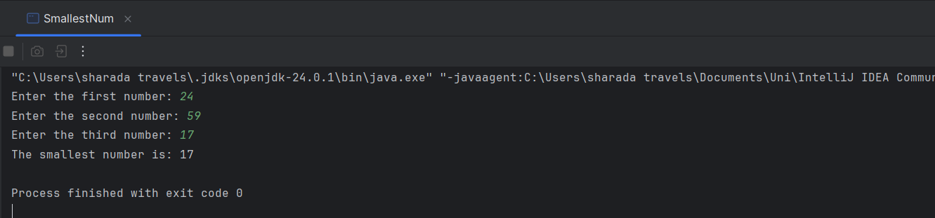

**Question 02**

**Code:**

package Q_02;  
  
import java.util.Scanner;  
  
public class Main {  
 public static void main(String[] args) {  
 Scanner scanner = new Scanner(System.*in*);  
  
 System.*out*.println("0. Magenta");  
 System.*out*.println("1. Cyan");  
 System.*out*.println("2. Red");  
 System.*out*.println("3. Blue");  
 System.*out*.println("4. Green");  
 System.*out*.println("Select one color from the above list: ");  
  
 int selection = scanner.nextInt();  
  
 switch (selection) {  
 case 0:  
 System.*out*.println("You selected Magenta");  
 break;  
 case 1:  
 System.*out*.println("You selected Cyan");  
 break;  
 case 2:  
 System.*out*.println("You selected Red");  
 break;  
 case 3:  
 System.*out*.println("You selected Blue");  
 break;  
 case 4:  
 System.*out*.println("You selected Green");  
 break;  
 default:  
 System.*out*.println("Invalid selection");  
 }  
 scanner.close();  
 }  
}

**Output:**

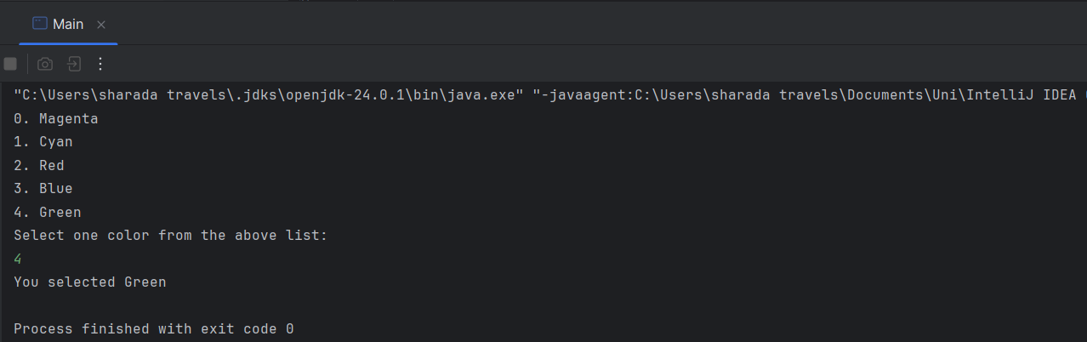

**Question 03**

**Code:**

package Q_03;  
  
import java.util.Scanner;  
  
public class IntroductionToPower {  
 public static void main(String[] args) {  
 Scanner scanner = new Scanner(System.*in*);  
  
 System.*out*.print("Enter a power of 10 (6,9,12 etc): ");  
 int power = scanner.nextInt();  
  
 switch(power) {  
 case 6:  
 System.*out*.println("Million");  
 break;  
 case 9:  
 System.*out*.println("Billion");  
 break;  
 case 12:  
 System.*out*.println("Trillion");  
 break;  
 case 15:  
 System.*out*.println("Quadrillion");  
 break;  
 case 18:  
 System.*out*.println("Quintillion");  
 break;  
 case 21:  
 System.*out*.println("Sextillion");  
 break;  
 case 30:  
 System.*out*.println("Nonillion");  
 break;  
 case 100:  
 System.*out*.println("Googol");  
 break;  
 default:  
 System.*out*.println("No corresponding word for this power");  
 }  
 scanner.close();  
 }  
}

**Output:**

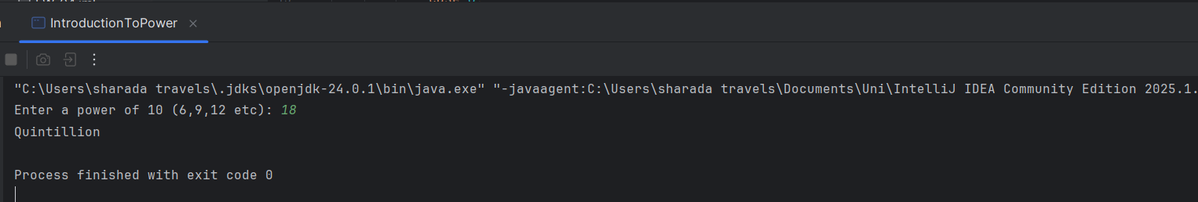

**Question 04**

**Code:**

package Q_04;  
  
import java.util.Scanner;  
  
public class FindLeapYear {  
 public static void main(String[] args) {  
 Scanner scanner = new Scanner(System.*in*);  
  
 System.*out*.print("Enter the year: ");  
 int year = scanner.nextInt();  
  
 if (year % 4 == 0) {  
 if (year % 100 != 0) {  
 System.*out*.println(year + " is a leap year");  
 } else if (year % 400 == 0) {  
 System.*out*.println(year + " is a leap year");  
 } else {  
 System.*out*.println(year + " is not a leap year");  
 }  
 } else {  
 System.*out*.println(year + " is not a leap year");  
 }  
 scanner.close();  
 }  
}

**Output:**

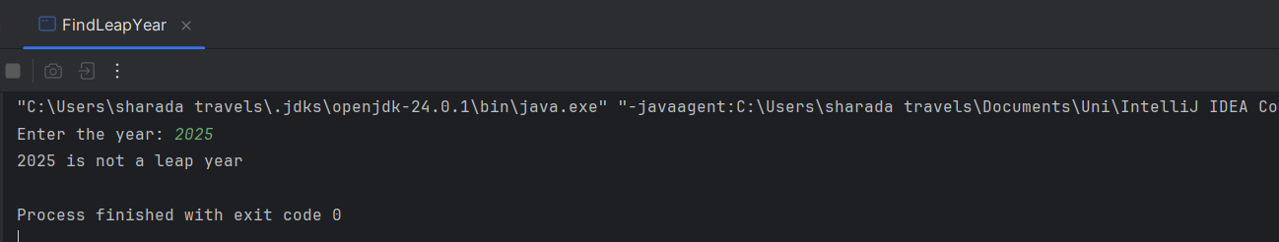

**Question 05**

**Code:**

package Q_05;  
  
import java.util.Scanner;  
  
public class MyJavaLoFatBurgers {  
 public static void main(String[] args) {  
 Scanner scanner = new Scanner(System.*in*);  
  
 double total = 0;  
 boolean valid = true;  
  
 System.*out*.println("1. Tofu Burger - $3.49");  
 System.*out*.println("2. Cajun Chicken - $4.59");  
 System.*out*.println("3. Buffalo Wings - $3.99");  
 System.*out*.println("4. Rainbow Fillet - $2.99");  
 System.*out*.print("Select Entree: ");  
 int entree = scanner.nextInt();  
  
 switch (entree) {  
 case 1:  
 total += 3.49;  
 break;  
 case 2:  
 total += 4.59;  
 break;  
 case 3:  
 total += 3.99;  
 break;  
 case 4:  
 total += 2.99;  
 break;  
 default:  
 System.*out*.println("Invalid entree selection");  
 valid = false;  
 }  
  
 System.*out*.println("1. Rice Cracker - $0.79");  
 System.*out*.println("2. No-Salt Fries - $0.69");  
 System.*out*.println("3. Zucchini - $1.09");  
 System.*out*.println("4. Brown Rice - $0.59");  
 System.*out*.print("Select Side Dish: ");  
 int sideDish = scanner.nextInt();  
  
 switch (sideDish) {  
 case 1:  
 total += 0.79;  
 break;  
 case 2:  
 total += 0.69;  
 break;  
 case 3:  
 total += 1.09;  
 break;  
 case 4:  
 total += 0.59;  
 break;  
 default:  
 System.*out*.println("Invalid side dish selection");  
 valid = false;  
 }  
  
 System.*out*.println("1. Cafe Mocha - $1.99");  
 System.*out*.println("2. Cafe Latte - $1.90");  
 System.*out*.println("3. Espresso - $2.49");  
 System.*out*.println("4. Oolong Tea - $0.99");  
 System.*out*.print("Select Drink: ");  
 int drink = scanner.nextInt();  
  
 switch (drink) {  
 case 1:  
 total += 1.99;  
 break;  
 case 2:  
 total += 1.90;  
 break;  
 case 3:  
 total += 2.49;  
 break;  
 case 4:  
 total += 0.99;  
 break;  
 default:  
 System.*out*.println("Invalid drink selection");  
 valid = false;  
 }  
 scanner.close();  
  
 if (valid) {  
 System.*out*.println("Your selections are: Entree #" + entree + ", Side Dish #" + sideDish + " and Drink #" + drink);  
 System.*out*.printf("Your total price is: $%.2f%n", total);  
 }  
 }  
}

**Output:**

