**CTEC 22043**

**Object Oriented Programming**

**Lab worksheet 5: Repetition Statements**

**Question 01**

**Code:**

package Q_01;  
  
public class Q1 {  
 public static void main(String[] args) {  
 for (int i = 10; i <= 49; i++) {  
 System.*out*.print(i + " ");  
 if (i % 10 == 9) {  
 System.*out*.println();  
 }  
 }  
 }  
}

**Output:**

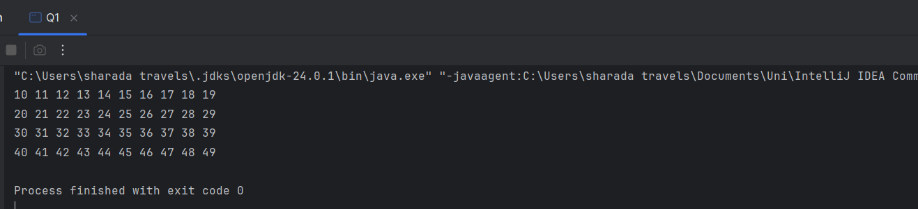

**Question 02**

**Code:**

package Q_02;  
  
import java.util.Scanner;  
  
public class Q2 {  
 public static int countDigits(int number) {  
 int count = 0;  
 if (number == 0) return 1;  
 number = Math.*abs*(number);  
 while (number > 0) {  
 count++;  
 number /= 10;  
 }  
 return count;  
 }  
  
 public static void main(String[] args) {  
 Scanner input = new Scanner(System.*in*);  
 int num;  
  
 while (true) {  
 System.*out*.print("Enter an integer (negative to stop): ");  
 num = input.nextInt();  
 if (num < 0) break;  
 System.*out*.println("Number of digits: " + *countDigits*(num));  
 }  
 }  
}

**Output:**

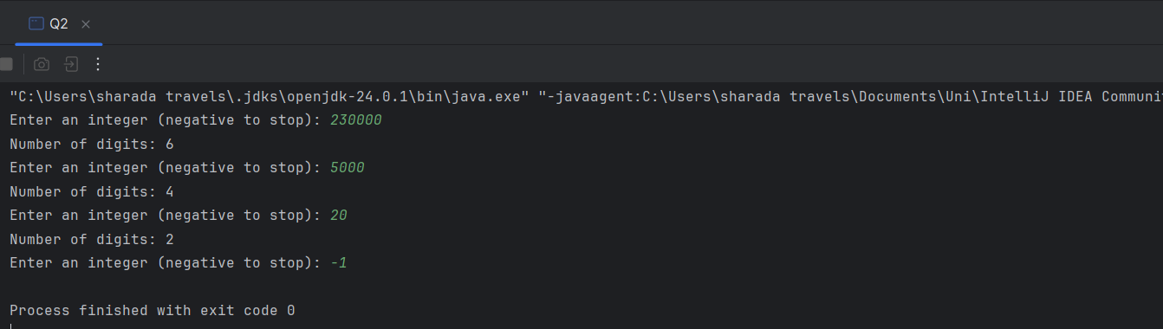

**Question 03**

**Code:**

package Q_03;  
  
import java.util.Scanner;  
  
public class Q3 {  
 public static void main(String[] args) {  
 Scanner input = new Scanner(System.*in*);  
 System.*out*.print("Enter a number: ");  
 int N = input.nextInt();  
  
 for (int i = 1; i <= 10; i++) {  
 System.*out*.println(N + " x " + i + " = " + (N * i));  
 }  
 }  
}

**Output:**

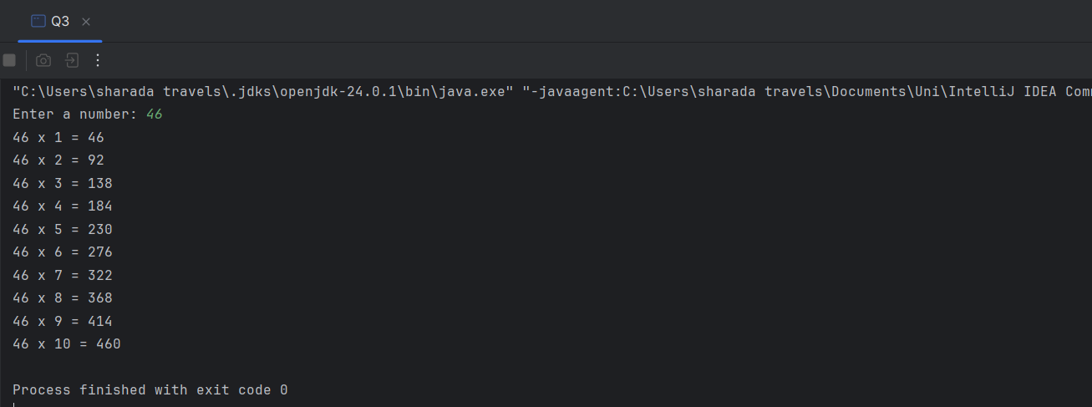

**Question 04**

**Code:**

package Q_04;  
  
import java.util.Scanner;  
  
public class Q4 {  
 public static void main(String[] args) {  
 Scanner input = new Scanner(System.*in*);  
 System.*out*.print("Enter number of rows: ");  
 int rows = input.nextInt();  
  
 for (int i = 1; i <= rows; i++) {  
  
 for (int j = i; j < rows; j++) {  
 System.*out*.print(" ");  
 }  
  
 for (int k = 1; k <= (2 * i - 1); k++) {  
 System.*out*.print("*");  
 }  
 System.*out*.println();  
 }  
 }  
}

**Output:**

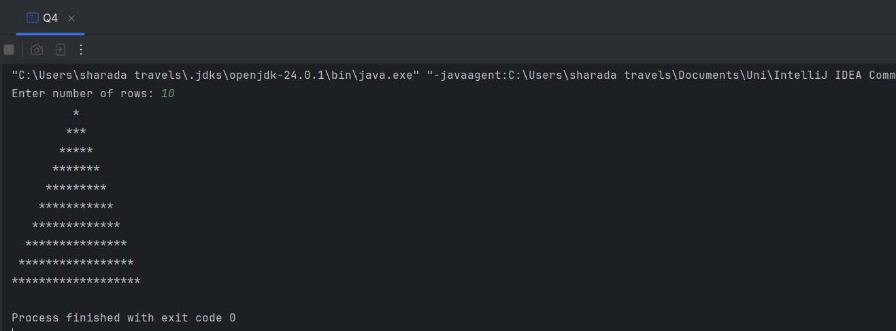

**Question 05**

**Code:**

package Q_05;  
import java.util.Scanner;  
  
public class Q5 {  
 public static void main(String[] args) {  
 Scanner input = new Scanner(System.*in*);  
 System.*out*.print("Enter a word or phrase: ");  
 String str = input.nextLine();  
  
 str = str.replaceAll("[^a-zA-Z0-9]", "").toLowerCase();  
  
 boolean isPalindrome = true;  
 int len = str.length();  
  
 for (int i = 0; i < len / 2; i++) {  
 if (str.charAt(i) != str.charAt(len - 1 - i)) {  
 isPalindrome = false;  
 break;  
 }  
 }  
  
 if (isPalindrome) {  
 System.*out*.println("It is a palindrome.");  
 } else {  
 System.*out*.println("It is not a palindrome.");  
 }  
 }  
}

**Output:**

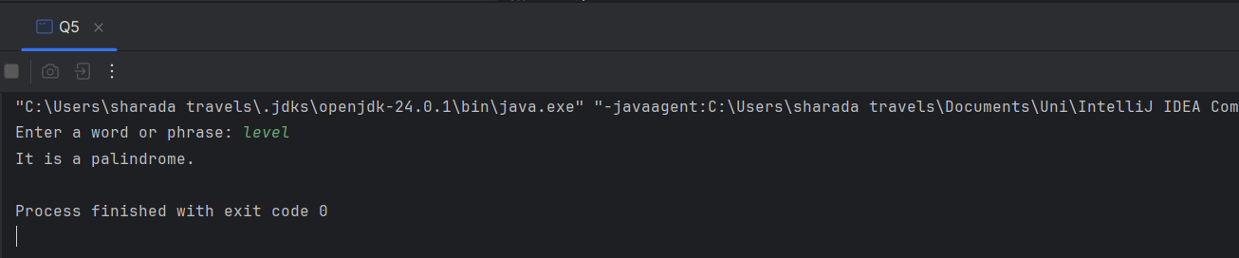

**Question 06**

**Code:**

package Q_06;  
  
import java.util.Scanner;  
import java.util.Random;  
  
public class Q6 {  
 public static void main(String[] args) {  
 Scanner input = new Scanner(System.*in*);  
 Random random = new Random();  
 int secretNumber = random.nextInt(100) + 1;  
 int guess = 0;  
 System.*out*.println("Welcome to the number guessing game!");  
  
 while (guess != secretNumber) {  
 System.*out*.println("Guess a number between 1 and 100: ");  
 guess = input.nextInt();  
  
 if (guess < secretNumber) {  
 System.*out*.println("Too low!,Try again");  
 } else if (guess > secretNumber) {  
 System.*out*.println("Too high!,Try again");  
 } else {  
 System.*out*.println("Congratulations..! You guessed the number.");  
 }  
 }  
 }  
}

**Output:**

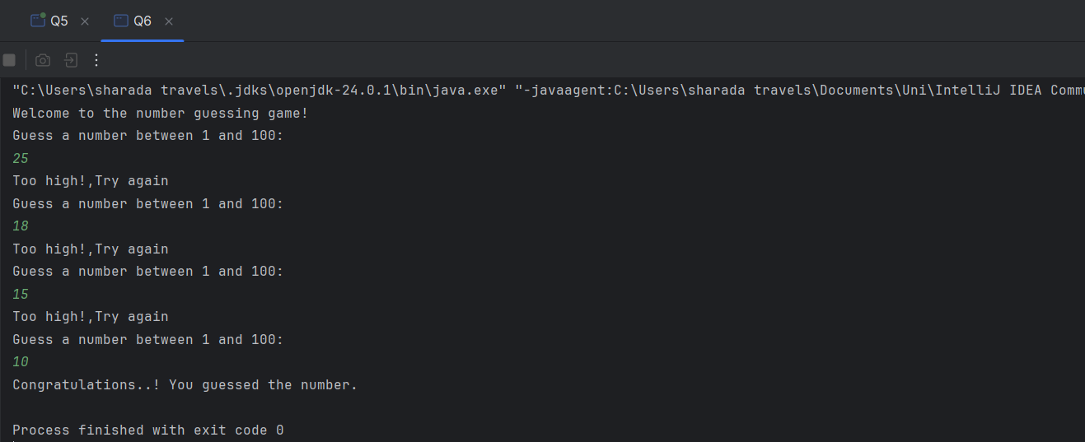

**Question 07**

**Code:**

package Q_07;  
  
import java.util.Scanner;  
  
public class Q7 {  
 public static void main(String[] args) {  
 Scanner scanner = new Scanner(System.*in*);  
  
 System.*out*.print("Enter a sentence: ");  
 String sentence = scanner.nextLine();  
  
 System.*out*.print("Enter the word to be replaced: ");  
 String wordToReplace = scanner.nextLine();  
  
 System.*out*.print("Enter the replacement word: ");  
 String replacementWord = scanner.nextLine();  
  
 String[] words = sentence.split(" ");  
  
 String modifiedSentence = "";  
  
 for (int i = 0; i < words.length; i++) {  
 if (words[i].equals(wordToReplace)) {  
 modifiedSentence += replacementWord;  
 } else {  
 modifiedSentence += words[i];  
 }  
  
 if (i < words.length - 1) {  
 modifiedSentence += " ";  
 }  
 }  
  
 System.*out*.println("Modified sentence: " + modifiedSentence);  
  
 scanner.close();  
 }  
}

**Output:**

