Question 01
Code:
import javax.swing. *;
public class Q_01 {
public static void main(String[] args) {
JFrame myWindow;
myWindow = new JFrame();
myWindow.setSize(800, 600);
myWindow.setTitle("Welcome to Java");
myWindow.setVisible(true);
}
}

Output:

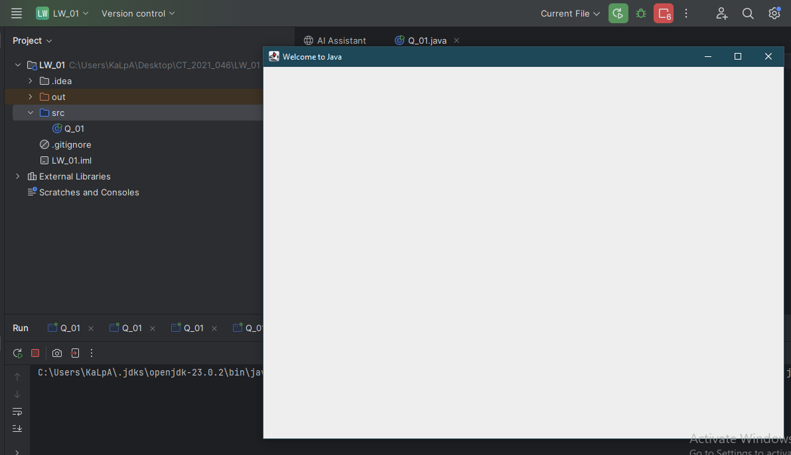

Question 02
Code:
import javax.swing. *;
import java.util.Scanner;
public class Q_02 {
public static void main(String[] args) {
Scanner scanner = new Scanner(System.in);
String firstName;
System.out.print("Enter your first name: ");
firstName = scanner.next() ;
String lastName;
System.out.print("Enter your last name: ");
lastName = scanner.next() ;
scanner.close() ;
String fullName = firstName + " " + lastName;
JFrame frame;
frame = new JFrame(fullName);
frame.setSize(400, 300);
frame.setVisible(true);
}
}

Output:

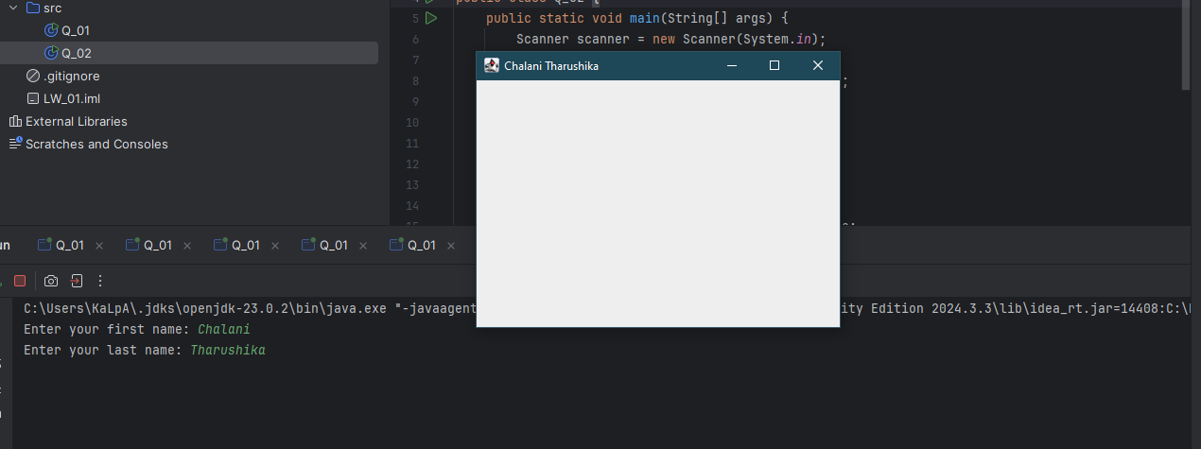
Question 03
Code:

import java.util.Scanner;
public class Q_03 {
public static void main(String[] args) {
Scanner scanner = new Scanner(System.in);
String firstName;
System.out.print("Enter your first name: ");
firstName = scanner.next();
String middleName;
System.out.print("Enter your middle name: ");
middleName = scanner.next();
String lastName;
System.out.print("Enter your last name: ");
lastName = scanner.next();
scanner.close();
System.out.println(firstName + " " + middleName.charAt(0) + "." + lastName);
scanner.close();
}
}

Output:

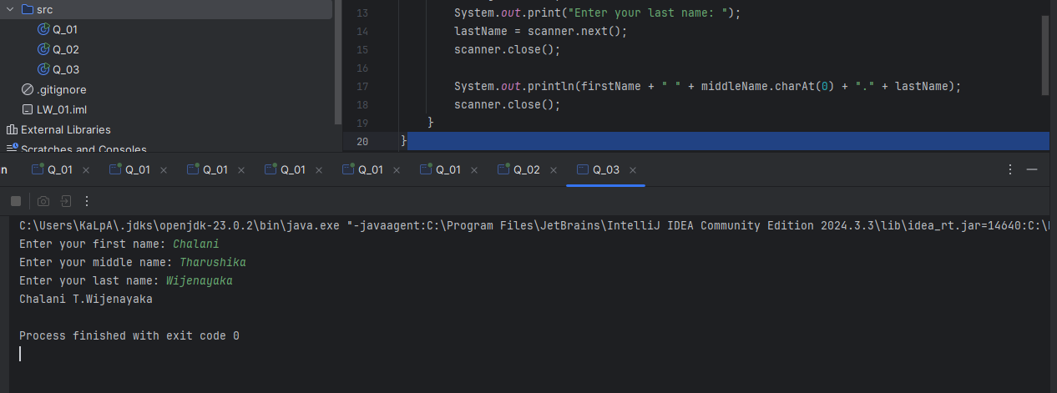

Question 04
Code:

import java.time.LocalDate;
import java.time.format.DateTimeFormatter;
public class Q_04 {
public static void main(String[] args) {
LocalDate today = LocalDate.now();
DateTimeFormatter formatter = DateTimeFormatter.ofPattern("d MMM yyyy");
System.out.println(today.format(formatter));
}
}

Output:
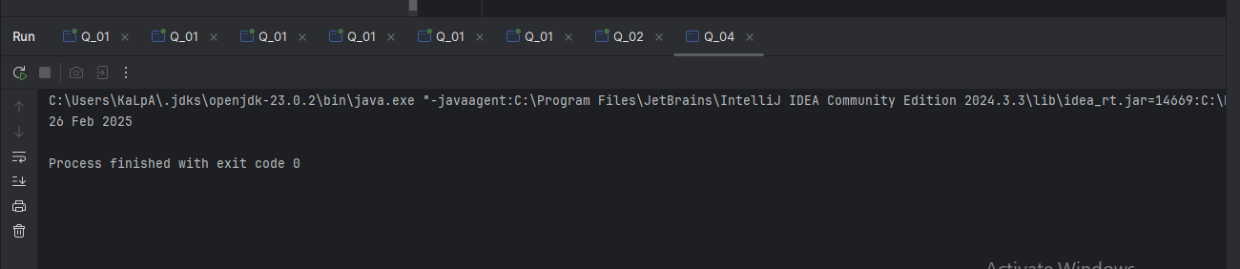

Question 05
Code:

import java.time.LocalDate;
import java.time.format.DateTimeFormatter;
public class Q_05 {
public static void main(String[] args) {
LocalDate today = LocalDate.now();
DateTimeFormatter formatter = DateTimeFormatter.ofPattern("EEEE, MMM d, yyyy");
System.out.println(today.format(formatter));
}
}
Output:

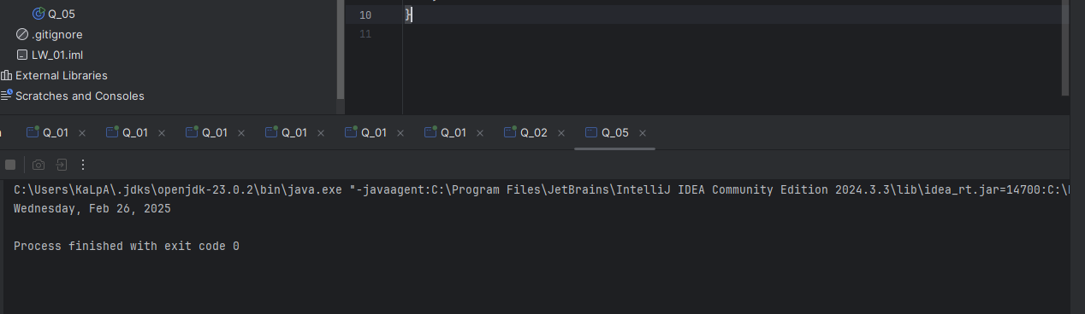

Question 06

Code:
import javax.swing.*;
import java.util.Scanner;
public class Q_06 {
public static void main(String[] args) {
Scanner scanner = new Scanner(System.in);
System.out.print("Enter the width in pixels: ");
int W = scanner.nextInt();
System.out.print("Enter the hei6ght in pixels: ");
int H = scanner.nextInt();
System.out.print("Enter the frame title: ");
String frameTitle = scanner.next();
scanner.close();
JFrame frame;
frame = new JFrame(frameTitle);
frame.setSize(W, H);
frame.setVisible(true);
}
}

Output:

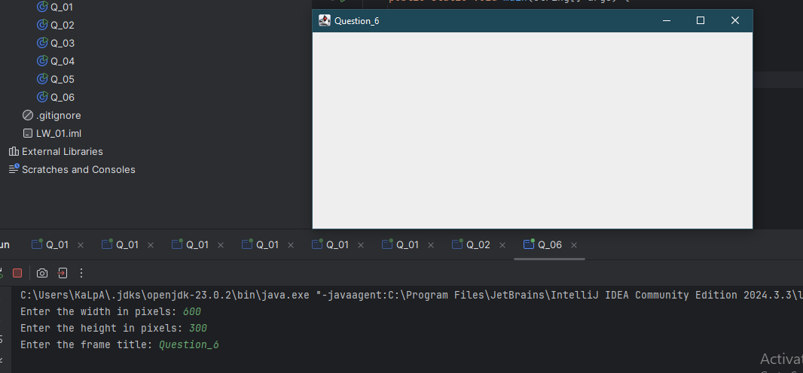

Question 07
Code:

import javax.swing.*;
import java.text.SimpleDateFormat;
import java.util.Date;
public class Q_07 {
public static void main(String[] args) {
Date now = new Date();
SimpleDateFormat timeFormat = new SimpleDateFormat("hh:mm:ss a");
String currentTime = timeFormat.format(now);
JFrame frame = new JFrame(currentTime);
frame.setSize(500, 200);
frame.setVisible(true);
}
}

Output:
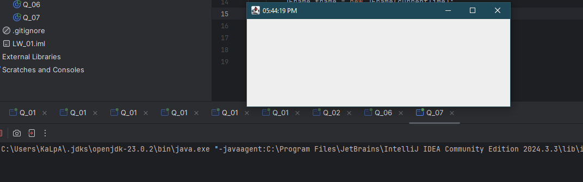

Question 08

Code:
import java.util.Scanner;
public class Q_08 {
public static void main(String[] args) {
Scanner scanner = new Scanner(System.in);
System.out.print("Enter a string with a single exclamation mark: ");
String input = scanner.nextLine();
scanner.close();
int index = input.indexOf('!');
if (index != -1) {
String before = input.substring(0, index).trim();
String after = input.substring(index + 1).trim();
System.out.println(before);
System.out.println(after);
} else {
System.out.println("Error. No exclamation mark found in the input");
}
}
}

Output:
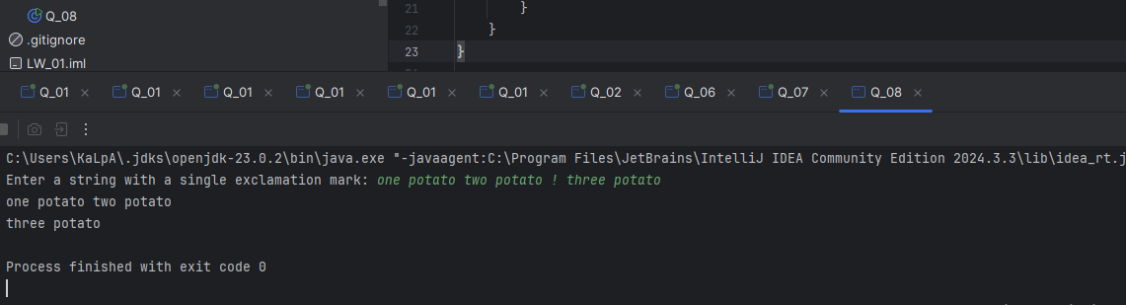

Question 09
Code:
import java.util.Scanner;
public class Q_09 {
public static void main(String[] args) {
Scanner scanner = new Scanner(System.in);
System.out.print("Enter a string: ");
String input = scanner.nextLine();
scanner.close();
System.out.println(input.length());
System.out.println(input.charAt(0));
System.out.println(input.charAt(input.length() - 1));
}
}

Output:
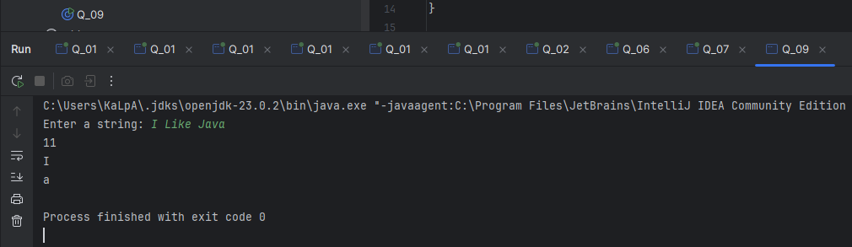

Question 10

Code:
import java.util.Scanner;
public class Q_10 {
public static void main(String[] args) {
Scanner scanner = new Scanner(System.in);
System.out.print("Enter an odd-length word: ");
String word = scanner.next();
scanner.close();
int length = word.length();
if (length % 2 == 1) {
int middleIndex = length / 2;
System.out.println(word.charAt(middleIndex));
} else {
System.out.println("Error. The word doesn't have odd number of characters.");
}
}
}

Output:

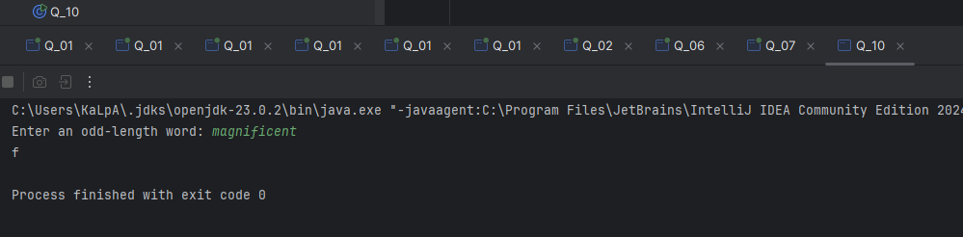

Question 11

Code:

import java.util.Scanner;
public class Q_11 {
public static void main(String[] args) {
Scanner scanner = new Scanner(System.in);
System.out.print("Enter your first name: ");
String firstName = scanner.next();
System.out.print("Enter your middle name: ");
String middleName = scanner.next();
System.out.print("Enter your last name: ");
String lastName = scanner.next();
scanner.close();
System.out.println(lastName + "," + firstName + " " + middleName.charAt(0) + ".");
}
}

Output:

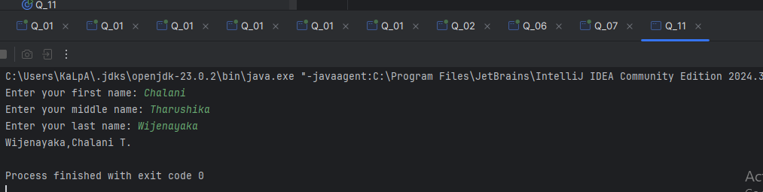

Question 12
Code:

import javax.swing.*;
public class Q_12 {
public static void main(String[] args) {
JFrame frame = new JFrame();
frame.setSize(300, 200);
frame.setTitle("My First Frame");
frame.setLocation(100, 50);
frame.setDefaultCloseOperation(JFrame.EXIT_ON_CLOSE);
frame.setVisible(true);
}
}

Output:

