Lab worksheet 1: Introduction to Program Components

Q1)

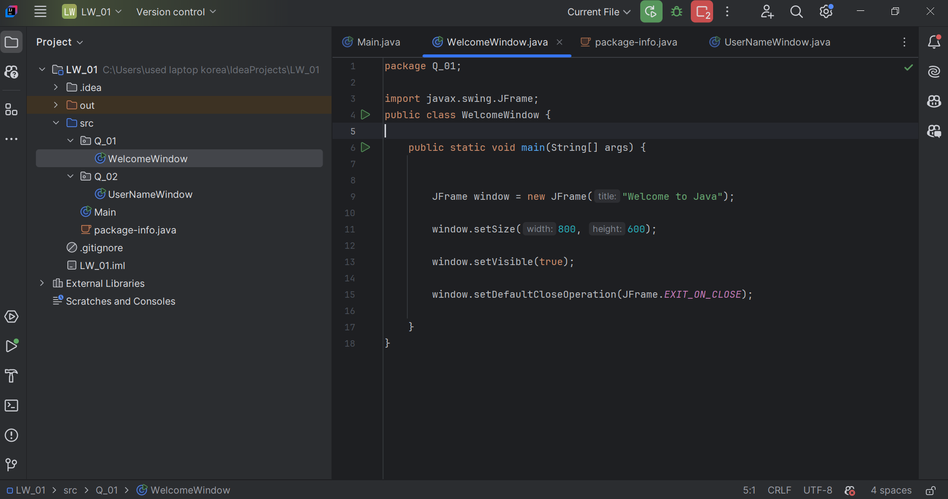

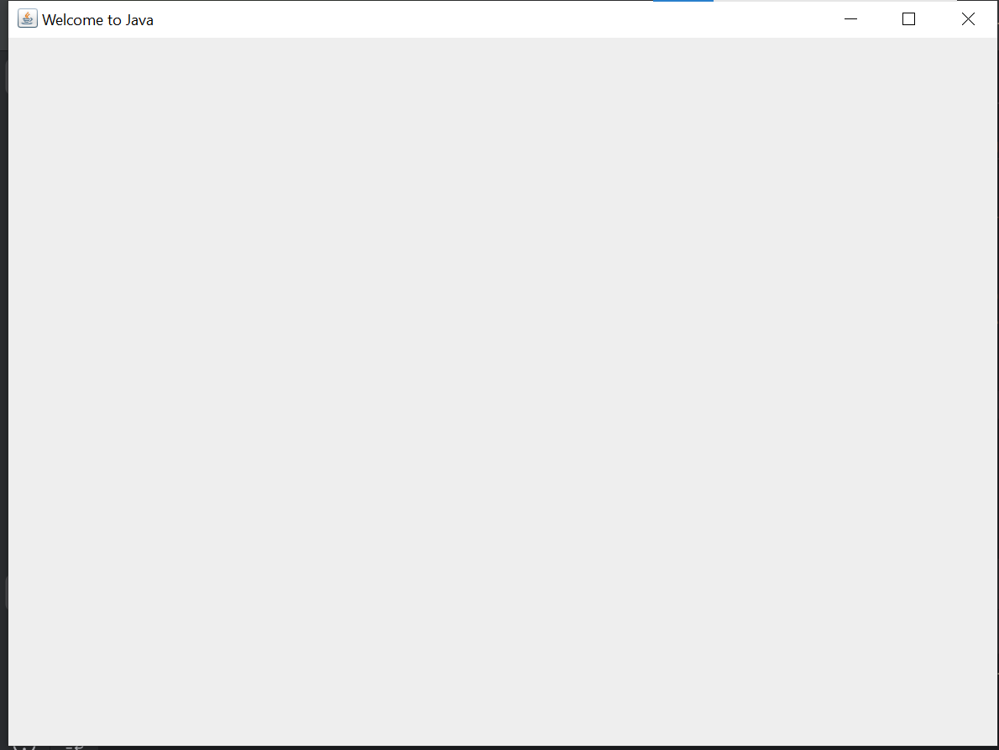

Q2) 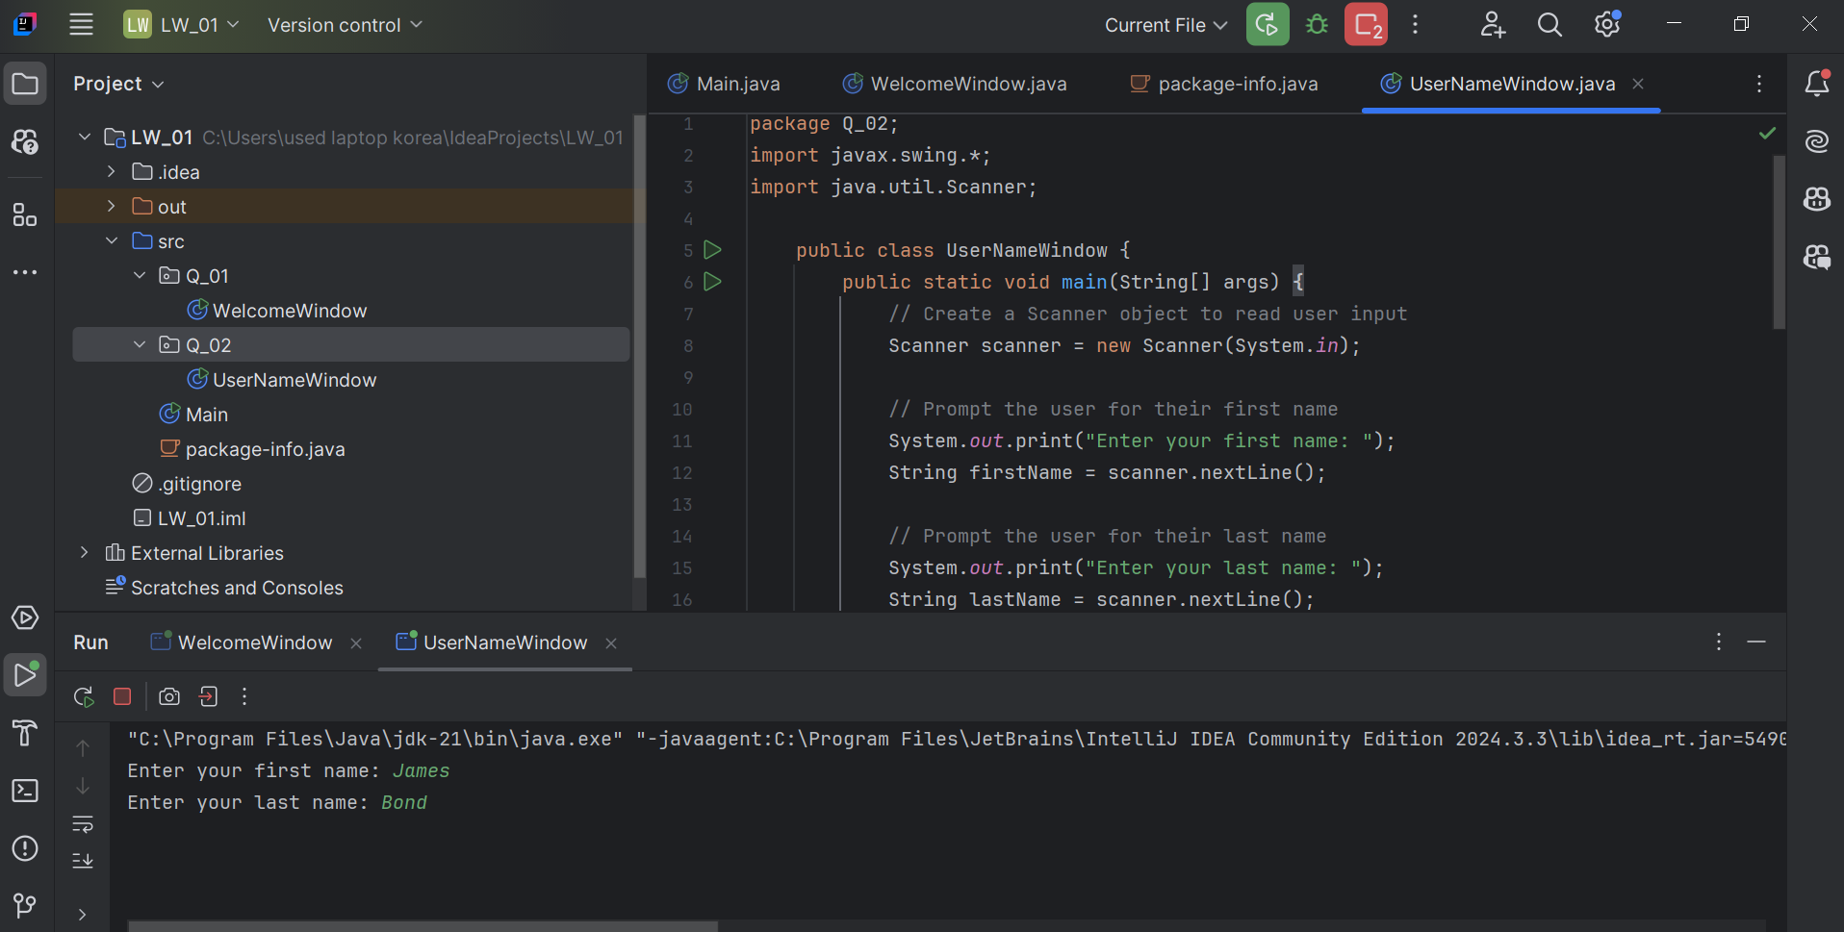

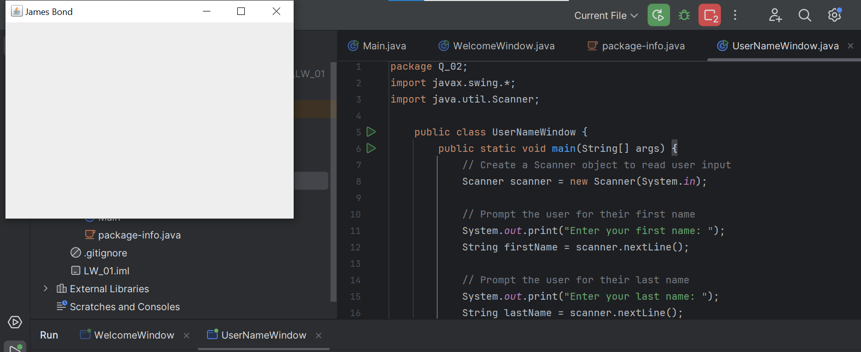

Q3)

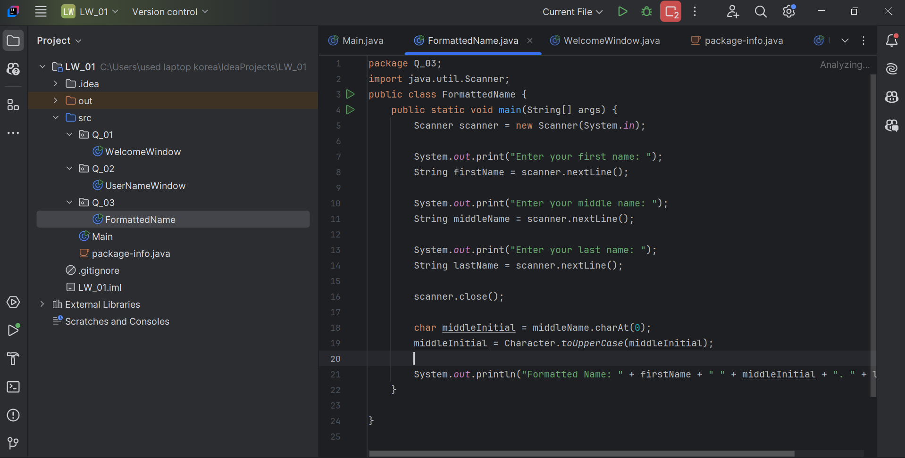

Q4)

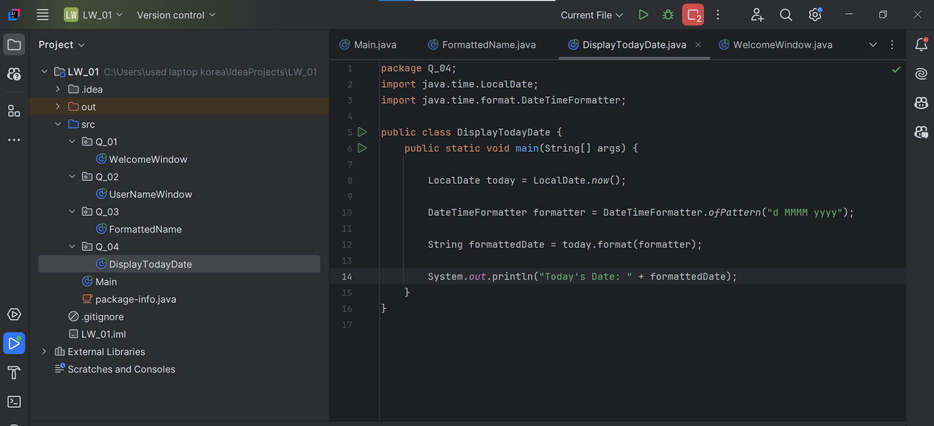

Q5)

package Q_05;  
import java.time.LocalDate;  
import java.time.format.DateTimeFormatter;

public class DisplayFormattedDate {  
 public static void main(String[] args) {  
   
 LocalDate today = LocalDate.*now*();  
   
 DateTimeFormatter formatter = DateTimeFormatter.*ofPattern*("EEEE, MMMM d, yyyy");  
   
 String formattedDate = today.format(formatter);  
   
 System.*out*.println("Today's Date: " + formattedDate);  
 }  
}

Q6)

package Q_06;  
import javax.swing.*;  
import java.util.Scanner;  
  
public class CustomFrame {  
 public static void main(String[] args) {  
 // Create a Scanner object to read user input  
 Scanner scanner = new Scanner(System.*in*);  
  
 // Prompt the user for the width (W)  
 System.*out*.print("Enter the width of the frame (W): ");  
 int width = scanner.nextInt();  
  
 // Prompt the user for the height (H)  
 System.*out*.print("Enter the height of the frame (H): ");  
 int height = scanner.nextInt();  
  
 // Consume the newline character left by nextInt()  
 scanner.nextLine();  
  
 // Prompt the user for the title of the frame  
 System.*out*.print("Enter the title of the frame: ");  
 String title = scanner.nextLine();  
  
 // Close the scanner  
 scanner.close();  
  
 // Create a JFrame with the specified title  
 JFrame frame = new JFrame(title);  
  
 // Set the size of the frame using the user-provided width and height  
 frame.setSize(width, height);  
  
 // Set the default close operation  
 frame.setDefaultCloseOperation(JFrame.*EXIT_ON_CLOSE*);  
  
 // Make the frame visible  
 frame.setVisible(true);  
 }  
}

Q7)

package Q_07;  
  
import javax.swing.*;  
import java.time.LocalTime;  
import java.time.format.DateTimeFormatter;  
  
public class TimeInFrameTitle {  
 public static void main(String[] args) {  
  
 LocalTime currentTime = LocalTime.*now*();  
  
 DateTimeFormatter formatter = DateTimeFormatter.*ofPattern*("hh:mm:ss a");  
  
 String formattedTime = currentTime.format(formatter);  
  
 JFrame frame = new JFrame("Current Time: " + formattedTime);  
  
 frame.setSize(400, 300);  
  
 frame.setDefaultCloseOperation(JFrame.*EXIT_ON_CLOSE*);  
   
 frame.setVisible(true);  
 }  
}

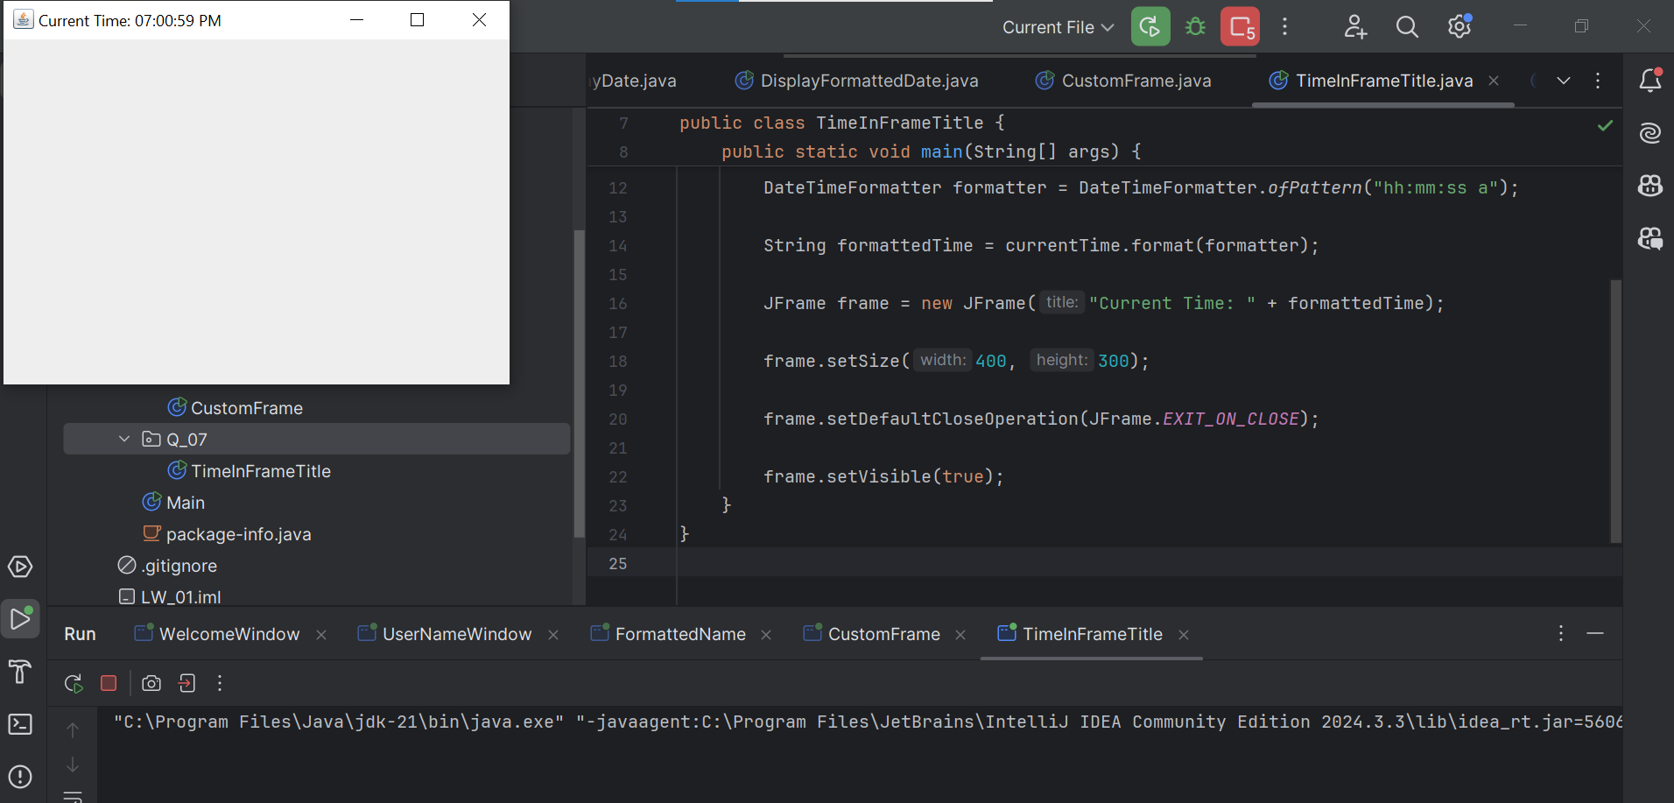

Q8)

package Q_08;  
  
import java.util.Scanner;  
  
public class SplitStringAtExclamation {  
 public static void main(String[] args) {  
 Scanner scanner = new Scanner(System.*in*);  
  
 System.*out*.print("Enter a string containing a single exclamation mark (!): ");  
 String input = scanner.nextLine();  
  
 int exclamationIndex = input.indexOf('!');  
  
 if (exclamationIndex == -1) {  
 System.*out*.println("The input string does not contain an exclamation mark.");  
 } else {  
  
 String beforeExclamation = input.substring(0, exclamationIndex).trim();  
  
 String afterExclamation = input.substring(exclamationIndex + 1).trim();  
  
 System.*out*.println("Before exclamation mark: " + beforeExclamation);  
 System.*out*.println("After exclamation mark: " + afterExclamation);  
 }  
   
 scanner.close();  
 }  
}

Q9)

package Q_09;  
  
import java.util.Scanner;  
  
public class StringInfo {  
 public static void main(String[] args) {  
   
 Scanner scanner = new Scanner(System.*in*);  
   
 System.*out*.print("Enter a string: ");  
 String input = scanner.nextLine();  
   
 int length = input.length();  
   
 char firstChar = input.charAt(0);  
   
 char lastChar = input.charAt(length - 1);  
   
 System.*out*.println(length);   
 System.*out*.println(firstChar);   
 System.*out*.println(lastChar);   
   
 scanner.close();  
 }  
}

Q10)

package Q_10;  
  
import java.util.Scanner;  
  
public class MiddleCharacter {  
 public static void main(String[] args) {  
   
 Scanner scanner = new Scanner(System.*in*);  
   
 System.*out*.print("Enter an odd-length word: ");  
 String word = scanner.nextLine();  
   
 int length = word.length();  
   
 if (length % 2 == 1) {  
   
 int middleIndex = length / 2;  
   
 char middleChar = word.charAt(middleIndex);  
   
 System.*out*.println("The middle character is: " + middleChar);  
 } else {  
   
 System.*out*.println("The word must have an odd length.");  
 }  
  
   
 scanner.close();  
 }  
}

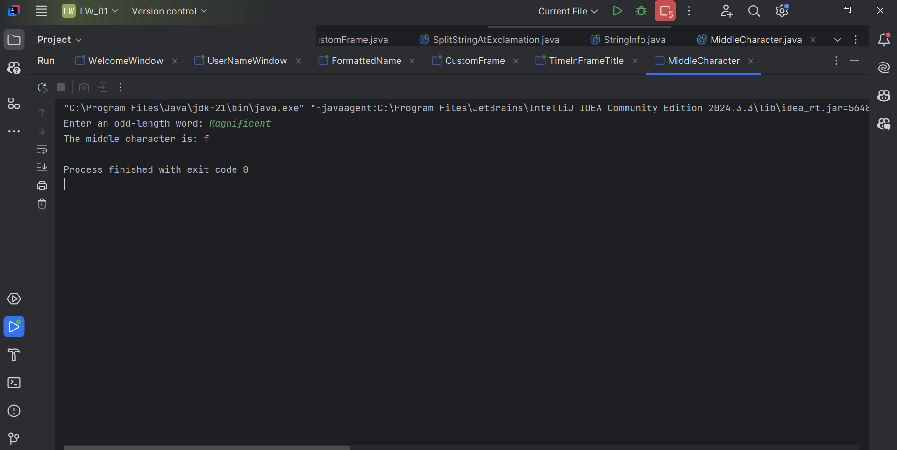

Q11)

package Q_11;  
  
import java.util.Scanner;  
  
public class FormatFullName {  
 public static void main(String[] args) {  
   
 Scanner scanner = new Scanner(System.*in*);  
   
 System.*out*.print("Enter your full name (first middle last): ");  
 String fullName = scanner.nextLine();  
   
 String[] nameParts = fullName.split(" ");  
   
 if (nameParts.length == 3) {  
 String firstName = nameParts[0];  
 String middleName = nameParts[1];  
 String lastName = nameParts[2];  
   
 char middleInitial = middleName.charAt(0);  
 middleInitial = Character.*toUpperCase*(middleInitial);  
   
 String formattedName = lastName + ", " + firstName + " " + middleInitial + ".";  
   
 System.*out*.println("Formatted Name: " + formattedName);  
 } else {  
   
 System.*out*.println("Invalid input. Please enter your full name in the format 'first middle last'.");  
 }  
   
 scanner.close();  
 }  
}

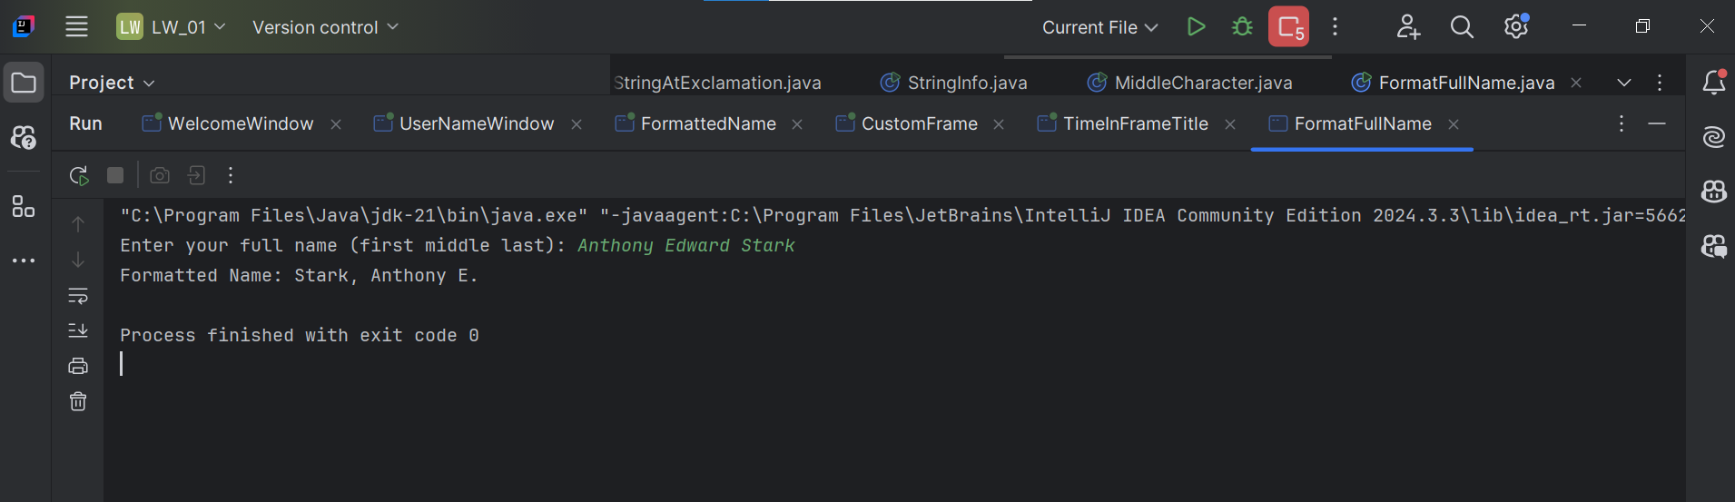

Q12)

package Q_12;  
  
import javax.swing.*;  
  
public class MyFirstFrame {  
 public static void main(String[] args) {  
 // Create a JFrame with the title "My First Frame"  
 JFrame frame = new JFrame("My First Frame");  
  
 // Set the size of the frame to 300 pixels wide and 200 pixels high  
 frame.setSize(300, 200);  
  
 // Set the location of the frame (100 pixels from the left, 50 pixels from the top)  
 frame.setLocation(100, 50);  
  
 // Set the default close operation to exit the application when the frame is closed  
 frame.setDefaultCloseOperation(JFrame.*EXIT_ON_CLOSE*);  
  
 // Make the frame visible  
 frame.setVisible(true);  
 }  
}

