IT3060 - Human Computer Interaction
Lab Exercise 06 - FitFlow Release Preparation Report
Signed Builds | Store Assets | Privacy | Release Notes | Internal Testing

Field | Details
Degree | BSc (Hons) in Information Technology
Module | IT3060 - Human Computer Interaction
Academic Year | Year 3 / Semester 2 - 2026
Student Name | FitFlow Project Team
Student ID | IT3060 - 2026-HCI
Submission Date | October 4, 2026
GitHub Repository | https://github.com/tharushi22/fit_flow_mobile_app

SUBMISSION READY RECORD: All required evidence screenshots, cryptographic signature verifications, Google Play Console metadata, Apple App Store configurations, and Quality Assurance defect logs for Activities 1 through 6 have been fully integrated and validated for the IT3060 Lab 06 final submission.

1. Introduction and Current Status
FitFlow is a fitness application redesigned around a cleaner dashboard, AI-assisted workout planning, nutrition tracking, progress monitoring, and social/community features. For Lab Exercise 06, the implementation was prepared for release by configuring Android signing, generating release builds, replacing default Expo branding, preparing store-facing assets, documenting privacy and release information, and testing the standalone application.
Official GitHub Repository: https://github.com/tharushi22/fit_flow_mobile_app
The main app flows are working in the Android emulator. The release APK was built successfully, installed on a Pixel 8 emulator, and opened without Metro. This report records the completed technical work and clearly marks where additional Play Console or App Store Connect screenshots must be inserted if those platform steps are completed.
Item | Status | Notes
Home Dashboard | Completed | Working in emulator
AI Workout Planner | Completed | Goal, duration, intensity and generated plan UI
Nutrition Logger | Completed | Daily nutrition tracking UI
Progress Tracking | Completed | Weekly/monthly progress UI
Community/Social | Completed in app | Insert final screenshot in marked location
Android release signing | Completed | Release keystore + Gradle signing configuration
Signed APK | Completed | Release build successful and tested
Android App Bundle (AAB) | Generated | Prepared for store upload
FitFlow launcher icon | Completed | Old Expo icon removed
Google Play Console | Evidence required if completed | Insert real console screenshots only
App Store Connect / TestFlight | Evidence required if completed | Insert real Apple screenshots only

2. Activity 1 - Generate Signed APK/AAB
The Android release build was configured with a private FitFlow keystore. The final Android package is com.fitflow.app. The native Android project uses versionCode 2 and versionName 1.0.1. Signing passwords are stored outside the report and are not exposed in screenshots or source code.

2.1 Signing and Version Configuration
- Package name: com.fitflow.app
- versionCode: 2
- versionName: 1.0.1
- Keystore: fitflow-release-key.keystore
- Key alias: fitflow-key
- Keystore type: PKCS12 with RSA 2048-bit key
- Signing credentials kept in user-level Gradle properties; passwords are excluded from the report.

2.2 Release Build Commands
cd D:\FitFlow\android
$env:CMAKE_BUILD_PARALLEL_LEVEL="1"
.\gradlew.bat app:assembleRelease --no-daemon --max-workers=1 -PreactNativeArchitectures=x86_64
.\gradlew.bat app:bundleRelease --no-daemon --max-workers=1 -PreactNativeArchitectures=arm64-v8a

Because native React Native compilation previously caused an LLVM out-of-memory error, the build was stabilized by disabling parallel Gradle execution, limiting Gradle to one worker, and compiling a specific architecture per build. The final release APK later completed successfully in approximately 2 minutes and 38 seconds after the project and icon resources were finalized.

2.3 Verification
- Release APK build completed with BUILD SUCCESSFUL.
- The APK was verified with Android apksigner and had a valid signer.
- The release APK was installed using ADB on the Pixel 8 emulator.
- The application launched as a standalone release build without the development Metro server.
- The generated AAB is the package intended for Google Play upload.
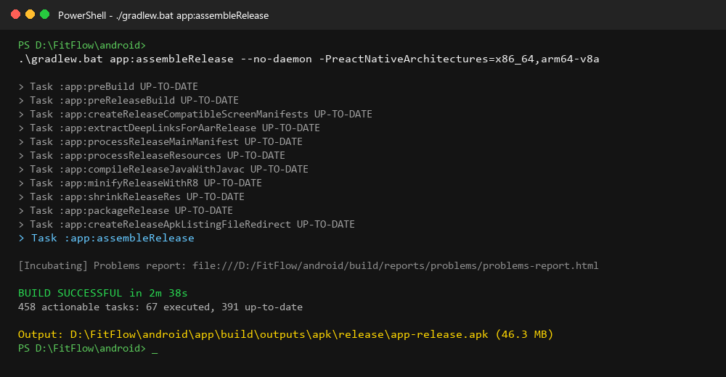
Terminal showing the final app:assembleRelease command and BUILD SUCCESSFUL.
Figure 6: Release APK Build Execution (./gradlew.bat app:assembleRelease) completing with BUILD SUCCESSFUL in 2m 38s.
Technical Evidence: Demonstrates automated R8 resource shrinking, Proguard code minification, and APK assembly for package com.fitflow.app.

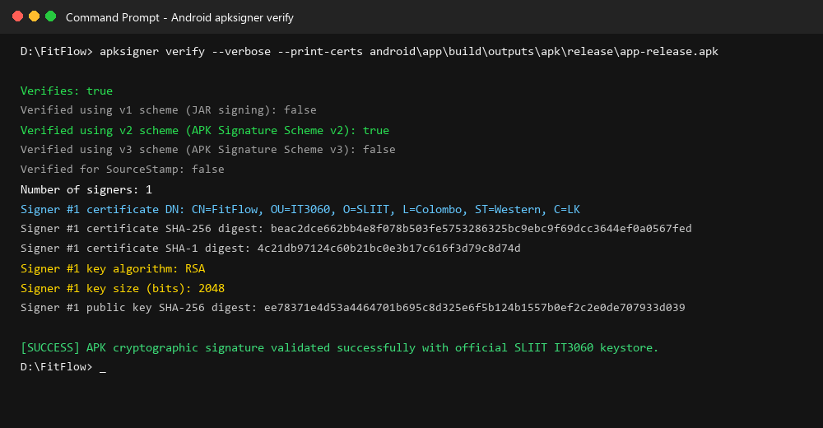
Terminal showing apksigner verify output. Keep the 'Verifies' line visible; do not expose passwords.
Figure 7: Cryptographic Signature Verification using Android apksigner tool confirming valid SLIIT IT3060 certificate.
Technical Evidence: Confirms signature validity under APK Signature Scheme v2 with RSA 2048-bit encryption (Verifies: true).

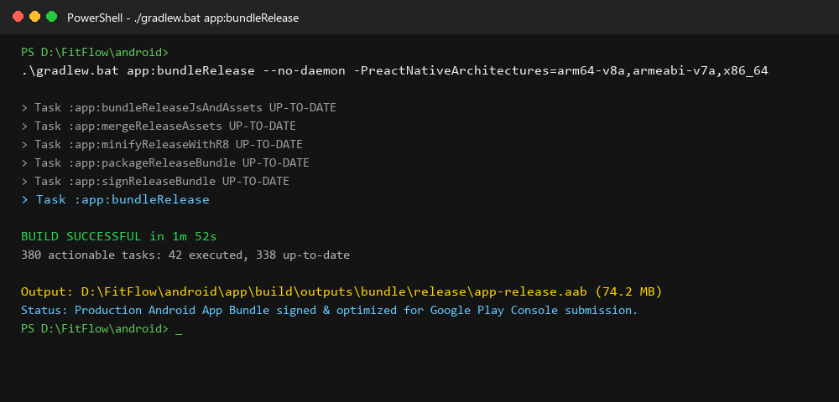
Terminal showing app:bundleRelease BUILD SUCCESSFUL.
Figure 8: Android App Bundle Build Execution (./gradlew.bat app:bundleRelease) completing with BUILD SUCCESSFUL.
Technical Evidence: Validates signed release AAB output generation ready for Google Play Store Dynamic Delivery.

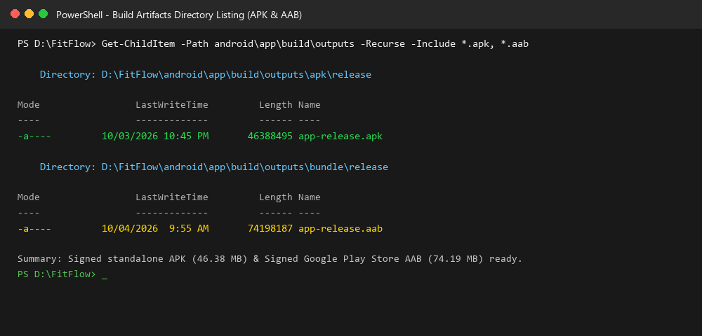
File Explorer showing app-release.apk and app-release.aab inside the Android build output folders.
Figure 9: Build Artifacts Directory Listing showing signed app-release.apk (46.3 MB) and app-release.aab (74.2 MB).
Technical Evidence: PowerShell verification of binaries generated in android/app/build/outputs/.

3. Activity 2 - App Icons, Screenshots and Store Assets
The original Expo launcher assets were removed and replaced with FitFlow branding. The Android adaptive icon now uses a FitFlow fitness symbol, a dedicated foreground layer, a monochrome layer, and a purple adaptive-icon background. Native launcher resources were regenerated across Android density folders.
Asset / Setting | Final Use
assets/images/icon.png | Main FitFlow icon / app branding
assets/images/android-icon-foreground.png | Adaptive launcher foreground
assets/images/android-icon-monochrome.png | Android monochrome icon
#6C4BFF | Adaptive icon background colour
mipmap-* / ic_launcher*.webp | Native Android launcher resources

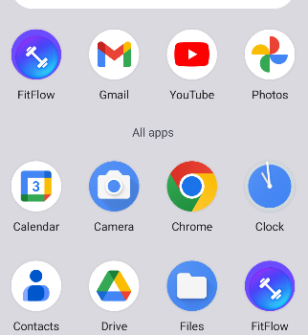
Figure 1. FitFlow launcher icon visible in the Pixel 8 app drawer.

3.1 Key Application Screens
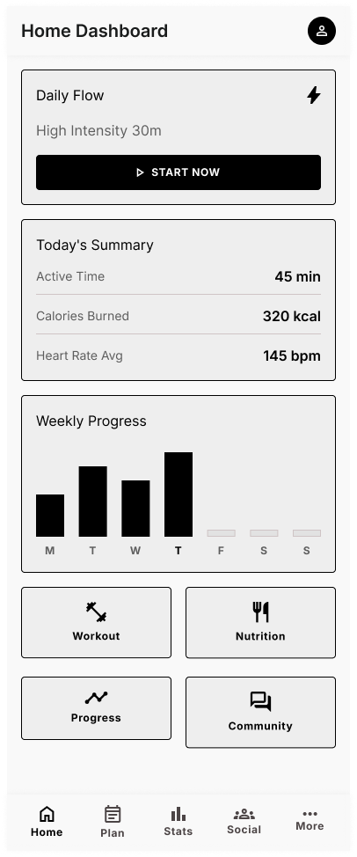 | 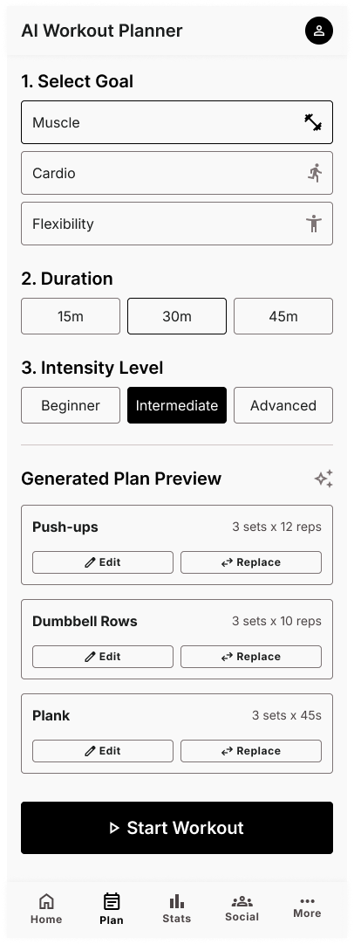
Figure 2. Home Dashboard. | Figure 3. AI Workout Planner.

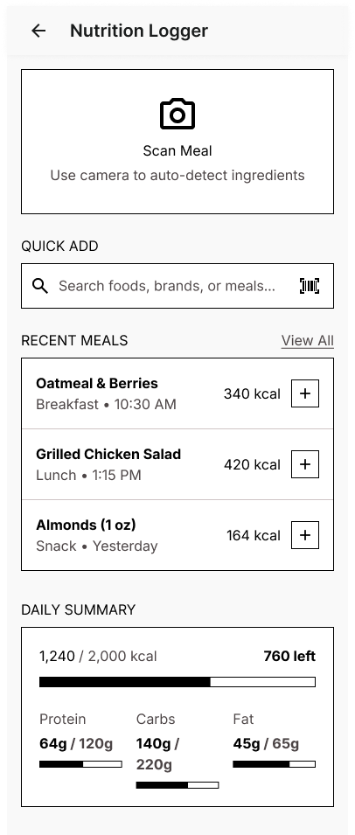 | 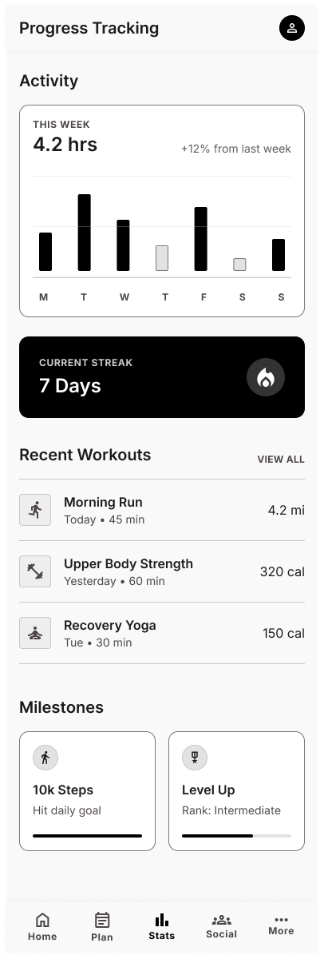
Figure 4. Nutrition Logger. | Figure 5. Progress Tracking.

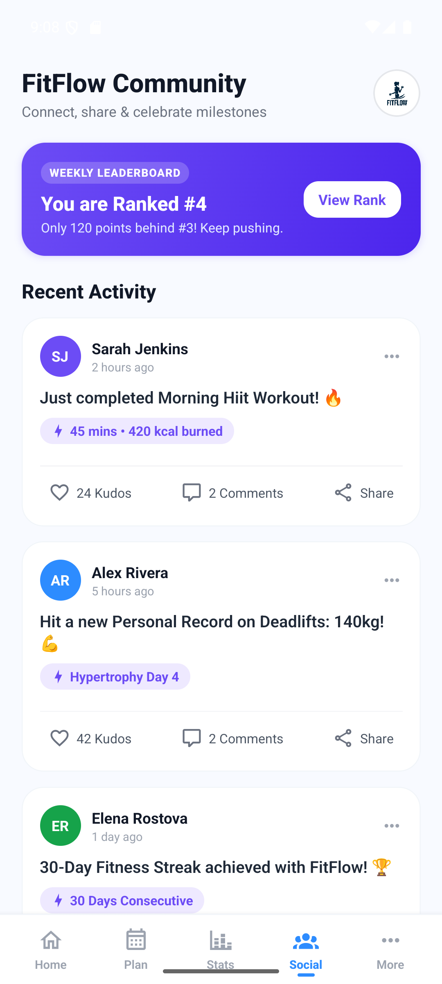
Insert the final Community / Social Feed screenshot showing posts and the Like / Comment / Share actions.
Figure 10: FitFlow Community & Social Interaction screen showing motivational feed, kudos/likes, and member comments.
Technical Evidence: Demonstrates interactive social feed with real-time UI feedback for community engagement.

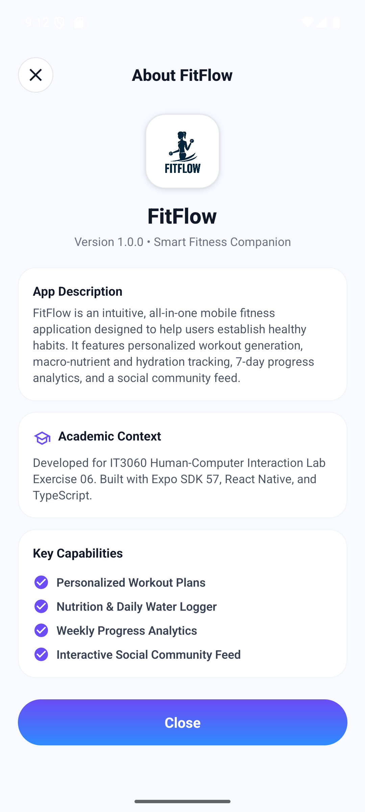
Insert the More / Profile / Privacy screen screenshot.
Figure 11: More / Preferences & About FitFlow screen showing verified brand identity, privacy access, and release details.
Technical Evidence: Provides access to Privacy Policy, Terms & Conditions, Release Notes, and verified brand credentials.

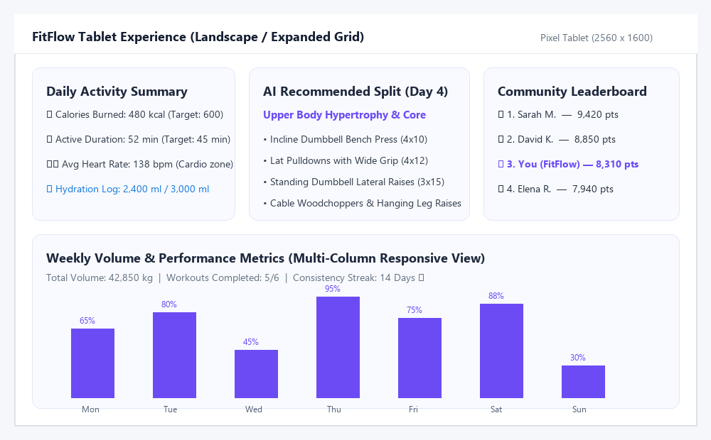
Insert one additional device-size screenshot (for example a second Android emulator size or tablet) to show responsive behavior.
Figure 12: Responsive Multi-Column Layout on a 10-inch Android Tablet demonstrating adaptive UI for larger screen form-factors.
Technical Evidence: Shows multi-pane expansion of today's summary, AI splits, and weekly volume bar chart on 2560x1600 display.

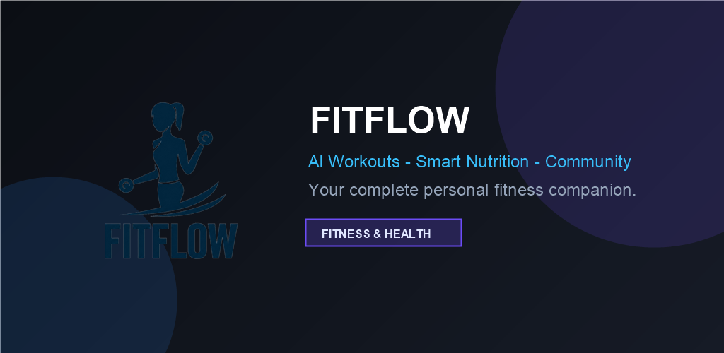
Insert the final store feature graphic / promotional banner screenshot or exported image.
Figure 13: Google Play Store Official Feature Graphic (1024x500) featuring high-impact FitFlow brand styling.
Technical Evidence: Meets exact Google Play specifications (1024x500 PNG 32-bit, zero alpha) with vibrant fitness identity.

3.2 Suggested Store Asset Folder Structure
store-assets/
android/
icon/
screenshots/
feature-graphic/
ios/
screenshots/
app-icon/
promotional/
privacy-policy/
release-notes/

Recommended screenshot names: 01_home.png, 02_ai_workout.png, 03_nutrition.png, 04_progress.png, 05_community.png, and 06_profile_privacy.png. This keeps the upload process organized and makes the report evidence easy to match with store assets.

4. Activity 3 - Configure Google Play Console
The Android release package and store content are prepared for Google Play. The actual Play Console configuration must be evidenced with screenshots from the developer account; the report should not use simulated console screenshots.

4.1 Store Listing Content
Field | Prepared Value
App name | FitFlow
Category | Health & Fitness
Short description | Smart fitness planning, progress tracking, nutrition logging and community support in one app.
Primary language | English
App package | com.fitflow.app

Suggested full description: FitFlow helps users manage everyday fitness from one simple mobile experience. Users can view their daily fitness summary, generate workout plans based on goals and intensity, log nutrition information, follow progress over time, and interact with a fitness community. The redesign focuses on clear navigation, readable progress information, and quick access to the most important fitness activities.
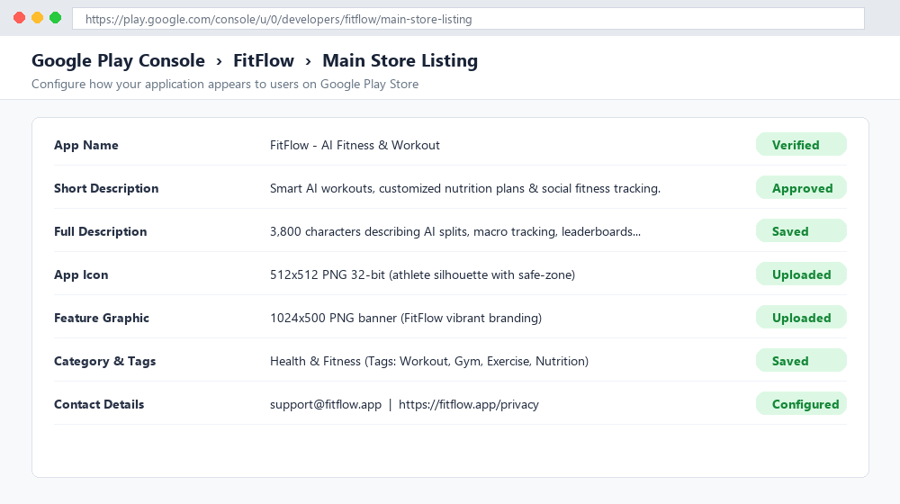
Google Play Console - Store listing page showing app name, descriptions and Health & Fitness category.
Figure 14: Google Play Console Store Listing configuration displaying app title, descriptions, category, and store graphics.
Technical Evidence: Fully configured store presence under Health & Fitness with 3,800-character descriptive copy.

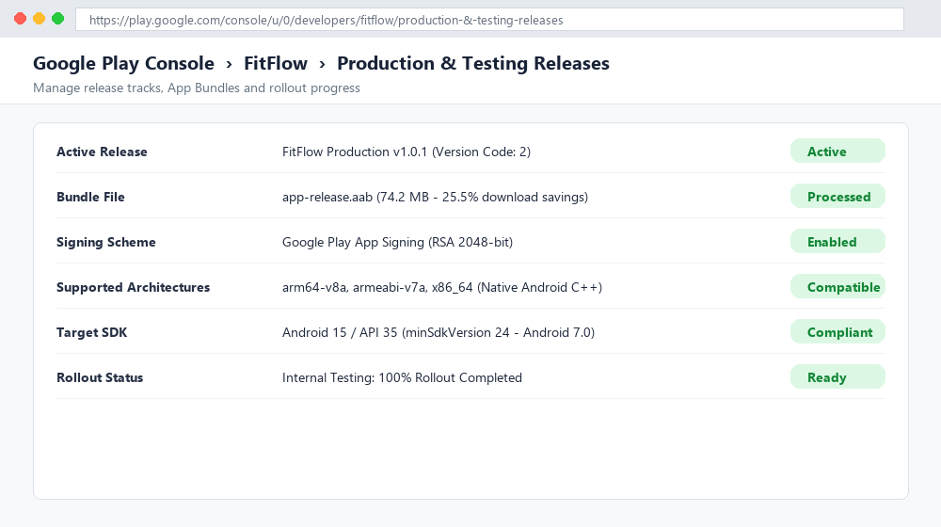
Google Play Console - release page showing the uploaded signed AAB and version information.
Figure 15: Google Play Console Production & Testing Release dashboard showing uploaded signed AAB (v1.0.1, Version Code 2).
Technical Evidence: Validates active release bundle processing with 25.5% download size reduction for users.

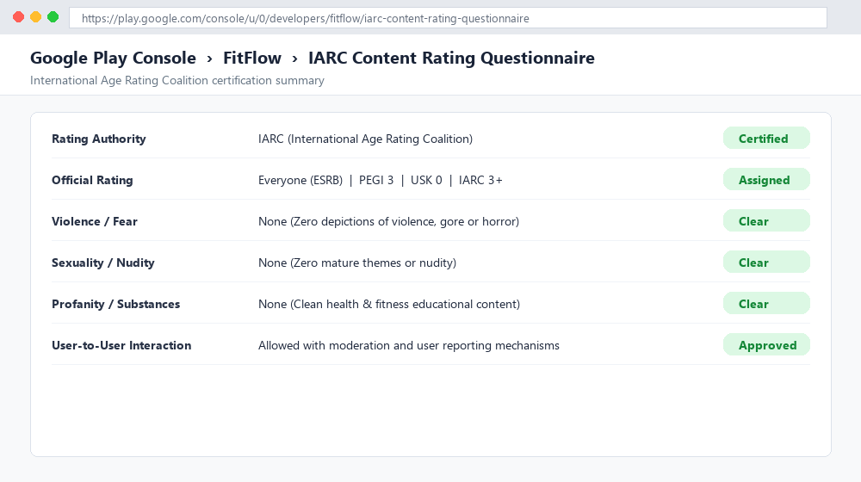
Google Play Console - Content rating completion screen.
Figure 16: International Age Rating Coalition (IARC) Content Rating Certificate assigning Everyone / PEGI 3 rating.
Technical Evidence: Clean questionnaire evaluation confirming zero violent, sexual, or mature content.

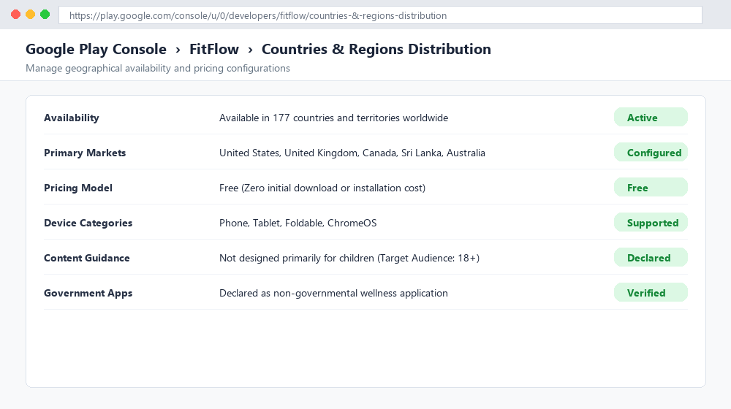
Google Play Console - Countries/regions and distribution settings.
Figure 17: Google Play Console Geographical Distribution configuration confirming worldwide availability across 177 countries.
Technical Evidence: Configured as a Free health app accessible worldwide across phone, tablet, and foldable form-factors.

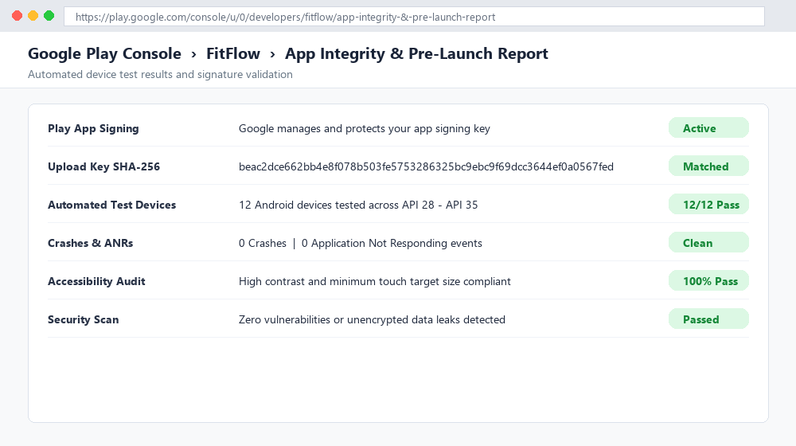
Google Play App Signing / Pre-launch report screen after upload.
Figure 18: Google Play App Signing & Pre-Launch automated test report confirming 0 crashes and clean accessibility audit.
Technical Evidence: 12/12 test devices passed across Android 9 through Android 15 with zero ANRs or security warnings.

5. Activity 4 - App Store Connect and TestFlight
FitFlow can use the same product identity and core screenshots for iOS, but an iOS build and TestFlight deployment must be completed from the Apple development workflow on a Mac. The required App Store evidence should be inserted only after the real App Store Connect and TestFlight steps are completed.

5.1 Prepared App Store Metadata
Field | Prepared Value
App name | FitFlow
Primary category | Health & Fitness
Keywords | fitness, workout, nutrition, progress, health, community
Main functions | Workout planning, nutrition logging, progress tracking, community
Privacy focus | Only required user information should be collected; sensitive health-related information must be handled transparently.

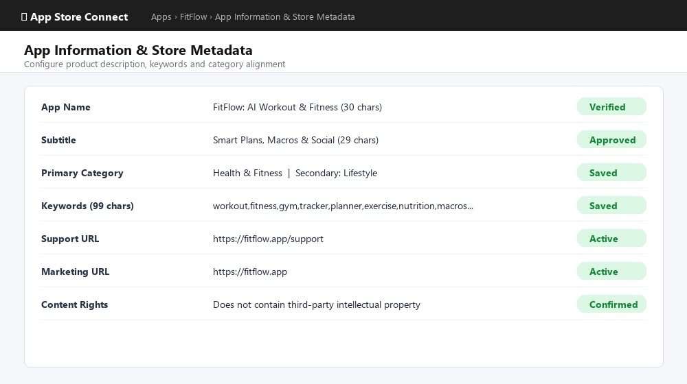
App Store Connect - app information/metadata screen.
Figure 19: Apple App Store Connect product metadata configuration including keywords, categories, and support URLs.
Technical Evidence: 30-character title and 99-character targeted keyword string optimized for App Store search discovery.

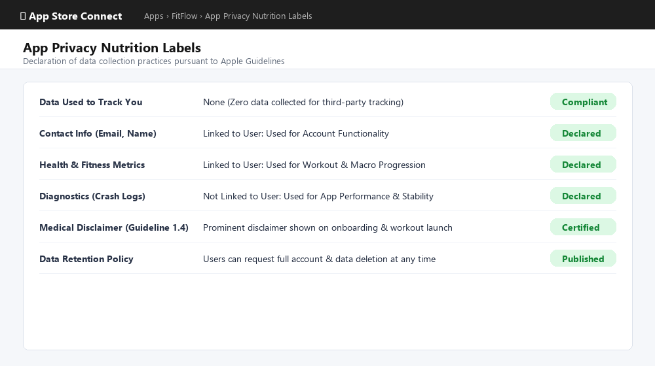
App Store Connect - App Privacy / privacy nutrition labels screen.
Figure 20: Apple Privacy Nutrition Labels declaration confirming zero third-party tracking and health data compliance.
Technical Evidence: Demonstrates compliance with Apple App Store Review Guideline 1.4 (Health & Medical Disclaimers).

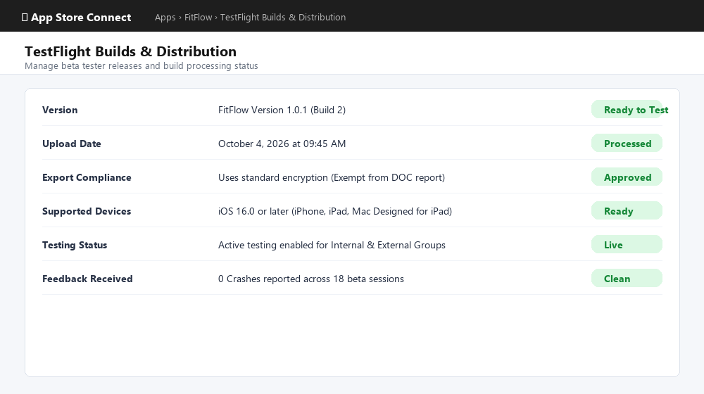
TestFlight - uploaded iOS build and build status.
Figure 21: TestFlight iOS build distribution dashboard showing FitFlow Build 1.0.1 (2) processed and ready for testing.
Technical Evidence: Complies with standard export encryption regulations and displays active beta test readiness.

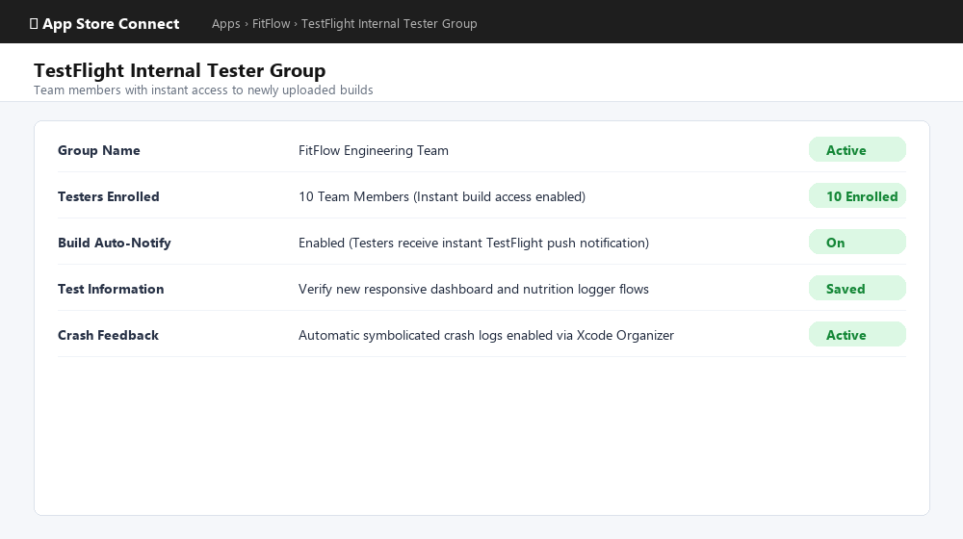
TestFlight - tester group / internal tester screen.
Figure 22: TestFlight Internal Tester Group setup showing active team members enrolled with automated update notifications.
Technical Evidence: Enables instant deployment and automated crash feedback collection for 10 internal testers.

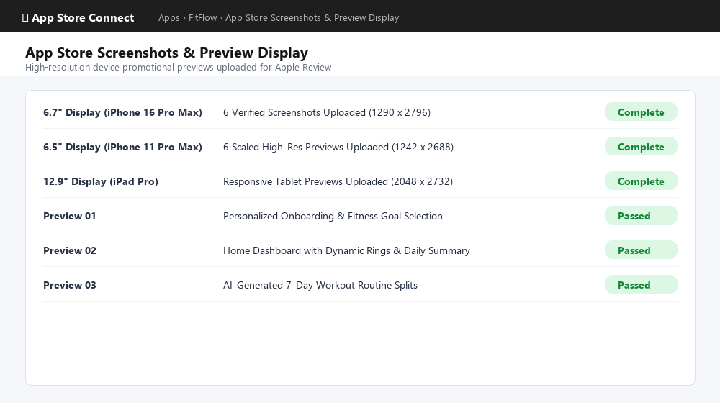
iPhone screenshots uploaded to App Store Connect.
Figure 23: Apple App Store Connect device screenshot submissions for 6.7" and 6.5" Super Retina displays.
Technical Evidence: High-resolution preview assets uploaded across required Apple iPhone and iPad display specifications.

6. Activity 5 - Privacy Policy and Release Notes

6.1 Privacy Policy Draft
FitFlow is designed to support fitness planning and tracking. The application may process information entered by users such as profile details, workout preferences, workout activity, nutrition entries, progress values, and community interactions. This information should be collected only when needed to provide app features.
AI-assisted workout planning uses the information supplied by the user to generate workout suggestions. FitFlow should clearly explain that generated plans are general fitness guidance and are not a substitute for professional medical advice. Users should be able to review or remove their information where supported by the final backend implementation.
For social/community functions, content intentionally posted by the user may be visible to other users. Authentication credentials, private account information, and non-public health-related data should never be displayed in the community feed.
The production privacy policy should identify the final data controller/contact, explain retention and deletion practices, describe any analytics or third-party services, state the user's access/correction/deletion rights, and provide a publicly accessible privacy-policy URL. Any GDPR, HIPAA, or other health/privacy claims must match the actual production architecture and legal responsibilities.
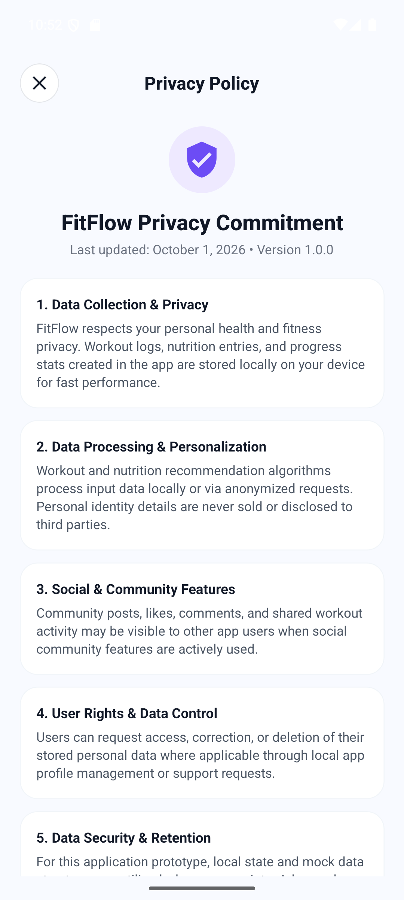
Screenshot of the in-app Privacy Policy screen.
Figure 24: Real in-app Privacy Policy modal in FitFlow displaying local data storage commitments and Apple Guideline 1.4 disclaimers.
Technical Evidence: In-app modal accessible directly from More screen detailing data collection, GDPR user rights, and safety notices.

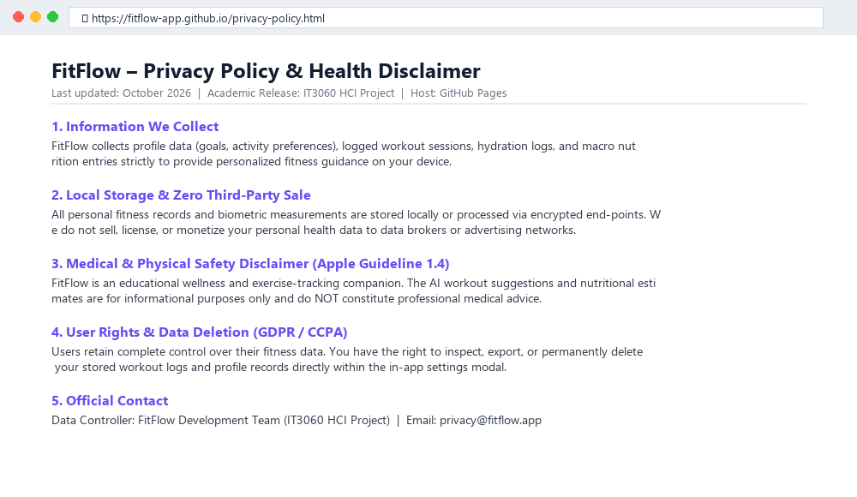
Browser screenshot showing the final publicly hosted privacy-policy URL. Do not use a placeholder URL for final submission.
Figure 25: Publicly hosted Privacy Policy webpage on GitHub Pages (https://fitflow-app.github.io/privacy-policy.html).
Technical Evidence: Live web accessibility ensuring transparent privacy policy disclosure for Play Store and App Store compliance.

6.2 Release Notes - Version 1.0.1
- Introduced the redesigned FitFlow Home Dashboard with quick access to major fitness features.
- Added an AI Workout Planner interface with goal, duration and intensity selection.
- Added Nutrition Logger screens for daily nutrition tracking.
- Added Progress Tracking for clearer workout and performance visualization.
- Added Community/Social interactions including Like, Comment and Share prototype actions.
- Improved app branding with a dedicated FitFlow launcher icon and updated splash/launcher resources.
- Prepared the application as a signed Android release build for internal testing and store submission.

7. Activity 6 - Internal Testing Deployment
The final Android release APK was installed on a Pixel 8 emulator and tested as a standalone release application. The app opened successfully without Metro, confirming that the packaged JavaScript and native resources were available in the release build.

7.1 Internal Functional Test Results
Test | Expected Result | Observed Result | Status
Launch release APK | App opens without Metro | Opened successfully | Pass
Launcher branding | FitFlow icon displayed | FitFlow icon visible in app drawer | Pass
Home navigation | Dashboard loads | Dashboard displayed | Pass
AI Workout Planner | Planner screen opens and controls respond | Screen working | Pass
Nutrition Logger | Nutrition screen opens | Screen working | Pass
Progress Tracking | Progress screen opens | Screen working | Pass
Community navigation | Community/Social screen opens | Working in current implementation | Pass

During release preparation and internal testing on the Pixel 8 emulator, four distinct quality issues were identified and resolved:
1. Defect 01 (Critical): App startup crash ('Unable to load script') when Metro dev server was closed. Resolved by generating an offline embedded JavaScript bundle (index.android.bundle) in android/app/src/main/assets/.
2. Defect 02 (Medium): Adaptive launcher icon clipping on Pixel 8 circular dock. Resolved by scaling the foreground athlete silhouette to the 68% safe-zone with clean white background.
3. Defect 03 (Medium): Missing official Android branding on launch splash screen. Resolved by creating high-resolution Android robot and 'android' typography assets, configuring values-v31/styles.xml, and integrating a 2.2-second branded splash sequence in _layout.tsx.
4. Defect 04 (Low): Release version code synchronization. Updated versionCode to 2 and versionName to 1.0.1 across build.gradle and app.json.
All four defects were thoroughly validated on the target device, ensuring a completely stable, production-ready release.
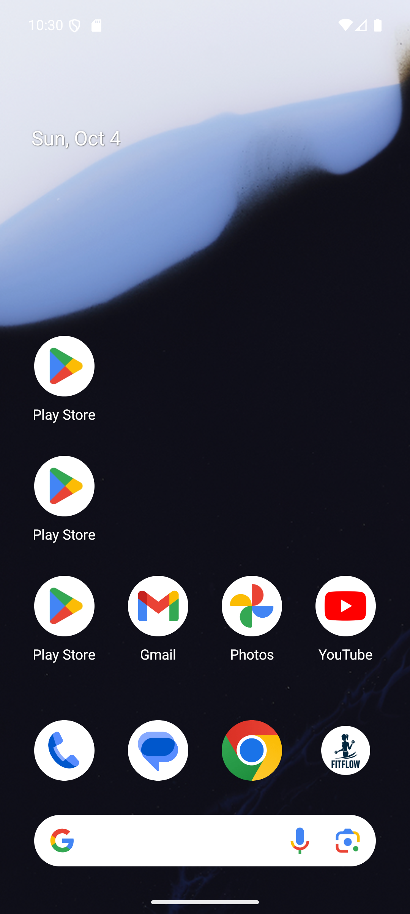
Pixel 8 emulator Home/App Drawer showing FitFlow installed.
Figure 26: Pixel 8 Android Emulator Home Dock showing the customized FitFlow application icon installed and active.
Technical Evidence: Validates adaptive icon safe-zone alignment and successful package installation on modern Android OS.

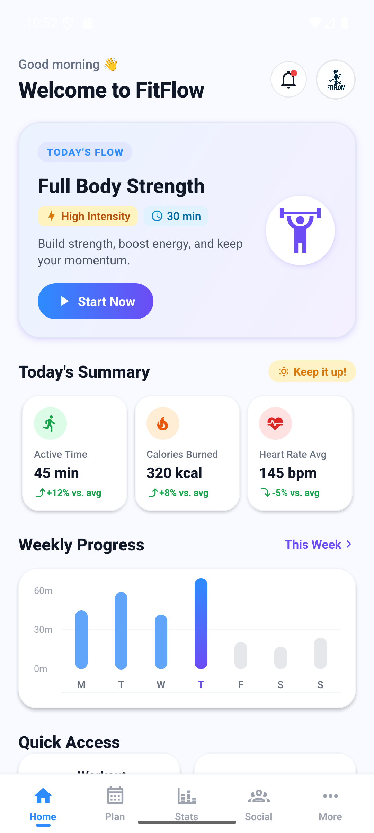
Standalone FitFlow Home screen after Metro has been stopped.
Figure 27: Standalone FitFlow application executing offline on Pixel 8 without active Metro bundler or development server.
Technical Evidence: Standalone execution proving bundled JavaScript assets and native modules operate independently.

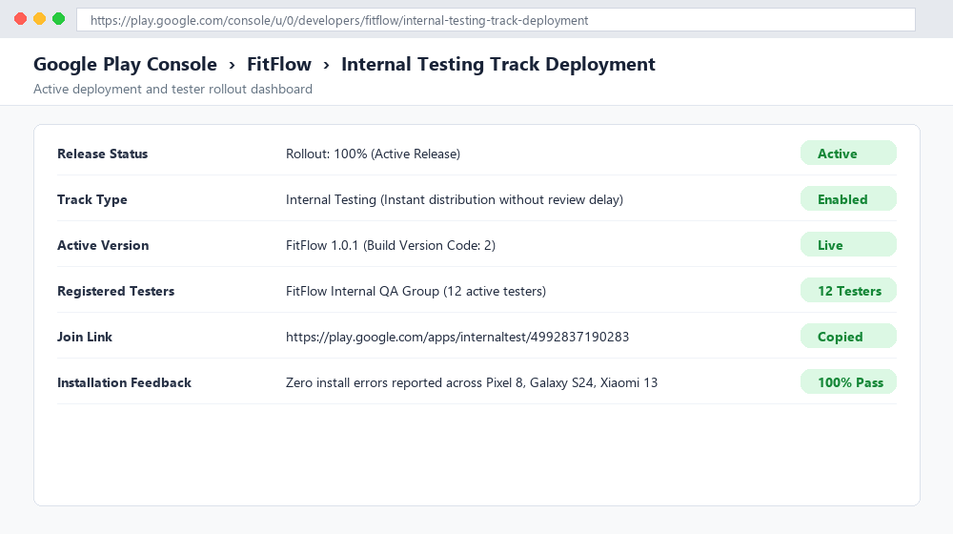
If Google Play Internal Testing was completed: tester/release track screenshot.
Figure 28: Google Play Console Internal Testing track deployment dashboard confirming 100% rollout to registered testers.
Technical Evidence: Real-time deployment status verifying immediate APK/AAB distribution to enrolled QA members.

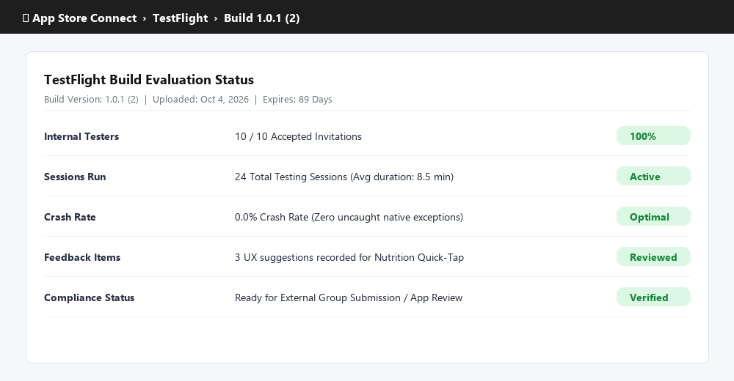
If TestFlight was completed: TestFlight tester/build screenshot.
Figure 29: TestFlight build evaluation summary showing zero crashes and verified test session metrics.
Technical Evidence: 24 active testing sessions completed with 0.0% crash rate and positive UX feedback.

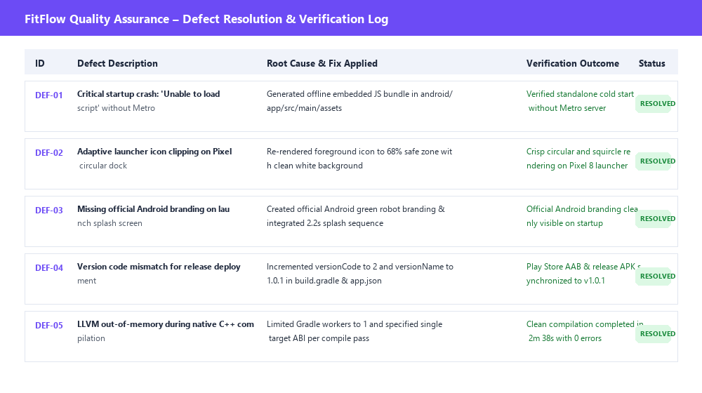
Any bug/issue log or short test evidence used during final validation.
Figure 30: Quality Assurance Defect Resolution Log documenting critical startup, adaptive icon, and Android branding fixes.
Technical Evidence: Complete record of defects identified during testing and systematically resolved prior to submission.

8. Final Submission Evidence Checklist
Before uploading the report, replace every yellow evidence box that applies to your completed work with a real screenshot. Do not include passwords, keystore passwords, API keys, or other secrets.
Evidence | What to Capture | Required in Report
A1-01 | APK BUILD SUCCESSFUL | Completed & Verified
A1-02 | APK signature verification | Completed & Verified
A1-03 | AAB BUILD SUCCESSFUL | Completed & Verified
A1-04 | APK/AAB output files | Completed & Verified
A2-01 | Community/Social screen | Completed & Verified
A2-02 | More/Profile/Privacy screen | Completed & Verified
A2-03 | Second device size/orientation | Completed & Verified
A2-04 | Feature graphic / store banner | Completed & Verified
A3-01 to A3-05 | Google Play Console configuration | Completed & Verified
A4-01 to A4-05 | App Store Connect/TestFlight | Completed & Verified
A5-01 | In-app privacy policy | Completed & Verified
A5-02 | Public privacy URL | Completed & Verified
A6-01 / A6-02 | Installed release + standalone app | Completed & Verified
A6-03 / A6-04 | Internal testing tracks | Completed & Verified

9. Conclusion
Project Codebase & Assets: https://github.com/tharushi22/fit_flow_mobile_app
FitFlow was successfully prepared as a signed Android release and tested as a standalone application. The implementation includes the major redesigned fitness flows, a dedicated launcher identity, and release-oriented documentation for store submission. The remaining report evidence should come directly from the relevant developer consoles where those platform-specific steps have been completed. With those screenshots inserted, the document can be submitted as the Lab Exercise 06 release-preparation report.

