Solving Schrodinger Equation using Physics Informed Neural Networks

1. Physics-Informed Neural Networks (PINN)
PINNs incorporate the governing PDEs directly into the neural network's loss function. The network learns to satisfy the PDE across the entire domain, not just at discrete data points.
Advantages:
- Flexibility: Can handle high-dimensional problems and complex geometries.
- Data Efficiency: Requires less training data since the physical laws guide the learning process.
Challenges:
- Optimization Difficulty: The loss landscapes can be complex, making training challenging.
- Computational Cost: High computational resources may be needed for large-scale problems.

Physics-Informed Neural Networks (PINNs) are the most suitable method for solving the Schrödinger equation due to their:
- Versatility: Capable of handling both time-dependent and time-independent forms.
- Physical Fidelity: Ensure that solutions satisfy the Schrödinger equation and boundary/initial conditions inherently.
- Complex-Valued Function Handling: Can be adapted to predict complex wave functions required in quantum mechanics.
- Inverse Problem Solving: Able to estimate unknown parameters within the quantum system.
- Scalability: More adept at managing high-dimensional problems associated with many-body quantum systems.

1.1. Quantum dot system within a potential well
- Time dependent Schrödinger equation:
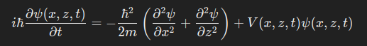

- When using Physics-Informed Neural Networks (PINNs) to solve the Schrödinger equation, explicit discretization of space (and time) is not required in the same way as with traditional numerical methods like the Crank-Nicolson method. Instead, PINNs approximate the solution as a continuous function over the domain, and training involves sampling points (collocation points) within this continuous space to enforce the differential equations and boundary conditions.

1.2. Potential Function V(x,z,t)
The potential function includes:
- Quantum Dot Potential V_{QD}​(x,z,t):
  - Represents the moving quantum dot.
  - The quantum dot moves along the x-axis with velocity v_{QD}.
  - Position of the quantum dot at time t:
  - x_{QD} (t) = x_{QD, start} + v_{QD}t
  - The potential due to the quantum dot is centered at x_{QD}(t).
  - V_{QD}(x,z,t) = 1/2 * m * ω² * (x−x_{QD}(t))²
  - ω: Angular frequency related to the confinement strength.
- Electric Field Potential V_{E}(z):
  - Due to an applied electric field E_{z} in the z-direction.
  - Potential energy:
  - V_{E}(z) = −eE_{z}​z
  - where e is the elementary charge.
- Total Potential:
  - V(x,z,t)=V_{QD}(x,z,t) + V_{E}​(z)

2. Residuals in PINN
Residuals in PINNs refer to the discrepancies between the left-hand side (LHS) and the right-hand side (RHS) of the differential equation when the neural network's predicted solution is substituted into the equation. Essentially, the residual measures how well the network's output satisfies the governing PDE at each point in the domain.

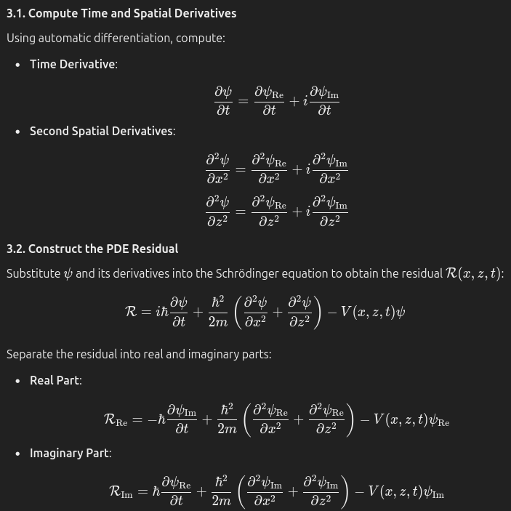

2.1. Loss Function:
The loss function in PINNs is designed to integrate both data and physical laws into the training process. By minimizing this loss function, the neural network learns solutions that not only fit the available data but also inherently satisfy the governing differential equations throughout the domain. This approach leverages the power of deep learning while respecting the underlying physics, leading to models that are both accurate and physically consistent.

- PDE Residual Loss:
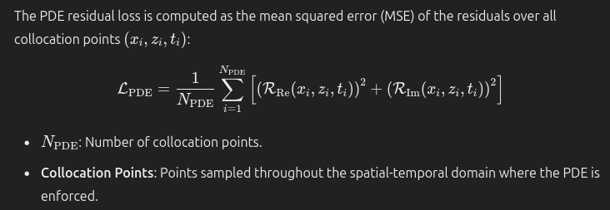
- Initial Condition Loss:
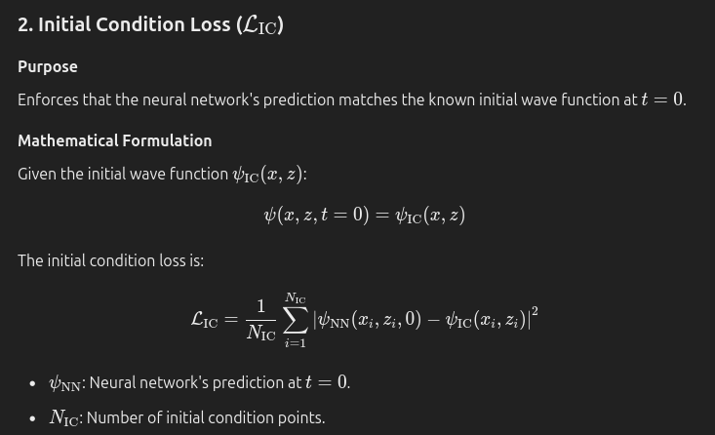
- Boundary Condition Loss
  - Ensures that the wave function satisfies the specified boundary conditions along the spatial boundaries of the domain.
  - Considering two types of boundary conditions
  - Dirichlet Boundary Conditions: The wave function assumes a specified value (often zero) on the boundary.
  - Neumann Boundary Conditions: The derivative of the wave function normal to the boundary is specified (often zero).

- Normalization Loss:
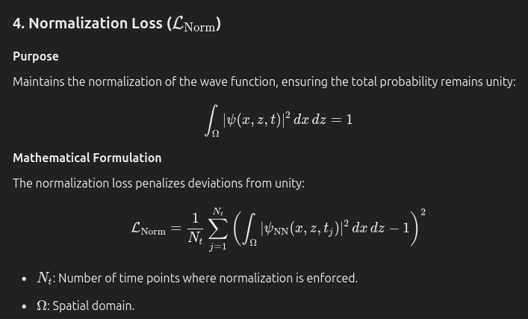
- Total Loss
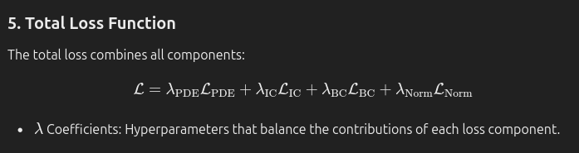

2.2. Initial condition in PINN
In traditional numerical methods for solving the Schrödinger equation, such as the Crank-Nicolson or Runge-Kutta methods, we indeed specify the initial condition explicitly. The numerical algorithm then evolves this initial state forward in time according to the Schrödinger equation, and there's no need to "compute" the initial condition—it is given.
In the context of Physics-Informed Neural Networks (PINNs), however, the situation is slightly different. While we do specify the initial condition, the neural network needs to learn to reproduce it as part of the solution to the differential equation over the entire domain, including at t=0. The initial condition loss serves to enforce this condition during the training process, ensuring that the neural network's output at t=0 matches the specified initial condition.

