**CLOUD COMPUTING**

TASLEEM SULTHANA

18MCMT17 MTECH-CS

This project mainly focuses to demonstrate the deployment of a service on the cloud based environment.

The cloud environment used for deployment of my services is GOOGLE CLOUD.

Google cloud is PAAS to deploy our services into the cloud area.

Google App Engine, provided with a dashboard, we need to create a new project in Google Cloud Platform Console by creating a new account (if you have no google cloud account).

[NOTE: Check that you have enabled billing with in your account]

**Creating a new project in gcloud:**

Console->create new project->project name/id->save.

**Writing the service code:**

The service is implemented using a nodejs for the server side code and html for the front end.

The package.json is a file to specify the node modules we are using. Expressjs is used for the server code for our project.

The server.js is written using the express it uses the get post calls of the rest services to post and get the values parses them and calculates the BMI for the input provided and displays the results.

**App.yaml:**

Create an app.yaml file to deploy the service in google cloud with the source folder, file provides the information about the environment and the runtime used.

runtime: nodejs

env: flex

**BMI-LOGIC**:

BMI is the body mass index, is a measure of body size. It combines a person's weight with their height and give a value to state if a person is having a proper weight according to his/her height.

BMI formula: ((weight/height)/height) * 10000

The units of height and weight used here are cms and kgs respectively

**BMI of less than 18.5**

A BMI of less than 18.5 indicates that you are underweight, so you may need to put on some weight. You are recommended to ask your doctor or a dietitian for advice.

**BMI of 18.5–24.9**

A BMI of 18.5-24.9 indicates that you are at a healthy weight for your height. By maintaining a healthy weight, you lower your risk of developing serious health problems.

**BMI of 25–29.9**

A BMI of 25-29.9 indicates that you are slightly overweight. You may be advised to lose some weight for health reasons. You are recommended to talk to your doctor or a dietitian for advice.

**BMI of over 30**

A BMI of over 30 indicates that you are heavily overweight. Your health may be at risk if you do not lose weight. You are recommended to talk to your doctor or a dietitian for advice.

**Deployment:**

Steps to deploy the service

1. Install the google cloud SDK in your system.
2. Open terminal and go to source folder.
3. Run command “gcloud init”.
4. Select the area where you want to deploy your service (selected south Asia here) and select the new project you created.
5. Then run the command ”google app deploy “.
6. Use the link to see the deployed service

**SCREENSHOTS:**

**1.**

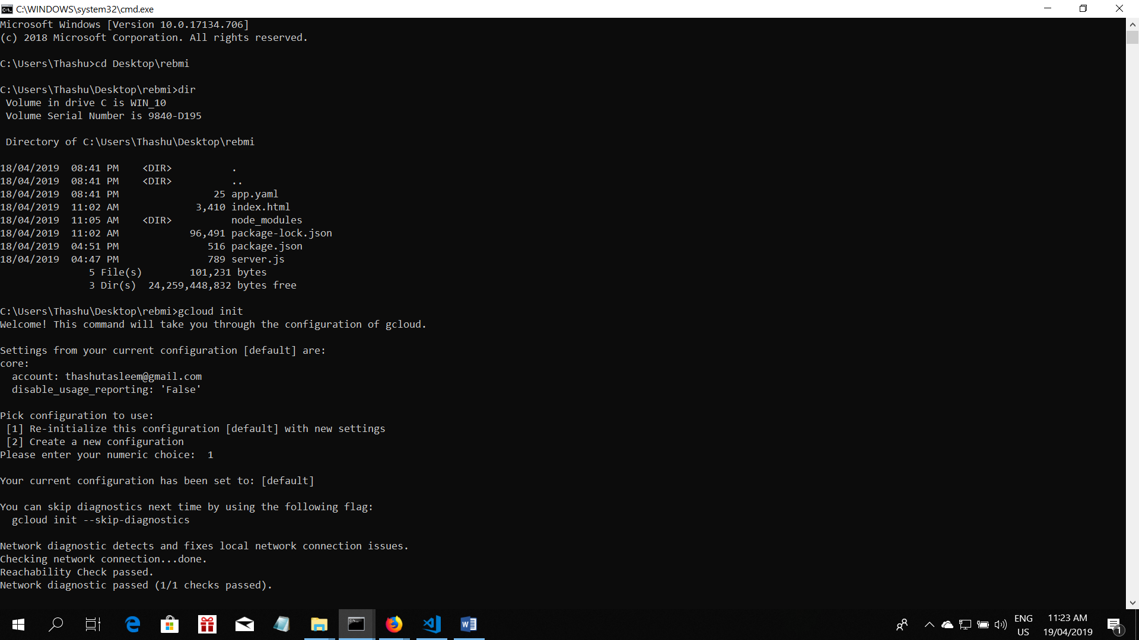

**2**

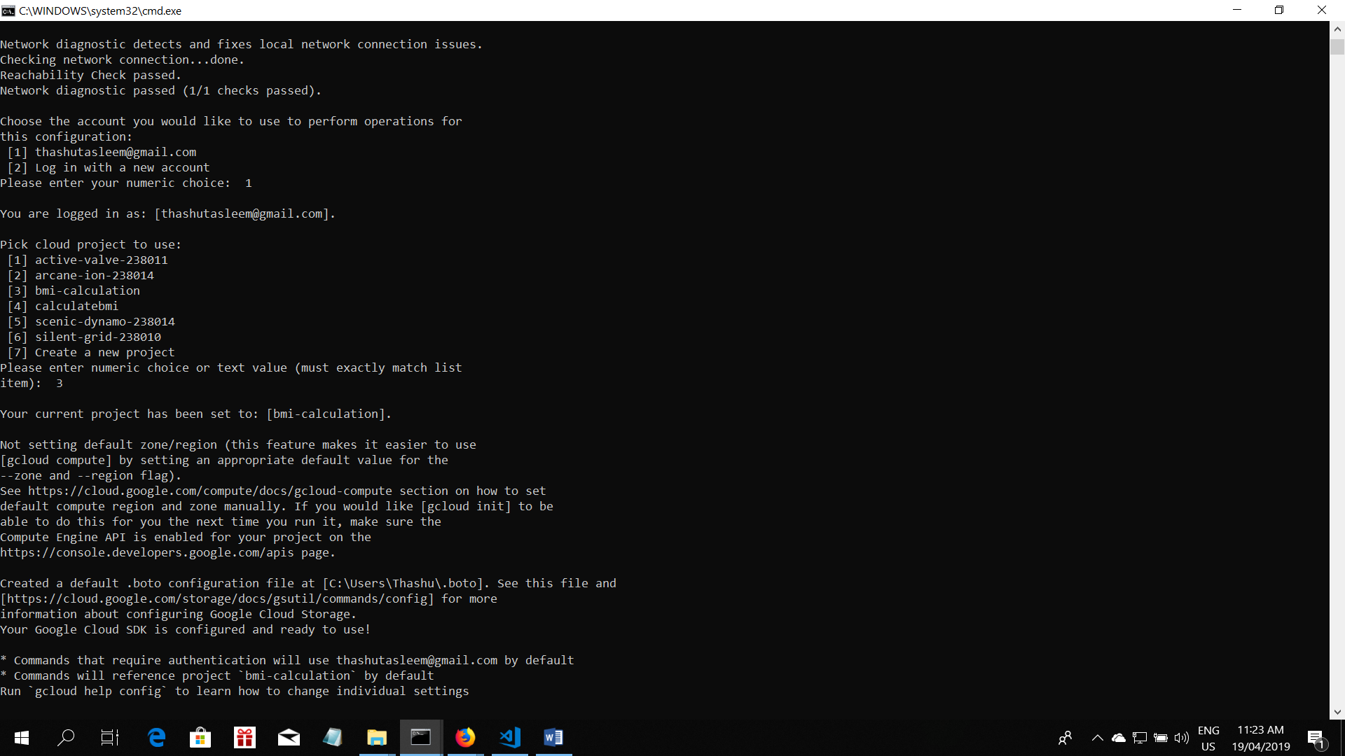

3.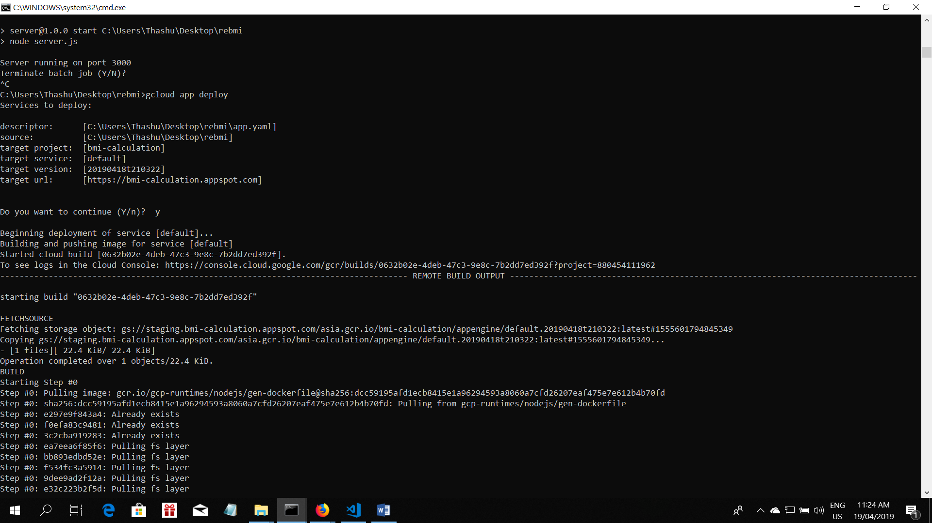

4.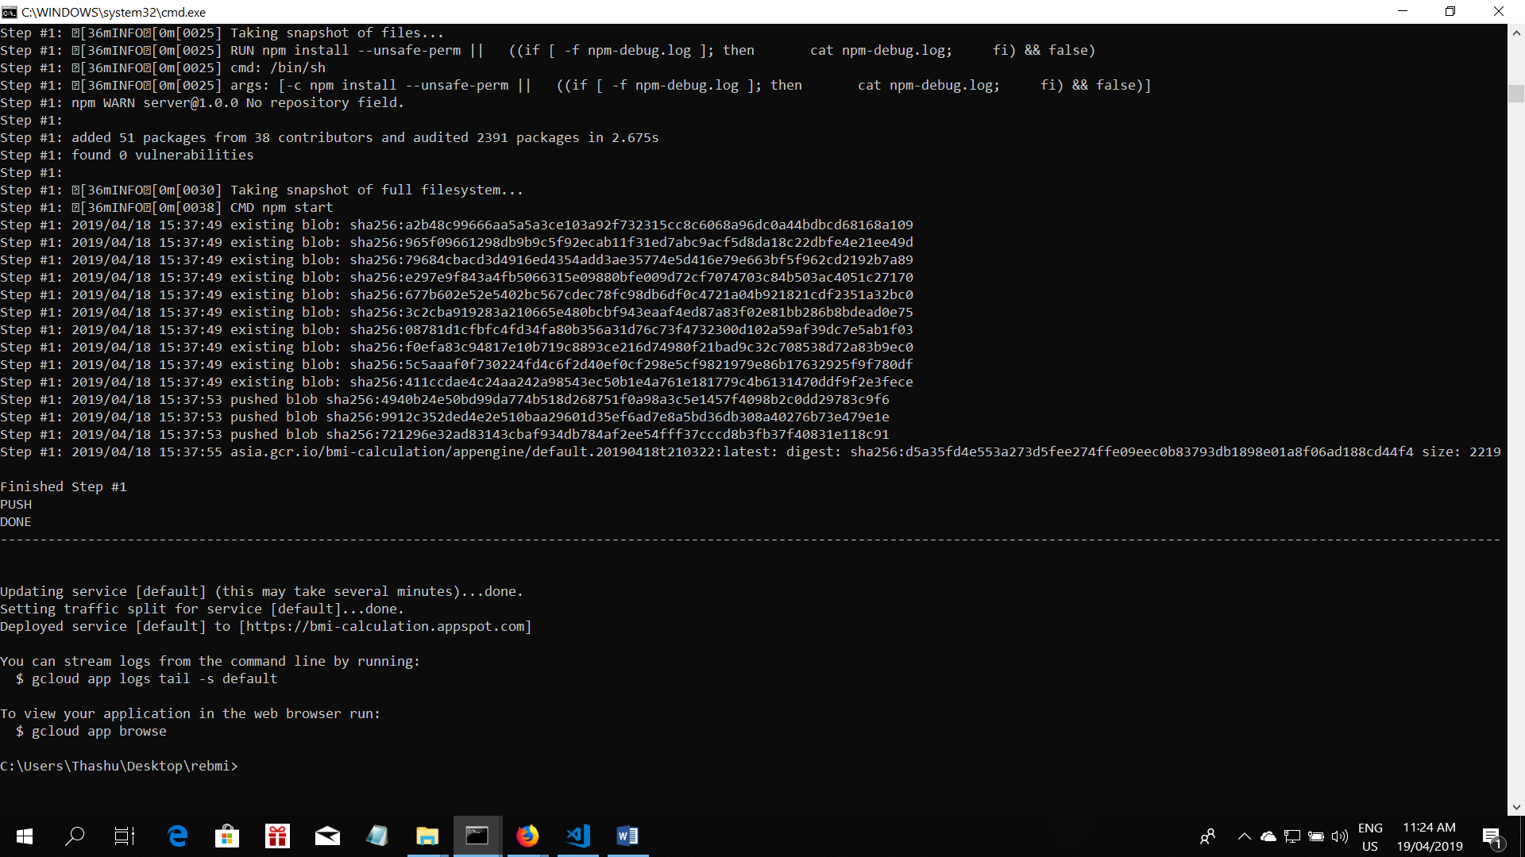

THERE FORE SERVICE GOT SUCCESFULLY DEPLOYED

OPEN THE LINK TO USE THE DEPLOYED SERVICE: <https://bmi-calculation.appspot.com>