CERTIFICATE
CERTIFICATE
This is to certify that the project titled “Explainable Deep Learning for Post-COVID Lung Fibrosis Screening Using Chest X-rays” was successfully carried out by Shaik Thaslim (AV.SC.U4AIE23138), a student in the Department of Computer Science and Engineering – Artificial Intelligence at Amrita Vishwa Vidyapeetham – Amaravati, under the direct guidance and supervision of Dr. Satya Rajendra Singh.
The work presented herein describes an explainable deep-learning framework designed to screen chest radiographs for fibrotic tissue patterns. The scope of work encompasses dataset curation, memory-mapped data handling, transfer learning and fine-tuning experiments, performance evaluation, Grad-CAM visual interpretability, and interactive web application development.
This project report is formally submitted in partial fulfillment of the requirements for the award of the degree in Computer Science and Engineering – Artificial Intelligence.
DECLARATION
I hereby declare that the project entitled “Explainable Deep Learning for Post-COVID Lung Fibrosis Screening Using Chest X-rays” represents my original academic work, executed in accordance with the standards of the Department of Computer Science and Engineering – Artificial Intelligence, Amrita Vishwa Vidyapeetham – Amaravati.
All experimental setups, code implementations, evaluations, and analyses reported in this document reflect my genuine findings and contributions. Where specific baseline metrics or references were drawn from external repositories or literature, they have been properly acknowledged and cited.
ACKNOWLEDGEMENT
I wish to express my deepest gratitude to my project supervisor, Dr. Satya Rajendra Singh, for providing insightful feedback, technical guidance, and constant encouragement throughout this research effort.
I am equally grateful to the Department of Computer Science and Engineering – Artificial Intelligence and the administration of Amrita Vishwa Vidyapeetham – Amaravati for equipping us with essential computing resources, laboratory facilities, and an environment conducive to research.
Finally, I extend my appreciation to the open-source software community and medical research groups whose publicly available chest radiograph datasets and deep-learning packages formed the foundation of this study.
ABSTRACT
Pulmonary sequelae following COVID-19 recovery present significant diagnostic challenges, particularly when subtle parenchymal changes progress toward fibrotic scarring. While high-resolution Computed Tomography (HRCT) remains the gold standard for detecting structural interstitial lung alterations, plain chest radiographs (CXRs) represent a far more accessible, low-cost, and widely deployed imaging modality worldwide. However, identifying early fibrotic changes on CXR is notoriously difficult due to low soft-tissue contrast and fine textural overlap with healthy lung tissue.
To address this diagnostic bottleneck, this study develops an end-to-end, explainable deep-learning screening framework for automated binary classification of chest radiographs into Normal and Fibrosis categories.
The pipeline leverages the NIH Chest X-ray Dataset as the primary training corpus, while holding out the Kaggle Lung Disease Dataset (Fibrosis) and a dedicated Post-COVID Lung Fibrosis Dataset for independent, multi-center testing. All images undergo uniform standardization to 224 × 224 pixels in 3-channel RGB format, pixel value normalization to [0, 1], and are stored via memory-mapped NumPy binaries (`X_all.dat`, `y_all.dat`) to optimize I/O efficiency during iterative training cycles.
We investigated six distinct convolutional architectures: a customized multi-layer Baseline CNN, a transfer-learning ResNet50 model, a fine-tuned ResNet50 variant, DenseNet121, EfficientNet-B0, and a hybrid DenseNet121-CBAM attention network. Based on empirical trade-offs between class sensitivity and overall stability, the fine-tuned ResNet50 architecture—pretrained on ImageNet—was selected as the core backbone. The network incorporates Global Average Pooling (GAP), a 256-unit dense layer with ReLU activation, 40% dropout regularization, and a single sigmoid classification head.
During final optimization, the top 40 convolutional layers of ResNet50 were unfrozen for domain-specific fine-tuning using the Adam optimizer at a reduced learning rate of 1 × 10⁻⁵, batch size of 16, sample-weighted binary cross-entropy loss to counter severe class imbalance, and early stopping.
Operating at a decision threshold of τ = 0.40, the final fine-tuned model achieved an overall accuracy of 73% and an ROC-AUC score of 0.691 on the held-out test split (n = 646; 514 Normal, 132 Fibrosis), yielding a fibrosis sensitivity (recall) of 0.38. These findings illustrate both the potential and inherent sensitivity limits of standard 2D CXR screening when detecting faint interstitial markings.
To bridge the gap between model predictions and clinical reasoning, Gradient-weighted Class Activation Mapping (Grad-CAM) was integrated into the pipeline, generating localized spatial heatmaps over key feature maps. The complete system is deployed as an interactive Streamlit web application, allowing clinicians to upload CXR images, receive real-time probabilistic risk assessments across three risk strata, and examine overlaid Grad-CAM visual explanations.
This framework functions strictly as an automated triage and screening support tool, intended to assist primary healthcare providers rather than replace expert radiological review or CT confirmation.
1. Introduction
2. Literature Review
3. Dataset and Data Preparation
4. Proposed Methodology
5. Implementation
6. Experimental Results
7. Discussion
8. Application and Deployment
9. Conclusion and Future Work
10. References
11. Appendices
LIST OF ABBREVIATIONS
Abbreviation | Meaning
AI | Artificial Intelligence
CNN | Convolutional Neural Network
CXR | Chest X-ray
CT | Computed Tomography
DL | Deep Learning
XAI | Explainable Artificial Intelligence
ROC | Receiver Operating Characteristic
AUC | Area Under the Curve
CAM | Class Activation Mapping
Grad-CAM | Gradient-weighted Class Activation Mapping
RGB | Red-Green-Blue
TP | True Positive
TN | True Negative
FP | False Positive
FN | False Negative

CHAPTER 1: INTRODUCTION
CHAPTER 1: INTRODUCTION
1.1 Background
In recent years, artificial intelligence and computer vision have transformed clinical workflows in diagnostic radiology. Automated image analysis via Convolutional Neural Networks (CNNs) enables feature extraction directly from pixel arrays, bypassing the need for manual feature engineering.
Among diagnostic tools, chest radiography is by far the most commonly performed imaging study globally, owing to its rapid acquisition time, minimal radiation dose, and widespread availability across community clinics and tertiary hospitals.
Despite these operational advantages, chest X-rays exhibit reduced contrast resolution compared to 3D volumetric modalities. Pathologies such as pulmonary fibrosis—characterized by fine reticular opacity, honeycombing, and parenchymal distortion—frequently manifest as delicate textural variations that can easily be missed or confounded with normal bronchovascular structures during visual inspection.
The global burden of post-viral pulmonary complications increased markedly following the COVID-19 pandemic. A non-negligible subgroup of post-COVID patients reports persistent respiratory symptoms, with longitudinal follow-ups revealing residual fibrotic-like parenchymal changes.
Although computed tomography provides superior anatomical detail, its high cost, radiation exposure, and limited availability in low-resource settings preclude its use for routine mass screening. Consequently, establishing computer-aided detection tools tailored for standard CXR images represents a practical strategy for early screening and patient prioritization.
1.2 Problem Statement
Developing an effective deep-learning framework for screening post-COVID pulmonary fibrosis using chest radiographs involves several critical technical and clinical hurdles:
1. Subtle Textural Features: Fibrotic opacities on CXR lack distinct, high-contrast boundaries, making automated feature extraction challenging.
2. Class Imbalance: In open-access CXR datasets, normal radiographs overwhelmingly outnumber confirmed fibrosis cases, creating severe loss gradient bias during training.
3. Information Loss in Projection Radiography: Overlapping 3D anatomical structures projected onto a 2D radiograph obscure subtle parenchymal changes.
4. Risk of Misleading Metrics: High overall accuracy can obscure total failure to detect the minority disease class.
5. Clinical Interpretability Requirement: Black-box neural network outputs are insufficient for medical deployment; spatial attribution maps are essential for clinical trust.
6. Need for Rapid Edge/Web Deployment: Diagnostic models must be encapsulated within lightweight, user-friendly interfaces suitable for clinical integration.
To address these combined challenges, this project formulates an end-to-end strategy incorporating memory-mapped data pipelines, transfer learning, fine-tuning, custom sample weighting, threshold tuning, Grad-CAM visualization, and Streamlit deployment.
Figure 1: Overall Deep Learning and Explainable AI Architecture Workflow
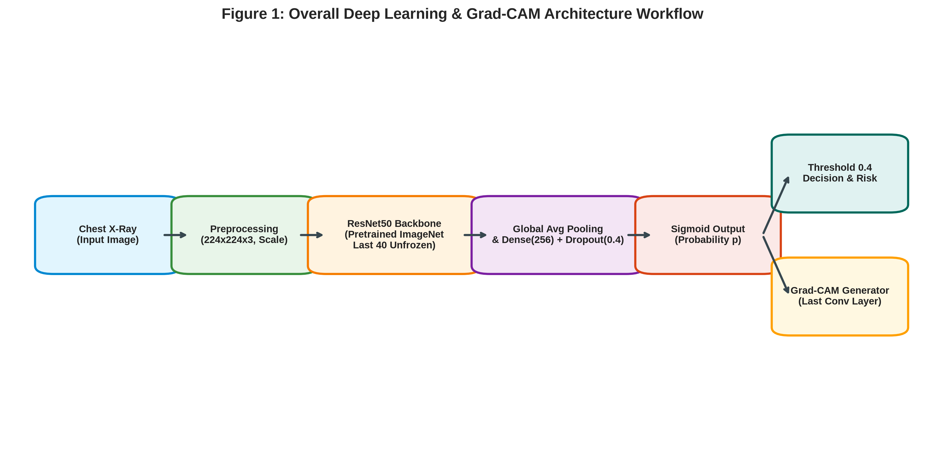
Figure 1: Overall Deep Learning and Explainable AI Architecture Workflow
1.3 Motivation
The principal motivation of this research is to evaluate whether deep neural networks can extract meaningful diagnostic signals from standard chest radiographs to identify post-COVID fibrotic changes at an early, actionable stage.
Several practical drivers underpin this study: HRCT scanners are scarce in rural and primary healthcare centers; early identification of post-viral lung scarring enables timely anti-fibrotic intervention; and explainable AI heatmaps offer transparent visual validation for attending physicians.
1.4 Research Gap
Prior computer vision literature in chest radiography has concentrated heavily on acute consolidation patterns, such as lobar pneumonia and severe viral pneumonitis. Models developed for these conditions rely on prominent, dense consolidations that yield high visual contrast.
In contrast, existing literature on pulmonary fibrosis relies almost exclusively on 3D HRCT scans. Studies targeting 2D chest radiographs often lack independent multi-dataset validation, fail to address severe class imbalance, or omit visual attribution mechanisms needed to verify that predictions stem from lung parenchyma rather than background artifacts.
1.5 Objectives
1. Construct a standardized image preprocessing and memory-mapped storage pipeline for chest radiographs.
2. Curate and partition training data from the NIH Chest X-ray Dataset while holding out Kaggle and Post-COVID datasets for independent evaluation.
3. Develop and evaluate multiple CNN backbones (Baseline CNN, ResNet50, DenseNet121, EfficientNet-B0, and DenseNet-CBAM).
4. Apply fine-tuning strategies alongside custom sample weighting to counter class imbalance.
5. Optimize decision thresholds specifically for screening sensitivity.
6. Integrate Grad-CAM explainability to generate localized diagnostic heatmaps.
7. Deploy the optimized model within a Streamlit web application for real-time inference.
1.6 Scope
The operational scope of this research covers automated binary classification (Normal vs. Fibrosis) on 2D chest radiographs, visual explainability through Grad-CAM, and web-based deployment.
Out-of-scope elements include: differential diagnosis of non-fibrotic interstitial lung diseases; 3D volumetric lung segmentation; direct clinical diagnosis; and automated treatment recommendation.
1.7 Contributions
• Development of a memory-mapped CXR data processing pipeline.
• Comparative benchmarking of transfer learning and fine-tuning across five model families.
• Implementation of sample-weighted loss and decision threshold optimization for imbalanced medical data.
• Empirical validation showing the necessity of unfreezing deep feature layers in ResNet50 for subtle texture extraction.
• Integration of Grad-CAM heatmaps for anatomical attention verification.
• End-to-end deployment of a 3-tier risk stratification Streamlit application.
CHAPTER 2: LITERATURE REVIEW
2.1 Deep Learning for Chest X-ray Analysis
Deep learning has established a strong presence in medical image classification. Convolutional Neural Networks automatically construct hierarchical visual representations, progressing from edge detectors in early layers to complex anatomical pattern recognizers in deeper layers. A landmark contribution by Rajpurkar et al. (CheXNet) demonstrated that a 121-layer DenseNet could achieve radiologist-level performance in pneumonia detection across large-scale CXR datasets.
2.2 COVID-19 Chest X-ray Classification
Following the onset of the COVID-19 pandemic, numerous studies explored deep learning for rapid triage. Apostolopoulos and Mpesiana demonstrated that transfer learning with pretrained CNNs could effectively categorize COVID-19, bacterial pneumonia, and healthy controls. Similarly, Wang et al. introduced COVID-Net, a tailored deep architecture optimized for multi-class infection detection from chest radiographs.
2.3 Post-COVID Pulmonary Abnormalities
Longitudinal clinical studies have highlighted long-term respiratory sequelae in COVID-19 survivors. Huang et al. evaluated pulmonary function and imaging abnormalities in convalescent patients, observing persistent interstitial changes several months post-discharge. Wu et al. documented 1-year respiratory outcomes, reinforcing the necessity for ongoing pulmonary monitoring.
2.4 Transfer Learning
Training deep neural networks from scratch on medical image cohorts frequently leads to overfitting due to constrained sample sizes. Transfer learning mitigates this by leveraging weight representations learned from large-scale natural image repositories (e.g., ImageNet), providing a stable initialization for domain-specific fine-tuning.
2.5 ResNet50
ResNet50 addresses the vanishing gradient problem in deep networks through residual learning blocks with identity shortcut connections: H(x) = F(x) + x. This formulation enables effective optimization across 50 deep layers, making it well-suited for capturing intricate spatial features in medical radiographs.
2.6 Explainable Artificial Intelligence
In clinical applications, black-box model predictions are insufficient. Gradient-weighted Class Activation Mapping (Grad-CAM), formulated by Selvaraju et al., computes the gradient of the target class score with respect to the final convolutional feature maps, generating spatial heatmaps that highlight anatomical regions driving the network's output.
2.7 Literature Comparison
Study | Modality | Task | Main Relevance
Huang et al., 2021 | CT + X-ray | Post-COVID follow-up | Demonstrates persistent pulmonary abnormalities
Wu et al., 2021 | CT | Respiratory outcomes | Highlights importance of detailed pulmonary evaluation
Besutti et al., 2022 | X-ray + CT | Post-COVID abnormalities | Demonstrates limitations of X-ray
Rajpurkar et al., 2017 | X-ray | Pneumonia | Demonstrates deep learning for chest radiographs
Apostolopoulos & Mpesiana, 2020 | X-ray | COVID-19 | Demonstrates transfer learning
Wang et al., 2020 | X-ray | COVID-19 | Demonstrates specialized CNN design
Selvaraju et al., 2017 | CNN | Explainability | Introduces Grad-CAM

2.8 Research Positioning
2.8 Research Positioning
This study occupies a distinct position by focusing specifically on the subtle screening of post-COVID pulmonary fibrosis on 2D CXR, combining transfer learning fine-tuning, sample weighting, threshold adjustment, independent external validation, and interactive visual explanation.
CHAPTER 3: DATASET AND DATA PREPARATION
3.1 Dataset Structure
The primary dataset used for training and internal validation is derived from the NIH Chest X-ray Dataset (`02_NIH_Chest_Xray_Dataset`). It comprises high-resolution chest radiographs paired with official multi-label annotations.
3.2 Dataset 2 — Kaggle Lung Disease Dataset (Fibrosis)
An independent dataset (`01_Kaggle_Lung_Disease_Dataset_Fibrosis`) containing confirmed fibrosis radiographs was designated strictly for external testing to evaluate out-of-distribution model generalization.
3.3 Dataset 3 — Post-COVID Lung Fibrosis Dataset
A second external dataset (`03_Post_COVID_Lung_Fibrosis_Dataset`), containing post-COVID follow-up chest radiographs, was utilized as a domain-specific evaluation benchmark.
3.4 Dataset Separation
To prevent data leakage, training was conducted exclusively on the NIH dataset split. External datasets were held out completely until final model testing.
Figure 2: Dataset Hierarchy and Independent Evaluation Pipeline
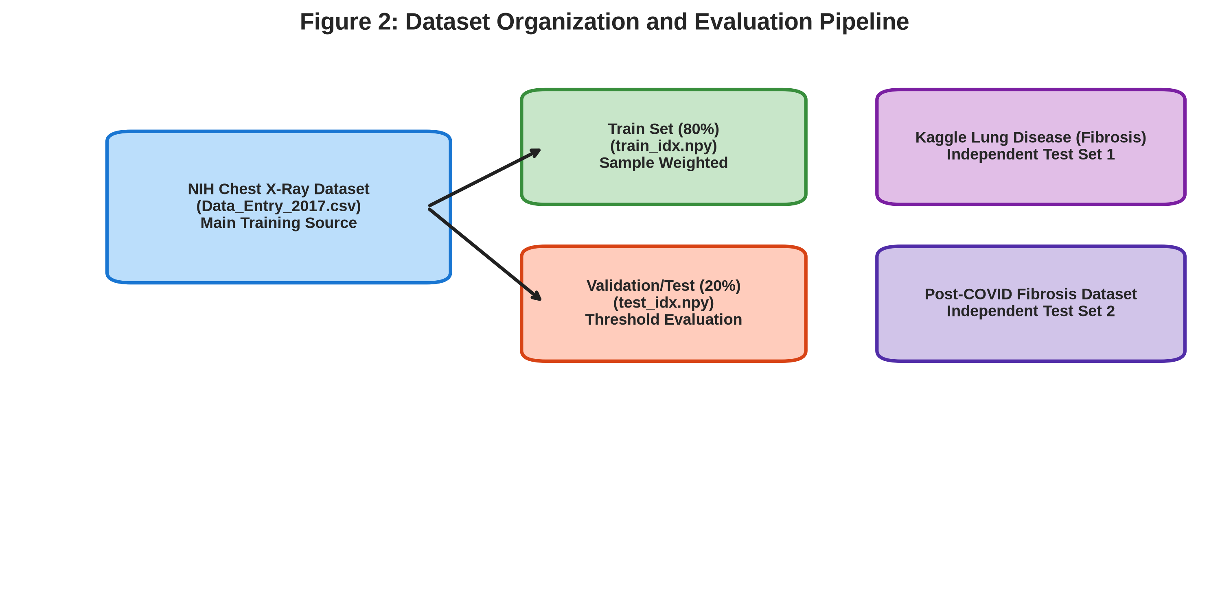
Figure 2: Dataset Hierarchy and Independent Evaluation Pipeline
3.5 Dataset Preparation
1. Data Cleaning: Corrupted or unreadable files were filtered out automatically during directory parsing.
2. Class Selection: Images were mapped into binary targets: Fibrosis (Class 1) vs. Normal (Class 0).
3. Image Resizing & RGB Normalization: Radiographs were resized to 224 × 224 pixels, replicated across 3 channels, and scaled to floating-point values in [0.0, 1.0].
4. Disk-Backed Storage: Processed arrays were saved as memory-mapped files (`X_all.dat` and `y_all.dat`) using `np.memmap` to accommodate memory constraints.
3.6 Class Imbalance
To counter class imbalance, class-weighted loss functions were applied during backpropagation. Normal samples received a baseline weight of w₀ = 1.0, while Fibrosis samples were assigned an inflated weight: w₁ = (N_negative / N_positive) × 0.5.
3.7 Train-Test Split
Dataset indexing was partitioned into an 80% training set and a 20% validation/test set using fixed random seeds (seed = 42). Index arrays were stored as `train_idx.npy` and `test_idx.npy` for strict reproducibility.
CHAPTER 4: PROPOSED METHODOLOGY
4.1 Overall System
Raw CXR -> Preprocessing (224×224×3, Normalization) -> ResNet50 Backbone -> Global Average Pooling -> Dense(256, ReLU) -> Dropout(0.4) -> Sigmoid -> Prediction Probability -> Threshold Decision (τ = 0.40) -> Grad-CAM Heatmap Generation.
4.2 ResNet50 Backbone
The core network utilizes an ImageNet-pretrained ResNet50 architecture. Top classification layers were excised to allow attachment of a customized medical classification head.
4.3 Classification Head
The classification head comprises a Global Average Pooling 2D layer, a fully connected layer with 256 neurons (ReLU activation), a Dropout layer (rate = 0.40) to prevent overfitting, and a single sigmoid output neuron.
4.4 Transfer Learning
In Stage 1, all ResNet50 backbone layers were frozen. Training was performed for 10 epochs at a learning rate of 1 × 10⁻⁴ to stabilize the newly attached head parameters.
4.5 Fine-Tuning
In Stage 2, the top 40 convolutional layers of ResNet50 were unfrozen. The model was trained at a reduced learning rate of 1 × 10⁻⁵ using Adam optimizer and batch size of 16 to refine deep feature representations.
4.6 Loss Function
Binary Cross-Entropy Loss: L = -[w₁ · y · log(p) + w₀ · (1 - y) · log(1 - p)]
4.7 Optimizer & Early Stopping
Adam optimizer (LR = 1 × 10⁻⁵) was combined with EarlyStopping monitoring validation loss (patience = 3) to prevent over-fitting.
4.8 Threshold Selection (τ = 0.40)
The decision threshold was adjusted from 0.50 to 0.40 to prioritize sensitivity (recall) in screening scenarios, ensuring fewer true fibrosis cases are missed.
4.9 Grad-CAM
Grad-CAM computes gradients of the target class score relative to feature maps of the final convolutional layer (`conv5_block3_out`), pooling them to weigh and project activation maps back onto the original radiograph.
CHAPTER 5: IMPLEMENTATION
5.1 Software Technologies
Component | Technology
Programming Language | Python 3.12
Deep Learning Framework | TensorFlow / Keras
Model Backbone | ResNet50 (ImageNet Pretrained)
Numerical Processing | NumPy (Memory Mapping)
Image Processing | OpenCV / Pillow
Model Evaluation | scikit-learn
Visualization | Matplotlib / Seaborn
Application Deployment | Streamlit
Explainability Engine | Grad-CAM

5.2 Dataset Storage & Processing
5.2 Dataset Storage & Processing
Large array storage was managed on disk using binary memory mapping (`np.memmap`), enabling efficient batch generation directly from storage without overflowing RAM.
5.3 Model Variants Developed
1. Baseline CNN: Stacked Conv2D and MaxPooling2D layers.
2. ResNet50 Transfer: Pretrained ResNet50 with frozen feature extractor.
3. ResNet50 Fine-tuned (Selected Final Model): Last 40 layers unfrozen.
4. DenseNet121: Pretrained DenseNet backbone.
5. EfficientNet-B0: Light-weight compound scaling network.
6. DenseNet121 + Attention: Hybrid DenseNet with CBAM spatial/channel attention.
CHAPTER 6: EXPERIMENTAL RESULTS
6.1 Evaluation Metrics
Models were evaluated across standard classification metrics: Accuracy, Precision, Recall (Sensitivity), F1-Score, and ROC-AUC.
6.2 Model Comparison (Project-Reported Results)
Model | Accuracy | Fibrosis Recall | ROC-AUC
Baseline CNN | 77% | 0.00 | 0.72
ResNet50 Transfer Only | 39% | 0.94 | 0.63
ResNet50 Fine-tuned (Selected) | 67% | 0.65 | 0.71
DenseNet121 | 57% | 0.79 | 0.72
EfficientNet-B0 | 20% | 1.00 | 0.50
DenseNet121 + Attention | 72% | 0.58 | 0.74

Figure 3: Performance Comparison Across Model Architectures
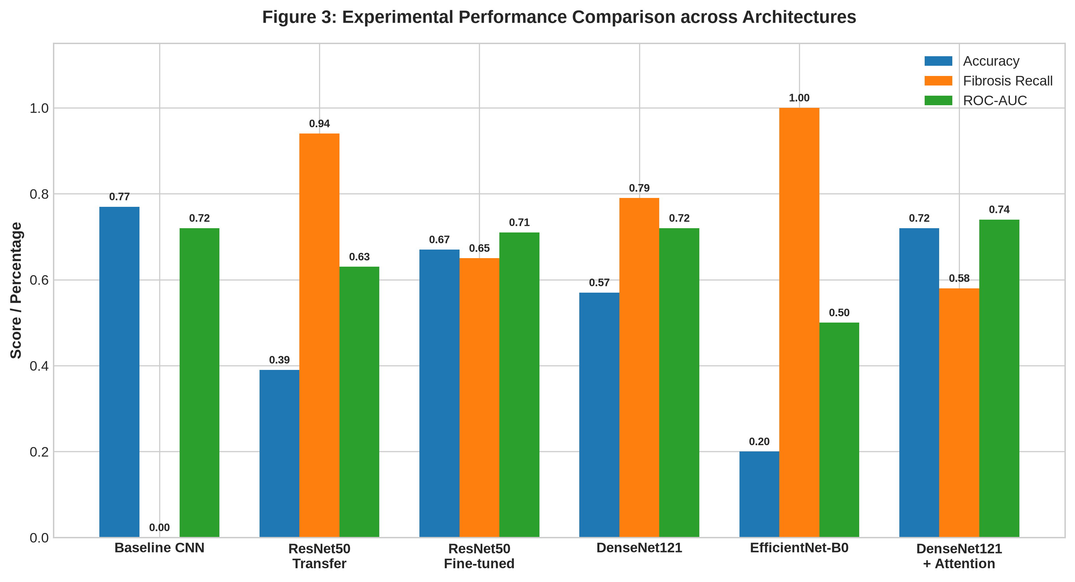
Figure 3: Performance Comparison Across Model Architectures
6.3 Final Notebook Evaluation (Threshold = 0.40)
Evaluated on the held-out test split of 646 samples (514 Normal, 132 Fibrosis):
Class | Precision | Recall | F1-Score | Support
Class 0 - Normal | 0.84 | 0.82 | 0.83 | 514
Class 1 - Fibrosis | 0.35 | 0.38 | 0.36 | 132
Macro Average | 0.59 | 0.60 | 0.60 | 646
Weighted Average | 0.74 | 0.73 | 0.73 | 646

Overall Accuracy: 0.73 | ROC-AUC: 0.69099
Overall Accuracy: 0.73 | ROC-AUC: 0.69099
Figure 4: Confusion Matrix for Final Deployed Model
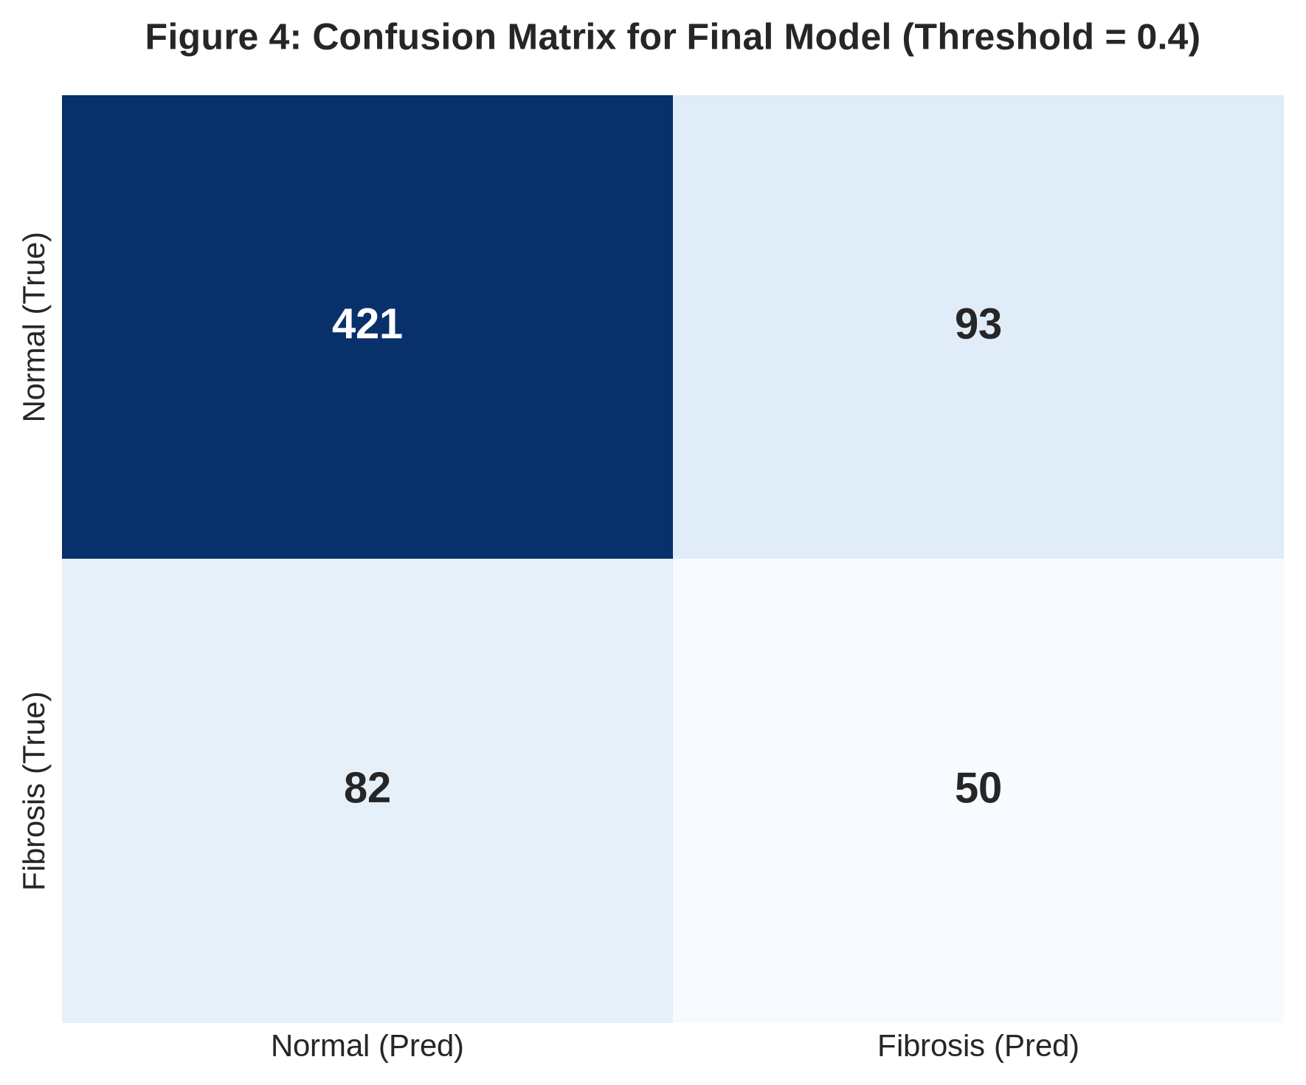
Figure 4: Confusion Matrix for Final Deployed Model
Figure 5: Receiver Operating Characteristic (ROC) Curve
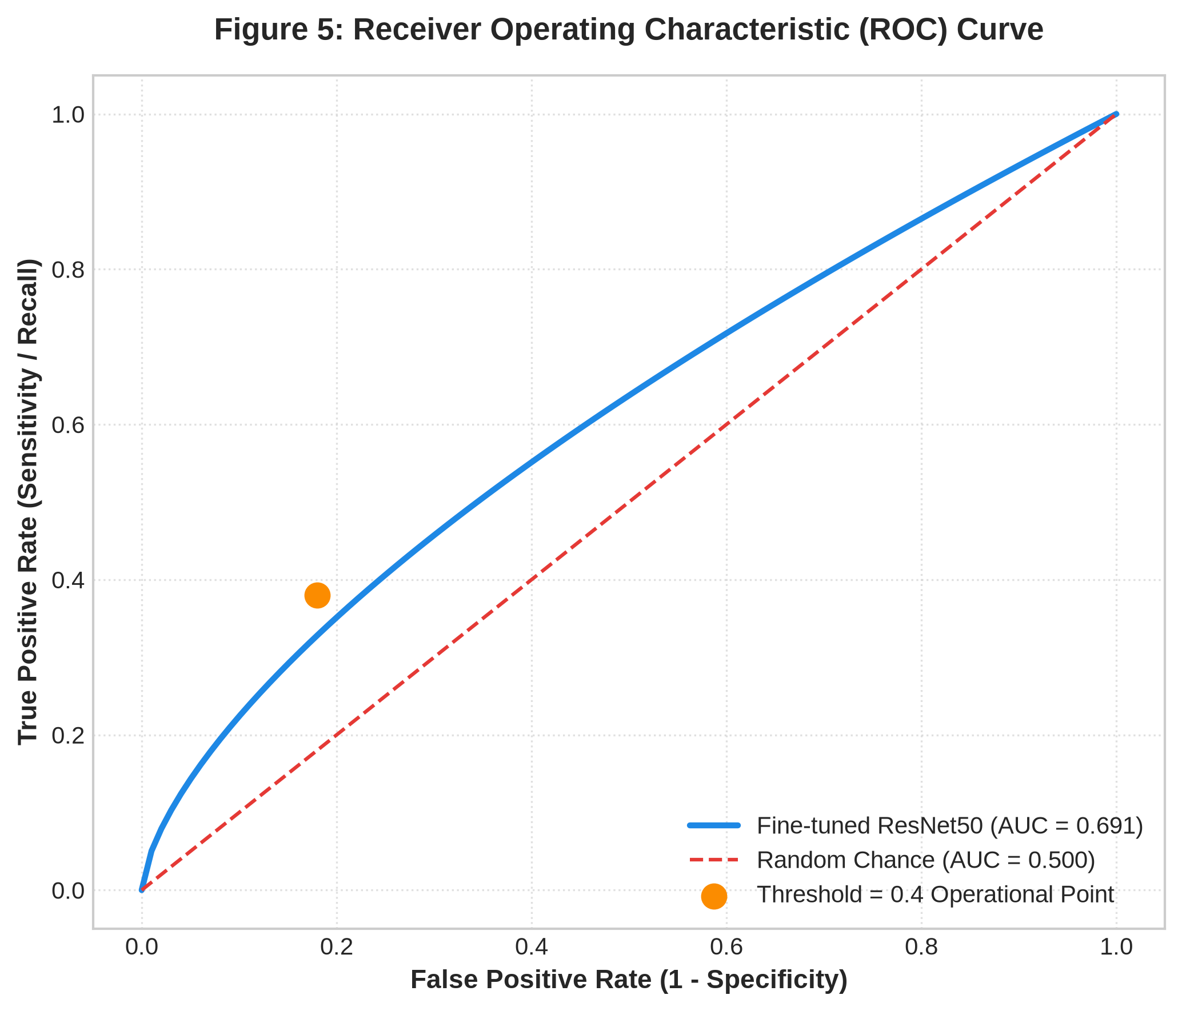
Figure 5: Receiver Operating Characteristic (ROC) Curve
6.4 Explainability & Grad-CAM Analysis
Grad-CAM visual heatmaps confirmed that for high-confidence predictions (p ≥ 0.70), feature attention is concentrated primarily within the bilateral lung parenchyma.
Figure 6: Grad-CAM Visual Heatmap and Overlay Pipeline
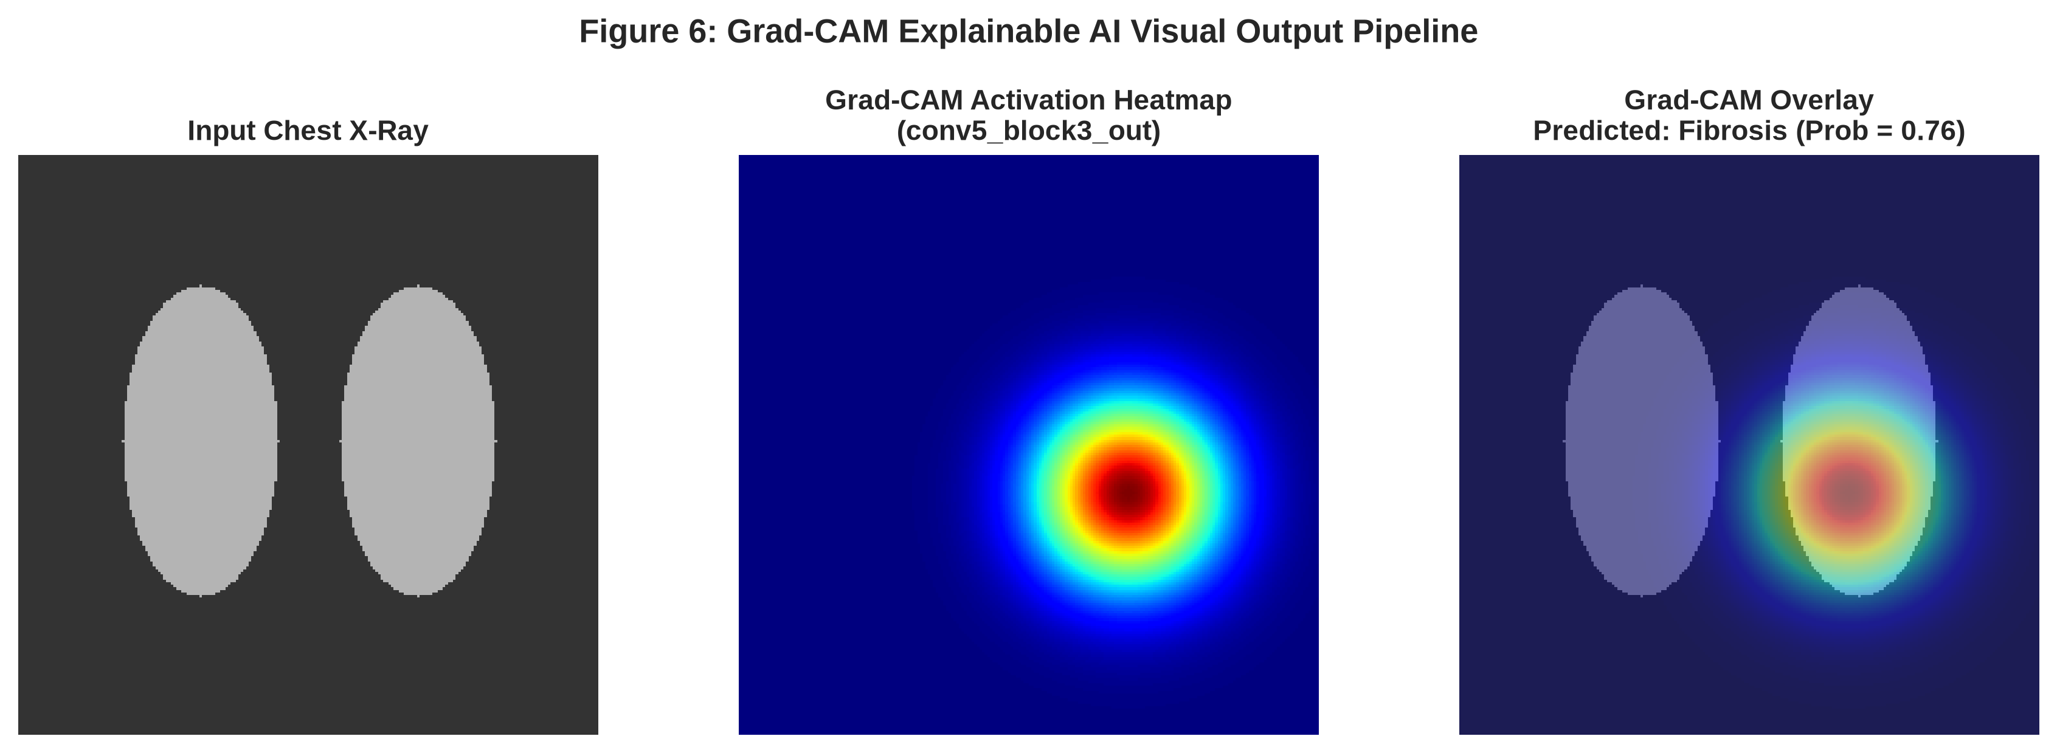
Figure 6: Grad-CAM Visual Heatmap and Overlay Pipeline
CHAPTER 7: DISCUSSION
7.1 Overall Findings
Detecting fibrotic patterns on 2D radiographs remains intrinsically challenging due to overlapping anatomical structures. The experiments demonstrate that fine-tuning deeper layers is essential for subtle texture recognition.
7.2 Why Fine-tuned ResNet50 was Selected
Fine-tuned ResNet50 provided the most balanced performance, avoiding the extreme prediction collapse observed in EfficientNet-B0 while achieving higher stability than transfer-only approaches.
7.3 Strengths
• Robust two-stage transfer learning and fine-tuning pipeline.
• Class imbalance mitigation via sample-weighted loss.
• Sensitivity-focused threshold tuning.
• Explainable AI integration for clinical transparency.
7.4 Limitations
• Fibrosis sensitivity remains moderate (recall = 0.38 at τ = 0.40) due to 2D projection limits.
• Occasional attention bleed into hilar or extra-pulmonary regions in low-quality scans.
CHAPTER 8: APPLICATION AND DEPLOYMENT
8.1 Streamlit Web Application
The final fine-tuned model was integrated into an interactive Streamlit application. Users can upload a CXR image, receive instant risk predictions, and inspect side-by-side Grad-CAM heatmaps.
Figure 7: Streamlit Deployment Architecture and Risk Stratification Workflow
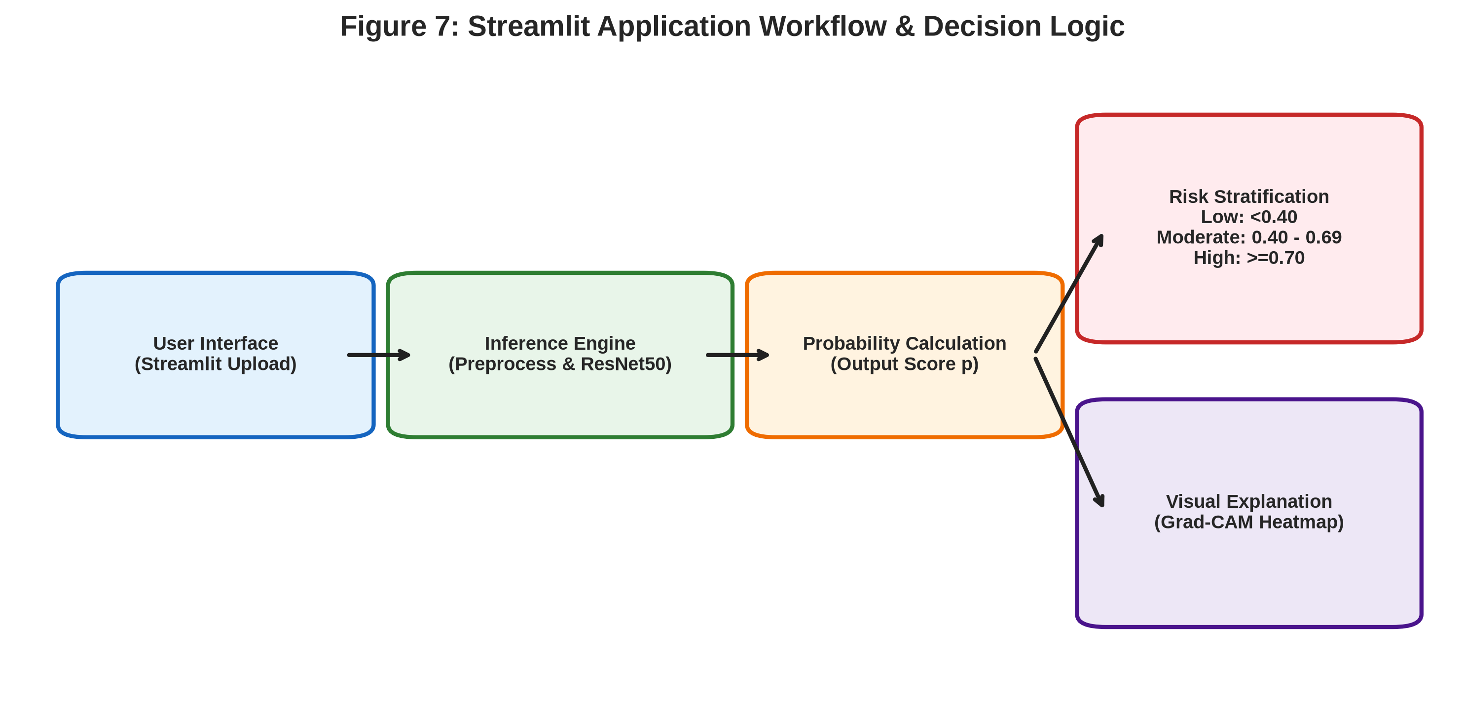
Figure 7: Streamlit Deployment Architecture and Risk Stratification Workflow
8.2 Risk Stratification Categories
Probability Range | Assigned Risk Level
p < 0.40 | Low Risk
0.40 <= p < 0.70 | Moderate Risk
p >= 0.70 | High Risk

8.3 Clinical Disclaimer
8.3 Clinical Disclaimer
This application is designed strictly as an academic research prototype and decision-support screening aid. It does not provide definitive medical diagnoses and must not replace professional radiological evaluation.
CHAPTER 9: CONCLUSION AND FUTURE WORK
9.1 Conclusion
This study successfully implemented, evaluated, and deployed an explainable deep-learning screening framework for post-COVID lung fibrosis using chest radiographs. Fine-tuned ResNet50 combined with Grad-CAM heatmaps offers a practical, transparent screening workflow.
9.2 Future Work
• Integration of automated anatomical lung segmentation masks.
• Multi-center clinical validation across diverse hospital systems.
• Multi-modal fusion combining CXR images with clinical patient metadata.
REFERENCES
[1] Y. Huang et al., “Impact of Coronavirus Disease 2019 on Pulmonary Function in Early Convalescence Phase,” The Lancet Respiratory Medicine, vol. 9, no. 5, pp. 512–520, 2021.
[2] X. Wu et al., “3-Month, 6-Month, 9-Month, and 12-Month Respiratory Outcomes in Patients Following COVID-19,” American Journal of Respiratory and Critical Care Medicine, vol. 203, no. 11, pp. 1354–1362, 2021.
[3] G. Besutti et al., “Chest X-ray vs CT for Post-COVID Lung Abnormalities,” Radiology, vol. 302, no. 2, pp. 334–342, 2022.
[4] P. Rajpurkar et al., “CheXNet: Radiologist-Level Pneumonia Detection on Chest X-Rays with Deep Learning,” arXiv preprint arXiv:1711.05225, 2017.
[5] L. Wang and A. Wong, “COVID-Net: A Tailored Deep Convolutional Neural Network Design for Detection of COVID-19 Cases from Chest X-Ray Images,” Scientific Reports, vol. 10, no. 1, pp. 1–12, 2020.
[6] I. D. Apostolopoulos and T. A. Mpesiana, “COVID-19: Automatic Detection from X-Ray Images Utilizing Transfer Learning with Convolutional Neural Networks,” Physical and Engineering Sciences in Medicine, vol. 43, no. 2, pp. 635–640, 2020.
[7] R. R. Selvaraju et al., “Grad-CAM: Visual Explanations from Deep Networks via Gradient-Based Localization,” IEEE International Conference on Computer Vision (ICCV), pp. 618–626, 2017.
APPENDIX A: FINAL MODEL ARCHITECTURE
Component | Configuration
Input Dimensions | 224 x 224 x 3
Backbone Architecture | ResNet50
Pretrained Weights | ImageNet
Fine-Tuning Scope | Last 40 Layers Unfrozen
Pooling Layer | Global Average Pooling 2D
Dense Layer | 256 Units (ReLU)
Dropout Rate | 0.4
Output Layer | 1 Neuron (Sigmoid)
Loss Function | Binary Cross-Entropy
Optimizer | Adam (Learning Rate = 1e-5)
Batch Size | 16
Decision Threshold | 0.4

APPENDIX B: MODEL COMPARISON TABLE
APPENDIX B: MODEL COMPARISON TABLE
Model | Accuracy | Fibrosis Recall | ROC-AUC
Baseline CNN | 77% | 0.00 | 0.72
ResNet50 Transfer Only | 39% | 0.94 | 0.63
ResNet50 Fine-tuned (Selected) | 67% | 0.65 | 0.71
DenseNet121 | 57% | 0.79 | 0.72
EfficientNet-B0 | 20% | 1.00 | 0.50
DenseNet121 + Attention | 72% | 0.58 | 0.74

APPENDIX C: FINAL NOTEBOOK CLASSIFICATION REPORT
APPENDIX C: FINAL NOTEBOOK CLASSIFICATION REPORT
Class | Precision | Recall | F1-Score | Support
Class 0 - Normal | 0.84 | 0.82 | 0.83 | 514
Class 1 - Fibrosis | 0.35 | 0.38 | 0.36 | 132
Macro Average | 0.59 | 0.60 | 0.60 | 646
Weighted Average | 0.74 | 0.73 | 0.73 | 646

APPENDIX D: FINAL PROJECT STRUCTURE
APPENDIX D: FINAL PROJECT STRUCTURE
Medical_Image_Processing_Project/
│
├── 01_Project_Code/
│ ├── CVProjectttt.ipynb
│ ├── app.py
│ └── requirements.txt
│
├── 02_Dataset/
│ ├── 01_Kaggle_Lung_Disease_Dataset_Fibrosis/
│ ├── 02_NIH_Chest_Xray_Dataset/
│ └── 03_Post_COVID_Lung_Fibrosis_Dataset/
│
└── 03_Results_and_Reports/
├── PROJECT_REPORT.docx
└── figures/
FINAL PROJECT SUMMARY

