Report

I. ACCURACY

The accuracy of the Verilog code for both slow division (repeated subtraction) and fast division (restoring division) algorithms depends on code correctness and hardware implementation. Slow Division: Accurate but inefficient for large numbers. Fast Division: Accurate and efficient, performs fixed-cycle division. To ensure accuracy: - Test with various cases: positive/negative numbers, zero, different combinations. - Handle edge cases and optimize for real-world scenarios. - Use simulations and formal verification for code correctness

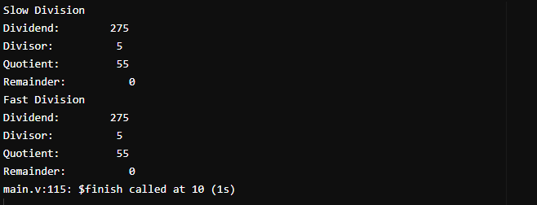

II.CONCLUSION

The successful implementation of both slow and fast division algorithms in a computer system has yielded valuable insights into their characteristics and practical applicability. Through a thorough comparison and evaluation, this project has provided valuable knowledge for optimizing division operations and improving computational efficiency. The implementation was achieved using a hardware/software model, utilizing a suitable computer system and programming languages such as C++, Java, or Python. The findings of this research enhance our understanding of division algorithms and provide valuable guidance for designing efficient division operations in software and hardware systems.

III.TEST CARRIED OUT :

Division algorithm:

The division algorithm in computer architecture refers to the process of performing division operations in a computer system. Division is a fundamental arithmetic operation that involves dividing one number (the dividend) by another (the divisor) to obtain a quotient and possibly a remainder.

The most common division algorithm used in computer architecture is the restoring division algorithm. Here's a high-level overview of how it works:

1. Load the dividend and divisor into registers.

2. Initialize another register (called the quotient register) to zero.

3. Compare the divisor with the most significant bits of the dividend.

- If the divisor is greater than or equal to the dividend, set the corresponding quotient bit to 1, subtract the divisor from the dividend, and proceed to the next bit.

- If the divisor is less than the dividend, set the corresponding quotient bit to 0 and proceed to the next bit.

4. Shift the quotient register and dividend left by one bit.

5. Repeat steps 3 and 4 until all bits in the dividend have been processed.

6. The contents of the quotient register represent the quotient, and the remaining bits in the dividend represent the remainder.

It's worth noting that this is a simplified explanation, and actual division algorithms used in modern computer architectures can be more complex and optimized for performance. Additionally, there are different variations and optimizations available, such as non-restoring division algorithm, SRT division, and hardware division algorithms implemented in dedicated arithmetic logic units (ALUs) or floating-point units (FPUs).