MediFlow ERP
Medical Clinic Management System
Project Report
[Student Name]
[Date]

Table of Contents

1. Introduction
MediFlow ERP is a Medical Clinic Management System built with Laravel 12. It is designed for small to medium medical clinics that need a single web application to coordinate patient records, doctor schedules, appointments and billing instead of relying on paper records or disconnected spreadsheets.
The system is built around role-based access control for three types of internal staff: administrators, who have full access to every module; receptionists, who manage patients, appointments and billing on a day-to-day basis; and doctors, who have read-only access to their own appointment schedule and patient queue. Each role is given a dedicated dashboard summarizing the information most relevant to that role's daily work.
The core purpose of the project is to demonstrate a complete, database-backed CRUD workflow — patient registration, appointment booking with availability checking, and invoice generation — secured behind Laravel's authentication and a custom role-checking middleware.

2. Technology Stack

Backend
- Framework: Laravel 12.0
- PHP Version: ^8.2
- Database: SQLite (default)
- Authentication: Laravel Breeze ^2.4
- Queue, Cache and Session: Database driver

Frontend
- CSS Framework: TailwindCSS ^3.1.0, with @tailwindcss/forms and a custom design-token configuration (colors, spacing, typography)
- Build Tool: Vite ^7.0.7
- JavaScript: Alpine.js ^3.4.2
- HTTP Client: Axios ^1.11.0

Development Tools
- Testing: PHPUnit ^11.5.50
- Code Style: Laravel Pint ^1.24
- Development Server: Laravel Sail ^1.41 / php artisan serve
- Logging: Laravel Pail ^1.2.2
- Faker: ^1.23 (test data generation)

3. Page-by-Page Description

Login Page
Single entry point for all users (Admin, Receptionist, Doctor) to authenticate before reaching any protected area of the system.
- Email and password fields with inline validation error messages
- "Remember me" persistent-session option
- "Forgot Password?" link into the password-reset flow
- Role-aware redirect after login: each role lands on its own dashboard
- Session-based authentication provided by Laravel Breeze
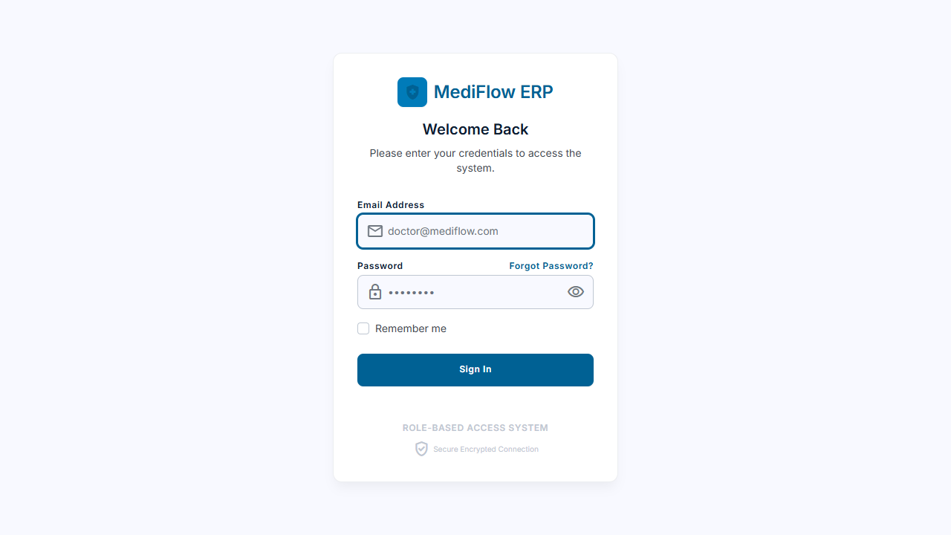

Registration Page
Default Laravel Breeze self-registration form, scaffolded with the authentication starter kit.
- Name, email, password and password-confirmation fields
- Server-side validation with inline error display
- New accounts default to the "receptionist" role
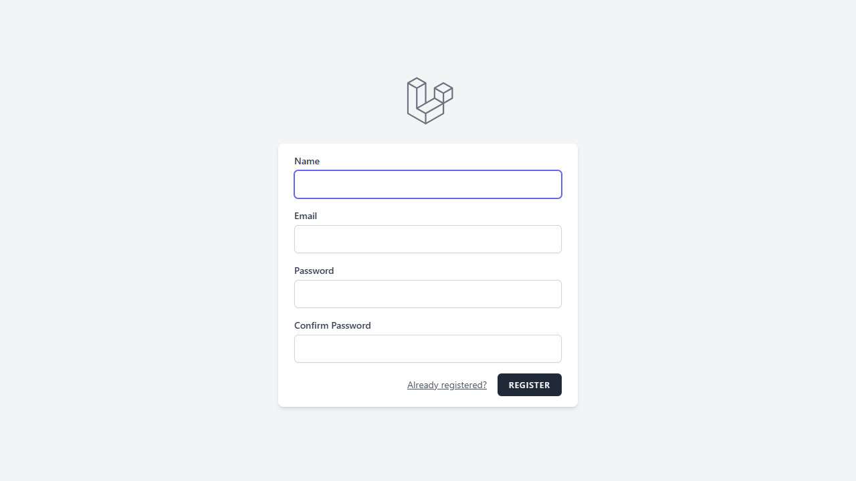

Forgot Password Page
Lets a user request a password-reset link by email when they cannot sign in.
- Email input with validation
- Sends a signed, time-limited reset link via the configured mail driver
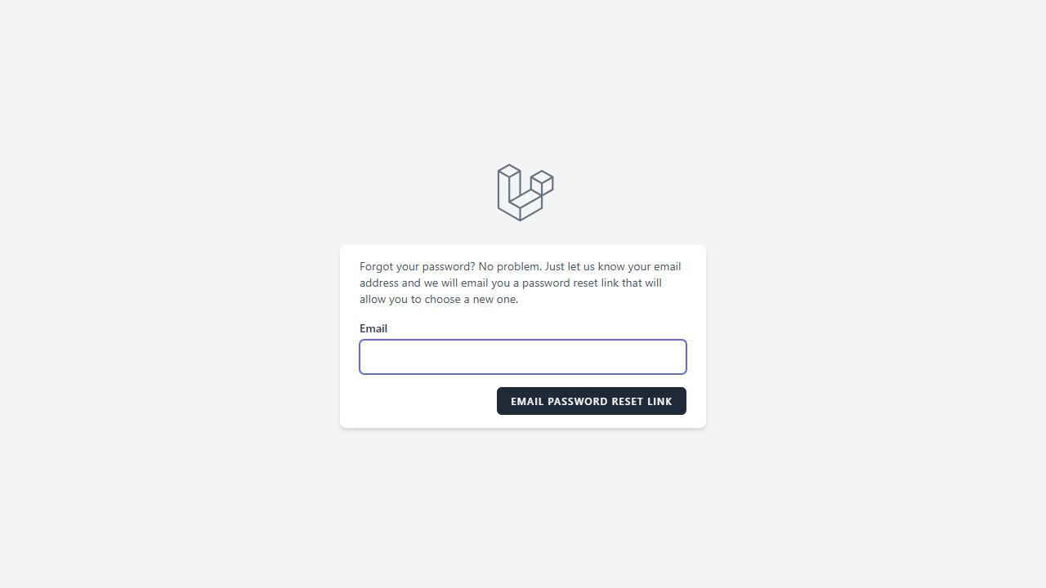

Admin Dashboard
Landing page for administrators, giving a clinic-wide operational snapshot.
- Key metric tiles: total patients, today's appointments, monthly revenue, active doctors
- Recent appointments table (patient, doctor, time, status)
- Revenue trend chart panel
- System notifications panel
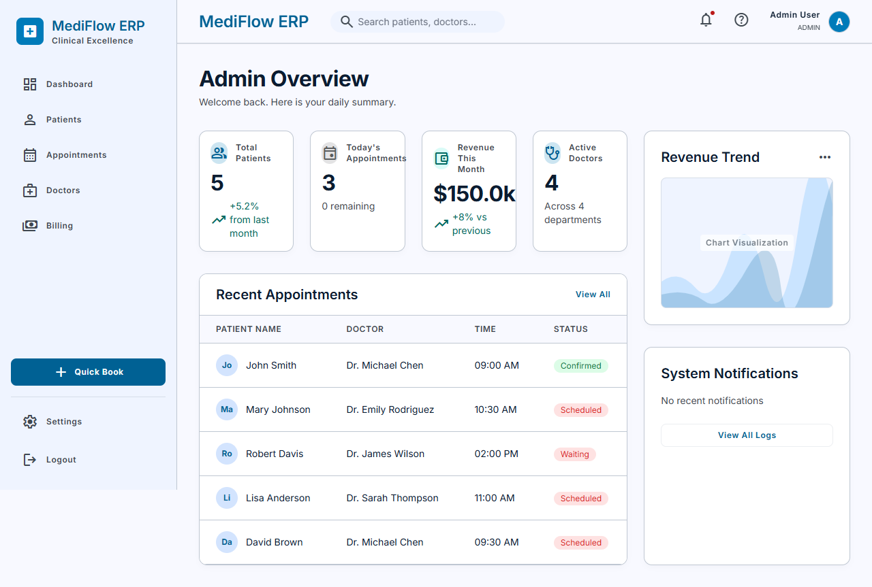

Receptionist Dashboard
Front-desk operational view focused on the current day's patient flow.
- Waiting-room counter and today's appointment count
- Quick actions: "Register New Patient" and "Book New Appointment"
- Incoming patients table with live status badges (waiting, checked-in, in-consultation)
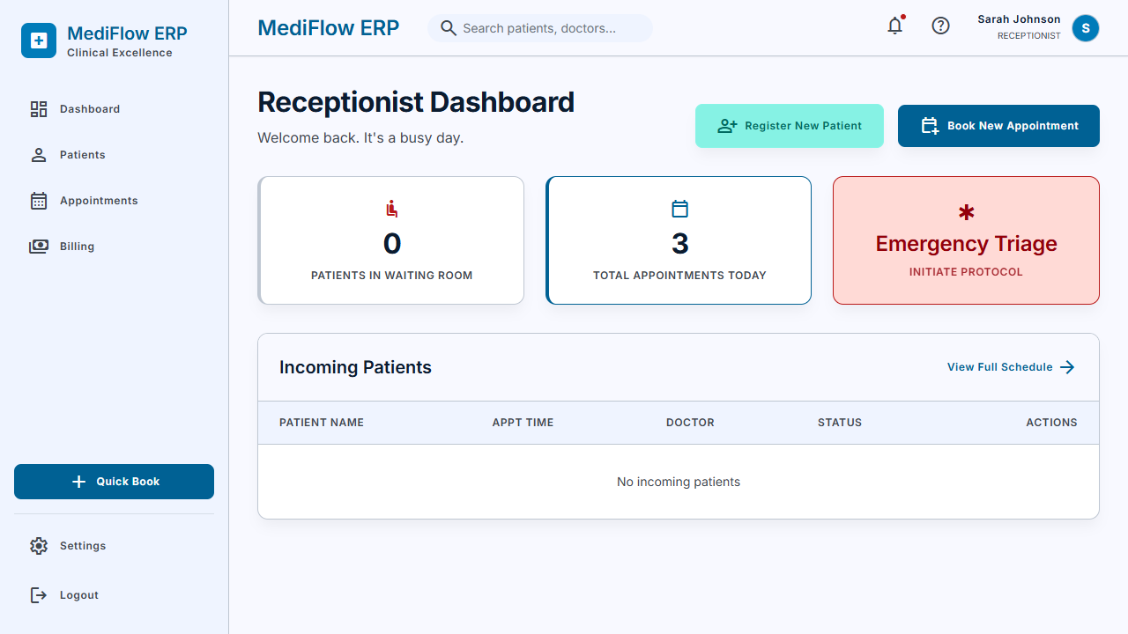

Doctor Dashboard
Clinical view for a doctor to manage their own patient queue for the day.
- Completed-today / remaining-today counters
- "Up Next" card with a one-click "Start Consultation" action
- Full patient queue table with reason for visit, time and status
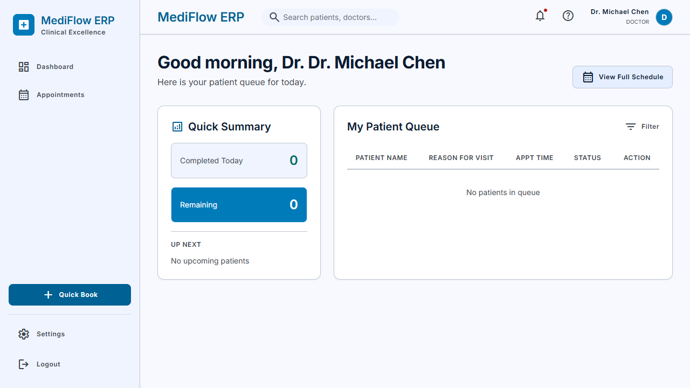

Patient Directory (List)
Central, paginated list of every registered patient, used by Admin and Receptionist roles.
- Patient name, ID, age/gender, contact number and status columns
- View and edit action icons per row
- Pagination and a "Register New Patient" call-to-action
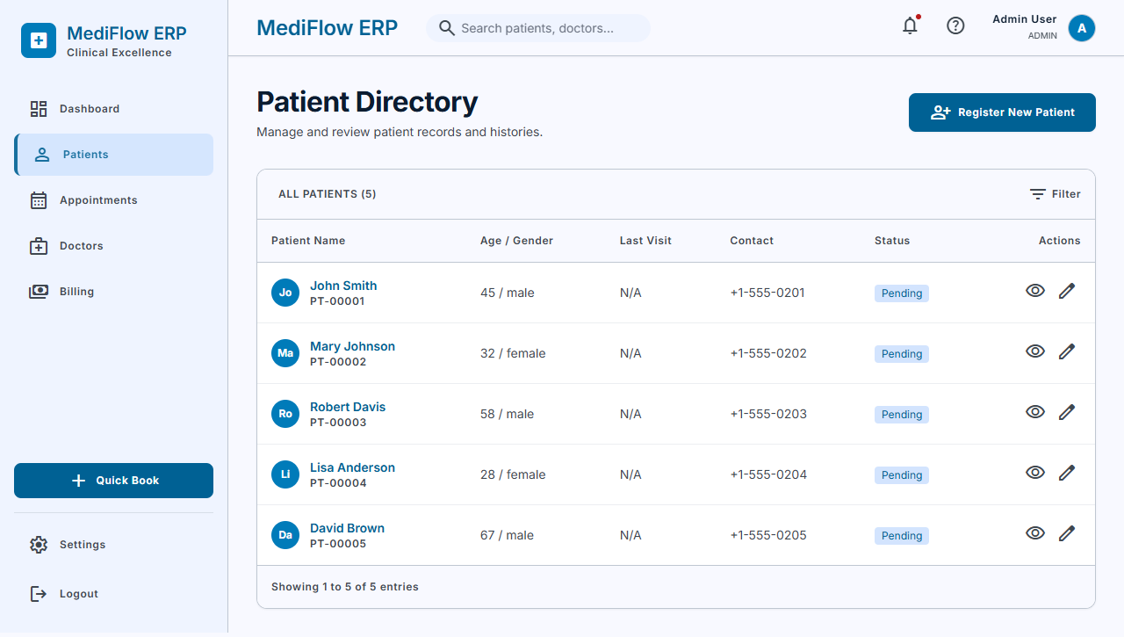

Register New Patient
Form used to capture a new patient's demographic and medical information.
- First name, last name, age, gender and contact fields
- Optional email, address and medical-notes fields
- Server-side validation (e.g. age 0–150, required contact)
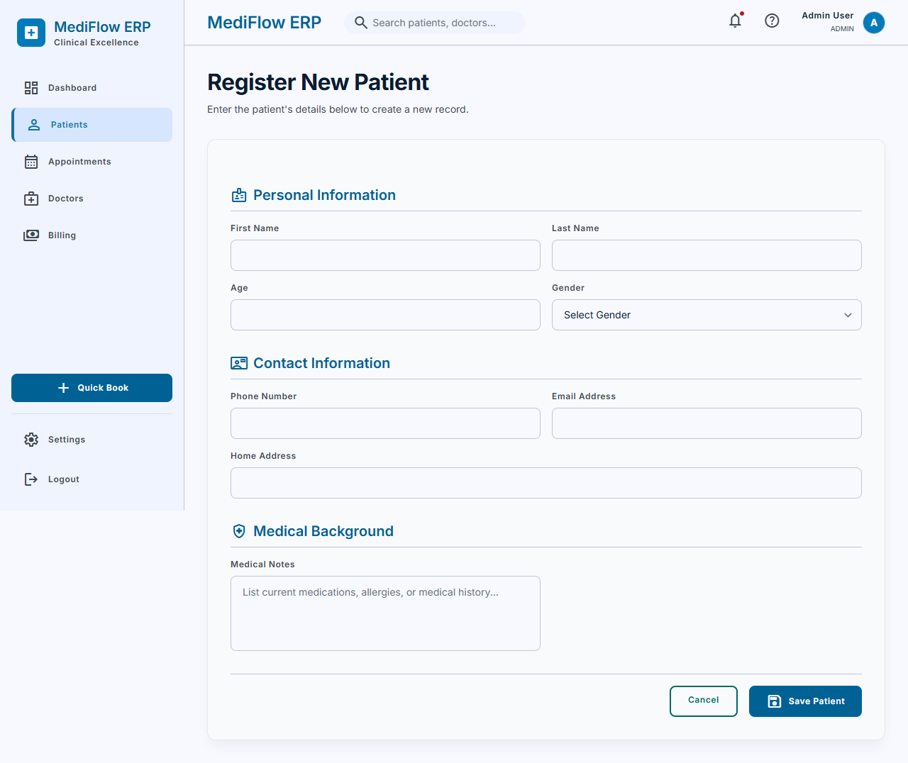

Patient Profile (View)
Intended to show a single patient's full profile together with their appointment and billing history (the controller already loads both relationships).
- Not currently reachable: the patients.show Blade view has not been created yet
- Visiting it returns a server error ("View [patients.show] not found")
[SCREENSHOT MISSING — insert manually]

Edit Patient
Intended to pre-fill the patient form for updating an existing record.
- Not currently reachable: the patients.edit Blade view has not been created yet
[SCREENSHOT MISSING — insert manually]

Doctor Directory
Intended to list all doctors with specialization and working hours, for Admin management.
- Not currently reachable: no view files exist yet under resources/views/doctors/
[SCREENSHOT MISSING — insert manually]

Add Doctor
Intended form to register a new doctor (name, specialization, contact, working hours).
- Not currently reachable: the doctors.create Blade view has not been created yet
[SCREENSHOT MISSING — insert manually]

Doctor Profile
Intended to show a single doctor's details together with their appointments.
- Not currently reachable: the doctors.show Blade view has not been created yet
[SCREENSHOT MISSING — insert manually]

Edit Doctor
Intended form to update an existing doctor's details.
- Not currently reachable: the doctors.edit Blade view has not been created yet
[SCREENSHOT MISSING — insert manually]

Book New Appointment
Interactive scheduler used by Admin and Receptionist to book a patient with a doctor.
- 14-day rolling date picker
- Morning and afternoon time-slot grid showing live availability
- Patient and doctor selection
- AJAX conflict check against existing bookings before submission
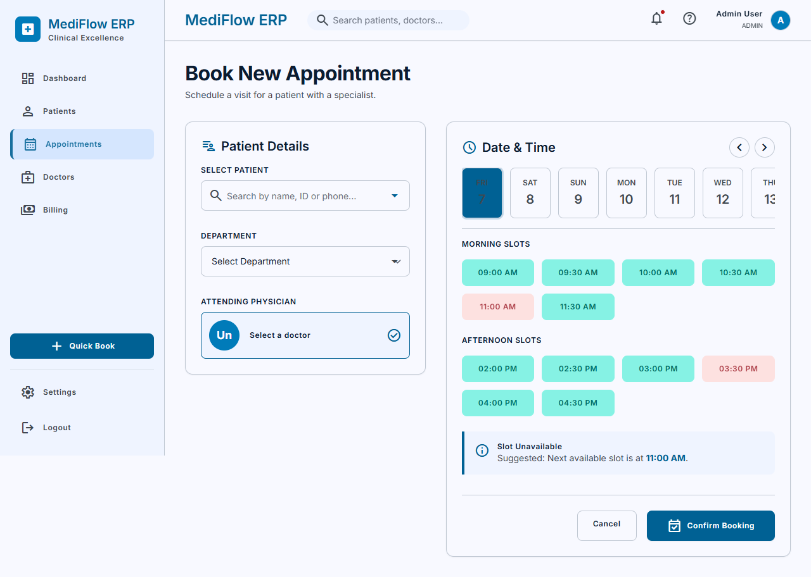

Appointments List
Intended to list appointments, filtered by role (all appointments for Admin/Receptionist, own appointments only for Doctor).
- Not currently reachable: the appointments.index Blade view has not been created yet
- A routing issue was also found: two routes in web.php are both named "appointments.index" (one restricted to Admin/Receptionist, one to Doctor) for the same GET /appointments URL — the second definition silently overrides the first, so the route Admin/Receptionist actually hit is doctor-only
[SCREENSHOT MISSING — insert manually]

Appointment Details
Intended to show a single appointment with its linked patient, doctor and billing record.
- Not currently reachable: the appointments.show Blade view has not been created yet
[SCREENSHOT MISSING — insert manually]

Edit Appointment
Intended form to reschedule or update an existing appointment, with the same availability check used on creation.
- Not currently reachable: the appointments.edit Blade view has not been created yet
[SCREENSHOT MISSING — insert manually]

Create Invoice
Form used by Admin and Receptionist to generate a new patient invoice.
- Patient and attending-physician selection
- Payment method selection (card, cash, insurance, bank transfer)
- Itemized service line items with running subtotal, tax, discount and total
- "Finalize & Print Invoice" and "Send to Insurance" actions
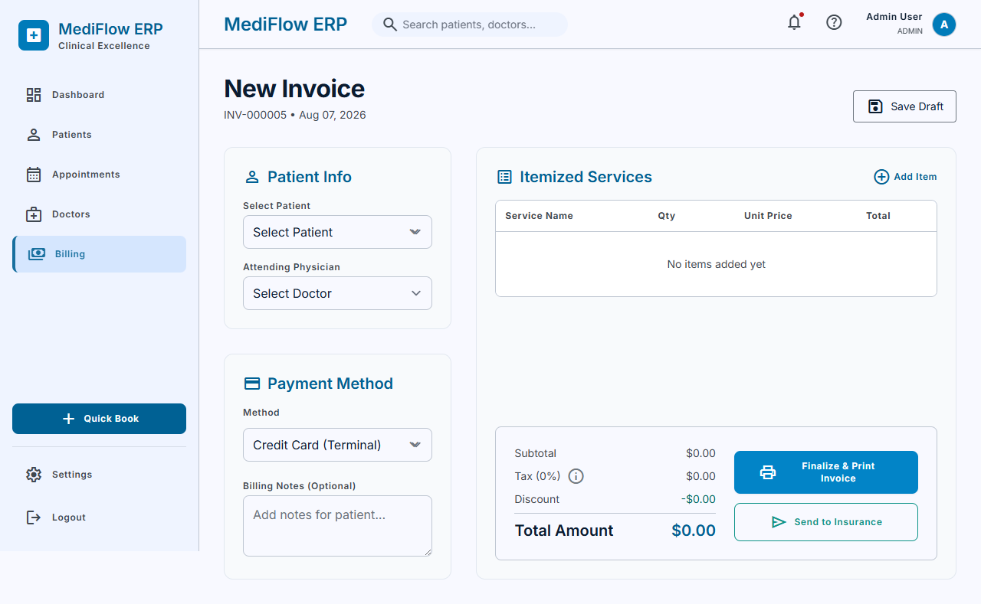

Invoice List
Intended to list all invoices with monthly revenue and pending-payment statistics.
- Not currently reachable — this one fails for a different reason than a missing view: BillingController@index eager-loads a doctor() relationship on the Billing model, but Billing.php only defines patient() and appointment(). The mismatch raises a RelationNotFoundException before the (existing) billing.index view is ever rendered.
[SCREENSHOT MISSING — insert manually]

Invoice Details
Intended to show a single invoice with patient, doctor and appointment details, plus a "mark as paid" action.
- Not currently reachable: same missing Billing::doctor() relationship error as the Invoice List page
[SCREENSHOT MISSING — insert manually]

Edit Invoice
Intended form to update an existing invoice's amount, status, payment method or notes.
- Not currently reachable: the billing.edit Blade view has not been created yet
[SCREENSHOT MISSING — insert manually]

Printable Invoice
Intended print-friendly layout of a finalized invoice.
- Not currently reachable: same missing Billing::doctor() relationship error as the Invoice List page
[SCREENSHOT MISSING — insert manually]

Profile Settings
Standard account-management page available to every authenticated user, regardless of role.
- Update name and email address
- Change password
- Delete account (with confirmation)
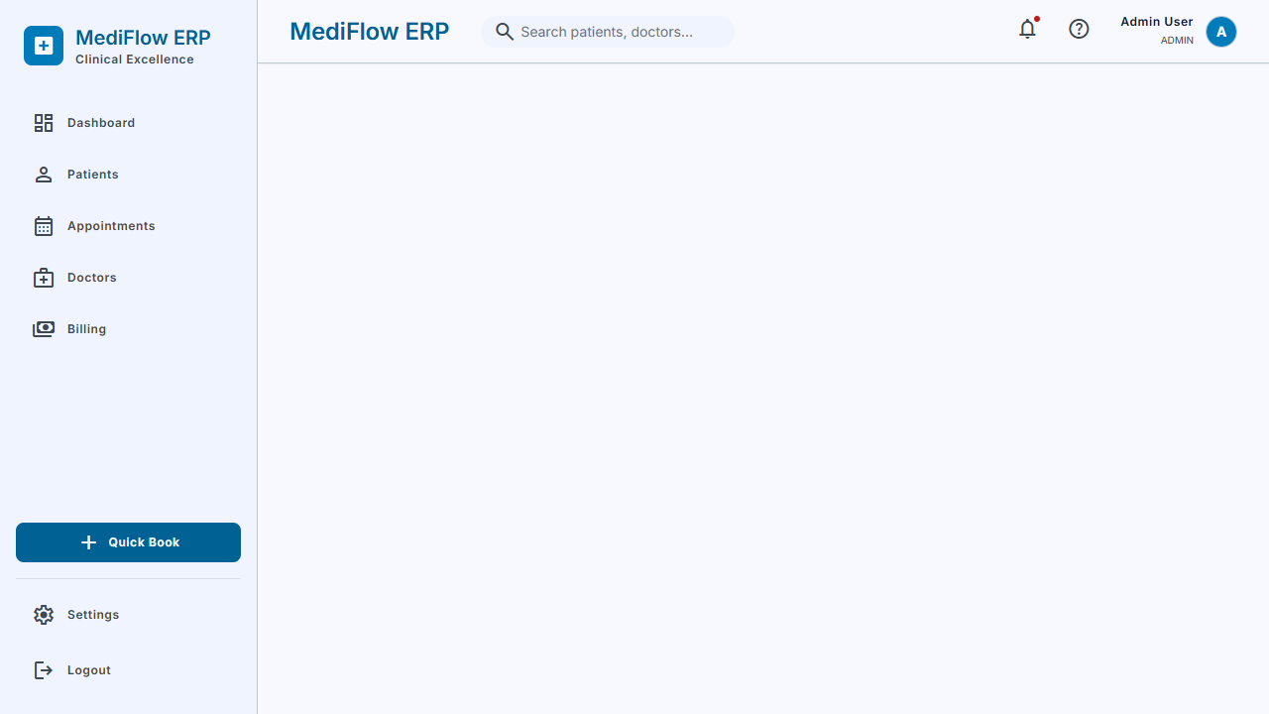

4. What You Learned
[Draft — personalize this with your own experience before submitting]
Working on MediFlow ERP gave me hands-on experience with the Laravel MVC architecture end to end: defining Eloquent models and relationships (hasMany, belongsTo, hasOne), writing Form Request classes for validation, and building resource controllers around RESTful routes. I practiced implementing role-based authorization through custom middleware (CheckRole) rather than relying only on Laravel's default gates, and saw firsthand how route grouping and middleware stacking affect which controller method actually handles a request.
On the frontend side, I learned to build a consistent design system on top of TailwindCSS by extending the config with custom color, spacing and typography tokens, and to keep the compiled CSS in sync with the Blade templates using Vite. I also gained experience with lightweight interactivity using Alpine.js, and with structuring role-specific dashboards that each query and present different subsets of the same underlying data.

5. Challenges Faced
[Draft — personalize this with your own experience before submitting]
The biggest challenge was keeping every Blade view in sync with what its controller expected: several controller actions (for example, doctors.index, patients.show, appointments.index and billing.edit) already contain working logic and pass the correct data, but the corresponding view files were not finished by the time this report was generated, which caused those pages to fail with a "view not found" error.
A second challenge was making sure every Eloquent relationship a view or controller depends on actually exists on the model — the Billing model, for instance, is missing a doctor() relationship that BillingController@index and BillingController@show both rely on, which broke the entire invoice list and invoice detail pages even though their views exist.
A more subtle challenge was route configuration: because two different route groups in web.php both registered a GET /appointments route under the same name "appointments.index" (one for Admin/Receptionist, one for Doctor), the second definition quietly overrode the first, so Admin and Receptionist users were being sent to a doctor-only route instead of their own. Bugs like this are easy to miss because the application does not raise an error at boot time — it only shows up when you actually click through the affected page as a specific role, which is exactly what this screenshot-driven testing process caught.

6. Conclusion
MediFlow ERP demonstrates a working role-based clinic management foundation: authentication and role-aware redirection, three distinct staff dashboards, patient registration and listing, an availability-checked appointment booking flow, and invoice creation are all functional end to end. A defined set of pages — mainly the "show" and "edit" views for patients, doctors, appointments and billing, plus one missing Eloquent relationship on the Billing model and a duplicate route name — remain to be finished before every feature described in the project documentation is fully reachable. Completing those views and fixing the two code-level issues identified during this walkthrough would bring the implementation fully in line with the system's documented scope.

