FIELD NOTES FROM BUILDING AN AI DOCUMENT PIPELINE
Double-Check or Double-Cost?
What we learned running every shipping document through our AI extractor twice - once without, once with a precision verification pass
17 ground-truthed documents | live vision endpoint | strict scoring | measured 2026-08-21

The stakes: one wrong digit can spoil a vaccine shipment
We run CryoSync, a cold-chain logistics platform for pharmaceutical shipments - cord blood units, cell therapies, temperature-controlled reagents moving between labs at +2 to +8 C, -80 C, or in liquid nitrogen vapor. Every shipment arrives with paper: packing slips, shipping labels, bills of lading, certificates of analysis.
Somebody has to re-key that paper into our receiving form. Tracking numbers, seal numbers, declared values, UN dangerous-goods numbers. A misread digit in a tracking number delays a shipment; a missed UN3373 flag is a compliance incident. So we automated it: upload a photo or PDF, get back structured, form-ready fields with confidence scores and the exact evidence quote each value came from.
The question this post answers: is a second AI pass - where another model call independently re-reads the document and reconciles every field - worth doubling the latency? We measured it on a ground-truth corpus, and the honest answer is more interesting than either marketing extreme.

Two modes, one API
Standard mode is what you'd expect: one vision-model call per document. The model reads every page and returns JSON - twenty fields covering shipment identity, parties, product details and compliance - each with a confidence score and an evidence quote transcribed verbatim from the page.
Precision mode adds a second, independent pass. A fresh model call re-reads the same pages with no knowledge of the first answer, then a reconciliation layer compares the two field by field:
- Agreement: both passes agree - confidence goes up.
- Disagreement: they disagree - the verifier's value wins, confidence is discounted, and the correction is logged in human-readable warnings.
- Doubt: either pass flags doubt - the field carries a needs-review flag into the UI so a human looks at exactly those fields, not the whole form.
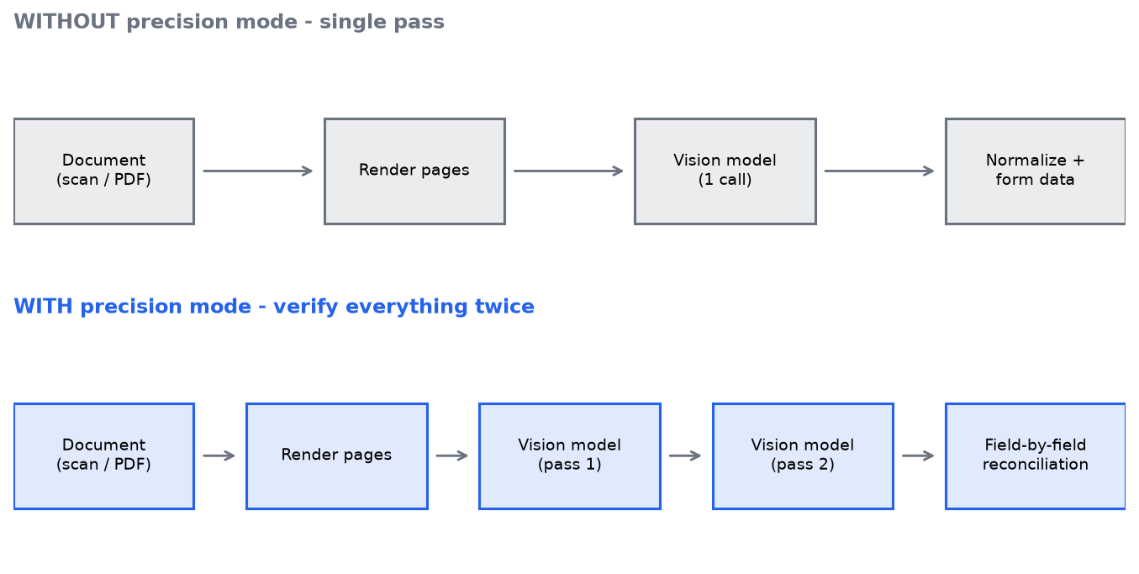
Standard mode makes one model call; precision mode adds an independent second pass plus field-level reconciliation.

The experiment: 17 documents, strict scoring, no cherry-picking
We assembled a corpus of seventeen documents with hand-transcribed ground truth: nine clean scans across four template types, one noisy rotated scan, three multi-page PDFs whose key figures only make sense if you read all pages, and four adversarial inputs we generated to be genuinely hard - a 420-pixel blurry JPEG compressed at quality 22, a faded gray thermal label skewed seven degrees, a bill of lading set entirely in 6.5-point type with an eight-lot manifest table, and a certificate stamped diagonally across the data block.
Scoring is strict where it matters. ID-like fields - shipment, tracking, BOL, PO, seal and UN numbers - must match ground truth exactly after punctuation and case normalization. A tracking number that's off by one digit scores zero, because that's exactly how it fails in the real world. Both modes ran on all seventeen documents against the production vision endpoint.
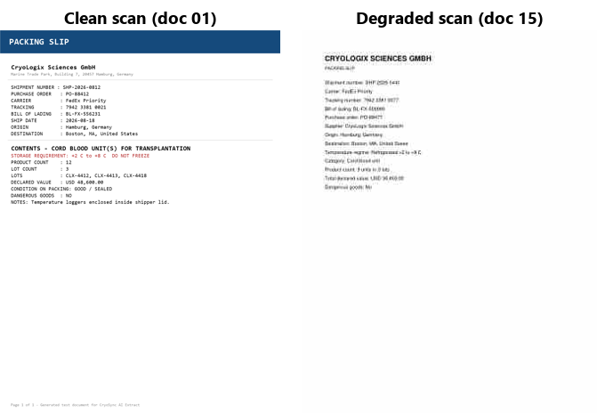
Same layout, wildly different difficulty. The right image is a real 420px, quality-22 JPEG - the kind of photo that arrives over WhatsApp.

Headline results
Metric | Standard (without precision) | Precision (with verification)
Mean field accuracy | 94% | 94%
Mean latency per document | 9.6s | 17.0s
Model calls per document | 1 | 2
Evidence quotes verified verbatim | 35/35 | 35/35
Amendment conflict resolved | yes | yes

On this corpus, precision mode scored the same 94% accuracy as standard mode's 94% - while taking 1.8x longer. That is the finding, and it deserves unpacking rather than a spin.
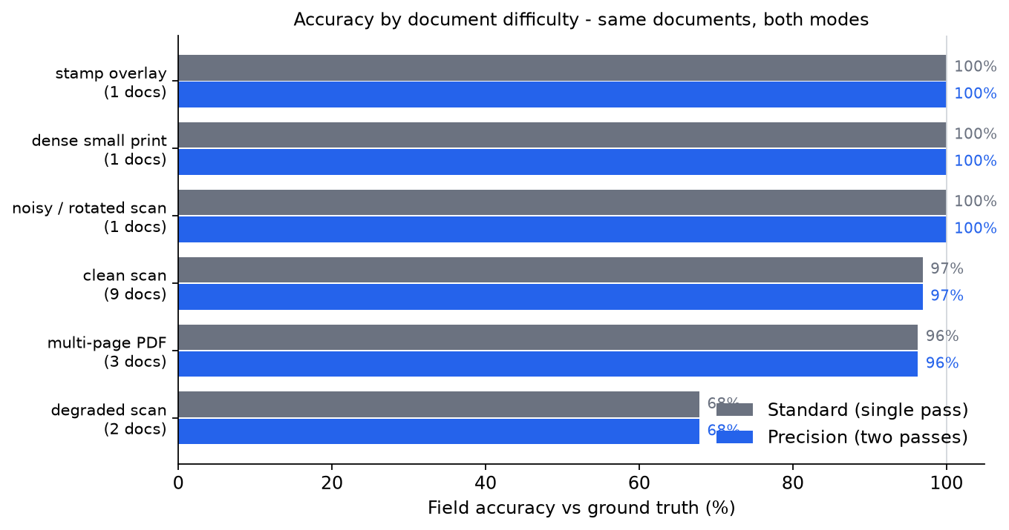
Both modes are perfect on readable documents and fail together on the unreadable one. Difficulty, not mode, drives accuracy here.

Where both modes shine - and where they break
On the twelve readable documents - clean scans, the noisy rotated scan, dense small print, the stamped certificate, multi-page PDFs - both modes scored 89-100%, and most hit 100%. The dense 6.5-point bill of lading with its eight-lot table extracted perfectly, including totals that only exist by aggregating page 2. The diagonal RECEIVED stamp crossing the data block didn't cost a single field. Modern vision models are very good at exactly the things humans find tedious.
The failure mode is different: the genuinely unreadable document. On the 420-pixel blurry JPEG, standard mode scored 36% and precision mode 36%. A human squinting at the same image would struggle too - and crucially, the second pass can't rescue information the pixels don't contain. Verification fixes reasoning mistakes, not physics.
Across the whole corpus we logged 13 missed fields in standard mode. The most instructive ones:
Field | Doc | Ground truth | Extracted
carrier | 06 | Cryoport | (null)
notes | 07 | crushed | Driver signature obtained with damage remark. Photos taken by receiving clerk. Inner packs appear intact, QA inspection due.
billOfLading | 08 | BOL-XPO-77120 | BOL-XP-77120
destination | 13 | Boston MA, USA | (null)
shipmentNumber | 15 | SHP-2026-1441 | SHP 020 1431
trackingNumber | 15 | 7942 3381 0077 | 7672 5331 3077

Notice what these misses have in common: the model usually returned something plausible rather than garbage, or skipped a field printed in small type. This is the error profile you inherit when you automate document intake - and why confidence scores and review flags matter more than raw accuracy.

So is precision mode pointless?
On this corpus, its verification pass changed no scored value - every disagreement was already correct in the first pass, or wrong in both. But raw accuracy is the wrong lens for three reasons:
- It measures trust, not just truth: the corrections counter, merged confidences and review flags give the operator a measured, per-document trust signal instead of a guess. Our UI shows every extraction's own telemetry: model time, evidence quotes verified against the document's text layer, which page each field came from, and how many corrections the second pass made.
- Failure detection is the product: on documents where the first pass is shaky - unusual layouts, marginal scan quality - two independent reads disagree precisely on the fields a human should check. The flag arrives with the data, not after a complaint.
- Determinism under conflict: in our amendment-conflict test (page 1 declares USD 48,600; page 3 supersedes with USD 51,200 and a new seal number), both modes resolved the conflict correctly - but the reconciliation layer is where such cross-page logic is enforced deterministically rather than hoped for.
Our rule of thumb after measuring: run standard mode by default, and precision mode when the document class is new, the scan quality is questionable, or the shipment is high-value enough that 7 extra seconds are noise against the cost of a wrong seal number.

Latency and calibration
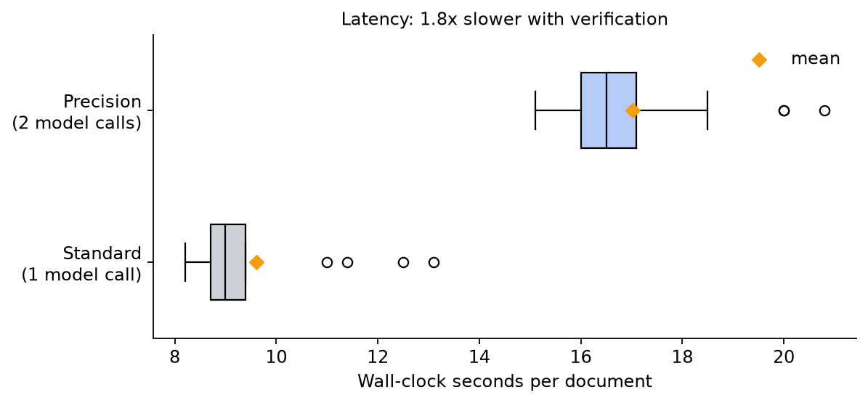
Per-document wall-clock across the corpus. Means: 9.6s vs 17.0s (1.8x).
We also checked whether the model's stated confidence means anything. Across 182 ground-truthed fields, values the model rated at 0.9+ confidence were 96% actually correct. Notably, the model almost never emits mid-range confidence - it commits. That makes the rare low-confidence flag a strong review signal.
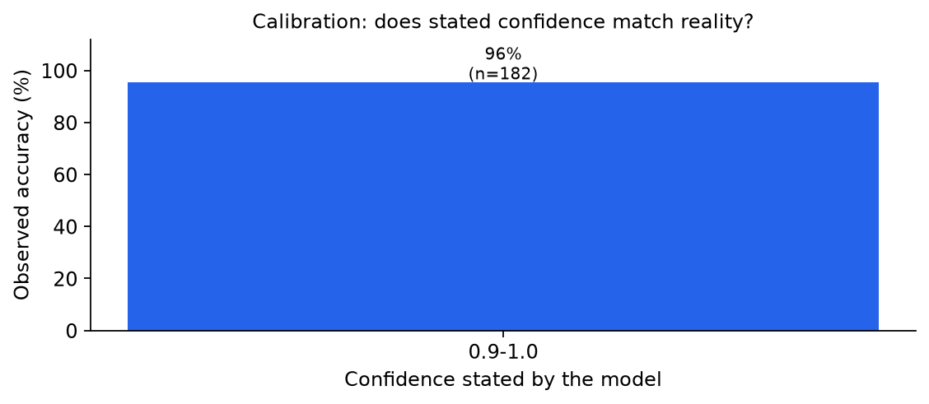
Stated confidence vs observed correctness, bucketed.
One more traceability check: every extracted value ships with an evidence quote. For the generated PDFs we verified all 35 of 35 quotes appear verbatim in the document's own text layer - the model quotes the source rather than paraphrasing it.

Takeaways
- Modern vision extraction is startlingly good on readable documents - including stamps, skew, tiny type and multi-page aggregation.
- Accuracy lives and dies on image quality. No amount of verification recovers information that isn't in the pixels.
- A second pass bought no scored accuracy here but buys measurable trust: corrections, merged confidence, review flags, per-document telemetry.
- Ship both behind one flag and route by risk - cheap and fast normally, verify-twice when it matters.

Reproduce it
Corpus generation, evaluator and blog builder all live in the repo:
python backend/generate_samples.py # sample documents
python backend/evaluate_extract.py # live evaluation -> docs/
python backend/make_blog_docx.py # this document

Endpoint: Databricks Model Serving vision endpoints inside your own workspace; documents never leave the tenant. All timings measured on the production configuration during the run date above - expect variance with model version and load.

