REQUIREMENTS SPECIFICATION

Student Management System

DOCUMENT CHANGE RECORD FORM
Day | Version | Describe | Author
20/8/2026 | 1.0 | REQUIREMENTS SPECIFICATION | Member 1

1.System Overview
1.1 Purpose
The Student Management System is designed to assist schools and administrators in managing student information in a centralized, accurate, and convenient manner.
The system enables users with student management privileges to perform comprehensive student data administration tasks, including:
+View student list: The system displays the complete list of students currently in the database, showing basic details such as student ID, full name, date of birth, gender, email, phone number, address, and class code. The list supports pagination, sorting by various criteria (student ID, name, class), and data filtering to facilitate easy monitoring.
+ Add student: Allows users to input new student information via an entry form. The system validates the data (checking formats for email, phone number, and date of birth; ensuring unique student IDs; and verifying that mandatory fields are not left blank) before saving it to the database.
+ Update student information: Users can edit the details of existing students. The system displays current data, allows editing of individual fields, and performs validation checks before updating the database.
+ Delete student: Allows a student to be removed from the system based on their student ID. A confirmation dialog appears before deletion to prevent accidental actions; upon confirmation, the student's data is removed from the database.
+ Search for students: The system supports searching by various criteria, such as student ID, full name, email, phone number, or class code. Search results are displayed as a list, and multiple filter conditions can be combined.
+ Validate student information: Before adding or updating records, the system verifies all input data to ensure accuracy and consistency, including format checks, data constraint verification, and duplicate checks. Student information storage: All valid data—whether added or updated—is permanently stored in the database, ensuring data integrity and retrievability throughout the system's operation.
+ Operation result notifications: Upon the execution of any function (add, edit, delete, or search), the system must provide a clear notification to the user; this includes success messages or error alerts specifying the cause, thereby facilitating easy resolution by the user.
1.2. System scope
The Student Management System focuses on managing student information.
Key scope
numerical order | Function | Describe
1 | View student list | Display the list of students
2 | Add student | Add new students to the system
3 | Update student information | Update student information
4 | Delete student | Remove student from the system
5 | Search for students | Search for students by ID, name, or class.
6 | Validate student information | Check data before saving
7 | Operation result notifications | Success/failure notification

Beyond the scope of this module
The following functions may belong to other members/modules:
- Subject management.
- Class management.
- Grade management.
- Tuition management.
- Account management.
- Advanced statistical reporting.
1.3. Target users
Administrator / Staff
Person authorized to manage student information.
Can:
- View the list.
- Add students.
- Edit students.
- Delete students.
- Search for students.
Student
- Students may access other system functions, subject to the scope of the entire system.
- Within the student management module, a student does not have the authority to directly add, edit, or delete data belonging to other students.
1.4. System Objectives
The system aims to achieve the following objectives:
- Reduce reliance on paper-based or fragmented file-based student management.
- Minimize data redundancy.
- Support quick search capabilities.
- Ensure the accuracy of student data.
- Provide a user-friendly interface.
- Allow for future expansion to include modules for managing grades, courses, and classes.
2. REQUIREMENTS SPECIFICATION

2.1. FUNCTIONAL REQUIREMENTS

FR-01 – View student list
The system must allow the administrator to view the list of students.
Minimum information to be displayed:
- Student ID.
- Full name.
- Date of birth.
- Gender.
- Email.
- Phone number.
- Address.
- Class code.
The list must support pagination if the number of students is large.

FR-02 – Add Student
The system must allow the administrator to add a new student.
Process:
- The administrator selects the "Add Student" function.
- The system displays an information entry form.
- The administrator enters the information.
- The system validates the data.
- The system checks whether the student ID already exists.
- If the data is valid, the system saves the student record.
- The system notifies the user of the successful addition.

If the data is invalid:
- The data is not saved.
- An error message is displayed.
- The administrator is allowed to correct the information.

FR-03 – Update Student
The system must allow the administrator to update student information.
Process:
- The administrator selects a student.
- The system displays the current information.
- The administrator makes edits.
- The administrator selects "Update".
- The system validates the data.
- The system updates the data.
- The system notifies the user of the result.
If the data is invalid, the system must not perform the update.

FR-04 – Delete Student
The system must allow the administrator to delete a student.

- Process:
- The administrator selects a student.
- Selects "Delete".
- The system displays a confirmation dialog.
- The administrator confirms.
- The system verifies the student's existence.
- The system deletes the student.
- The system reports the result.
If the administrator selects "Cancel", the data remains unchanged.

FR-05 – Student Search
The system must allow searching for students.

Search criteria:
- Student ID.
- Full name.
- Email.
- Phone number.
- Class ID.

Example:
The administrator enters:
SV001
The system returns the student with the ID:
SV001
Partial name searches are supported.
Example:
Nguyễn
The system returns all students whose names contain the keyword "Nguyễn".

FR-06 – Validation Check
Before saving data, the system must verify the following:
Student ID
- Must not be empty.
- Must be unique.
- Must follow the prescribed format.
Full Name
- Must not be empty.
- Must not contain numeric characters.
- Length must be between 2 and 100 characters.
Email
- Must not be empty.
- Must follow the correct email format.

Example:
student@gmail.com
Phone Number
Must not be empty.
Must contain only digits.
Must consist of 10 digits.
Date of Birth
Must not be empty.
Must not be later than the current date.
Class Code
Must not be empty.
Must exist in the list of valid classes.

FR-07 – Manage Classes
The system must allow the administrator to manage class information.
- The administrator must be able to:
- View the list of classes.
- Add a new class.
- Update existing class information.
- Delete a class.
- Search for classes by class code or class name.
- Process:
- The administrator selects the "Class Management" function.
- The system displays the list of existing classes.
- The administrator can select the Add, Update, Delete, or Search function.
- Add Class:
- The administrator enters the class information.
- The system validates the required data.
- The system checks whether the class code already exists.
- If the data is valid, the system saves the new class information.
- The system notifies the user of the successful operation.

- If the data is invalid:
  - The data is not saved.
  - An error message is displayed.
  - The administrator is allowed to correct the information.
  - Delete Class:
  - The administrator selects a class.
  - The system displays a confirmation dialog.
  - The administrator confirms the deletion.
  - The system verifies whether the class exists.
  - If the class can be deleted, the system removes the class information.
  - The system reports the result.
FR-08 – Manage Courses
The system must allow the administrator to manage course information.
- The administrator must be able to:
  - View the list of courses.
  - Add a new course.
  - Update course information.
  - Delete a course.
  - Search for courses by course ID or course name.

- Process:
  - The administrator selects the "Course Management" function.
  - The system displays the list of existing courses.
  - The administrator can select the Add, Update, Delete, or Search function.

- Add Course:
  - The administrator enters the course information.
  - The system validates the required data.
  - The system checks whether the course ID already exists.
  - If the data is valid, the system saves the new course information.
  - The system notifies the user of the successful operation.

- If the data is invalid:
  - The data is not saved.
  - An error message is displayed.
  - The administrator is allowed to correct the information.

- Update Course:
  - The administrator selects a course.
  - The system displays the current course information.
  - The administrator makes changes.
  - The system validates the updated data.
  - If the data is valid, the system updates the course information.
  - The system notifies the user of the result.
FR-09 – Manage Student Enrollment
The system must allow the administrator to manage student enrollment in courses.

- The administrator must be able to:
  - View student enrollment information.
  - Enroll a student in a course.
  - Update enrollment information when applicable.
  - Cancel or remove a student's enrollment.
  - Search for enrollment records by student ID or course ID.

- Enrollment Process:
  - The administrator selects the "Student Enrollment Management" function.
  - The administrator selects a student.
  - The administrator selects a course.
  - The system verifies whether the student exists.
  - The system verifies whether the course exists.
  - The system checks whether the student has already enrolled in the selected course.
  - If the enrollment information is valid, the system saves the enrollment record.
  - The system notifies the user of the successful enrollment.

- If the enrollment is invalid:
  - The enrollment record is not saved.
  - An error message is displayed.

- Cancel Enrollment:
  - The administrator selects an enrollment record.
  - The administrator selects "Cancel Enrollment".
  - The system displays a confirmation dialog.
  - The administrator confirms the operation.
  - The system removes the enrollment record.
  - The system reports the result.
FR-10 – Manage Grades
The system must allow authorized users to manage student grades.

- The authorized user must be able to:
  - View student grades.
  - Add a new grade.
  - Update an existing grade.
  - Search for grades by student ID or course ID.

- Process:
  - The authorized user selects the "Grade Management" function.
  - The system displays the relevant student and course information.
  - The authorized user enters or updates the grade.
  - The system validates the grade data.
  - The system verifies whether the student is enrolled in the selected course.
  - If the data is valid, the system saves or updates the grade.
  - The system notifies the user of the result.

- Grade Validation:
  - Before saving grade information, the system must verify:
  - The student ID must exist.
  - The course ID must exist.
  - The student must be enrolled in the selected course.
  - The grade must not be empty.
  - The grade must be within the valid range defined by the system.

- If the grade information is invalid:
  - The data is not saved.
  - An appropriate error message is displayed.
  - The authorized user is allowed to correct the information.

FR-11 – Generate Reports and Statistics
The system must allow authorized users to generate reports and statistical information based on the data stored in the system.

- The system must support reports and statistics related to:
  - The total number of students.
  - The number of students in each class.
  - Student enrollment information.
  - The number of students enrolled in each course.
  - Student grade information.
  - Academic performance statistics.

- Process:
  - The authorized user selects the "Reports and Statistics" function.
  - The system displays the available report and statistical options.
  - The user selects the desired report type.
  - The user may select filtering conditions when applicable.
  - The system retrieves the relevant data from the database.
  - The system processes and summarizes the data.
  - The system displays the report or statistical results.

- The user must be able to:
- View reports on the system interface.
- Search or filter report data based on available criteria.
- Generate statistical summaries based on the selected data.

- If no data is found:
- The system displays a clear notification indicating that no matching data is available.
2.2. NON-FUNCTIONAL REQUIREMENTS

NFR-01 – Usability
NFR-01.1 – Learnability
New users can perform the "add student" operation after a maximum of 5 minutes of instruction.

NFR-01.2 – Ease of use
Each primary function—Add, Edit, Delete, and Search—must be placed in a clearly visible location on the interface.

NFR-01.3 – Error Messages
When data is invalid, the system must display a specific message.
Do not use generic messages such as:
Example:
"An error occurred."
Instead, use:
"Student ID SV001 already exists."
or:
"Invalid email format."

NFR-01.4 – Operation Time
Users can complete the standard student addition operation in no more than 2 minutes, excluding data entry time.

NFR-02 – Reliability
NFR-02.1 – Operational Rate
The system must achieve a minimum availability of:
99.5% during monthly operational hours.

NFR-02.2 – No data loss
If an add, update, or delete operation fails:
The original data must remain unchanged.
Partial data cannot be saved.

NFR-02.3 – Data integrity
Student IDs must be unique.
Two students cannot share the same student ID.

NFR-02.4 – Error Handling
If a database error occurs during an update:
- The system must report the error.
- Incomplete data must not be updated.
- The user must be allowed to retry the operation.

NFR-03 – Performance
NFR-03.1 – Search
With a database containing up to 100,000 students, standard search operations must return results within:
≤ 2 seconds for at least 95% of requests.

NFR-03.2 – Add Student
Time to complete the add operation:
≤ 2 seconds for at least 95% of requests.

NFR-03.3 – Update
Update time:
≤ 2 seconds for at least 95% of requests.

NFR-03.4 – Delete
Deletion time:
≤ 2 seconds for at least 95% of requests.

NFR-04 – Security
NFR-04.1
Only accounts with student management privileges are permitted to:
- Add.
- Edit.
- Delete.

NFR-04.2
Users without administrative privileges must not directly access student management APIs or functions.

NFR-04.3
The system must use parameterized queries to prevent SQL injection.

NFR-04.4
User input must be validated on the server side.

NFR-04.5
Technical information—such as SQL queries, database passwords, or stack traces—must not be displayed to end-users when an error occurs.

NFR-05 – Maintainability
The student management module must be divided into the following components:
- Student Model/Entity.
- Student Repository/DAO.
- Student Service.
- Student Controller.
- Student UI.
The components must have distinct responsibilities to facilitate maintainability.

NFR-06 – Compatibility
The system must operate stably within the deployment environment selected by the team (e.g., C++, Python, or Java).
3. DATA FLOW DIAGRAM – DFD
3.1. Conventions
DFD utilizes the following components:
External Entity: external agent.
Process: processing step.
Data Store: data storage location.
Data Flow: flow of data.

Context Diagram.
Level 0.
Level 1.
Level 2.
This approach exceeds minimum requirements and helps developers clearly understand the processing flow.
3.2. DFD CONTEXT DIAGRAM
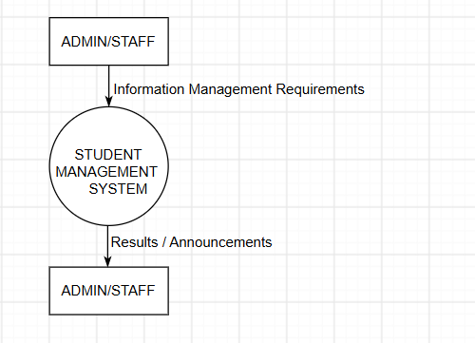

- External Entity: ADMIN/STAFF — Administrative users or staff members interacting with the system.

- Process:
- STUDENT MANAGEMENT SYSTEM: The overarching process representing the entire student management system.

- Data Store: None at the context diagram level.

- Data Flow:
- Information Management Requirements: Input data sent from Admin/Staff to the system (information management requests).
- Results / Announcements: Output data from the system sent back to Admin/Staff (results, notifications).

3.3. DFD LEVEL 0
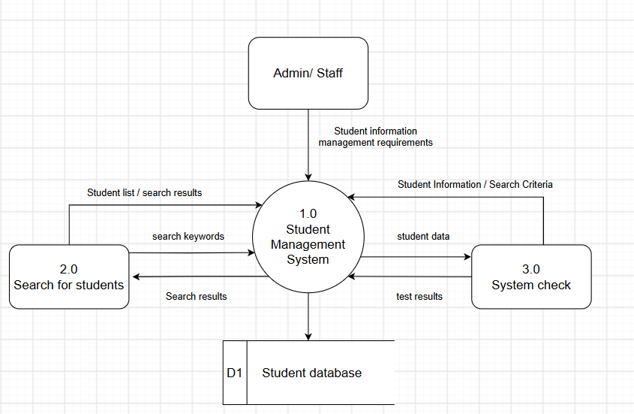

- Processes:
  - Student Management System: Central process handling general management functions.
  - 2.0 Search for students: Process that accepts keywords and returns student search results.
  - 3.0 System check: Process that checks the system/student data.

- Data Store:
  - D1 Student database: Repository for the entire student database.

- Data Flows:
  - Student information management requirements: Sent from Admin/Staff to process 1.0.
  - Search keywords: Sent from process 2.0 to 1.0.
  - Student list / search results: Sent from 2.0 to 1.0.
  - Search results: Sent from 1.0 to 2.0 (data query results).
  - Student data: Transferred from 1.0 to 3.0 for verification.
  - Student Information / Search Criteria: Information/search criteria returned from 3.0 to 1.0.
  - Test results: Verification results sent from 3.0 to 1.0.
  - Arrow from 1.0 to D1 Student database: System writes/stores data to the repository.

3.4. DFD LEVEL 1
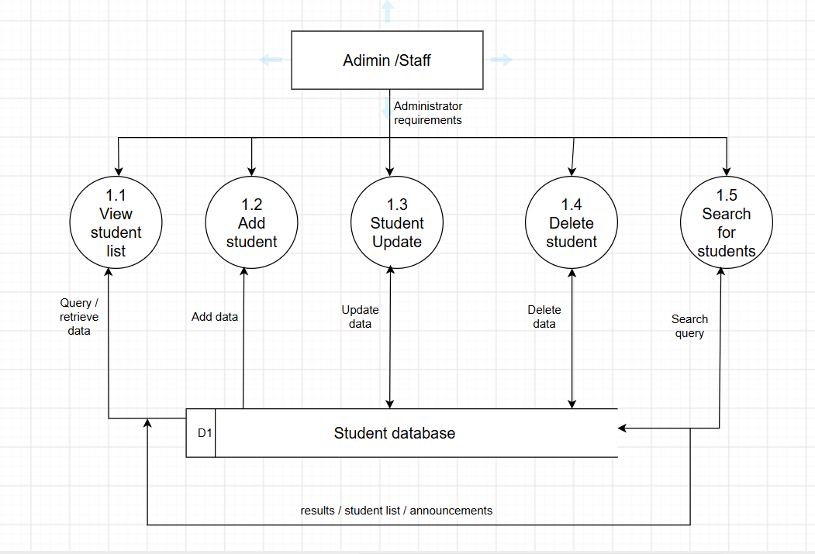

- Processes:
  - View student list: View the list of students.
  - Add student: Add a new student.
  - Student Update: Update student information.
  - Delete student: Delete student data.
  - Search for students: Search for students.

- Data Store:
  - D1 Student database: Student data repository shared by all functions.

- Data Flows:
  - Administrator requirements: Request flow from Admin/Staff branching to the 5 processing functions (1.1 to 1.5).
  - Query / retrieve data: Bidirectional flow/data query between 1.1 and the D1 Student database.
  - Add data: Push new data from 1.2 into the D1 Student database.
  - Update data: Bidirectional interaction flow for updating data between 1.3 and the D1 Student database.
  - Delete data: Bidirectional interaction flow for deleting data between 1.4 and the D1 Student database.
  - Search query: Search query flow sent from 1.5 to the D1 Student database.
  - results / student list / announcements: General response data flow returning results from the D1 database to the user/system.

3.5. DFD LEVEL 2
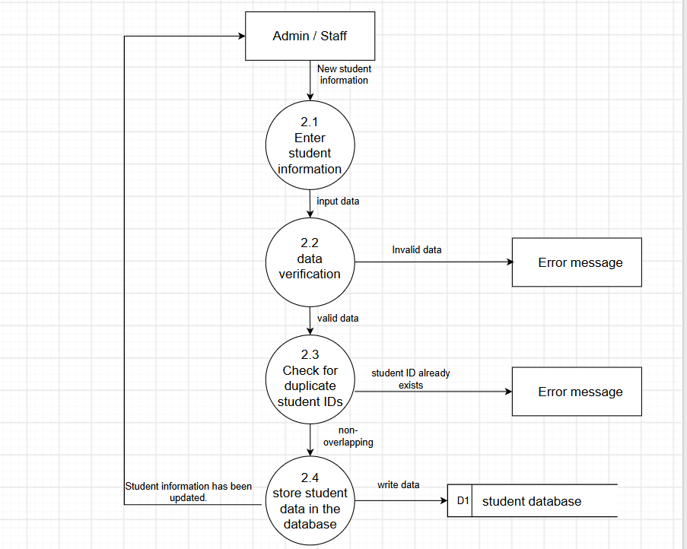

- External Entities:
  - Admin / Staff: Administrative user or staff member entering information.
  - Error message: Error notification issued by the system/interface to the user when data is invalid or duplicated.

- Processes:
  - 2.1 Enter student information: Inputting new student information provided by the user.
  - 2.2 Data verification: Checking/validating the input data (format, mandatory fields, etc.).
  - 2.3 Check for duplicate student IDs: Checking for duplicate Student IDs.
  - 2.4 Store student data in the database: Saving the verified student information into the database.

- Data Store:
  - D1 Student database: Database storing all student information.

- Data Flows:
  - New student information: Data flow of new student information entered by Admin/Staff and sent to process 2.1.
  - Input data: Data transferred from 2.1 to the validation process 2.2 after entry.
  - Invalid data: Notification flow regarding invalid data sent from 2.2 to Error message.
  - Valid data: Validated data transferred from 2.2 to the duplicate check process 2.3.
  - Student ID already exists: Notification flow indicating the Student ID already exists, sent from 2.3 to Error message.
  - Non-overlapping: Student data with no ID conflict (fully valid) transferred from 2.3 to the storage process 2.4.
  - Write data: Data write flow from process 2.4 to the D1 student database.
  - Student information has been updated: Notification flow confirming successful storage, sent from 2.4 back to the Admin/Staff.

