MyCAT In Action

Sharding Strategy
MyCAT supports horizontal sharding and vertical sharding:
- Horizontal Sharding: The data of a table is splitted up into many nodes by row
- Vertical Sharding: There are many tables in a database, such as A,B,C. And A is storaged in the first node, B is storaged in the secord node and C is storaged in the third node.
MyCAT implements sharding through defined sharing rule of tables. Every table can bing a sharding rule. Every rule indicates a sharding field and bings a function to implement dynamic sharding algorithm. Take the sharding function org.MyCAT.route.function.PartionByFileMap for example , which bases on integer mapping and is offen used , this function through a configuration file to determined the mapping relation. Take the following sharding-by-intfile sharding rule for example:

<tableRule name="sharding-by-intfile">
<rule>
<columns>sharding_id</columns>
<algorithm>hash-int</algorithm>
</rule>
</tableRule>
<tableRule name="auto-sharding-long">
<rule>
<columns>id</columns>
<algorithm>rang-long</algorithm>
</rule>
</tableRule>
<function name="hash-int" class="org.MyCAT.route.function.PartitionByFileMap">
<property name="mapFile">partition-hash-int.txt</property>
</function>
<function name="rang-long" class="org.MyCAT.route.function.AutoPartitionByLong">
<property name="mapFile">autopartition-long.txt</property>
</function>
The content of partition-hash-int.txt file as follow：
10000=0
10010=1
It means that when sharding_id field is set equal to 10000, MyCAT will return the sharding node which ID is zero, and so on.
The sharding rule of customer table is the same principle as above in Schema.xml:
<table name="customer" dataNode="dn1,dn2" rule="sharding-by-intfile" />
So the horizontal sharding of customer table is on sharding_id field, and the sharding are storaged in two data nodes (dn1 and dn2).
How to konw a SQL was executed in which sharding? Using explain SQL statement:
explain select * from customer where sharding_id=10000
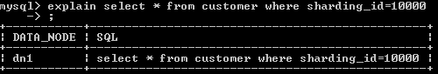
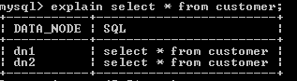

Base on your business scenario and data characteristic,you can use the following sharding rules:
- auto-sharding-long: Primary key is auto-increment number, and auto-sharding by range. Such the data will be storaged in zeroth sharding node which is between 0 to 2,000,000, in first sharding node which between 2,000,001 to 4,000,000, and so on. Base on the performance of database server, every sharding can be storaged between 100 to 500 of records. And using this way, every sharding table have a independent mechanismof ID auto-increementing to ensure records continuity.
- There is a sharding_id field in the table and its type is integer. The value of sharding_id corresponds a specific bussiness meaning. Such as 10000 corresponds China Telecom ,10010 corresponds China Unicon. In addition, it is a feasible way to define the value of sharding_id by encoding provinces.Encoding provinces to integer rather than string for efficiency. The file conf/partition-hash-int.txt defines the mapping relationship that which integer corresponds which sharding id.
- mod-long: If We rarely use rang query and only use a field(most likely primary key) to find location for some tables, we can use remainders way to randomly assigned a record into one node.
All of sharding rules are defined in rule.xml. Different tables can be defined different sharding rules depending on the requirement.
For some tables which are non-sharding or same sharding rule, you can use a simplify way to define table rule like :<table name="customer,product" rule="auto-sharding-long" />. For this way, tables which are defined in the name have the same attributes and can’t have childTable element.

Base on E-R Relationshio Sharding Strategy

Traditional database sharding way are based on single table. For table association, this way would be diffcult to handle. Consider the following sharding model , Customer and Orders are sharded in different nodes, parent_id field of Orders stores primary key of parent table Customer
Dn1(customer)
Id:1
Id:2
Dn2(customer)
Id:3
Id:4
Dn3(customer)
Id:5
Id:6
Dn1(orders)
Parent_id:1
Parent_id:3
Dn2(orders)
Parent_Id:2
Parent_id :5
customer
orders

Dn3(orders)
Parent_id :1
Parent_id:3
Parent_id:5

In order to execute the union query of Customer and Orders, the data of sharding table must be tranfed on the netword by spanning nodes. In the example above:
- When Order table on the DN1 node execute JOIN, it needs DN1 and DN2 nodes.
- When Order table on the DN2 node execute JOIN, it needs DN1 and DN3 nodes.
- When Order table on the DN3 node execute JOIN, it needs DN1, DN2 and DN3 nodes.
There is not a good method about resolving the current JOIN approach in the industry. It is complex to implement, and the performance of the ways cannot meet the requirements of enterprise application development.

MyCAT leverage the design considerations of rookie Fundation DB in NewSQL field. Foundation DB innovatively propose the concept of Table Group. Storage location of the child tables depend on its primary tables in Fundation DB. The storage location of child tables next to primary tables in physical, so Funddation DB completely resolves the efficiency and performance issues. On the basis of this idea, the author of MyCAT propose the data sharding strategy which bases on E-R relationships, the child table records and its associated parent table records are stored in the same data sharding.
In the example above, schema.xml defines the sharding configurations following:
<table name="customer" dataNode="dn1,dn2" rule="sharding-by-intfile">
<childTable name="orders" joinKey="customer_id" parentKey="id"/>
</table>
Customer adopt sharding-by-intfile sharding strategy, sharding in dn1 and dn2 nodes. Orders depend on parent table to sharding. Thee relationships between Customer and Orders is Orders.customer_id = Customer.id. So data sharding and store as follow:
Dn1(customer)
Id:1
Id:2
Dn2(customer)
Id:3
Id:4
Dn1(orders)
Parent_id:1
Parent_id:2
Dn2(orders)
Parent_Id:3
Parent_id :4
customer
orders

That way, Customer sharding in Dn1 and Orders sharding in Dn1 can execute part JOIN union, so do in Dn2. Then merge the data of two data nodes for finishing overall JOIN. Think of all the fun, in every sharding there is one million records in Orders tables, so ten million for 10 sharding. The data sharding pattern bases on E-R mapping basically solves the problem which more than 80% enterprise application.
How to deal with many-to-many tables? There is some cases as follow for many-to-many tables generally：
- Primary table + relationship table + dictionary table
- Primary table + relationship table + primary table B
For the first case, dictionary table can be defined as “global table”, and its records size ranged from thousands to hundreds of thousands. Dictionary table change less basically and real-time synchronized to all the sharding by MyCAT automatically. So the three tables can be executed JOIN operation.
For the second case, we should konw that relationship table prefer to which primary table from a business view. That’s “relationship of A” or “relationship of B” to determine the relationship table stored following A or B. At present we does not support the three table union in this pattern temporarily. We will consider the bi-directional replication of the midle table in the future version to complement the bi-directional union query between A-relationship table and B-relationship.
About the implementation of global table, When inserting or updating the global, MyCAT will automatically executes the same operation in all data nodes defined in the global table to guarantee the consistent between all data nodes. Because of this features, global table can be executed JOIN operation with any table no matter sharding table or non-sharding table. Table that update data infrequently and is not larger in scale(within million ) can be defined as global to achieve the goals which trading storage for performance.
Primary Key Sharding VS Non-Primary Key Sharding
It’s not difficult for using primary key sharding or non-primary key sharding. When you haven’t any field as sharding field, primary key sharding is your only option. The fastest query on primary key is its advantage. When you use auto-incrementing serial number as primary key, the data can be sharded in different nodes more equably.
If there is a fit business field fit for being a sharding field, we support you to use this bussiness field to sharding. The conditions follow for choose a sharding field:
- As even as possible distributing all of the data into every nodes.
- This business field is the most frequent and important query condition.
Excepting primary key, the common sharding fields are that order creation time, shop type, shop province and so on. When you find a fit business field as shardind field, you don’t have to go through losing the query performance on primary key. Because in this case, MyCAT provices the memory cache mechanism from primary key to sharding. The hot data will be query by primary key, and the performance hasn’t suffered. By doing this:

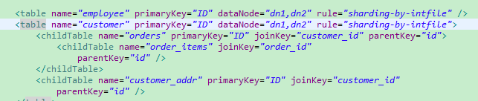
For non-primary key table, Using the properties primaryKey, at the moment MyCAT will analyze the SQL statement result which first executed by primary key to confirm a primary key of this table is on which sharding. And caching primary key to sharing ID. Take the following SQL statement as an example, because id is not the sharding field for orders, this SQL statement will be send to all of the shardings executing:
select * from orders where id=1;
After executed the SQL statement:
MyCAT puts a message into cache TableID2DataNodeCache.TESTDB_ORDERS that primary key as key and sharding ID as value. When we execute SQL statement above again, MyCAT will send the SQL to dn2.
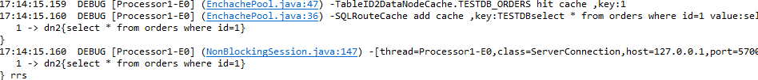
For multi-primary key query, MyCAT also can automatic optimize. Such as the statement--Select * from orders where id in(1,2,3), MyCAT will store respectively the relationship into the cache from 1,2,3 primary keys to sharding.
Imagining that, there is fifty million records in every table, hot data ten percent of the records is offen query by primary key. Then 50,000,000 * 10% = 5,000,000 , it’s need about 1.5G memory space for caching those message. We can tuned this memory the most precise by analyzing the using information of the cache. Executing the command -- show @@cache, it can shows use cases of current cache by analyzing the managemeng port 9066 of MyCAT.
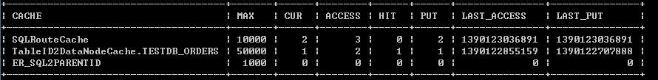
For more content, you can reference MyCAT Performance Tuning Handbook.

