Thatcher Lane

Feb 6, 2018

CS 372

Assignment 1

A.

<https://github.com/thatcherlane/testRepo.git>

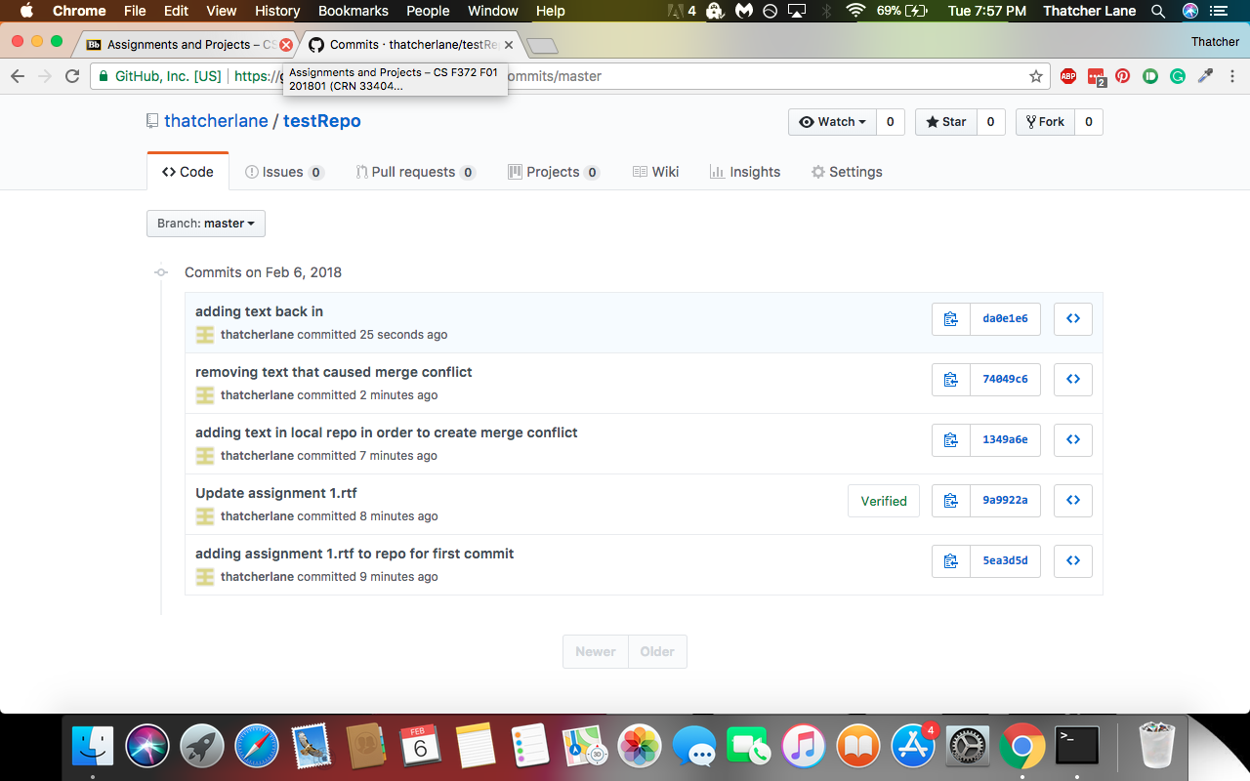

I created a text file in the local repo. After this I created a merge conflict using the Git web interface. I then added text to the local repo and committed, causing a merge conflict. I then un staged the commit, manually removed the text in the local repo that was causing the conflict, and then pulled from the repo. After this I added back in the text that I desired, committed the changes and pushed them to the repo.

B. N/A

C.

Command: git status

Action: the status command returns the current working branch and the current state of the repository. If there are no changes it will return “nothing to commit, working directory clean”

Command: git branch

Action: this command is used to either check which branch the repository is currently on, create a new branch, or delete an existing branch.

Command: git rm

Action: rm is used to delete files from the directory, there are two options. The first is to use rm force, which completely deletes the file. The cashed option removes the force from the working index