Week 1 DATA624 Time Series Graphics Exercises

Jonathan Hernandez

January 30, 2019

2.3 Download some monthly Australian retail data from the book website. These represent retail sales in various categories for different Australian   
states, and are stored in a MS-Excel file.  
  
a. You can read the data into R with the following script:  
retaildata <- readxl::read_excel("retail.xlsx", skip=1)

* Reading in the data:

retaildata <- readxl::read_excel("retail.xlsx", skip=1)

b. Select one of the time series as follows (but replace the column name with   
your own chosen column):  
myts <- ts(retaildata[,"A3349873A"],  
 frequency=12, start=c(1982,4))

* Let’s first read the data and see the column names and replace it with a column I choose. I’ll choose say the 10th column.

column_name <- names(retaildata)[10] # 10th column  
myts <- ts(retaildata[,column_name],  
 frequency=12, start=c(1982,4))

c. Explore your chosen retail time series using the following functions:  
autoplot(), ggseasonplot(), ggsubseriesplot(), gglagplot(), ggAcf()  
Can you spot any seasonality, cyclicity and trend? What do you learn about the series?

* Load the ggplot2 library and plot as requested and spot any trends, seasonality and cyclicity.

library(ggplot2)  
library(ggfortify)  
library(forecast)  
  
#autoplot  
autoplot(myts) +   
 ggtitle("Autoplot of Time Series of Retail Data") +  
 xlab("Time") +  
 ylab("Sales")

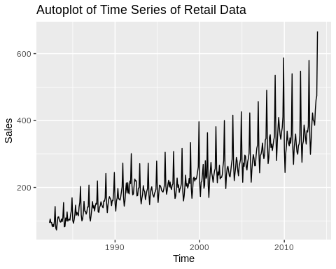

#ggseasonplot  
ggseasonplot(myts, year.labels=TRUE, year.labels.left=TRUE) +  
 ggtitle("Seasonal Plot of Retail Sales")

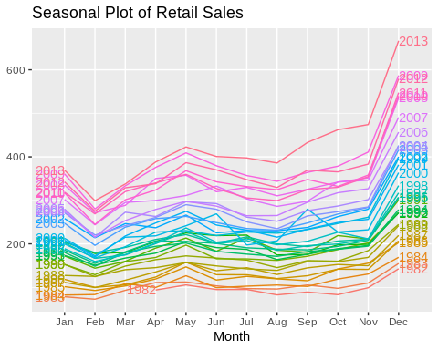

# ggsubseriesplot  
ggsubseriesplot(myts) +   
 ylab("Sales") +  
 xlab("Month") +  
 ggtitle("Seasonal Subseries Plot: Retail Sales in Australia")

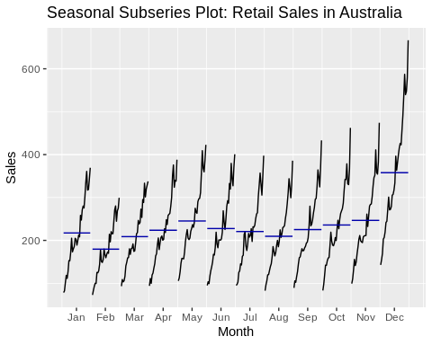

## gglagplot  
retail <- window(myts, start=1982)

## Warning in window.default(x, ...): 'start' value not changed

gglagplot(retail)

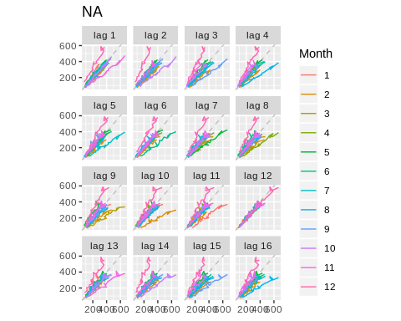

# ggAcf  
ggAcf(retail, lag=50)

