**Project Title:** PlacementConsultancy

**Objective:** To make a system for employer to post job on website, it opens door for job seekers to join and get selected by employers.

**Technology used:**

**Programming Language:**HypertextPreProcessor(PHP) ,Sequential Query Language (SQL)

**Framework :** Codeigniter 3

**DB Server:** mysql

**Paradigms used in Codeigniter:**

**To set database server connectivity**

In application/config/database.php

'hostname' => 'localhost', *set database host*

'username' => 'root', *username of your database*

'password' => ''”, *password entered*

'database' => 'placementconsultancy',

'dbdriver' => 'mysqli',

**To set basepath**

In application/config/config.php

$config['base_url'] = '<http://localhost/PlacementConsultancy>';*set your domain*

**To set helper classes**

In application/config/autoload.php

$autoload['helper'] = array('url','form','date','html');

**To set libraries of Codeigniter used**

In application/config/autoload.php

$autoload['libraries'] = array('session','database');

**To set routes**

In application/config/routes.php

$route['default_controller'] = 'Welcome';

$route['404_override'] = '';

$route['translate_uri_dashes'] = FALSE;

**Implementation:**

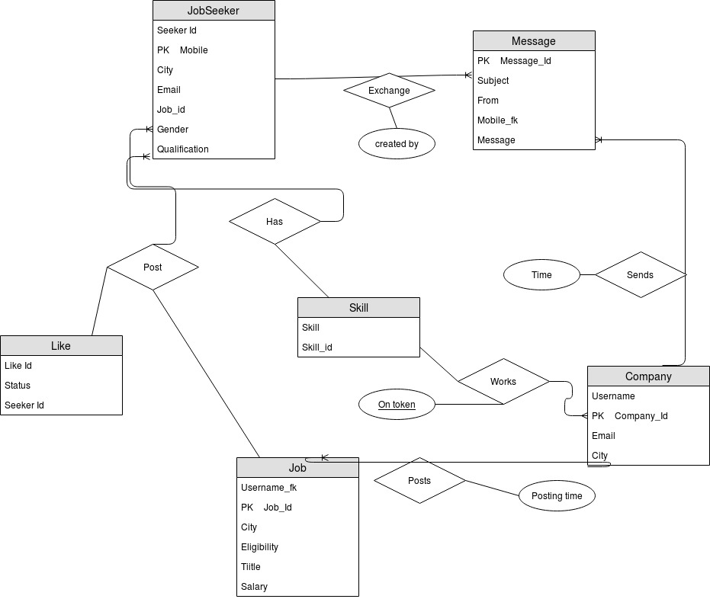

**ER Diagram**

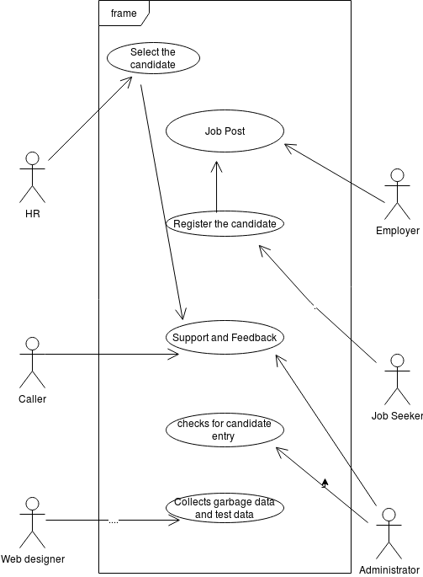

**UseCase Diagram**

**Methodologies:**

**For Employers:**

**Profile -** Employer can store Basic details of their company like Company name, Location and Other information like founded year. These data are used to

**Job Post –** Employer can post their Jobs with information like skills they want, description of

the job, Salary they offer .

**Messages** – The employer can pass message to candidates for recruitement.

**For Job Seeker:**

**Profile-** Job seeker can store their basic information like Name, Location and other information like Date of Birth, Skills, Qualification.

**View Jobs –** The job seeker can view jobs with information shared by the employer.

**Apply Jobs –** The job seeker can apply job after signining in.