Process Book

Data visualisation

The distribution of volumes between cryptocurrencies

EPFL 2017

Natalija Gucevska
Amaury Combes
Kevin Kappel
Table

Project Motivations

The cryptocurrency market is growing exponentially and is attracting more and more people who need some efficient tools to study the markets state.

Some websites (e.g. coinmarketcap.com) already provide some really useful data for analysts but don’t necessarily display them in the most effective way. For example, the exchange volume between any fiat, coins or tokens is shown as an exhaustive list that doesn’t fully take into account our sensorial capabilities. From this observation, we concluded that some nice interactive visualization could make a difference.

In order to improve the existing visualisation we will provide an interactive visualization that displays exchange volumes between cryptocurrencies in form of a graph where the nodes will represent cryptocurrencies and will be connected accordingly to the volume of the exchanges between them.

Target audience:

The exchange volume of cryptocurrencies pairs is an important indicator in technical analysis as it is used to measure the relative worth of a market move. If the markets make a strong price movement, then the strength of that movement depends on the volume for that period. The higher the volume during the price move, the more significant is the move. For this reason, our visualization aims to provide a quick way to analyze a particular aspect of the cryptocurrency market because the exchange volume is a fundamental metric in market understanding and analysis. We will thus provide a more practical tool to people who want to understand and see the evolution of the cryptocurrency market.

Read more: Volume https://www.investopedia.com/terms/v/volume.asp#ixzz4yLZS0MKD

Related work and inspiration

We were inspired by …

The visualization

The visualization will provide a quick way to analyze a particular aspect of the cryptocurrency market. Indeed, the exchange volume of a cryptocurrency is fundamental in the analysis and understanding of the market.
Since these data are not easy to find and analyze, we will provide a visualization that people who want to see and analyse evolution of the cryptocurrencies

Dataset description

The api that we aim to use for our visualisation provides a large list of cryptocurrencies, the actual volume-weighted price, total 24h volume, rate change as well as prices and volumes across all connected exchanges. It contains also the markets information.

The drawback of this dataset is the fact that history is not provided. In order to make the replay and window analysis possible for longer period than 24h we could save this information in our database every hour (or other period of time, which we could determine while experimenting with the visualisation).

The dataset is updated every 30 seconds, which will be the bottleneck for the live stream of our visualisation.

In case we encounter too many problems with the API provided by cryptonator, we will switch to coinmarketcap.com. This website doesn’t have an API for the data we want to get but we will still be able to scrap it through HTML.

Dataset URL

https://www.cryptonator.com/api/
https://coinmarketcap.com

Peer assessment :

We only had one idea so it was easy to agree on it. The understanding of the data were a little bit hard (differences in markets, how a cryptocurrency work, …).

Preparation : were they prepared during team meetings ?

Contrbution : did they contribute productively to the team discussion and work ?
Respect : for others idea ?
Flexibility : were they flexible when disagreements occured ?

Exploratory data analysis:

What visualization have you used to gain insights on the data?

Designs:

What are the different visualizations you considered?
Justify the design decisions you made using the perceptual and design principles.
Did you deviate from your initial proposal?

Implementation:

The first thing we will have to do is to get the data from the api that we have. To do this we implemented a …

From the moment we got our data we could work on the visualization. See how we could represent our data as clearly as possible, how to select them and where to put them on our html page.

Then add features bla bla bla

At the end there are some points that should be done like:

1 - User should be able to visualize exchanges volumes for any cryptocurrencies through some graph visualization.
2 - User should be able to select any set of cryptocurrencies he wants to display
3 - User should be able to select which market he wants to study (e.g. Poloniex, Bitfinex…)
4 -The graph should have smooth transitions between updates.
5 - User should be able to move any nodes he wants around the plan
6 - See other feature that will enter in the scope of this visualisation

Since we'll have access to the history of every cryptocurrency we will provide visual profile for each of them by keeping track of big events such as big price crash.

Our goal is to make these graphs easy to manipulate, simple to understand and up-to-date, i.e. provide live updates.

We have some optional backlog too:

1 - User should be able to visualize exchanges volumes through time by using replay feature.
2 - User should be able to select a time window to see the exchange volumes
3 - User should be able to browse the website on live mode. In this mode, the app displays the latest data at any time.
4 - User should be able to select how fast data is updated when looking at the past. (Streaming speed)
5 - User should be able to group some cryptos into one node

Evaluation :

Put visualization:

A sketch of our initial visualization. Add elements and images during the implementation to see the progress.
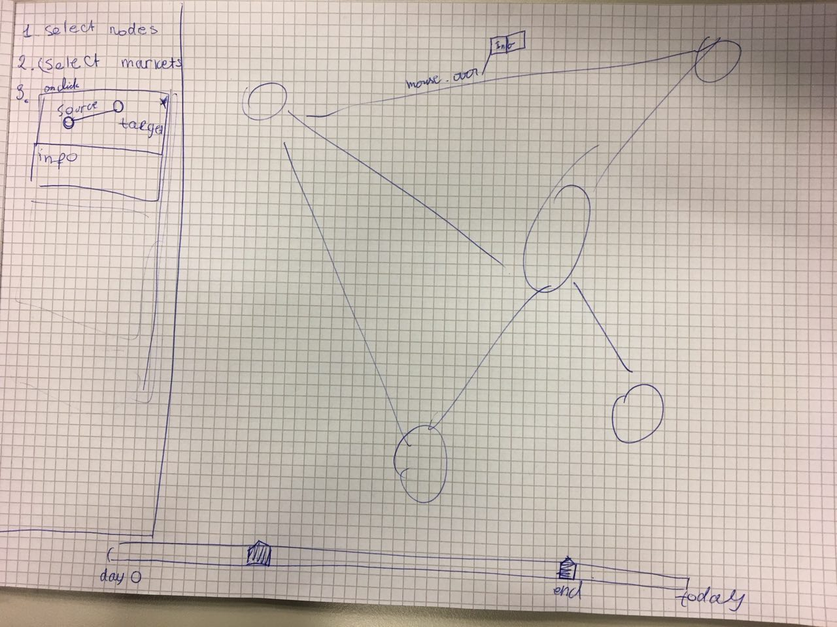

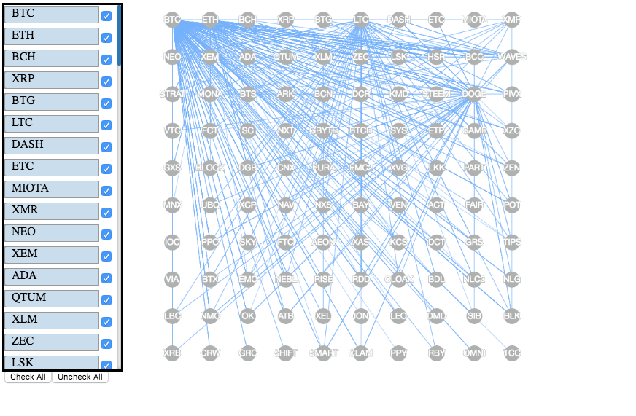

Design worksheet (color sheet)

