THE NEWSLETTER OF THE DELECTABLE MOUNTAIN QUILTERS GUILD
PEAKS & PIECES
January, 2014
Volume 20, Issue 200

PRESIDENT’S NOTE
Here it is 2014 already. Hope your holidays were spent with friends and family. Even though we are so busy, I wonder how many of us still had time to play with our fabric.
I hope you enjoyed our speakers last year. We learned about scrap quilting from Denice Knapp, how to do celtic applique from Tamie Buskirk, how to quilt feathers from Rita Meyerhoff, and an applique technique from Becky Goldsmith. I hope you took at least a little knowledge away from each of them.
I’m looking forward to the upcoming year. We will celebrate the guild’s 20th anniversary with some special events (still to be determined). If you would like to help out with this special committee please contact Tamie Buskirk. She has volunteered to make sure this year is eventful. Tamie will also help us get our raffle quilt off the ground. We still need many hands to help with that. We especially need someone to apply for the raffle license with the state.
Speaking of committees, we will have a sign- up sheet at the next meeting to fill in those blank spots on committees.
I am looking forward to stretching my quilting horizons with the workshops that Terri Meeks has planned for us. Check out the website for the dates. Put them on your calendar now so you won’t miss out of these opportunities.
Don’t be a stranger at the meetings.
Keep sewing, Maria

Inside this issue:

President’s Note | 1
Vice President’s Report | 2
Programs & Workshops 2014 | 3
Bulletin Board | 4
Minutes November 12, 2013 | 5
2014 Spring Retreat Registration Form | 7
2014 Membership Registration Form | 8
2014 Workshop Registration Form | 9
Advertisers | 10

NEXT BOARD MEETING
Monday, January 14, 2014
6:00 PM
Scott Senior Center ~ Selbe Apartments

NEXT GENERAL MEETING:
THURSDAY, JANUARY 16, 2014
Bill Kerr "Modernism & Quilts"

NEXT WORKSHOP:
NOTE CHANGE!
Saturday, January 18
Weeks Ringle
"Improvisational Piecing"

DELECTABLE MOUNTAIN
QUILTERS GUILD
The DMQG membership meetings are held the third Thursday of every month at the Stmbt Springs Community Center. Door opens at 6:00 pm for early sign-ups and meetings start promptly at 6:30pm. Membership is $20/per year. Meetings are free for members, and non-members pay a $3 guest fee.

DMQG Board Meetings are held the third Monday of each month at 6:00pm @ Selbe Apartments/Scott Center. Board meetings are open to all members.
2013 Board of Directors
President………………………………….…Maria Bidhgood
Vice President…………………………......Terri Meeks
Secretary……….Terry Hinde/RuthAnn Mewborn
Treasurer………………………………………Kathy Gonio

County Fair Liaison: Jackie Grimaldi
Fall Retreat:
Fat Quarter Exchange:
Hospitality:
Membership:
Morning Star Quilts:
Newsletter: Chris Hensen
Opportunity Quilt:
Publicity:
2014 Raffle Quilt:
Raffle Quilt Games Manager:
Senior Xmas Project Coordinator:
Silent Auction Coordinator:
Special Shows & Programs:
Sprg Retreat: G. Compestine, C.Spahr, D.Steverson
Website: Estella Heitman
20th Anniversary Coordinator:

DMQG reserves the right to select the articles and advertising that reflects the purpose of the Guild. Questions, articles and requests for permission to reprint information from the newsletter should be sent to the editor @ DMGQ Editor, PO Box 774383, Steamboat Springs, CO 80477.

Peaks & Pieces is published monthly by the DMQG. Deadline for submissions is the 26th of the previous month. Please send information to the Newsletter Editor: Chris Hensen, cdhensen@aol.com

Advertising rates are as follows:
Members
1 yr ¼ page $100 or Business Card Size $50
1-time ¼ page $10, or Business Card Size $5
Non-members
1 yr ¼ page $120 or Business Card Size $60
1-time ¼ page $15 or Business Card Size $6

The holidays are such a wonderful time for reflection and joy. Recently, a friend and I took the time to enjoy the Festival of Trees at The Tread of Pioneers’ Museum. Imagine my delight, when reading some letters to Santa printed in the Steamboat newspaper, as I realized I was reading a letter written by our guild member, Annabeth (Light) Lockhart! Little Annabeth wrote: “Dear Santa Claus; I don’t know what I want for Christmas but please bring me what you think I deserve. I’ve been a good girl. With love…”
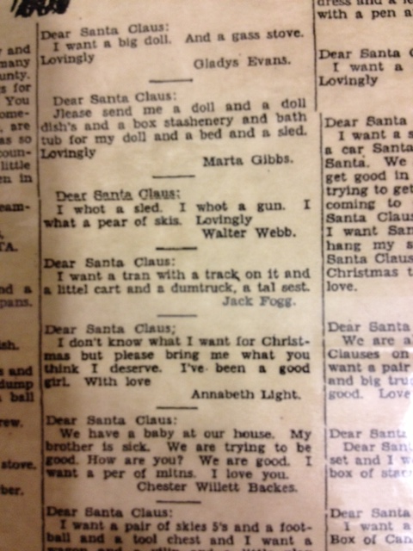

I’m excited for you to enjoy the programs that we have lined up this year, and our April program will be at the Tread of Pioneers Museum, with Annabeth and Grace Compestine, as well as the museum’s curator, talking about quilting in Routt County/Colorado.

But I’m getting ahead of myself! In January, we are fortunate to have nationally reknowned quilters and teachers coming: Weeks Ringle and Bill Kerr are professional quiltmakers and co-founders of Modern Quilt Studio (previously FunQuilts), a design studio in Oak Park, Illinois. Since 1999 Bill and Weeks have brought a modern twist to the great American quilting tradition with decades of quiltmaking experience and graduate design degrees.
If you are able to sign up for the Saturday, January 18th workshop on Improvisational Quilting, do! The signup form is available at http://www.dmqg.org/index.html . I hope you’ll join us there.

Have a wonderful holiday season – see you in the New Year! Terri Meeks

GREETINGS FROM YOUR
VICE PRESIDENT

PROGRAMS | WORKSHOPS
January 16th: Bill Kerr, from Modern Quilt Studio, Transforming Traditions: Modernism and Quilts - Early American quilts were born of necessity but have been transformed into a vibrant contemporary art form. Bill will trace this transformation as it parallels changes in art, architecture, design and society, showing how our quilts are expressive of the era in which we live | January 18th: Weeks Ringle from Modern Quilt Studio, 6-hour workshop  Improvisational Piecing - Learn different techniques for improvisational piecing and choose one to develop a new project. We will guide you through a strategy that will have you making design decisions as you go.
February 20th: Denise Knapp "Scrapp Happy II" | February 22nd: Denise Knapp "Two Block Illusion"
March 20th: DMQG's 20th Birthday Celebration. Bring the first quilt you ever made to show and share, as we celebrate how far we've come individually and as a Guild!

April 17th: Meeting at The Tread of Pioneers Museum. The Museum's Curator, Kate, will share quilts from the museum's storage, as she discusses their history and how to care for them. Special appearances by esteemed Guild members Annabeth Lockhart and Grace Compestine, who will also share a little about their family/quilting.

May 15th: TBD
June 19th: Deidre Adams, Contemporary Art Quilter, shares her artistic journey in the world of art quilting.

July 17th: Julie Hocker, from Lady Hawk Designs, fiber artist and quilt designer:  "Kick Start Your Creativity" | July 19th: Julie Hocker, "Texturescapes 3"  This is the workshop of your dreams. It is the perfect place to learn new techniques that you have been afraid to try. It is Julie's most popular class. It always proves to be a fun-filled inspirational day! This technique class addresses the 'embellishing' aspect of designs, to create a realistic, dimensional appearance.
August : Joint Meeting with the Craig's Piecemaker's guild

September 18th: Silent Auction

October 16th: Estella Heitman: "French Braid Designs" | October 18: Estella Heitman & Terry Hinde:  AM: French Braid Construction  PM: Napkin Construction
November 20th: Potluck, Officer Elections

BULLETIN BOARD
Opportunity Quilt to be sponsored by Sew Steamboat in 2014!
Sew Steamboat has offered to sponsor the DMQG Opportunity Quilt in 2014. They will supply up to 2 yards of fabric per month to the member making the quilted item. In return, the quilted item will be put on display either before or after each month’s Guild Meeting. We are still working on the finer details and will get that information to you soon. If you have any thoughts on the matter, please contact me. Thank-you! Tamie

SPRING RETREAT: APRIL 25 - APRIL 28 2014
HAMPTOM INN, LARAMIE WYOMING
A registration form for spring retreat is available on Page 7 of this newsletter. Please submit this registration form, along with the $40.00 registration fee to any of the retreat organizers listed on the form. We have a block of rooms set aside, and, like last year, each retreat participant will make her own reservations for rooms with the Hampton Inn. We have been given a rate of $89.00 per room/night + 10% tax. Each room has two queen sized beds. Use the reservation code "Quilter's Retreat 2014" to make your reservations at www.hamptoninn.com, or call 1 800 426-7866

Please Note: A Revised materials list for the February 22 Denise Knapp workshop has now been posted on line. Please visit the website and download this revised list.
Newsletter Submissions: All submissions for the newsletter are due on the 26th of the month prior to publication of the newsletter. If you are a board member who submits monthly articles, or if you want to use the newsletter for a one-time notice, it is important that you respect this deadline. Late articles are a burden to the newsletter editor, who also has a timeline to meet as well as other personal obligations. If you are traveling or otherwise engaged, make arrangements to send your submission AHEAD of this deadline.
Just a reminder, our email roster and all of the information in our directory is for the EXCLUSIVE purpose of communication of Guild information. It is NOT to be used for your personal advertising, regardless of how beneficial you may consider the information you send. We all get enough information about charities, special sales, etc, and nobody wants to add to that deluge through use of our Guild directory information.

Delectable Mountain Quilters Guild
General Membership Meeting ~ November 21, 2013
The meeting was called to order at 6:35 p.m. by President, Tamie Buskirk. Twenty-six members and one guest were in attendance. Everyone enjoyed a lovely pot luck dinner followed by the final business meeting of 2013.
Minutes of the October 17, 2013 General Membership Meeting were approved as presented in the newsletter.
Mary Lou Fahres gave the Treasurer’s report. The balance in the Christmas account is $210, the Raffle account balance is $721.56 and the General account balance is $8,666.93. A detailed Treasurer’s report is available on the website.
Maria Bidgood gave the Vice President’s report. Denice Knapp will present the February program. An updated schedule of her winter classes and a list of supplies for her February class are available on the website. Maria has job descriptions of Guild committees and encouraged members to volunteer to chair committees.
Terri Meeks the incoming Vice President summarized the schedule of upcoming programs. In January she hopes to bring Weeks Ringle and/or Bill Kerr of Modern Quilt Studio to the Guild; in February Denice Knapp will present Quilts and Their Stories; March will be a Guild anniversary celebration; April’s meeting will be held at the Tread of Pioneers Museum with a program sharing the museum’s quilt collection; in May we will have a silent auction; in June, Deidre Adams, a mixed media artist will present the program, July will bring Julie Hocker of LadyHawk designs; August is the joint meeting with the Yampa Valley Piecemakers, In September, Sue Gallion, a local fiber artist will present the program; and in October Estella Heitman will present a program on French braid quilts.
Committee Reports
Terri Meeks, Membership Chairman, reported that there are 64 members. She also encouraged someone to volunteer to serve as membership chairman for 2014.
Ruth Ann Mewborn, Opportunity Quilt Chairman, circulated a list for members to volunteer to bring opportunity quilts for each 2014 meeting. Tamie Buskirk told the members that Sew Steamboat has offered to donate up to two yards of fabric each month to be used in the Opportunity Quilt. If a member uses fabric in their opportunity quilt that has been donated by Sew Steamboat they are asked to allow the shop to display the item from the first of the month to the date of the meeting when the opportunity quilt will be given away.
Peggy Hoff reported that she has quilts on hand to donate to Advocates Against Battering and Abuse. She also reported that the scholarship committee received only one application. The kindergarten teachers at South Routt Elementary presented a proposal. Peggy and Margaret Bruellman met with them and will work with them to implement their plan.
Jean Clougherty reported on the Senior Christmas project. Over thirty corn bags were made as gifts and Jean passed the hat for donations to purchase gift cards.
Jackie Grimaldi reported that the quilt show has been hung at the airport and will be in place through ski season.
Old Business
Tamie Buskirk asked for approval of the slate of officers for 2014. Cheryl Spar moved and Irene Meyers second the motion to approve election of the officers for 2014. They are: Maria Bidgood, President; Terri Meeks, Vice President; Kathy Gonio, Treasurer and Terry Hinde, Secretary.
New Business
Tamie gave each member attending the meeting a sheet summarizing the 20th anniversary quilt project and quilter’s journal project. She also circulated photos of a similar quilt project done by another Guild. She encouraged each Guild member to make a small quilt using the project guidelines and participate in the journaling project for this celebration. A copy of the instructions will be published in the newsletter or posted on the website. Both are due by the May 2014 meeting.
There was a discussion of whether to do a raffle quilt in 2014. Mary Lou Fahres, Treasurer, prepared a summary and comparison of the income and expenses from the last raffle quilt and from the little quilts that were sold. Copies were provided to members in attendance. Jackie Grimaldi offered to chair a raffle quilt committee in 2015 but no one at the meeting volunteered to chair the committee for 2014 and no decision was made as to whether to have a raffle quilt in 2014.
Member Announcements
Cheryl Spahr thanked the current Board for their service.
Irene Meyers presented Tamie Buskirk with a beautiful quilt made by the members to thank her and commemorate her service as President.
Chris Henson told the members she had copies of a Quilters List of 100 Things to Do Before I Die that anyone wanting a copy could have. She also asked if the members wanted to continue the fat quarter exchange in 2014. No decision was made.
Renata Beason, a Guild member and owner of the Embroidery Shoppe in Craig, provided quilt kits as a gift to each member.
For the member gift exchange, Maria Bidgood led a game that was fun for everyone.
Pat Zable and Sharon Rottman brought lovely quilts to show the group.
The meeting was adjourned at 8:40 p.m.
Respectfully submitted,
Terry Hinde, Secretary
DMQG SPRING RETREAT ~ APRIL 25-28, 2014
Retreat Fee $40.00
NAME: | MAILING ADDRESS:
HOME PHONE: | MOBILE PHONE:
WORK PHONE: | EMAIL ADDRESS:
EMERGENCY CONTACT: | MEDICAL INFORMATION:
SIGNATURE:

Make checks payable to DMQG  Mail this form and check to:  DMQG:  ATTENTION SPRING RETREAT  P O Box 774383  Steamboat Springs, CO 80477  You may also give your completed form and check to any Spring Retreat Committee member:  Cheryl Spahr  Diana Steverson  Please have your Retreat Registration to us by March 1, 2014 so that we will know how many to plan for conference set-up, etc room. | PLEASE MAKE YOUR ROOM RESERVATIONS DIRECTLY WITH THE HAMPTON INN.  Rooms at the Hampton Inn are $89.00/nite. Use code “Quilter’s Retreat 2014” when making your reservation.  Call: 307 742-0125 (direct) or 800-426-7866  You may also register online at www.hamptoninn.com

DELECTABLE MOUNTAIN QUILTERS GUILD 2014
PO BOX 774383, STEAMBOAT SPRINGS, CO 80477 www.dmqg.org
MEMBER INFORMATION
It takes many members, serving on the Board, chairing or serving on committees, to keep our Guild working. How would you like to help? I am willing to serve as a:
_____Committee Chair _____Committee Member
Circle the area(s) below where you would be willing to volunteer your time.
- Block of the Month
- CQC Coordinator
- Fall Retreat
- Hospitality
- Membership
- Morning Star Coordinator
- Newsletter/Website
- Nominations
- Public Relations/Publicity
- Raffle Quilt
- Raffle Quilt Ticket Sales
- Senior Christmas Project
- Spring Retreat
Other: ________________________

I am interested in:
_____ Presenting a program
_____ Workshop Instructor

Suggestions for a program, lecture or workshop:

________________________________

________________________________
I am willing to:
_____ Host an out-of-town speaker

_____ Provide transportation for out-of-town speaker
Other ________________________________________________________________

2014 MEMBERSHIP REGISTRATION FORM
_____NEW MEMBER ____ RENEWAL

NAME ________________________________

ADDRESS ______________________________

CITY ________________________________

STATE __________________ZIP+4 _________

HOME PHONE: __________________________

MOBILE PHONE: ________________________

WORK PHONE: __________________________

EMAIL ADDRESS ________________________

BIRTH MONTH ________________ DAY ____________
Annual Membership Dues are $20.00 – January 1-December 31. After August 1st dues are $10.00. Fees are waived for members over 80 years of age. Make check or money order payable to: DMQG. Mail it, along with this form to: DMQG-Membership, PO Box 774383, Steamboat Springs, CO 80477. Deadline to be included in Directory is the February Meeting (2/20/2014).

A member will not sell or give away the membership roster for personal gain. Membership in the Delectable Mountain Quilt Guild is not transferable or assignable.

Each member agrees, as a condition of membership, to release and waive any claim he or she has or may have against DMQG, its officers, employees, committee members or agents arising out of or related to the member’s participation in activities of the Guild or arising out of any action taken by the Guild or its Board of Directors to discipline or expel any member or officer.
Signature _______________________ Date _
DMQG has established a website at www.dmqg.org. The monthly newsletter will be available (by password only) by the 1st of each month. An email will be sent when the newsletter is available to view. If you do not have access to a computer, a newsletter will be mailed to you upon request.
Membership: $________ ($20.00)
_____ Cash _____ Check Ck# _________
Date Paid _______________________
_____ I am 80 years of age, fees waived.
_____ I do not have access to a computer; please mail my newsletter.
2014 DMQG WORKSHOP REGISTRATION FORM
Materials Lists for all 2014 workshops will be posted
on the website at www.dmqg.org. The lists can be printed from the site.
Lists will also be available at monthly meetings.

Workshop Fees: See Workshop List Below
If you need to cancel your registration for any workshop
30 days notice is required for a full refund. If you cancel 15 days before the workshop you will be refunded half the workshop fee. There will be no refund for cancellations less than fifteen days before any workshop.

Name: | ____________________________
2014 DMQG Member: | Yes No
Address: | ____________________________
City, State, Zip: | ____________________________
Daytime Phone: | ____________________________
Evening Phone: | ____________________________
E-Mail Address: | ____________________________

Workshop Date | Time  With 1 Hour Lunch Break | Workshop | Location | Workshop Fee
Saturday  January 18 | 9 AM - 4 PM | Weeks Ringle  Improvisational Quilting | Selbe Apartments Scott Center | Members: $35  Non-DMQG Members $45
Saturday  February 22 | 9 AM – 3 PM | Denice Knapp  Two Block Illusion | Selbe Apartments Scott Center | Members: $35  Non-DMQG Members $40
Saturday  July 19 | 9AM – 4 PM | Julie Hocker  Texture Scapes 3 | Selbe Apartments Scott Center | Members $35  Non-DMQG Members $45
Saturday  October 18 | 9 AM – 4 PM | Estella Heitman & Terry Hinde  French Braid/Napkins | Selbe Apartments Scott Center | Members $35  Non-DMQG Members $45
Total Amount Enclosed: |  |  |  | $
Send the above registration form with your check, payable to DMQG to:
Terri Meeks, 362 Cherry Drive, Steamboat Springs, CO 80487
Call 761-2050 for more information.

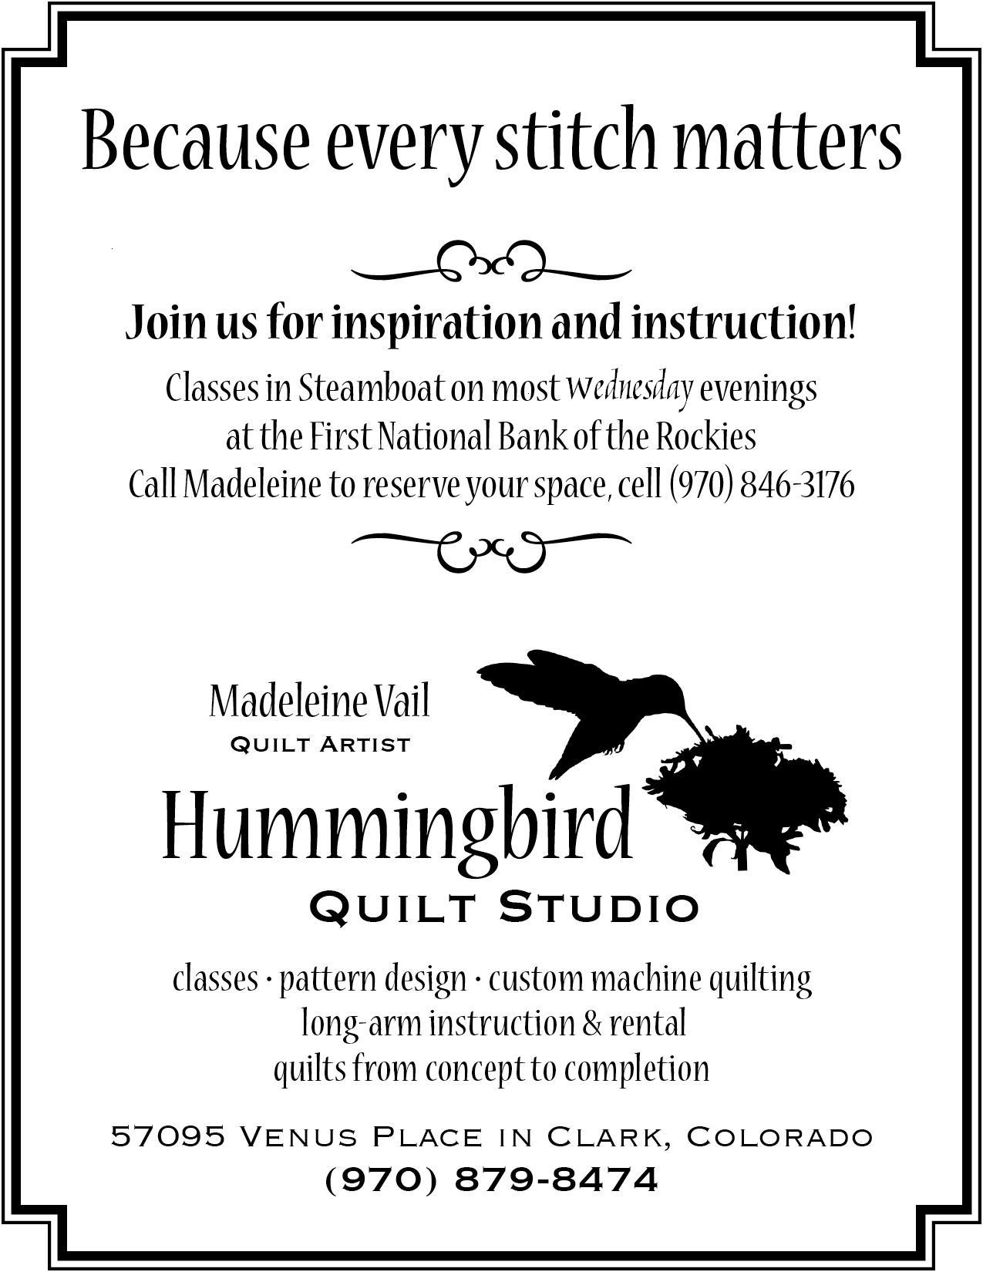  How to Participate: | 