THE NEWSLETTER OF THE DELECTABLE MOUNTAIN QUILTERS GUILD
PEAKS & PIECES
April, 2015
Volume 21, Issue 203

PRESIDENT’S NOTE
Here it is April already. I’m ready for the nicer weather. What a wonderful program we had in March from the Rocky Mountain Quilt Museum! Thank you, Terri, for arranging it.

With Easter here already, I’ve been making fabric eggs from my scraps and putting together a strip table runner with some Easter fabric I’ve had for years. My goal this year is to use what I have. Sorry quilt shop owners, but I have to try to sew up my stash. I figured that’s what I bought it for.

I was at Lift-up last week and met a very nice lady. She and I were going through the fabric bin. She had her basket full of fabric pieces. When she saw that I was looking at the cottons she let me look through what she had picked out. She was nice enough to let me have two great pieces, one 1 yard piece of Michael Miller and a yard piece of Moda fabric. She’s from Lancaster, Pennsylvania and said she was going back for a visit and would stock up when she was there. You never know where you are going to meet a fellow quilter. I invited her to a meeting and she said she had been to one with her sister. I’m not sure if the sister is a member or not. If you are, please thank your sister for me again. She made my day.

Keep sewing,

Maria Bidgood
President

Inside this issue:

President’s Note | 1
Vice President’s Report | 2
Programs & Workshops | 3
Bulletin Board | 3
Features – Member Bio, Tip & Recipe | 4
Minutes from last meeting | 5
2015 Budget | 6
Workshop Registration Form | 8
Spring Retreat Registration | 9
2015 Membership Registration Form | 10
Advertisers | 11

NEXT BOARD MEETING
Tuesday, April 14, 2015
at 6:00 p.m.
Scott Senior Center ~ Selbe Apartments

NEXT GENERAL MEETING:
THURS., April 16, 2015
Community Center

Doors open at 6:00 p.m.
Meeting starts at 6:30 p.m.

DELECTABLE MOUNTAIN
QUILTERS GUILD
The DMQG membership meetings are held the third Thursday of every month at the Stmbt Springs Community Center. Door opens at 6:00 pm for early sign-ups and meetings start promptly at 6:30 pm. Membership is $20/per year. Meetings are free for members, and non-members pay a $3 guest fee.

DMQG Board Meetings are held the third Tuesday of each month at 6:00 pm @ Selbe Apartments/Scott Center. Board meetings are open to all members.
2014 Board of Directors
President………………….………………….…Maria Bidgood
Vice President………………….…………..Terri Meeks
Secretary……….Terry Hinde/RuthAnn Mewborn
Treasurer……………………..………………Cheryl Spahr

County Fair Liaison: Jackie Grimaldi
Fabric Exchange: Chris Hensen
Fall Retreat:
Hospitality: Jean Clougherty
Membership: Margaret Bruellman
Morning Star Quilts: Peggy Hoff
Newsletter/Website: Chris Hensen
Opportunity Quilt: Grace Compestine
Publicity: Grace Compestine
Quilt Scholarship: Peggy Hoff
Quilt Shows: Madeleine Vail
2015 Raffle Quilt: Jackie Grimaldi
Raffle Quilt Games Manager: Cheryl Spahr
Senior Xmas Project Coordinator:
Silent Auction Coordinator:
Special Shows & Programs:
Spring Retreat: Sharon Rottman & Ruth Ann Mewborn
Tread of Pioneers Museum/XMAS Trees:

DMQG reserves the right to select the articles and advertising that reflects the purpose of the Guild. Questions, articles and requests for permission to reprint information from the newsletter should be sent to the editor @ DMGQ Editor, PO Box 774383, Steamboat Springs, CO 80477.

Peaks & Pieces is published monthly by the DMQG. Deadline for submissions is the 26th of the previous month. Please send information to the Newsletter Editor: Chris Hensen, cdhensen@aol.com

Advertising rates are as follows:
Members
1 yr ¼ page $100 or Business Card Size $50
1-time ¼ page $10, or Business Card Size $5
Non-members
1 yr ¼ page $120 or Business Card Size $60
1-time ¼ page $15 or Business Card Size $6

Greetings from Your Vice President,

Things happen for a reason. When our instructor from Illinois called a few weeks ago and said that she had double-booked and couldn’t come to Steamboat in March, I was beside myself. However, a quick search of the Internet turned up the programs available through the Rocky Mountain Quilt Museum, and fortunately, Brenda and Karen from the Museum were thrilled to be invited to Steamboat Springs. Wasn’t it amazing to see the craftsmanship and artwork so lovingly lavished into the crazy quilts? Inspiring.

This next month, on April 16th, Lorrae Moon from Yampa Valley Fiberworks will speak to us about her family’s new enterprise. On Saturday, April 25th, we will take a road trip to visit the facility. We will meet at the Community Center at 9 a.m. to rideshare up to Craig. After touring the Yampa Valley Fiberworks, we will be sure to visit Renata’s store, the Embroidery Shoppe, and Brenda’s store, Quilter’s Quest. Each has offered 15% off all purchases to those of us making the trip that day. And, we’ll manage to squeeze in a little lunch – probably at Fiesta Jalisco. Hope you’ll join us!

Happy Quilting,

Terri Meeks

GREETINGS FROM YOUR
VICE PRESIDENT

PROGRAMS | WORKSHOPS
April 16: Lorrae Moon from Yampa Valley Fiberworks | April 25: 10:00 a.m., Tour of Yampa Valley Fiberworks. Meet at the Community Center at 9:00 a.m. to carpool to Yampa Valley Fiberworks.
May 21: Theresa Rogers, Custom Quilter/ Designer, http://www.theresarogers.com/
June 18: Julie Hocker, lecture “Time of your Life” | June 20: Julie Hocker, Workshop “3D Thread Drawing,” Selbe Senior Center
July 16:
August TBD: Joint Meeting with the former Craig Guild, Hayden
September 17: Peggy Hoff, lecture | October 19: Peggy Hoff, “String Piecing,” Workshop, Selbe Senior Center
October 15: Frieda Anderson, lecture  “Fun Fast Fusing.” Her website may be found at http://www.friestyle.com/ | October 17: Frieda Anderson, Dye Class – “Flooded with Color.” Location TBD. Class list may be found at: http://www.friestyle.com/workshops/flooded-with-color/
November 20th: Potluck, Officer Elections
Bring your favorite dish to share at the Potluck.

BULLETIN BOARD
BIRTHDAYS IN APRIL

Roberta Ahlstrom April 3 Lynn Wunder (Sew Steamboat) April 6
Sharon Yannaccone April 8 Marcia Spitellie April 9
Tina Smith April 13 Cindy Looper April 18
Madeleine Vail April 22

Happy Birthday ladies! Thank you for the treats for April’s meeting!

OPPORTUNITY QUILTS FOR 2015

April Marcia Spitellie May Amy Pederson
June Mary Lou Fahres July Tina Smith
August Jo Stack September Sue Leeson
October Jackie Grimaldi November Pam Lindahl

2015 RAFFLE QUILT

Now that our stunning raffle quilt has been completed, we need volunteers to sell tickets to help raise money for our guild! Sew Steamboat has graciously volunteered to sell tickets INSIDE their store throughout the summer. However, we need volunteers situated OUTSIDE this business to sell tickets during First Friday Art Walks on June 5th, July 3rd, Aug. 7th and Sept. 4th. Set up should be about 4 p.m. and sales conclude by 7 p.m. If you can volunteer please contact Sharon at
879-0080 or my email s.yannaccone@comcast.net. If these dates don't work for your schedule, I am currently researching other dates and locations which might work for you and I will keep you updated. Let's make this years' raffle quilt a success and sell lots of tickets!

Sharon Yannaccone

SPRING RETREAT

Spring Retreat is just around the corner! There is still one more space left if you want to attend the Spring Retreat in Laramie. Don’t forget to make your hotel reservations. Then start planning your projects to work on and a snack to share. The quilt shops in Laramie will give us a 10% discount again this year!

See you May 1, 2015!

Sharon Rottman and Ruth Ann Mewborn
2015 MEMBERSHIPS

The 2015 Membership Registration form is attached. Annual Membership Dues are $20.00 – January 1 - December 31. After August 1st dues are $10.00. Fees are waived for members over 80 years of age.

2015 FABRIC EXCHANGE

April, May & June will be 5 inch squares.
Please bring as many 5 inch squares as you can get out of ½ yard of fabric
April’s fabric is Spring themed colors or prints.
Please bring your cut fabric in a Ziploc-style bag with your name on the bag.
Newsletter Submissions: All submissions for the newsletter are due on the 26th of the month prior to publication of the newsletter. If you are a board member who submits monthly articles, or if you want to use the newsletter for a one-time notice, it is important that you respect this deadline in order to get the newsletter completed timely. If you are traveling or otherwise engaged, please make arrangements to send your submission ahead of this deadline. Send submissions to cdhensen@aol.com in Word .doc, .docx, .xls or .xlsx formats.
Just a reminder, our email roster and all of the information in our directory is for the EXCLUSIVE purpose of communication of Guild information. It is NOT to be used for your personal advertising, regardless of how beneficial you may consider the information you send. We all get enough information about charities, special sales, etc, and nobody wants to add to that deluge through use of our Guild directory information.
FEATURES
Member Biography - Grace Compestine

I was born on a farm near New Raymer, Colorado, on November 2nd, 1932, the ninth of ten children. The family moved to Yampa, Colorado when I was about six and then to Steamboat Springs, Colorado in 1944. During the summers I worked at the Ben Franklin Store and also at the Chief Theater at night. I graduated from Steamboat Springs High in 1950. In November of that year I married Melvin Compestine who worked at Law Drug. In September 1951 I went to work for the Routt County National Bank as a secretary. In 1952 Mel went into the army and was stationed in Germany until August, 1954, when he was discharged and returned home. I was working at the Routt County National Bank when he left and spent my evenings again working at the Chief Theatre with a number of other wives of service men. When Mel returned we started a family and had three children, Diana, Douglas and Cheryl. In those days you had to quit if you had a baby but I worked off and on between each birth. I also worked for the Welfare Department for about three years, then returned to the Routt County National until I retired on May 28th, l993. We have four grandchildren and one great grandson.

I had never done much sewing except small items for the girls when they were young. After I retired from the Bank in 1993 I decided I wanted to learn to quilt. Kathy Faucett was teaching quilting class through Colorado Mountain College in Hayden, Colorado, so I started driving to Hayden for classes. She taught a different class once a month during the school year. I have a number of unfinished projects from those classes, but learned a lot and enjoyed the process.
I joined Delectable Mountain Quilters Guild in 1995 when they were meeting in the Steamboat Library and have been a member ever since. I have enjoyed knowing all the members over the years. At one time the Guild had a membership of around one hundred. We split our meetings between Steamboat Springs, Hayden and Craig, changing locations each month.

Diana had sewn a little over the years but Cheryl had not, not even buttons. I gave all the kids quilts for Christmas and the art wore off on Diana and she started to do some quilting. Cheryl and I went to Denver one year for “Shop Hop”, visiting about 17 stores in the area including Evergreen. Cheryl caught the buying fabric bug, and asked if I would make the items for her. Diana and I laughed because she bought more fabric than we did. She did do the sewing with help from me and other quilter friends.

Now Diana, her daughter Natalie, Cheryl and I all quilt and have attended retreats together. It is great fun for us all. Last retreat Diana, Cheryl and I worked on a quilt for Natalie’s boyfriend and it turned out great which is a miracle.
Denice Knapp’s Quilting Tip for April

When pressing quilt units and/or blocks, place them under a ruler immediately after pressing (stacking them as you press). The weight of the ruler in combination with the trapped heat will give you beautifully flat work.

Delectable Mountain Quilters Guild
General Membership Meeting
March 19, 2015

The March 19, 2015 meeting was called to order at 6:35 p.m. by President, Maria Bidgood. Thirty-two members and four guests attended.

Denice Knapp made a motion to approve the minutes of the February 19, 2015 General Meeting as presented in the newsletter. Barbara Swissler seconded the motion which was approved by those in attendance.

Cheryl Spahr gave the Treasurer’s report. The February 2015 balance in the General Account was $6,593.31; the Raffle Account balance was unchanged at $171.56; and the Christmas Account balance was also unchanged at $115.00. A detailed Treasurer’s report is available on the website.

Terri Meeks thanked everyone for attending and gave the Vice President’s report. The evening’s program will be a trunk show, Victorian Crazy Quilts: Pride of Victorian Womanhood provided by representatives of the Rocky Mountain Quilt Museum. In April, Lorae Moon of Yampa Valley Fiberworks will present the program. A road trip to Craig for a tour of Yampa Valley Fiberworks, followed by lunch and shopping at the Craig quilt shops will take place on April 25th. The Craig quilt shops are offering a discount that day.

Committee Reports

Margaret Bruellman reported that the Guild has 64 paid members. For directory purposes, membership will be closed on April 10. After that date, members will be notified of any additional members via e-mail. Members will also be sent an e-mail asking them to confirm their information that will appear in the directory. The directories should be ready for the April meeting.

Chris Henson is continuing to learn how the website works. Printed copies of the newsletter were available to the members.

The evening’s Opportunity Quilt, a very nice bag to store and carry notions was provided by Ruth Ann Mewborn.

Ruth Ann reported that there is one space left for spring retreat which will be held in Laramie on May 1 – 3.

Jean Clougherty, Hospitality Chairman, reminded members to bring a treat to the meeting held during their birthday month.

Chris Henson told members that the fabric exchange for April, May and June will be 5” squares. She asked for member input on the number of squares to contribute and the decision was to provide squares from ½ yard of fabric. For April the squares should be spring colors.

Peggy Hoff reported on the Grant project. She has been in contact with the second grade teacher at Strawberry Park Elementary and the plan for the project is being worked out.

Cheryl Spahr reported on plans for raffle quilt ticket sales. Tickets will be sold in front of Sew Steamboat during the First Friday Art Walk, May through September. Two to three members per night will be needed. Members who are in favor of selling tickets at the Library during Art in the Park should contact Sharon Yannaccone. Other suggestions for ticket sales include Mustang weekend in June and the Halloween Parade. Another suggestion would be to sell tickets at the grocery stores on some Saturdays. The raffle quilt will be kept on display and tickets will be on sale at Sew Steamboat when the quilt is not being displayed at other ticket sale venues.

Old Business

Cheryl Spahr distributed copies of the proposed 2015 budget to the members. Peggy Hoff made a motion to approve the 2015 budget as presented. Ruth Ann Mewborn seconded the motion which was approved by the members in attendance.

Maria discussed the Survey Monkey results. Fifty percent of Guild members responded to the survey. The results of the survey will be posted on the website.

New Business

Based on the Survey Monkey results, Maria told members that sign-up sheets were available at the front table for those wishing to volunteer to provide a recipe, a biography or a quilting tip for the newsletter.

Member Announcements

Maria told the members that the Denver National Quilt Festival will be held from April 30 – May 2.

Margaret Bruellman announced that she had brought some items that anyone could take.

Madeline Vail told members that she is now selling Floriani thread and stabilizers.

Tamie Buskirk discussed the President’s quilt and asked that members provide her with their blocks by the April meeting.

There was a break in the meeting after which Barbara Braden and Karen Roxburgh of the Rocky Mountain Quilt Museum spoke about the museum. The museum is located in downtown Golden, Colorado. It is celebrating its 25th Anniversary this year. As part of the celebration the museum is having a quilt challenge. Participating quilts should be 25” square and are due by July 15. Anyone interested in participating in the challenge should contact the museum. The museum’s Fabric and Friends annual fundraiser will be held at the Arvada Center on May 15. Barbara and Karen then presented a wonderful trunk show on Victorian Crazy Quilts: Pride of Victorian Womanhood.

Several members showed crazy quilts. Peggy Hoff showed a contemporary crazy quilt. Lynn Wunder showed an antique crazy quilt. Nancy Johnson showed a velveteen crazy quilt pillow. Jackie Grimaldi showed two quilts she made that incorporated neckties and embroidery depicting her family. Terri Meeks showed small crazy quilts from her family and pieces she had made.

Show and Tell

Debbie Matheny showed a contemporary Dresden plate quilt she had heavily quilted using “every stitch she could think of.” Bonnie Calhoun showed three scrap quilts she made; one incorporated 1,800 2” squares, a second included 1,008 2 ½” squares and the third 410 3 ½” squares. Cheryl Spahr showed her one block wonder.

The Opportunity Quilt was won by Terri Meeks.

Door Prizes were won by Elizabeth Danielson, Ruth Ann Mewborn, Maria Bidgood, Grace Compestine, Tobi Duncan, Jane Haack-DeBroux, Chris Hensen, Peggy Hoff, Tina Look and Judy Winter. Thank you to members who donated the door prizes.

There being no further business, the meeting was adjourned at 8:50 p.m.

Respectfully submitted,
Terry Hinde, Secretary

2015 DMQG WORKSHOP REGISTRATION FORM
Materials Lists for all 2015 workshops will be posted
on the website at www.dmqg.org. The lists can be printed from the site.
Lists will also be available at monthly meetings.

Workshop Fees: See Workshop List Below
If you need to cancel your registration for any workshop
30 days notice is required for a full refund. If you cancel 15 days before the workshop you will be refunded half the workshop fee. There will be no refund for cancellations less than fifteen days before any workshop.

Name: | ____________________________
2015 DMQG Member: | Yes No
Address: | ____________________________
City, State, Zip: | ____________________________
Daytime Phone: | ____________________________
Evening Phone: | ____________________________
E-Mail Address: | ____________________________

Workshop Date | Time  With 1 Hour Lunch Break | Workshop | Location | Workshop Fee
Saturday  April 25 | 9 AM - ?? | Road Trip: Yampa Valley Fiberworks, Quilter’s Quest, Lunch! | Meet at Community Center at 9 AM | Reservations Only; N/C
Saturday  June 20 | 9 AM – 4 PM | Julie Hocker  3-D Thread Drawing | Selbe Apartments Scott Center | Members $35  Non-DMQG Members $45
Saturday  September 19 | 9 AM – 4 PM | Peggy Hoff  String Piecing | Selbe Apartments Scott Center | Members $35  Non-DMQG Members $45
Saturday  October 17 | 9 AM – 4 PM | Freida Anderson  Dyeing Class  “Flooded with Color” | TBD | Members $35  Non-DMQG Members $45
Total Amount Enclosed: |  |  |  | $
Send the above registration form with your check, payable to DMQG to:
Terri Meeks, 362 Cherry Drive, Steamboat Springs, CO 80487
Call 761-2050 for more information.
DMQG SPRING RETREAT ~ May 1, 2 & 3 2015
Retreat Fee $40.00
NAME: | MAILING ADDRESS:
HOME PHONE: | MOBILE PHONE:
WORK PHONE: | EMAIL ADDRESS:
EMERGENCY CONTACT: | MEDICAL INFORMATION:
SIGNATURE:

Make checks payable to DMQG  Mail this form and check to:  DMQG:  ATTENTION SPRING RETREAT  P O Box 774383  Steamboat Springs, CO 80477  You may also give your completed form and check to any Spring Retreat Committee member:  Sharon Rottman  Ruth Ann Mewborn  Please have your Retreat Registration to us by March 1, 2015 so that we will know how many to plan for conference set-up, etc room. | PLEASE MAKE YOUR ROOM RESERVATIONS DIRECTLY WITH THE HAMPTON INN.  Rooms at the Hampton Inn are $89.00/nite. Use code “Quilter’s Retreat 2015” when making your reservation.  Call: (307) 742-0125 (direct) or 800-426-7866  You may also register online at www.hamptoninn.com

DELECTABLE MOUNTAIN QUILTERS GUILD 2015
PO BOX 774383, STEAMBOAT SPRINGS, CO 80477 www.dmqg.org
MEMBER INFORMATION
It takes many members, serving on the Board, chairing or serving on committees, to keep our Guild working. How would you like to help? I am willing to serve as a:
___Committee Chair ___Committee Member

Circle the area(s) below where you would be willing to volunteer your time.
- Block of the Month
- CQC Coordinator
- Fall Retreat
- Hospitality
- Membership
- Morning Star Coordinator
- Newsletter/Website
- Nominations
- Public Relations/Publicity
- Raffle Quilt
- Raffle Quilt Ticket Sales
- Senior Christmas Project
- Spring Retreat
Other: ________________________

I am interested in:
_____ Presenting a program
_____ Workshop Instructor

Suggestions for a program, lecture or workshop:
________________________________

________________________________

________________________________
I am willing to:
_____ Host an out-of-town speaker

_____ Provide transportation for out-of-town speaker
Other ______________________________________________________________________

2015 MEMBERSHIP REGISTRATION FORM
_____ NEW MEMBER ____ RENEWAL

NAME ________________________________

ADDRESS ______________________________

CITY ________________________________

STATE __________________ZIP+4 _________

HOME PHONE: __________________________

MOBILE PHONE: ________________________

WORK PHONE: __________________________

EMAIL ADDRESS ________________________

BIRTH MONTH ________________ DAY ____________
Annual Membership Dues are $20.00 – January 1-December 31. After August 1st dues are $10.00. Fees are waived for members over 80 years of age. Make check or money order payable to: DMQG. Mail it, along with this form to: DMQG-Membership, PO Box 774383, Steamboat Springs, CO 80477. Deadline to be included in Directory is the February Meeting (2/20/2014).

A member will not sell or give away the membership roster for personal gain. Membership in the Delectable Mountain Quilt Guild is not transferable or assignable.

Each member agrees, as a condition of membership, to release and waive any claim he or she has or may have against DMQG, its officers, employees, committee members or agents arising out of or related to the member’s participation in activities of the Guild or arising out of any action taken by the Guild or its Board of Directors to discipline or expel any member or officer.
Signature _______________________ Date _
DMQG has established a website at www.dmqg.org. The monthly newsletter will be available (by password only) by the 1st of each month. An email will be sent when the newsletter is available to view. If you do not have access to a computer, a newsletter will be mailed to you upon request.
Membership: $________ ($20.00)
_____ Cash _____ Check Ck# _________
Date Paid _______________________
_____ I am 80 years of age, fees waived.
_____ I do not have access to a computer; please mail my newsletter.

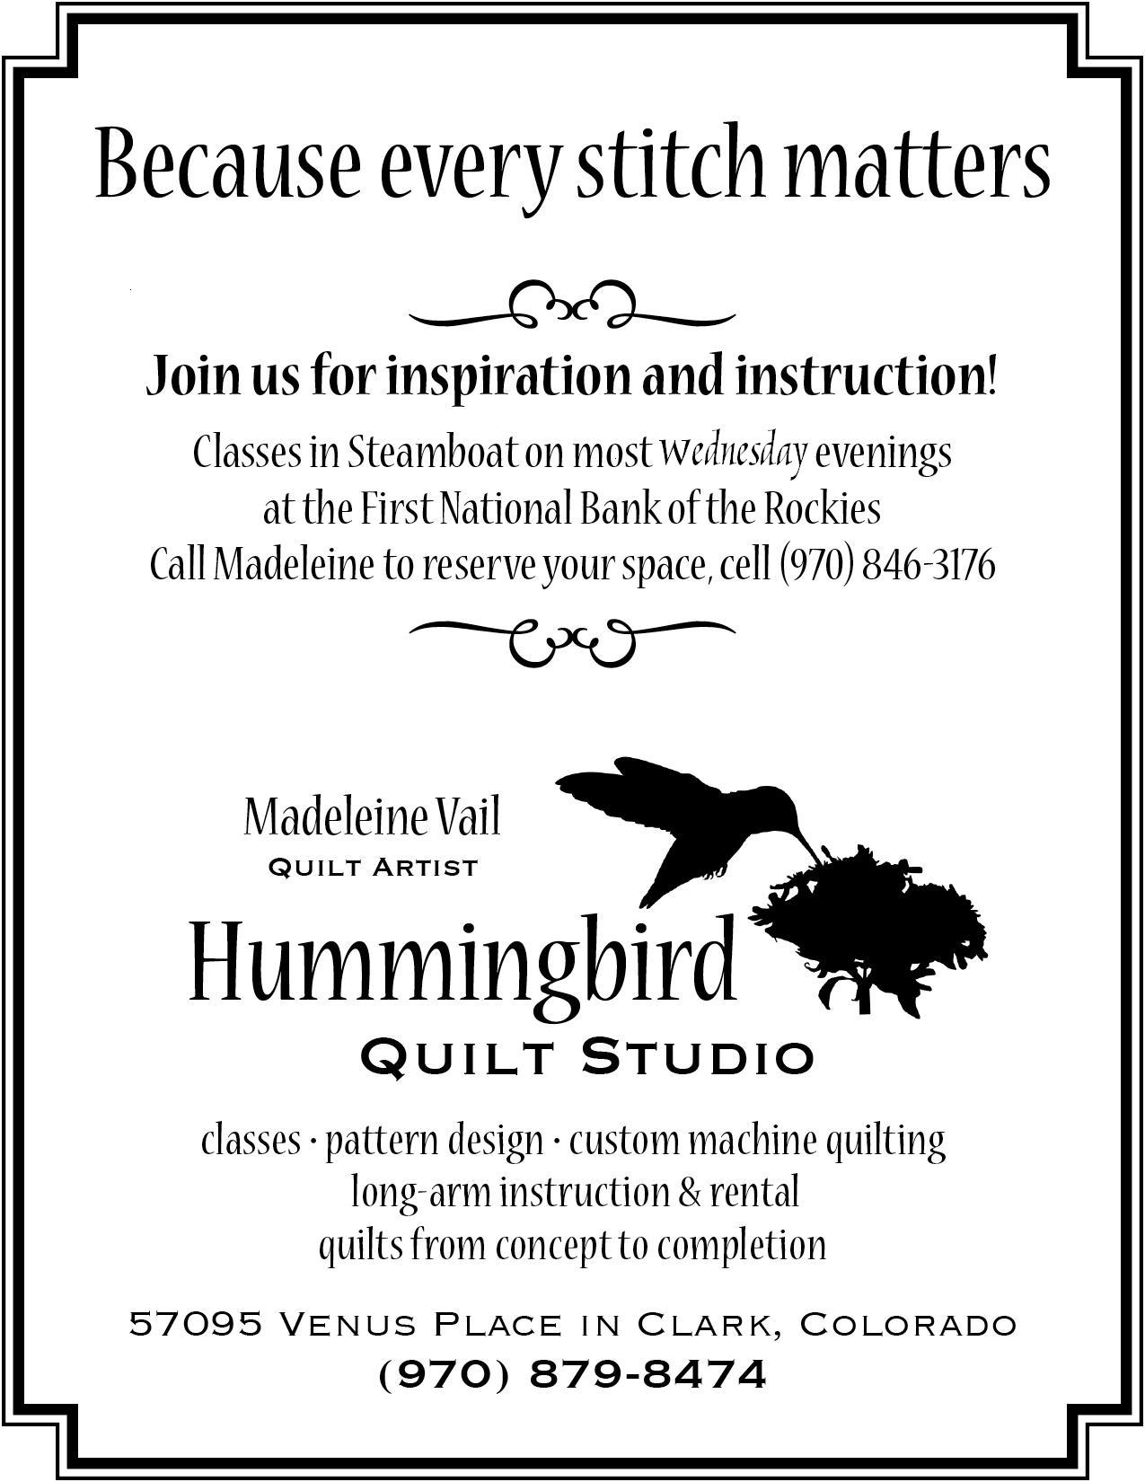  How to Participate: | 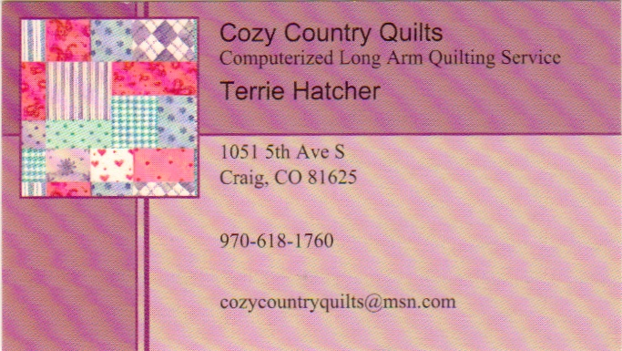
 | 