THE NEWSLETTER OF THE DELECTABLE MOUNTAIN QUILTERS GUILD
PEAKS & PIECES
February, 2015
Volume 21, Issue 201

PRESIDENT’S NOTE
 February 2015 Newsletter

I’m planning a vacation to Pella, Iowa for the Tulip Festival in May and I was delighted to find a quilt show happening at the same time. That made me wonder about the quilt shows scheduled in our state this year.
There’s a great website call the Quilter’s Travel Companion that takes you across the country. Click on Colorado and you’ve got all the quilt shows listed. Besides the well-known ones such as the Denver National Quilt Festival the first weekend in May at the Merchandise Mart, there’s the Rocky Mountain Quilt Festival in Loveland the 3rd weekend in August, Quilt-a-Fair in September in Longmont and all summer long, the Capitol Quilt Show in our state capitol building in Denver (personally, that’s a must see) there are many others.
Some other towns that are having quilt shows are Glenwood Springs on Mother’s Day, an outdoor show in Berthoud on June 20 in their downtown, Montrose the 2nd weekend in July, and Salida, the 4th weekend in June. Don’t forget to check out the Rocky Mountain Quilt Museum in Golden any time of year.
If you are traveling, you can click on any state and check out a quilt show. So plan some trips and some stops along the way to see the quilts.
Don’t forget to take those quilt shop pictures too so we can have our own travel slide show.

Keep sewing,

Maria Bidgood, President

Inside this issue:

President’s Note | 1
Vice President’s Report | 2
Programs & Workshops | 3
Bulletin Board | 3
Minutes from last meeting | 4
Workshop Registration Form | 6
Spring Retreat Registration | 7
2015 Membership Registration Form | 8
Advertisers | 9

NEXT BOARD MEETING
Tuesday, February 17, 2015
at 6:00 p.m.
Scott Senior Center ~ Selbe Apartments

NEXT GENERAL MEETING:
THURS., February 19, 2015
Community Center

Doors open at 6:00 p.m.
Meeting starts at 6:30 p.m.

DELECTABLE MOUNTAIN
QUILTERS GUILD
The DMQG membership meetings are held the third Thursday of every month at the Stmbt Springs Community Center. Door opens at 6:00 pm for early sign-ups and meetings start promptly at 6:30pm. Membership is $20/per year. Meetings are free for members, and non-members pay a $3 guest fee.

DMQG Board Meetings are held the third Monday of each month at 6:00pm @ Selbe Apartments/Scott Center. Board meetings are open to all members.
2014 Board of Directors
President………………….………………….…Maria Bidgood
Vice President………………….…………..Terri Meeks
Secretary……….Terry Hinde/RuthAnn Mewborn
Treasurer……………………..………………Cheryl Spahr

County Fair Liaison: Jackie Grimaldi
Fabric Exchange: Chris Hensen
Fall Retreat:
Hospitality: Jean Clougherty
Membership: Margaret Bruellman
Morning Star Quilts: Peggy Hoff
Newsletter/Website: Chris Hensen
Opportunity Quilt: Grace Compestine
Publicity: Grace Compestine
Quilt Scholarship: Peggy Hoff
Quilt Shows: Madeleine Vail
2015 Raffle Quilt: Jackie Grimaldi
Raffle Quilt Games Manager: Cheryl Spahr
Senior Xmas Project Coordinator:
Silent Auction Coordinator:
Special Shows & Programs:
Spring Retreat: Sharon Rottman & Ruth Ann Mewborn
Tread of Pioneers Museum/XMAS Trees:

DMQG reserves the right to select the articles and advertising that reflects the purpose of the Guild. Questions, articles and requests for permission to reprint information from the newsletter should be sent to the editor @ DMGQ Editor, PO Box 774383, Steamboat Springs, CO 80477.

Peaks & Pieces is published monthly by the DMQG. Deadline for submissions is the 26th of the previous month. Please send information to the Newsletter Editor: Chris Hensen, cdhensen@aol.com

Advertising rates are as follows:
Members
1 yr ¼ page $100 or Business Card Size $50
1-time ¼ page $10, or Business Card Size $5
Non-members
1 yr ¼ page $120 or Business Card Size $60
1-time ¼ page $15 or Business Card Size $6

Greetings from your Vice President
What a warm and wonderful start to our year, with DMQG member Denice Knapp presenting both an informative program (Historic French White Quilts) and workshop (The Flying Geese Unit). I was mesmerized by the intricate, uniform hand quilting on the white quilts – didn’t you just love the irony of using those painstakingly made items for harsh, everyday use like baby bibs and underskirts? During Denice’s workshop,
we learned several different ways to make the flying geese units, as well as a variety of ways to use the finished units.
And we’re off and running with possibilities for this New
Year!

Our February meeting will be held at 6:30 pm on February
19th at Casey’s Pond. Please bring a quilt and a memory or little story to share. The residents are excited to have us visit again!

In March, we have Frieda Anderson, quilt artist from Chicago, visiting us. Her website is found at http://www.friestyle.com/ . She does blog about the dyeing, and various places she will be teaching the class, including on an Alaskan cruise! The workshop information for “Flooded with Color: A Fabric Dyeing Class” is at: http://www.friestyle.com/workshops/flooded-with-color/ .
I am not posting this on the web, but the class will be held at Jackie’s house. For anyone planning on experiencing this
class, please let me know ASAP if you would like to put together supplies as a group. Won’t it be fun to create your own colors?!

Terri Meeks, Vice President and Programs Chair

GREETINGS FROM YOUR
VICE PRESIDENT

PROGRAMS | WORKSHOPS
February 19: Casey’s Pond, meeting will be held at Casey’s Pond.
March 19: Frieda Anderson, lecture  “Fun Fast Fusing.” Her website may be found at http://www.friestyle.com/ | March 21: Frieda Anderson, Dye Class – “Flooded with Color.” Class list may be found at http://www.friestyle.com/workshops/flooded-with-color/ Location TBD
April 16: Lorrae Moon from Yampa Valley Fiberworks | April 25: 10:00 a.m., Tour of Yampa Valley Fiberworks. Meet at the Community Center at 9:00 a.m. to carpool to Yampa Valley Fiberworks.
May 14: Theresa Rogers, Custom Quilter/ Designer, http://www.theresarogers.com/
June 18: Julie Hocker, lecture “Time of your Life” | June 20: Julie Hocker, Workshop “3D Thread Drawing,” Selbe Senior Center
July 16:
August TBD: Joint Meeting with the former Craig Guild, Hayden
September 17:
October 17: Peggy Hoff, lecture | October 19: Peggy Hoff, “String Piecing,” Workshop, Selbe Senior Center
November 20th: Potluck, Officer Elections
Bring your favorite dish to share at the Potluck.

BULLETIN BOARD
BIRTHDAYS IN FEBRUARY

Pam Lindahl February 1 Tamie Buskirk February 11
Jan Cook February 3 Anna Beth Lockhart February 15
Nancy Johnson February 6 Chris Hensen February 22
Margaret Bruellman February 11 Victoria Strohmeyer-Smalley February 25
Happy Birthday ladies! Thank you for the treats for January’s meeting!
OPPORTUNITY QUILTS FOR 2015
February Nancy Johnson March Ruth Ann Mewborn
April Marcia Spitellie May Amy Pederson
June Mary Lou Fahres July Tina Smith
August Jo Stack September Sue Leeson
October Jackie Grimaldi November Pam Lindahl

2015 MEMBERSHIPS
The 2015 Membership Registration form is attached. Annual Membership Dues are $20.00 – January 1 - December 31. After August 1st dues are $10.00. Fees are waived for members over 80 years of age.

2015 RAFFLE QUILT
How are your ticket sales going? If you haven’t picked up tickets yet or if you need more tickets, please contact Cheryl Spahr or Jackie Grimaldi. Sew Steamboat will display the raffle quilt in their upstairs area when the quilt is not on display for a sales event.

SPRING RETREAT
Seats for the Spring Retreat in Laramie on May 1, 2 and 3 is going fast. At the writing of the newsletter there are only two spaces left. If you want to attend, please contact Sharon Rottmann or Ruth Ann Mewborn. The registration form is included later in the newsletter.

2015 FABRIC EXCHANGE
February & March will be 2 ½ inch strips

Please bring 12 – 2 ½ strips of Red solids or prints for February.

March will be green solids or prints.
Please bring your cut fabric in a Ziploc-style bag with your name on the bag.
Newsletter Submissions: All submissions for the newsletter are due on the 26th of the month prior to publication of the newsletter. If you are a board member who submits monthly articles, or if you want to use the newsletter for a one-time notice, it is important that you respect this deadline in order to get the newsletter completed timely. If you are traveling or otherwise engaged, please make arrangements to send your submission ahead of this deadline. Send submissions to cdhensen@aol.com in Word .doc, .docx, .xls or .xlsx formats.
Just a reminder, our email roster and all of the information in our directory is for the EXCLUSIVE purpose of communication of Guild information. It is NOT to be used for your personal advertising, regardless of how beneficial you may consider the information you send. We all get enough information about charities, special sales, etc, and nobody wants to add to that deluge through use of our Guild directory information.

Delectable Mountain Quilters Guild
General Membership Meeting
January 15, 2015

The January 2015 meeting was called to order at 6:30 p.m. by President, Maria Bidgood. Twenty-nine members and one guest were in attendance.

Tamie Buskirk made a motion to approve the minutes of the November 20, 2014 General Meeting as presented in the newsletter. Adele Vandenburgh seconded the motion which was approved by those in attendance.

Cheryl Spahr gave the Treasurer’s report. The December 31, 2014 balance in the General Account was $4,654.51; the Raffle Account balance was unchanged at $171.56; and the Christmas Account balance was $115.00. A detailed Treasurer’s report is available on the website.

Terri Meeks gave the Vice President’s report. Denice Knapp will present the evening’s program, titled Historic White Stuffed/Corded Quilts of Provence. She will teach a workshop on her Gaggle of Geese quilt on January 17. The February meeting will be held at Casey’s Pond. Members are encouraged to bring quilts for show and tell with the residents. In March, Frieda Anderson will present a lecture and trunk show at the general meeting and will teach a workshop on hand dyeing. The workshop will be held at Jackie Grimaldi’s home. In April, Lorrae Moon of Yampa Valley Fiberworks will present the program. A road trip for a tour of Yampa Valley Fiberworks, followed by lunch and shopping at the Craig quilt shops will also take place in April. In May, Theresa Rogers, a local custom quilter will present the program. In June Julie Hocker will return to present a program and workshop. A Christmas sew-in will take place in July. August will bring pot luck with ladies from the former Yampa Valley Piecemakers. A work session for the Seniors Christmas project is planned for September. In October, Peggy Hoff will present a program and workshop. November will bring the annual pot luck dinner.

Committee Reports
- Margaret Bruellman reported that the Guild has 26 paid members.
- Chris Hensen provided hard copies of the newsletter for members.
- Grace Compestine reported that the evening’s Opportunity Quilt offering was a basket of goodies she provided
- Sharon Rottmann told the members that Spring Retreat will be held May 1 – 3, 2015 at the Hampton Inn in Laramie, WY. The Guild fee is $40. Attendees should make their room reservations directly with the Hampton.
- Peggy Hoff read a thank you note from Advocates Against Battering and Abuse for the quilts the guild provided.
- Jean Clougherty made a birthday cake for the Guild which was served at the break.
- Chris Hensen reported that the fabric exchange for February and March will be 12 – 2 ½” strips, red for February and green for March.
- Peggy Hoff reported that the Grant Program at the Elementary School in Yampa is finished. She will contact the teacher who received the grant and request that she attend a future Guild meeting and make a short presentation about the project.
- Cheryl Spahr has raffle tickets for members who have not received theirs. The quilt is finished.

Old Business
Maria asked for a volunteer to serve as Chairman of raffle ticket sales. The person will be responsible for scheduling venues and members to sell raffle quilt tickets. Sharon Yannaccone volunteered. Lynn Wunder will talk with her partners about the possibility of displaying the raffle quilt at Sew Steamboat when it is not being displayed at a ticket sales venue.

New Business
Members will receive an e-mail with a link to a survey on Survey Monkey. The survey will include questions about several aspects of the Guild. Maria explained that the survey is being done to get feedback from members, the responses will help guide the Guild in the coming year.

Maria also challenged each member to invite someone to attend a Guild meeting with them.

Member Announcements
Peggy Hoff read a thank you note from her friend Ann thanking the members for their hospitality during Fall Retreat.

Jean Clougherty asked if anyone would be willing to donate a quilt to Strings in the Mountains for one of their silent auctions.

Denice Knapp told the members that her display included a small sample of a white quilt along with books about the Historic White Quilts of Provence. She also has samples for her Saturday class.

After a break in the meeting, Denice Knapp presented her program.

Show and Tell

Peggy Hoff showed a quilt made from the convergence pattern by her granddaughter Irene, who is 10.

Maria Bidgood showed her French braid table runner and disappearing 4 patch quilt.

Margaret Bruellman showed her table runner from Denice’s December class and a beautiful advent calendar made for her grandchildren and quilted by Estella Heitmann.

Sally Divorsky shared her first quilt made from fabrics she purchased in New Zealand.

Jean Clougherty showed a baby quilt made for her niece.

There being no further business, the meeting was adjourned at 8:40 p.m.

Respectfully submitted,

Terry Hinde, Secretary

2015 DMQG WORKSHOP REGISTRATION FORM
Materials Lists for all 2015 workshops will be posted
on the website at www.dmqg.org. The lists can be printed from the site.
Lists will also be available at monthly meetings.

Workshop Fees: See Workshop List Below
If you need to cancel your registration for any workshop
30 days notice is required for a full refund. If you cancel 15 days before the workshop you will be refunded half the workshop fee. There will be no refund for cancellations less than fifteen days before any workshop.

Name: | ____________________________
2015 DMQG Member: | Yes No
Address: | ____________________________
City, State, Zip: | ____________________________
Daytime Phone: | ____________________________
Evening Phone: | ____________________________
E-Mail Address: | ____________________________

Workshop Date | Time  With 1 Hour Lunch Break | Workshop | Location | Workshop Fee
Saturday  March 21 | 9 AM – 4 PM | Freida Anderson  Dyeing Class  “Flooded with Color” | TBD | Members $35  Non-DMQG Members $45
Saturday  June 20 | 9 AM – 4 PM | Julie Hocker  3-D Thread Drawing | Selbe Apartments Scott Center | Members $35  Non-DMQG Members $45
Saturday  October 19 | 9 AM – 4 PM | Peggy Hoff  String Piecing | Selbe Apartments Scott Center | Members $35  Non-DMQG Members $45
Total Amount Enclosed: |  |  |  | $
Send the above registration form with your check, payable to DMQG to:
Terri Meeks, 362 Cherry Drive, Steamboat Springs, CO 80487
Call 761-2050 for more information.
DMQG SPRING RETREAT ~ May 1, 2 & 3 2015
Retreat Fee $40.00
NAME: | MAILING ADDRESS:
HOME PHONE: | MOBILE PHONE:
WORK PHONE: | EMAIL ADDRESS:
EMERGENCY CONTACT: | MEDICAL INFORMATION:
SIGNATURE:

Make checks payable to DMQG  Mail this form and check to:  DMQG:  ATTENTION SPRING RETREAT  P O Box 774383  Steamboat Springs, CO 80477  You may also give your completed form and check to any Spring Retreat Committee member:  Sharon Rottman  Ruth Ann Mewborn  Please have your Retreat Registration to us by March 1, 2015 so that we will know how many to plan for conference set-up, etc room. | PLEASE MAKE YOUR ROOM RESERVATIONS DIRECTLY WITH THE HAMPTON INN.  Rooms at the Hampton Inn are $89.00/nite. Use code “Quilter’s Retreat 2015” when making your reservation.  Call: (307) 742-0125 (direct) or 800-426-7866  You may also register online at www.hamptoninn.com

DELECTABLE MOUNTAIN QUILTERS GUILD 2015
PO BOX 774383, STEAMBOAT SPRINGS, CO 80477 www.dmqg.org
MEMBER INFORMATION
It takes many members, serving on the Board, chairing or serving on committees, to keep our Guild working. How would you like to help? I am willing to serve as a:
___Committee Chair ___Committee Member

Circle the area(s) below where you would be willing to volunteer your time.
- Block of the Month
- CQC Coordinator
- Fall Retreat
- Hospitality
- Membership
- Morning Star Coordinator
- Newsletter/Website
- Nominations
- Public Relations/Publicity
- Raffle Quilt
- Raffle Quilt Ticket Sales
- Senior Christmas Project
- Spring Retreat
Other: ________________________

I am interested in:
_____ Presenting a program
_____ Workshop Instructor

Suggestions for a program, lecture or workshop:
________________________________

________________________________

________________________________
I am willing to:
_____ Host an out-of-town speaker

_____ Provide transportation for out-of-town speaker
Other ______________________________________________________________________

2015 MEMBERSHIP REGISTRATION FORM
_____ NEW MEMBER ____ RENEWAL

NAME ________________________________

ADDRESS ______________________________

CITY ________________________________

STATE __________________ZIP+4 _________

HOME PHONE: __________________________

MOBILE PHONE: ________________________

WORK PHONE: __________________________

EMAIL ADDRESS ________________________

BIRTH MONTH ________________ DAY ____________
Annual Membership Dues are $20.00 – January 1-December 31. After August 1st dues are $10.00. Fees are waived for members over 80 years of age. Make check or money order payable to: DMQG. Mail it, along with this form to: DMQG-Membership, PO Box 774383, Steamboat Springs, CO 80477. Deadline to be included in Directory is the February Meeting (2/20/2014).

A member will not sell or give away the membership roster for personal gain. Membership in the Delectable Mountain Quilt Guild is not transferable or assignable.

Each member agrees, as a condition of membership, to release and waive any claim he or she has or may have against DMQG, its officers, employees, committee members or agents arising out of or related to the member’s participation in activities of the Guild or arising out of any action taken by the Guild or its Board of Directors to discipline or expel any member or officer.
Signature _______________________ Date _
DMQG has established a website at www.dmqg.org. The monthly newsletter will be available (by password only) by the 1st of each month. An email will be sent when the newsletter is available to view. If you do not have access to a computer, a newsletter will be mailed to you upon request.
Membership: $________ ($20.00)
_____ Cash _____ Check Ck# _________
Date Paid _______________________
_____ I am 80 years of age, fees waived.
_____ I do not have access to a computer; please mail my newsletter.

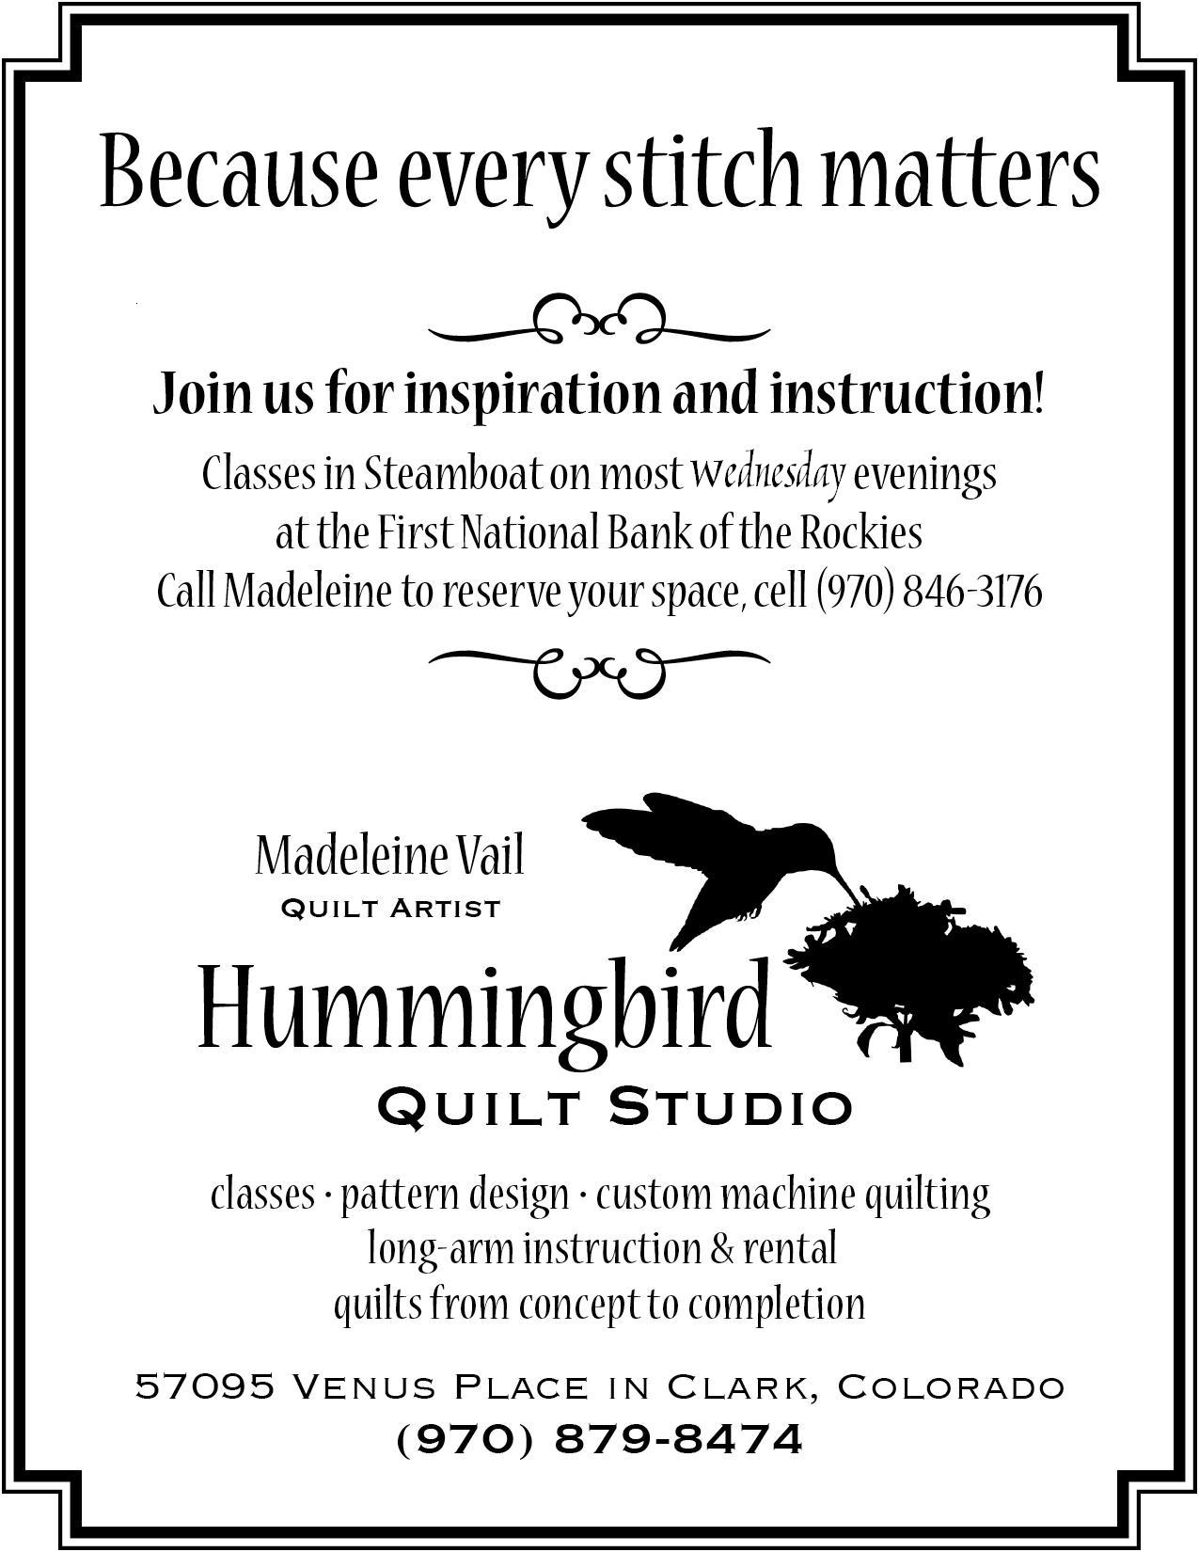  How to Participate: | 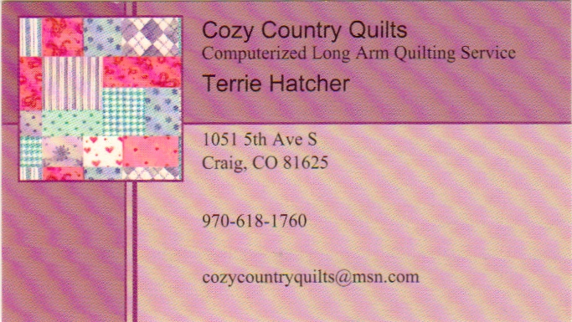
 | 