THE NEWSLETTER OF THE DELECTABLE MOUNTAIN QUILTERS GUILD
PEAKS & PIECES
May, 2014
Volume 20, Issue 204

PRESIDENT’S NOTE

I hope you all had a wonderful Easter. It seems Mother Nature does not want to give up winter. We will just have to be patient. Warm sun and green grass are around the corner.

We have a great treasure in town and we were privileged to visit it last month. The Tread of Pioneers Museum is a great resource to the past here in Steamboat. Katie, the curator, opened up the vaults and showed us some quilts and explained how they stored them at the museum. Thank you to Annabeth Lockhart and Grace Compestine for sharing their family stories and quilts.

This month we will see all your efforts come together for our “A River Runs Through It” quilt. I can’t wait to see what you all have done. Keep working on your journal page for June also.

In April, we showed our support to Tamie Buskirk by agreeing that we would like to see our guild represented in the 4th of July parade. Please contact Tamie if you know of a way to get a hay wagon and a team of horses or truck to pull it. It will be great fun to be a part of the parade.

Keep sewing,

See you Thursday, May 15th
Maria Bidgood

Inside this issue:

President’s Note | 1
Vice President’s Report | 2
Programs & Workshops 2014 | 3
Bulletin Board | 3
Minutes – March 20, 2014 | 5
2014 Membership Registration Form | 7
2014 Workshop Registration Form | 8
Advertisers | 9

NEXT BOARD MEETING
Monday, May 12, 2014
at 6:00 p.m.
Scott Senior Center ~ Selbe Apartments

NEXT GENERAL MEETING:
THURSDAY, May 15, 2014
at 6:30 p.m.
Community Center

DON’T FORGET to bring your
“River Runs Though It”
Quilt!

DELECTABLE MOUNTAIN
QUILTERS GUILD
The DMQG membership meetings are held the third Thursday of every month at the Stmbt Springs Community Center. Door opens at 6:00 pm for early sign-ups and meetings start promptly at 6:30pm. Membership is $20/per year. Meetings are free for members, and non-members pay a $3 guest fee.

DMQG Board Meetings are held the third Monday of each month at 6:00pm @ Selbe Apartments/Scott Center. Board meetings are open to all members.
2014 Board of Directors
President………………….………………….…Maria Bidgood
Vice President………………….…………......Terri Meeks
Secretary……….Terry Hinde/RuthAnn Mewborn
Treasurer……………………..……………………Kathy Gonio

20th Anniversary Coordinator: Tamie Buskirk
County Fair Liaison: Jackie Grimaldi
Fabric Exchange: Chris Hensen
Fall Retreat: Marcia Spitelli, Terri Meeks,
and Irene Meyer
Hospitality: Jean Clougherty
Membership: Margaret Bruellman
Morning Star Quilts: Peggy Hoff
Newsletter: Chris Hensen
Opportunity Quilt: Grace Compestine
Publicity: Grace Compestine
Quilt Scholarship: Peggy Hoff
Quilt Shows: Madeleine Vail
2015 Raffle Quilt: Jackie Grimaldi
Raffle Quilt Games Manager: Cheryl Spahr
Senior Xmas Project Coordinator:
Silent Auction Coordinator:
Special Shows & Programs:
Spring Retreat: Cheryl Spahr, D.Steverson
and Grace Compestine
Tread of Pioneers Museum/XMAS Trees:
Peggy Hoff and Pat Zabel
Website: Estella Heitman

DMQG reserves the right to select the articles and advertising that reflects the purpose of the Guild. Questions, articles and requests for permission to reprint information from the newsletter should be sent to the editor @ DMGQ Editor, PO Box 774383, Steamboat Springs, CO 80477.

Peaks & Pieces is published monthly by the DMQG. Deadline for submissions is the 26th of the previous month. Please send information to the Newsletter Editor: Chris Hensen, cdhensen@aol.com

Advertising rates are as follows:
Members
1 yr ¼ page $100 or Business Card Size $50
1-time ¼ page $10, or Business Card Size $5
Non-members
1 yr ¼ page $120 or Business Card Size $60
1-time ¼ page $15 or Business Card Size $6

Dear Friends,

Isn’t it fun to go back in time and reminisce about days gone by? Many thanks to Katie Adams, Curator at the Tread of Pioneers Museum, for sharing tips about cleaning and caring for quilts, while showing us a few of the museum’s quilts and the storage area. Weren’t those wonderful stories from Annabeth Lockhart and Grace Compestine, who shared beautiful quilts handmade by their mothers? Photos of all of these may be seen on the Delectable Mountain Quilters Guild Facebook page.

I think about the days to come when members of my family may lovingly use and share quilts that I made especially for them, telling and retelling family stories as oral history enhanced by the very real, visible and tactile proof of my love for them – a quilt. (By the way…be sure to put labels on your quilts!)

Our May 15th meeting will be a chance for us to catch up with award-winning quilter and teacher, David Taylor of Steamboat Springs.

June 19th will feature art quilter Deirdre Adams from the Denver area. In July, Julie Hocker of LadyHawk Designs will be here to speak at our meeting on the 17th, and to teach us thread techniques on Saturday, July 19th. See her information and photos on the website - sign up now!

Happy Quilting!

Terri Meeks

GREETINGS FROM YOUR
VICE PRESIDENT

PROGRAMS | WORKSHOPS
May 15th: An evening with award-winning quilter and teacher, David Taylor of Steamboat Springs.
June 19th: Deidre Adams, Contemporary Art Quilter, shares her artistic journey in the world of art quilting.
July 17th: Julie Hocker, from Lady Hawk Designs, fiber artist and quilt designer:  "Kick Start Your Creativity" | July 19th: Julie Hocker, "Texturescapes 3"  This is the workshop of your dreams. It is the perfect place to learn new techniques that you have been afraid to try. It is Julie's most popular class. It always proves to be a fun-filled inspirational day! This technique class addresses the 'embellishing' aspect of designs, to create a realistic, dimensional appearance.
August 15: Joint Meeting with Craig's Piecemaker's guild
NOTE: This is a Tuesday meeting.
September 18th: Silent Auction
October 16th: Estella Heitman: "French Braid Designs" | October 18: Estella Heitman & Terry Hinde:  AM: French Braid Construction  PM: Napkin Construction
November 20th: Potluck, Officer Elections

BULLETIN BOARD
BIRTHDAYS IN MAY

Amy Pederson May 3 Ruthann Mewborn May 4 Barbara Swissler May 4
Judy Winter May 4 Kathy Gonio May 12 Cathy Gero May 14
Tara Sanders May 14 Debbie Heller May 23 Sharon Rottmann May 27
Terry Hinde May 29

Happy Birthday ladies! Thank you for the treats for May’s meeting!
Opportunity Quilt is sponsored by Sew Steamboat in 2014!
Sew Steamboat has offered to sponsor the DMQG Opportunity Quilt in 2014. They will supply up to 2 yards of fabric per month to the member making the quilted item. In return, the quilted item will be put on display either before or after each month’s Guild Meeting. Thank-you! Tamie

May Sharon Rottmann September Tamie Buskirk
June Mary Lou Fahres October Estella Heitman/Terry Hinde
July Maria Bidgood November Cindy Doran

Congratulations to the winner of the April Opportunity Quilt – Maria Bidgood!
SPRING RETREAT: APRIL 25 - APRIL 28, 2014
Thank you Cheryl Spahr, Diana Steverson and Grace Compestine!!!!
Spring Retreat was a great success thanks to the three of you! Everyone enjoyed the goody bags with the Santas, scrubbies and other treats. The bag exchange was a hit and you had a lot of fantastic door prizes for everyone. Sewing machines were whirring as many projects were completed. Many “River Runs Through It” projects were being worked on over the weekend. I am always so impressed when I attend the retreats. We have so many creative and talented ladies in our Guild. You are all so inspiring to newbies, like me!

20th ANNIVERSARY RIVER RUNS THROUGH IT QUILT PROJECT

Don’t forget to bring your completed “River Runs Through It” quilt to the May meeting.
Tammie will collect the quilts on May 15 to get ready for the June First Friday Art Walk Quilt Show at Sew Steamboat on June 6. Tammie can use some help getting the quilts hung in the upstairs display area of Sew Steamboat on June 4 and 5. She will also need a volunteer to coordinate appetizers and a couple people to help during the evening. A volunteer is also needed to prepare a poster for the show. Please contact Tammie at 819-6234 or at the May meeting if you would like to help.

20th ANNIVERSARY QUILTERS JOURNAL PROJECT - MEMBER/QUILTERS STORY
Please go to our web site for the quilters journal project information.
Remember the journal submissions are due by the June 19 meeting.
September’s Silent Auction
As you are Spring cleaning, keep an eye out for items that you would like to donate for the silent auction that will be held at the September meeting. Some ideas: quilt books that you don’t use or are duplicates, quilt patterns or kits that have been sitting around for a long time or are duplicates, fabrics that you loved a few years ago, but have no clue how to use them, maybe you have a pin cushion, table runner or small wall hanging that has been sitting in a closet, on a shelf or in a drawer unused, or sewing notions or tools that you haven’t used or are duplicates, or ??????
2014 Fabric Exchange
May 12 - 10" squares – Three-Color Exchange – Red, White and Black
June 12 - 2 1/2 inch strips - Patriotic - Red, White and Blues
July 25 - 5 inch squares in Kid's Prints - boy or girl
August 4 - Fat Quarters - Batik Bonanza!
September 12 - 10 inch squares - Reproduction Prints - 1930's/Aunt Gracie's/Civil War patterns
October 1 Holiday or Seasonal Panel - Halloween/Thanksgiving/Christmas/Easter or Winter/ Spring/Summer/Fall
November 4 - Fat Quarters - Christmas or Wintery Flannels

Please bring your cut fabric in a Ziploc-style bag with your name on the bag.
If you are inspired by the fabric that you are collecting, make a small project (wall hanging/ placemat/table runner, etc.) with the fabrics that you collected in this year’s exchange and bring it to the January 2015 meeting for Show & Tell!
SAVE THE DATES!
Fall Retreat will be held September 26, 27 and 28 at the Ranch in Steamboat Springs.
Newsletter Submissions: All submissions for the newsletter are due on the 26th of the month prior to publication of the newsletter. If you are a board member who submits monthly articles, or if you want to use the newsletter for a one-time notice, it is important that you respect this deadline in order to get the newsletter completed timely. If you are traveling or otherwise engaged, please make arrangements to send your submission ahead of this deadline. Send submissions to cdhensen@aol.com in Word .doc, .docx, .xls or .xlsx formats.
Just a reminder, our email roster and all of the information in our directory is for the EXCLUSIVE purpose of communication of Guild information. It is NOT to be used for your personal advertising, regardless of how beneficial you may consider the information you send. We all get enough information about charities, special sales, etc, and nobody wants to add to that deluge through use of our Guild directory information.

Delectable Mountain Quilters Guild
General Membership Meeting
April 17, 2014
The meeting was called to order at 6:30 p.m. by President, Maria Bidgood. Twenty-eight members and two guests were in attendance.
Cheryl Spahr made a motion to approve the minutes of the March 20, 2014 General Meeting Minutes as presented in the newsletter. Barbara Swissler seconded the motion. The motion was approved by those in attendance
Maria asked for approval of a motion to approve an Amendment to Article III of the Guild Bylaws. Motion was made by Ruth Ann Mewborn and seconded by Cheryl Spahr at the March meeting but was not put to a vote. The proposed language had been communicated to the Board and to the membership as required in the Bylaws. The following language will be added to Article III, Section 1 of the DMQG Bylaws.
“Business Memberships in the amount of $30.00 per year are available to businesses interested in the art of quilting as stated above. One representative from the business may attend the monthly meeting. If two or more business members attend, they would pay a guest fee of $3.00 each.”
The motion to make the above change to the bylaws was approved by those in attendance.
Kathy Gonio gave the Treasurer’s report. The February 28, 2014 balance in the General account was $8,374.58; the Raffle account balance was unchanged at $721.56; and the Christmas account balance was $123. A detailed Treasurer’s report is available on the website.
Terri Meeks gave the Vice President’s report. Katie Adams, Tread of Pioneers Museum curator and Guild members Annabeth Lockhart and Grace Compestine will present the evening’s program. David Taylor may possibly present the May program. Deidre Adams will present the program in June. Julie Hocker of Lady Hawk Designs will present the July program and a Saturday, July 19, workshop.
Committee Reports
Margaret Bruellman, Membership Chairman, told members that the Guild Directory and its corrections and additions will be e-mailed to members as changes occur.
The evening’s Opportunity Quilt provided by Peggy Hoff includes fabrics she won in January that were donated by Bill Kerr and Weeks Ringle.
Cheryl Spahr reported that Spring Retreat in Laramie will be next weekend, April 25 - 28. She reminded members there will be a bag exchange for those who wish to participate.
Irene Meyers told members that Fall Retreat will be held at the Ranch in Steamboat on the last weekend in September.
Jean Clougherty, Hospitality Chairman, asked for a member to volunteer to fill her role at the June meeting.
Chris Hensen asked for a consensus of what members would like for the fabric exchange for May. The exchange will be 10” squares in red, white and black.
Tamie Buskirk, 20th Anniversary Celebration Chairman, reminded members that their River Runs Through It Quilts are due at the May meeting. Sew Steamboat has agreed to hang the group display in the upstairs gallery of the shop during the First Friday Art Walk on June 6. She will need member volunteers to help hang the quilts on Wednesday and Thursday, June 4 and June 5. She will also need a volunteer to coordinate appetizers for the evening of June 6 and someone to serve the food. A volunteer is also needed to prepare a poster. Members should let Tamie know if they can help.
Tamie also asked members if there was interest in having a float in the 4th of July Parade and if members were willing to help. A number of members volunteered.
Old Business
Maria told members that the Board recommends that action be taken to reinstate the Guild’s tax exempt status. She has an appointment with an accountant to discuss this and other financial items on May 6.
New Business
Maria asked if any member knew the status of the Craig Guild. Adele Vandenburgh said that the Craig group plans to continue this year but does not have a full slate of officers. Maria will contact someone in Craig to see if the group plans on a joint meeting with DMQG in August.
Member Announcements
Madeline Vail told the members that her husband will be adding scissor and knife sharpening to his business.
Tamie Buskirk told the members that the airport was very pleased with the quilt show that was hung at the airport during ski season.
There was a break in the meeting while members enjoyed refreshments.
Katie Adams, Tread of Pioneers Museum curator, showed two quilts from the museum’s collection and discussed ways of caring for, preserving and storing quilts. Annabeth Lockhart talked about her family history in Steamboat and showed a quilt made by her grandmother. Grace Compestine talked about her family and showed two quilts made by her mother.
For Show and Tell, Barbara Swissler showed a reversible table runner she made in Denice Knapp’s class. Madeline Vail and Terri Meeks showed their quilts from the Brown Bag Challenge which were also hung at the airport show.
The evening’s Opportunity Quilt, provided by Peggy Hoff was won by Maria Bidgood.

Door prizes, copies of her book, F. M. Light & Sons: One Vision, One Store, 100 Years: 1905-2005, were provided by Annabeth Lockhart and were won by Sharon Yannaccone, Tina Look and Chris Hensen.
There being no further business, the meeting was adjourned at 8:05 p.m.
Respectfully submitted,

Terry Hinde, Secretary

DELECTABLE MOUNTAIN QUILTERS GUILD 2014
PO BOX 774383, STEAMBOAT SPRINGS, CO 80477 www.dmqg.org
MEMBER INFORMATION
It takes many members, serving on the Board, chairing or serving on committees, to keep our Guild working. How would you like to help? I am willing to serve as a:
_____Committee Chair _____Committee Member
Circle the area(s) below where you would be willing to volunteer your time.
- Block of the Month
- CQC Coordinator
- Fall Retreat
- Hospitality
- Membership
- Morning Star Coordinator
- Newsletter/Website
- Nominations
- Public Relations/Publicity
- Raffle Quilt
- Raffle Quilt Ticket Sales
- Senior Christmas Project
- Spring Retreat
Other: ________________________

I am interested in:
_____ Presenting a program
_____ Workshop Instructor

Suggestions for a program, lecture or workshop:

________________________________

________________________________
I am willing to:
_____ Host an out-of-town speaker

_____ Provide transportation for out-of-town speaker
Other ________________________________________________________________

2014 MEMBERSHIP REGISTRATION FORM
_____ NEW MEMBER ____ RENEWAL

NAME ________________________________

ADDRESS ______________________________

CITY ________________________________

STATE __________________ZIP+4 _________

HOME PHONE: __________________________

MOBILE PHONE: ________________________

WORK PHONE: __________________________

EMAIL ADDRESS ________________________

BIRTH MONTH ________________ DAY ____________
Annual Membership Dues are $20.00 – January 1-December 31. After August 1st dues are $10.00. Fees are waived for members over 80 years of age. Make check or money order payable to: DMQG. Mail it, along with this form to: DMQG-Membership, PO Box 774383, Steamboat Springs, CO 80477. Deadline to be included in Directory is the February Meeting (2/20/2014).

A member will not sell or give away the membership roster for personal gain. Membership in the Delectable Mountain Quilt Guild is not transferable or assignable.

Each member agrees, as a condition of membership, to release and waive any claim he or she has or may have against DMQG, its officers, employees, committee members or agents arising out of or related to the member’s participation in activities of the Guild or arising out of any action taken by the Guild or its Board of Directors to discipline or expel any member or officer.
Signature _______________________ Date _
DMQG has established a website at www.dmqg.org. The monthly newsletter will be available (by password only) by the 1st of each month. An email will be sent when the newsletter is available to view. If you do not have access to a computer, a newsletter will be mailed to you upon request.
Membership: $________ ($20.00)
_____ Cash _____ Check Ck# _________
Date Paid _______________________
_____ I am 80 years of age, fees waived.
_____ I do not have access to a computer; please mail my newsletter.
2014 DMQG WORKSHOP REGISTRATION FORM
Materials Lists for all 2014 workshops will be posted
on the website at www.dmqg.org. The lists can be printed from the site.
Lists will also be available at monthly meetings.

Workshop Fees: See Workshop List Below
If you need to cancel your registration for any workshop
30 days notice is required for a full refund. If you cancel 15 days before the workshop you will be refunded half the workshop fee. There will be no refund for cancellations less than fifteen days before any workshop.

Name: | ____________________________
2014 DMQG Member: | Yes No
Address: | ____________________________
City, State, Zip: | ____________________________
Daytime Phone: | ____________________________
Evening Phone: | ____________________________
E-Mail Address: | ____________________________

Workshop Date | Time  With 1 Hour Lunch Break | Workshop | Location | Workshop Fee
Saturday  July 19 | 9AM – 4 PM | Julie Hocker  Texture Scapes 3 | Selbe Apartments Scott Center | Members $35  Non-DMQG Members $45
Saturday  October 18 | 9 AM – 4 PM | Estella Heitman & Terry Hinde  French Braid/Napkins | Selbe Apartments Scott Center | Members $35  Non-DMQG Members $45
Total Amount Enclosed: |  |  |  | $
Send the above registration form with your check, payable to DMQG to:
Terri Meeks, 362 Cherry Drive, Steamboat Springs, CO 80487
Call 761-2050 for more information.

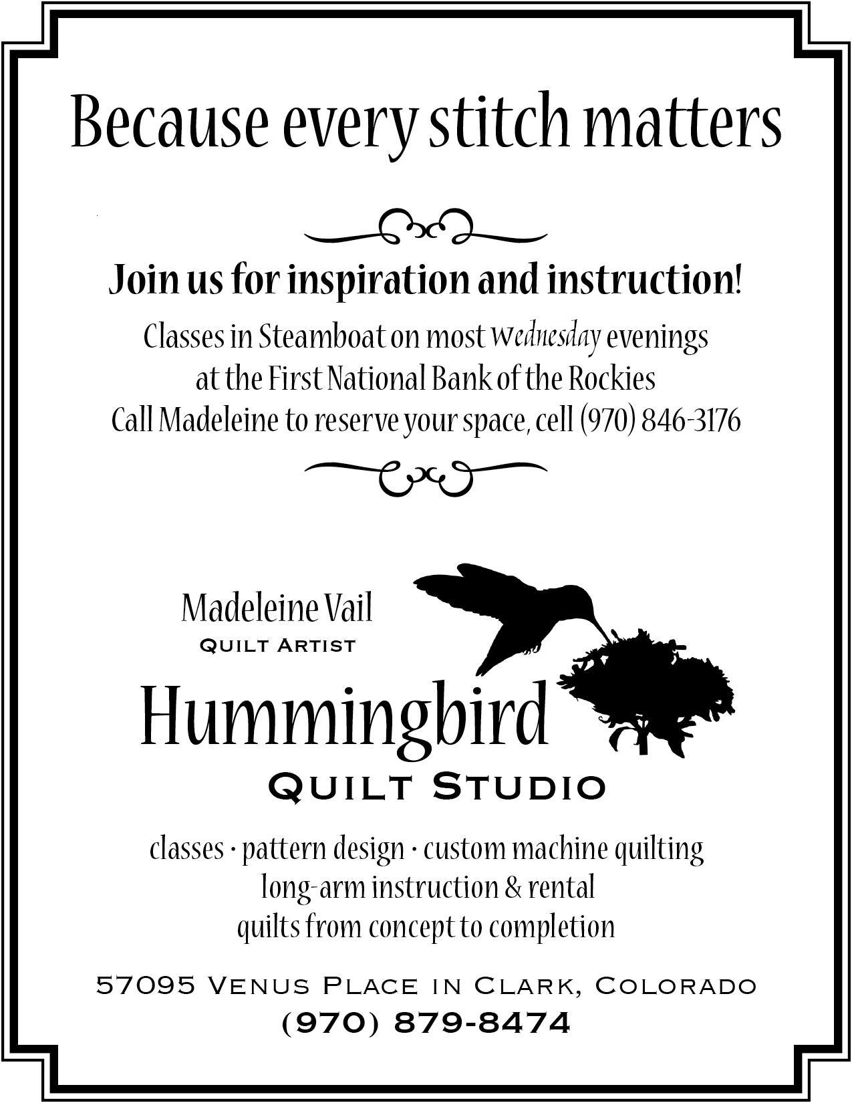  How to Participate: | 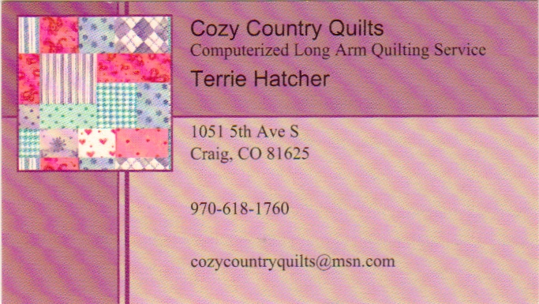
 | 