THE NEWSLETTER OF THE DELECTABLE MOUNTAIN QUILTERS GUILD
PEAKS & PIECES
November, 2014
Volume 20, Issue 210

PRESIDENT’S NOTE
 Here we are at the end our year. We have seen so many beautiful quilts at show and tell. We are learning so much with every one we make. That’s why it’s so important to keep taking classes where ever you are, to learn new techniques, new ways to do things and new perspectives on the art of quilting.
This month we will celebrate the end of our year with a pot luck supper. Please bring a main dish, side dish or dessert. For our gift giving we are exchanging a special food item. It can be a homemade baked item or any special edible treat that you would give as a gift. Can I suggest that if you bake something to include the recipe with the item? We are always asking people for recipes when we taste their baked goods. This would save a step.
During our November meeting we will be voting on our board members. The nominees are: Maria Bidgood, President, Terri Meeks, Vice-President, Cheryl Spahr, Treasurer, and Terry Hinde, Secretary.
There will also be a sign-up sheet for those who would like to sign up for various committees. Please consider each of the committees and choose one that you would be interested in.
We are in immediate need of someone who would like to chair a group to make a small gift item for needy Routt county seniors. We have a suggestion of a lanyard or a pot holder. If you have time, please make at least a couple of either of these before November 20 and bring it to the meeting. Directions for potholders are plentiful online and I will include the directions for the lanyard at the end of this letter.

How to make a lanyard: Sew enough 2” wide scraps together to make a strip about 40” long. Press seams open. Fold in half lengthwise and press. Open up the seam and fold outside edges to the middle fold line. Press. Fold in half again and press. Sew along outside edges 1/8” from edge to secure. This is all you have to do. We don’t have the hardware yet to attach to the bottom. To see these directions on line, go to: twopeasinapoddesigns.com
Consider fabrics that would be suitable for male users as well as female users.
*Note: These lanyards can certainly be made from a 2” WOF strip of colorful fabric. Using scraps gives them more interest.

See you at the pot luck,
Maria Bidgood, President

Inside this issue:

President’s Note | 1
Vice President’s Report | 2
Programs & Workshops 2014 | 3
Bulletin Board | 3
Minutes from last meeting | 4
2015 Membership Registration Form | 6
Advertisers | 7

NEXT BOARD MEETING
Tuesday, November 18, 2014
at 6:00 p.m.
Scott Senior Center ~ Selbe Apartments

NEXT GENERAL MEETING:
THURS., Nov. 20, 2014
Community Center

Doors open at 6:00 p.m.
Meeting starts at 6:30 p.m.

DELECTABLE MOUNTAIN
QUILTERS GUILD
The DMQG membership meetings are held the third Thursday of every month at the Stmbt Springs Community Center. Door opens at 6:00 pm for early sign-ups and meetings start promptly at 6:30pm. Membership is $20/per year. Meetings are free for members, and non-members pay a $3 guest fee.

DMQG Board Meetings are held the third Monday of each month at 6:00pm @ Selbe Apartments/Scott Center. Board meetings are open to all members.
2014 Board of Directors
President………………….………………….…Maria Bidgood
Vice President………………….…………......Terri Meeks
Secretary……….Terry Hinde/RuthAnn Mewborn
Treasurer……………………..……………………Kathy Gonio

20th Anniversary Coordinator: Tamie Buskirk
County Fair Liaison: Jackie Grimaldi
Fabric Exchange: Chris Hensen
Fall Retreat: Marcia Spitelli, Terri Meeks,
and Irene Meyer
Hospitality: Jean Clougherty
Membership: Margaret Bruellman
Morning Star Quilts: Peggy Hoff
Newsletter: Chris Hensen
Opportunity Quilt: Grace Compestine
Publicity: Grace Compestine
Quilt Scholarship: Peggy Hoff
Quilt Shows: Madeleine Vail
2015 Raffle Quilt: Jackie Grimaldi
Raffle Quilt Games Manager: Cheryl Spahr
Senior Xmas Project Coordinator:
Silent Auction Coordinator:
Special Shows & Programs:
Spring Retreat: Cheryl Spahr, D.Steverson
and Grace Compestine
Tread of Pioneers Museum/XMAS Trees:
Peggy Hoff and Pat Zabel
Website: Estella Heitman

DMQG reserves the right to select the articles and advertising that reflects the purpose of the Guild. Questions, articles and requests for permission to reprint information from the newsletter should be sent to the editor @ DMGQ Editor, PO Box 774383, Steamboat Springs, CO 80477.

Peaks & Pieces is published monthly by the DMQG. Deadline for submissions is the 26th of the previous month. Please send information to the Newsletter Editor: Chris Hensen, cdhensen@aol.com

Advertising rates are as follows:
Members
1 yr ¼ page $100 or Business Card Size $50
1-time ¼ page $10, or Business Card Size $5
Non-members
1 yr ¼ page $120 or Business Card Size $60
1-time ¼ page $15 or Business Card Size $6

Due to technical difficulties that Terri is experiencing we

don’t have the Vice President’s report for this month’s

newsletter.

☹

GREETINGS FROM YOUR
VICE PRESIDENT

PROGRAMS | WORKSHOPS
November 20th: Potluck, Officer Elections
Please consider serving on the Guild Board of Directors as the Treasurer! Bring your favorite dish to share at the Potluck. Don’t forget to bring a “Sweet Treat” to exchange!

BULLETIN BOARD
BIRTHDAYS IN NOVEMBER & DECEMBER

GRACE COMPESTINE - November 2 DIANA STEVERSON - November 4
DENICE KNAPP - November 6

JEAN CLOUGHERTY - December 1 SUE LEESON - December 9
BONNIE CALHOUN - December 20

Since the potluck dinner is this month and there is no meeting in December, the ladies with November and December birthdays were invited to bring a treat to the October meeting along with the October birthdays.

Thank you to everyone who brought treats to the meetings throughout 2014!

Happy Birthday ladies!
Opportunity Quilt is sponsored by Sew Steamboat in 2014!
Sew Steamboat has offered to sponsor the DMQG Opportunity Quilt in 2014. They will supply up to 2 yards of fabric per month to the member making the quilted item. In return, the quilted item will be put on display either before or after each month’s Guild Meeting. Thank-you! Tamie

November - Cindy Doran

2015 Memberships
The 2015 Membership Registration form is attached. If you would like to submit your registration early, print and complete the form and bring it to the November meeting. If you know of anyone who would still like to join in 2014, we will offer a pro-rated membership fee.

2015 Quilt Show at the Airport
If you have quilts that you would like to display at the Yampa Valley Regional Airport this winter, please drop them off at Jackie’s house no later than Saturday, November 8.
For Sale
Ann Noyes has a hand-quilting rack for sale. For more information, please call Ann at 879-1790.
2014 Fabric Exchange

November Fat Quarters - Christmas or Wintery Flannels - For each fat quarter that you bring, you’ll receive the same number of fat quarters back.

Please bring your cut fabric in a Ziploc-style bag with your name on the bag.
If you are inspired by the fabric that you are collecting, make a small project (wall hanging/ placemat/table runner, etc.) with the fabrics that you collected in this year’s exchange and bring it to the January 2015 meeting for Show & Tell!

2015 Fabric Exchange
January, February & March will be 2 ½ inch strips
April, May & June will be 5 inch squares
July, August & September will be fat quarters
October and November will be 10 inch squares
Hopefully, this format will make it easier to plan for a few months at a time. Each month can have a different color or theme. I would like suggestions for how many of each cut of fabric should be brought each month, what themes/colors you would like to have and any other suggestions to make the exchange successful! Please get in touch with me at November’s meeting or email me at cdhensen@aol.com. Thanks! Chris
Newsletter Submissions: All submissions for the newsletter are due on the 26th of the month prior to publication of the newsletter. If you are a board member who submits monthly articles, or if you want to use the newsletter for a one-time notice, it is important that you respect this deadline in order to get the newsletter completed timely. If you are traveling or otherwise engaged, please make arrangements to send your submission ahead of this deadline. Send submissions to cdhensen@aol.com in Word .doc, .docx, .xls or .xlsx formats.
Just a reminder, our email roster and all of the information in our directory is for the EXCLUSIVE purpose of communication of Guild information. It is NOT to be used for your personal advertising, regardless of how beneficial you may consider the information you send. We all get enough information about charities, special sales, etc, and nobody wants to add to that deluge through use of our Guild directory information.

Delectable Mountain Quilters Guild
General Membership Meeting
October 16, 2014
The meeting was called to order at 6:35 p.m. by President, Maria Bidgood. Twenty-nine members were in attendance.
Cheryl Spahr made a motion to approve the minutes of the September 14, 2014 General Meeting as presented in the newsletter. Jean Clougherty seconded the motion. The motion was approved by those in attendance.
Kathy Gonio gave the Treasurer’s report. The September 30, 2014 balance in the General account was $4,806.87; the Raffle account balance was unchanged at $271.56; and the Christmas account balance was unchanged at $123.00. A detailed Treasurer’s report is available on the website.
Terri Meeks gave the Vice President’s report. She reminded members to bring a dish to share for the November pot luck dinner and a food item to exchange if they wish to participate in a holiday game. Denice Knapp will present the January 2015 program.
Committee Reports
Estella Heitman reminded the members that she will be stepping down as website chairman and asked for a volunteer to assume her duties.
Grace Compestine reported that the evening’s Opportunity Quilt offerings were a French braid table runner made by Estella Heitman and coordinating napkins made by Terry Hinde.
Sharon Rottman reported that Spring Retreat will be held in Laramie on May 2 – 3, 2015. The price will be the same as last year.
Chris Hensen reported that the fabric exchange for 2015 will be structured so that the same size fabrics will be exchanged during each quarter of the year.
Cheryl Spahr reported that there have been three applications for the Quilt Guild Education Grant.
Jackie Grimaldi reported on the raffle quilt. She is making a quilt top which should be complete for members to see at the November meeting. She also circulated a photo for members to see. Cheryl Spahr has applied for the gaming license. There was a discussion of whether the raffle tickets should be purchased locally or through the internet. The internet price is significantly less than having the tickets printed locally.
After discussion, Gail Nelson made a motion to allow the Raffle Committee to order raffle tickets through the internet supplier Jackie Grimaldi has found. Cheryl Spahr seconded the motion. The motion was approved by those in attendance.
Jackie will order 6,000 raffle tickets and will prepare packets of 50 tickets and a photo of the quilt top to be given to each member to sell or purchase. She suggested that the tickets make great stocking stuffers. She also told members that anyone not wishing to sell or purchase tickets may return them to her.
Tamie Buskirk reported that the River Runs Through It exhibit has been hung in the common area of the airport and will remain there during ski season. Tamie also reported that the Rocky Mountain Quilt Expo, to be held at the Ranch in Loveland in August 2015 has expressed an interest in the exhibit.
Jackie Grimaldi and Madeline Vail discussed the quilt exhibit to be hung in the secure area of the airport. They requested approximately 30 quilts, none over 70”. Quilts may be delivered to Jackie’s home by November 12 and will be hung at the airport by November 15.
Jackie also told the members that she has been contacted by Cindy Wither as representative of the Arts Council asking if the Guild would be interested in having a quilt show at the Depot in December. After discussion, it was decided not to do a December show but to notify the Arts Council that the Guild would prefer to do a show in June or July.
Old Business
Maria reported she has received correspondence from the IRS reinstating of the Guild’s non-profit status retroactive to May 15, 2011.
Maria asked for a volunteer to assume the Treasurer’s office, after Kathy Gonio resigns at the end of 2014. Cheryl Spahr volunteered.
New Business
Maria asked for suggestions for gifts for the Guild seniors’ Christmas project. Suggestions were pot holders and lanyards that could include a clip or ring for keys.
Maria announced that the Guild Board has established a workshop enrollment policy as follows: The account of any member wishing to attend a class offered by DMQG must be current, meaning that DMQG dues and all prior class fees must have been paid.
Maria also announced that there is a committee sign-up sheet on the front table for members use in volunteering to serve on Guild committees for 2015.
Member Announcements
Estella Heitman reported that the Craig Guild, Yampa Valley Piecemakers, will be disbanding at the end of the year and at Tina Smith’s request, she gave permission for the DMQG newsletter to be distributed to the members of the Craig Guild so that they would have a DMQG membership application.
There was a break in the meeting while members enjoyed refreshments.
The evening’s program was presented by Estella Heitman. She discussed French braid quilts, their construction and alternative layouts.
Show and Tell
Sue Leeson showed her beautiful bed size quilt inspired by traditional Navajo designs. Maria Bidgood shared her batik leaf quilt. Madeline Vail shared a wall size quilt from her Flora and Fauna pattern. Jackie Grimaldi shared a beautiful hand embroidered throw from Mongolia. She also shared three of her own creations: A McKenna Ryan Christmas quilt, a red and black quilt featuring the silhouettes of women’s’ faces and a quilt called Dolly and Me made for her granddaughter. Jo Stack shared a quilt made for a friend that featured comical hunting motifs. Terri Meeks shared a pieced flower wall hanging.
The evening’s Opportunity Quilt was won by Sue Leeson.

Door prizes provided by Jo Stack and Marcia Spitellie were won Ruth Ann Mewborn, Nancy Johnson, Maria Bidgood, Chris Henson and Susan Ellis. Thank you, Jo and Marcia.
There being no further business, the meeting was adjourned at 8:30 p.m.
Respectfully submitted, Terry Hinde, Secretary
DELECTABLE MOUNTAIN QUILTERS GUILD 2015
PO BOX 774383, STEAMBOAT SPRINGS, CO 80477 www.dmqg.org
MEMBER INFORMATION
It takes many members, serving on the Board, chairing or serving on committees, to keep our Guild working. How would you like to help? I am willing to serve as a:
_____Committee Chair _____Committee Member
Circle the area(s) below where you would be willing to volunteer your time.
- Block of the Month
- CQC Coordinator
- Fall Retreat
- Hospitality
- Membership
- Morning Star Coordinator
- Newsletter/Website
- Nominations
- Public Relations/Publicity
- Raffle Quilt
- Raffle Quilt Ticket Sales
- Senior Christmas Project
- Spring Retreat
Other: ________________________

I am interested in:
_____ Presenting a program
_____ Workshop Instructor

Suggestions for a program, lecture or workshop:

________________________________

________________________________
I am willing to:
_____ Host an out-of-town speaker

_____ Provide transportation for out-of-town speaker
Other ________________________________________________________________

2015 MEMBERSHIP REGISTRATION FORM
_____ NEW MEMBER ____ RENEWAL

NAME ________________________________

ADDRESS ______________________________

CITY ________________________________

STATE __________________ZIP+4 _________

HOME PHONE: __________________________

MOBILE PHONE: ________________________

WORK PHONE: __________________________

EMAIL ADDRESS ________________________

BIRTH MONTH ________________ DAY ____________
Annual Membership Dues are $20.00 – January 1-December 31. After August 1st dues are $10.00. Fees are waived for members over 80 years of age. Make check or money order payable to: DMQG. Mail it, along with this form to: DMQG-Membership, PO Box 774383, Steamboat Springs, CO 80477. Deadline to be included in Directory is the February Meeting (2/20/2014).

A member will not sell or give away the membership roster for personal gain. Membership in the Delectable Mountain Quilt Guild is not transferable or assignable.

Each member agrees, as a condition of membership, to release and waive any claim he or she has or may have against DMQG, its officers, employees, committee members or agents arising out of or related to the member’s participation in activities of the Guild or arising out of any action taken by the Guild or its Board of Directors to discipline or expel any member or officer.
Signature _______________________ Date _
DMQG has established a website at www.dmqg.org. The monthly newsletter will be available (by password only) by the 1st of each month. An email will be sent when the newsletter is available to view. If you do not have access to a computer, a newsletter will be mailed to you upon request.
Membership: $________ ($20.00)
_____ Cash _____ Check Ck# _________
Date Paid _______________________
_____ I am 80 years of age, fees waived.
_____ I do not have access to a computer; please mail my newsletter.

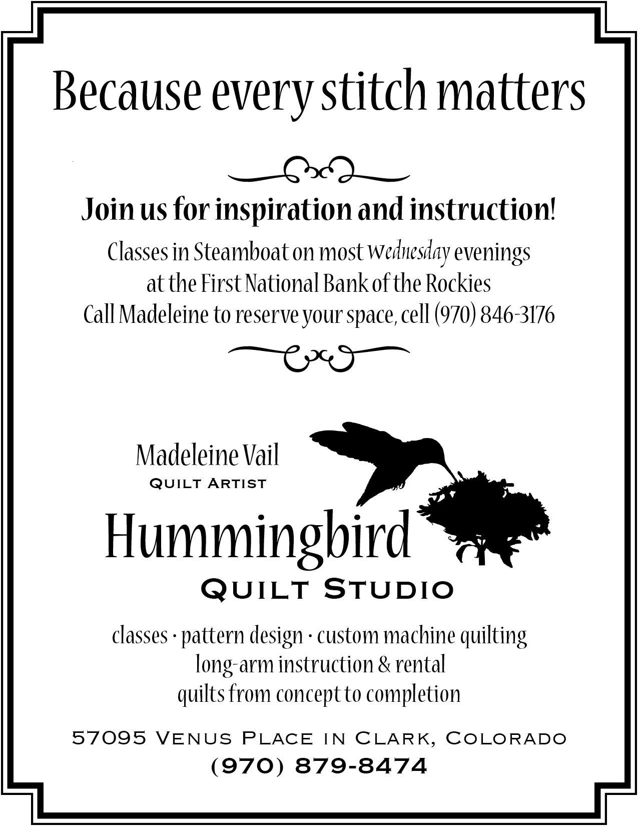  How to Participate: | 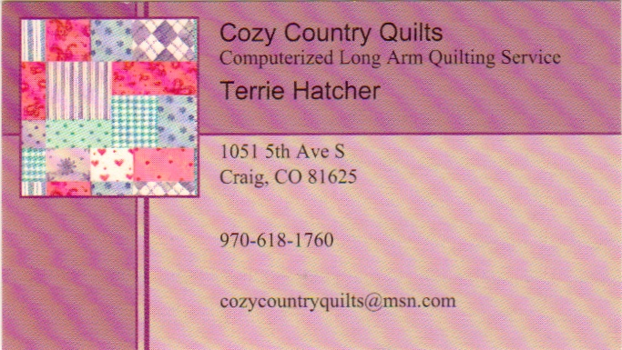
 | 