**Kathy McNeil Landscape Workshop**

**Presentation Date/Cost:**

Thursday, March 16, 2017 at 6:30 p.m.

Steamboat Springs Community Center, 1604 Lincoln Avenue, Steamboat Springs, CO

**Workshop Date/Cost:**

March 18, 2017 from 9:00-4:00

Scott Selbe Senior Center, 500 Rollingstone Drive, Steamboat Springs, Colorado

Members: $35.00; Non-members: $45.00

To sign up: Send an email to both [dmqgss@gmail.com](mailto:dmqgss@gmail.com) and [bedoschwartz@gmail.com](mailto:bedoschwartz@gmail.com) or use the workshop registration form on our website at <http://steamboatquilters.net/>. We will order patterns as a group for everyone who signs up and identifies the pattern they want by 1 February 2017.

**Workshop Material List:** Information can be found online at: ttps://www.kathymcneilquilts.com/workshop-info.htm In addition to the workshop fee, there is a ***$12.00 pattern fee,***your choice of one of these seven patterns to be used in class.***Patterns may be ordered before the workshop by the guild as a group, or students can use my web store to order their own.*** The following are pictures of the patterns that can be used for the workshop. Detailed material lists are online for each pattern.

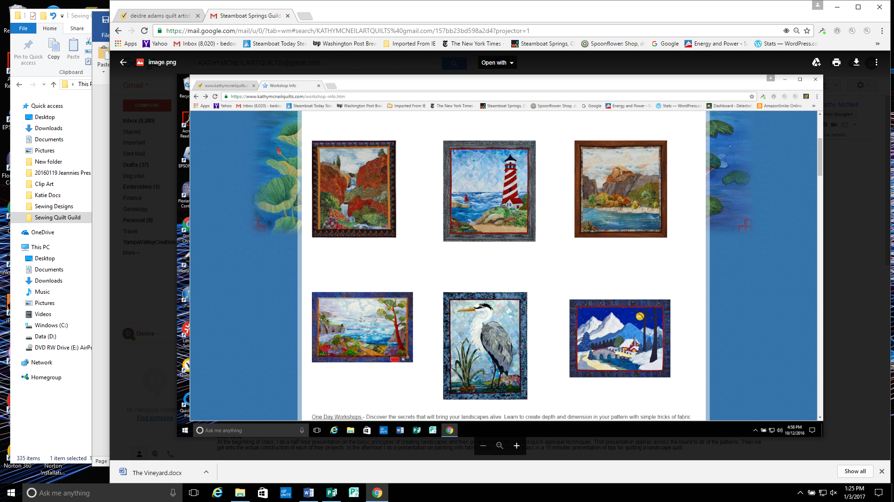

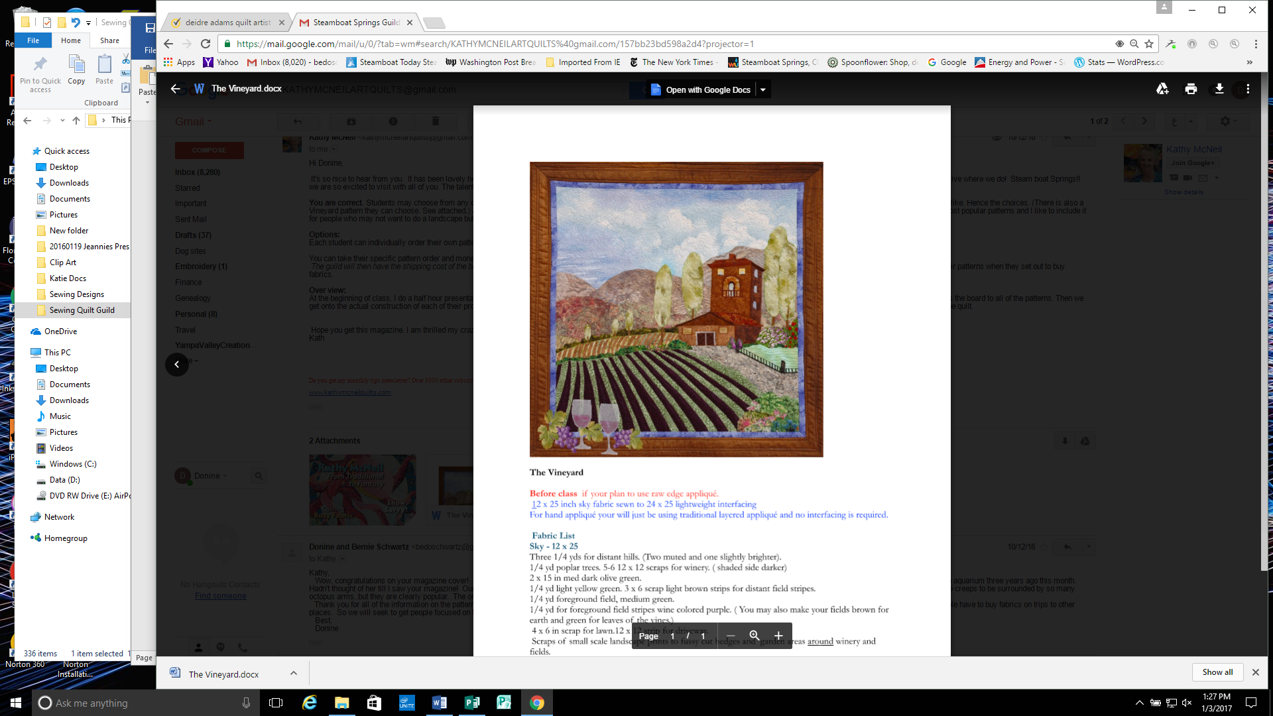

Patterns from left to right, top to bottom:

1. Rainbow Falls, Summer Lighthouse, Alpine Glow

2. Coastal Memories, Blue Heron, Winter Cabin

3. My Vineyard

Interesting note: Kathy designed the Blue Heron pattern because Blue Herons are found in all 50 states.